

MANAGING MEDICINE POLICY
Appendix B
Anaphylaxis
[Roby Park Primary School]



Appendix B of the Administration of Medicines Policy - Anaphylaxis

Anaphylaxis

Anaphylaxis is a severe and often sudden allergic reaction which may be life-threatening and must be treated immediately. Allergic reactions occur when a person’s immune system responds inappropriately to a food or substance that it wrongly perceives as a threat.

What causes an anaphylaxis reaction?

The common causes of allergies and anaphylaxis among children include:
- Peanuts
- Fish/seafood
- Milk
- Eggs
- Tree nuts (such as almonds, walnuts, cashew nuts, brazil nuts)
- Wheat
- Kiwifruit
- Less commonly, other foods
Non-food causes include wasp or bee stings, natural latex (rubber), penicillin or any other medicines.

Most healthcare professionals consider an allergic reaction to be anaphylaxis when it involves a difficulty in breathing or affects the heart rhythm or blood pressure. Any one or more of the following symptoms may be present. These are often referred to as the ABC symptoms:

Airway | Breathing | Consciousness/Circulation
Persistent cough  Vocal changes (hoarse voice)  Difficulty in swallowing  Swollen tongue | Difficult or noisy breathing  Wheezing (like an asthma  attack) | Feeling lightheaded or faint.  Clammy skin  Confusion  Unresponsive/unconscious  (due to a drop-in blood  pressure)

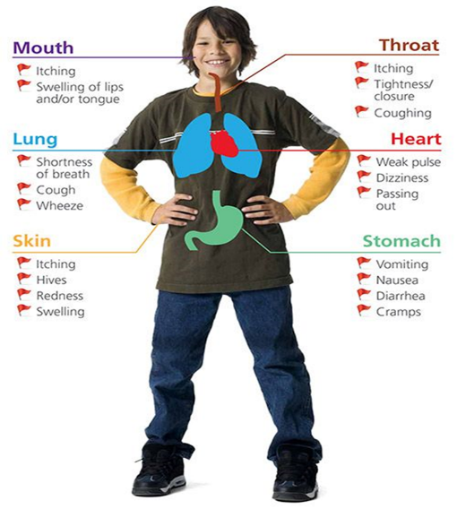
This school welcomes all students with allergies/anaphylaxis and aims to support these children in participating fully in school life, which could include ensuring that a child with a food allergy is able to eat a school lunch. We recognise the seriousness of this condition, but with accurate and comprehensive information we feel their condition can be managed.
We endeavour to do this by ensuring we have:
- all students have an up-to-date allergies and anaphylaxis healthcare plan
- an allergies and anaphylaxis register
- up-to-date allergies and anaphylaxis policy,
- an allergies and anaphylaxis lead,
- all students with immediate access to their adrenaline auto-injectors at all times,
- an emergency adrenaline auto-injector
- ensure all staff have regular anaphylaxis and adrenaline training
- promote anaphylaxis awareness students, parents/carers and staff.
- practical measures to eliminate or reduce the allergen in school.

Anaphylaxis Healthcare Plan

To comply with our statutory duty to support students with medical conditions. The school will complete a Healthcare Plan with all students known to suffer from Anaphylaxis or who have been prescribed an Adrenaline Auto-injector.
The school Healthcare Plan ensures the school is effectively supporting a student’s medical condition by providing clarity about the child’s condition, what the child is allergic to, recognising the first signs of allergic reaction and what to do in an emergency.
Students parents/guardians, relevant staff, and if necessary, healthcare professionals will be consulted.

Our Healthcare Plan includes the following information:

- The child’s details
- Contact details – Telephone and mobile numbers of parent or guardian and any other emergency contact details.
- Contact details of family GP
- The child’s allergies – A list of the specific allergies and what to avoid
- A list of possible symptoms
- Prescribed Medication
- Details of Emergency Procedure – Including an assessment of symptoms, when and how to administer medication, contact numbers and the ambulance procedure
- Who can help? – A list of staff members who have been trained
- Consent and agreement – A parent or guardian must give written consent for staff to take responsibility for administering medication.
https://www.gov.uk/government/publications/supporting--at-school-with-medical-conditions--3

Anaphylaxis Register

We have an anaphylaxis register of children within the school, which we update yearly. We do this by asking parents/carers if their child is diagnosed with anaphylaxis or has been prescribed an adrenaline auto-injector. When parents/carers have confirmed that their child is anaphylaxis or has been prescribed an adrenaline auto-injector we ensure that the student has been added to the anaphylaxis register and has:

- an up-to-date copy of their personal anaphylaxis healthcare plan,
- their adrenaline auto-injectors (Epi-Pen, Jext, Emerade) is with them in school,
- permission from the parents/carers to use the emergency Epi-Pen, Jext, Emerade adrenaline auto-injector if they require another dose before the emergency services arrive

Anaphylaxis Lead

This school has an anaphylaxis lead [XXXX]. It is the responsibility of the anaphylaxis lead to manage the anaphylaxis register, update the anaphylaxis policy, manage the emergency Epi-Pen, Jext, Emerade adrenaline auto-injector (please refer to the Department of Health Guidance on the use of adrenaline auto-injectors in schools, September 2017) ensure measures are in place so that children have immediate access to their adrenaline auto-injector.

https://assets.publishing.service.gov.uk/government/uploads/system/uploads/attachment_data/file/645476/Adrenaline_auto_injectors_in_schools.pdf

Access to a child’s Adrenaline Auto-injector

All children with anaphylaxis should always have immediate access to their adrenaline auto-injector. The adrenaline auto-injector medication acts on the whole body to block the progression of the allergic response. It constricts the blood vessels, leading to increased blood pressure, and decreased swelling.

Children are encouraged to carry their adrenaline auto-injectors as soon as they are responsible enough to do so. However, we will discuss this with each child’s parent/carer and teacher. We recognise that all children may still need supervision in administering their adrenaline auto-injector.

School staff are not required to administer adrenaline auto-injector to students however the school understands that in an emergency a failure to administer the child’s medication could end in hospitalisation or even death.
Therefore, the school will ensure an adequate number of staff have had adrenaline auto-injector training and/or administering medication training and are happy to support children. Please refer to the Administering Medicines policy for further details about administering medicines.

Emergency Adrenaline Auto-injector in school

Legislation which came into effect in 2017 enables schools in the UK to buy Adrenaline Auto-injector (AAIs) without a prescription for emergency use on children who are at risk of anaphylaxis.
Adrenaline Auto-injector are intended for use in emergency situations when an allergic individual is having a reaction consistent with anaphylaxis, as a measure that is taken until an ambulance arrives.
Therefore, unless directed otherwise by a healthcare professional, the spare Adrenaline Auto-injector should only be used on students known to be at risk of anaphylaxis, where both medical authorisation and written parental consent for use of the spare Adrenaline Auto-injector has been provided.

We have _____ emergency kit(s), which are kept in the ________________________, _______________ and _________________ so it is easy to access.

Each kit contains:

- A pre-loaded Adrenaline Auto-injector.
- Instructions on using the device(s).
- Instruction on cleaning and storing the Adrenaline Auto-injector
- Manufacturer’s information.
- A checklist of Adrenaline Auto-injector, identified by their batch number and expiry date, with monthly checks recorded.
- A note of the arrangements for replacing the Adrenaline Auto-injector.
- A list of children to whom the Adrenaline Auto-injector can be administered:
- A record of administration
Adrenaline Auto-injectors are available in different doses, depending on the manufacturer. The Resuscitation Council (UK) recommends that healthcare professionals treat anaphylaxis using the age-based criteria, as follows:

- For children age under 6 years: a dose of 150 microgram (0.15 milligram) of adrenaline is used (e.g. using an Epipen Junior (0.15mg), Emerade 150 or Jext 150 microgram device).
- For children age 6-12 years: a dose of 300 microgram (0.3 milligram) of adrenaline is used (e.g. using an Epipen (0.3mg), Emerade 300 or Jext 300 microgram device)
Once an Adrenaline Auto-injector has been used it cannot be reused and must be disposed of according to manufacturer’s guidelines. Used Adrenaline Auto-injector can be given to the ambulance paramedics on arrival or can be disposed of in a pre-ordered sharps bin for collection by the local council.

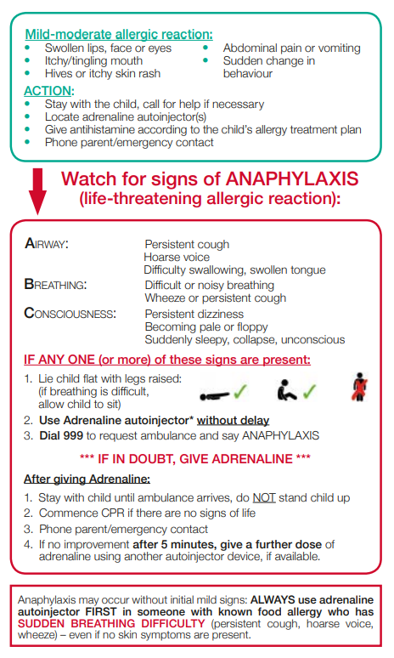
School trips including sporting activities

Schools should conduct a risk-assessment for any student at risk of anaphylaxis taking part in a school trip off school premises, in much the same way as they already do so with regards to safe-guarding etc.
Students at risk of anaphylaxis should have their Adrenaline Auto-injector with them, and there should be staff trained to administer Adrenaline Auto-injector in an emergency. Schools may wish to consider whether it may be appropriate, under some circumstances, to take spare Adrenaline Auto-injector obtained for emergency use on some trips.

Staff training

Severe anaphylaxis is an extremely time-critical situation: Delays in administering adrenaline have been associated with fatal outcomes. Therefore, it is important that as many of our staff are trained in how to administer an Adrenaline Auto-injector.

School Environment

The school does all that it can to ensure the school environment is favourable to students with anaphylaxis. The school has a definitive no-nut policy. Student’s anaphylaxis triggers will be recorded as part of their anaphylaxis healthcare plans and the school will endeavour that student’s will not come into contact with their triggers, where possible.

As part of our responsibility to ensure all children are kept safe within the school grounds and on trips away, a risk assessment will be performed by staff. These risk assessments will establish anaphylaxis triggers which the children could be exposed to and plans will be put in place to ensure these triggers are avoided, where possible.

Food prepared on site - Lunch

All food and drink provided in our school meet the national food standards in England. All school lunches are cooked by our school caterers Knowsley Council.

Our school caterers comply with School Food Standards to ensure that food provided to students in school is nutritious and of high quality; to promote good nutritional health in all students; protect those who are nutritionally vulnerable; and promotes good eating behaviours.
Reasonable adjustments are made to the menu to reflect medical, dietary, and cultural needs of our students.
To comply with the EU Food Information for Consumers Regulation information is made available listing all allergenic ingredients contained within the food and drinks we serve.

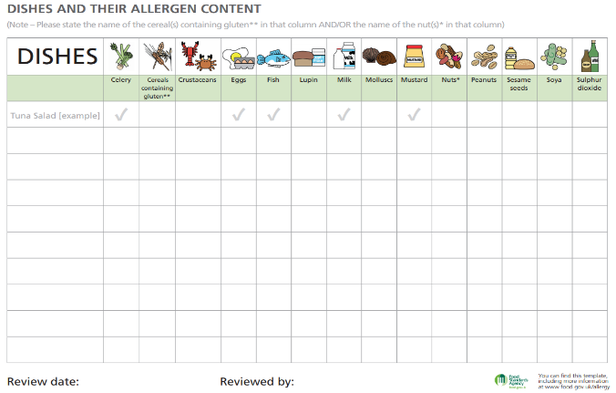
Food prepared on site – Breakfast club.

Food prepared for the breakfast club is provided by the school and consist of low-risk foods e.g. toast, muffins, crumpets and a selection of drinks.

Food prepared off site (Packed Lunches, Birthday celebrations and festive treats)

All parents providing a packed lunch for their child is made aware of any known allergens and are asked to co-operate with the school.
Children with known allergens are encouraged to check with an adult before eating or before taking part in certain activities. Just a “is that okay for me?” will make the adult think again, and also teach the child awareness of their allergy and develop good management techniques.

References

- Department of Health Guidance on the use of adrenaline auto-injectors in school
https://assets.publishing.service.gov.uk/government/uploads/system/uploads/attachment_data/file/645476/Adrenaline_auto_injectors_in_schools.pdf
- Department of Education Allergy Guidance for schools 17th November 2020
https://www.gov.uk/government/publications/school-food-standards-resources-for-schools/allergy-guidance-for-schools
- Department of Education Supporting Pupils with Medical Conditions at School
https://assets.publishing.service.gov.uk/government/uploads/system/uploads/attachment_data/file/803956/supporting-pupils-at-school-with-medical-conditions.pdf
- Department of Education School food in England
https://assets.publishing.service.gov.uk/government/uploads/system/uploads/attachment_data/file/788884/School-food-in-England-April2019-FINAL.pdf
- Department of Education School Food Standards
https://www.gov.uk/government/publications/school-food-standards-resources-for-schools
- Anaphylaxis Campaign
https://www.anaphylaxis.org.uk/information-training/our-factsheets/

