

MANAGING MEDICINE POLICY
Appendix A
Asthma
Roby Park Primary School


Appendix A of the Administration of Medicines Policy - Asthma

Asthma

Asthma is a condition that affects small tubes (airways) that carry air in and out of the lungs. When a person with asthma comes into contact with something that irritates their airways (an asthma trigger), the muscles around the walls of the airways tighten so that the airways become narrower and the lining of the airways becomes inflamed and starts to swell. Sometimes, sticky mucus or phlegm builds up, which can further narrow the airways. These reactions make it difficult to breathe, leading to symptoms of asthma.

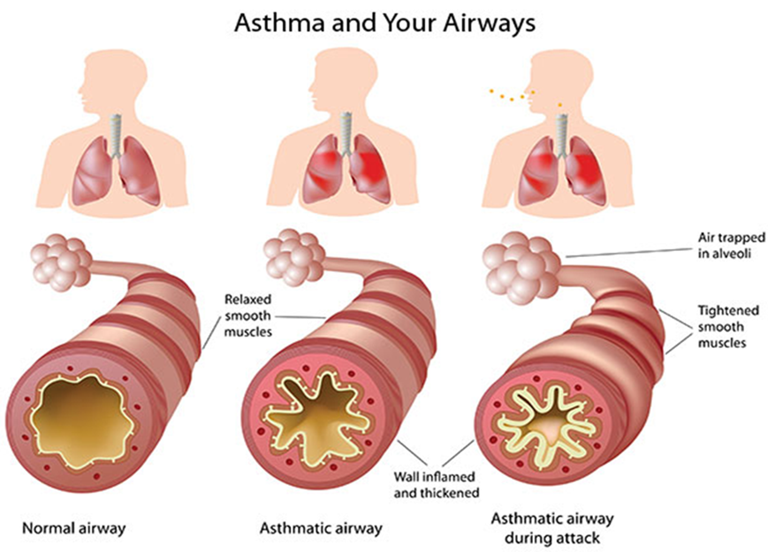

As a school, we recognise that asthma is a widespread, serious, but controllable condition. This school welcomes all students with asthma and aims to support these children in participating fully in school life. We endeavour to do this by ensuring we have:
- an asthma register
- up-to-date asthma policy,
- an asthma lead,
- all students with immediate access to their reliever inhaler at all times,
- all students have an up-to-date asthma action plan,
- an emergency salbutamol inhaler
- ensure all staff have regular asthma training
- promote asthma awareness students parents/carers and staff.

Asthma Register

We have an asthma register of children within the school, which we update yearly. We do this by asking parents/carers if their child is diagnosed as asthmatic or has been prescribed a reliever inhaler. When parents/carers have confirmed that their child is asthmatic or has been prescribed a reliever inhaler we ensure that the students has been added to the asthma register and has:

- an up-to-date copy of their personal asthma action plan,
- their reliever (salbutamol/terbutaline) inhaler in school,
- permission from the parents/carers to use the emergency salbutamol inhaler if they require it and their own inhaler is broken, out of date, empty or has been lost.
Asthma Lead

This school has an asthma lead. It is the responsibility of the asthma lead to manage the asthma register, update the asthma policy, manage the emergency salbutamol inhalers (please refer to the Department of Health Guidance on the use of emergency salbutamol inhalers in schools, March 2015) ensure measures are in place so that children have immediate access to their inhalers.

https://assets.publishing.service.gov.uk/government/uploads/system/uploads/attachment_data/file/416468/emergency_inhalers_in_schools.pdf

Medication and Inhalers

All children with asthma should always have immediate access to their reliever (usually blue) inhaler. The reliever inhaler is a fast-acting medication that opens up the airways and makes it easier for the child to breathe.

Some children will also have a preventer inhaler, which is usually taken morning and night, as prescribed by the doctor/nurse. This medication needs to be taken regularly for maximum benefit. Children should not bring their preventer inhaler to school as it should be taken regularly as prescribed by their doctor/nurse at home. However, if the student is going on a residential trip, we are aware that they will need to take the inhaler with them so they can continue taking their inhaler as prescribed.

Children are encouraged to carry their reliever inhaler as soon as they are responsible enough to do so. However, we will discuss this with each child’s parent/carer and teacher. We recognise that all children may still need supervision in taking their inhaler.

School staff are not required to administer asthma medicines to students however many children have poor inhaler technique or are unable to take the inhaler by themselves. Failure to receive their medication could end in hospitalisation or even death. Staff who have had asthma training and/or administering medication training and are happy to support children as they use their inhaler, can be essential for the well-being of the child. If we have any concerns over a child’s ability to use their inhaler, we will refer them to the school nurse and advise parents/carers to arrange a review with their GP/nurse. Please refer to the Administering Medicines policy for further details about administering medicines.

Asthma Action Plans

Asthma UK evidence shows that if someone with asthma uses personal asthma action plan, they are four times less likely to be admitted to hospital due to their asthma. As a school, we recognise that having to attend hospital can cause stress for a family. Therefore, we believe it is essential that all children with asthma have a personal asthma action plan to ensure asthma is managed effectively within school to prevent hospital admissions.
https://www.asthma.org.uk/advice/child/life/school/

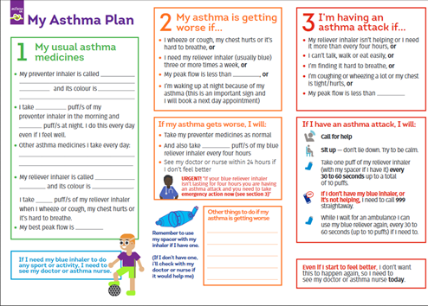

Staff training

Staff will need regular asthma updates. This training can be provided by the school nursing team and/or Compliance Education.

School Environment

The school does all that it can to ensure the school environment is favourable to students with asthma. The school has a definitive no-smoking policy. Student’s asthma triggers will be recorded as part of their asthma action plans and the school will ensure that student’s will not come into contact with their triggers, where possible.

We are aware that triggers can include:
- Colds and infection
- Dust and house dust mite
- Pollen, spores and moulds
- Feathers
- Furry animals
- Exercise, laughing
- Stress
- Cold air, change in the weather
- Chemicals, glue, paint, aerosols
- Food allergies
- Fumes and cigarette smoke

As part of our responsibility to ensure all children are kept safe within the school grounds and on trips away, a risk assessment will be performed by staff. These risk assessments will establish asthma triggers which the children could be exposed to and plans will be put in place to ensure these triggers are avoided, where possible.

Exercise and activity

Taking part in sports, games and activities is an essential part of school life for all students. All staff will know which children in their class have asthma and all PE teachers at the school will be aware of which students have asthma from the school’s asthma register.

Students with asthma are encouraged to participate fully in all activities. PE teachers will remind students whose asthma is triggered by exercise to take their reliever inhaler before the lesson, and to thoroughly warm up and down before and after the lesson. If a student needs to use their inhaler during a lesson they will be encouraged to do so.

There has been a large emphasis in recent years on increasing the number of children and young people involved in exercise and sport in and outside of school. The health benefits of exercise are well documented and this is also true for children and young people with asthma. It is therefore important that the school involve students with asthma as much as possible in and outside of school. The same rules apply for out of hours sport as during school hours PE.

When asthma is affecting a student’s education

The school are aware that the aim of asthma medication is to allow people with asthma to live a normal life. Therefore, if we recognise that if asthma is impacting on their life as a student, and they are unable to take part in activities, tired during the day, or falling behind in lessons we will discuss this with parents/carers, the school nurse, with consent, and suggest they make an appointment with their asthma nurse/doctor. It may simply be that the student needs an asthma review, to review inhaler technique, medication review or an updated Personal Asthma Action Plan, to improve their symptoms. However, the school recognises that Students with asthma could be classed as having disability due to their asthma as defined by the Equality Act 2010, and therefore may have additional needs because of their asthma.

Emergency Salbutamol Inhaler in school

As a school we are aware of the guidance ‘The use of emergency salbutamol inhalers in schools from the Department of Health’ (March 2015) which gives guidance on the use of emergency salbutamol inhalers in schools (March 2015). A summary of the key points from this document can be found below.

https://assets.publishing.service.gov.uk/government/uploads/system/uploads/attachment_data/file/416468/emergency_inhalers_in_schools.pdf

As a school we are able to purchase salbutamol inhalers and spacers from community pharmacists without a prescription.
We have _____ emergency kit(s), which are kept in the ________________________, _______________ and _________________ so it is easy to access. Each kit contains:

- A salbutamol metered dose inhaler.
- At least two spacers compatible with the inhaler.
- Instructions on using the inhaler and spacer.
- Instruction on cleaning and storing the inhaler.
- Manufacturer’s information.
- A checklist of inhalers, identified by their batch number and expiry date, with monthly checks recorded.
- A note of the arrangements for replacing the inhaler and spacers.
- A list of children permitted to use the emergency inhaler:
- A record of administration
We understand that salbutamol is a relatively safe medicine, particularly if inhaled, but all medicines can have some adverse effects. Those of inhaled salbutamol are well known, tend to be mild and temporary are not likely to cause serious harm. The child may feel a bit shaky or may tremble, or they may say that they feel their heart is beating faster.

We will ensure that the emergency salbutamol inhaler is only used by children who have asthma or who have been prescribed a reliever inhaler and for whom written parental consent has been given.

The school’s asthma lead and team will ensure that:
- On a monthly basis the inhaler and spacers are present and in working order, and the inhaler has sufficient number of doses available.
- replacement inhalers are obtained when expiry dates approach.
- Replacement spacers are available following use.
- The plastic inhaler housing (which holds the canister) has been cleaned, dried, and returned to storage following use, or that replacements are available if necessary. Before using a salbutamol inhaler for the first time, or if it has not been used for 2 weeks or more, shake and release 2 puffs of medicine into the air.
Any puffs should be documented so that it can be monitored when the inhaler is running out. The inhaler has _________ puffs, so when it gets to _______ puffs having been used we will replace it.

The spacer cannot be reused as there is a risk of cross-infection therefore, the spacer will be disposed of or assigned to the child for future personal use.

The inhaler can be reused, so long as it hasn’t come into contact with any bodily fluids. Following use, the inhaler canister will be removed and the plastic inhaler housing and cap will be washed in warm running water, and left to dry in air in a clean safe place. The canister will be returned to the housing when dry and the cap replaced.

Spent inhalers will be returned to the pharmacy to be recycled.
As spent inhalers count as waste for disposal the school has a legal responsibility to register as a lower-tier waste carrier.
https://www.gov.uk/register-renew-waste-carrier-broker-dealer-england
The emergency salbutamol inhaler will only be used by children:
- Who have been diagnosed with asthma and prescribed a reliever inhaler OR who have been prescribed a reliever inhaler AND for whom written parental consent for use of the emergency inhaler has been given.
The name(s) of these children will be clearly written in our emergency kit(s). The parents/carers will always be informed in writing if their child has used the emergency inhaler, so that this information can also be passed onto the GP.

Common ‘day to day’ symptoms of asthma

As a school we require that children with asthma have a personal asthma action plan which can be provided by their doctor / nurse. These plans inform us of the day-to-day symptoms of each child’s asthma and how to respond to them in an individual basis. We will also send home our own information and consent form for every child with asthma each school year. This needs to be returned immediately and kept with our asthma register.

However, we also recognise that some of the most common day-to-day symptoms of asthma are:
- Dry cough
- wheeze (a ‘whistle’ heard on breathing out) often when exercising
- Shortness of breath when exposed to a trigger or exercising
- Tight chest
These symptoms are usually responsive to the use of the child’s inhaler and rest (e.g. stopping exercise). As per Department of Health Document, they would not usually require the child to be sent home from school or to need urgent medical attention.

Asthma Attacks

The school recognises that if all of the above is in place, we should be able to support students with their asthma and hopefully prevent them from having an asthma attack. However, we are prepared to deal with asthma attacks should they occur.

All staff will receive an asthma update annually, and as part of this training, they are taught how to recognise an asthma attack and how to manage an asthma attack.

The department of health Guidance on the use of emergency salbutamol inhalers in schools (March 2015) states the signs of an asthma attack are:

- Persistent cough (when at rest)
- A wheezing sound coming from the chest (when at rest)
- Difficulty breathing (the child could be breathing fast and with effort, using all accessory muscles in the upper body)
- Nasal flaring
- Unable to talk or complete sentences. Some children will go very quiet
- May try to tell you that their chest ‘feels tight’.
If the child is showing these symptoms, we will follow the guidance for responding to an asthma attack recorded below. However, we also recognise that we need to call an ambulance immediately and commence the asthma attack procedure without delay if the child:

Appears exhausted | Is going blue
Has a blue/white tinge around lips | Has collapsed

It goes on to explain that in the event of an asthma attack:
- Keep calm and reassure the child
- Encourage the child to sit up and slightly forward
- Use the child’s own inhaler – if not available, use the emergency inhaler
- Remain with the child while the inhaler and spacer are brought to them
- *Shake the inhaler and remove the cap
- *Place the mouthpiece between the lips with a good seal, or place the spacer mask securely over the nose and mouth.
- *Immediately help the child to take two puffs of salbutamol via the spacer, one at a time.(1 puff to 5 breaths)
- If there is no improvement, repeat these steps* up to a maximum of 10 puffs
- Stay calm and reassure the child. Stay with the child until they feel better. The child can return to school activities when they feel better.
- If you have had to treat a child for an asthma attack in school, it is important that we inform the parents/carers and advise that they should make an appointment with the GP
- If the child has had to use 6 puffs or more in 4 hours the parents should be made aware and they should be seen by their doctor/nurse.
- If the child does not feel better or you are worried at ANYTIME before you have reached 10 puffs, call 999 FOR AN AMBULANCE and call for parents/carers.
- If an ambulance does not arrive in 10 minutes give another 10 puffs in the same way
- A member of staff will always accompany a child taken to hospital by an ambulance and stay with them until a parent or carer arrives

References

- Asthma UK website School Policy Guidelines
https://www.asthma.org.uk/advice/child/life/school/
- BTS/SIGN asthma Guideline
https://www.brit-thoracic.org.uk/quality-improvement/guidelines/asthma/
- Department of Health (2014) Guidance on the use of emergency salbutamol inhaler in schools
https://assets.publishing.service.gov.uk/government/uploads/system/uploads/attachment_data/file/416468/emergency_inhalers_in_schools.pdf

