INTENT

Intent from Subject
At Roby Park Primary School, the importance of children being able to write legibly, fluently and
at a reasonable speed is recognised. With these skills, children have a much greater chance of being able to reach and demonstrate their true potential throughout their school careers and in their lives beyond school.

Aims from National Curriculum
- To develop a neat, legible, speedy handwriting style using continuous cursive letters, which leads to producing letters and words automatically in independent writing.
- To establish and maintain high expectations for the presentation of written work.
- For pupils to understand, by the end of Year 6, the importance of neat presentation and the need for different letterforms (cursive, printed or capital letters) to help communicate meaning clearly.

IMPLEMENTATION

Teaching & Learning
To ensure a consistent approach, the school follows the Letterjoin Scheme and children are explicitly taught the skill of handwriting throughout the whole curriculum but with specific attention during spelling and phonic sessions.

Across the school, handwriting is carefully modelled by the teacher and outcomes are recorded by the children in their exercise books. The use of patterns to support letter formation and appropriate letter-joins is also embedded enabling children to also further develop their fine motor skills. High expectations are also communicated as part the success criteria for the lesson. Children’s successes and improvements are recognised through the ‘Handwriting Hall of Fame’ which displays work in a prominent part of the school building. Each week, a headteachers’ award is also given to a child in each class whose efforts and progress in handwriting have been recognised.

A high standard of presentation is also encouraged and expected in children’s written work
across the wider curriculum.

At Roby Park we are very proud of our pupil’s handwriting and take particular care in our cursive handwriting style. We use Letter-join’s on-line handwriting resource as the basis of our handwriting policy as it covers all the requirements of the National Curriculum.

Expectations
All teaching staff are encouraged to model the cursive style in all their handwriting, whether on whiteboards, displays or in pupils’ books.

Consistency throughout the school
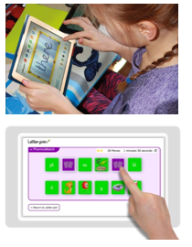
Pupils should experience coherence and continuity in the learning and teaching of handwriting across all school years and be encouraged to take pride in the presentation of their work. Our objective is to help pupils enjoy learning and developing their handwriting with a sense of achievement and pride.

Pens and pencils
Children will start handwriting using a soft pencil. Y5 & Y6 pupils can use a blue ballpoint pen.

Handwriting at Home
Pupils are encouraged to practise their handwriting at home by using the Pupil log-in for Letter-join. Teachers will set specific tasks such as:
- Magic Patterns
- Magic Words
- Phonics Match
- Word Search
- Word Bank
- Write it Right!
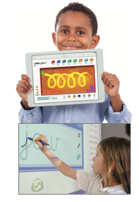
Children can also watch the word and letter animations and practice and explore other handwriting resources on Letter-join.

Key Stage Teaching

Early Years expectations include the following:
- Enhancing gross motor skills such as air-writing, pattern-making and physical activities
- Exercises to develop fine motor skills such as mark-making on paper, whiteboards, sensory trays, iPads, tablets, etc.
- Becoming familiar with letter shapes, their sounds, formation and vocabulary
- Correct sitting position and pencil grip for handwriting
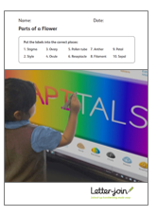
- Pre-cursive patterns
- Easy letters and words
- Harder letters and words
At the end of Early Years, children should be able to recognise and form all the lowercase letters of the alphabet and write words using the correct formation techniques.

Key Stage 1 expectations include the following:
- Continuing with gross and fine motor skills exercises
- Strengthening cursive handwriting, learning and practice
- Numerals, capitals and printed letters; where and when to use capital letters
- Printed letters
- Numbers and symbols

Year 2:
Children are to improve letter formation and orientation of letters through regular practice and to support spelling, grammar and punctuation in readiness for KS1 SATs. With the regular handwriting practice, children should now be developing the fluency and speed of their writing.
At the end of Key Stage 1, children should be confident in writing all the capital and printed letters, numbers and symbols and start to become familiar with their use.
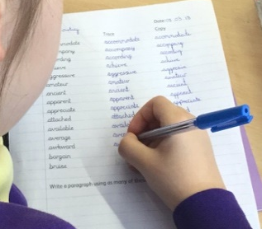
Lower Key Stage 2: Years 3 and 4 expectations include:
KS2 pupils should be using a cursive style throughout their independent writing in all subjects, helping to refine their handwriting in line with the requirements of each lesson.
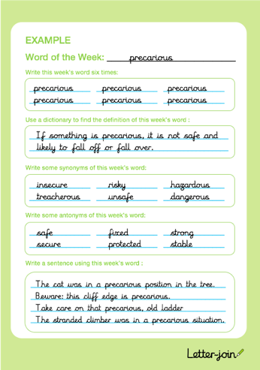
Children need to ensure improvement in the legibility, consistency and quality of the children’s handwriting through a variety of resources which link handwriting to other areas of the curriculum.

Year 4:
Focuses on using handwriting practice to support other subjects in the curriculum and, at the same time, builds on fluency and consistency. It aims to promote meaningful links with other subjects such as English, maths, science, geography, French and Spanish. Learners will continue to build on producing fluent, consistent and legible handwriting through regular practice.
At the end of LKS2, children will have practised applying size-appropriate handwriting to all areas of the curriculum whilst maintaining fluency and legibility.

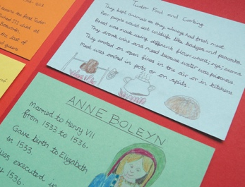
Upper Key Stage 2: Years 5 and 6
Year 5 continue to build on combining fluent handwriting with other subjects across the curriculum.
Learners will have plenty of opportunity to develop the stamina and skills to write at length, with accurate spelling and punctuation. With Letter-join’s wide range of resources they will be able to work towards producing consistently neat and well-presented handwriting in all curriculum subjects.
At the end of year 5, children should be producing cursive writing automatically, enabling them to focus on the content of their work rather than the process of writing.
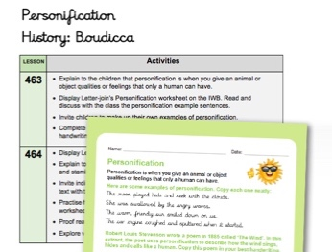
Year 6 allows children to decide on an appropriate style of handwriting. Promoting speedy, fluent writing continues to be a strong feature.

By the end of Year 6, children should be able to adapt their handwriting for a range of tasks and purposes and to create different effects. They should be clear about what standard of handwriting is appropriate for a particular task, for example, quick notes, a final handwritten version, an un-joined style or capital letters.

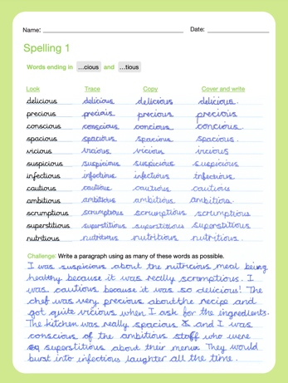

Correct posture and pencil grip for handwriting
Pupils should be taught to sit correctly at a table, holding a pencil comfortably and correctly.

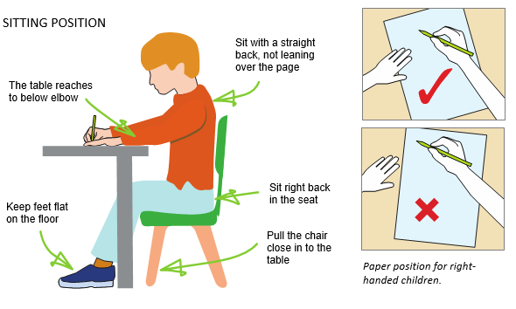
LEFT-HANDED CHILDREN
Left-handed children may find it difficult to follow the movements of right-handed teachers as they model letter formation (and vice versa). Teachers should demonstrate to left-handers on an individual or group basis.
- Left-handed pupils should sit to the left of a right-handed child so that they are not competing for space.
- Pupils should position the paper/book to their left side and slanted, as shown.
- Pencils should not be held too close to the point as this can interrupt pupils’ line of vision.
- Extra practice with left-to-right exercises may be necessary before pupils write left-to-right automatically.
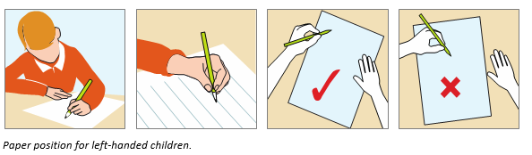

The Tripod Pencil Grip
Both right and left handed children should be encouraged to use the tripod grip which allows the pen/pencil to be held securely whilst allowing controlled movements of the pen/pencil nib. We use the Tripod Grip Rhyme:

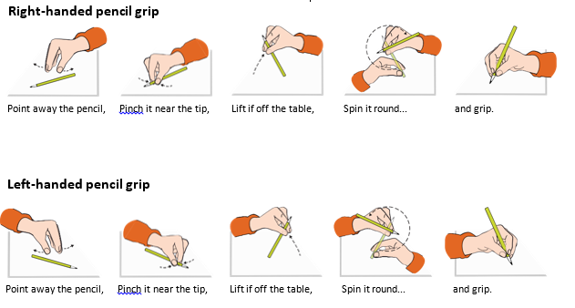

Cross Curricular Links
Taking pride in handwriting and presentation is an expectation across all of the curriculum. Handwriting expectations are embedded across all subjects and are modelled by all staff, in all lessons.

Modelled handwriting can be seen across all books and displays in all classrooms, across all subjects.

Inclusion
Children with English as an additional language:
Children with EAL are encouraged to make the same outstanding progress in handwriting as
their peers. To support their understanding of letter formation handwriting should be consistently modelled by the class teacher.

Children with Special Educational Needs:
For children who experience handwriting difficulties due to fine motor development, including those who are left-handed and those with special educational needs, the appropriate additional support will be put into place.

Some children experience difficulties making good progress in their handwriting development. They may need additional support with their fine motor development, pencil grip or letter formation. The class teacher should liaise with the English subject leader and SENDCo to put into place the most appropriate form of support. This could include:
- Pencil grip or jumbo triangular pencil
- Fine motor skills intervention
- Additional handwriting group
- Additional handwriting homework

High Achievers:
Children with advanced skills in handwriting will be supported and given opportunities for extension work.

Equal Opportunities
All children have equal opportunities to reach their full potential in handwriting, regardless of their race, gender, cultural background, and ability, or of any physical or sensory disability.

Wellbeing
At Roby Park, we are committed to supporting the positive mental health and wellbeing of our whole school community (children, staff, parents and carers). We recognise that mental health and emotional wellbeing is just as important to our lives as our physical health.

At Roby Park, we endeavour to ensure that children are able to manage times of change and stress. We ensure that children learn about what they can do to maintain positive mental health, what affects their mental health, how they can help reduce the stigma surrounding mental health issues, and where they can go if they need help and support. The promotion of positive wellbeing is woven throughout our curriculum.

IMPACT

Impact
This systematic approach ensures development in the skill of handwriting throughout each year group. Children take pride in their written work and achieve proficiency in their own handwriting. Outcomes in children’s wider curriculum work, as well as in their English books and school displays, evidence the progress that children make in this area, as well as the consistency of the approach across the school

Assessment
Teachers will assess children’s handwriting progression during lessons as they write as well
as once they have completed their writing. Criteria for assessment may include:
- Does the child adapt the correct posture?
- Does the child hold the pencil correctly?
- Does the child use the correct movements when forming/joining?
- Does the child write fluently?
- Is the writing legible?
- Is the writing appropriate?
- Is the child’s handwriting developing in-line with statutory curricula?

The subject leader for literacy will regularly assess handwriting across the school. Criteria for
whole-school assessment may include:
- Is the handwriting generally legible and pleasant?
- Are letters being shaped correctly?
- Are joins being made correctly?
- Are spaces between letters, words and lines correct?
- Is writing size appropriate?
- Are the writing standards demonstrated by the majority of children in line with
- statutory curricula?

Monitoring and Evaluation
Subject leads play an active role in the school self-evaluation cycle and throughout the year they will participate in:
- Ensure there is clear progression throughout the school
- Creation of termly data reports
- Reporting to SLT & Governors
- Pupil voice
- Work samples
- Learning exploration blinks
- Developing cultural capital opportunities and events
- Identify any training needs and offer extra support and guidance to staff when it is appropriate
- Ensure that there are suitable resources to help with the teaching and learning of their subject

Review Date
Policy Agreed: September 2026
Policy Review: September 2028

