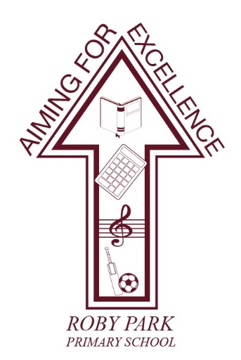

Roby Park Primary School

Easton Road

Huyton

Knowsley

L36 4NY

Tel: 0151 477 8340

Website: www.robyparkprimary.co.uk

E-mail: robypark@knowsley.gov.uk

Headteacher: Mrs K Allen

The Governors are seeking to appoint:

A Temporary Early Years Teacher for October 2026 to cover Maternity Leave

Pay Range 1 – 6 / £32,916 - £45,352 per annum
Upper Pay Range 1 - 3 / £47,472 - £51,048 per annum
The Governing Body of Roby Park Primary School is seeking to appoint an outstanding and inspirational Early Years teacher, who has vision, to join our successful and inclusive one form entry school. We pride ourselves on our high expectations, commitment to ensuring pupil progress and high quality, enriching teaching and learning provision for all. We are looking for a dynamic teacher who shares these values and is able to enthuse and motivate our children with passion and creative teaching, presence and personality. We are looking for someone who is ambitious and who will embrace being part of our school improvement journey.
Roby Park Primary has a clear vision of ‘Aiming for Excellence’, with a continued commitment to making a difference for all of our children, with superb care, nurture and support as the foundation stones of our inclusive approach. With an unwavering child-centred ethos, we put our children at the heart of every decision we make.
We can offer you fantastic, eager children who enjoy coming to school. We can offer an excellent environment with a recently developed bespoke outdoor area. Our dynamic and friendly staff are passionate about raising standards and aspirations for all children. Our school is well resourced and has a supportive and reflective Senior Leadership Team and Governing Body. We have a whole school commitment to professional development, as we believe that development of staff is a key aspect in raising standards for our pupils.
The position will commence October 2026 and we anticipate it being a 12 month contract, subject to change.
The successful candidates will:
- Be an outstanding classroom practitioner with high expectations of children’s achievements, attainment and behaviour
- Able to demonstrate the ability to create a stimulating learning environment for children and a determination to make learning fun, enriching and relevant
- Have excellent communication skills
- Have energy, tenacity, enthusiasm and excellent interpersonal skills
- Be committed to working in close partnership with parents and carers
- Have a willingness to contribute to the wider life of the school

The school offers:
- Hard working and well-behaved children who want to do well and deserve the best
- A well-resourced learning environment
- A supportive staff team with governors and leaders who value quality teaching
- Positive and supportive relationships with the local community
- A real commitment to high quality continuous professional development
- An opportunity to be a part of a journey of whole school improvement and celebration

Roby Park Primary School is committed to safeguarding, to promoting the welfare of children and adhering to the Equality Act 2010. The successful candidate will be required to undertake an enhanced Disclosure and Barring Service check. To comply with the Asylum and Immigration Act 1996 all prospective employees will be required to supply evidence of eligibility to work in the UK. The successful candidate will be subject to satisfactory references and an online check.
By engaging in this recruitment process, shortlisted candidates consent to an online search in line with the Keeping Children Safe in Education Statutory Guidance 2022.

How to apply:

Further details and an application form are available on the school website at www.robyparkprimary.co.uk
Closing Date for applications: 11th September 2026 at mid-day
Shortlisting: 11th September 2025
Lesson Observations: 15th September 2026
Interviews: 16th September 2026
Please e-mail your completed application forms for the attention of Mrs Allen, Headteacher at: robypark@knowsley.gov.uk

