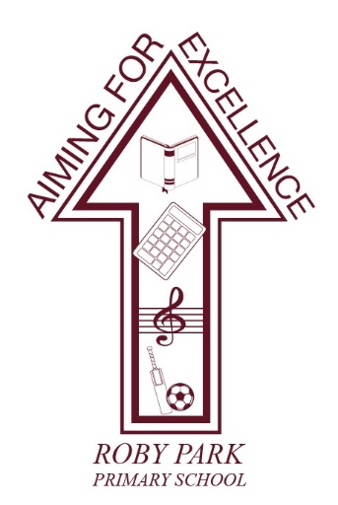

Roby Park Primary School

Easton Road

Huyton

Knowsley

L36 4NY

Tel: 0151 477 8340

Website: www.robyparkprimary.co.uk

E-mail: robypark@knowsley.gov.uk

Headteacher: Mrs K Allen

Date: Thursday 2nd July 2027

Y6 London Residential
Weds 8th July – Fri 10th July

Dear parents/carers,

We have been busy finalising our plans for London.

Itinerary

Weds 8th July | Thurs 9th July | Fri 10th July
London River Cruise  Pizza Express  Hercules the Musical | Shrek Adventure  London Eye  Downing Street  Buckingham Palace  Hard Rock Cafe | Legoland Windsor

Departure Time
All children need to be at school no later than 7.15am so they can go to the bathroom ahead of a prompt 7.30am departure. The coach will not wait so please be early.

Arrival Home Time
We anticipate arriving home, on Friday 10th July, between 9 – 10pm. Updates will be sent via Arbor in app messaging so please keep an eye on your messages for any updates.

Kit List

Towel  Suncream  Toothbrush  Toothpaste  Shampoo  Conditioner  Body wash  Roll on deodorant  Hairbrush/comb  Hair bobbles | Underwear x4  Socks x4  3x daytime outfits  Pyjamas x2  3x cardigans/jumpers  1x light weight waterproof jacket with hood | Trainers  Indoors shoes/slippers | Binbag for dirty washing  Reusable water bottle

Footwear
Children will be on foot throughout the residential, walking around London taking in the sights. Therefore, they need to be in comfortable trainers which have been worn and not brand new footwear as these will cause blisters.

Backpacks
On Monday 6th July, your child will be sent home with a Roby Park backpack which will be used for our day trips. Please make sure inside their backpack they have:
- Reusable water bottle
- Snack
- Packed lunch
- Wallet/purse
- Suncream

Lunch
Your child needs to have a packed lunch in their backpack which they will eat on our journey down.

Mobile Phones
Unfortunately, children will not be allowed to take their mobile phones or any electronic devices due to safeguarding. Please make sure your child’s mobile remains at home.

Tracking Devices
In line with the school policies, children must not bring or wear tracking devices (including GPS trackers, AirTags or similar devices) during the residential visit. Children are also not permitted to wear smart watches.

Whilst we understand that these devices may be used by families for reassurance, they can present safeguarding risks, including the sharing of a child's location and the collection or transmission of personal data. Smart watches may also allow unauthorised communication, internet access, photography, audio recording and location tracking which can compromise the privacy and safety of children and staff.

To ensure the safety, privacy and wellbeing of all pupils, any tracking devices or smart watches brought on the trip will be collected by staff and returned at the end of the residential.

Money
Children are able to bring pocket money with them should they want to buy anything. The amount of pocket money provided is down to parental discretion. Children are solely responsible for looking after their own money.

As discussed in the welcome meeting, we recommend children bringing a pre-paid card with them as a payment method as many places in London only take car payment and not cash.

Medicines
Medical forms will be sent home on Friday 3rd July. Please make sure they are returned no later than Tuesday 7th July, with any relevant labelled medication or inhalers.

Suncream
Please provide your child with factor 50 suncream as the weather currently is predicted to be very hot and sunny so we want to avoid the risk of sunburn. Children will be responsible for putting on their own sun cream and will be reminded by adults to apply it throughout the day.

Travel Sickness Tablets
Please make sure if your child suffers from travel sickness, they either wear the travel sickness bands or take travel sickness medication prior to leaving home. Please provide us with further medication/bands for their return journey.

If you have any questions, please do not hesitate to contact myself or Miss Beggs.

Warmest regards,

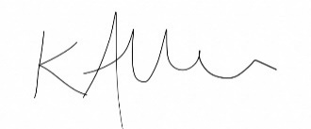

Mrs Kat Allen
Headteacher

