

Complaints Policy

Written May 2026

Review Sept 2027

Signed – Mrs Kat Allen

(Headteacher)

Signed – Mrs Kami Lester

(Chair of Governors)

1. Purpose
Roby Park Primary School is committed to resolving concerns and complaints promptly, fairly and respectfully. Most issues can be resolved informally at the earliest stage. Where this is not possible, this policy sets out a clear, staged complaints process with defined responsibilities and timescales.

2. Legal and guidance framework
This policy is based on Section 29 of the Education Act 2002 and has regard to the Department for Education guidance School complaints procedures: guidance for maintained schools, Best practice guidance for school complaints procedures 2020, the Department for Education model policy for managing serial and unreasonable complaints, and Ombudsman good practice on managing unreasonable actions by complainants.

3. Principles
Complaints will be handled in a way that is accessible, impartial, non-adversarial and proportionate. The school will communicate clearly, keep appropriate records, and review learning points to improve practice.

4. Scope
This policy covers complaints about the school and the services it provides where there is no separate statutory procedure.
This policy does not cover:
- safeguarding or child protection concerns
- admissions, exclusions or SEND statutory processes
- staff grievance, conduct or disciplinary matters
- data protection or subject access requests
- criminal matters or incidents that must be referred externally

5. Definitions
A concern is an expression of worry or doubt for which reassurance is sought. A complaint is an expression of dissatisfaction, however made, about actions taken or a lack of action.

6. Early resolution and timescales
Complaints should be raised within 3 months of the issue occurring, or of the complainant becoming aware of it. The school may consider older complaints where there are exceptional circumstances.

7. Roles and responsibilities
- Class teacher / relevant staff member: Receives and responds to informal concerns; seeks early resolution; records agreed actions or outcomes.
- Headteacher: Investigates Stage 1 formal complaints unless the complaint is about the Headteacher; issues written outcomes; ensures learning points are considered.
- Chair of Governors: Receives complaints about the Headteacher or where this is otherwise appropriate; may nominate another impartial governor if necessary.
- Clerk to Governors: Receives Stage 2 requests; arranges the governors’ panel; circulates papers and records the final outcome.
- Governors’ Complaints Panel: Hears Stage 2 complaints where the complainant remains dissatisfied; reaches a final school decision.

8. Stage 0 – Informal concern
Most concerns should first be raised with the class teacher or relevant member of staff. The aim is to resolve the issue quickly and informally.
- Acknowledgement within 2 school days.
- Discussion / meeting / review within 5 school days.
- If resolved, the outcome will be shared and logged.
- If unresolved, the complainant may proceed to Stage 1.
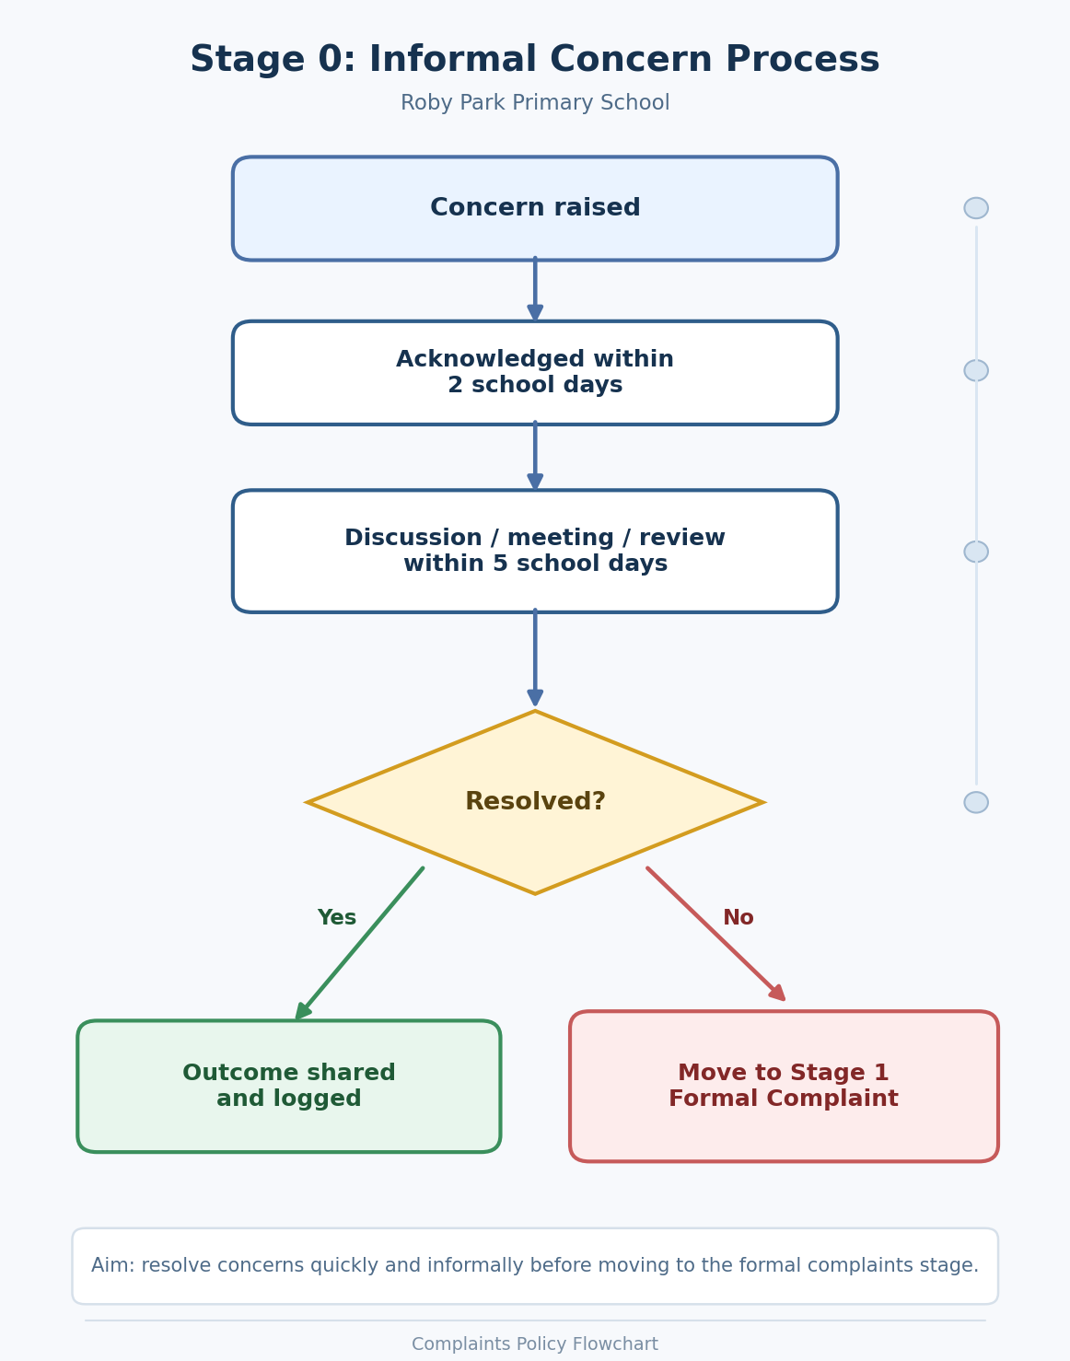

9. Stage 1 – Formal complaint
If the matter is not resolved informally, a formal complaint should be made in writing to the Headteacher. If the complaint is about the Headteacher, it should be sent to the Chair of Governors.
- Acknowledgement within 3 school days.
- Investigation begins within 5 working days of receipt.
- Written outcome issued within 10 school days from the start of the investigation.
- If dissatisfied, the complainant may request Stage 2 within 10 school days of the Stage 1 outcome.
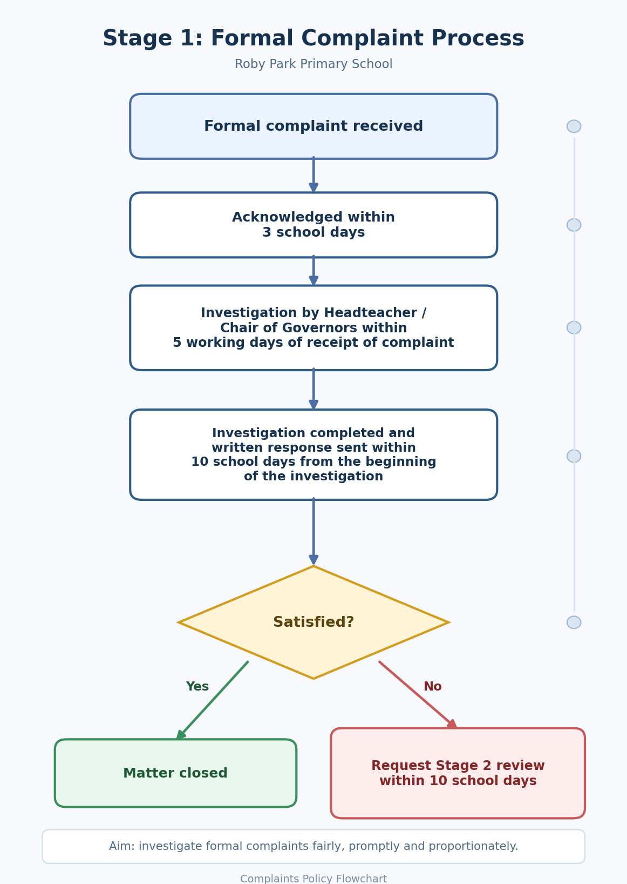

10. Stage 2 – Governors’ Complaints Panel
If the complainant remains dissatisfied, they may write to the Clerk to Governors requesting a review by a Governors’ Complaints Panel.
- Request must be received within 10 school days of the Stage 1 outcome.
- Acknowledgement within 3 school days.
- Panel arranged within 20 school days.
- Written decision issued within 5 school days of the hearing.
- This is the final stage of the school procedure.
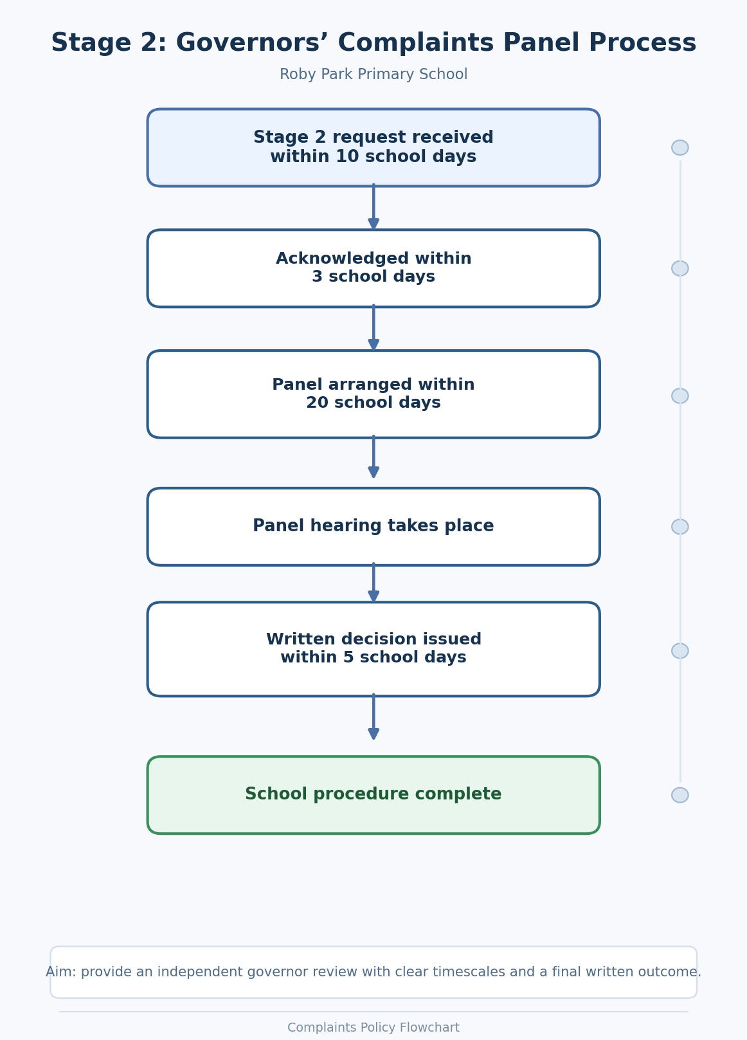

11. External review
Once the school procedure has been completed, a complainant may refer the matter to the Department for Education if they believe the school did not follow its complaints procedure properly. Ofsted does not resolve individual disputes or overturn school complaint decisions.

12. Complaints drafted with artificial intelligence (AI)
The school will consider the substance of any complaint regardless of how it is drafted. Where a complaint includes extensive or repetitious lists of demands, questions or requested actions generated by AI or otherwise, the school will respond in line with this policy only. Responses will be proportionate, relevant and within the scope of the complaints procedure; the school will not respond separately to excessive or procedurally irrelevant demands.

13. Serial, unreasonable or abusive complaints
The school recognises that a small minority of complaints may become serial, unreasonable, abusive or vexatious. Where this happens, the school may adapt the way it manages contact in order to protect staff wellbeing, use resources fairly and allow the complaint process to operate properly. Any restriction will be evidence-based, reasonable, proportionate, recorded clearly, communicated in writing and reviewed after a specified period.

13.1 Principles
When considering whether to apply this section, the school will act in accordance with the following principles:
- Persistence alone will not be treated as unreasonable. A complainant may be persistent because they believe the matter has not been handled properly.
- The school will focus on the nature and impact of the contact or behaviour rather than labelling the person.
- Any restriction must be proportionate to the circumstances, time limited and open to review.
- The school will consider whether disability, mental health needs, communication needs, language barriers or other vulnerabilities require reasonable adjustments.

13.2 Definitions
For the purpose of this policy:
- A serial complaint is repeated contact or repeated complaints about the same issue, or substantially the same issue, after the school procedure has been completed and where no significant new information has been provided.
- An unreasonable or unreasonably persistent complaint is one where the frequency, volume, nature or manner of contact hinders the school’s consideration of the complaint or places a disproportionate burden on staff time and resources.
- Abusive conduct includes behaviour that is offensive, threatening, intimidating, discriminatory or harassing towards staff, governors, pupils or other members of the school community.
- For the purposes of this policy, vexatious conduct means pursuing a complaint in a way that appears intended to harass, overload or disrupt the school rather than seek a genuine resolution.

13.3 Examples of behaviour that may trigger this section
The following are examples only and are not exhaustive. Context will always be considered.
- Refusing to identify the substance of the complaint, or repeatedly changing the basis of the complaint during the investigation.
- Submitting excessive volumes of correspondence, repeated lists of questions or demands, or insisting that all material must be answered separately.
- Making repeated contact about the same issue after the school has completed its procedure and provided a clear response, without significant new evidence.
- Pursuing parallel complaints about the same matter with multiple members of staff or governors in a way that disrupts the process.
- Refusing to engage with reasonable attempts to clarify the complaint while insisting on immediate escalation or response.
- Using abusive, offensive, threatening or intimidatory language or behaviour in person, by telephone, in writing, by email or online.

13.4 What will not normally trigger this section
- Making a complaint or expressing dissatisfaction with the school’s response.
- Asking for clarification, correction of factual inaccuracies or an explanation of timescales.
- Escalating a complaint through the proper stages of the published complaints procedure.
- Seeking support from an advocate, friend, interpreter or other representative.

13.5 Before any restriction is applied
Before deciding to restrict contact, the school will usually satisfy itself that:
- the complaint has been or is being considered properly under the published procedure;
- communication with the complainant has been clear and adequate;
- there is no significant new information that materially affects the complaint; and
- relevant equality and accessibility considerations have been taken into account.
Where appropriate, the school may first issue a warning, offer a clarification meeting, identify a single point of contact or explain the specific behaviour that must stop.

13.6 Decision-making
A decision to apply restrictions under this section will normally be made by the Headteacher. If the complaint concerns the Headteacher, the decision will be made by the Chair of Governors or another impartial governor nominated by the Clerk. If the complaint concerns the Chair of Governors, the Clerk will arrange for the matter to be considered by an appropriate impartial governor or panel.

13.7 Possible restrictions
Depending on the circumstances, the school may take one or more of the following actions:
- require contact to be made only in writing or only through one named point of contact;
- limit the frequency, length or number of telephone calls, emails, meetings or visits;
- require meetings to be by appointment only and/or attended by a second member of staff;
- respond only to significant new issues or material new evidence;
- advise that future correspondence on a completed matter will be read and filed but not acknowledged unless it contains significant new information;
- decline to reopen or re-investigate a complaint where the procedure has been completed and no substantive new information has been presented.

13.8 Notification, duration and review
Where restrictions are applied, the school will write to the complainant explaining the reason for the decision, the behaviour relied upon, the restriction being applied, the date it takes effect, the review date and the route for requesting a review. Restrictions will normally apply for up to six months in the first instance, unless the circumstances justify a shorter or longer period.
A complainant may request a review of the decision in writing within 10 school days of the notification letter. The review will be carried out by a person senior to, or independent from, the original decision-maker wherever possible. The outcome of the review will be confirmed in writing.

13.9 New complaints and new issues
If a complainant who is subject to restrictions raises a genuinely new complaint on a different issue, that complaint will be considered on its own merits under the usual complaints procedure.

13.10 Unacceptable behaviour and immediate action
The school will not tolerate conduct that is abusive, threatening, discriminatory, intimidating or harassing. Where behaviour presents an immediate risk to staff or others, the school may end a call or meeting, require a visitor to leave the site, restrict access to the premises, report the matter to the police or seek legal advice. These actions may be taken in addition to any restriction under this policy.

14. Records, confidentiality and monitoring
The school will keep a secure record of formal complaints, investigations, decisions and actions. Complaint themes will be reviewed to identify learning and improve practice. Confidentiality will be maintained as far as possible, subject to the need to investigate and any legal or safeguarding duties.

15. Useful links
- School complaints procedures: guidance for maintained schools: https://www.gov.uk/government/publications/school-complaints-procedures
- Best practice guidance for school complaints procedures 2020: https://www.gov.uk/government/publications/school-complaints-procedures/best-practice-advice-for-school-complaints-procedures-2019
- Education Act 2002, section 29: https://www.legislation.gov.uk/ukpga/2002/32/section/29
- How to complain about a school: https://www.gov.uk/complain-about-school
- Model policy for managing serial and unreasonable complaints (Department for Education): https://www.gov.uk/government/publications/school-complaints-procedures
- Managing unreasonable actions by complainants: A guide for organisations (Local Government and Social Care Ombudsman): https://www.lgo.org.uk/information-centre/information-for-organisations-we-investigate/councils/good-practice-guides/managing-unreasonable-actions-by-complainants-a-guide-for-organisations

Appendix – Email and letter templates
These templates are designed to promote consistency. They can be adapted to suit the circumstances of each case.

1. Informal concern acknowledgement – Stage 0
Subject: Acknowledgement of Concern
Dear [Name],
Thank you for contacting Roby Park Primary School on [date] regarding your concern about [brief issue]. Your concern has been passed to [name/role], who will review the matter and respond by [date].
We will always try to resolve concerns at the earliest stage in a fair and constructive way.
Kind regards
[Name]
[Role]

2. Informal concern outcome – Stage 0
Subject: Outcome of Informal Concern
Dear [Name],
Thank you for raising your concern regarding [brief issue]. Having reviewed the matter, including [brief summary of steps taken], I can confirm the following:
• [point]
• [point]
• [action / clarification]
I hope this resolves your concern. If you remain dissatisfied, you may submit a formal complaint in writing in line with the Complaints Policy.
Kind regards
[Name]
[Role]

3. Stage 1 formal complaint acknowledgement
Subject: Formal Complaint Acknowledgement
Dear [Name],
Thank you for your formal complaint received on [date] regarding [brief issue]. I am writing to acknowledge receipt of your complaint. In line with the school’s Complaints Policy, your complaint will now be investigated by [Headteacher / Chair of Governors]. We aim to provide a full written response by [date].
If additional time is required, we will write to you with an updated timescale and reason.
Kind regards
[Name]
[Role]

4. Stage 1 request for clarification
Subject: Clarification of Formal Complaint
Dear [Name],
In order to investigate the matter fairly and fully, please could you clarify the following points by [date]:
1. [point]
2. [point]
3. [point]
This request is made to ensure the school addresses the substance of the complaint clearly and proportionately in line with the Complaints Policy.
Kind regards
[Name]
[Role]

5. Stage 1 extension letter
Subject: Update on Formal Complaint Investigation
Dear [Name],
Additional time is required to complete the investigation into your complaint dated [date] because [brief reason]. I now expect to provide a full written response by [new date].
Thank you for your patience while we ensure the matter is considered properly and fairly.
Kind regards
[Name]
[Role]

6. Stage 1 outcome letter
Subject: Stage 1 Formal Complaint Outcome
Dear [Name],
Thank you for your formal complaint dated [date] regarding [brief issue]. I have now completed my investigation. This included [review of records / meetings / staff responses / relevant documentation].
Complaint points considered:
1. [point]
2. [point]
3. [point]
Findings:
• [finding]
• [finding]
Decision: [upheld / partially upheld / not upheld]
Actions / next steps:
• [action]
• [action]
If you remain dissatisfied, you may request that the complaint is considered by a Governors’ Complaints Panel. Any request must be sent in writing to the Clerk to Governors within 10 school days of the date of this letter.
Kind regards
[Name]
[Role]

7. Stage 2 panel acknowledgement
Subject: Acknowledgement of Request for Governors’ Complaints Panel
Dear [Name],
Thank you for your letter/email dated [date], requesting that your complaint be considered by a Governors’ Complaints Panel. I acknowledge receipt of your request. In line with the school’s Complaints Policy, arrangements are now being made for a panel hearing. The hearing will usually take place within 20 school days.
Kind regards
[Name]
Clerk to Governors

8. Panel invitation letter
Subject: Governors’ Complaints Panel Hearing
Dear [Name],
I am writing to confirm that a Governors’ Complaints Panel hearing has been arranged as follows:
Date: [date]
Time: [time]
Venue / format: [details]
Please find enclosed/attached the complaint papers, the school’s previous response and details of the hearing procedure. If you wish to submit any further written information, please do so by [date].
Kind regards
[Name]
Clerk to Governors

9. Stage 2 panel outcome letter
Subject: Governors’ Complaints Panel Outcome
Dear [Name],
Thank you for attending / submitting information to the Governors’ Complaints Panel on [date]. The panel has now considered the complaint afresh.
The panel’s findings:
• [finding]
• [finding]
Decision: [upheld / partially upheld / not upheld]
Recommendations / actions:
• [action]
• [action]
This concludes the school’s complaints procedure. If you believe the school has not followed its complaints procedure properly, you may refer the matter to the Department for Education.
Kind regards
[Name]
Clerk to Governors

10. Scope letter for excessive / AI-assisted complaints
Subject: Scope of Complaint Response
Dear [Name],
The school will consider and respond to the substance of your complaint in line with its Complaints Policy. Where correspondence includes extensive lists of questions, requested actions, deadlines or demands that are repetitive, speculative, disproportionate or outside the scope of the procedure, the school will determine the appropriate scope and format of its response.
This ensures complaints are handled fairly, consistently and proportionately for all parties.
Kind regards
[Name]
[Role]

11. Closure letter after completion of procedure
Subject: Conclusion of Complaints Process
Dear [Name],
The school’s complaints procedure has now been completed in relation to the matters you raised. Unless significant new information is provided that has not previously been considered, the school will not reopen the complaint or enter into repeated correspondence on the same matters.
Kind regards
[Name]
[Role]

12. Restriction / managed contact letter under section 13
Subject: Managed Contact Arrangements under the Complaints Policy
Dear [Name],
I am writing further to your correspondence/contact regarding [brief issue]. The school remains committed to handling complaints fairly and respectfully. However, having reviewed the pattern and nature of recent contact, I have concluded that section 13 of the Complaints Policy now applies.
This decision has been made because:
• [brief factual reason]
• [brief factual reason]
• [brief factual reason]
With effect from [date], the following contact arrangements will apply:
• [for example: all correspondence must be sent to one named contact]
• [for example: contact must be in writing only]
• [for example: the school will respond only to significant new issues or evidence]
These arrangements are intended to be proportionate and will be reviewed on [date]. If you wish to request a review of this decision, you may write to [name/role] within 10 school days of the date of this letter.
Yours sincerely
[Name]
[Role]

