

Anti-Bullying Policy

Written May 2026

Review Sept 2027

Signed – Mrs Kat Allen

(Headteacher)

Signed – Mrs Kami Lester

(Chair of Governors)

1. Policy Statement
Roby Park Primary School is committed to providing a safe, respectful, inclusive and nurturing environment where every child feels valued, protected and able to learn.

Bullying in any form is unacceptable and will not be tolerated. This includes face-to-face bullying, cyberbullying, racist bullying, prejudice-based bullying and bullying related to any protected characteristic. We are committed to taking all concerns seriously and responding promptly, consistently and proportionately.

We recognise that bullying can have a significant impact on children's emotional wellbeing, safety, attendance, confidence and achievement. Our approach is therefore both preventative and responsive. We aim to create a strong whole-school culture in which kindness, inclusion and respect are actively taught, modelled and expected.

This policy should be read alongside the school's Positive Relationships Policy, Safeguarding and Child Protection Policy, Online Safety Policy, RSHE/PSHE Policy, SEND Policy and Equality Information and Objectives.

2. Aims
- prevent bullying through a strong whole-school ethos and curriculum;
- ensure all members of the school community understand what bullying is and how to report it;
- provide clear procedures for responding to bullying behaviours;
- ensure that racist behaviour and prejudice-based incidents are identified, challenged, recorded and addressed;
- protect pupils who may be more vulnerable to bullying, including those with protected characteristics;
- support pupils who have experienced bullying, pupils who have displayed bullying behaviours and pupils who have witnessed bullying;
- ensure records are kept and incidents are monitored so that patterns can be identified and addressed;
- promote a culture in which all children feel safe to speak out and know they will be listened to.

3. Legal and Statutory Context
This policy is informed by the school's duties under current legislation and statutory guidance relating to safeguarding and child protection, behaviour and discipline in schools, equality duties and protection from discrimination, harassment and victimisation, relationships, sex and health education, online safety and child-on-child abuse.

The school will continue to review this policy to ensure it remains in line with current statutory guidance and best practice.

4. Definition of Bullying
Bullying is behaviour by an individual or group, usually repeated over time, that intentionally hurts another individual or group and often involves an imbalance of power.
- Physical – such as hitting, kicking, pushing, pinching, tripping, spitting, damaging belongings or any form of physical intimidation.
- Verbal – such as name-calling, taunting, mocking, threatening, insulting or using discriminatory language.
- Relational / social – such as excluding others, spreading rumours, manipulating friendships, humiliating someone or encouraging others to target them.
- Online / cyberbullying – such as sending threatening or unkind messages, sharing harmful or humiliating content, creating fake accounts, excluding others from online spaces or intimidating others through digital means.
- Prejudice-based – such as bullying related to race, religion or belief, disability, SEND, sex, sexual orientation, gender reassignment, family circumstance, appearance or any other difference.

A single serious incident may also be treated as bullying where it is particularly harmful, discriminatory, humiliating, threatening or has a serious impact on a child's safety or wellbeing.

5. What Bullying Is Not
The school recognises that not all friendship difficulties or incidents of poor behaviour are bullying. Single incidents of conflict, falling out, argument or thoughtless behaviour may not in themselves constitute bullying.

However, all unkind behaviour will be taken seriously and addressed. Staff will consider whether the behaviour was intended to hurt, whether it has happened before, whether there is a power imbalance, whether the child feels targeted, intimidated or unsafe, and whether the behaviour is discriminatory or linked to prejudice.

6. Protected Characteristics and Inclusive Practice
The school will take particularly seriously any bullying, harassment or victimisation related to a protected characteristic.
- disability;
- race;
- religion or belief;
- sex;
- sexual orientation;
- gender reassignment;
- pregnancy and maternity.

The school will also respond firmly to bullying related to perceived characteristics, association with someone who has a protected characteristic, family circumstance, socioeconomic disadvantage, care experience, young carer status, appearance or other personal difference.

We are committed to fostering an environment where diversity is respected, language is inclusive and all pupils feel a strong sense of belonging.

7. Racist Behaviour and Other Prejudice-Based Incidents
Any racist, discriminatory or prejudice-based language or behaviour will be challenged immediately.
- racist name-calling or insults;
- mocking accents, language, culture or appearance;
- racial stereotyping;
- exclusion based on race, ethnicity, religion or culture;
- discriminatory remarks about disability, sex, sexual orientation, gender reassignment, religion or family background;
- online discriminatory abuse;
- graffiti, symbols or gestures intended to cause offence.

Such incidents will be treated as serious and will be stopped immediately, clearly named as unacceptable, recorded appropriately, investigated promptly, communicated to relevant leaders, addressed with suitable sanctions and educational action and followed up to ensure the behaviour has stopped and the child affected feels safe.

Where necessary, the school will seek advice from external agencies and consider whether the incident raises wider safeguarding or criminal concerns.

8. Scope of the Policy
- on the school site;
- during the school day;
- before and after school where children are on the premises;
- during educational visits, school clubs, sporting events and school-organised activities;
- online or off site where the behaviour affects a pupil's safety, wellbeing or experience in school.

9. Roles and Responsibilities

Governing Board
- ensure the school has effective measures to prevent and tackle bullying;
- monitor patterns and trends through safeguarding, behaviour and equality reporting;
- ensure this policy is reviewed regularly.

Headteacher
- ensure the policy is implemented consistently;
- ensure staff are trained and supported;
- ensure incidents are addressed appropriately and proportionately;
- oversee recording, reporting and monitoring;
- ensure bullying is considered within behaviour, safeguarding and equality systems.

Designated Safeguarding Lead (DSL)
- advise staff where bullying may be a safeguarding concern;
- support staff in responding to serious, repeated or complex incidents;
- consider thresholds for referral to external services where appropriate;
- ensure bullying concerns are understood within the wider context of child vulnerability and child-on-child abuse.

Staff
- model respectful and inclusive behaviour;
- listen to pupils and take concerns seriously;
- challenge bullying, prejudice language and discriminatory behaviour immediately;
- report and record incidents in line with this policy;
- support pupils involved and contribute to follow-up and prevention.

Pupils
- treat one another with kindness, respect and care;
- report bullying if they experience it or witness it;
- speak to a trusted adult if they feel worried or unsafe;
- avoid being a bystander and seek help for themselves or others.

Parents and Carers
- work with the school to resolve concerns promptly and constructively;
- inform the school if they have concerns about bullying;
- support the school's work in promoting respectful behaviour and inclusion.

10. Prevention
- a strong behaviour culture with clear expectations;
- regular teaching through PSHE/RSHE on respectful relationships, kindness, belonging, boundaries, online safety and how to seek help;
- assemblies and class discussions that promote equality, diversity and inclusion;
- curriculum content that reflects different identities, families and experiences appropriately and respectfully;
- staff training on bullying, safeguarding, discrimination and prejudice-based behaviour;
- pupil voice opportunities, such as school council, surveys, worry boxes and discussion forums;
- clear reporting routes for pupils, parents and staff;
- supervision, risk assessment and review of times and places where concerns may arise;
- regular analysis of incident data to identify patterns and preventative actions.

11. Reporting Bullying
Pupils, parents, carers and staff can report bullying in a number of ways, including:
- speaking to any trusted member of staff;
- telling the class teacher;
- reporting to a senior leader, the DSL or the Headteacher;
- contacting the school directly by phone, email or written note.

All reports will be taken seriously and acted upon.

Children will be encouraged to understand that reporting bullying is the right thing to do and that they will be listened to and supported.

12. Responding to Bullying: Clear Actions for Staff

Step 1: Stop and Make Safe
- intervene immediately;
- stop the behaviour;
- separate pupils, if necessary;
- check for injury, distress or immediate safeguarding concerns;
- ensure the child or children affected are safe.

Step 2: Listen and Reassure
- listen carefully to all accounts;
- reassure the child that they have done the right thing by telling an adult;
- avoid dismissing or minimising the concern;
- remain calm and factual.

Step 3: Record on CPOMs
- names of pupils involved;
- date, time and location;
- what happened and what was said;
- witnesses;
- any immediate action taken;
- whether it may involve racism, discrimination, protected characteristics or safeguarding concerns.

Step 4: Inform Relevant Staff
- the class teacher;
- the key stage lead
- the DSL;
- the Deputy Headteacher
- the Headteacher.

Step 5: Investigate
- speaking to pupils involved and witnesses;
- considering previous incidents or patterns;
- reviewing any relevant written, digital or online evidence;
- considering whether the behaviour is bullying, prejudice-based behaviour, a safeguarding issue or another form of misbehaviour.

Step 6: Decide and Act
- support and protection for the child targeted;
- restorative discussion where appropriate and safe;
- educational consequence or reflection work;
- apology or repair work;
- loss of privileges;
- behaviour sanctions in line with the Positive Relationships Policy;
- parent meetings;
- increased supervision or changes to seating/playtimes/groups;
- pastoral support or intervention;
- targeted PSHE/RSHE work;
- risk assessment;
- referral to external support where needed.

Step 7: Follow Up
- the bullying has stopped;
- the child affected feels safe and supported;
- agreed actions have been completed;
- there is no pattern of recurrence;
- if the behaviour continues, the response will be escalated.

13. Flowcharts

Flowchart 1: Responding to a Bullying Concern
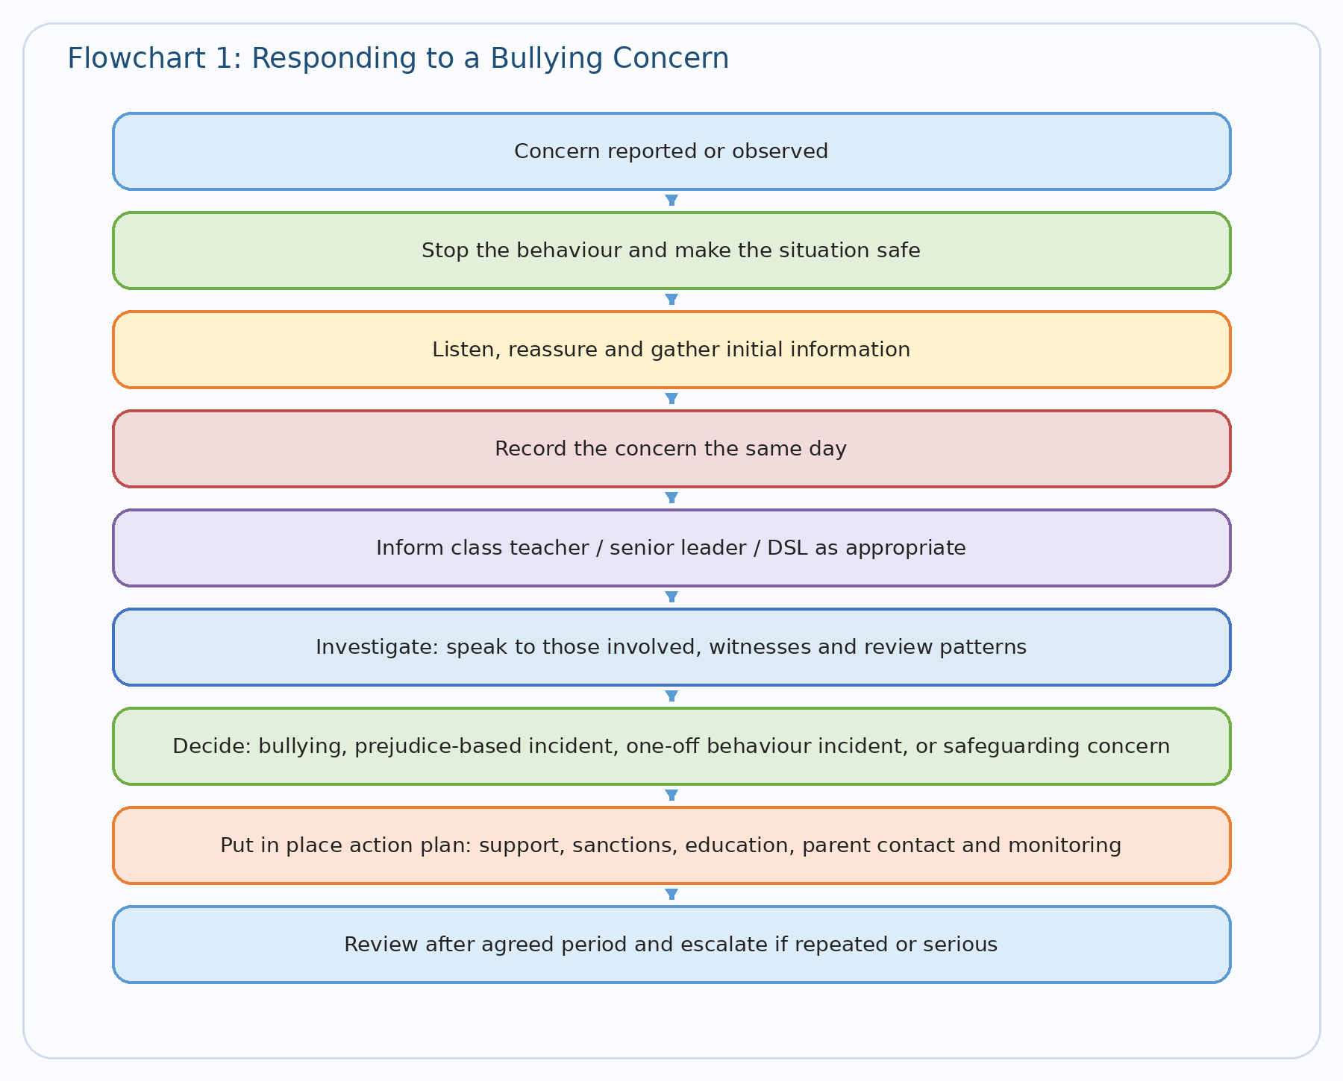

Flowchart 2: Racist or Prejudice-Based Incident
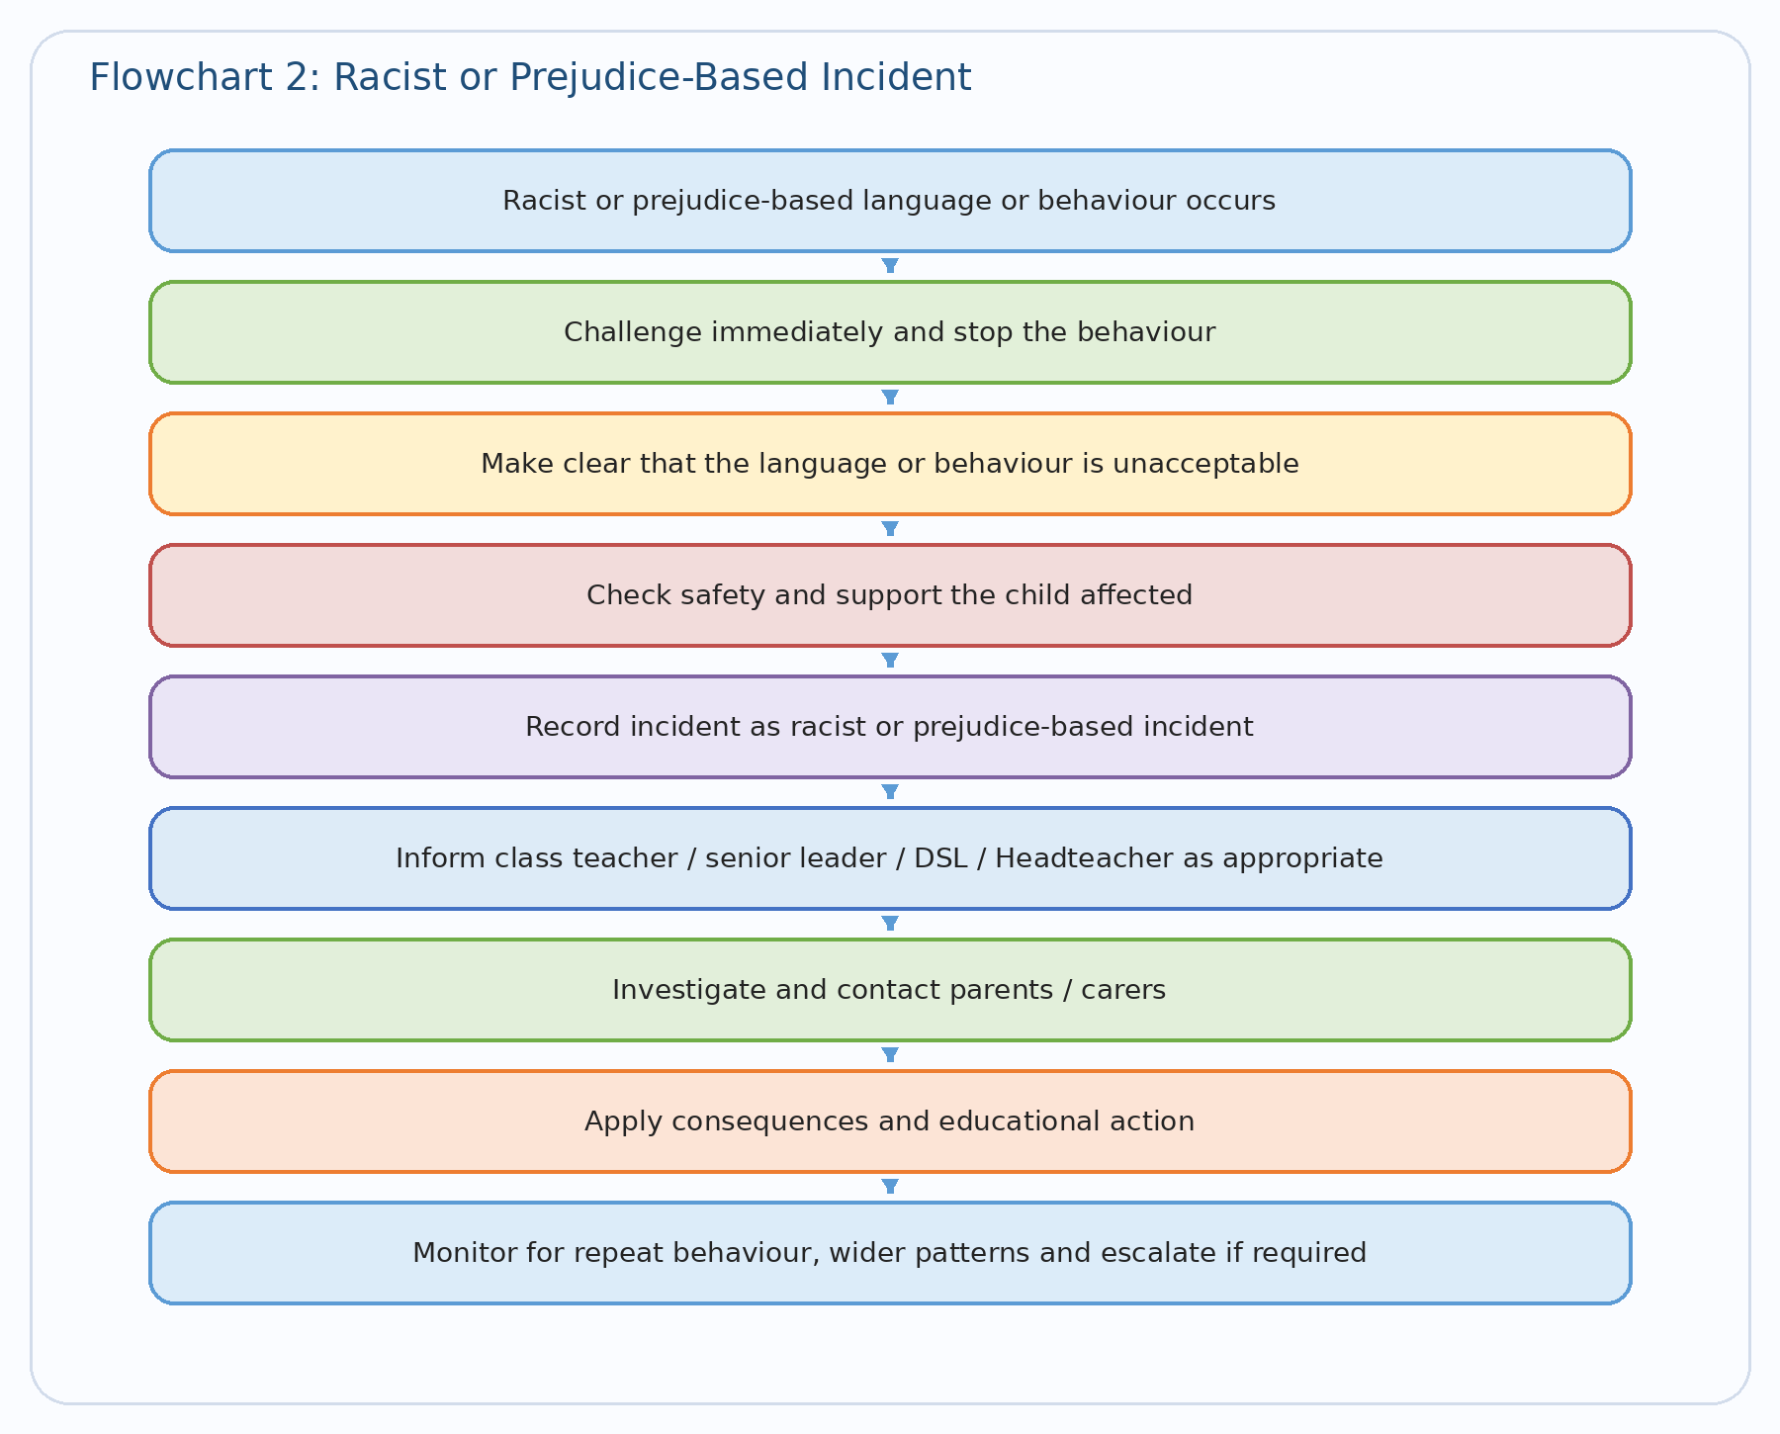

14. Possible Actions and Consequences
The school will respond proportionately, taking account of age, understanding, intent, harm caused, repetition, vulnerability and safeguarding context.
- restorative conversation;
- verbal reminder or warning;
- restorative task;
- apology, repair or reconciliation work;
- loss of privilege;
- removal from activity or group;
- time with a senior member of staff;
- parent/carer meeting;
- behaviour report or monitoring plan;
- internal support programme;
- targeted social, emotional or behavioural intervention;
- referral for pastoral or SEND support;
- suspension, where behaviour is serious and in line with statutory guidance.

Consequences will always be accompanied by support and follow-up to reduce the likelihood of recurrence.

15. Support for Pupils

Support for the Child Who Has Experienced Bullying
- immediate reassurance and protection;
- check-ins with a trusted adult;
- support to rebuild confidence and friendships;
- adjustments to routines, groups or supervision where needed;
- emotional wellbeing support;
- help to report and save online evidence, where relevant.

Support for the Child Displaying Bullying Behaviour
- clear explanation of the impact of their behaviour;
- opportunities to reflect and repair;
- coaching in empathy, language and relationships;
- support with emotional regulation;
- behaviour targets and monitoring;
- parental involvement;
- SEND, pastoral or safeguarding assessment where appropriate.

Support for Bystanders
Pupils who have witnessed bullying may also require support and reassurance. The school will help them understand how to be safe and how to report concerns.

16. Cyberbullying
Cyberbullying will be treated as seriously as face-to-face bullying.
The school will respond where online behaviour causes distress or intimidation, targets a pupil or group of pupils, affects a child's safety, wellbeing or ability to learn, or impacts on relationships or behaviour in school.
- support pupils to report and save evidence;
- involve parents/carers;
- address online behaviour through behaviour and safeguarding systems;
- teach pupils how to stay safe online, respond appropriately and seek help.

17. Children More Vulnerable to Bullying
Some children may be at greater risk of bullying or less likely to report it. This can include pupils who:
- have SEND;
- are disabled;
- are from minoritised ethnic or faith backgrounds;
- have protected characteristics;
- are looked after or previously looked after;
- are young carers;
- have experienced trauma, bereavement or family difficulty;
- are socially isolated;
- are perceived as different in some way.

The school will be alert to vulnerability and ensure these pupils are identified and supported.

18. Recording and Monitoring
The school will record all bullying concerns and outcomes in line with school procedures, on CPOMs.

Racist and other prejudice-based incidents will be recorded clearly so that patterns can be identified, repeat behaviours can be addressed, vulnerable pupils can be protected, staff training and curriculum responses can be improved, and leaders and governors can monitor trends effectively.

Data may be analysed by type of behaviour, location, time of day, class or year group, pupils involved, and protected characteristic or prejudice theme.

This will support the school in evaluating the effectiveness of its anti-bullying work.

19. Links to Curriculum and RSHE
The school's curriculum plays a key role in preventing bullying.

Through PSHE/RSHE and wider curriculum provision, pupils will be taught in an age-appropriate way about:
- respectful relationships;
- kindness, empathy and inclusion;
- protected characteristics and respect for difference;
- stereotypes and prejudice;
- personal safety and seeking help;
- boundaries and consent in age-appropriate ways;
- online behaviour, digital respect and reporting concerns;
- the difference between healthy conflict and bullying.

The school will continue to review its curriculum in line with current statutory guidance and implementation requirements.

20. Complaints
If a parent or carer is dissatisfied with the school's response to a bullying concern, they should raise the matter in the following order:
- class teacher;
- senior leader;
- Headteacher;
- governing board via the school's complaints procedure.

The school will always seek to resolve concerns promptly, fairly and sensitively.

21. Monitoring and Review
This policy will be reviewed annually, or sooner if required due to changes in legislation or statutory guidance, safeguarding developments, behaviour trends in school, or governor or leadership review.

The governing board will be provided with appropriate oversight information so that it can monitor the effectiveness of the school's anti-bullying arrangements.

Appendix 1: Staff Quick Guide
If you see or hear bullying:
Stop it. Make the situation safe. Listen carefully. Reassure the child. Record it. Report it to the right person. Follow it up.

Remember:
- Never ignore racist or discriminatory language.
- Never tell children to just sort it out themselves if they feel unsafe.
- Never assume it is “just banter” without checking the impact.
- Always consider whether there may be a safeguarding concern.
- Always follow up.

Appendix 2: Governor Review Questions
- Do pupils say they feel safe?
- Do pupils know how to report bullying?
- Are incidents recorded consistently?
- Are racist and prejudice-based incidents identified clearly?
- Are patterns reviewed by leaders?
- Are vulnerable groups protected effectively?
- Is the curriculum supporting prevention well?
- Are staff confident in responding?
- Are parents clear about school expectations and procedures?

