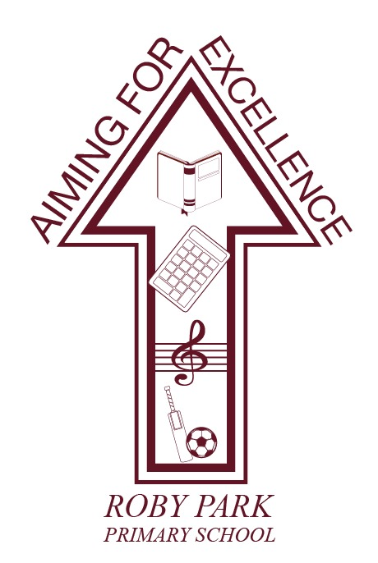

Active Uniform Policy

Written April 2025

Review Sept 2026

Signed – Mrs Kat Allen

(Headteacher)

Signed – Mrs Kami Lester

(Chair of Governors)

1) Purpose and rationale
Roby Park Primary’s uniform should support belonging, inclusion, comfort, learning and active play across the whole school day. Our Active Uniform Policy is designed to:
- Promote a clear school identity while ensuring uniform remains affordable and accessible to all families. [gov.uk]
- Reduce barriers to participation by prioritising comfort, movement, and sensory-friendly options, as highlighted in stakeholder feedback. [Active Uni...il Results | Word], [Active Uni...er Results | Word], [Active Uni...ff Results | Word]
- Ensure the total cost of uniform (including PE kit) is reasonable and does not prevent pupils from taking part fully in school life, in line with statutory guidance. [gov.uk]

2) Our approach to affordability and access
In line with national statutory guidance, Roby Park prioritises value for money, minimises barriers linked to supply routes, and provides opportunities for second-hand uniform. [gov.uk]
To support families:
- We maintain a Pre-Loved Uniform Area in school (help-yourself for all families). [gov.uk]
- We offer summer term ordering and collection via school to improve access and convenience (details in Section 6).
- We keep requirements simple and widely available, enabling families to purchase from mainstream retailers, where possible. [gov.uk]

3) The Active Uniform (Approved Items)
The Active Uniform is designed to be gender-neutral, practical, and supportive of movement across lessons, playtimes and outdoor learning.

A) Everyday essentials (required)
To maintain a clear Roby Park identity while allowing flexibility, we have defined:
Core compulsory items
- Navy school branded PE jacket
- Plain white crew-neck T-shirt
- Navy PE bottoms or approved options from the link below
- Suitable trainers of parents/carers choice
- Navy or white plain, unbranded socks
- Burgundy and/or white hair accessories

Approved bottom options from George @ Asda
- Navy PE joggers (no ankle cuff)
- Navy shorts
- Navy leggings
- Navy cycling shorts
- Navy skorts

These options allow children to choose what feels most comfortable while keeping a consistent school look.

Choice supports comfort, confidence and inclusion while maintaining consistency and identity.

B) Footwear (required)
- Trainers are required for all pupils to support active play and should be suitable for daily activity (no flashing lights).
- EYFS and KS1 pupils must wear Velcro trainers only, to support independence and safety.
- Children are allowed lace up trainers only if they can tie their own laces independently. We would encourage all parents to start practising with children over the coming months.
- No requirement for formal school shoes as part of the Active Uniform. (School implementation to reduce cost barriers and support activity.)

C) Socks
- Plain white or navy blue socks.
- No brands or logos.
- Socks must be worn underneath bottoms and not over the bottom of leggings, for example.

4) Seasonal guidance (comfort across the year)
We will always allow pupils to dress appropriately for weather, ensuring comfort and participation. Stakeholder feedback emphasised the importance of seasonal suitability.

Summer options (warm weather)
- Navy shorts / navy cycling shorts / navy skort are approved. See links above.
- Plain white crew-neck t-shirt remains the approved top.

Winter options (cold weather)
- Navy joggers/leggings, plus PE jacket for warmth.
- Coats should be practical and suitable for weather (not required to be branded, to avoid unnecessary cost). [gov.uk]

5) Maintaining school identity and consistency
We know families value a consistent, identifiable uniform. Clear guidance helps prevent drift into “any sportswear,” which was raised as a potential concern in consultation.

We ask families to follow these principles:
- Plain school colours only (white top, navy bottoms as linked above).
- No large logos, brand names or slogans on visible clothing.
- Items should be fit for purpose: comfortable for sitting and learning, safe for running, climbing, PE and outdoor play.

6) How to purchase the uniform (multiple routes)
To ensure accessibility and reduce reliance on restricted opening hours or single supplier routes, Roby Park supports multiple purchase options, in line with statutory guidance on affordability and supply arrangements. [gov.uk]

A) Mainstream retailer
Families can purchase approved items from mainstream retailers (George at ASDA) to support affordability, convenience and choice. [gov.uk]

B) School ordering and collection (summer term)
- During the summer term, school will offer the option to order key items through school and collect from school. (School implementation plan)

C) Pre-Loved Uniform (in school)
- A pre-loved area will be available in school for parents/carers to help themselves to (no questions asked). [gov.uk]

7) Sustainability: reuse and recycling
We are committed to reducing waste and supporting sustainability:
- Donate: Families can donate clean, good-quality uniform items to our pre-loved area.
- Recycle: School will provide a uniform recycling opportunity for old items that cannot be reused. (School sustainability commitment)

8) Equality, inclusion and reasonable adjustments
Roby Park is committed to ensuring uniform does not become a barrier to attendance, participation or wellbeing. Statutory guidance highlights that schools must consider affordability and comply with relevant equalities duties when setting uniform expectations. [gov.uk]
We will:
- Support pupils with SEND, sensory needs, medical needs, or specific requirements (e.g., fabric sensitivities), recognising consultation feedback about comfort and sensory barriers. This is addressed by the variety of options now available to children as listed above.
- Make reasonable adjustments where needed (e.g., alternative fabrics, adapted footwear). This is addressed by the variety of options now available to children as listed above.
- Provide discreet support via pre-loved uniform, spares, and school purchasing routes to prevent stigma and ensure inclusion. [gov.uk]

9) Expectations and how we will support adherence
Our approach is high expectations with high support—uniform should never be a reason a child feels excluded from school life. [gov.uk]

How we support families to meet the policy
- Clear, simple uniform guidance shared in advance (website + paper copy).
- Multiple purchase routes (retail links, school order/collection, pre-loved). [gov.uk]
- Discreet access to spare uniform items if needed. (School practice)

Graduated approach to non-compliance (support-first)
- Gentle reminder to pupil/parent (assume good intent).
- Offer support: pre-loved items, school ordering route, spare kit if needed. [gov.uk]
- Follow-up discussion if repeated (identify barriers and resolve).
- Formal follow-up only if necessary, ensuring affordability barriers have been addressed first. [gov.uk]

10) What is NOT part of the uniform (to prevent inconsistency)
To keep a clear school identity and avoid confusion:
- No branded sportswear or any sort other than footwear and coats should parents/carers choose so.
- No fashion cropped tops / slogan tops.
- No denim or non-navy bottoms including navy items not listed above.
- Socks over the bottom of trousers or leggings.

11) Communication (Summer Term 2026)
By the end of Summer Term 2026, school will:
- Publish this policy and a one-page visual checklist on the website. [gov.uk]
- Provide clear purchase guidance and school ordering dates. (School implementation plan)
- Promote the pre-loved uniform area and recycling drive. [gov.uk]

Appendix One

Banned Footwear
For health and safety reasons, children must wear appropriate footwear to school each day, whether this is with school uniform or own clothes on non-uniform days.

The following footwear is not permitted under any circumstances:

- Flip flops
- Sliders
- Crocs

If a child attends school wearing any of the above items for any reason, parents/carers will be contacted and asked to bring suitable footwear, such as trainers, to school as soon as possible.

Until appropriate footwear is provided, children will not be permitted to:

- play outside
- take part in PE or sport
- engage in any physical activity

This is to ensure the safety of all pupils and to reduce the risk of injury.

