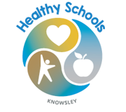
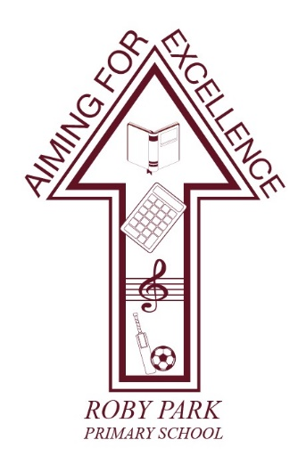

Roby Park Primary School

Easton Road

Huyton

Knowsley

L36 4NY

Tel: 0151 477 8340

Website: www.robyparkprimary.co.uk

E-mail: robypark@knowsley.gov.uk

Headteacher: Mrs K Allen
Date: Thursday 19th March 2026

Healthy School Awards
Dear parent/carers,

I am very excited to announce that Roby Park Primary School is taking part in the Knowsley Healthy School Awards. The Healthy School Awards provides a whole school approach which will enable pupils to access nutritious food to fuel learning and promote opportunities for children to be physically active throughout the school day.

All children and young people have the right to be healthy. Over recent years this has become increasingly challenging for Knowsley children and families due to a range of factors. We recognise that school is an important place for children to eat healthily, be active to develop healthy habits for life.

As we work towards the award, I would like to draw your attention to just some of the exciting and positive changes that will be made to achieve the Healthy Schools bronze level and request parents support and involvement throughout.

Healthier school menus: To support healthy children and healthy teeth our menu will offer milk and water only and provide fruit and yoghurt as dessert three days per week.

Healthy packed lunches: On going support/advice for healthy packed lunches, with a healthy swap station already implemented.

Staff training: Staff will take part in training that will support them to have health promoting conversations with children and parents and increase knowledge of local services to signpost families.

Healthy school events: We will be working towards providing healthier options at our schools events, fairs/galas etc.

Healthy School Champions: Our team of chosen staff and pupils will help drive these exciting changes and support our school in being as healthy as possible!

Thank you for your support. Both the pupils and staff will be working hard to ensure that school continues to have a healthy focus and help us to achieve our Healthy Schools status.

Warm regards,
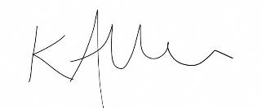

Kat Allen
Headteacher

