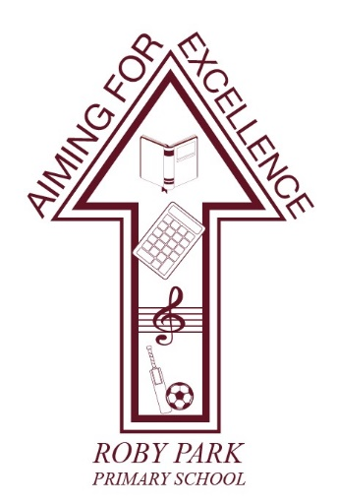

Roby Park Primary School

Easton Road

Huyton

Knowsley

L36 4NY

Tel: 0151 477 8340

Website: www.robyparkprimary.co.uk

E-mail: robypark@knowsley.gov.uk

Headteacher: Mrs K Allen

Date: Wednesday 18th March 2026

Active Uniform Consultation

Dear Parents and Carers,

At Roby Park, we are always exploring ways to improve our children’s wellbeing, comfort and readiness to learn. As part of this ongoing commitment, we are beginning a whole-school consultation on the introduction of an active uniform to replace our current formal school uniform from September 2026.

Over the past year, many pupils have been wearing their PE kit more regularly as part of our approach to increasing movement and active learning across the school day. Staff have observed how much more comfortable, confident and ready to learn children are when dressed in flexible clothing that supports movement. Building on this positive shift, we are now considering whether our current PE kit could become our full-time school uniform.

Why are we considering an active uniform?
There are several potential benefits we want to explore through this consultation:
- Comfort and wellbeing: Children can move more freely and feel more at ease throughout the day, which supports focus, engagement and confidence.
- Supports active learning: An active uniform removes barriers to participating in physical activity, outdoor learning and movement-based lessons.
- Simpler for families: A single, consistent uniform can reduce stress around daily routines, minimise lost property and lower the number of items families need to purchase.
- Cost-effective: Active uniforms are often more affordable and durable than traditional school uniforms. Only purchasing the active uniform without the additional costs of our formal uniform will reduce costs.
- No changing needed: Eliminating the need to change for sports competitions or after schools clubs saves time, supports smoother routines and reduces disruption.
- Promotes equality: A straightforward, consistent uniform helps ensure all children can access the same clothing without the pressure of branded or expensive items.

Our aim is to ensure that the uniform children wear every day supports their learning, wellbeing and school experience as effectively as possible.

Who is involved in the consultation?
This is a whole-community consultation, and every voice matters.

We will be gathering feedback from:
- Parents and carers
- Pupils
- All staff
- School governors

I’m pleased to share that our Governing Body is very supportive of exploring this proposal. However, no decisions will be made until all feedback has been collected and carefully considered.

What we need from you
Please take a few minutes to complete the questionnaire below:
🔗 https://forms.gle/nsvsQ9Vdrh9saNNZ8

Your feedback is vital in helping us understand the potential benefits, any concerns and the practicalities of introducing an active uniform. Responses will be confidential and will directly inform the final decision.

Staff will be completing their questionnaire before leaving school this evening and pupils will be consulted in age-appropriate ways.

Thank you, as always, for your continued support and partnership. At Roby Park, we want to ensure that every decision we make contributes positively to the experiences and outcomes of our children. We greatly appreciate you taking the time to share your views.

If you have any questions, please feel free to get in touch.

Deadline for consultation feedback: Wednesday 1st April 2026.

Warm regards,
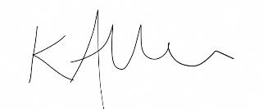

Kat Allen
Headteacher

