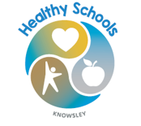


Roby Park Primary School

Easton Road

Huyton

Knowsley

L36 4NY

Tel: 0151 477 8340

Website: www.robyparkprimary.co.uk

E-mail: robypark@knowsley.gov.uk

Headteacher: Mrs K Allen

Date: Tuesday 14th April 2026

Healthy Schools Swap Station

Dear parent/carers,

Roby Park Primary School are excited to be launching our new healthy schools swap station!

Recently we have made some changes to our school menus to make the meals more nutritious, which has been well received by our pupils. This is part of a whole school approach to making sure that whilst in school our children are provided with healthy and nutritious foods which helps them with their learning and growth. For those who prefer packed lunches we would also like to support healthy choices. And supports our school’s policy/guidance on healthy eating.

The swap station aims to encourage and educate pupils on eating well and trying new foods. A range of healthy snacks will be displayed in the swap station during the lunchtime period. Pupils can choose to swap an item such as crisps or chocolate for a healthier alternative. The items that the pupils have swapped will be sent back home with them at the end of the day.

The swap station aims to:
- Support healthy habits that last a lifetime
- Reduce amount of high fat, sugar and salt pupils consume across the week. This will improve concentration and energy levels throughout the day.
- Contribute to pupils reaching their 5-a-day of fruit and vegetables.
- Encourage pupils to try new foods- great if your child is a picky eater!

We hope to have our whole school community on board with our swap station as we promote healthy eating habits for all our pupils.
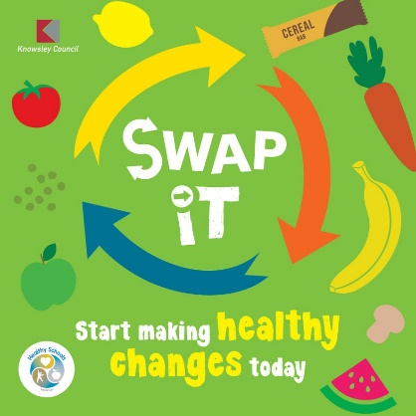
Warm regards,
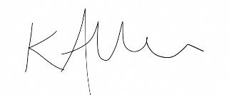

Kat Allen
Headteacher

