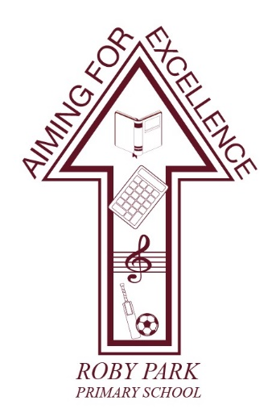

Roby Park Primary School

Easton Road

Huyton

Knowsley

L36 4NY

Tel: 0151 477 8340

Website: www.robyparkprimary.co.uk

E-mail: robypark@knowsley.gov.uk

Headteacher: Mrs K Allen

Date: Wednesday 18th March 2026

Active Uniform Consultation

Dear Parents and Carers,

Thank you to everyone who took the time to share their views as part of our Active Uniform Consultation. We are pleased to share the outcomes with you and to outline our next steps.

Consultation outcomes – what you told us
We received a strong response from parents, carers, pupils, staff and governors, with feedback clearly highlighting many positives. Some key findings included:
- 68.5% of parents felt positive about the introduction of an active uniform.
- 78% said their child is more comfortable in PE kit than in the current uniform.
- 75.6% felt an active uniform would support wellbeing, confidence and readiness to learn.
- 76.9% of pupils liked the idea of an active uniform, with many describing it as “more comfortable” and easier for learning and play.
- Staff and governors were overwhelmingly positive, particularly about increased activity levels, comfort and inclusion.

Your feedback strongly supports moving towards an active uniform that better reflects the way children learn, play and move at Roby Park.

Why an active uniform?
An active uniform supports:
- Comfort and wellbeing – fewer restrictive items, supporting focus and confidence.
- Active learning and play – children are ready for PE, outdoor learning and OPAL play every day.
- Inclusion and equality – particularly for pupils with SEND, sensory needs or difficulties with fastenings. An active uniform is more inclusive for girls because it prioritises comfort, movement, and choice, allowing them to participate confidently and fully in all aspects of school life without restrictive or gendered clothing expectations.
- Affordability and simplicity – one uniform instead of separate uniform and PE kit, with widely available items.
- Independence – especially for younger pupils managing dressing and toileting.

Timeline for implementation
We are taking a phased, supportive approach:
- April–May 2026
  - Final uniform list confirmed.
  - School Uniform Hub established (pre-loved, recycling and spare items).
  - Ordering opens via Arbor, allowing families to spread the cost.
- May–June 2026
  - Full uniform policy published on the website.
  - Clear guidance shared with families, including approved items and links.
- June–July 2026
  - Items ordered through school can be collected directly from school, making this easier for families.
  - Pre-Loved Uniform Week and recycling drive.
- September 2026
  - Active uniform becomes everyday uniform.

Supporting families
We are committed to making this change affordable and accessible:
- Uniform Hub: a help-yourself pre-loved uniform area, plus emergency spares.
- Pre-Loved Uniform Week: swap, donate and collect items.
- Arbor ordering from April onwards to spread costs.
- School collection of uniform orders to save time and travel.
- Minimal reliance on branded items.

Compulsory items vs optional choices
To maintain a clear Roby Park identity while allowing flexibility, we have defined:
Core compulsory items
- Navy school branded PE jacket
- Plain white crew-neck T-shirt
- Navy PE bottoms or approved options from the link below
- Suitable trainers of parents/carers choice
- Navy or white plain, unbranded socks
- Burgundy and/or white hair accessories

Approved bottom options from George @ Asda
- Navy PE joggers (no ankle cuff)
- Navy shorts
- Navy leggings
- Navy cycling shorts
- Navy skorts

These options allow children to choose what feels most comfortable while keeping a consistent school look.

Where to buy – George at ASDA
We have added a range of PE items to suit all children should they want some variation from the PE joggers. Links are below:

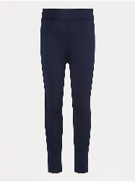 | 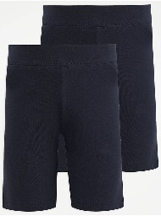 | 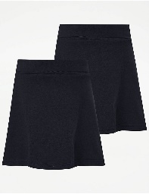 | 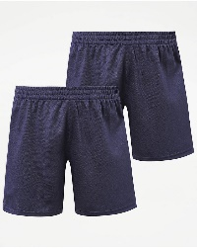 | 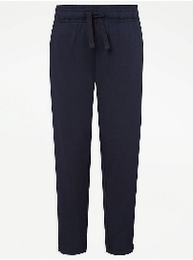 | 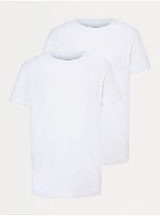
Asda Navy Active Stretch Leggings  from £5 | Asda Navy Jersey Cycling Shorts x2  from £4 | Asda Navy Skorts x2  from £5 | Asda Navy Football Shorts x2  from £4 | Asda Navy Active Joggers (no ankle  cuff)  from £6  (currently awaiting stock) | Asda White Crew Neck Tshirts x2  from £2

White crew neck tshirts can be purchased from other local retailers however the other optional items to the school PE kit are specifically from George @ Asda so all we maintain our Roby Park identity and there are no variations in materials or colour.

School will purchase a limited range of core George items that families can buy directly from school if preferred, subject to availability.

Footwear guidance
- Trainers are required for all pupils to support active play and should be suitable for daily activity (no flashing lights).
- EYFS and KS1 pupils must wear Velcro trainers only, to support independence and safety.
- Children are allowed lace up trainers only if they can tie their own laces independently. We would encourage all parents to start practising with children over the coming months.

Final reassurance
Our aim is high expectations with high support. Uniform should never be a barrier to attendance, wellbeing or participation. If you need support at any point, please contact school in confidence.

Thank you once again for your engagement and for supporting this positive step forward for our children.

Warm regards,
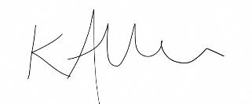

Kat Allen
Headteacher

Cost Effectiveness Comparison

Active Uniform Winter/Spring | Current Uniform Winter/Spring |  | Active Uniform  Summer/Autumn | Current Uniform Summer/Autumn
2x leggings £12  2x PE jackets £31.90  2x white plain t-shirts £3  5x white socks £4  Trainers*** | 2x polo shirts £4  5x tights £9  2x skirts £14  2x cardigans £22  1x PE tracksuit £26  1x PE tshirt £6  School shoes £17  Trainers*** |  | 4x skorts £ 7  Or  cycling shorts £5  Already have trainers, white socks, white t-shirts & jackets | 5x socks £4  2x Summer dresses £12  2x cycling shorts £5  1x PE shorts £6  Already have trainers, school shoes, cardigans, PE tracksuit & PE t-shirt
£50.90 | £98 |  | £7 or £5 depending on preference | £27

Active Uniform Winter/Spring | Current Uniform Winter/Spring |  | Active Uniform  Summer/Autumn | Current Uniform Summer/Autumn
2x tracksuits £52  2x white plain t-shirts £3  5x white socks £3.50  Trainers*** | 2x polo shirts £4  12x grey socks £4.50  2x school trousers £9  2x jumpers £22  1x PE tracksuit £26  1x PE tshirt £6  School shoes £20  Trainers*** |  | 2x PE shorts £5  Already have trainers, white socks, white t-shirts & jackets | 5x white socks £3.50  2x Summer shorts £9  1x PE shorts £6  Already have trainers, polo shirts, school shoes, jumpers, PE tracksuit & PE t-shirt
£58.50 | £91.50 |  | £5 | £18.50

*based on two uniforms per week
**based on age 7-8 years old
***trainers cost at parents/carers choosing

Active Uniform Winter/Spring | Current Uniform Winter/Spring |  | Active Uniform  Summer/Autumn | Current Uniform Summer/Autumn
3x leggings £18  3x PE jackets £47.85  4x white plain t-shirts £6  5x white socks £4  Trainers*** | 3x polo shirts £6  5x tights £9  3x skirts £21  3x cardigans £33  1x PE tracksuit £26  1x PE tshirt £6  School shoes £17  Trainers*** |  | 4x skorts £ 14  Or  cycling shorts £10  Already have trainers, white socks, white t-shirts & jackets | 5x socks £4  3x Summer dresses £18  3x cycling shorts £7.50  1x PE shorts £6  Already have trainers, school shoes, cardigans, PE tracksuit & PE t-shirt
£75.85 | £120 |  | £14 or £10 depending on preference | £35.50

Active Uniform Winter/Spring | Current Uniform Winter/Spring |  | Active Uniform  Summer/Autumn | Current Uniform Summer/Autumn
3x tracksuits £78  3x white plain t-shirts £7  5x white socks £3.50  Trainers*** | 3x polo shirts £6  12x grey socks £4.50  3x school trousers £13.50  3x jumpers £33  1x PE tracksuit £26  1x PE tshirt £6  School shoes £20  Trainers*** |  | 4x PE shorts £10  Already have trainers, white socks, white t-shirts & jackets | 5x white socks £3.50  3x Summer shorts £13.50  1x PE shorts £6  Already have trainers, school shoes, jumpers, polo shirts, PE tracksuit & PE t-shirt
£88.50 | £109 |  | £10 | £23

*based on three uniforms per week
**based on age 7-8 years old
***trainers cost at parents/carers choosing

Active Uniform Winter/Spring | Current Uniform Winter/Spring |  | Active Uniform  Summer/Autumn | Current Uniform Summer/Autumn
4x leggings £24  4x PE jackets £63.80  5x white plain t-shirts £7.50  5x white socks £4  Trainers*** | 4x polo shirts £8  5x tights £9  4x skirts £28  4x cardigans £44  1x PE tracksuit £26  1x PE tshirt £6  School shoes £17  Trainers*** |  | 4x skorts £ 14  Or  cycling shorts £10  Already have trainers, white socks, white t-shirts & jackets | 5x socks £4  4x Summer dresses £26  4x cycling shorts £10  1x PE shorts £6  Already have trainers, school shoes, cardigans, PE tracksuit & PE t-shirt
£99.30 | £138 |  | £14 or £10 depending on preference | £46

Active Uniform Winter/Spring | Current Uniform Winter/Spring |  | Active Uniform  Summer/Autumn | Current Uniform Summer/Autumn
4x PE jackets £63.80  4x PE joggers £39.80  5x white plain t-shirts £7.50  5x white socks £3.50  Trainers*** | 4x polo shirts £8  12x grey socks £4.50  4x school trousers £18  4x jumpers £44  1x PE tracksuit £26  1x PE tshirt £6  School shoes £20  Trainers*** |  | 4x PE shorts £10  Already have trainers, white socks, white t-shirts & jackets | 5x white socks £3.50  4x Summer shorts £18  1x PE shorts £6  Already have trainers, school shoes, polo shorts, jumpers, PE tracksuit & PE t-shirt
£114.60 | £126.50 |  | £10 | £27.50

*based on four uniforms per week
**based on age 7-8 years old
***trainers cost at parents/carers choosing

