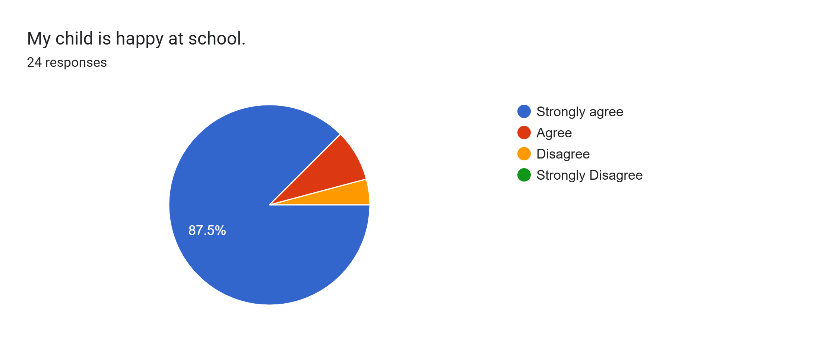
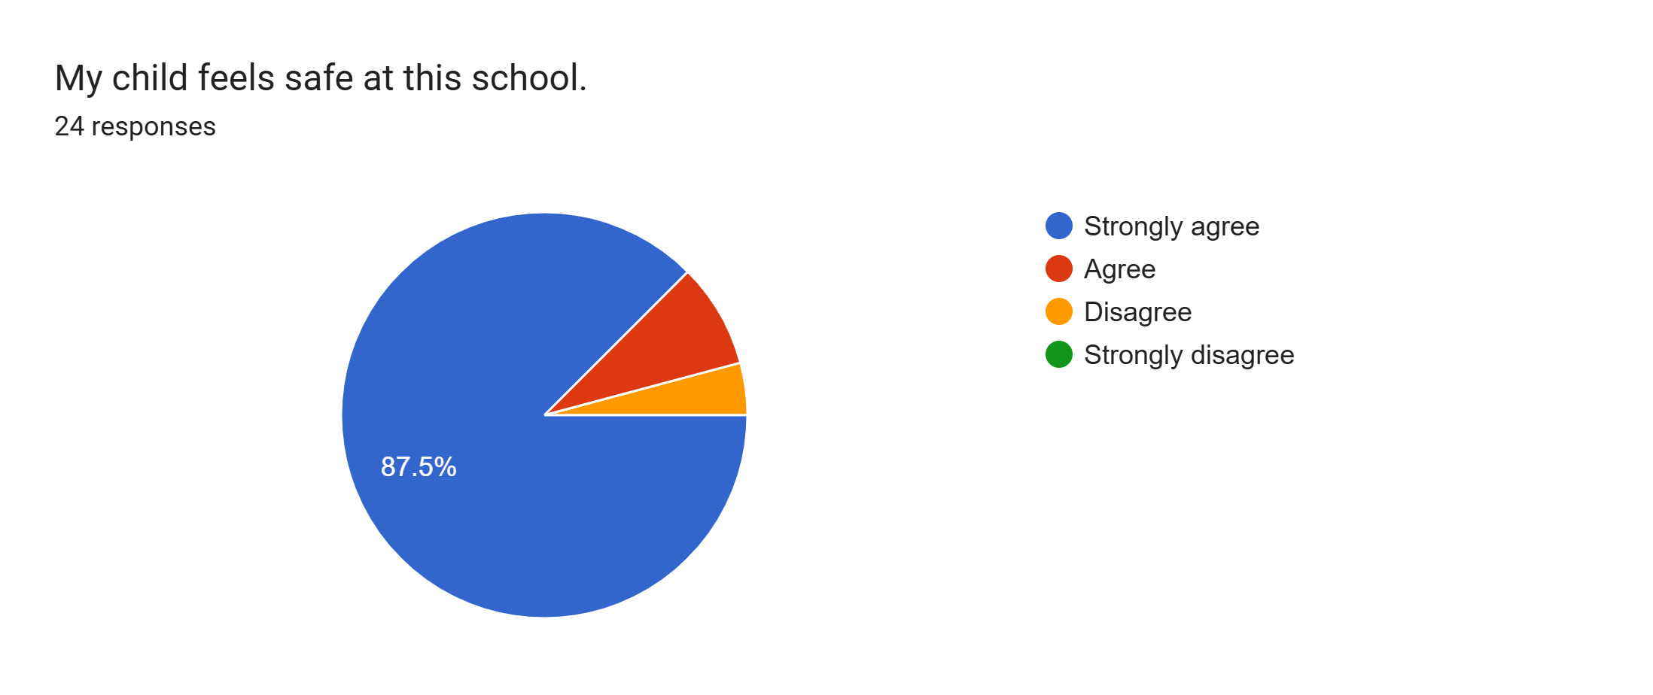
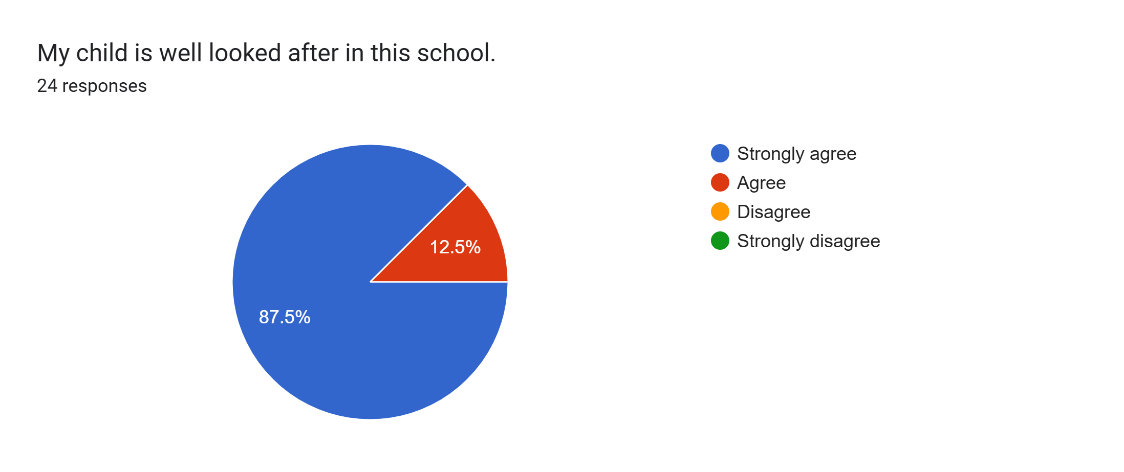
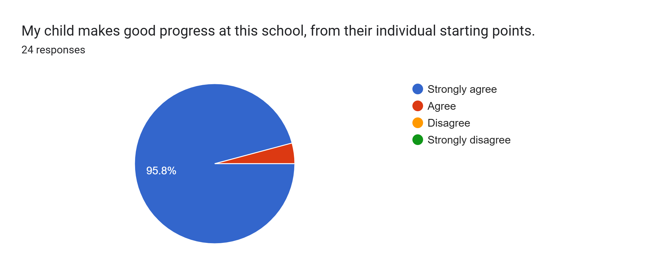
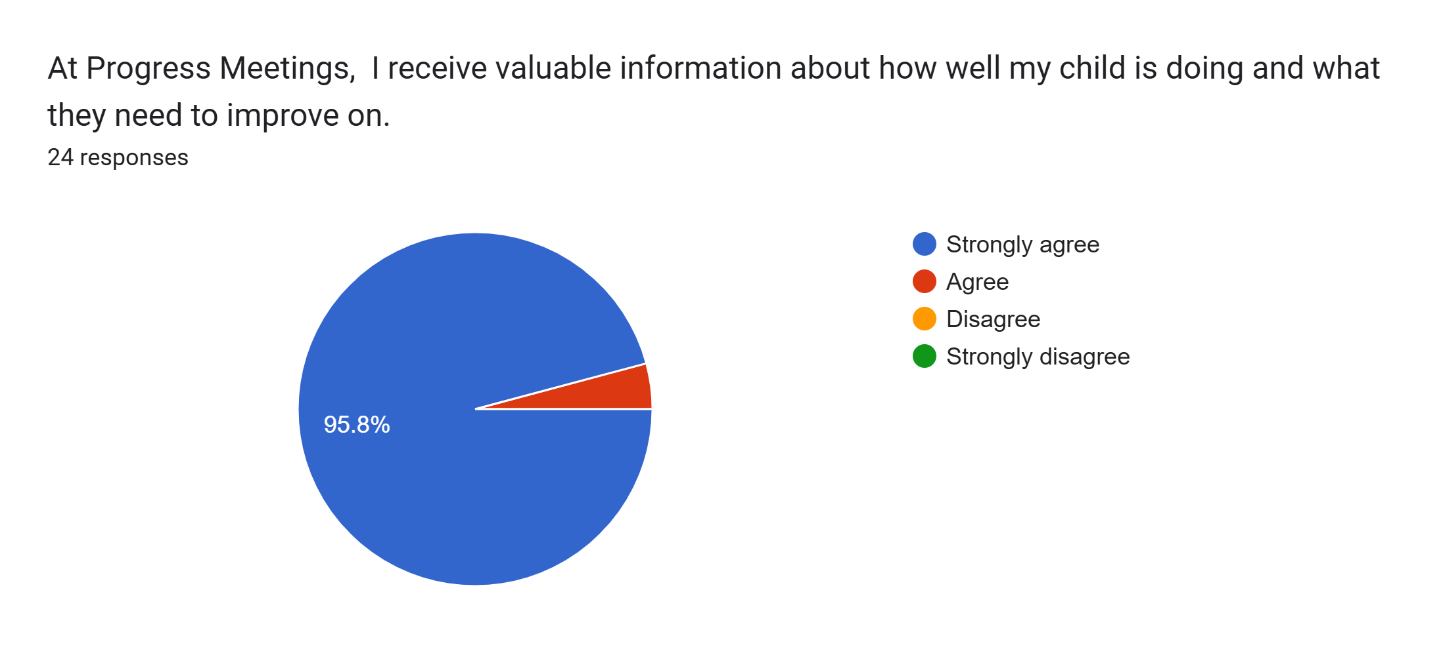
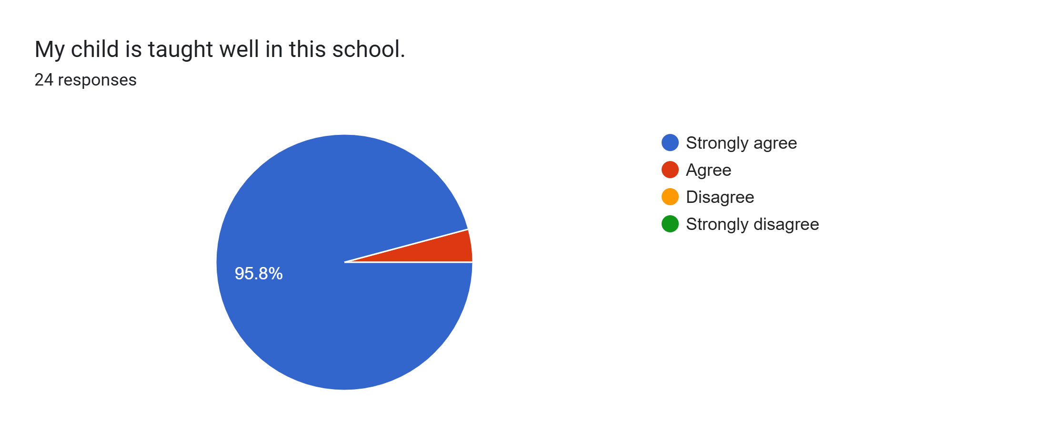
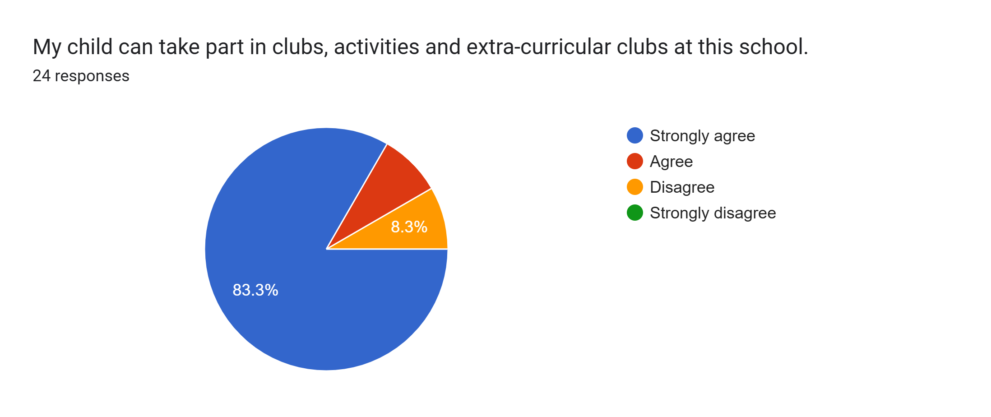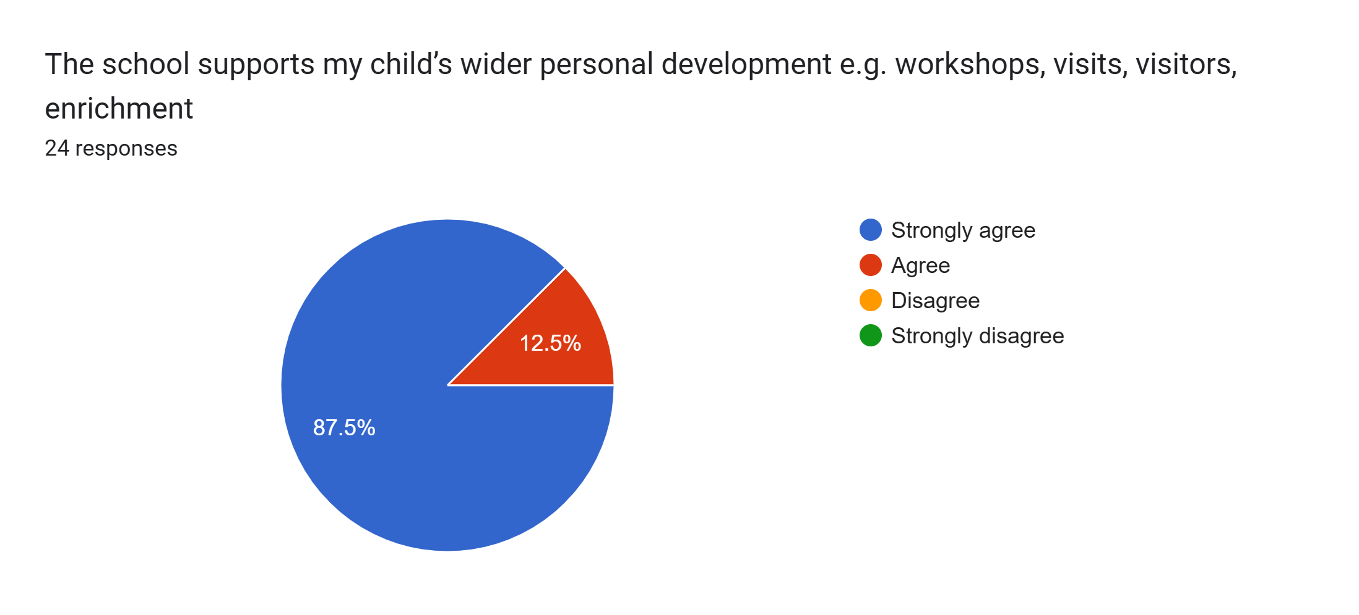
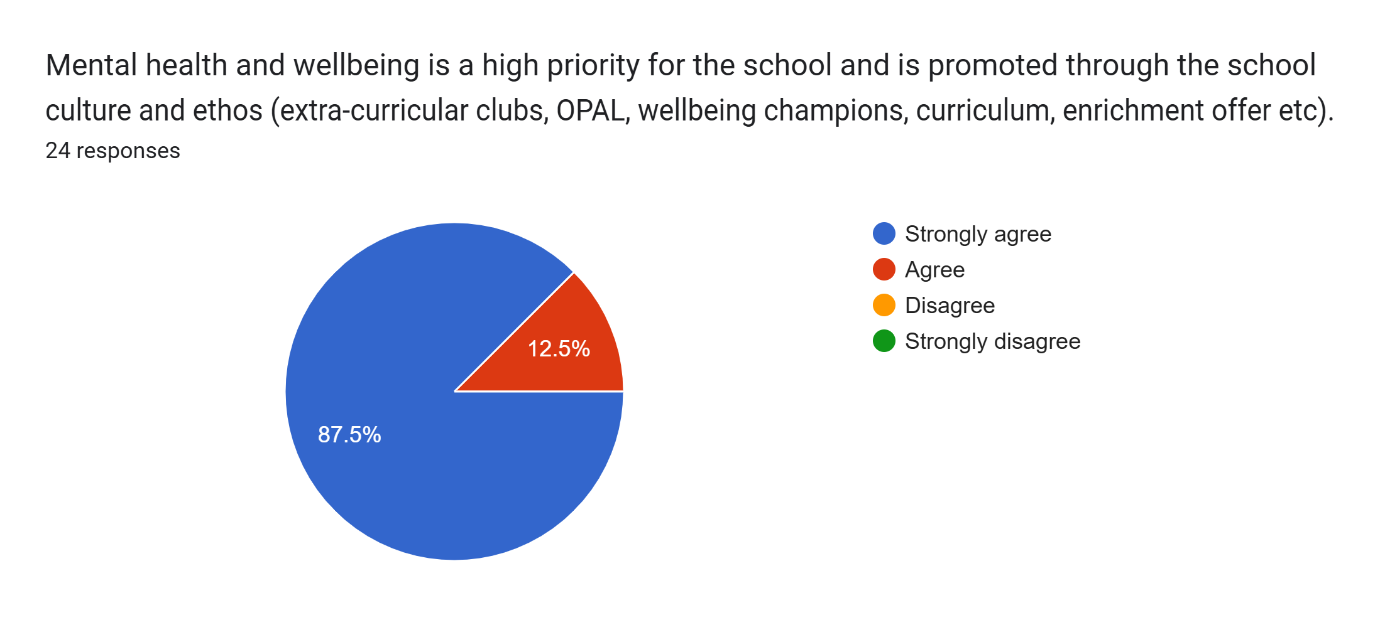
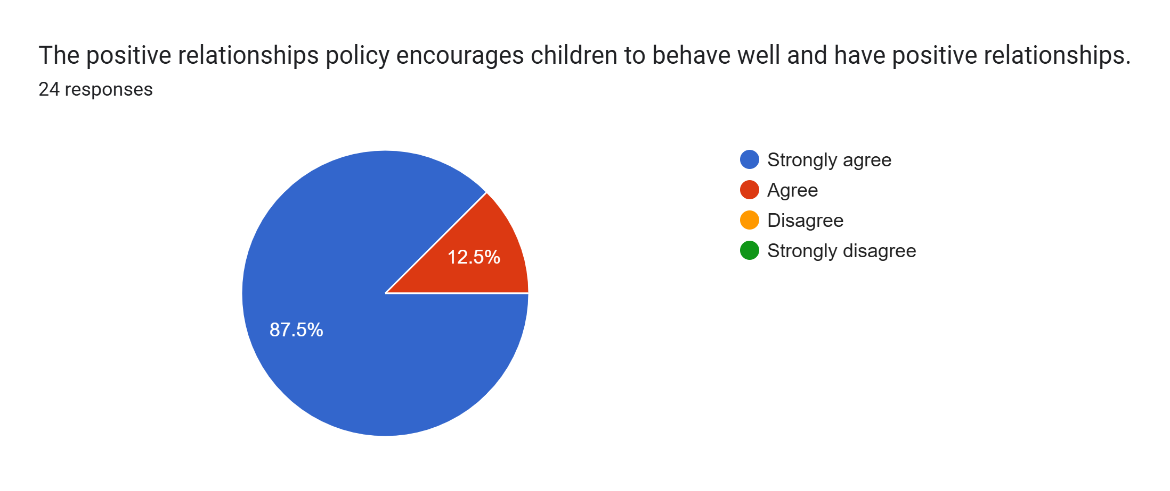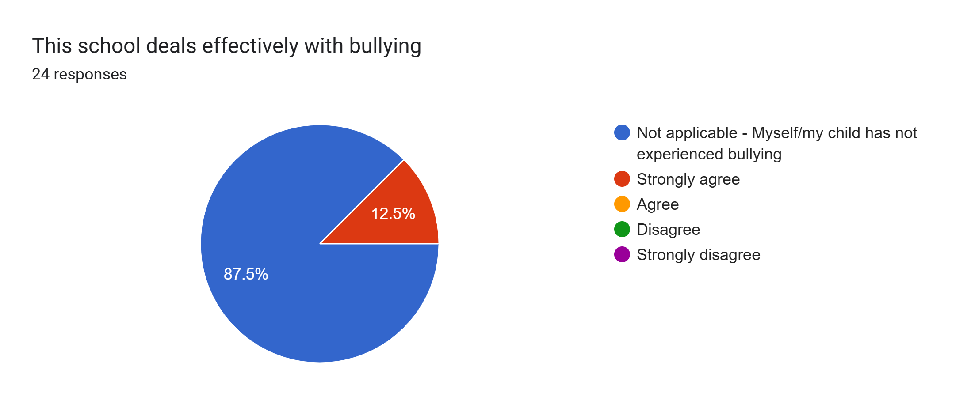
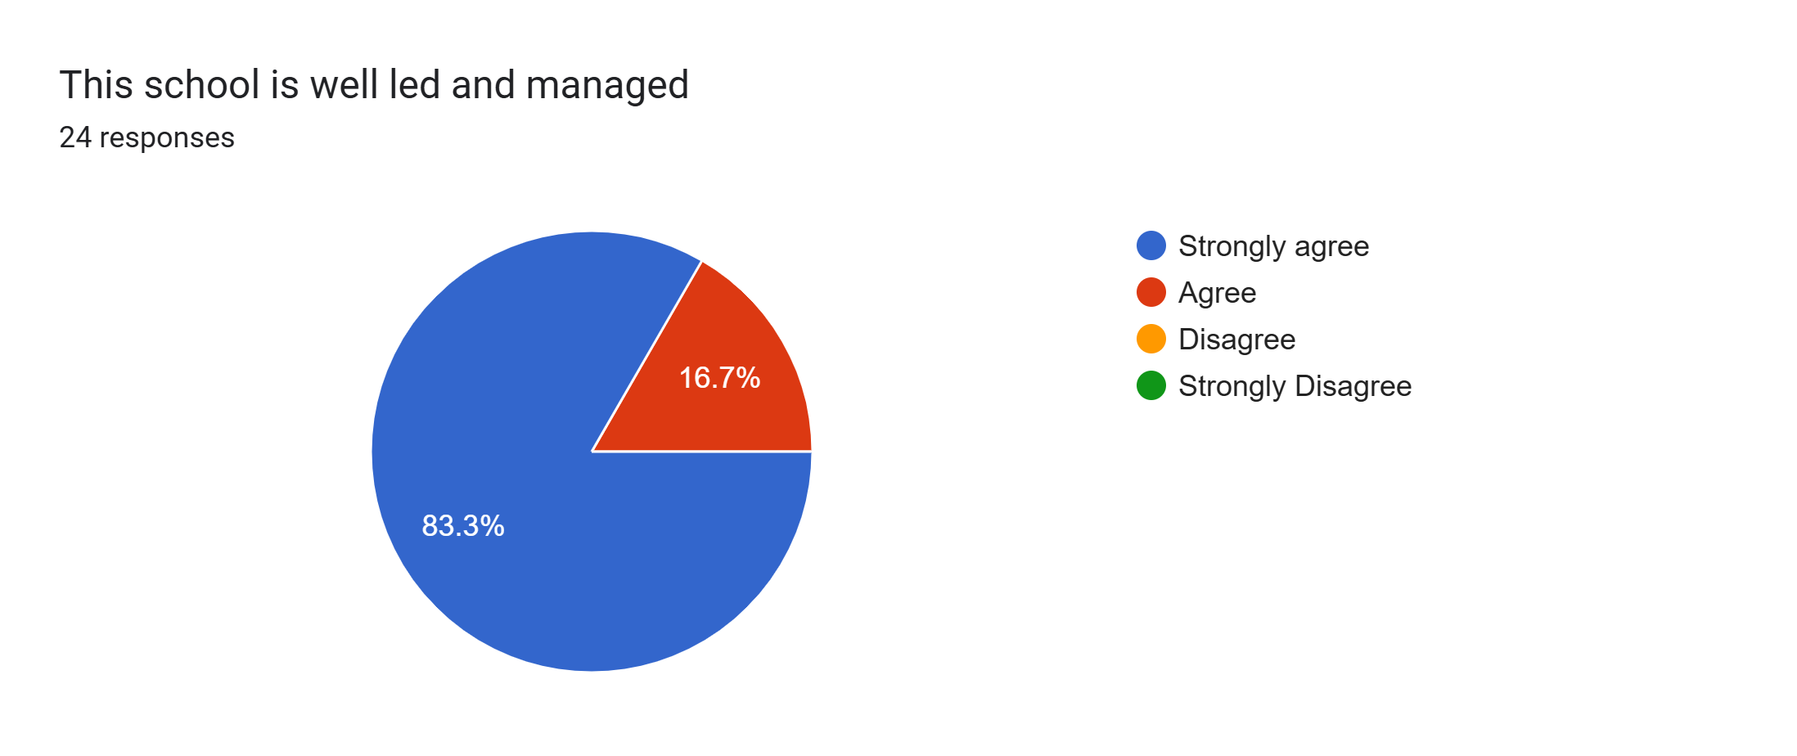
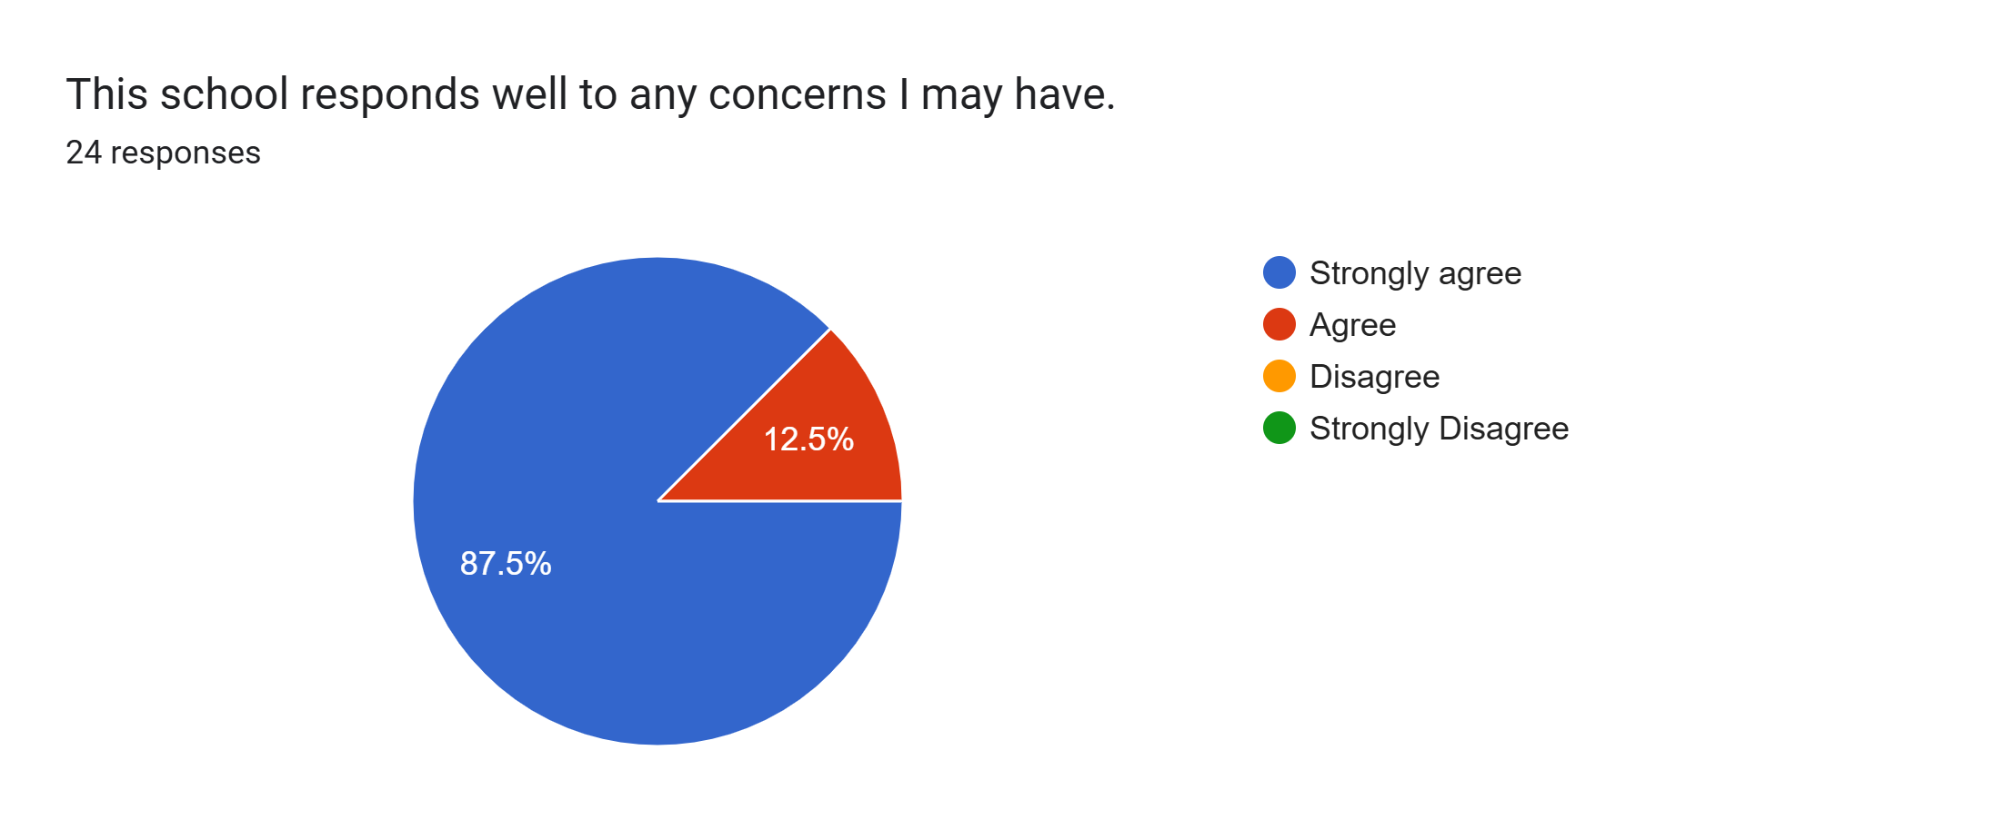
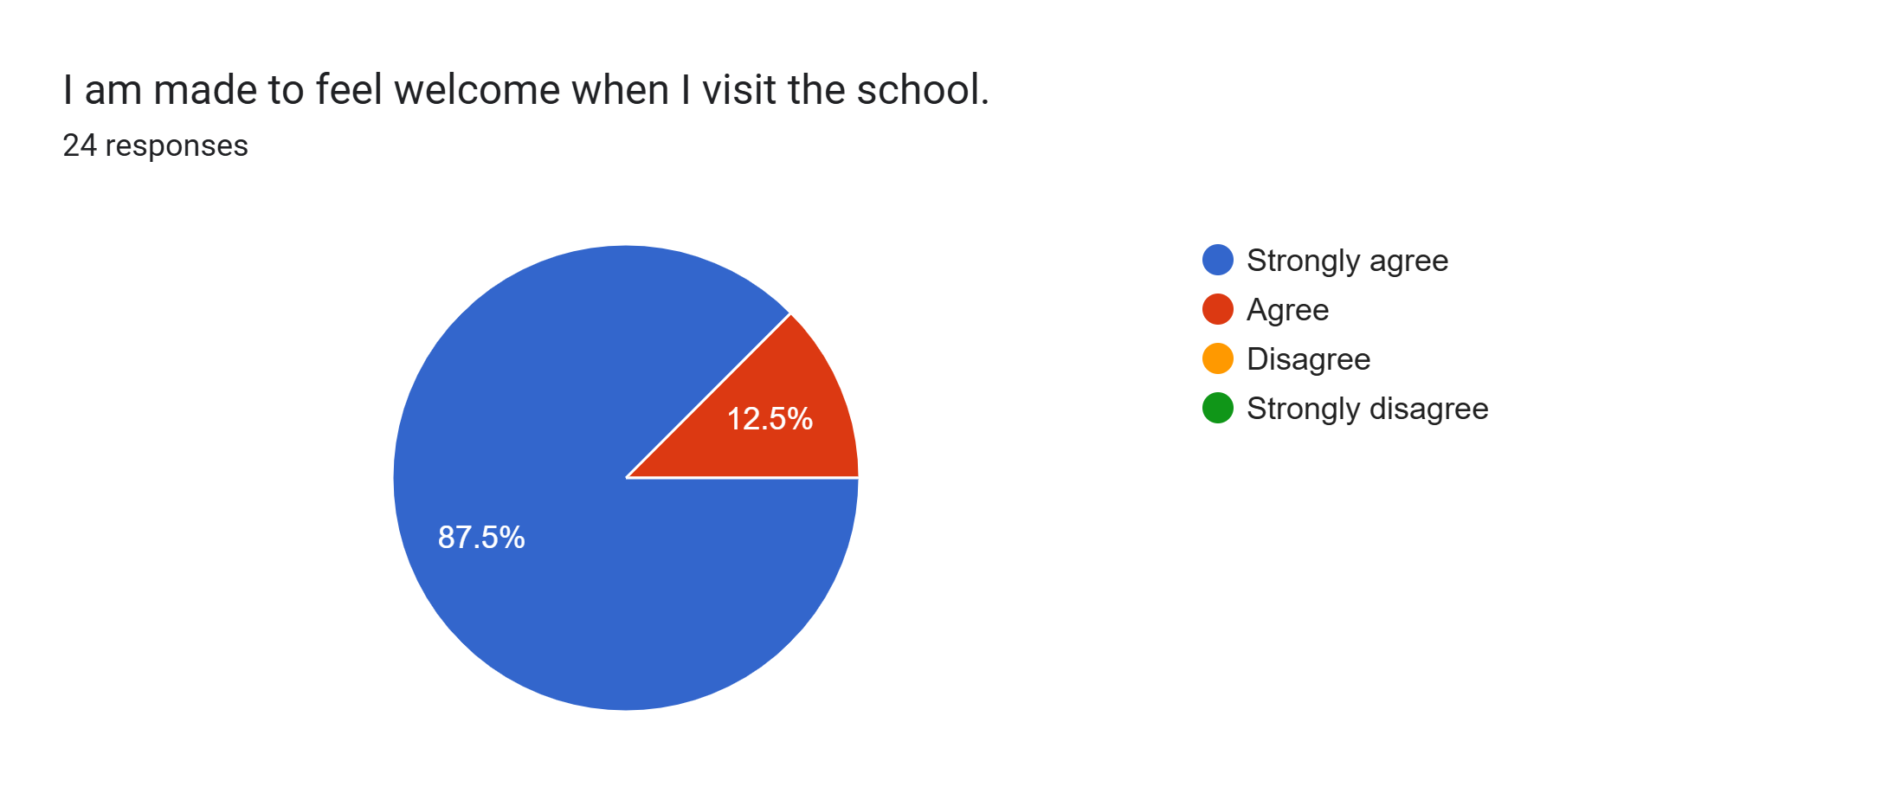
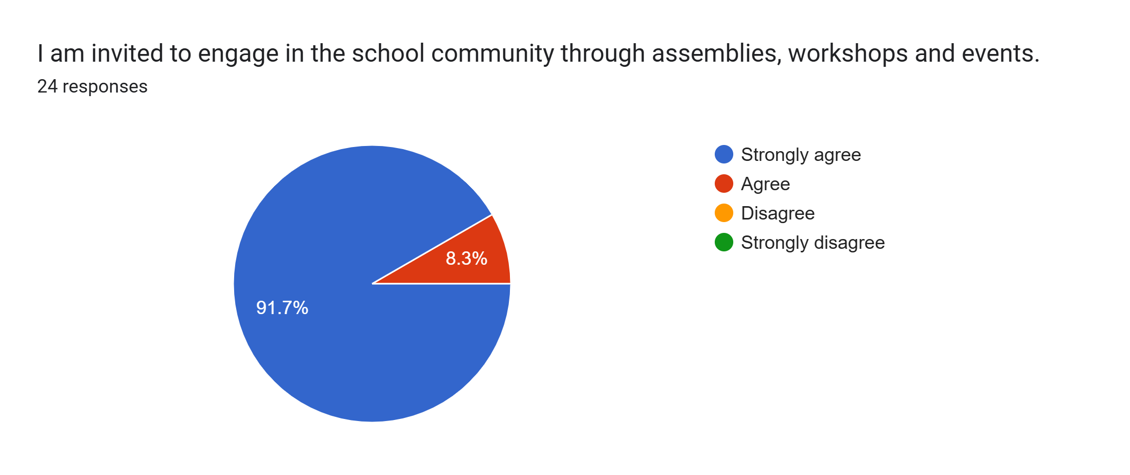
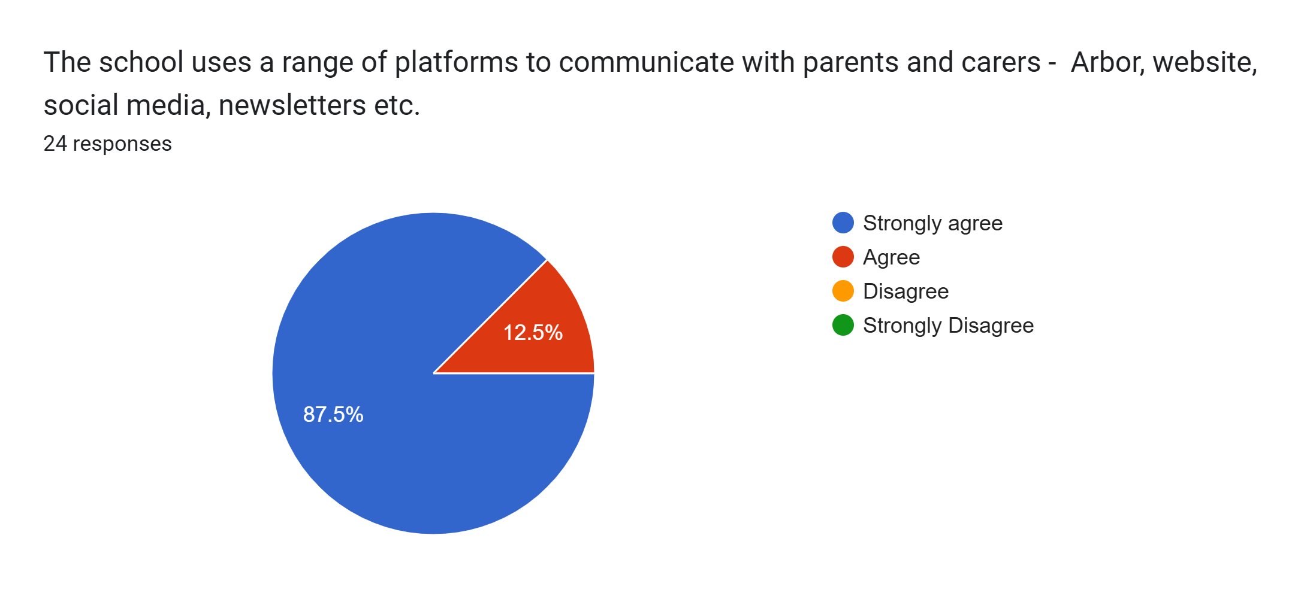
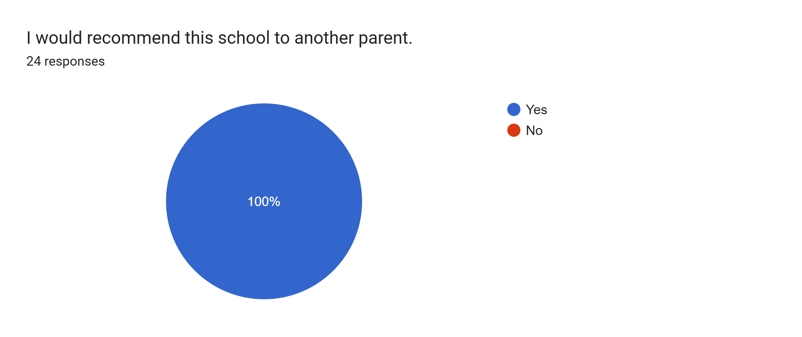
What other comments would you like to make to staff:
- Thank you to all of the staff and everything you guys do in EYFS.
- You are all amazing thank you x
- My son has come on leaps and bounds.
- Thank you all for everything you have done to support both my children. You are all amazing. 🤩
- I am very pleased how well my child is developing in school.
- Thank you EYFS for your kind and caring approach. My son loves school.
- Thank you so much to EYFS staff for making school so enjoyable that our child wants to stay for those extra hours after school!
- Thank you to the teachers.
- Thank you for everything.
- My child loves Reception and is coming on really well.
- Thank you for everything!
- Once again, another fantastic meeting with an outstanding teacher. Thank you for everything.
- Thank you very much to everyone.
- Our son absolutely loves coming to school and we couldn’t be happier as parents. Thank you.
- Staff always go above and beyond, thank you.
- Thank you for your support.
- All very lovely and helpful.
- Thank you for all you do.
- We are very happy with the education and support that our daughter receives at Roby Park!

