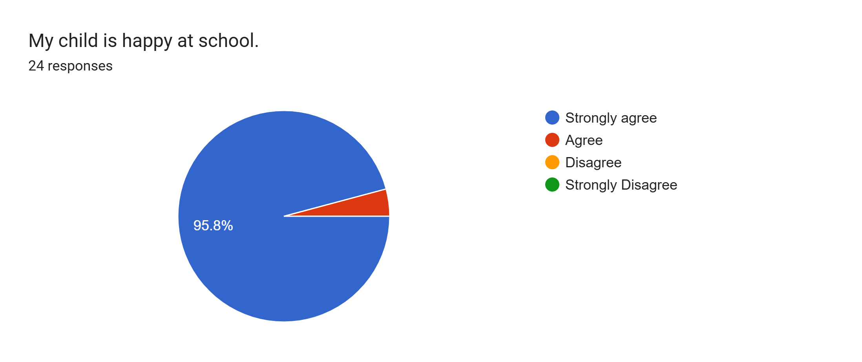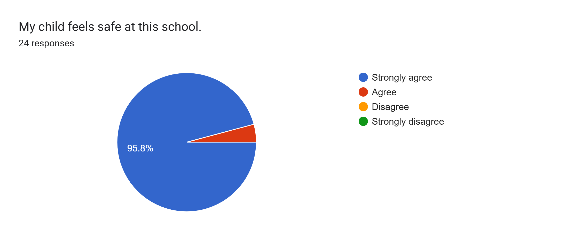
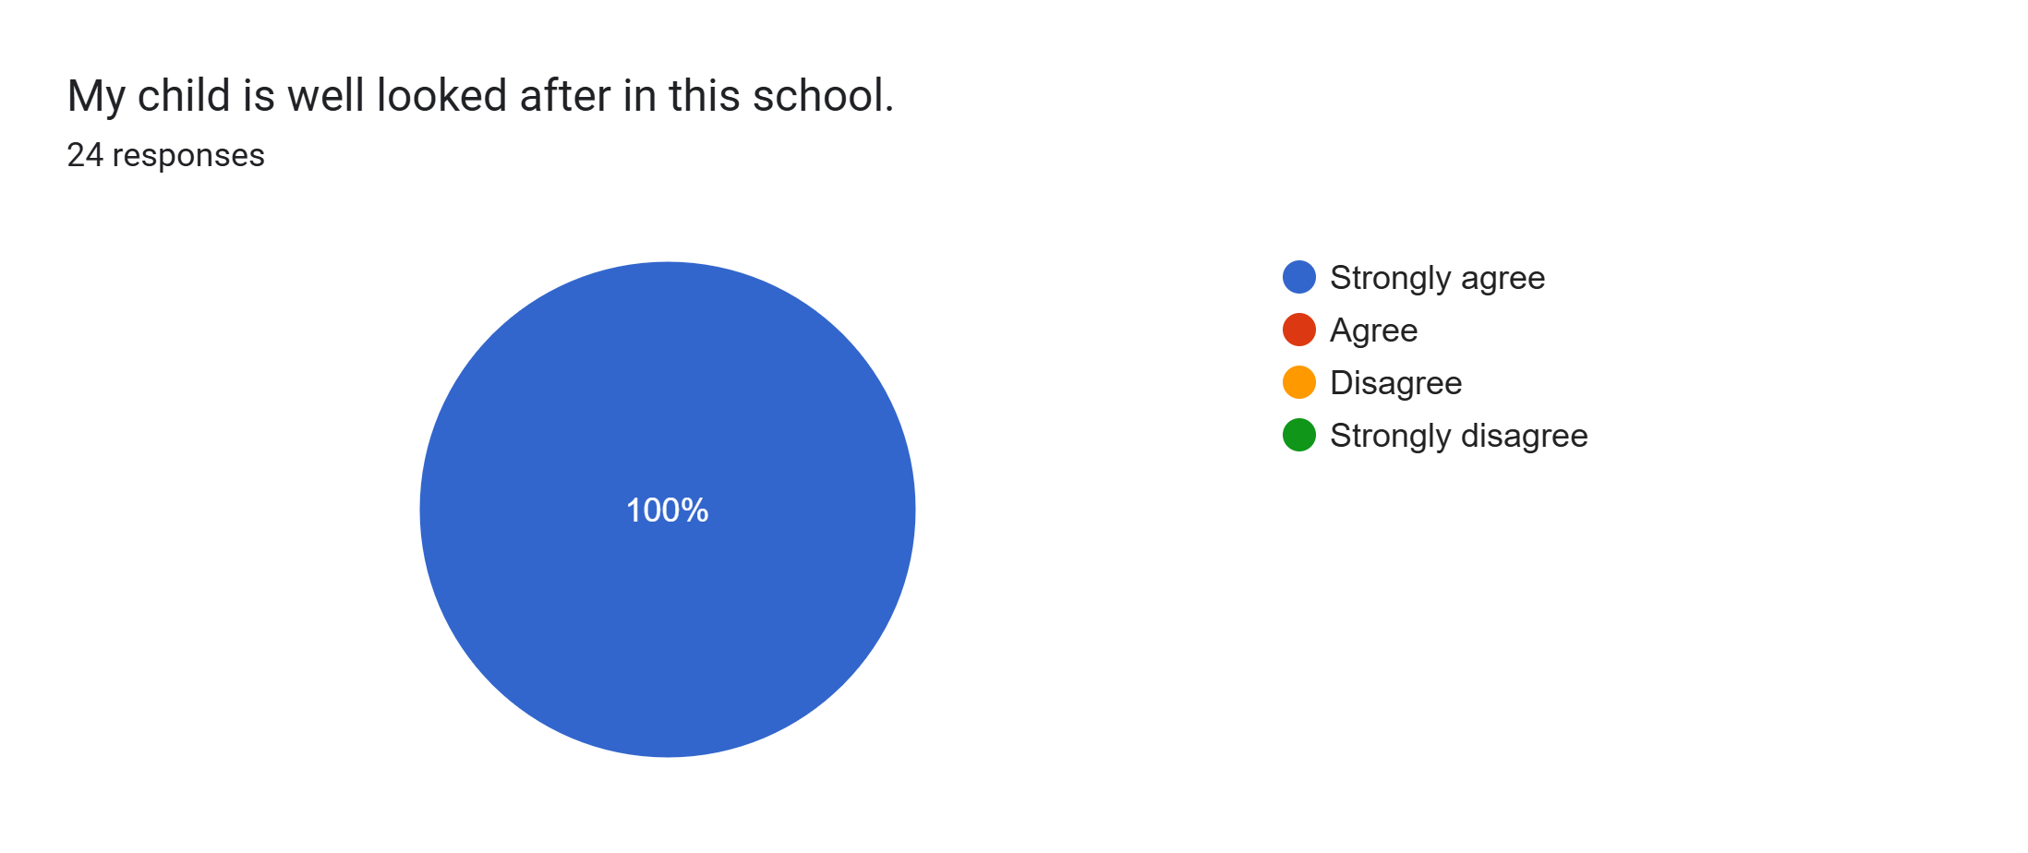
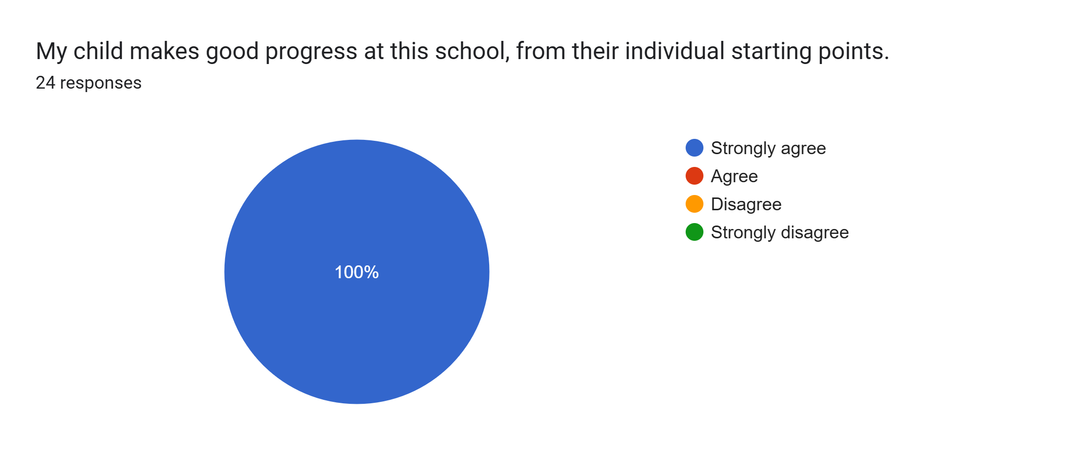
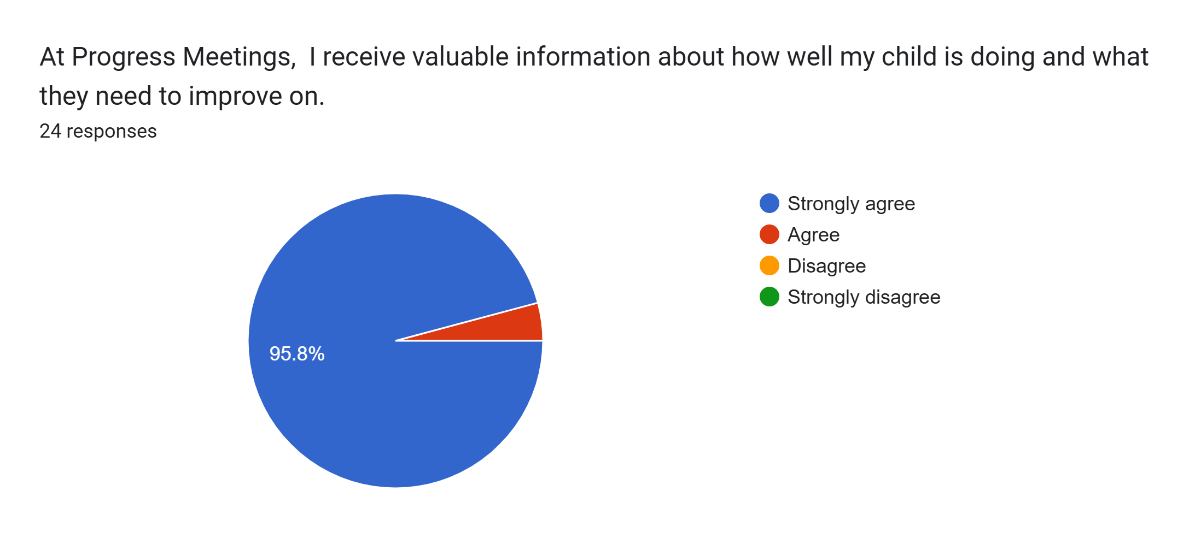
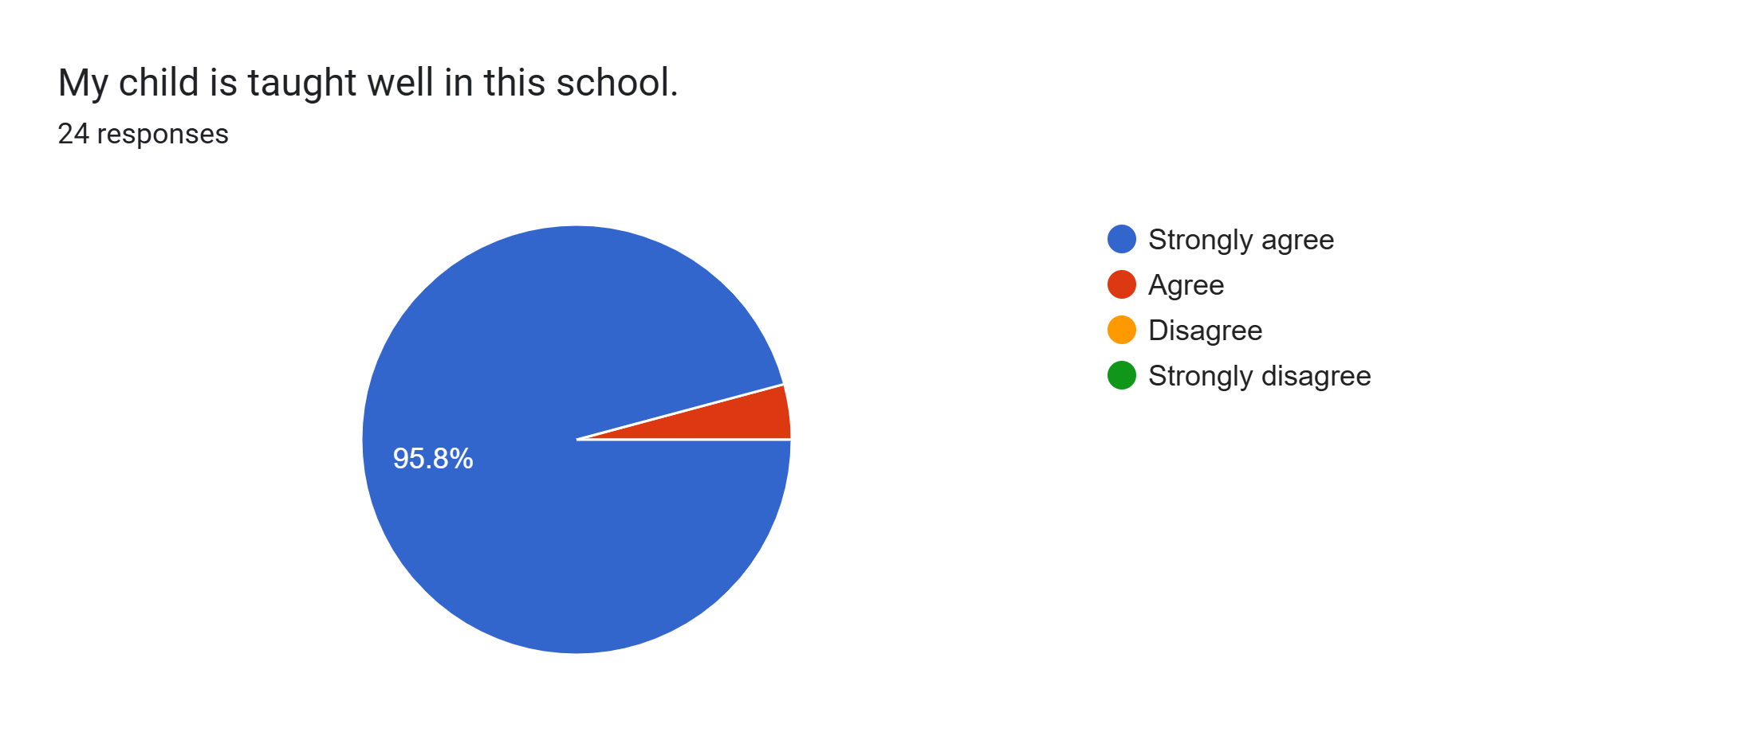
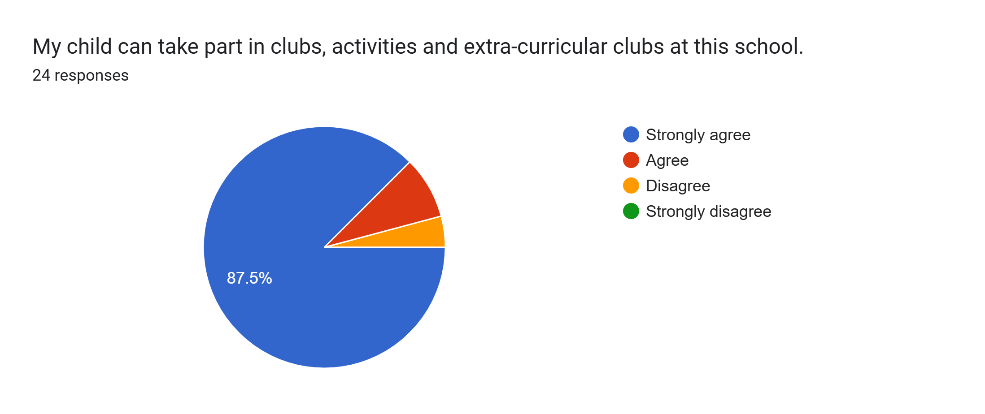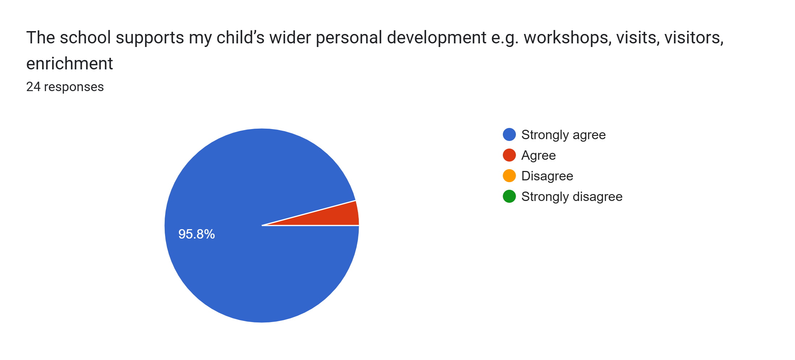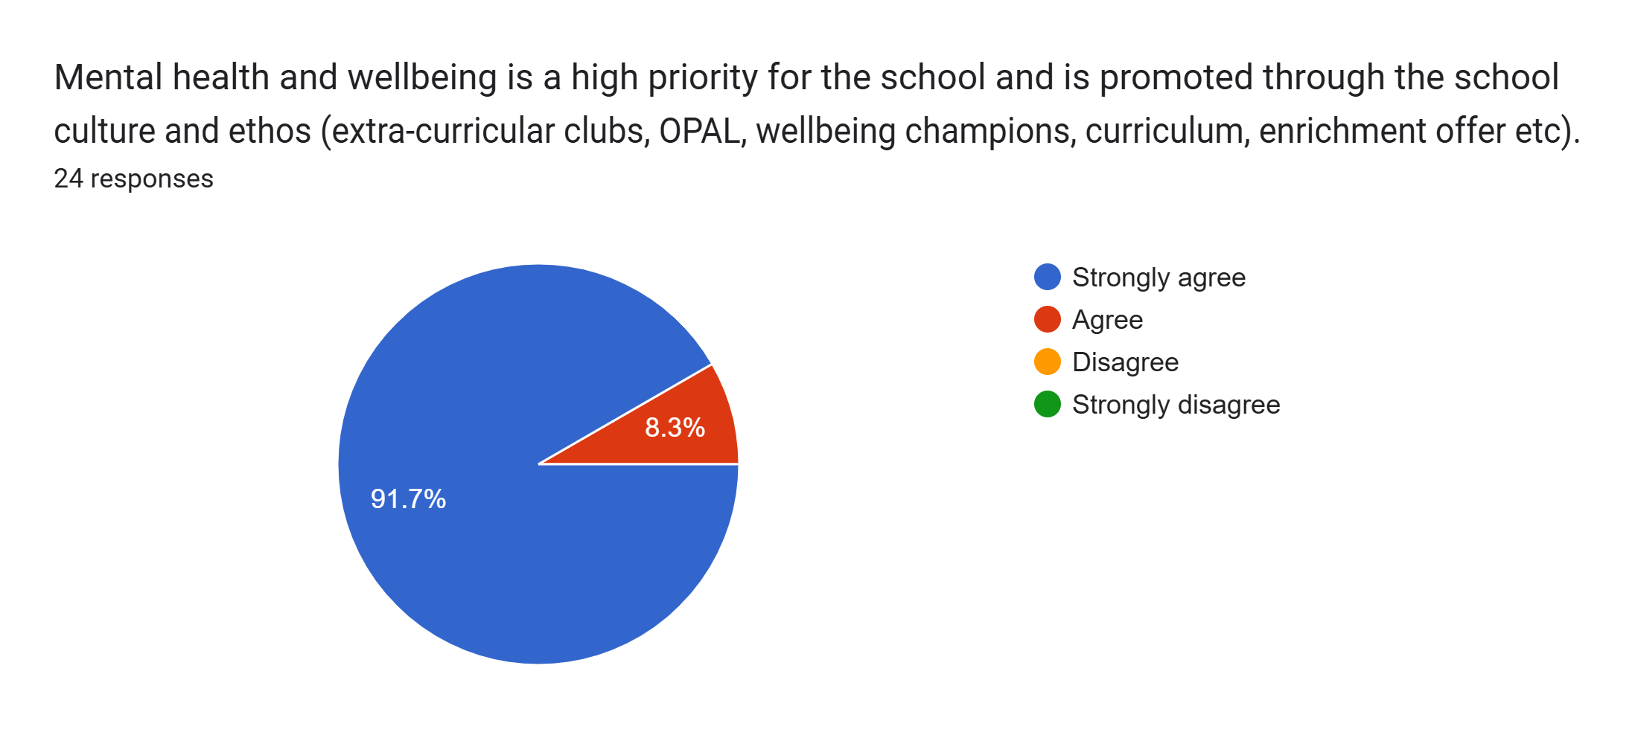
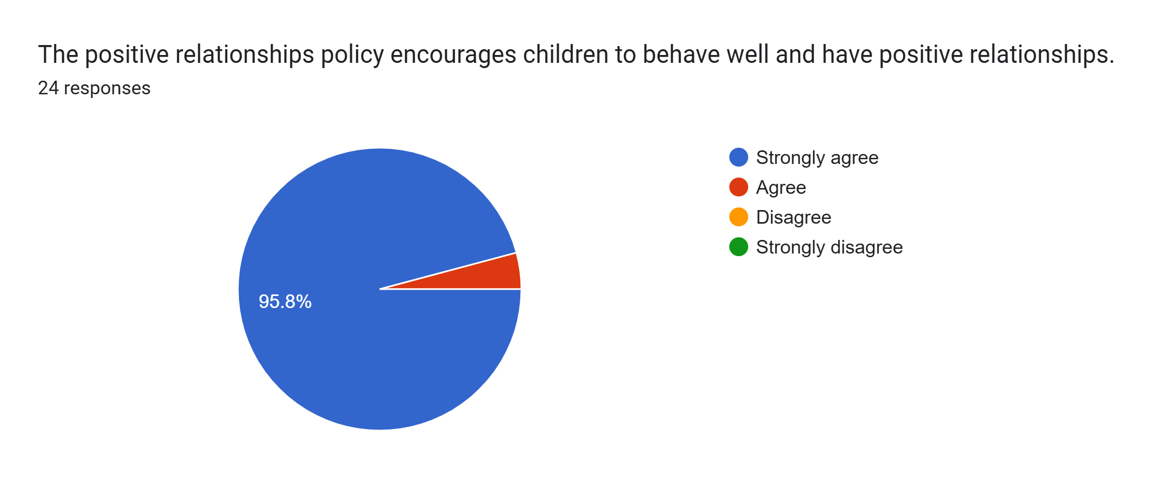
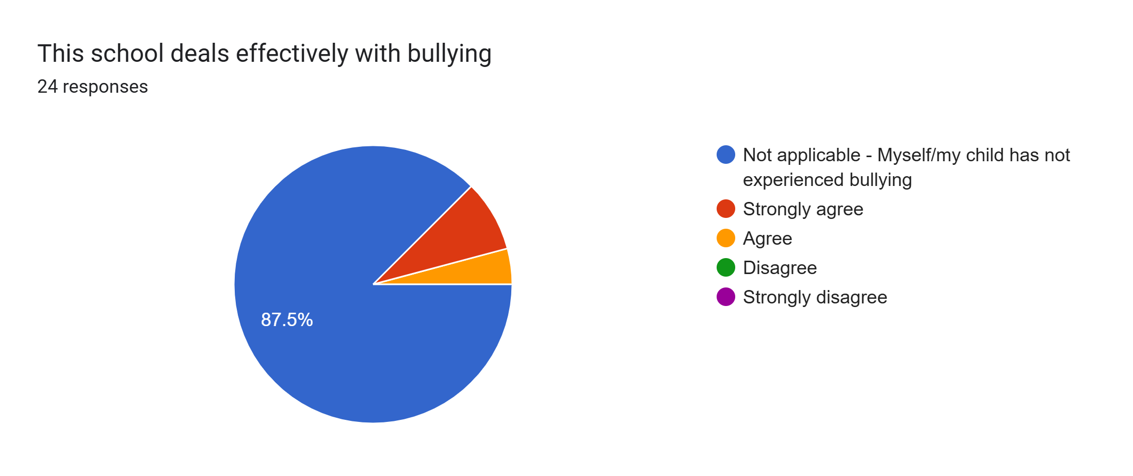
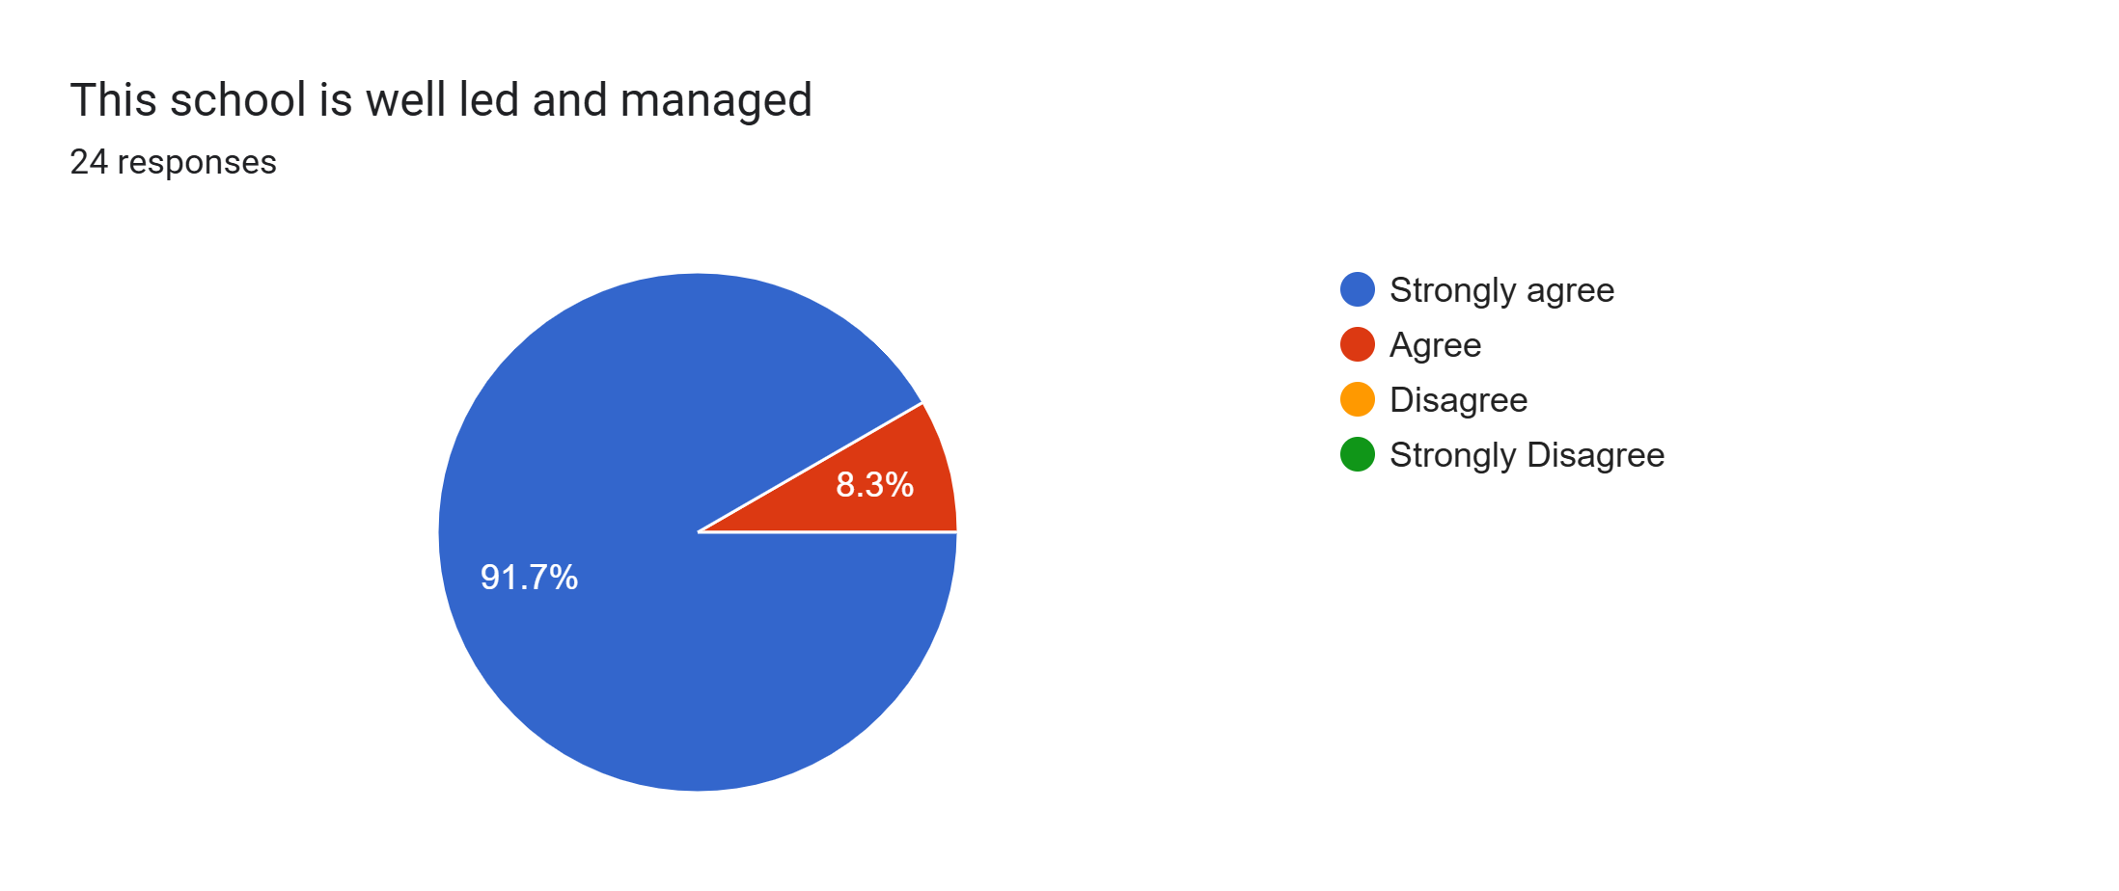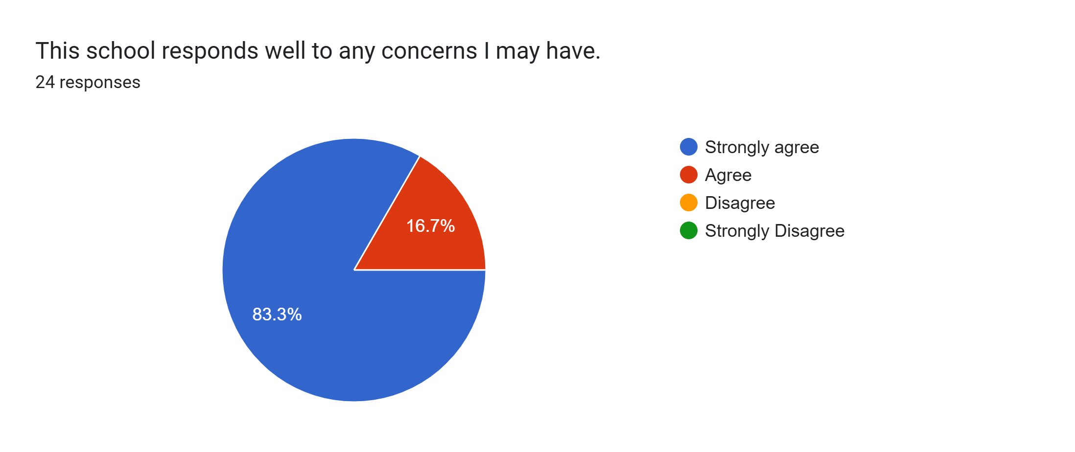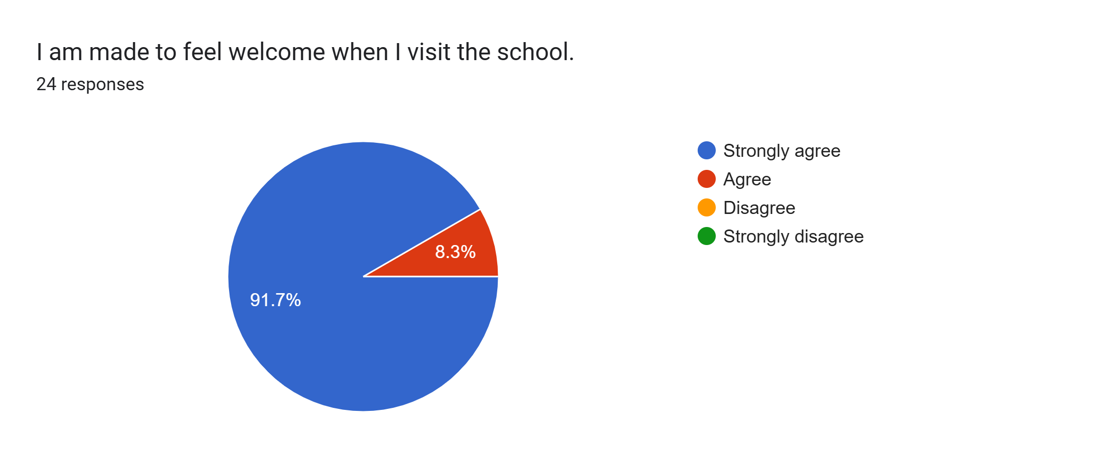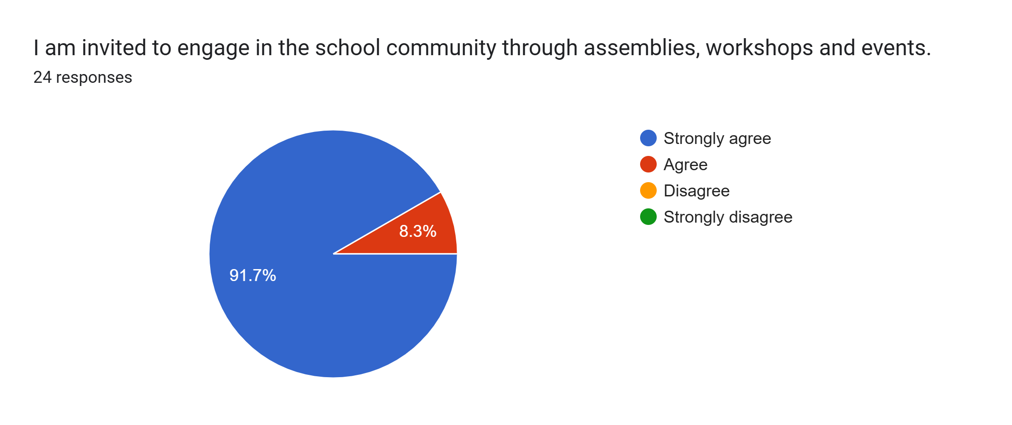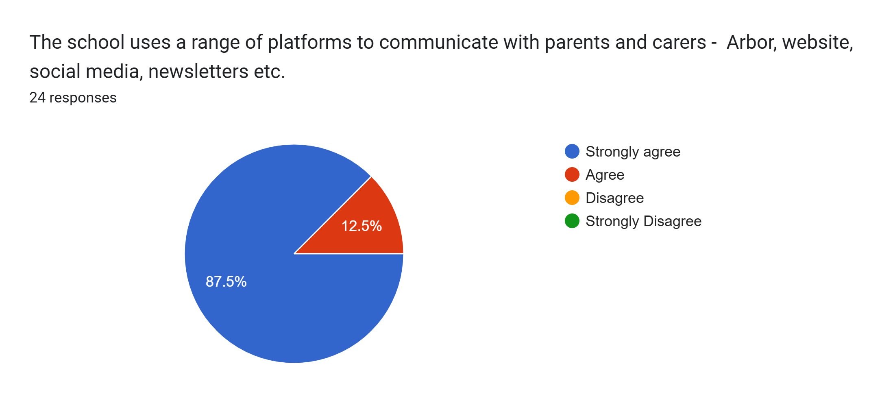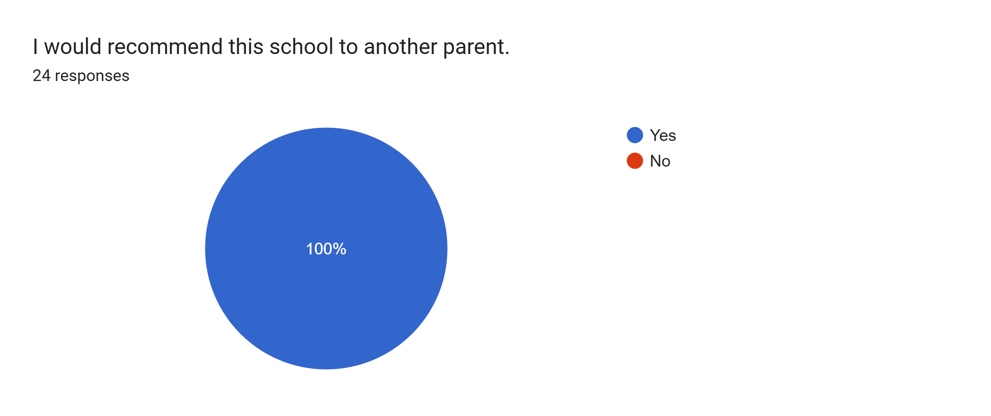

What other comments would you like to make to staff:
- Staff are lovely.
- A massive thank you too all the staff. Our daughter absolutely loves her school and is progressing amazingly. We appreciate everything you all do!!
- Thank you to all of the nursery staff for our son’s development.
- The best nursery teachers :)
- Great.
- Thank you for your hard work and commitment.
- Well done. Thank you!
- My daughter loves school thank you so much.
- Really good school.
- Amazing school and staff thank you x
- Always say good morning and very pleasant. Very confident my child is progressing
- We’re happy that our daughter is always well looked after in your care and enjoys coming to school every day.
- Thank you.
- Great school.
- My daughter is happy in class and enjoys school.
- Doing an amazing job. Thank you!
- It was really nice to come in and speak to Miss Waters about my daughter’s progress in school 😀
- My daughter speaks about her teachers all of the time.
- We feel listened to in this school and our daughter is very happy here. The after school clubs are brilliant and the amount of activities and fun days the school organise are great. Our daughter has developed so much even in the short time she has been at the school. Thank you so much to all the staff for all the work and effort they put in even down to knowing every child’s name.
- Great school and staff.
- Massive thank you to all staff for working so hard for the children.
- Very impressed and happy with the education my child is receiving. My daughter has achieved so much and grown hugely in confidence.
- Brilliant.
- I couldn’t be happier with my daughter in this school. She always comes home happy and teachers are lovely.

