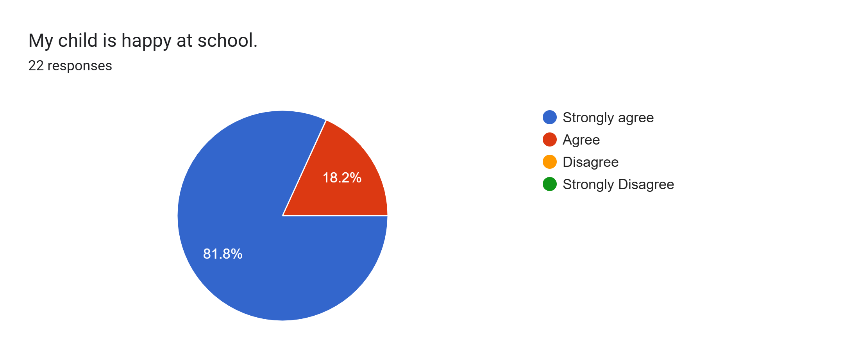
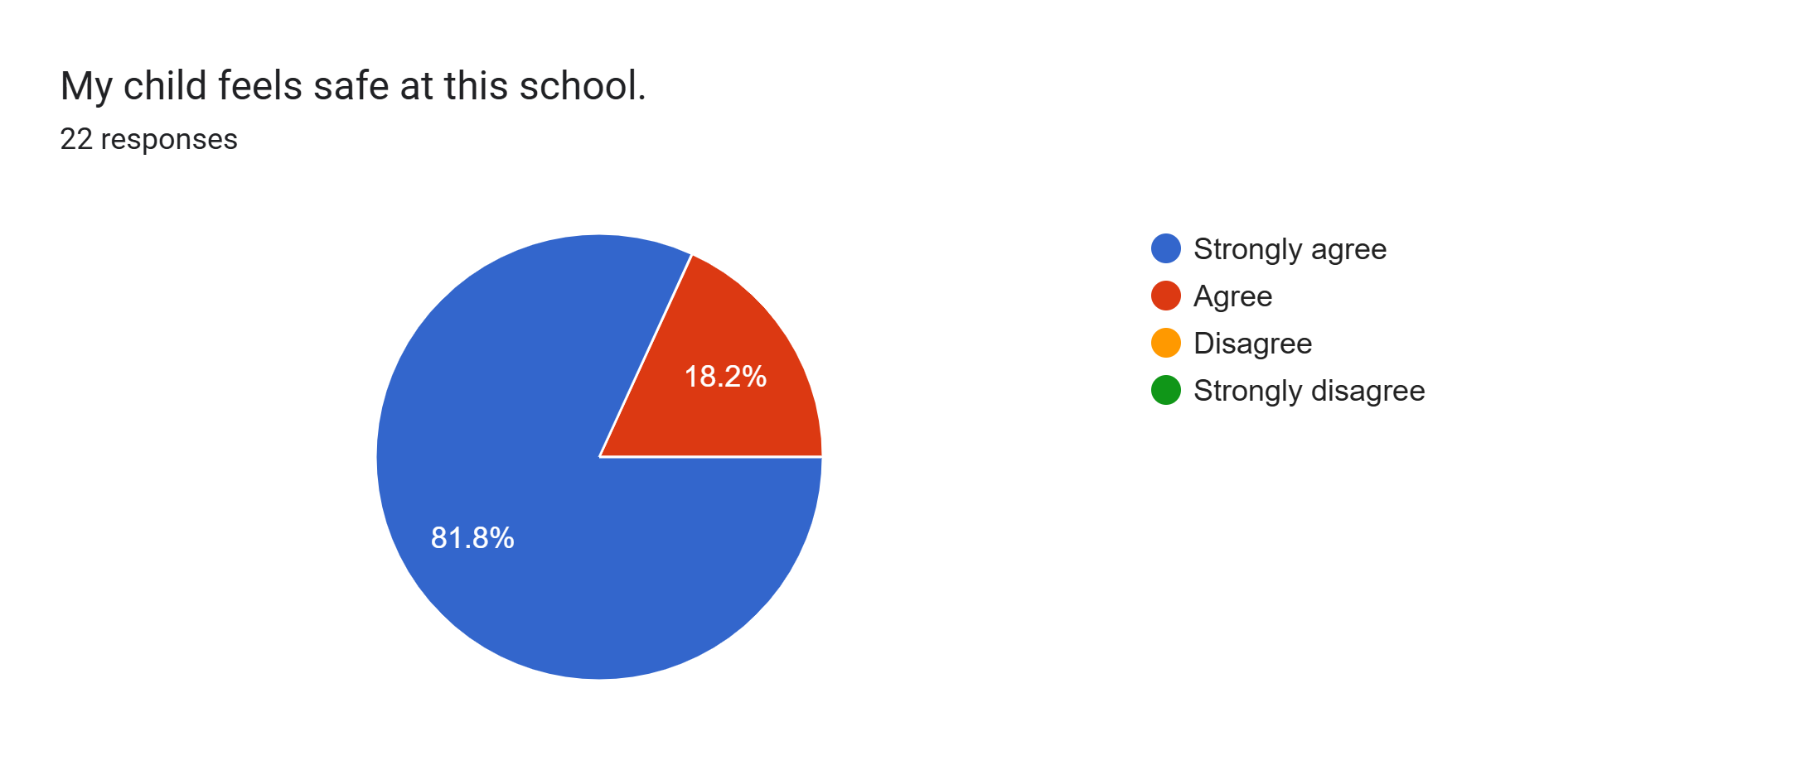
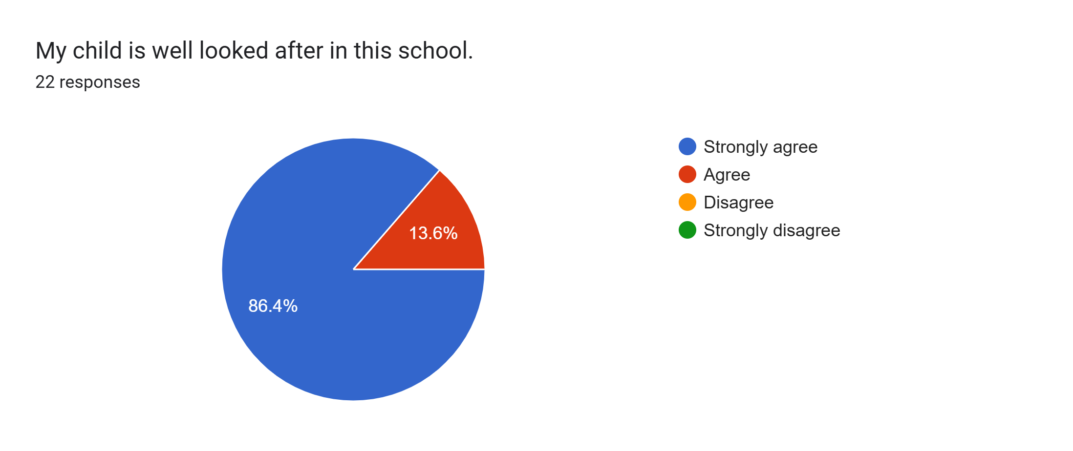
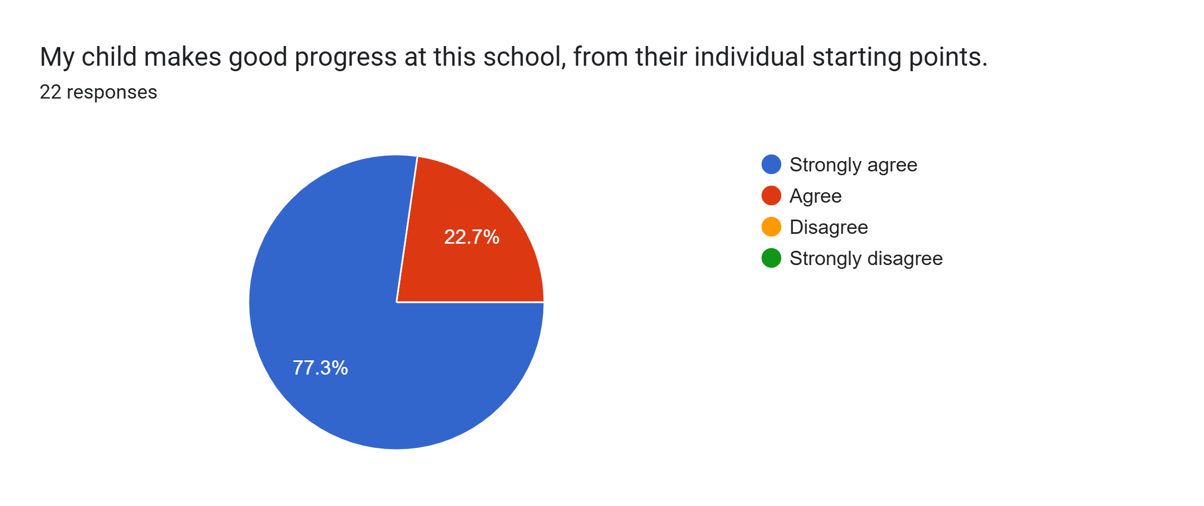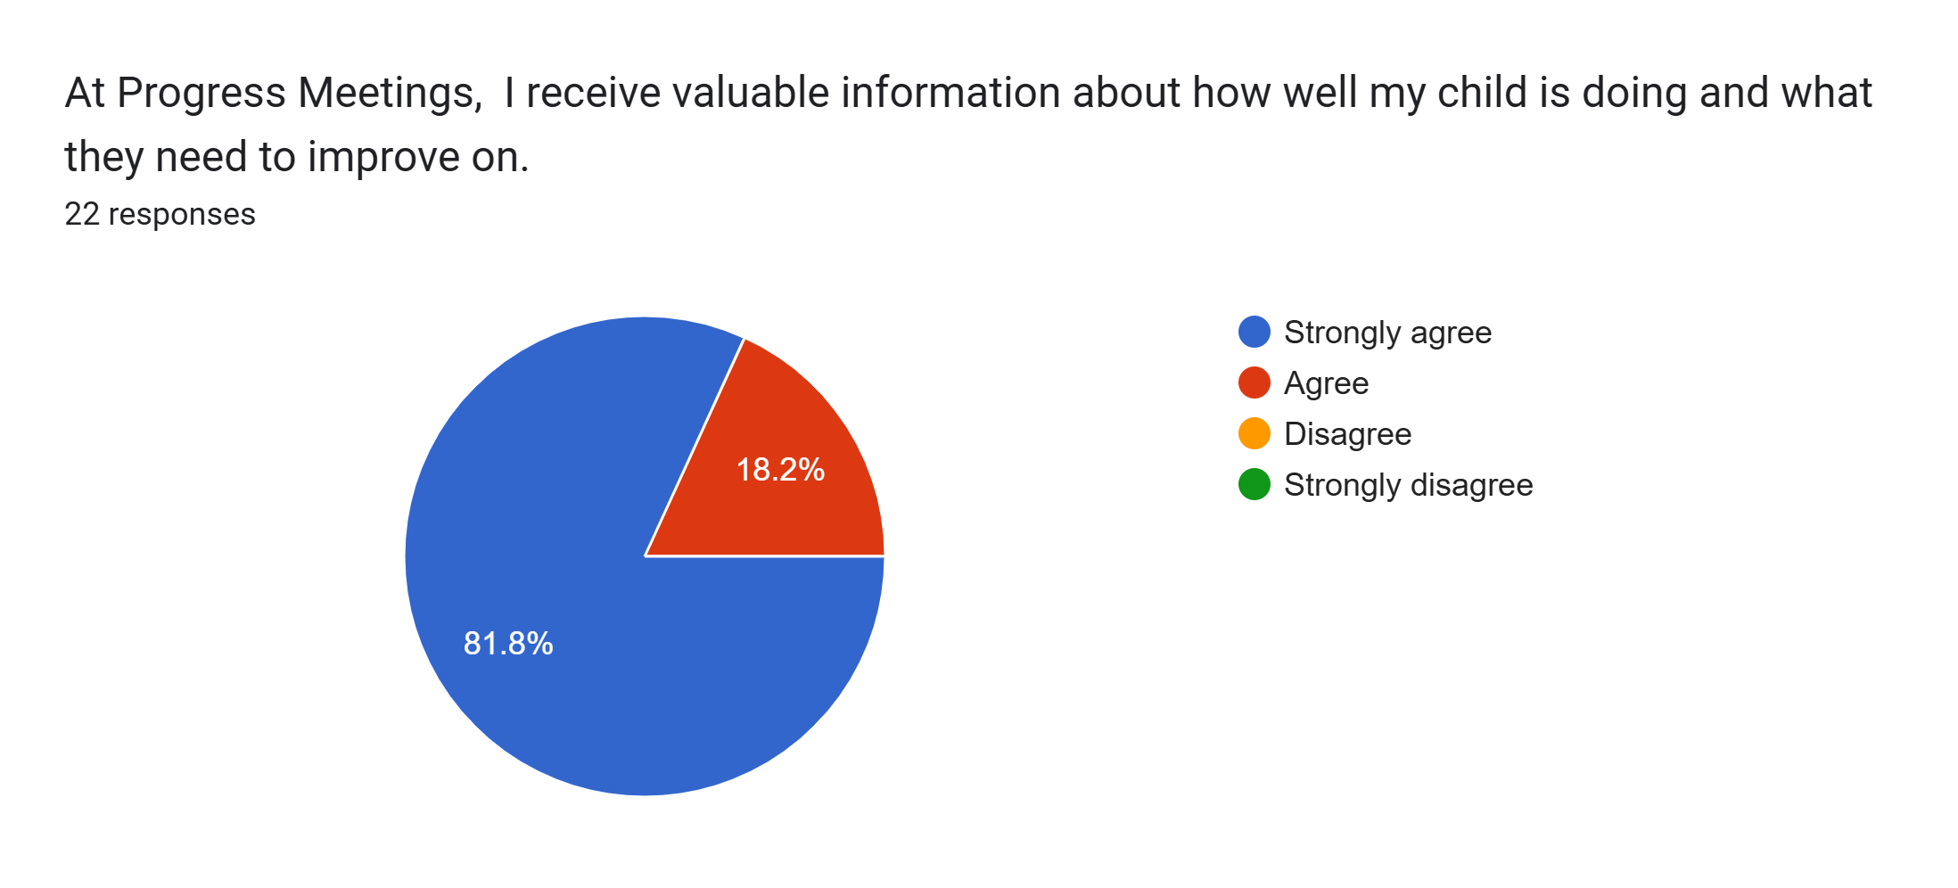
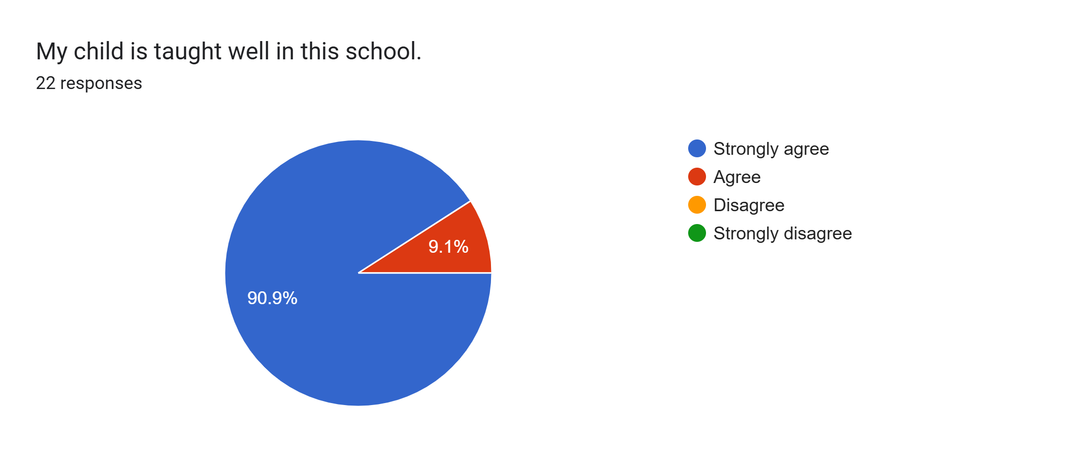
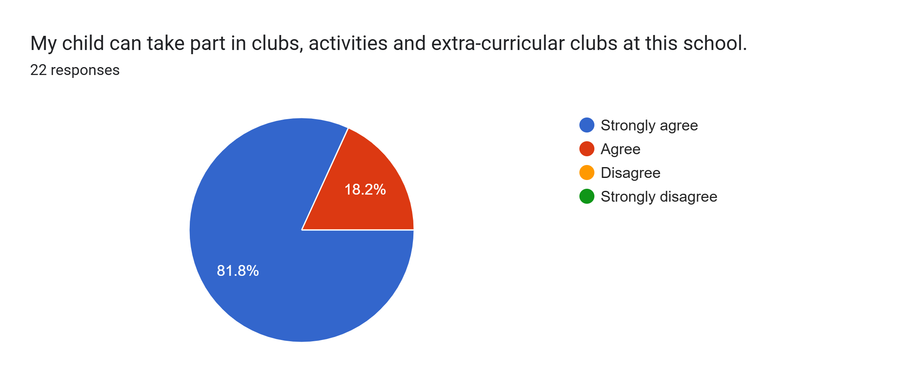
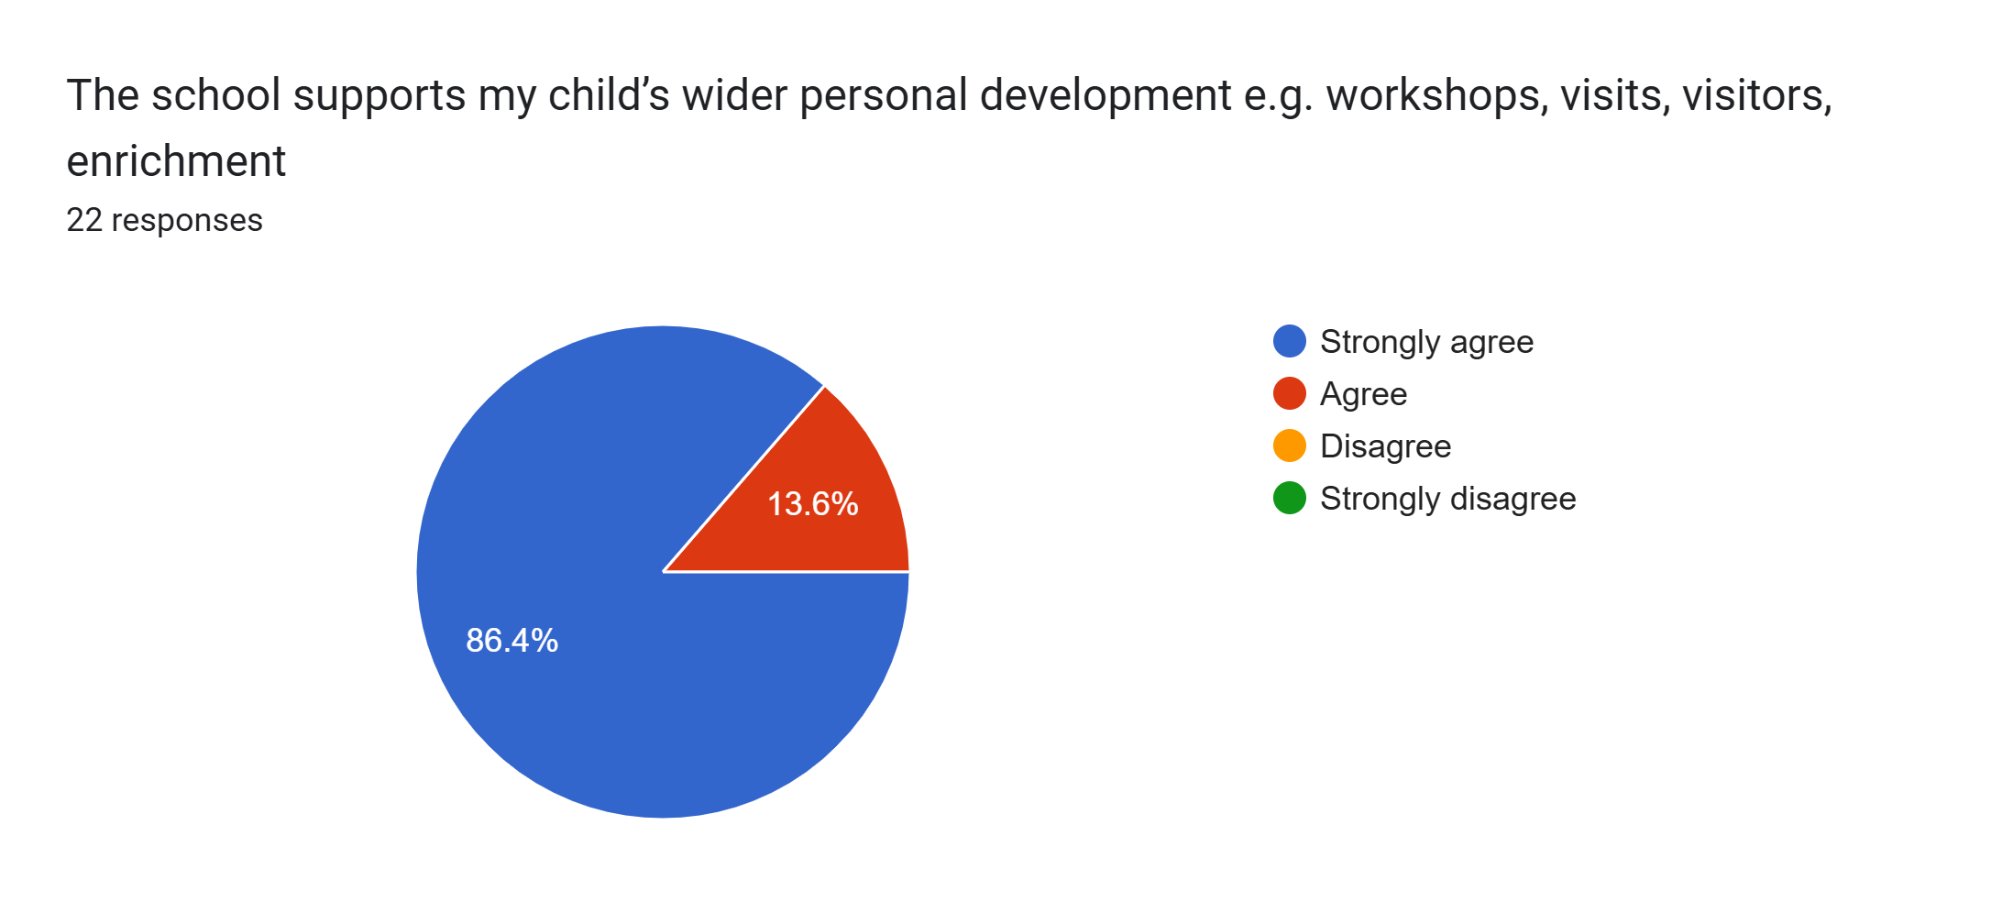
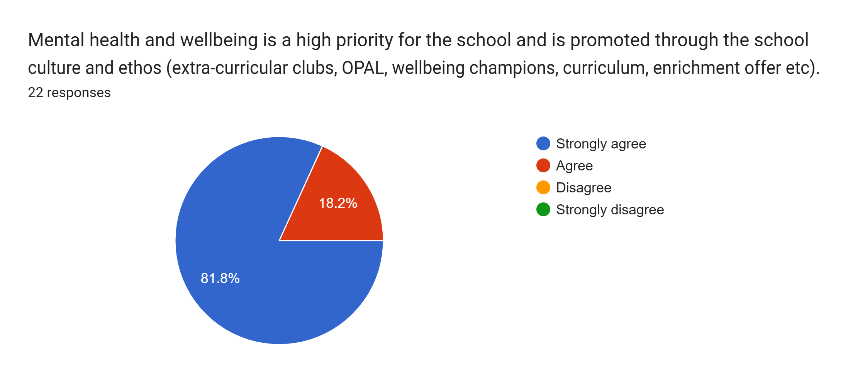
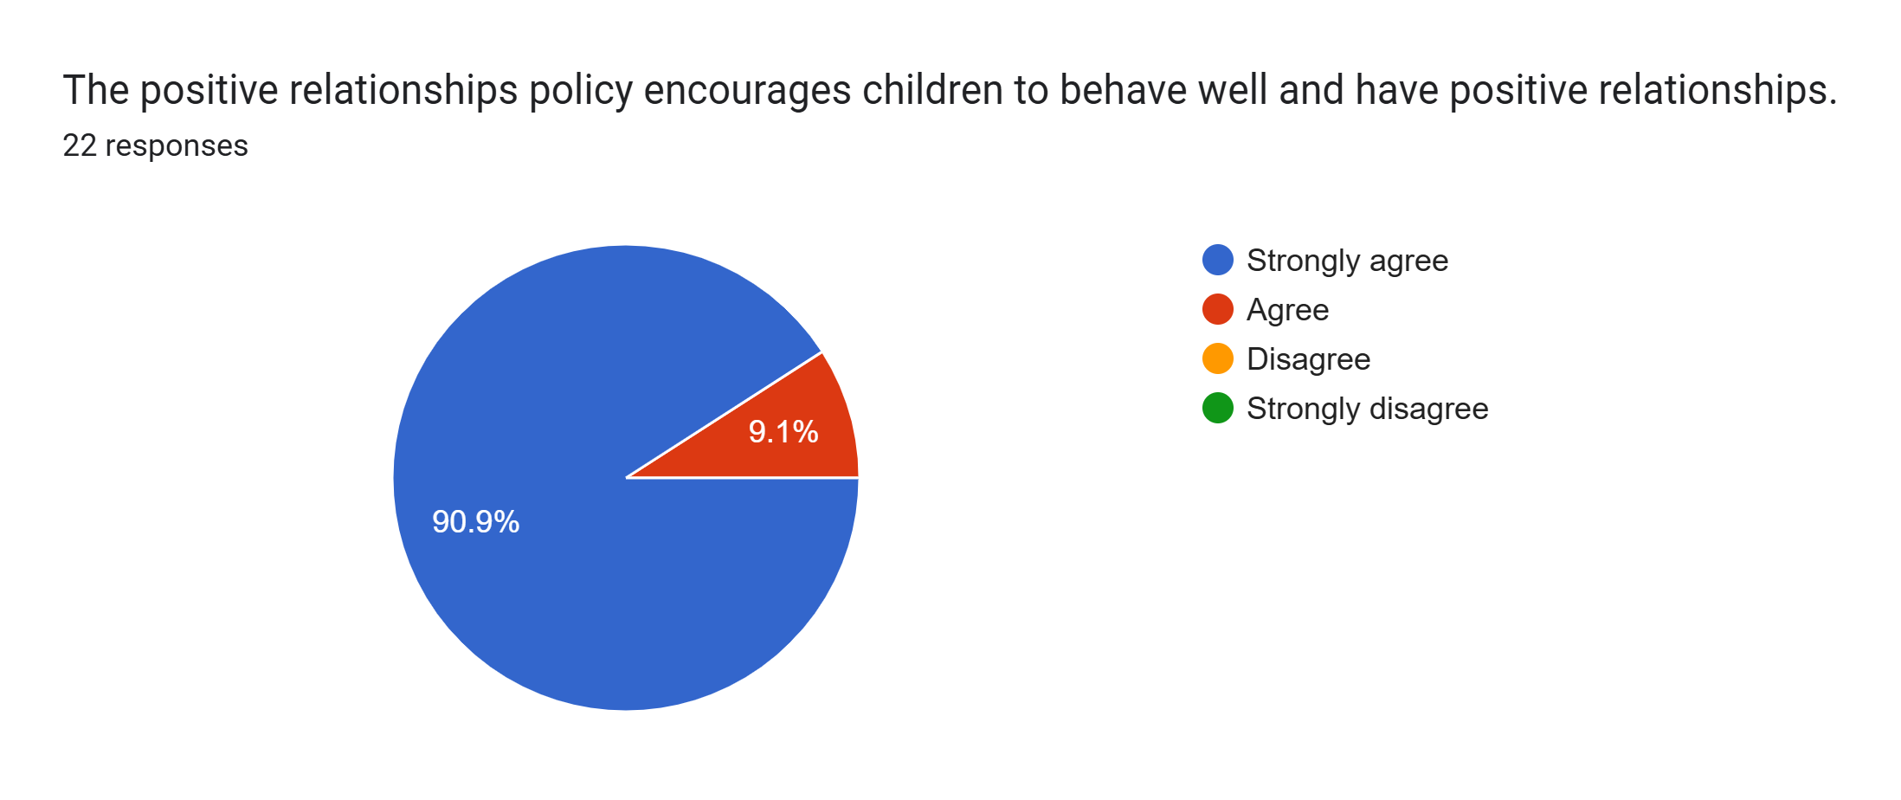
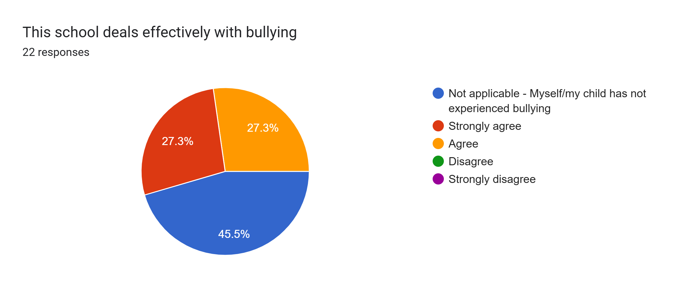
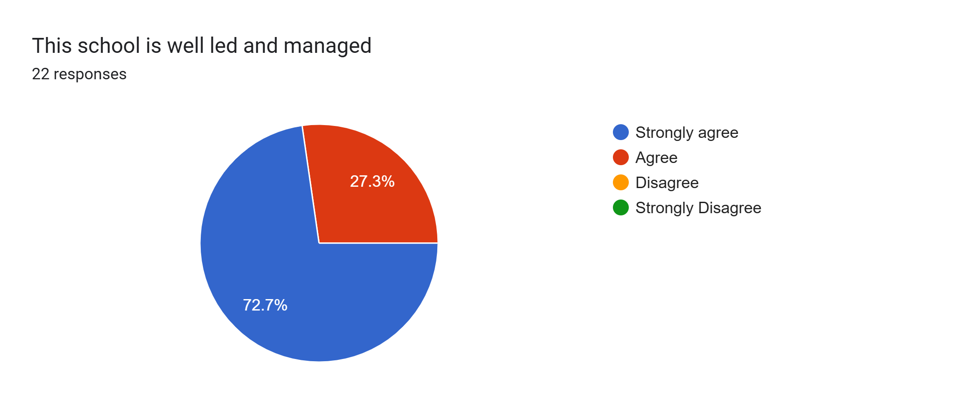
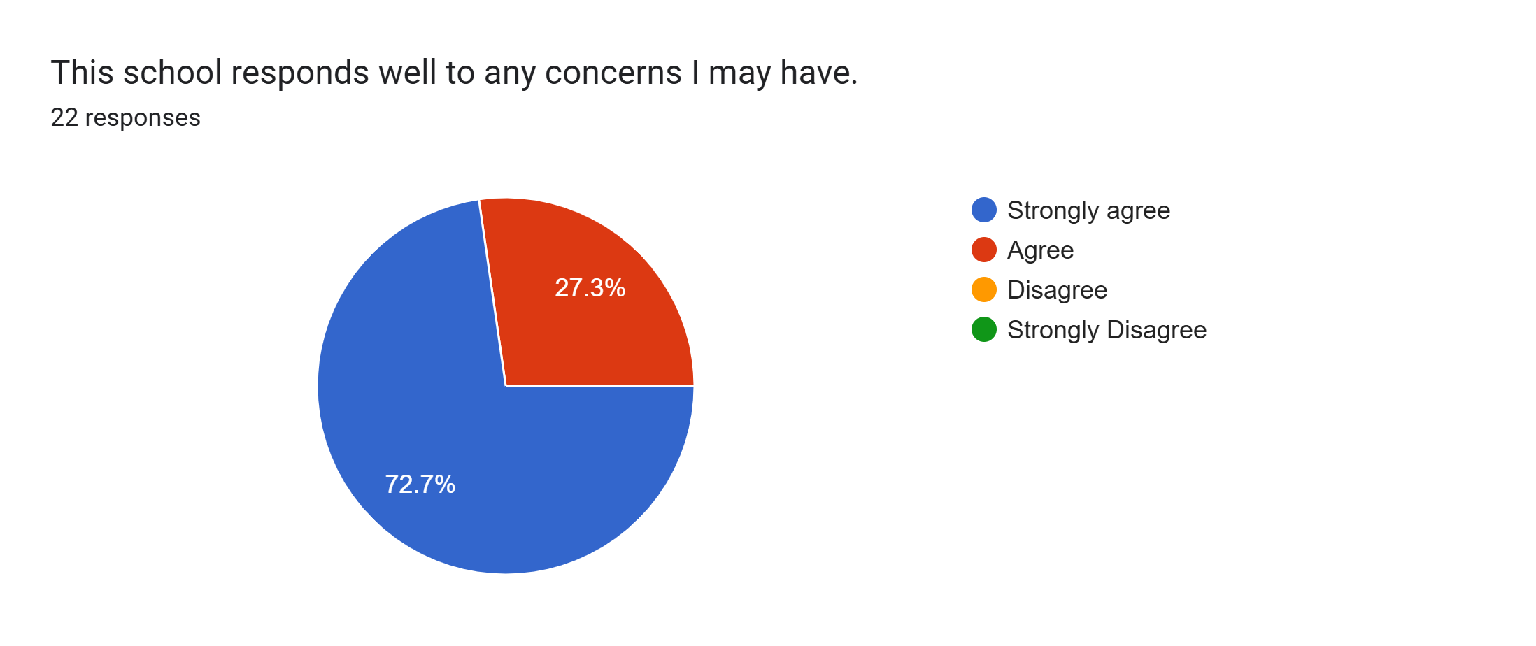
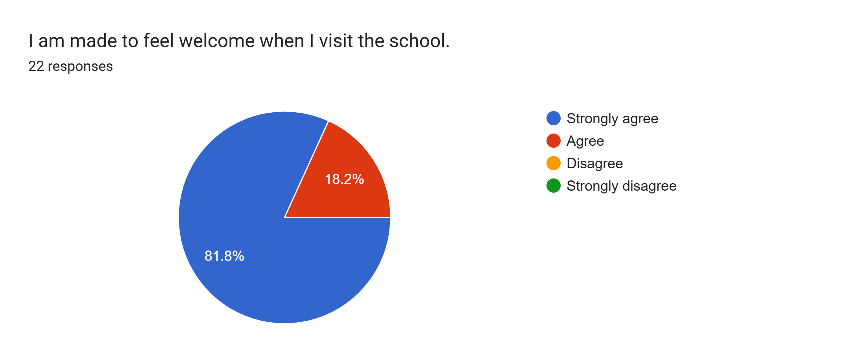
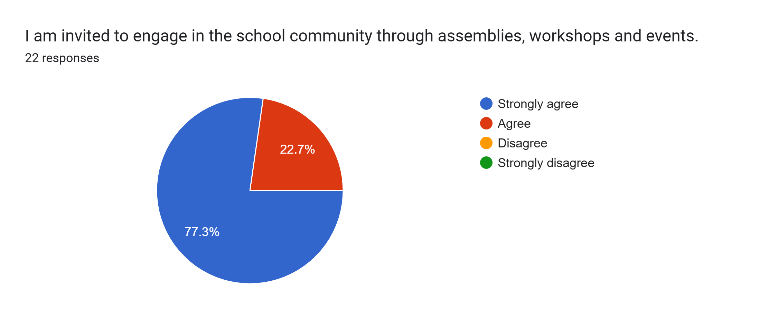
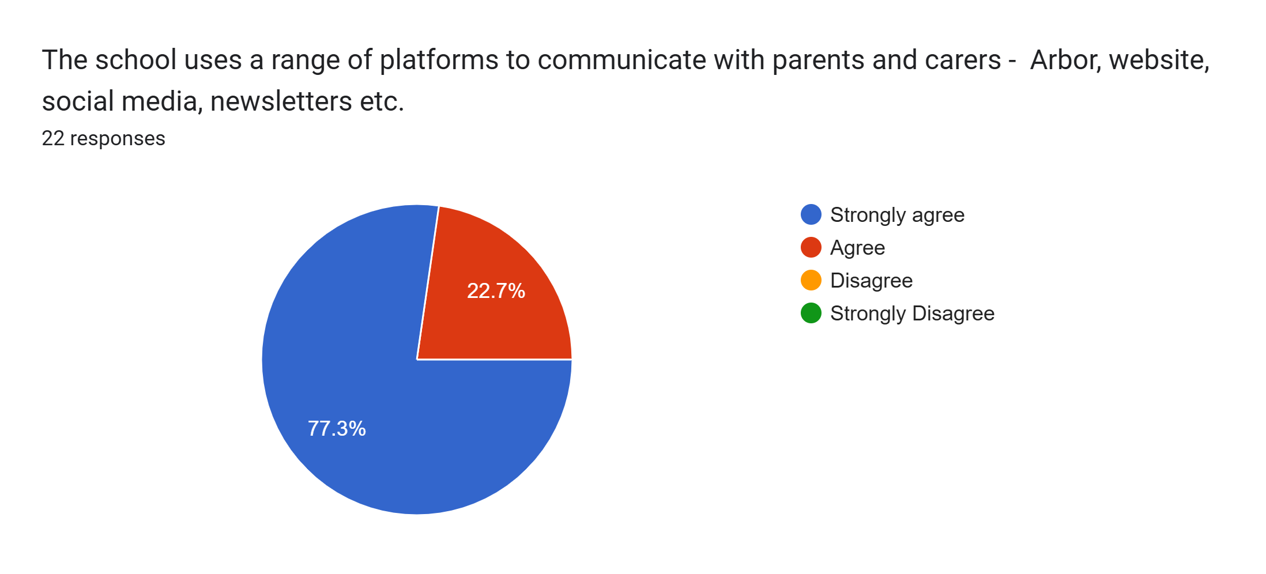
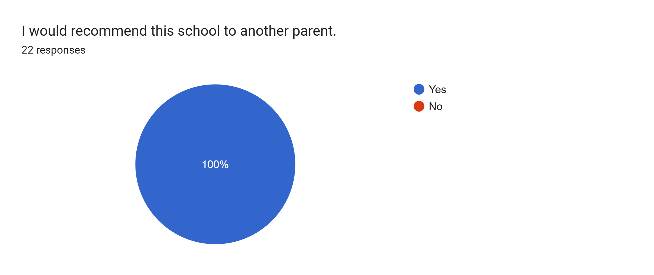

What other comments would you like to make to staff:
- Love this school.
- Fantastic school. Great staff. Amazing teachers.
- Lovely school.
- My child has enjoyed her time at Roby Park and has exceeded all expectations of her.
- Amazing school & staff .... thank you x
- Great support.
- My son really loves the school and staff here.
- I appreciate all your efforts with my daughter.
- To all the staff, thank you.
- Last parent’s evening and we have always had great feedback.
- A fabulous parents evening.
- Thank you.
- Love this school. You do an amazing job.
- My daughter is making great progress at school and is very happy.
- Brilliant work - thank you.
- Amazing.
- Amazing.
- Thank you for all of your support :-)
- Thank you for all that you do. You are amazing.

