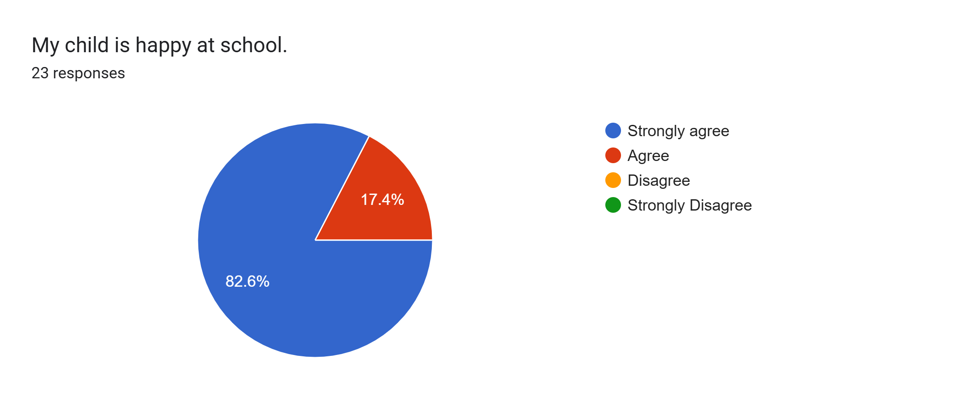
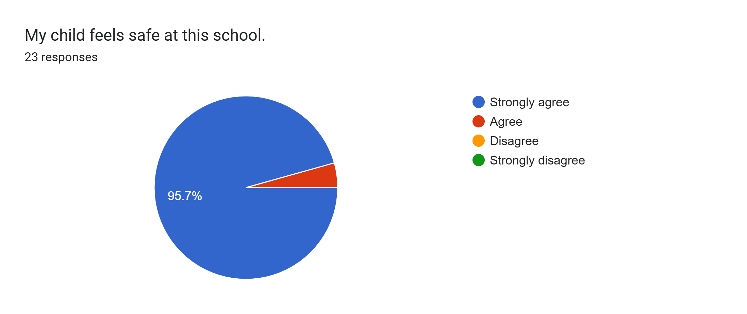
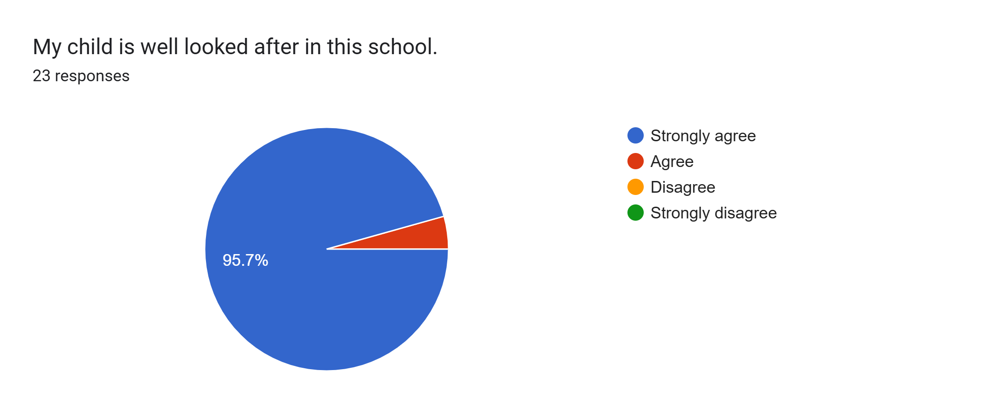
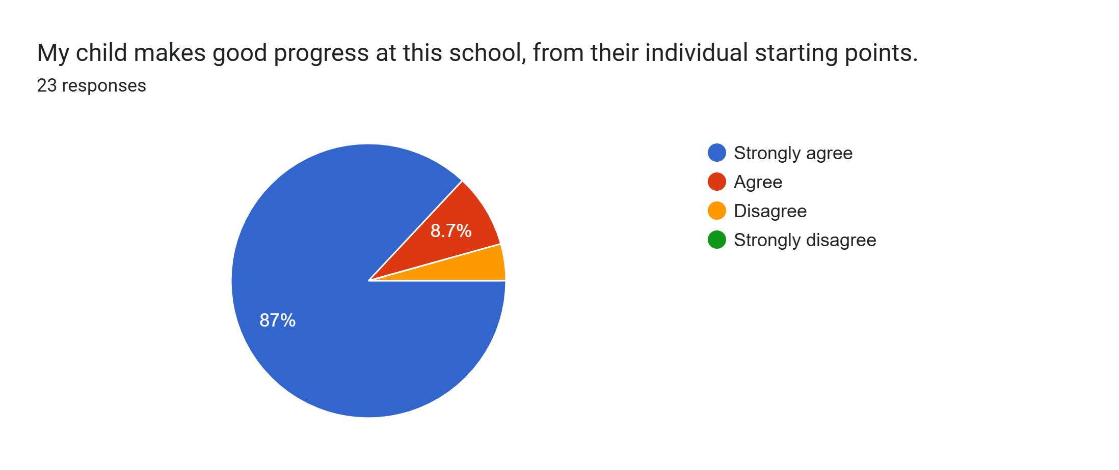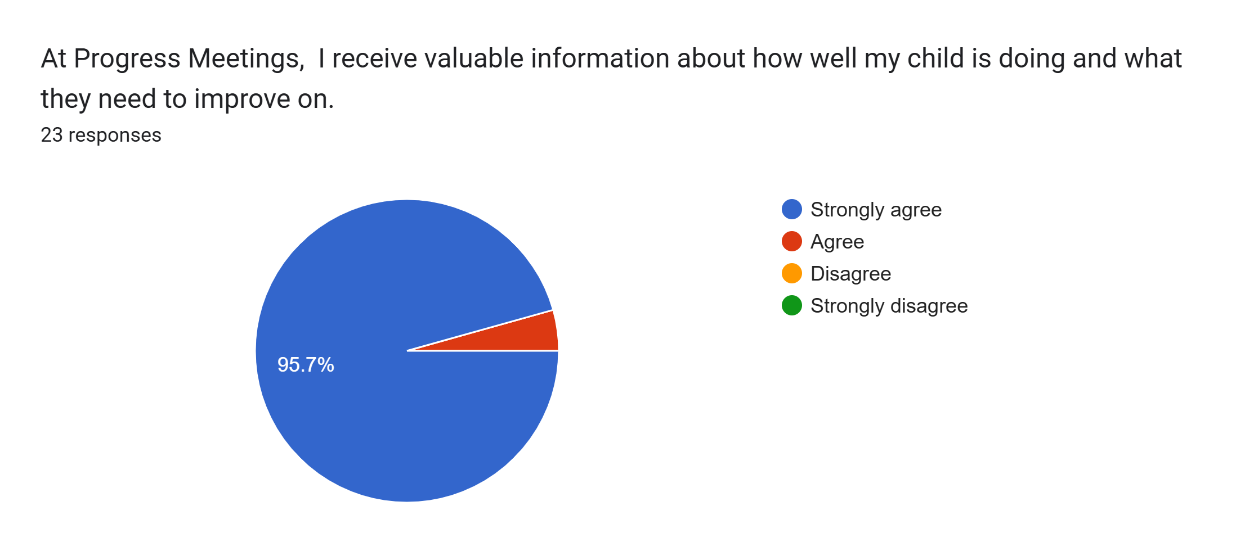
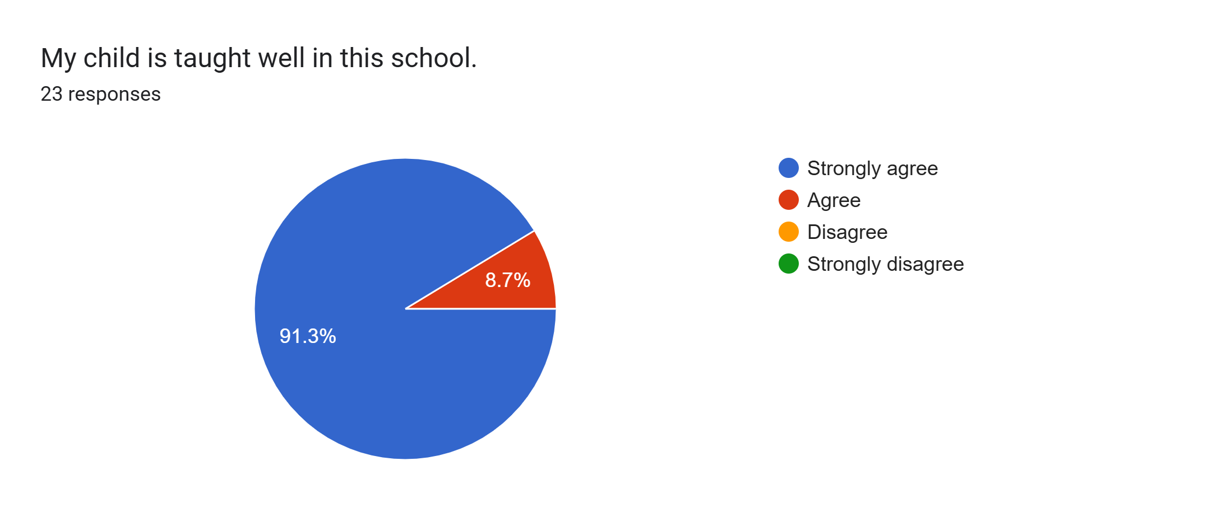
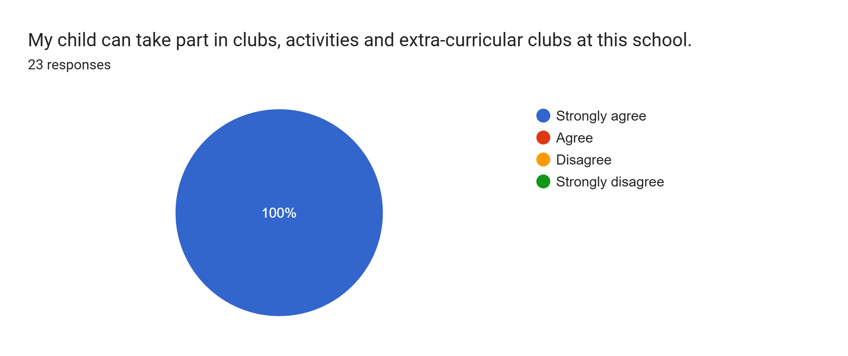
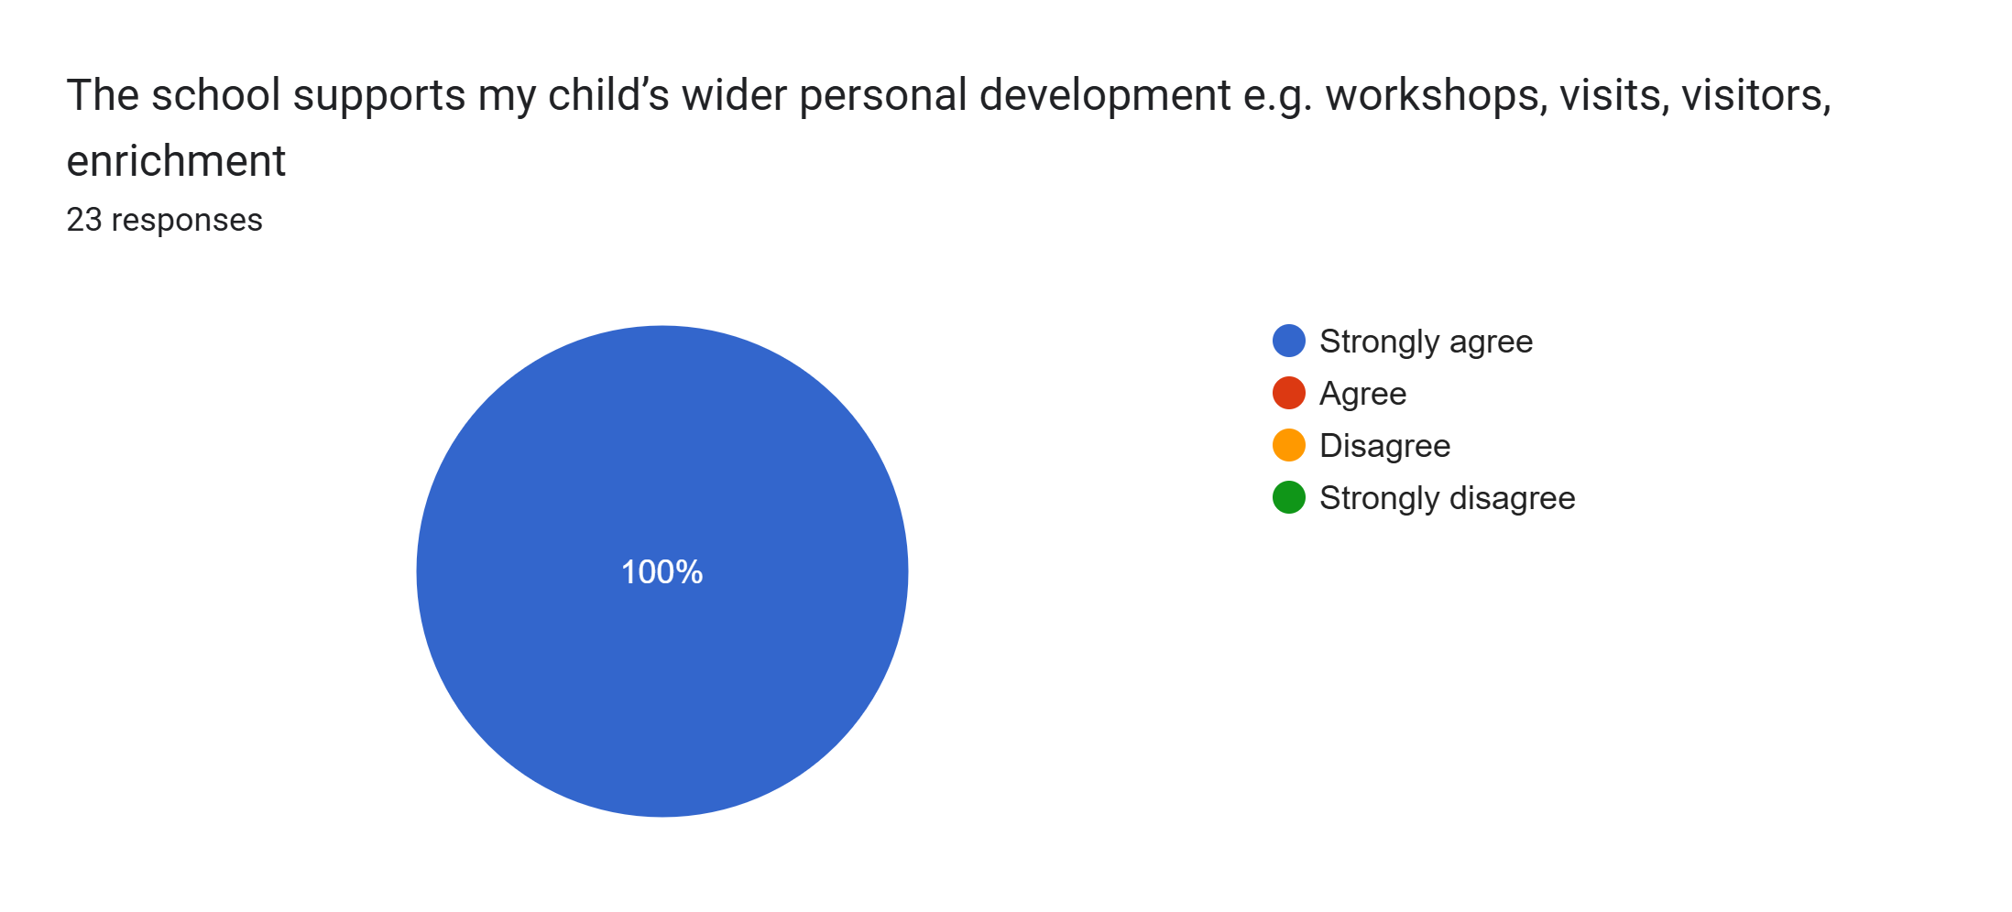
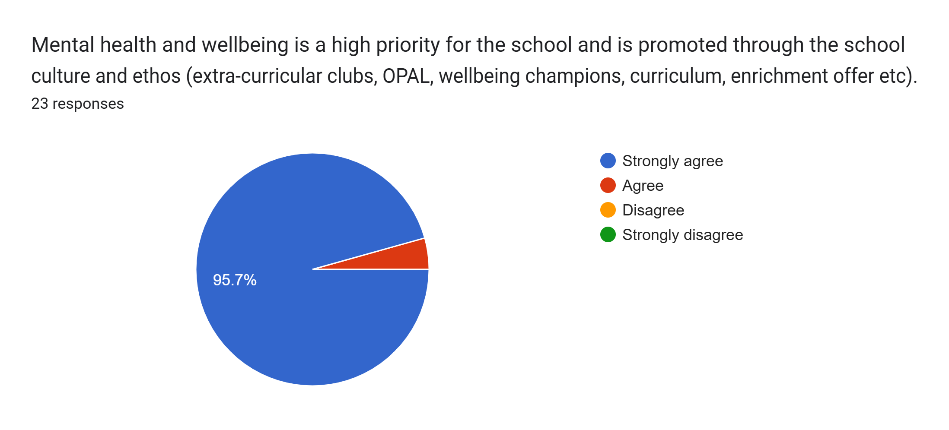
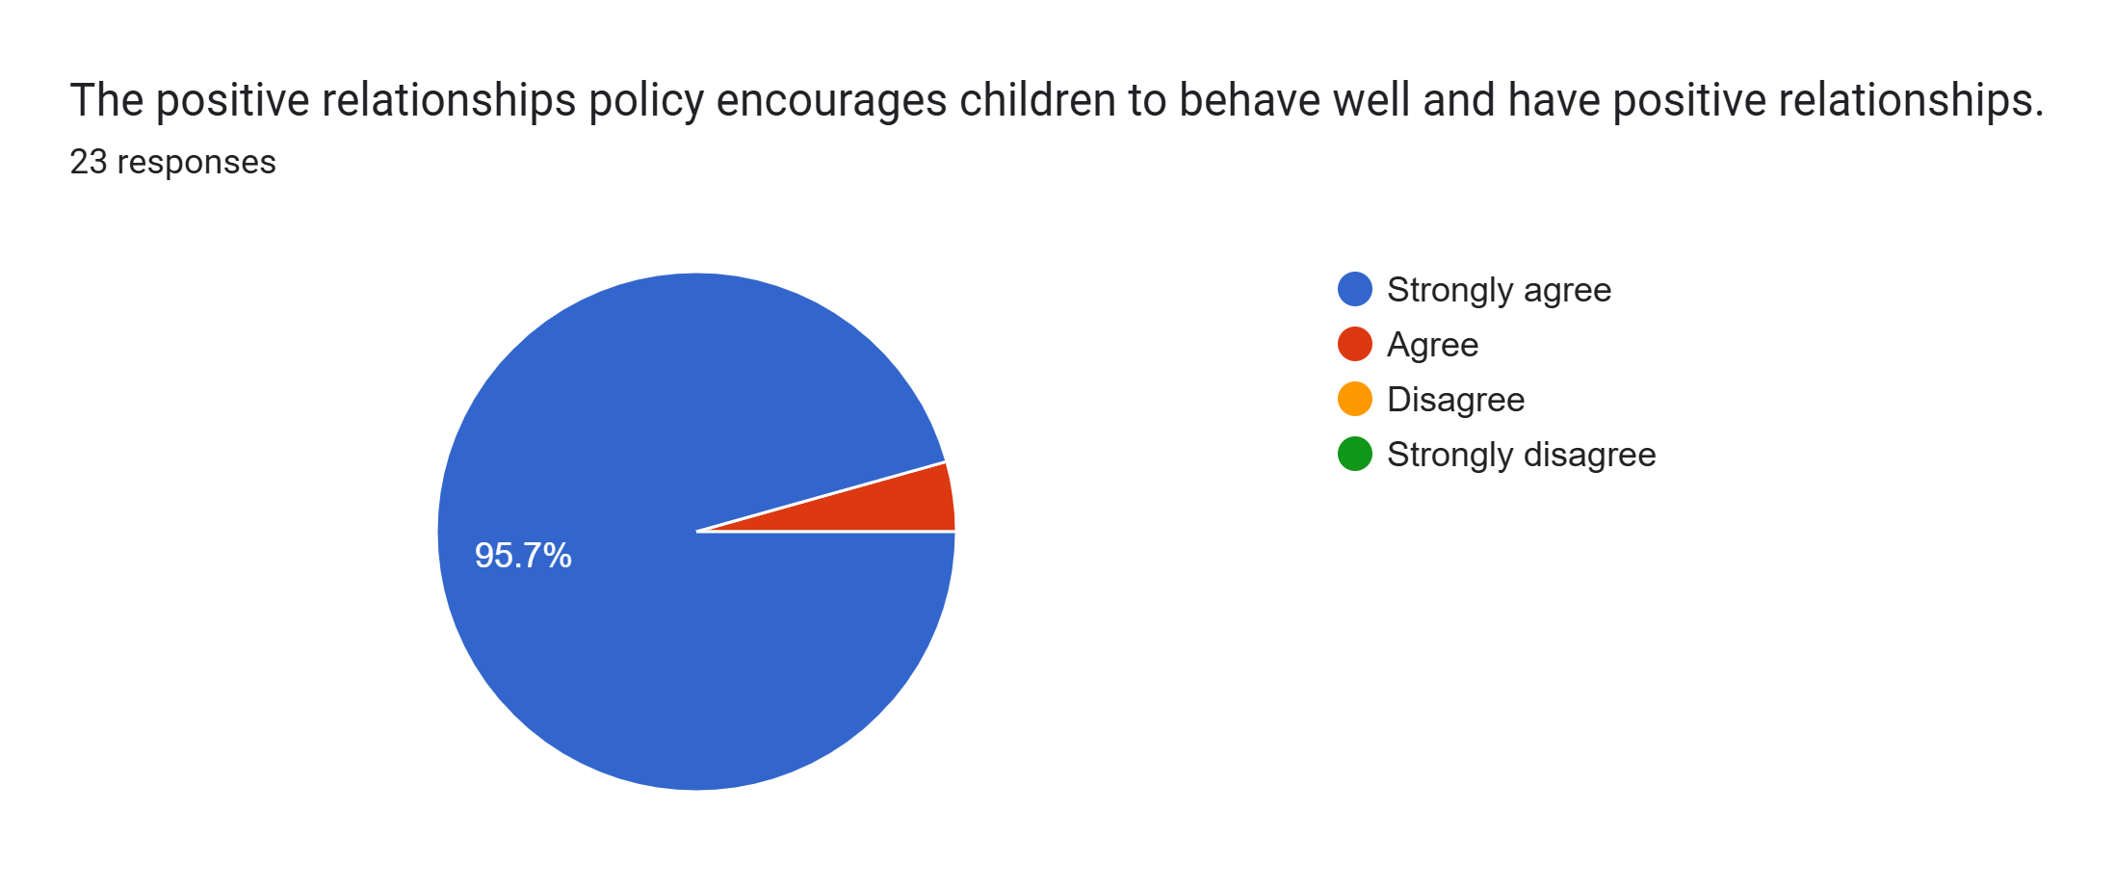
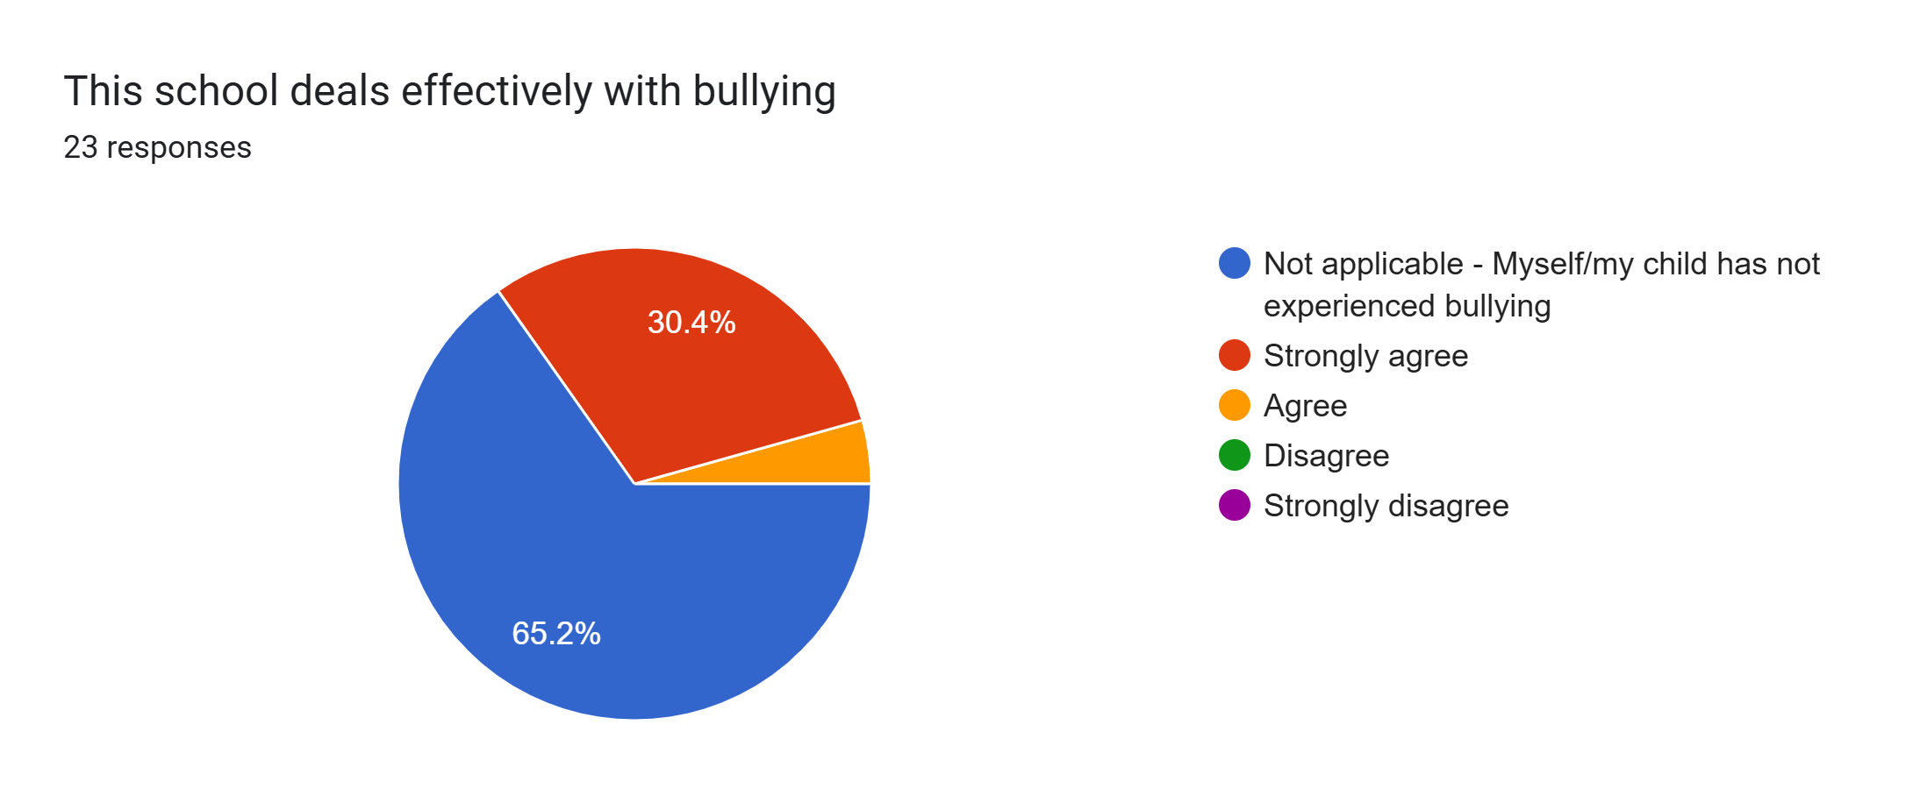
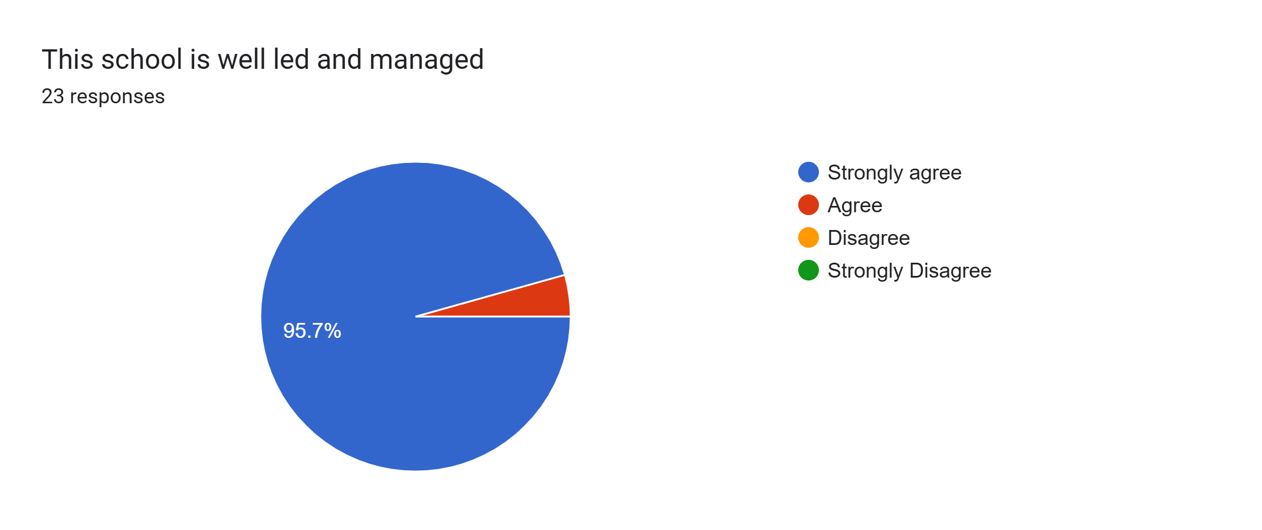
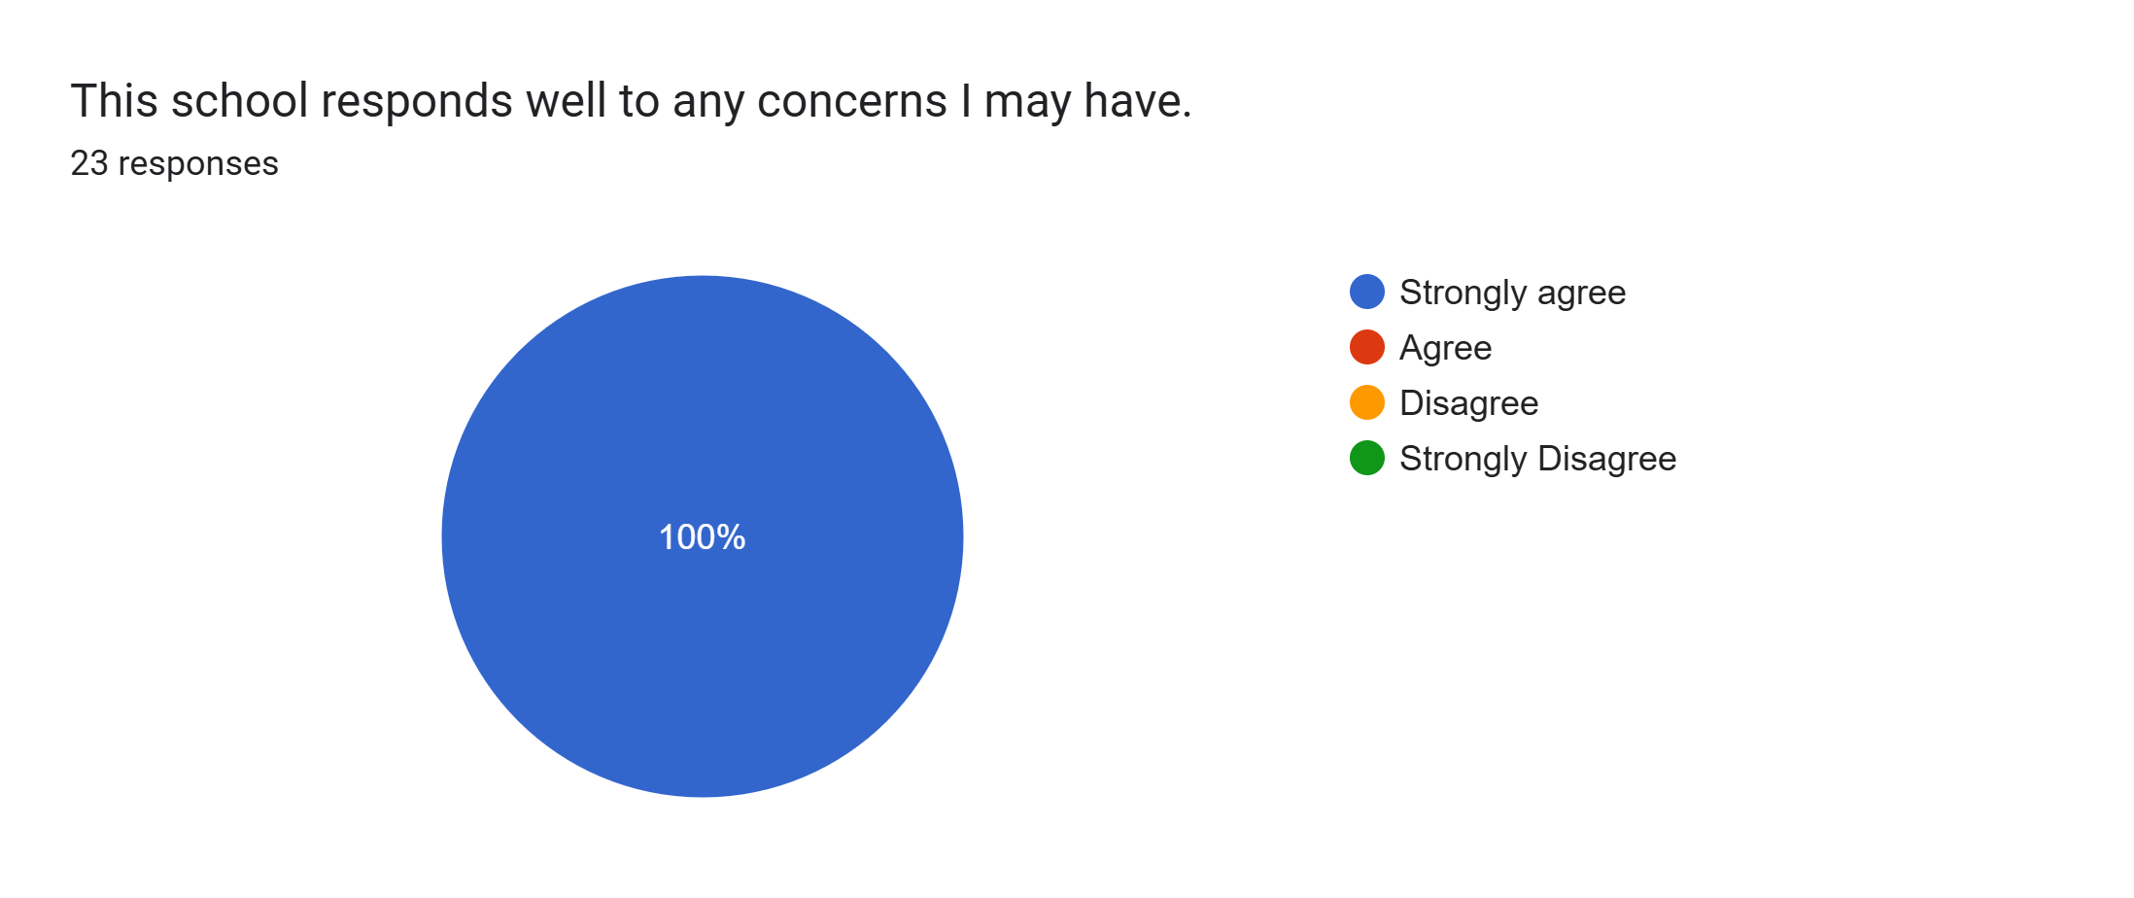
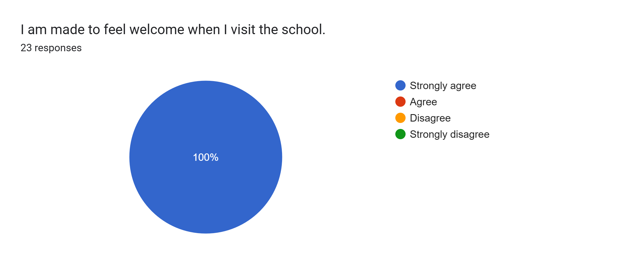
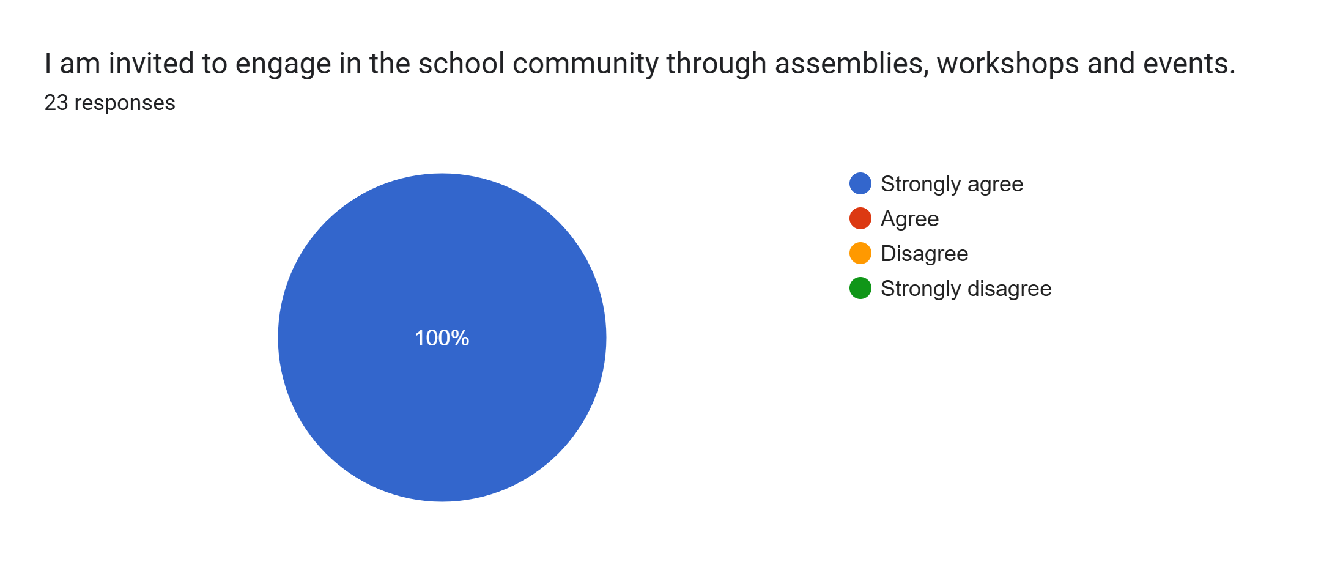
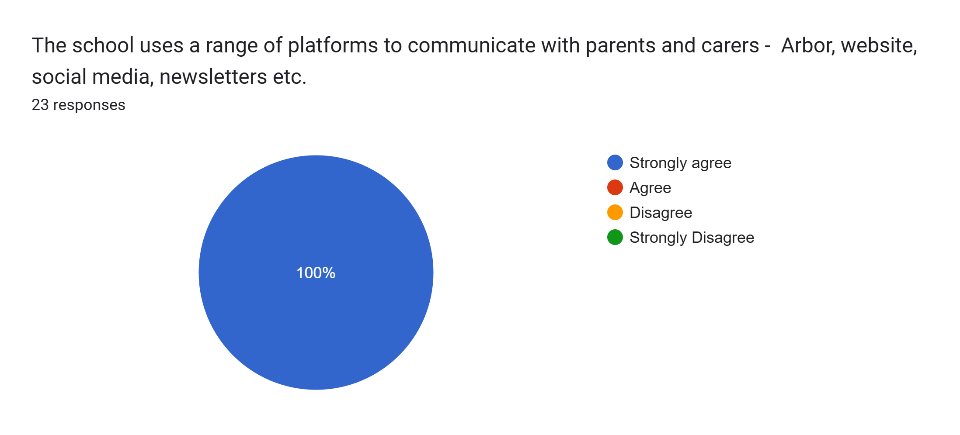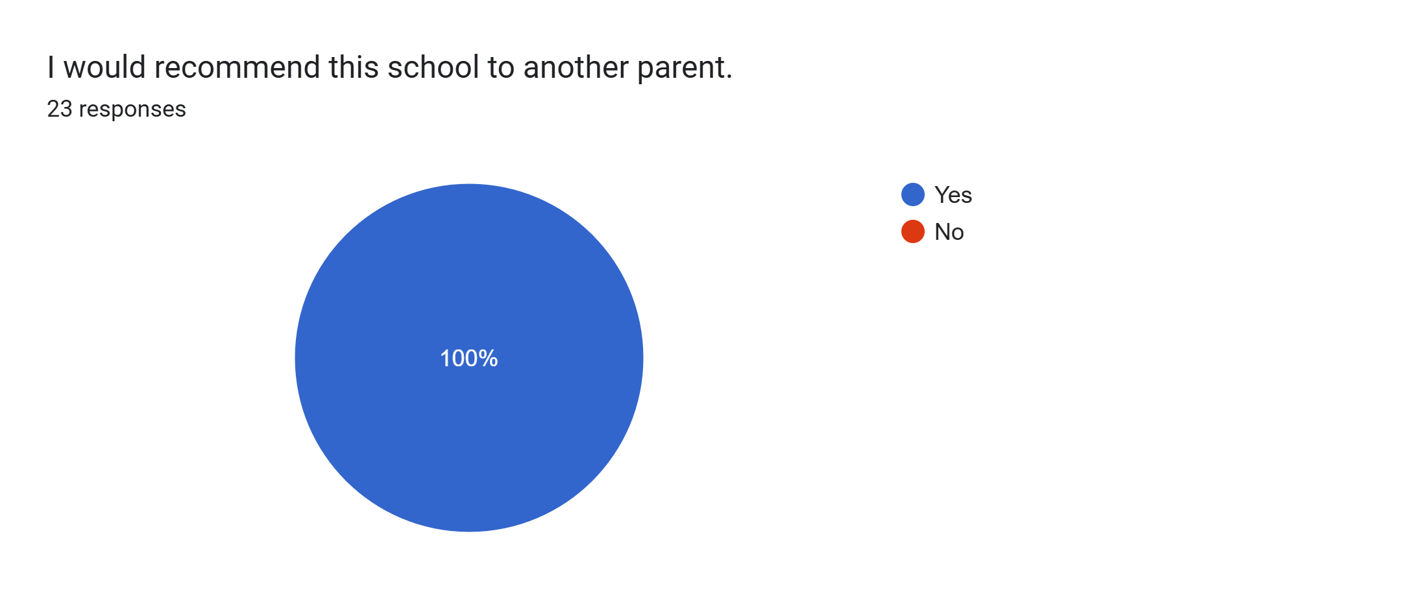

What other comments would you like to make to staff:
- Brilliant school and teacher.
- Amazing, thank you so much.
- Very good.
- Thank you for lovely feedback about my daughter. Much appreciated.
- Happy.
- Very pleased with my daughter’s progress.
- My daughter enjoys school and is happy and settled.
- Helpful.
- His school puts so much effort into the children and it really shows.
- This school is amazing and can’t be happier with all the staff do for us as a family and our daughter as their pupil. Thank you.
- Really good staff.
- Very good school. I’m happy for my son to be here.
- The staff do an amazing job.
- Thank you.
- Lovely school and staff.
- Really good school. Really happy with progress.
- Amazing teachers.
- My daughter loves school and enjoys all her lessons.
- Brilliant at teaching the triplets new things.

