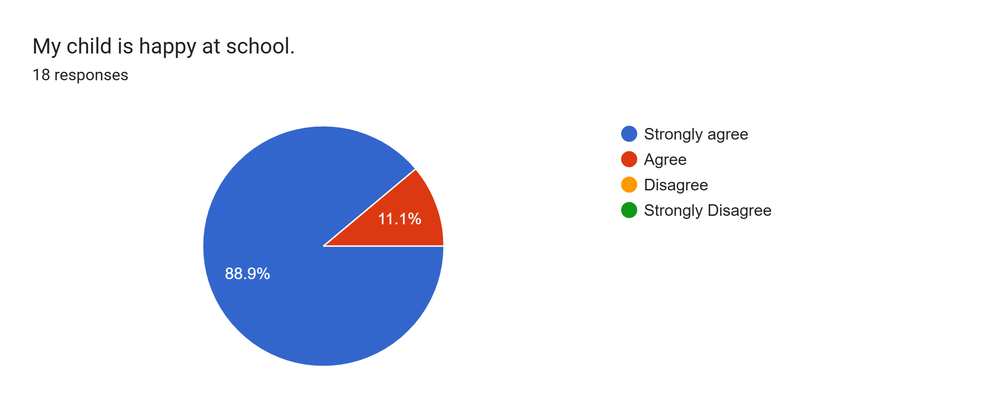
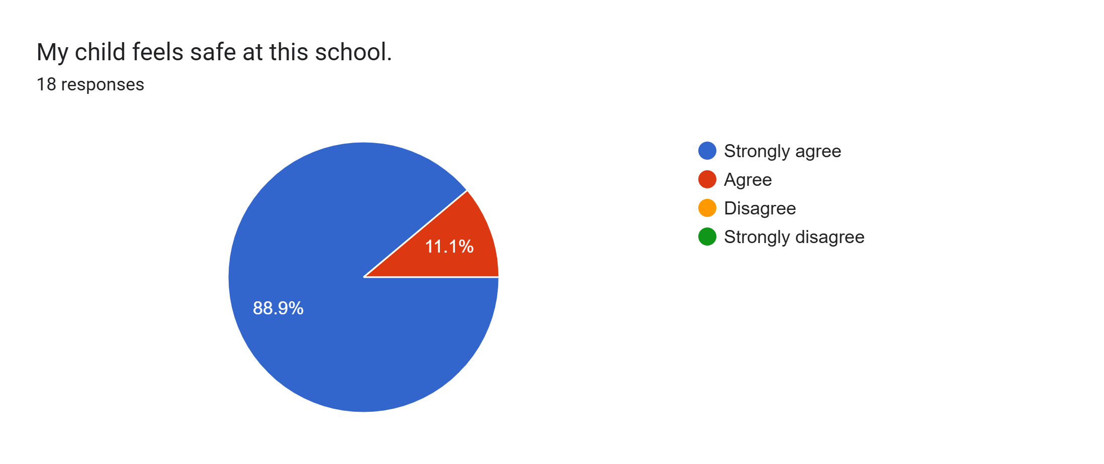
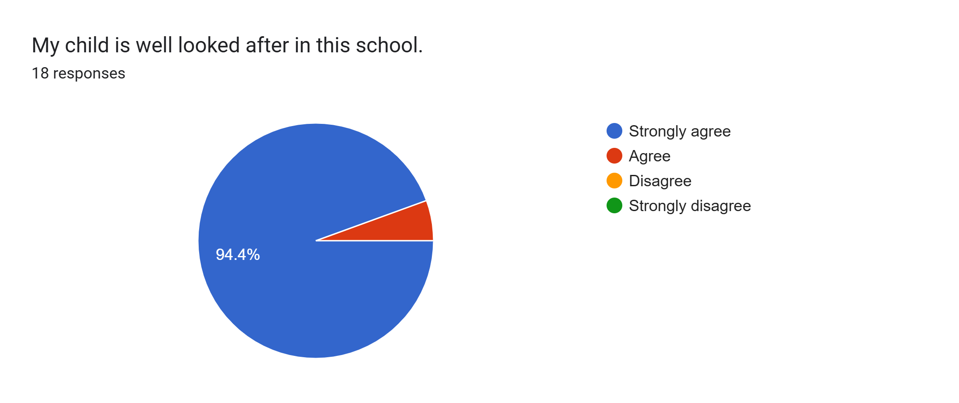
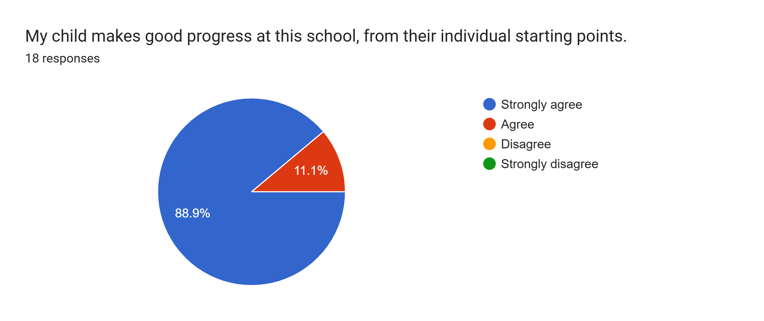
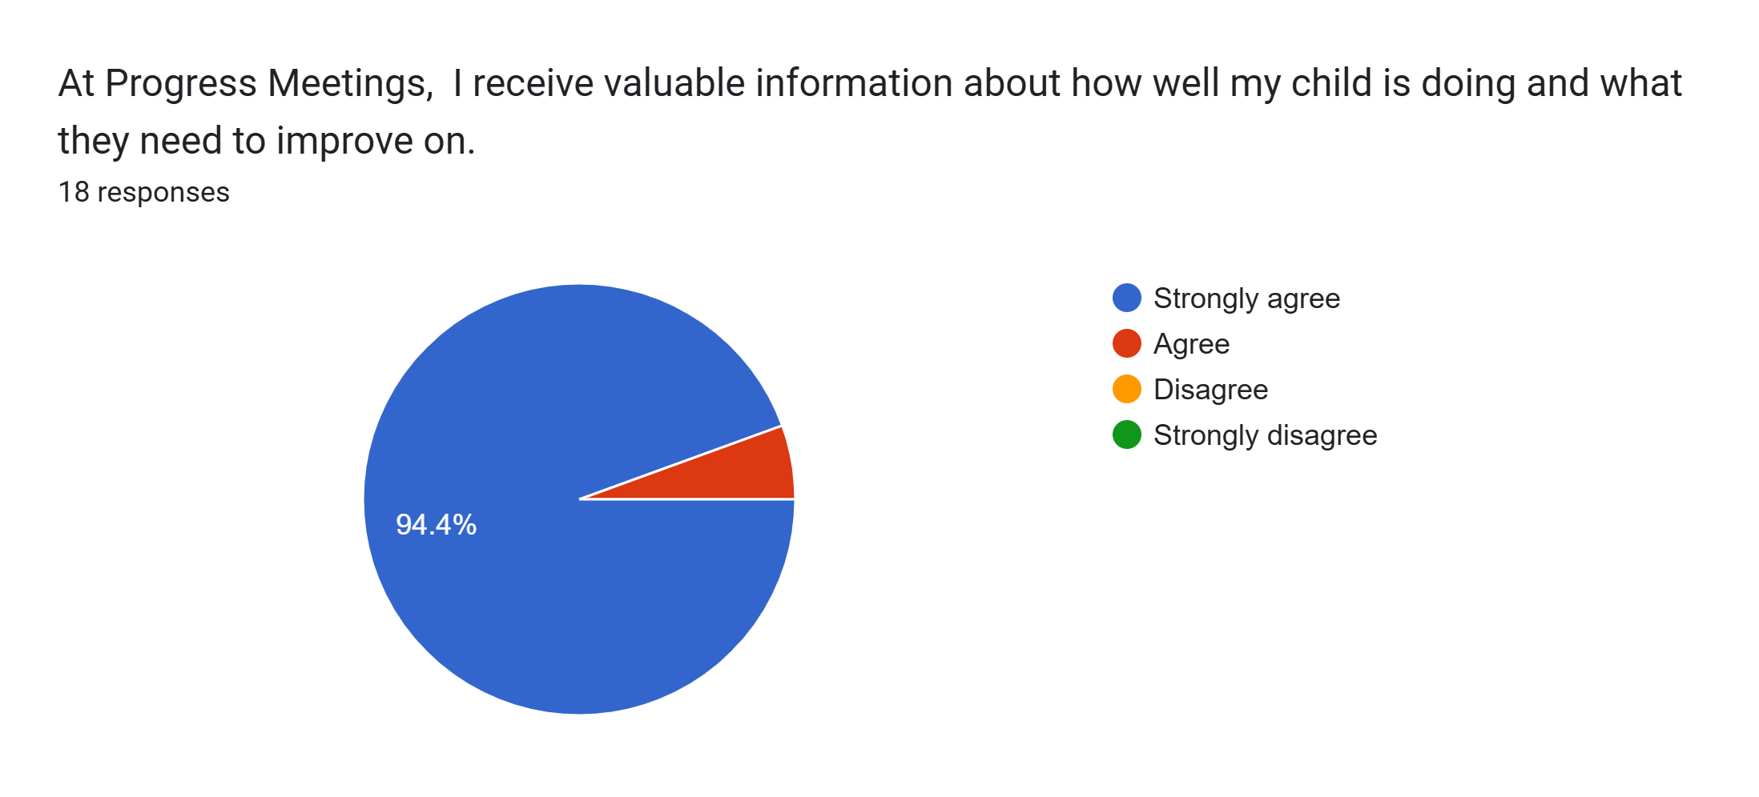
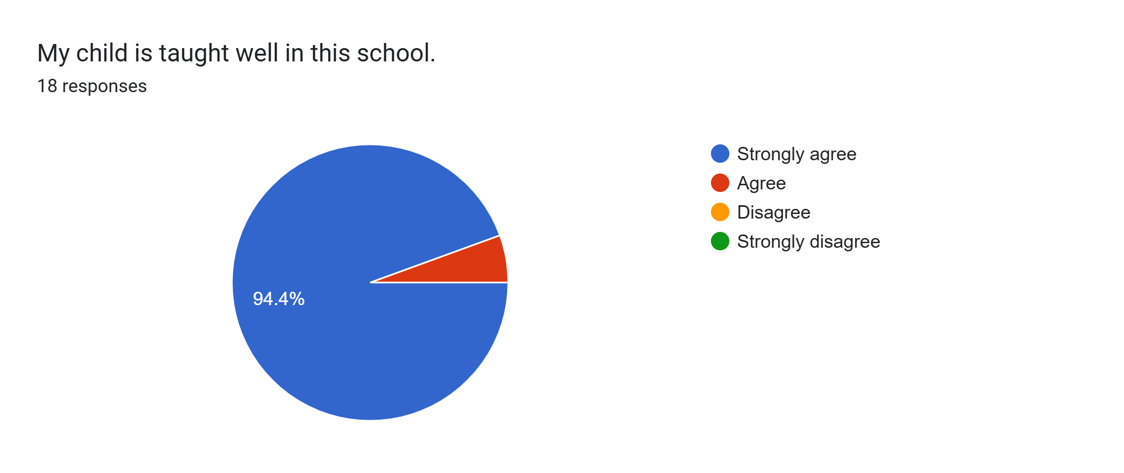
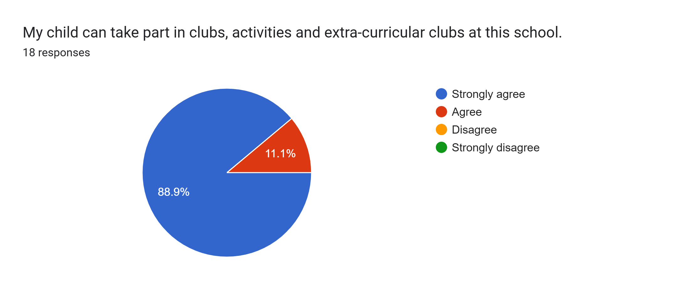
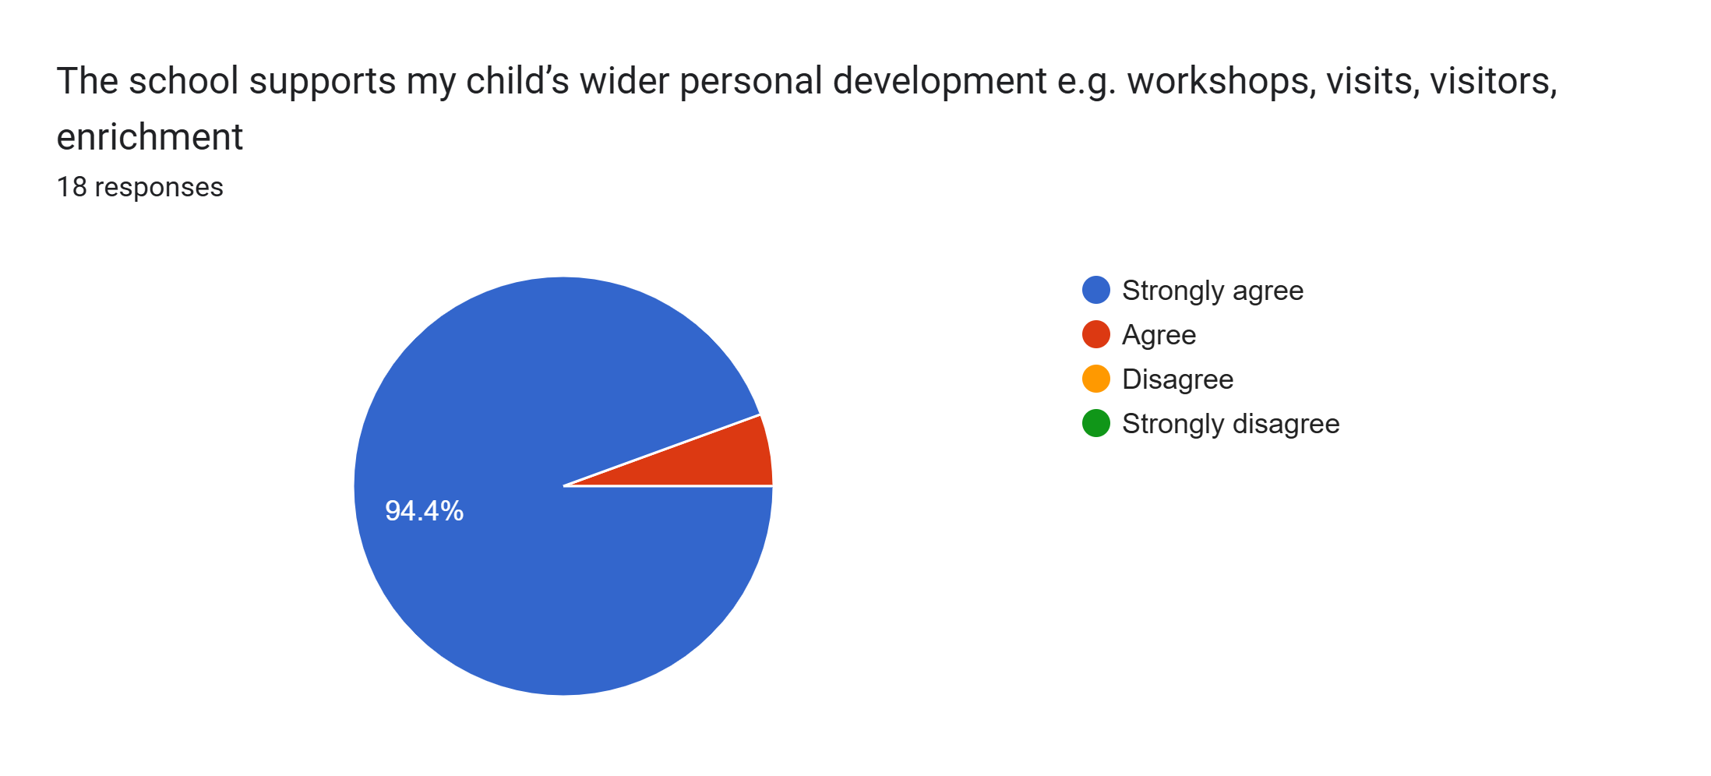
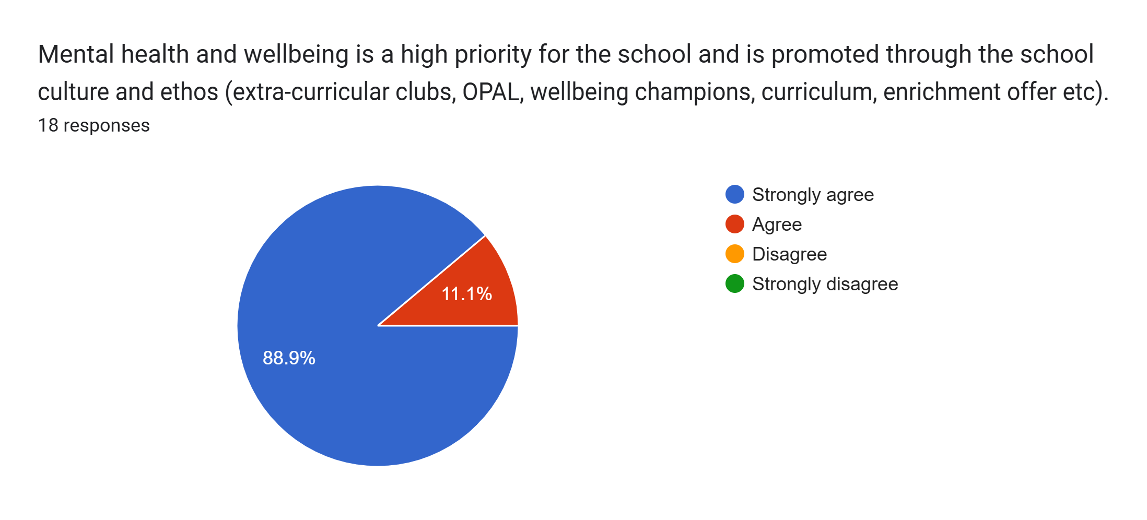
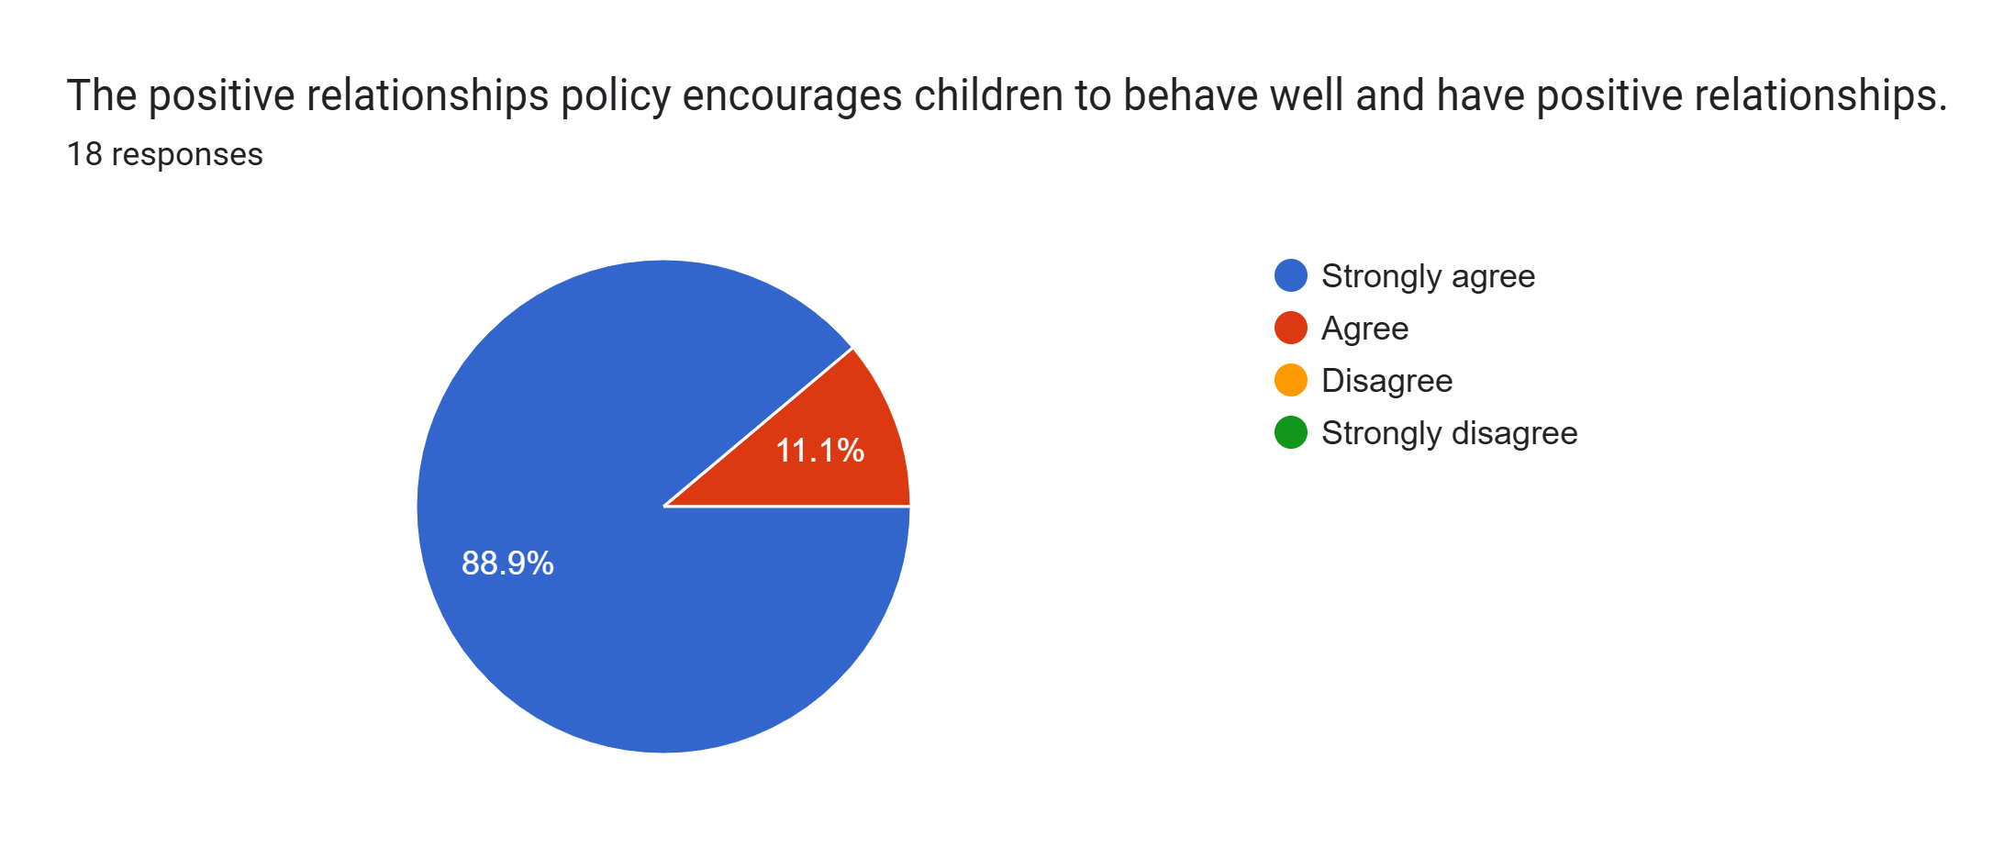
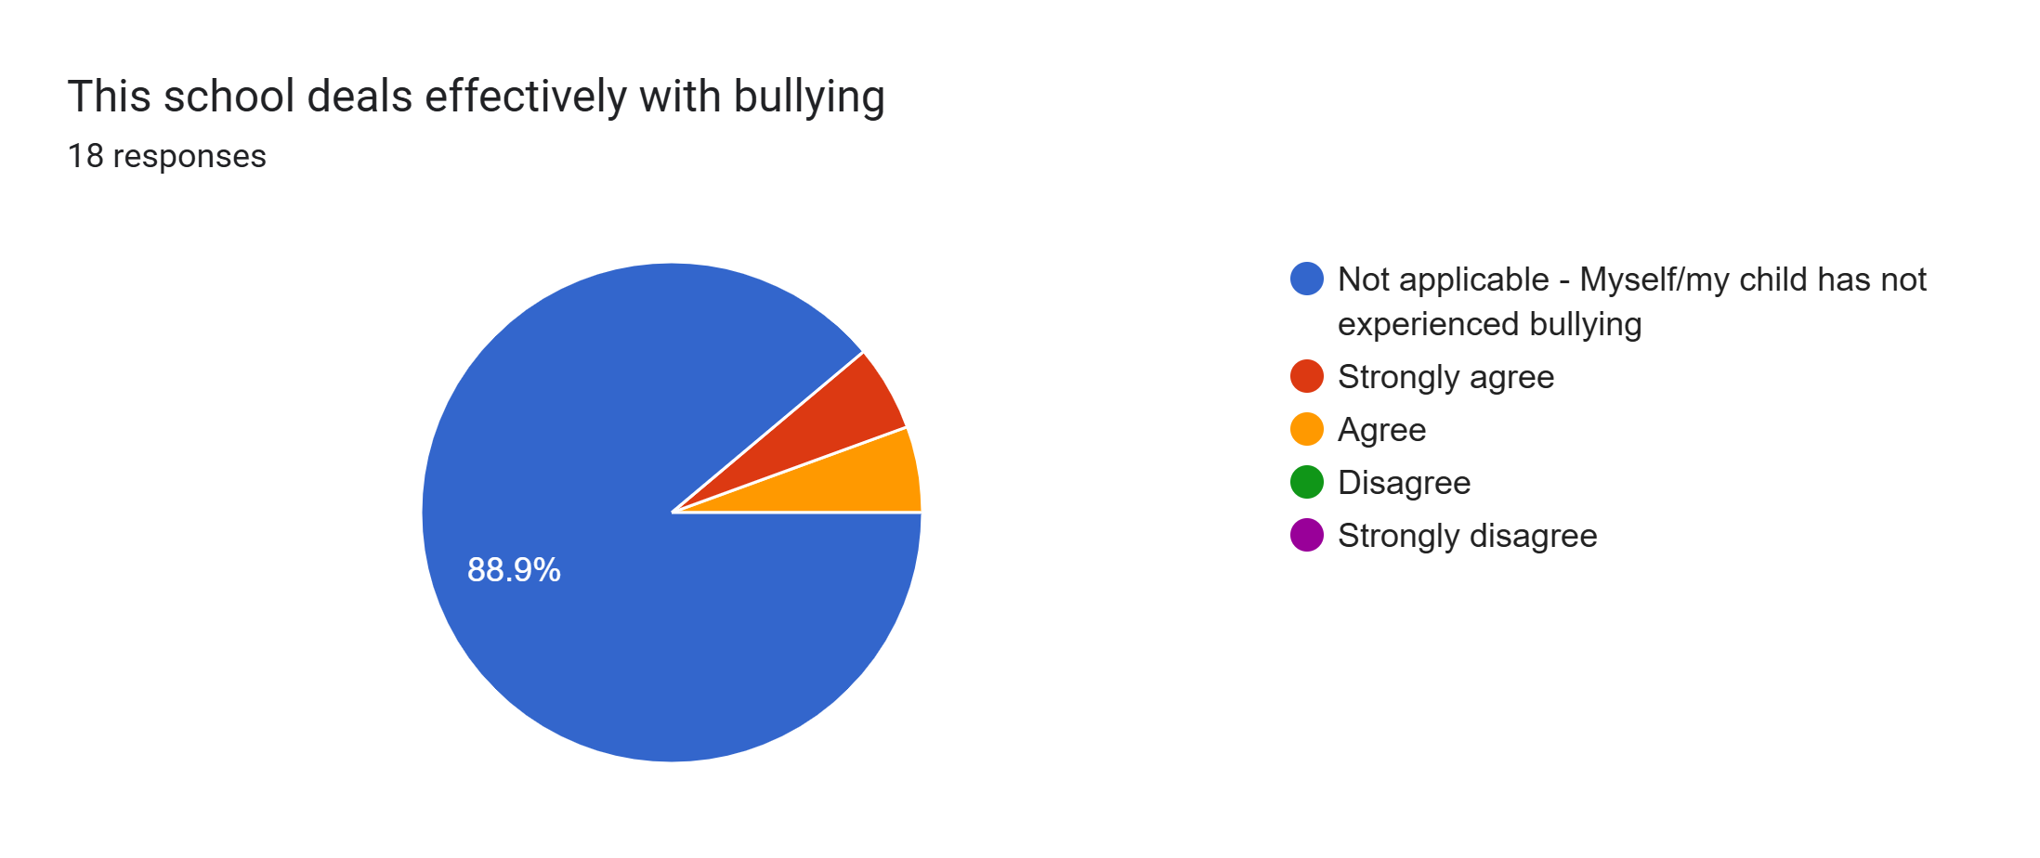
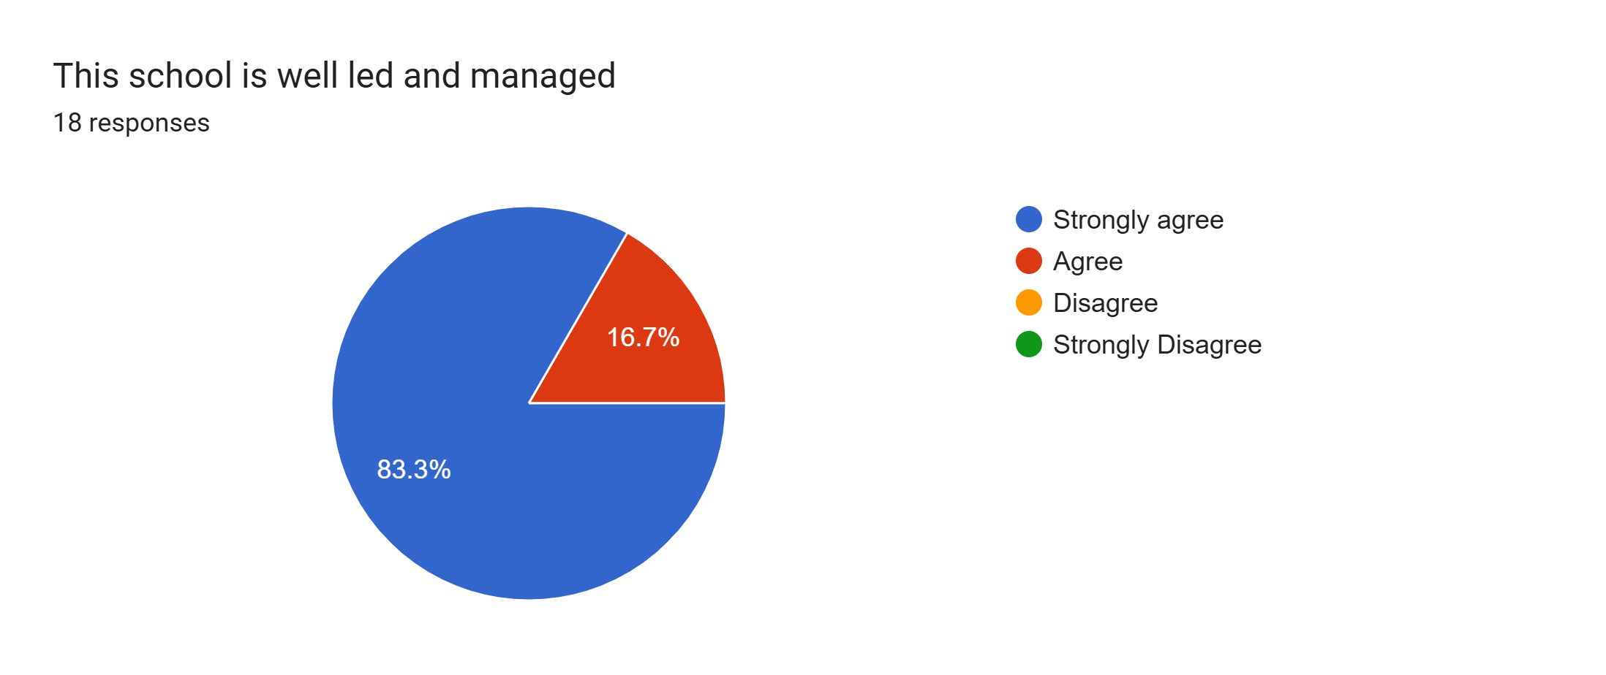
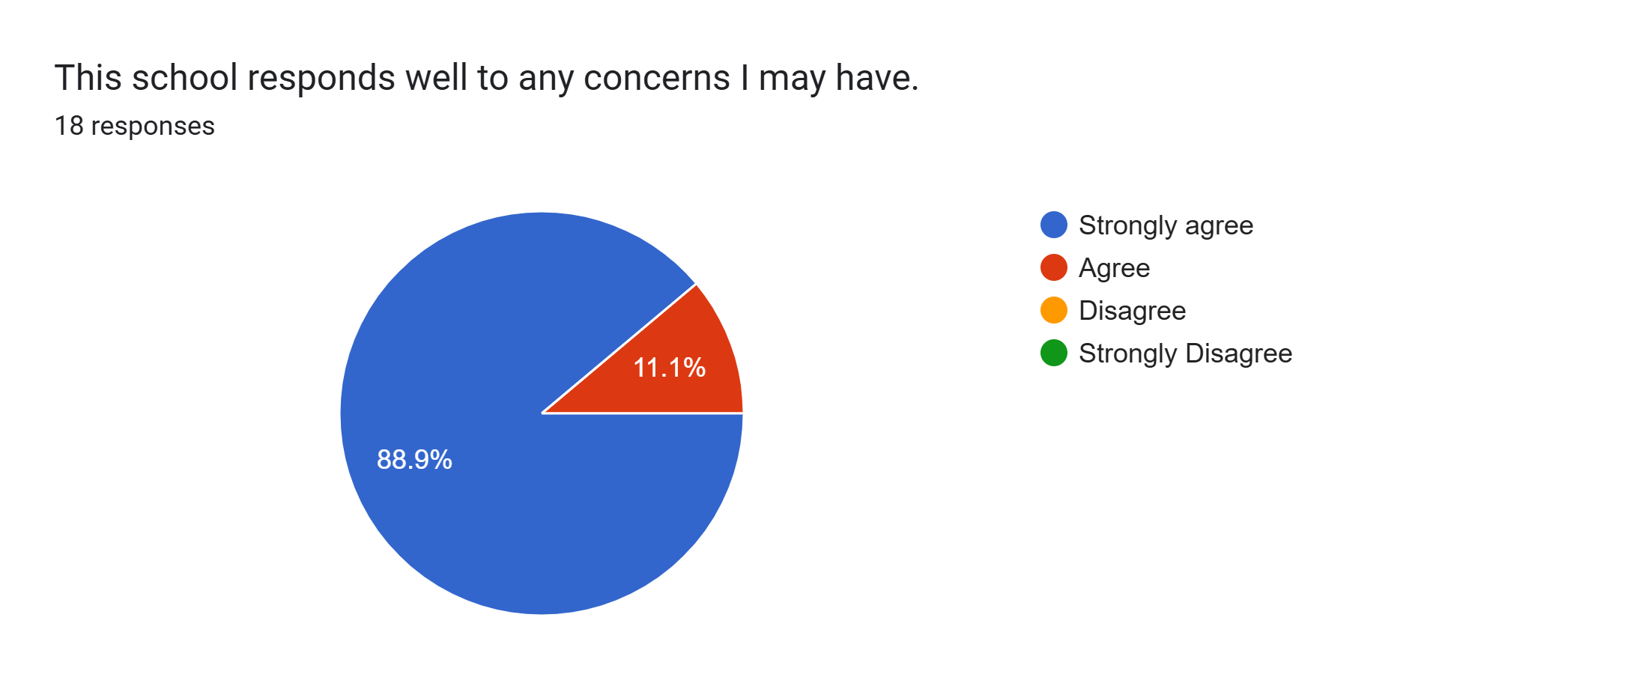
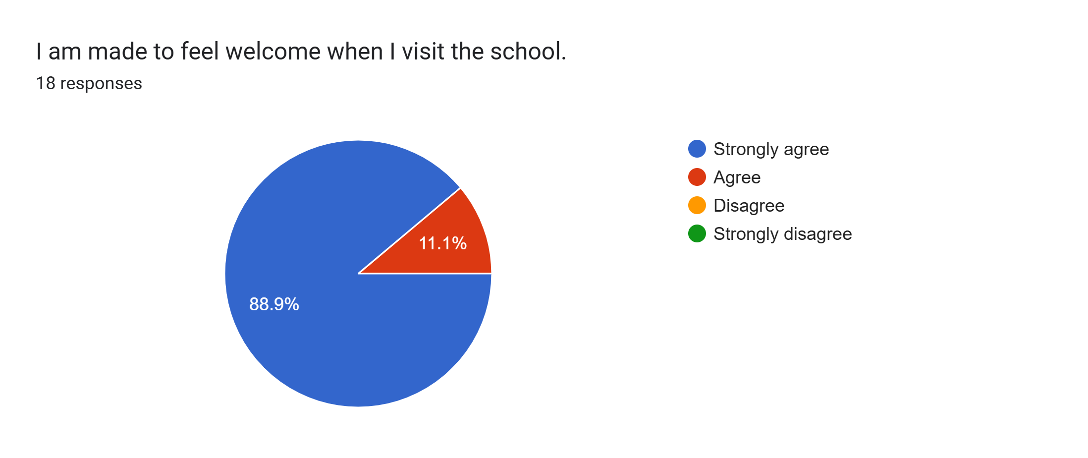
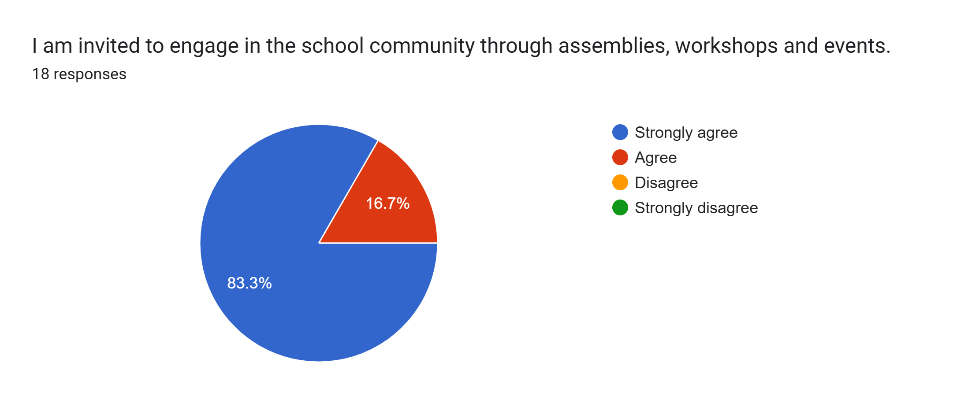
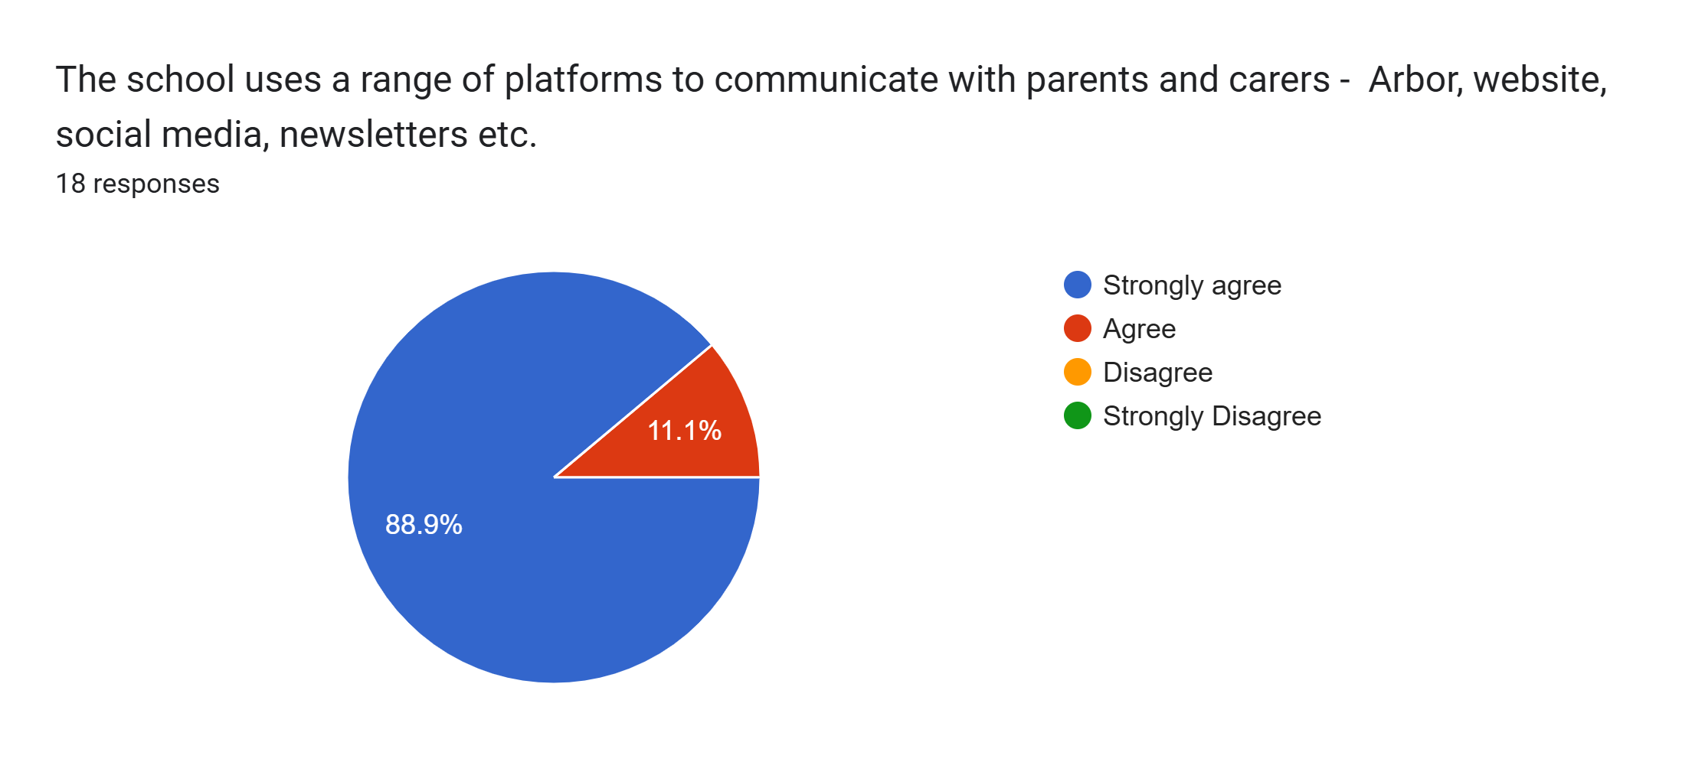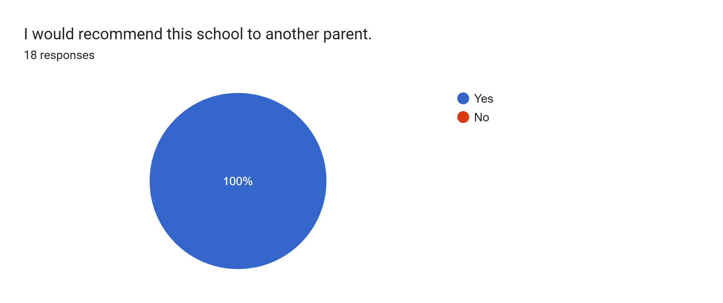

What other comments would you like to make to staff:
- Very happy with my son’s progress.
- Mr Swatman is a lovely teacher and my son is really happy in his class.
- Amazing parent’s evening. Thank you.
- Amazing.
- Great school. My son loves it here and is happy.
- Thank you for providing a safe and nurturing environment.
- Mr Swatman is such an amazing teacher and my child seeks great comfort when she is taught by him.
- My son seems very happy at school and with his teachers.
- Excellent staff.
- My daughter absolutely loves coming to school and is thriving so thank you very much.
- Thank you for all your help and support in making our son’s school experience enjoyable.
- Always happy with everything at Roby Park.
- My son is coming on so well.
- Very pleased with my daughter’s progress.
- All staff are great and make us feel welcome.
- Good school.
- All staff are friendly and welcoming.

