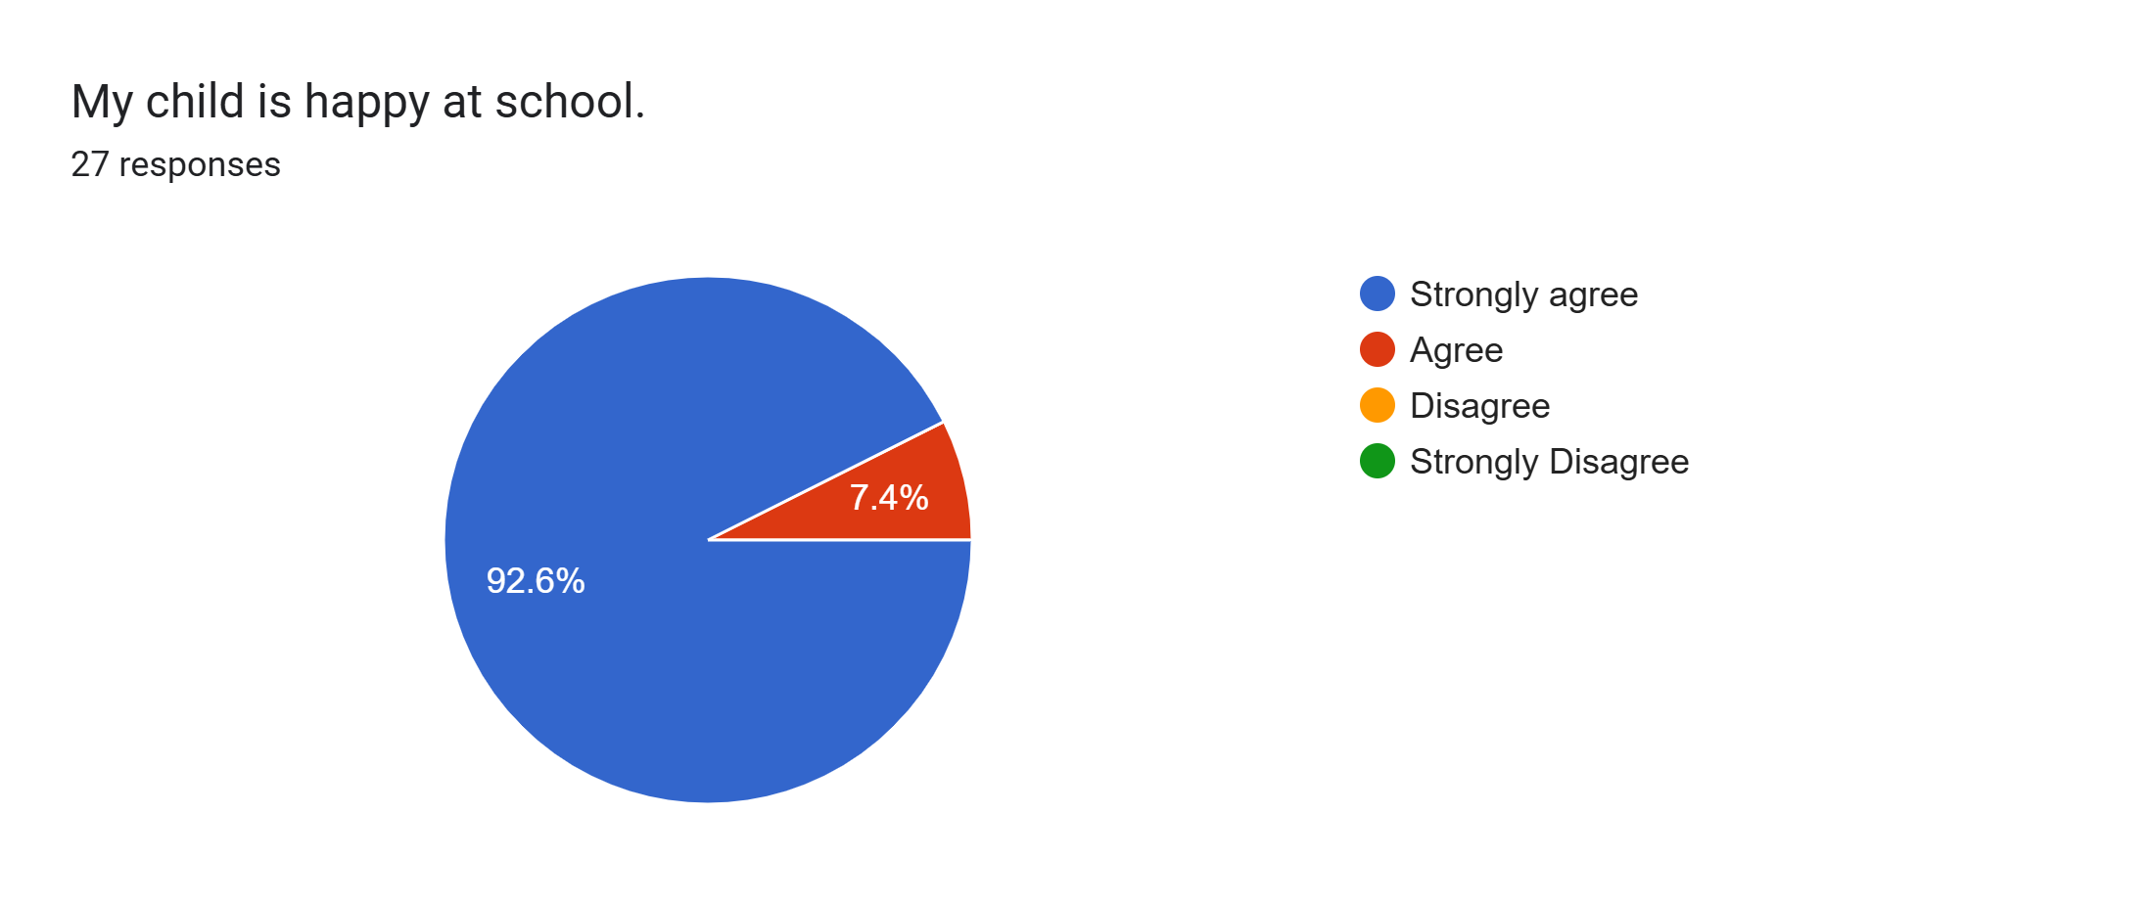
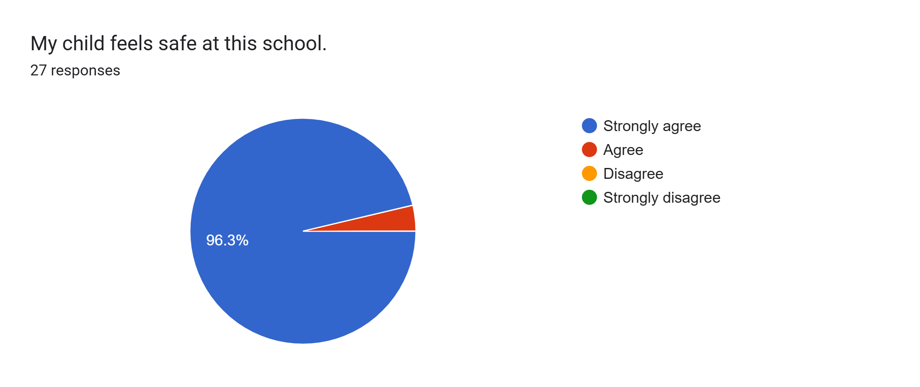
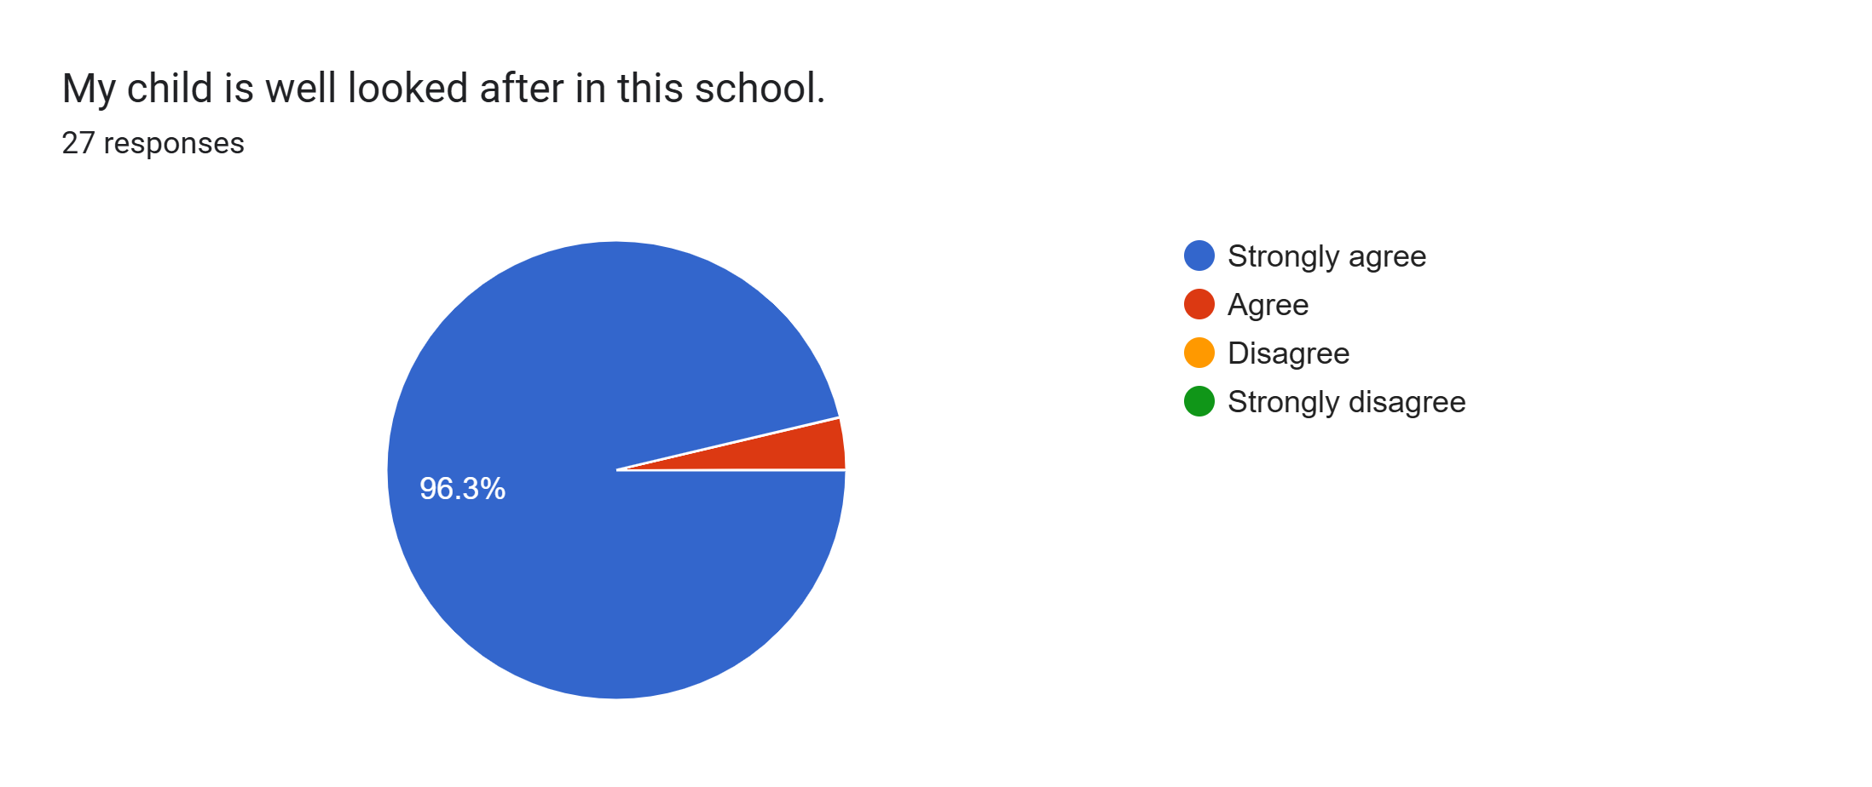
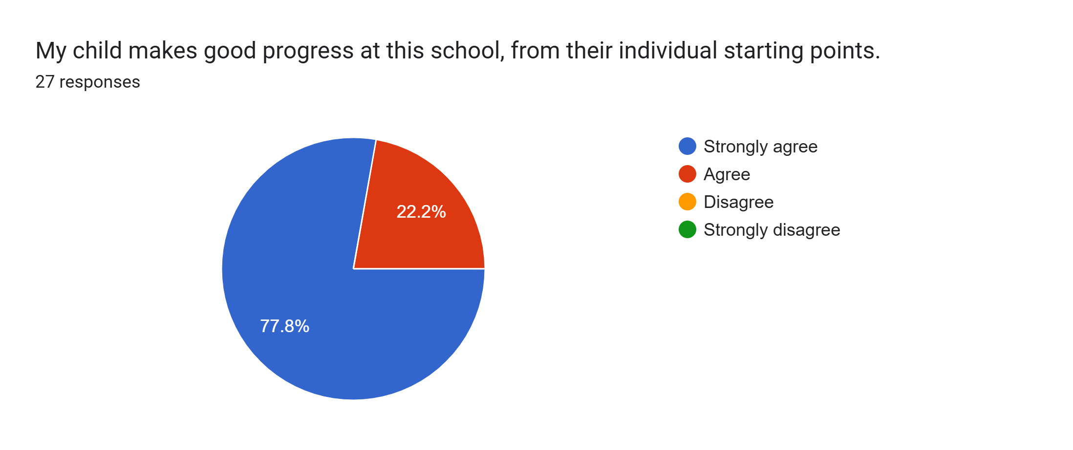
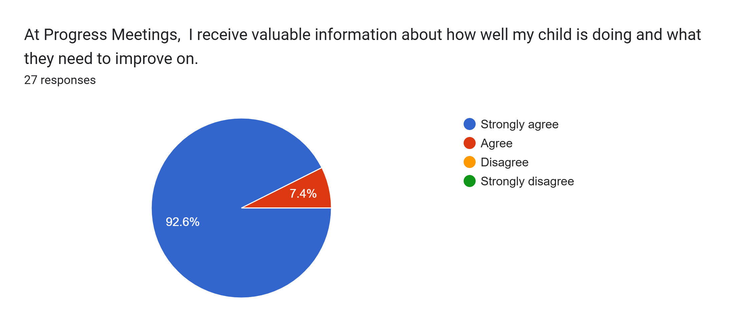
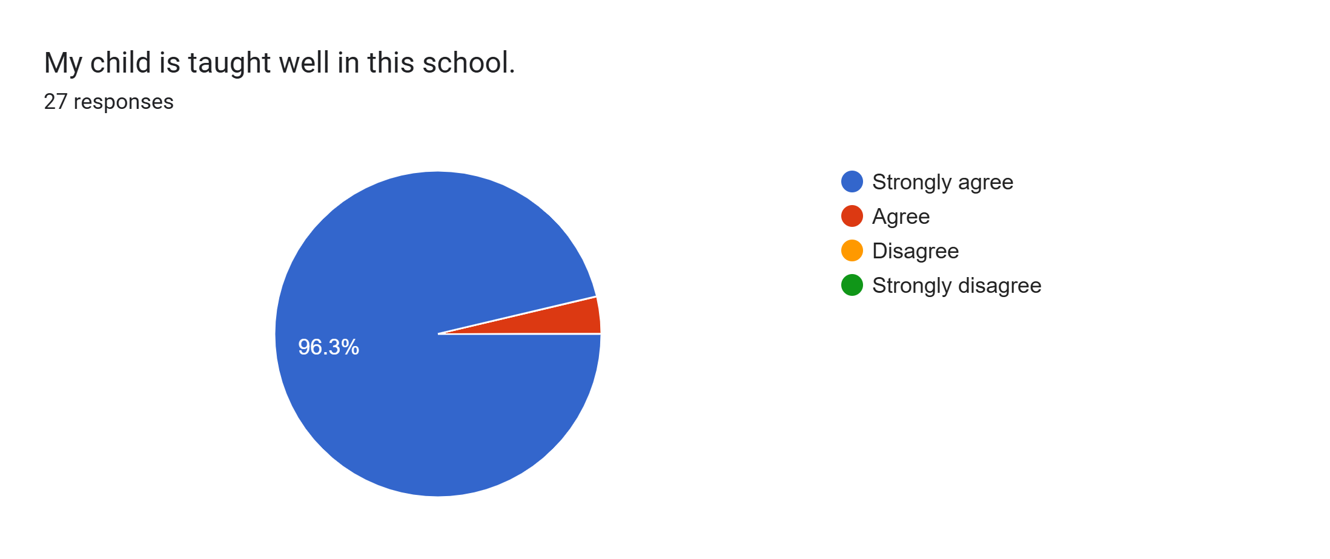
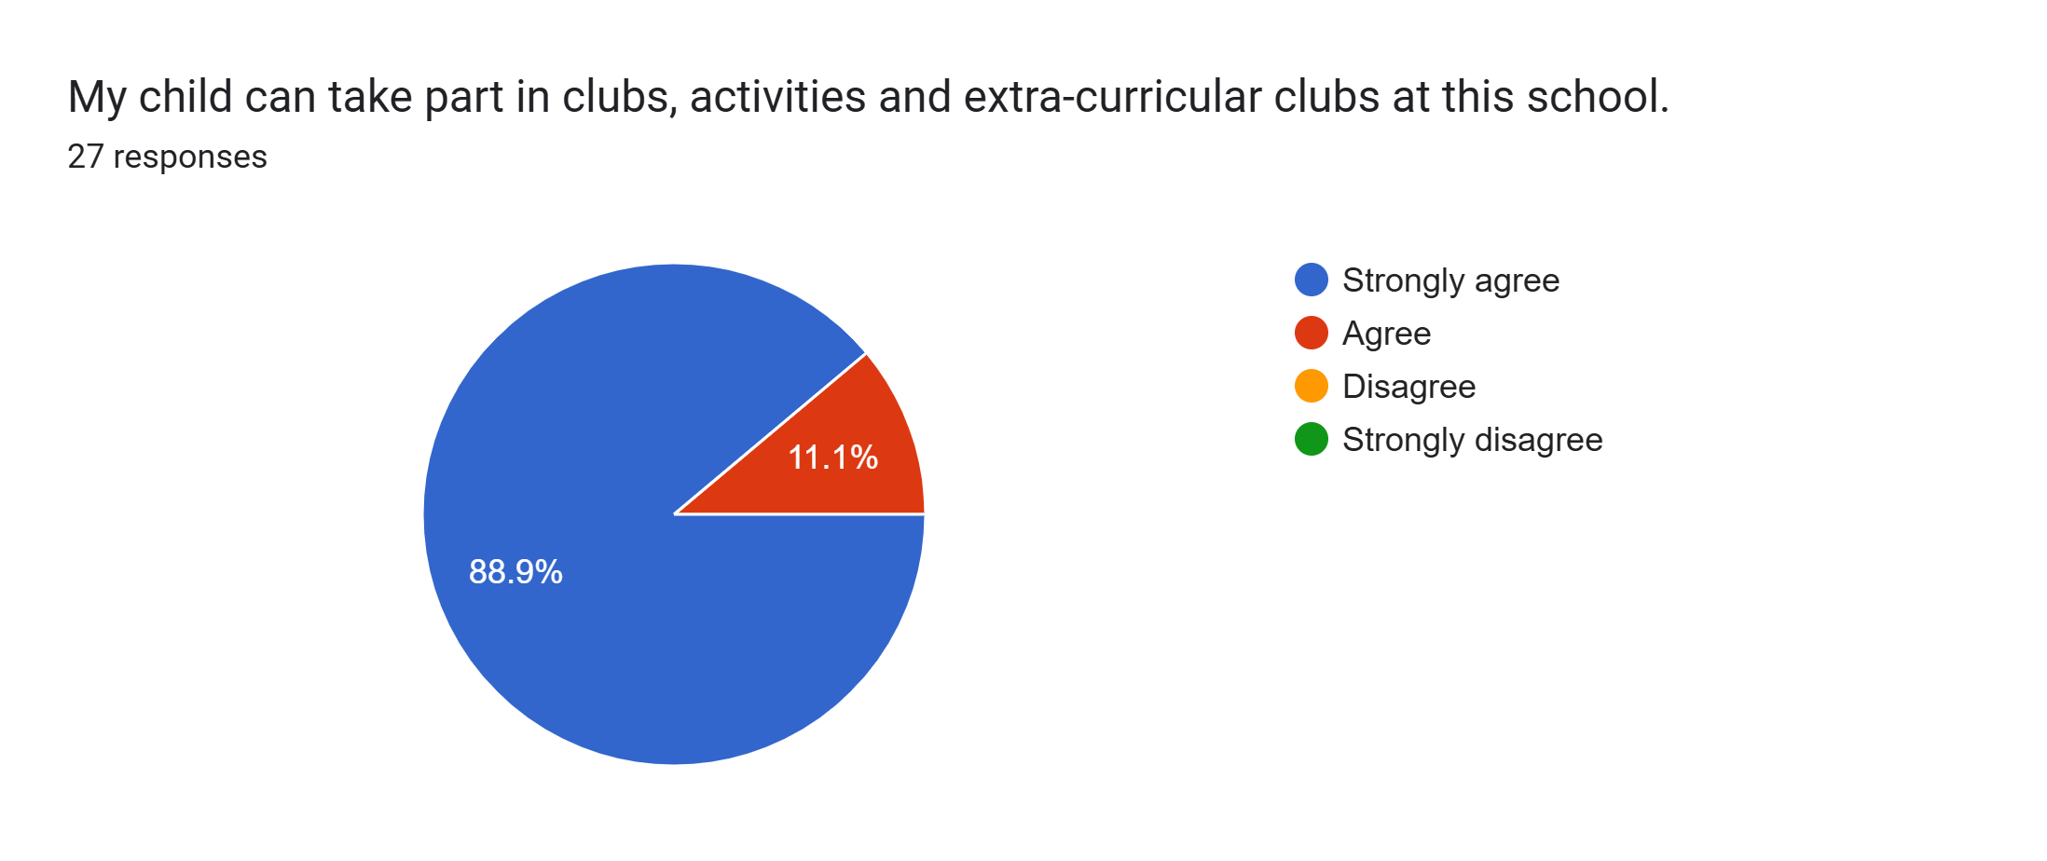
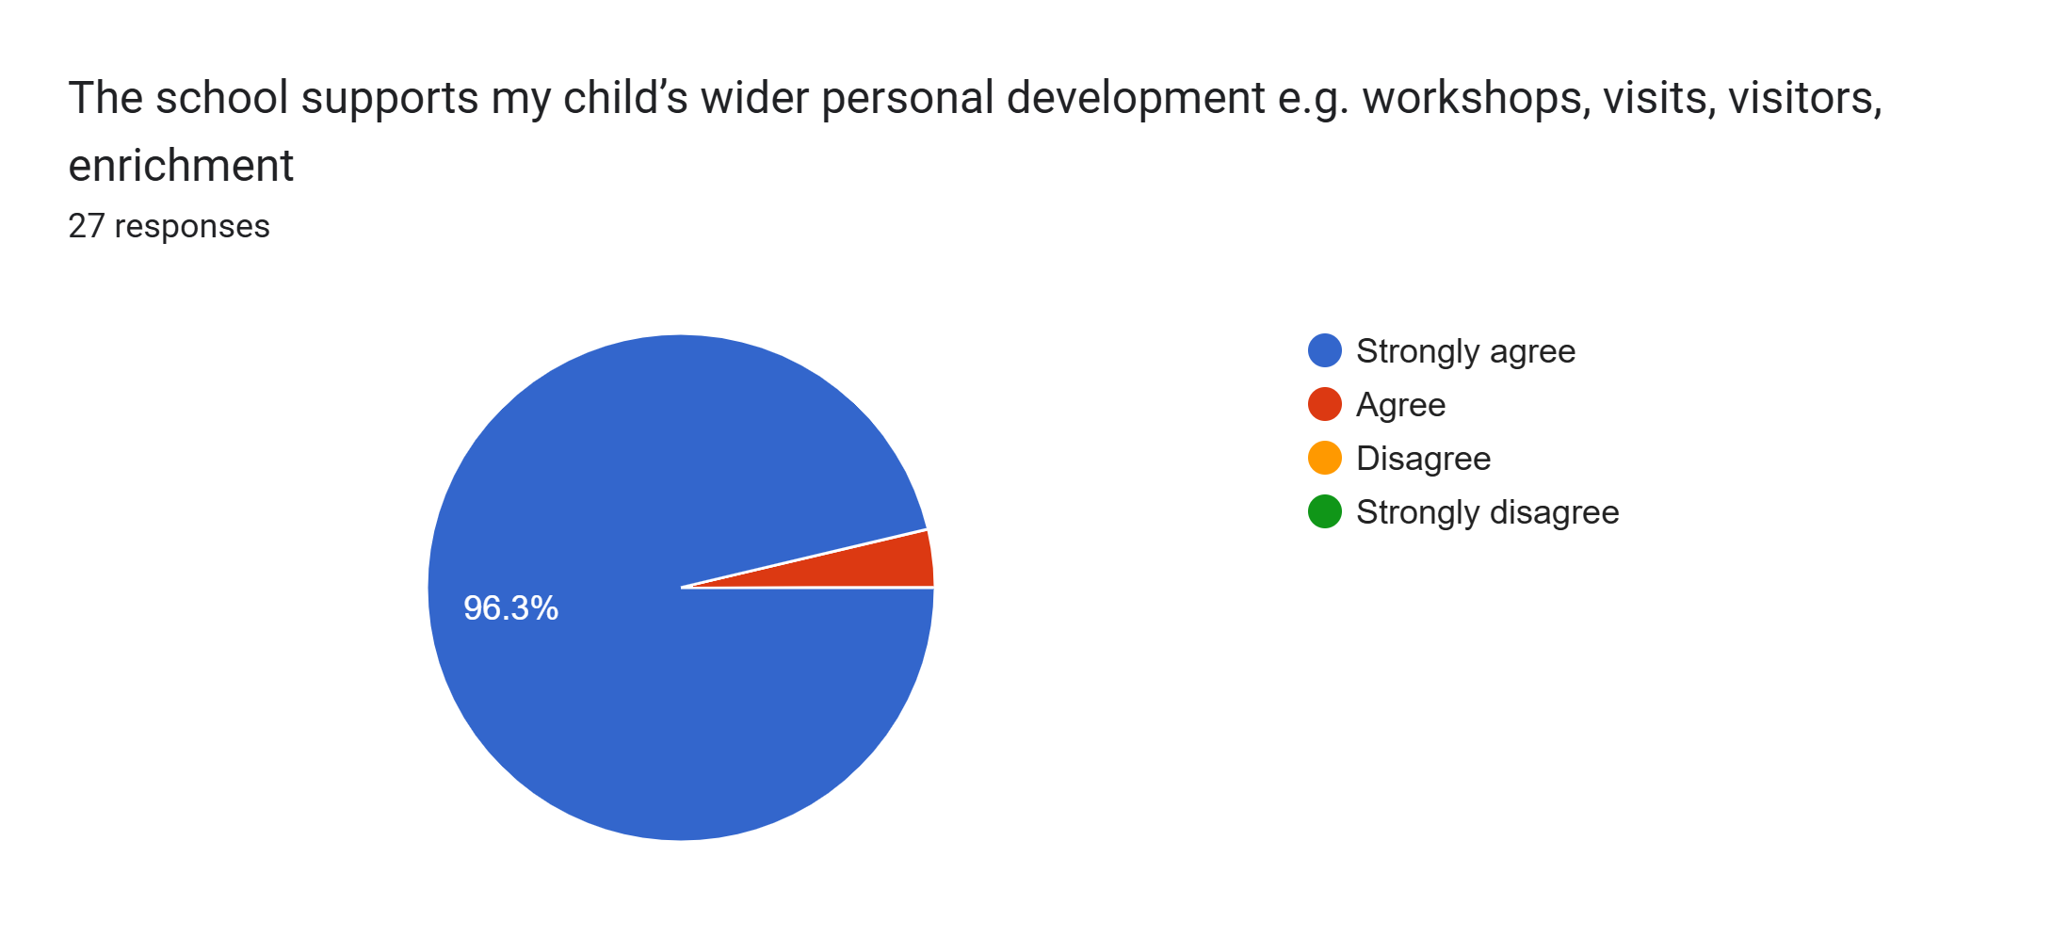
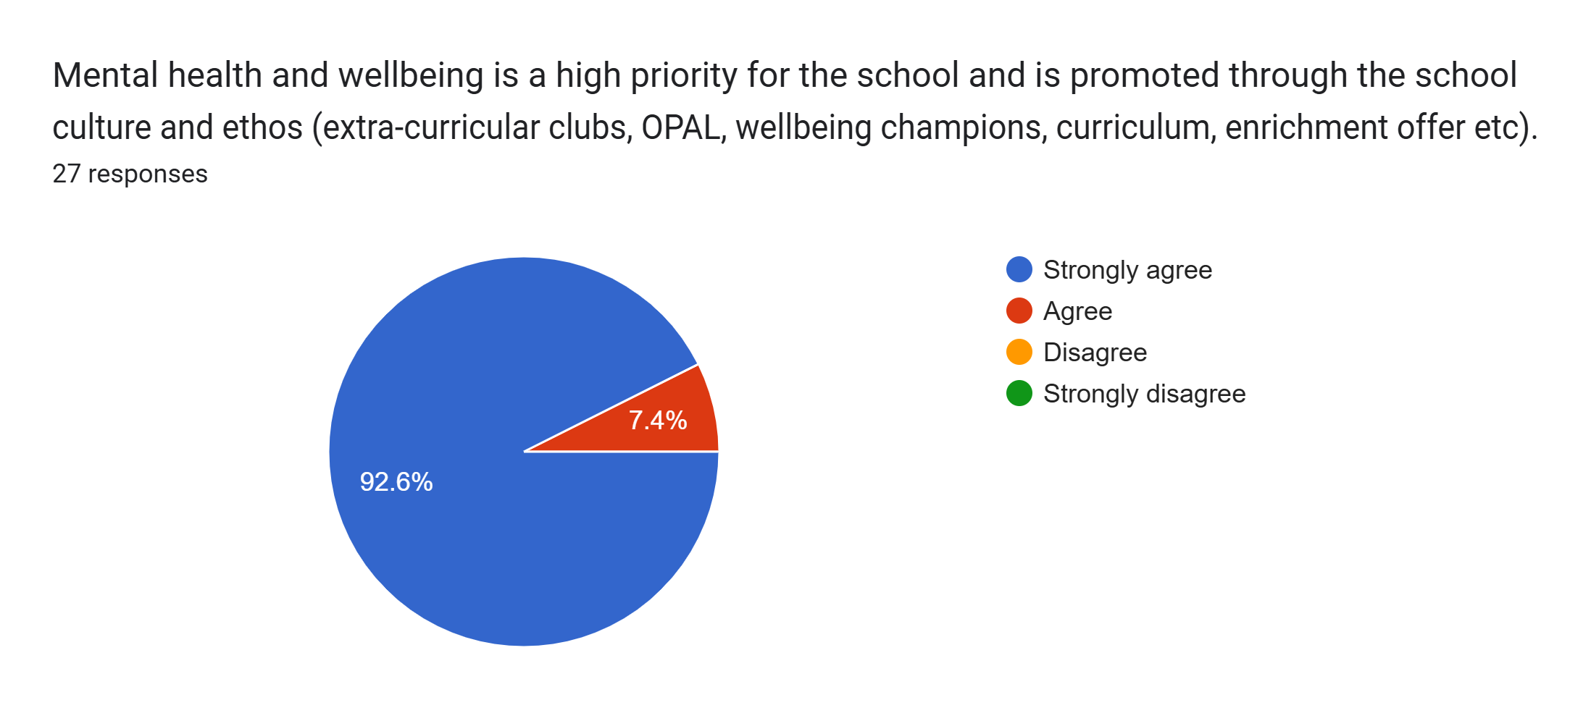
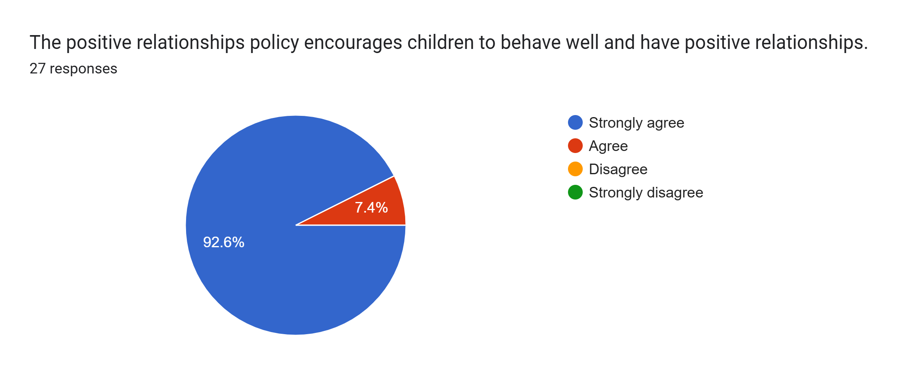
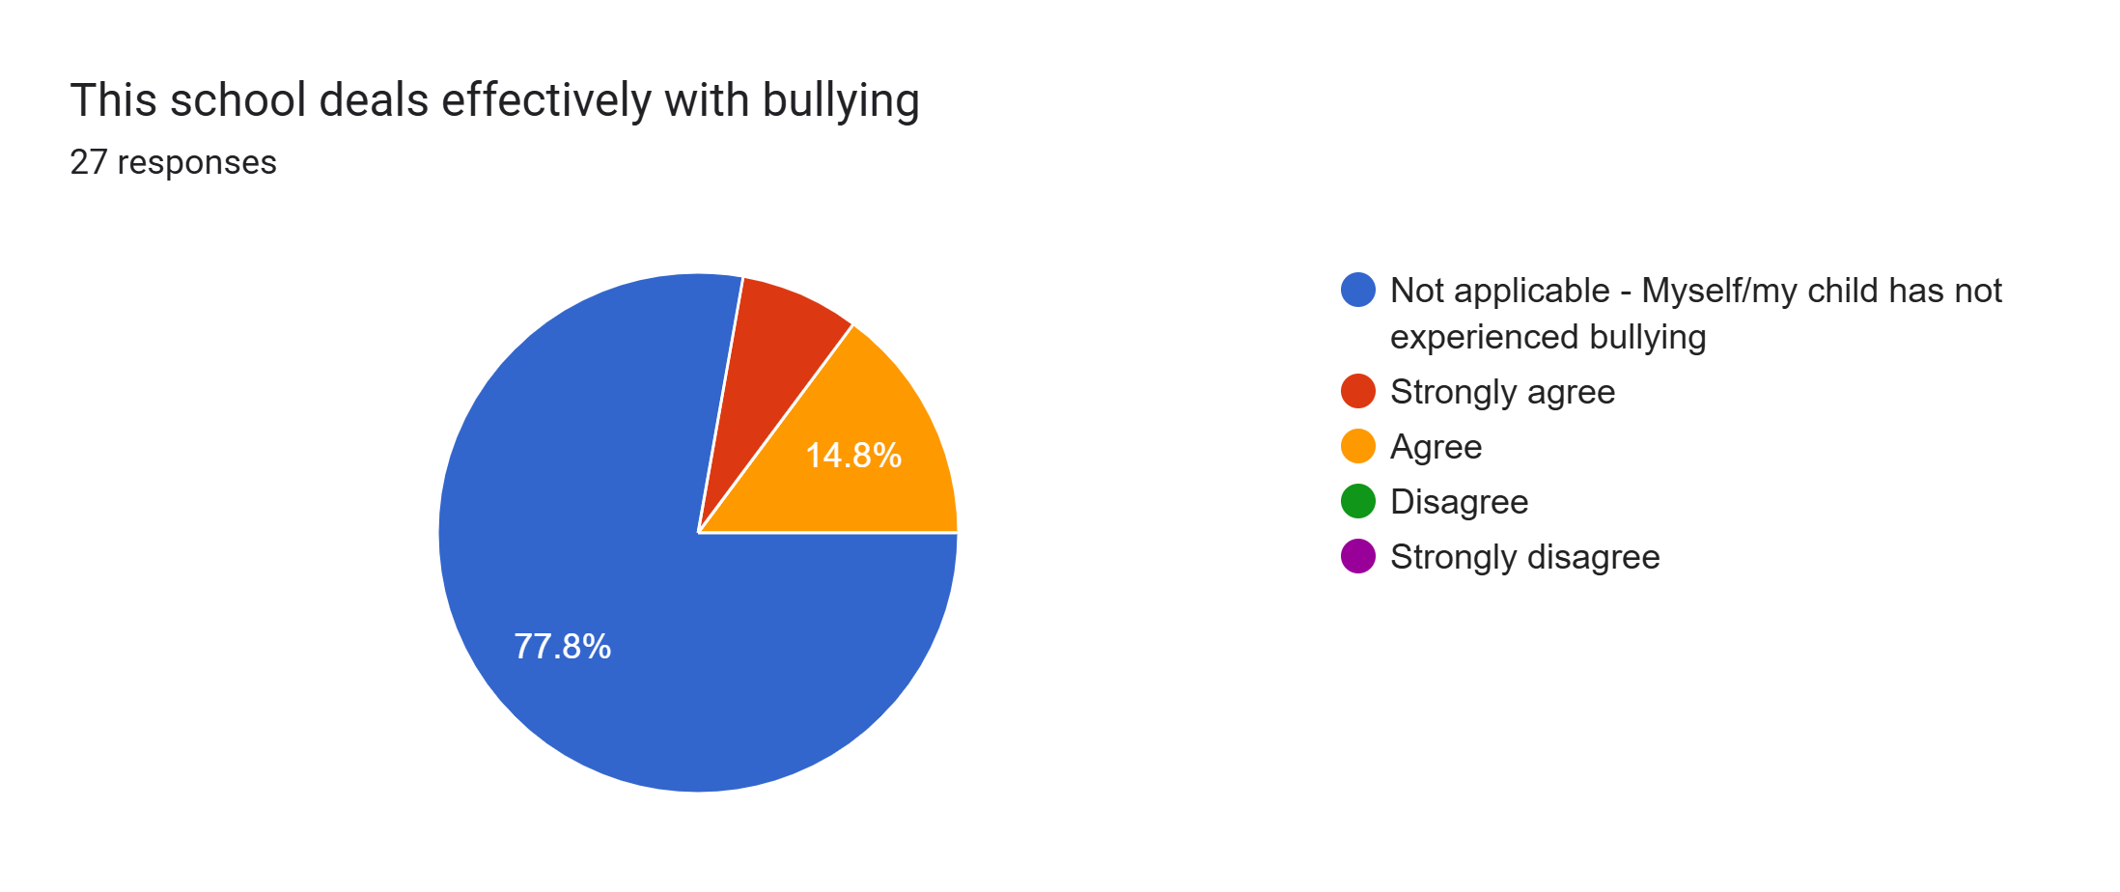
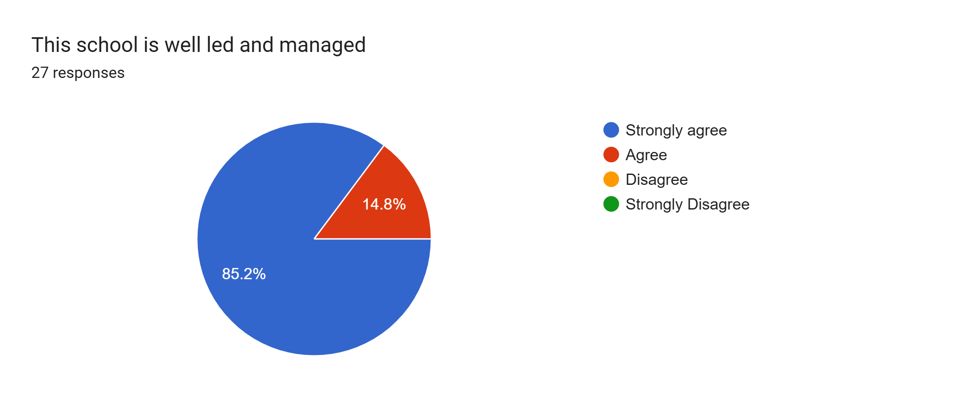
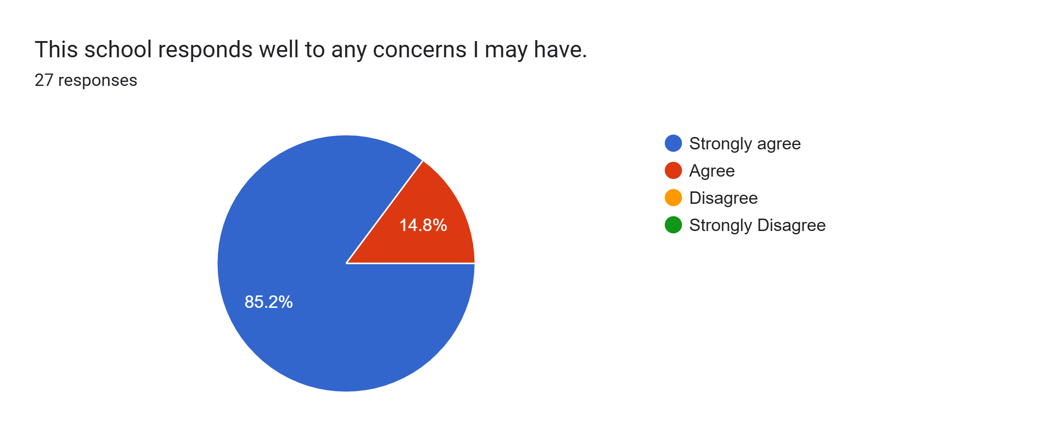
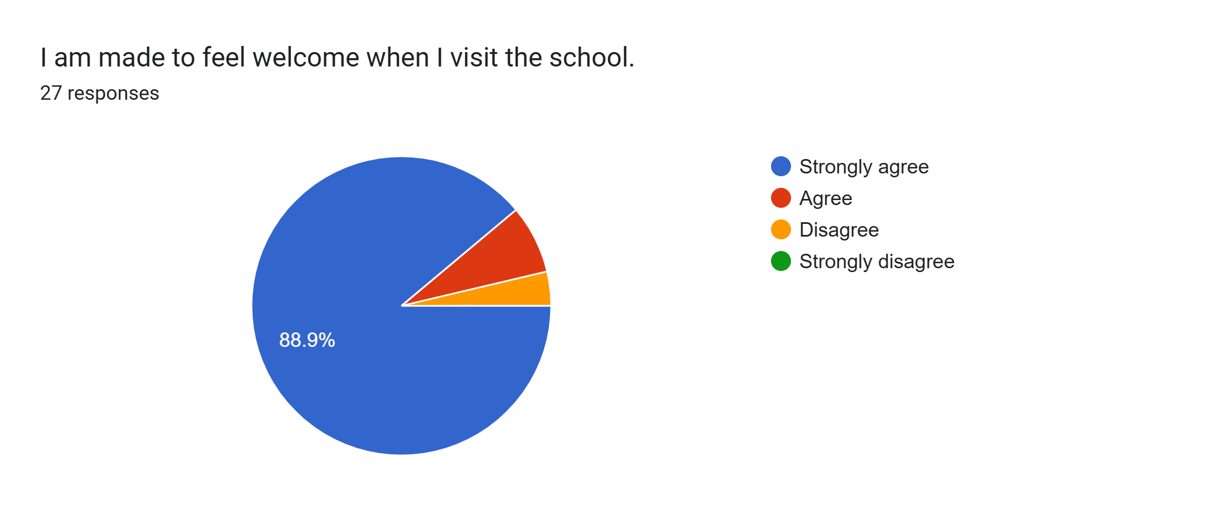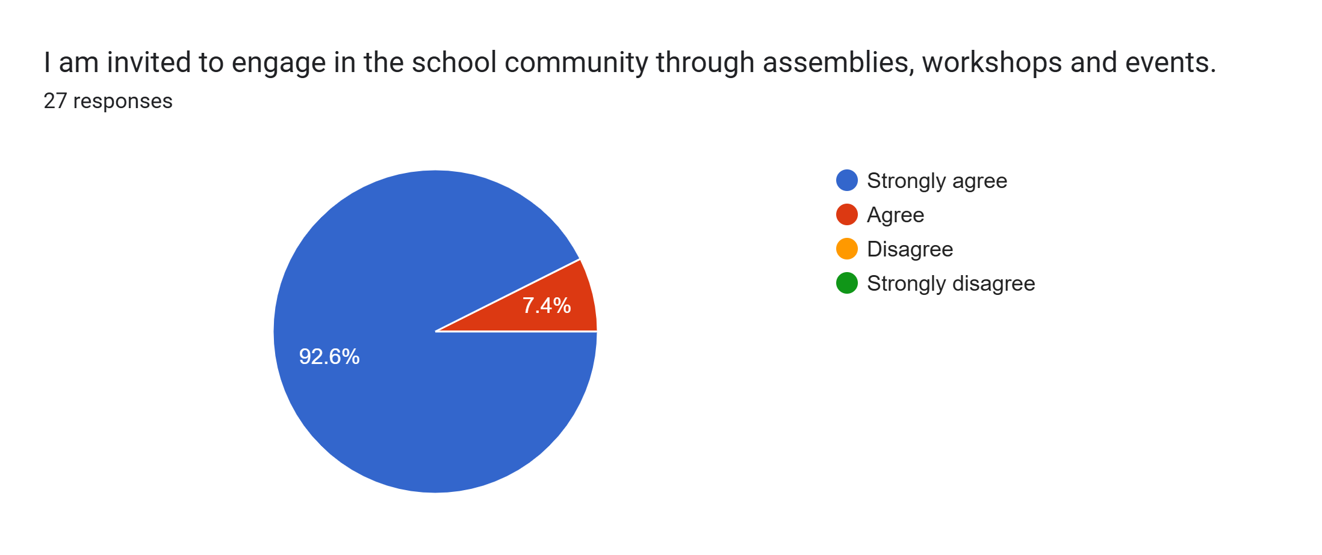
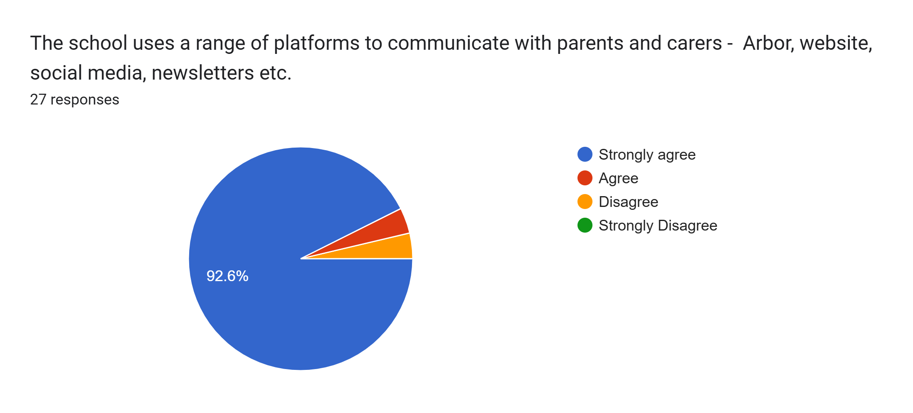
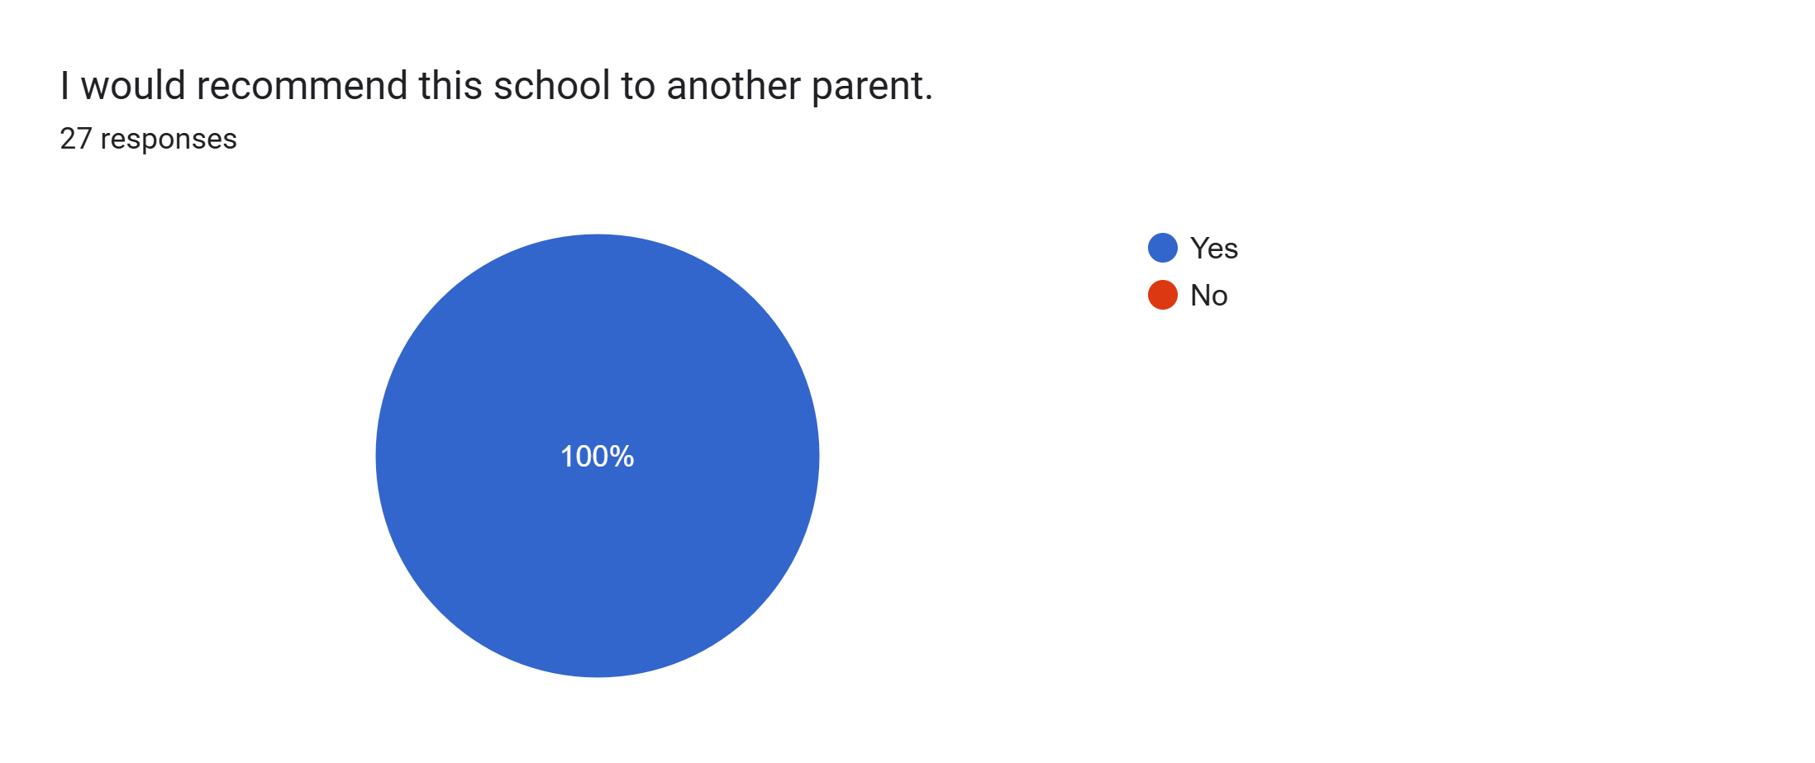

What other comments would you like to make to staff:
- Thank you
- We are very happy with the school.
- Our daughter loves coming to school. Really happy with the support she is getting with her learning and progress.
- My child is now feeling happy about coming back into school and is starting to enjoy school again. Could not fault the school, she is doing really well.
- We are very happy with our daughter’s progress.
- Amazing.
- My son is very happy attending school. He is very settled at Roby Park and loves the staff. I’m very happy with my son’s progress during this term and can’t wait to see how much he will improve next term.
- Thank you for everything all the staff do to make learning more adaptable to levels needed and making school enjoyable and learning fun.
- Amazing staff.
- So happy with my son’s progress and his support x
- Thank you. My daughter is making massive progress each parent’s evening.
- Wonderful school and staff with children making really good progress.
- Happy.
- Great.
- My daughter is happy at school.
- Keep,up the good work.
- Amazing.
- Absolutely amazing.
- Amazing school.
- Great school.
- My son loves coming to school and all his teachers.

