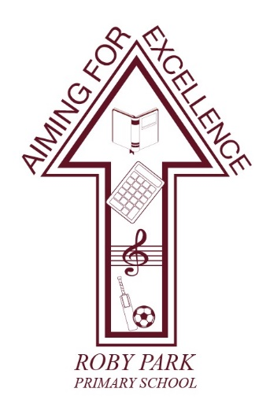

Roby Park Primary School

Easton Road

Huyton

Knowsley

L36 4NY

Tel: 0151 477 8340

Website: www.robyparkprimary.co.uk

E-mail: robypark@knowsley.gov.uk

Headteacher: Mrs K Allen

The Governors are seeking to appoint:

A Temporary SEND Teaching Assistant

Pay Band D / SCP 5 - 6
£25,583 - £25,989 pro rata per annum
SEN Allowance £1539

Actual Salary: £10,058 – £10,217 per annum

16 hours per week / 46 weeks per year / Term time
Actual SEN allowance £605

To start as soon as possible.
The contract is initially until July 2026 with the possibility of an extension.
We are seeking a committed and nurturing Teaching Assistant to support in a lower Key Stage 2 class. The successful candidate will work with pupils to help them access the curriculum, develop self worth and improve emotional wellbeing. Experience working with children with social communication difficulties would be beneficial.
Experience of supporting children with speech, language and communication needs is highly beneficial. An understanding of autism and how to adapt provision to meet individual needs would also be an advantage.
We are looking for someone who is patient, proactive and able to build positive, trusting relationships. A flexible approach and a willingness to work closely with the class teacher and wider team are essential.
Roby Park Primary has a clear vision of ‘Aiming for Excellence’, with a continued commitment to making a difference for all of our children, with superb care, nurture and support as the foundation stones of our inclusive approach. With an unwavering child-centred ethos, we put our children at the heart of every decision we make.

We can offer an excellent environment with a recently developed bespoke outdoor area. Our dynamic and friendly staff are passionate about raising standards and aspirations for all children. Our school is well resourced and has a supportive and reflective Senior Leadership Team and Governing Body. We have a whole school commitment to professional development, as we believe that development of staff is a key aspect in raising standards for our pupils.
We are looking for someone who: -
- Is an outstanding Teaching Assistant with the ability to support a child with additional needs
- Is an excellent team player
- Is committed to equality of opportunity for our pupils
- Has excellent organisational and inter-personal skills

In return we can offer you: -
- A well-resourced learning environment
- A supportive staff team with governors and leaders who value quality teaching
- Positive and supportive relationships with the local community
- A real commitment to high quality continuous professional development
- An opportunity to be a part of a journey of whole school improvement and celebration

Application forms and further details are available on the school website at https://robyparkprimary.co.uk/contact-us-2/job-vacancies/

Completed application forms should be returned via email to Mrs Kirstie Carroll, School Business Manager at robypark@knowsley.gov.uk by the closing date stated.

Roby Park Primary School is committed to safeguarding, to promoting the welfare of children and adhering to the Equality Act 2010. The successful candidate will be required to undertake an enhanced Disclosure and Barring Service check. The school will also undertake an online check prior to interview.

To comply with the Asylum and Immigration Act 1996 all prospective employees will be required to supply evidence of eligibility to work in the UK.

By engaging in this recruitment process, shortlisted candidates consent to an online search in line with the Keeping Children Safe in Education Statutory Guidance 2022

Closing date and shortlisting: 12.00 p.m. Tuesday, 24th March 2026
Interviews and task will be held on: Thursday, 26th March 2026

