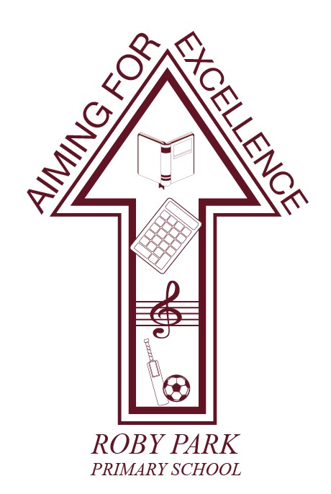

Food Policy

Written January 2026

Review September 2028

Signed – Mrs Kat Allen

(Headteacher)

Signed – Mr Mike Long

(Chair of Governors)

Introduction
Our school is supported by Public Health to be part of the Healthy Schools Knowsley scheme. Our school is dedicated to providing an environment that promotes healthy food and eating, enabling pupils to make informed choices about the food they eat. This will be achieved by the whole school approach to food and nutrition documented in this whole school food policy.

This policy was formulated through consultation between members of staff, governors, caterers, parents/carers, and pupils. This policy is communicated to the entire school community and is adhered to by everyone involved with the teacher/serving/cooking or food and drink in school during the day and our partners that share our school premises.

Food Policy Co-Ordinator
This school food policy and healthy eating strategy is co-ordinated by Mrs Kat Allen as well overseeing all aspects of food in school.

Food Policy Aims
The main aims for our school food policy are:
- To enable pupils to make healthy food choices through the provision of information and development of appropriate skills and attitudes.
- To provide healthy food/drinks choices throughout the school day and ensure food brought into school is healthy too.
- To ensure that all aspects of food and drink in school promote the health and wellbeing of pupils, staff and visitors to our school.
These aims will be addressed through the following areas:

Curriculum:
How Nutrition Fits into Our Curriculum
At Roby Park, nutrition and healthy living are embedded across the curriculum to ensure pupils develop the knowledge, skills and attitudes needed to make informed food choices. We teach nutrition through:
Science
- Understanding food groups, nutrition, digestion and the impact of diet on health.
- Investigating how lifestyle choices influence physical wellbeing.

Design & Technology (Food Technology)
- Teaching pupils how to prepare, cook and evaluate food safely and hygienically.
- Developing practical cookery skills that build confidence and independence.
- Exploring healthy recipes and adapting dishes to improve nutritional value.

PSHE / Health Education
- Learning about balanced diets, healthy choices, oral health, and self-care.
- Understanding how food affects physical and mental health.

Physical Education
- Linking healthy eating with physical activity and overall wellbeing.

Cross-curricular opportunities
- Celebrating cultural foods through Geography and RE.
- Using food-related contexts in Maths (e.g., measuring, weighing, budgeting).
Overall, food education is planned progressively so pupils build secure knowledge and form lifelong healthy habits.

Food & Drink Provision Throughout the School Day:
All schools are encouraged to promote healthy eating and provide healthy, tasty and nutritious food and drink. Compliance with the requirements for School Food Standards is mandatory for all maintained schools including academies. These School Food Standards are to ensure that food provided to pupils in school is nutritious and of high quality; to promote good nutritional health in all pupils; protect those who are nutritionally vulnerable and to promote good eating behaviour.

The regulations set out the requirements for school lunches provided to pupils, whether on the school premises or not, and to any other person on the school premises. Healthy food should not just be provided for lunch but to pupils on and off premises, including breakfast clubs, tuck shops, snacks and after school clubs.

Breakfast Club
Breakfast is an important start to the day for children, a healthy breakfast ensures they are ready to learn and concentrate during lessons.

Roby Rainbows operates a breakfast club that provides nutritious food for pupils before the school day and complies with the standards for school food other than lunch.

The breakfast menus can be obtained from the Breakfast Club section of the website which can be found here.

Breaktimes
The school understands that snacks can be an important part of a child’s diet and can contribute positively towards a balanced diet.

The school discourages the consumption of snacks high in fat, salt and sugar at breaktime. Children can bring low sugar cereal bars which do not include chocolate.

School operates a fruit trolley, thanks to Tesco Stronger Starts. Children have a vast range of fruit on offer each play time. Surplus food is available in the dining hall for children to use to supplement their lunch with.

We participate in the National Fruit & Vegetable Scheme, therefore KS1 pupils can access free fruit and vegetables each day across the week for free.

School Meals
Food prepared by the school catering team meets the School Food Standards.

As a school we encourage pupils to have a school lunch provided by the school, school meals are also provided to all those pupils who are entitled to them. Information on free school meals can be found here.

Healthy options are promoted and encouraged at lunchtime. Children/young people are consulted about food choices. School food menus can be found here.

Packed Lunches
The school encourages parents and carers to provide children with packed lunches that compliment the nutritional standards. This is achieved by promoting healthy balanced packed lunch options using the principles of the Eatwell Guide and our Packed Lunch Guidance which can be found here.
Useful information and ideas can also be found on the Councils Healthy Packed Lunch website. Following this advice will ensure children having packed lunches have a healthy balanced meal.

After School Clubs
The food and drink provision at our after-school club is in line with the overall whole school food policy and complies with the standards for all school food other than lunches. Pupils are regularly consulted on the food and drink on offer.

Information on the after-school club menu can be found here.

The Use of Food for Rewards/Birthdays
The school does not encourage the regular eating of sweets or other foods high in sugar or fat, especially as a reward for good behaviour or academic or other achievements. Other methods of positive reinforcement are used in school. Please see our Positive Relationships Policy here.

Drinking Water
The School Food Standards recommend that free, fresh drinking water must be available at all times.

The school agrees with this recommendation and provides a free supply of drinking water and will encourage pupils to drink at frequent intervals throughout the day. Water is free for all pupils at lunchtime meal service.

Children can bring their own water bottles to school with water only. Children can fill their water bottles up throughout the day, using the water fountains outside classrooms.

Special Dietary Requirements
The school provides food in accordance with pupil’s religious beliefs and cultural practices as required. School caterers offer a vegetarian option at lunch every day.

Schools have a duty to support pupils at their school with medical conditions. We recognise that some pupils may require special diets that do not allow for our food policy to be exactly met. In this case parents are asked to make us fully aware of this. Individual care plans need to be created for pupils with special dietary needs/requirements. These should document symptoms and adverse reactions, actions to be taken in an emergency.

Emergency contact details, along with any particular food requirements. The school and school caterers are made aware of any food allergies/food intolerance/medical diets and requests for these diets are submitted according to an agreed process.

Dietary requirements should be shared with the school office as soon as possible. Allergy and medical diet documentation is updated and disseminated to staff across the school.

Further information can be found on Allergy Guidance for schools at https://www.gov.uk/government/publications/school-food-standards-resources-for-schools
and Allergy UK https://www.allergyuk.org/living-with-an-allergy/at-school/

Food Safety
Appropriate food safety precautions are taken when food is prepared or stored. These vary depending on the food on offer and include, ensuring that adequate storage and washing facilities are available; that food handlers undergo appropriate food safety and hygiene training; and that suitable equipment and protective clothing are available. Any food safety hazards are identified and controlled. Information is cascaded to everyone who is involved with food related activities in school. We have food safety information displayed in the appropriate areas.

The Food and Eating Environment
The school will provide a clean, sociable environment for pupils to eat their lunch and has been developed the healthy/welcoming aspects of the dining room environment. Lunchtime staff will help ensure a safe, enjoyable experience at lunchtime and will always encourage healthy eating and that pupils try new foods.

Leading by Example
Teachers, caterers and lunchtime supervisors have a key role in influencing pupils’ knowledge and attitudes about food, so it is important that they are familiar with healthy eating guidelines. It is essential that staff are committed to setting an example with food in school.

Consultation/Monitoring and Evaluation
This policy has been developed through wide consultation with the whole school community. The policy and its impact is reviewed on an ongoing basis. The policy is communicated to the entire school community and new families/staff to our school are made aware of its importance.

