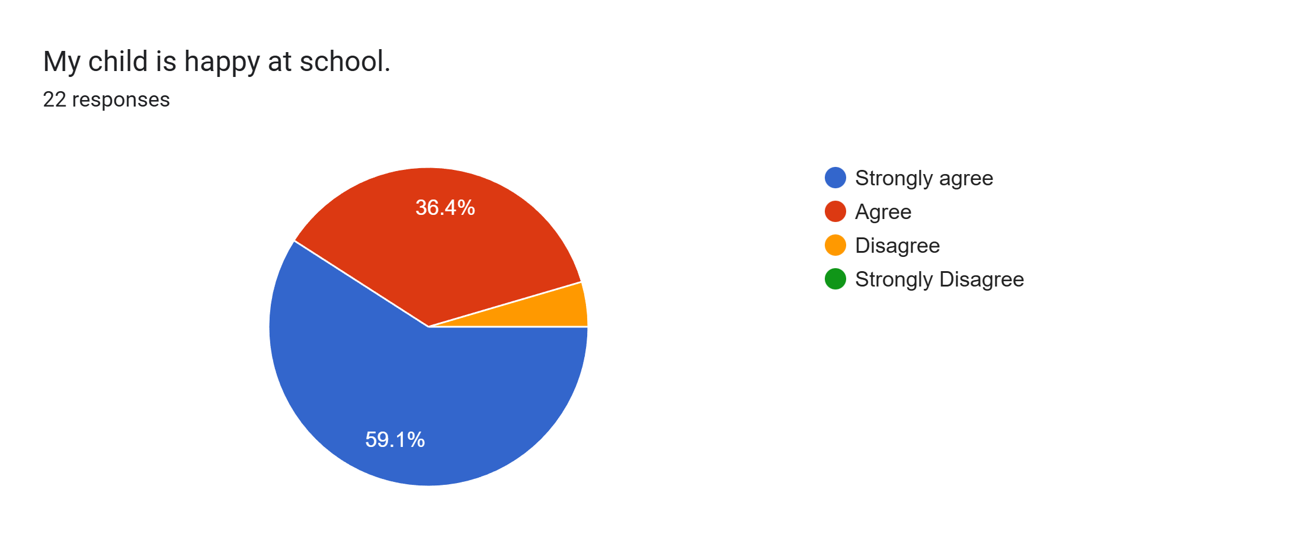
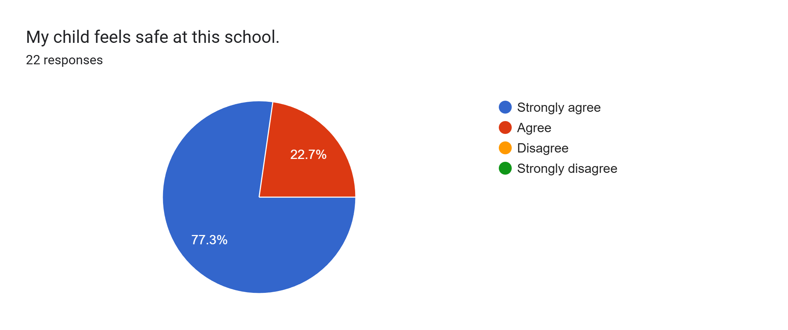
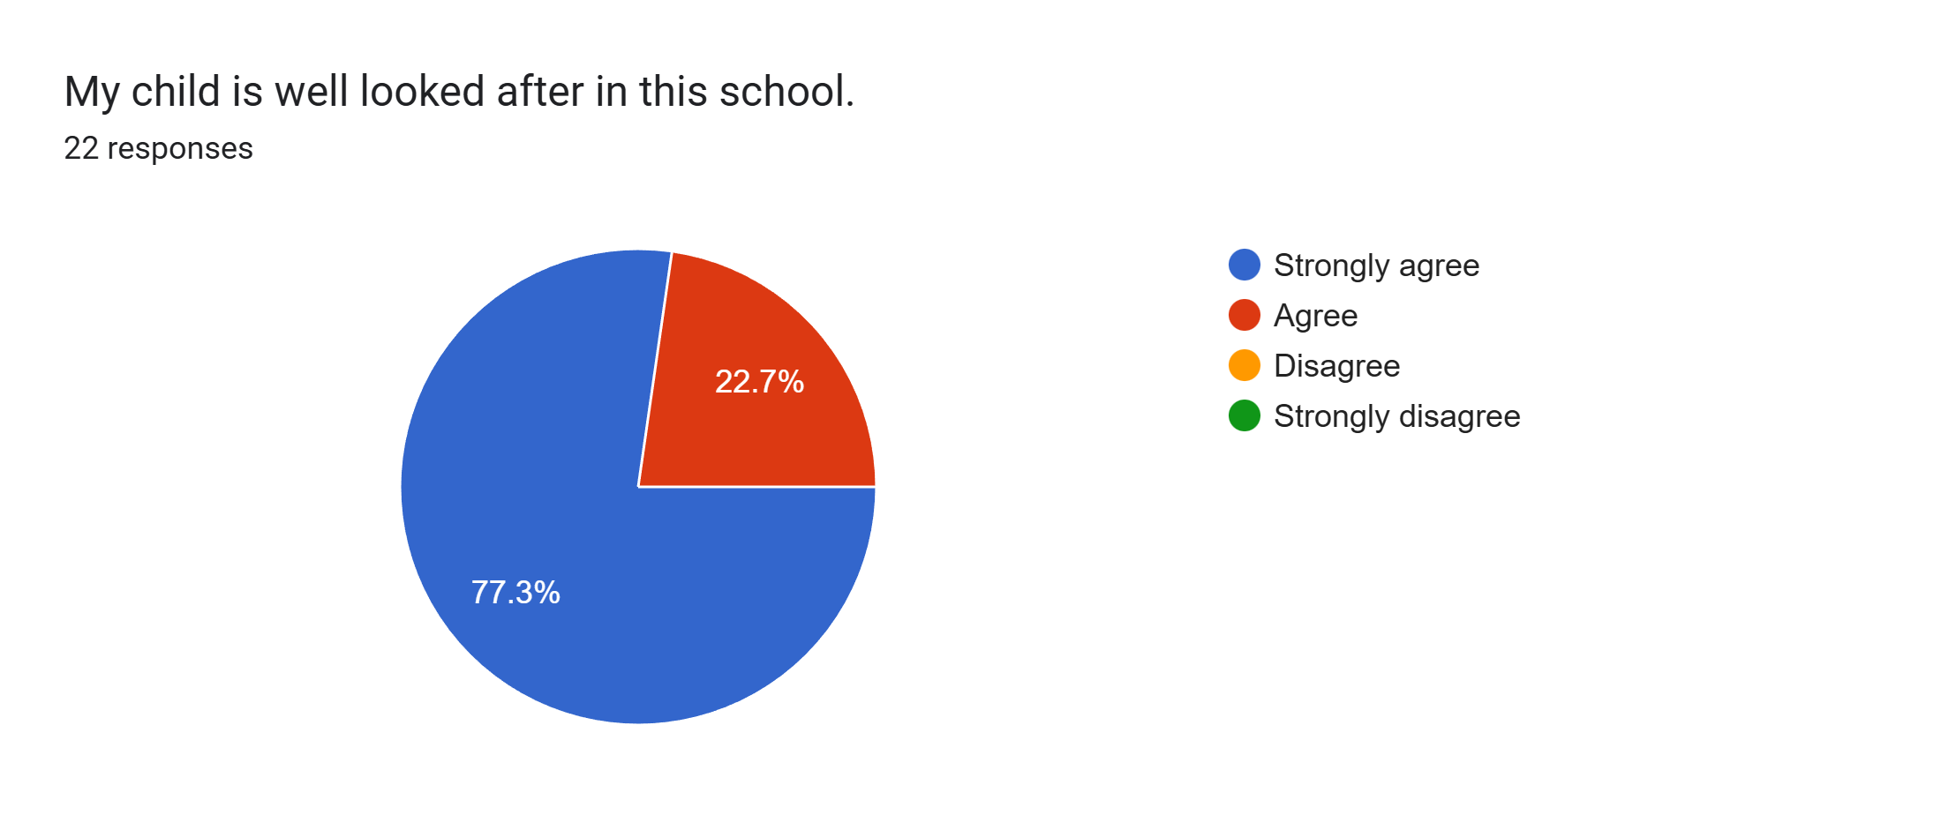
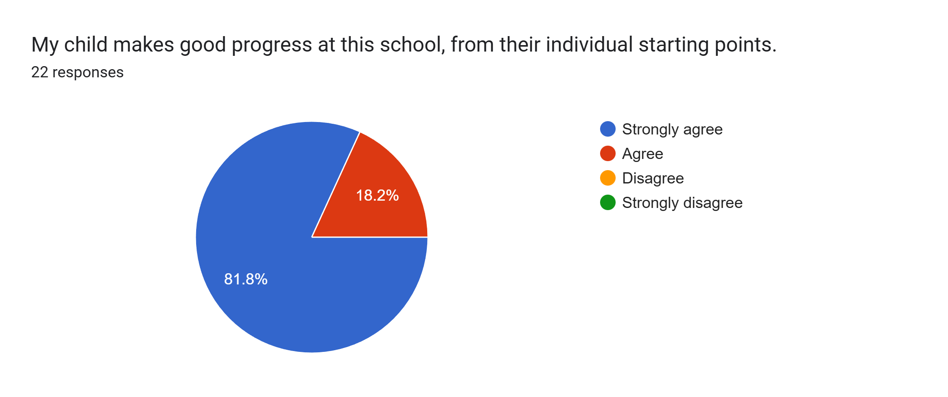
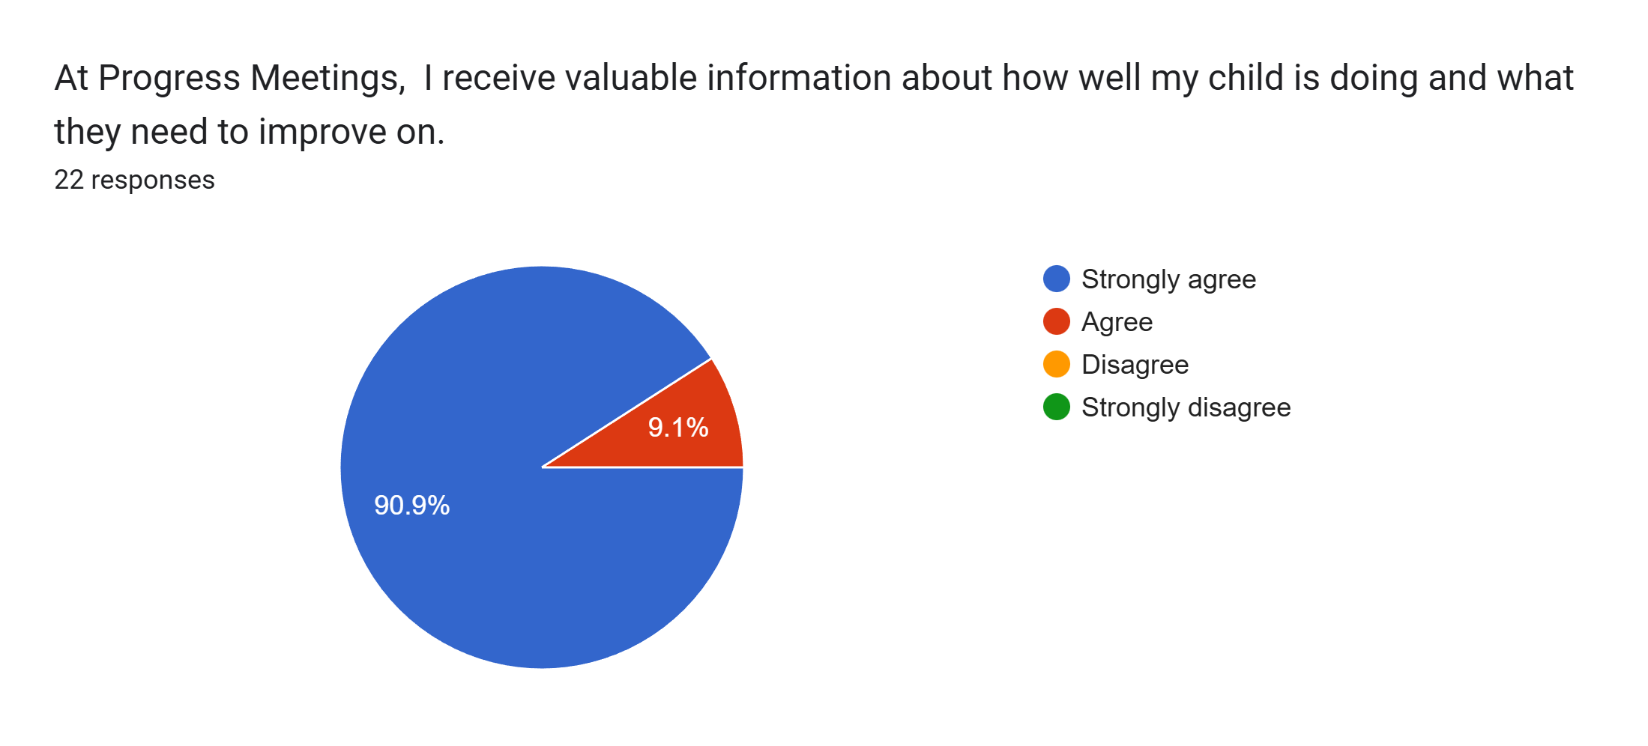
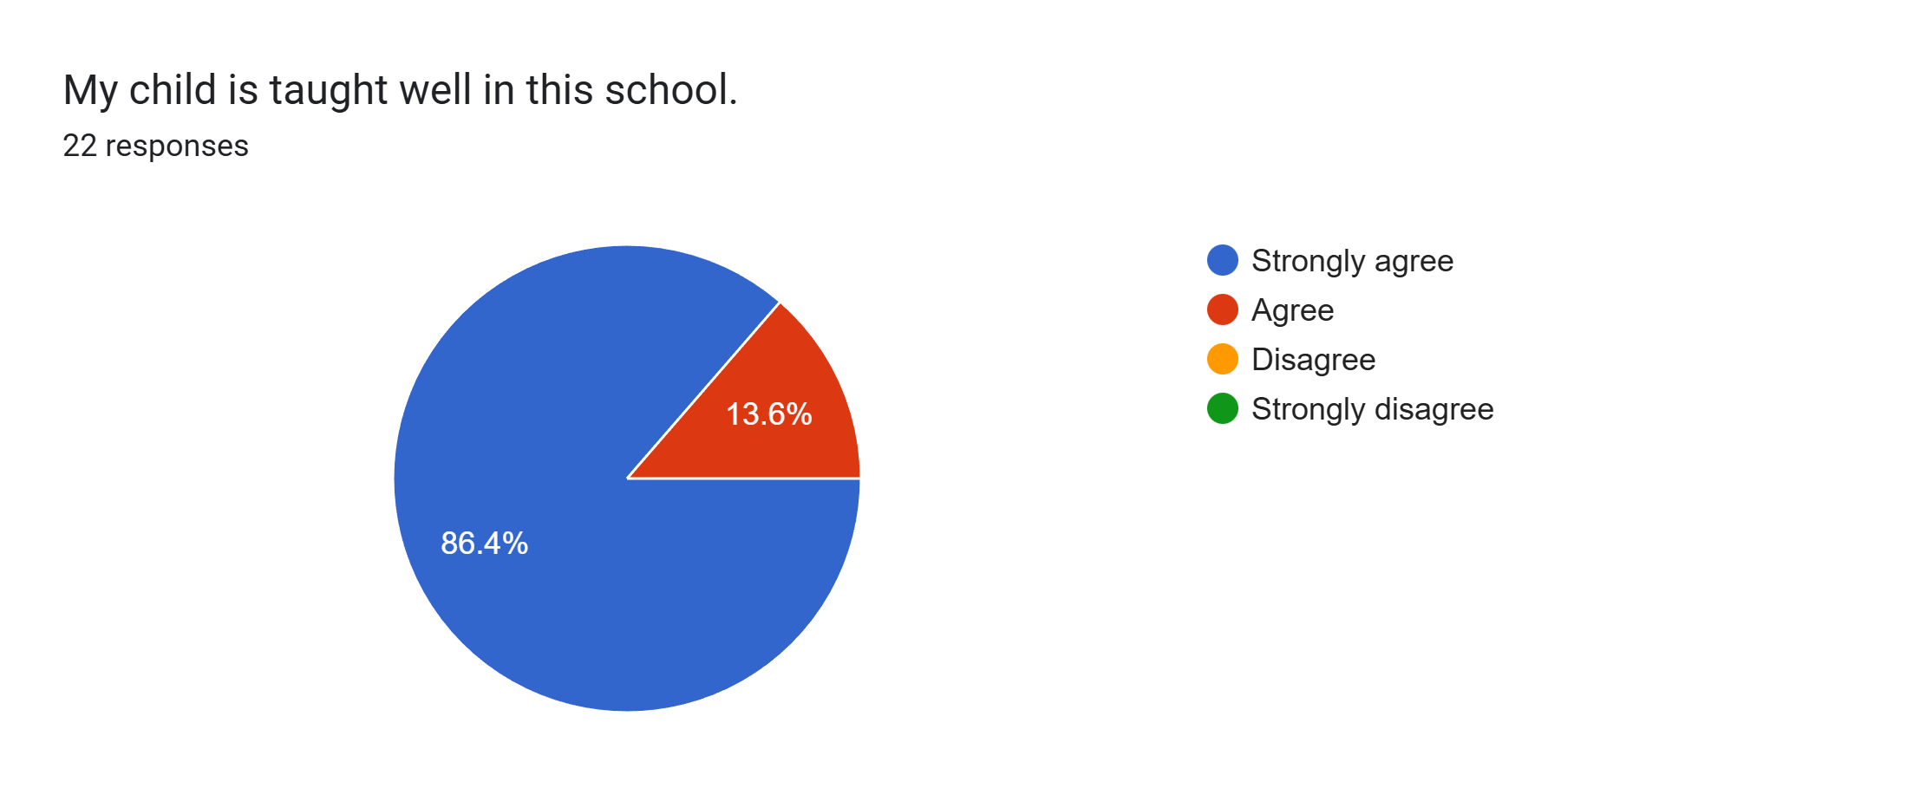
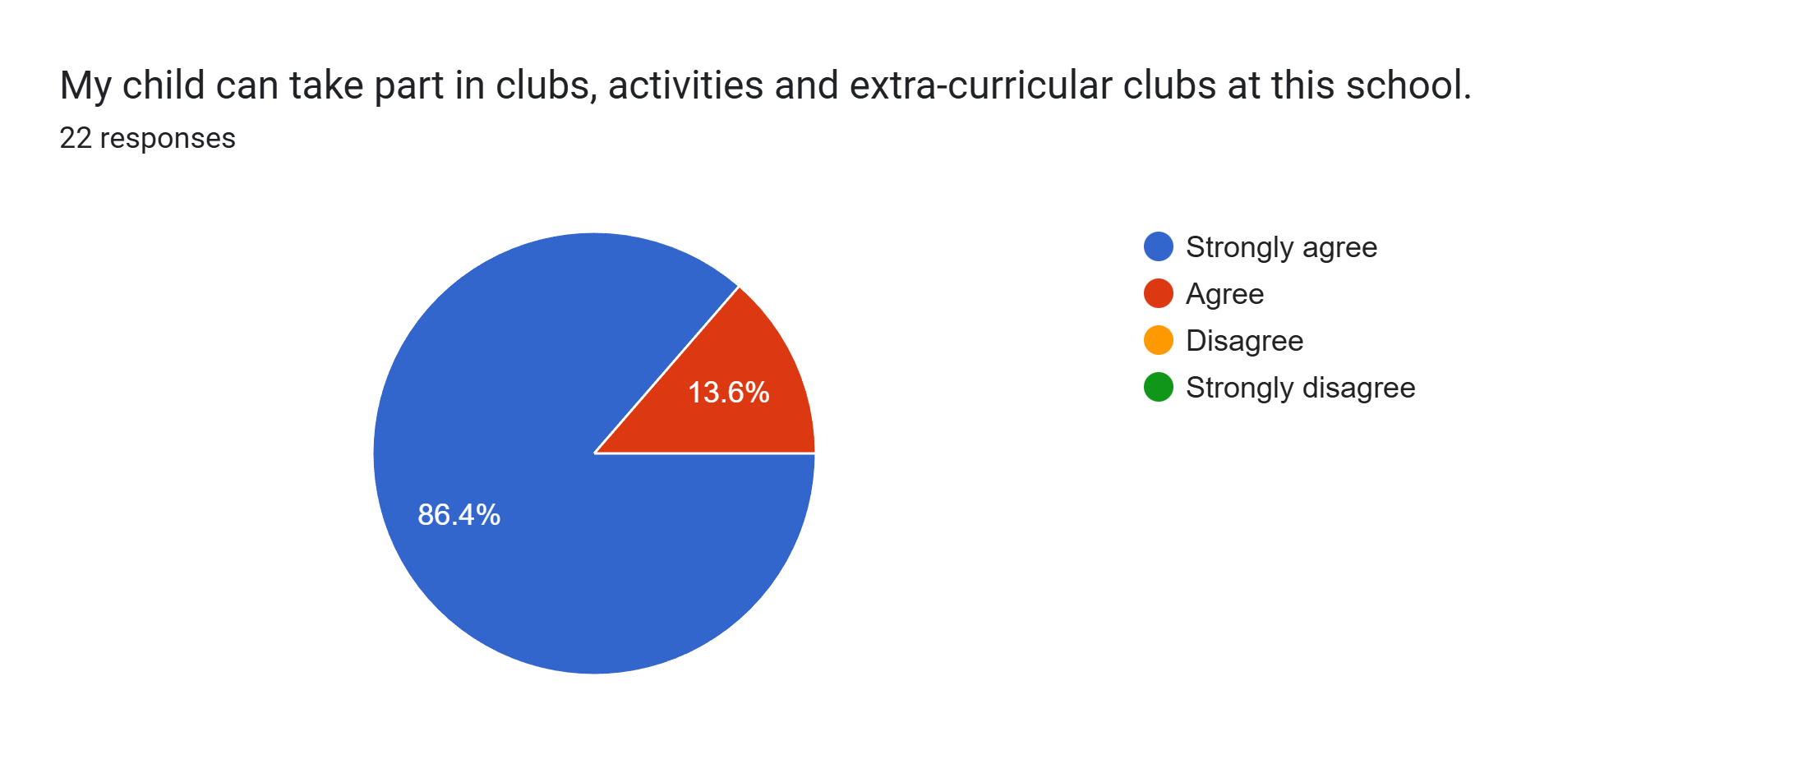
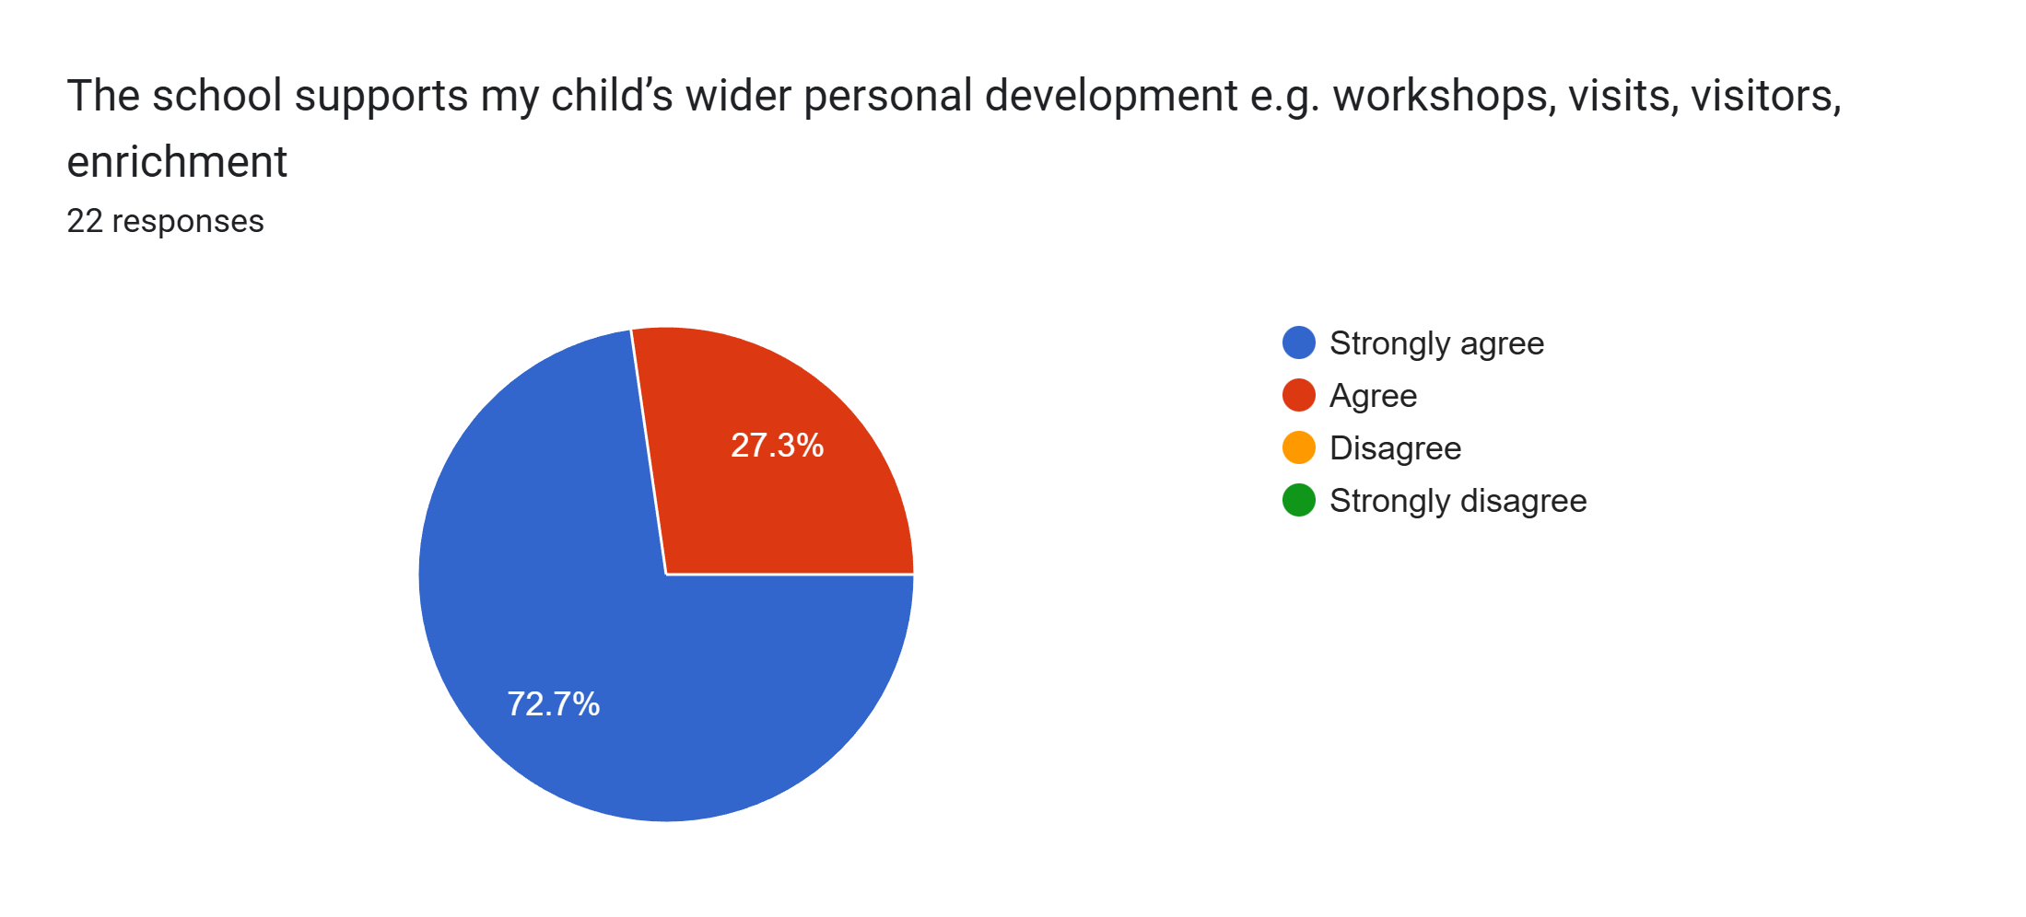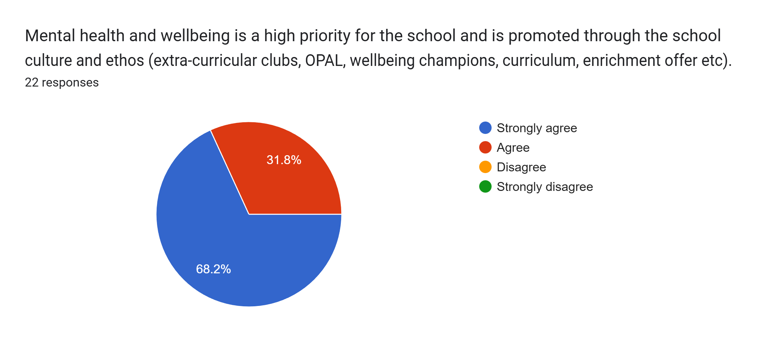
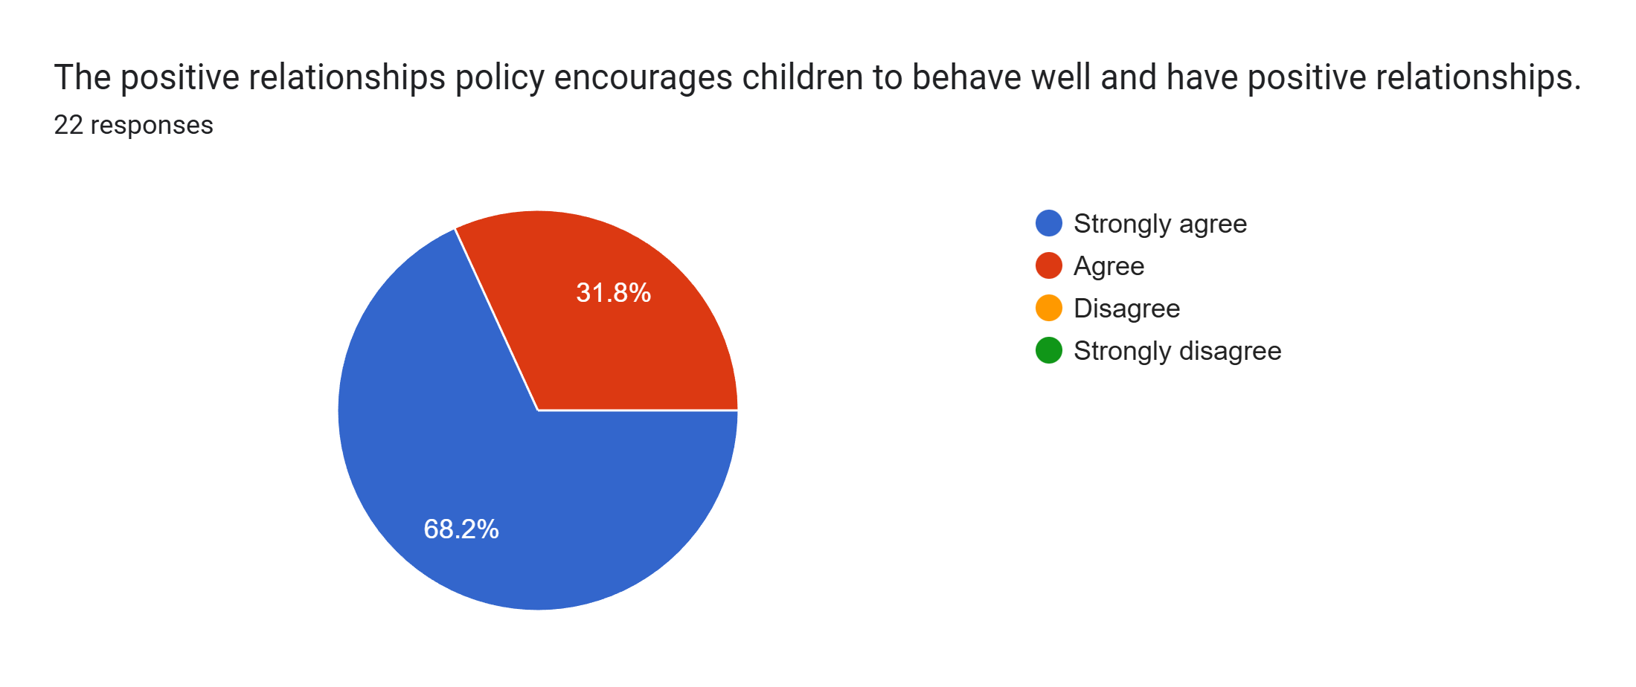
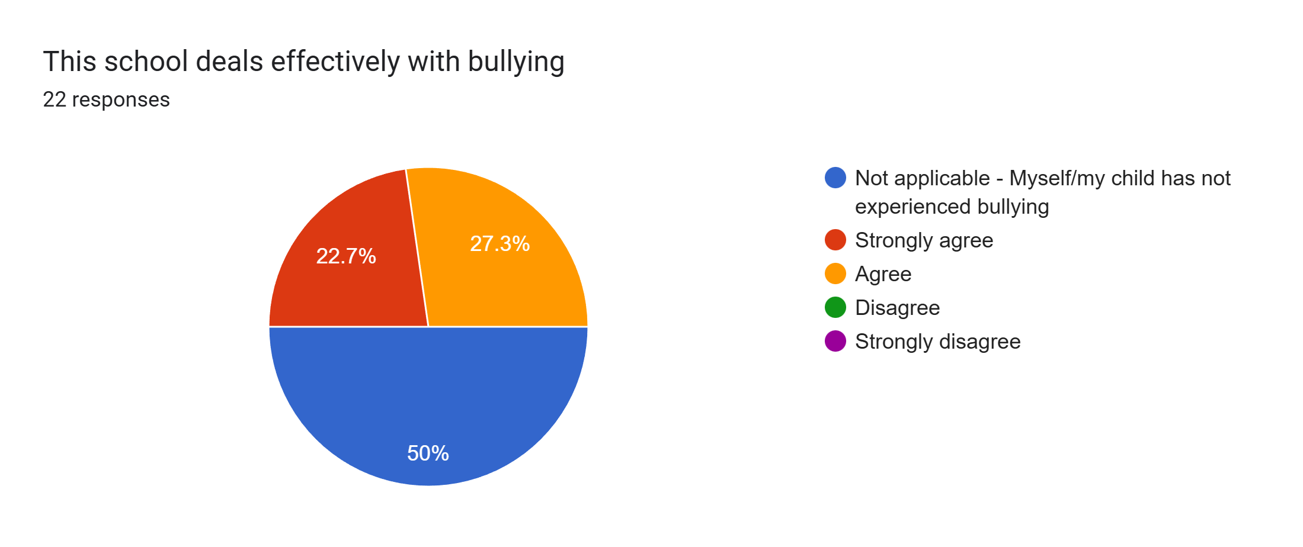
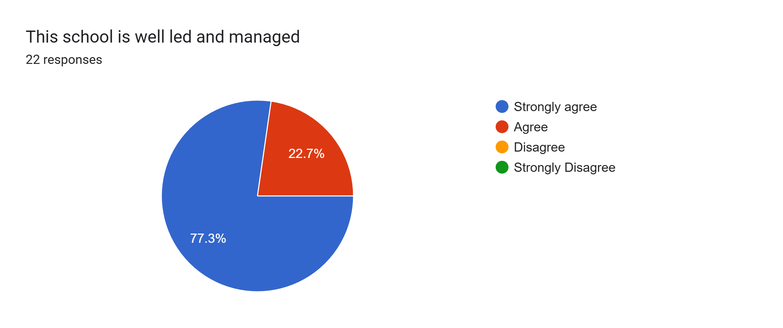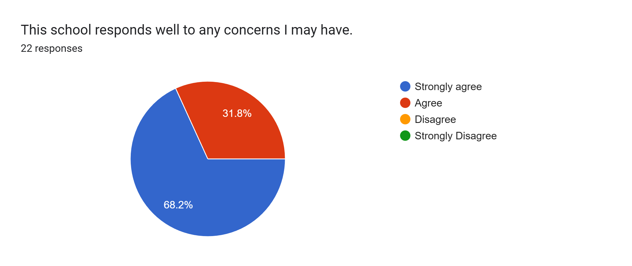
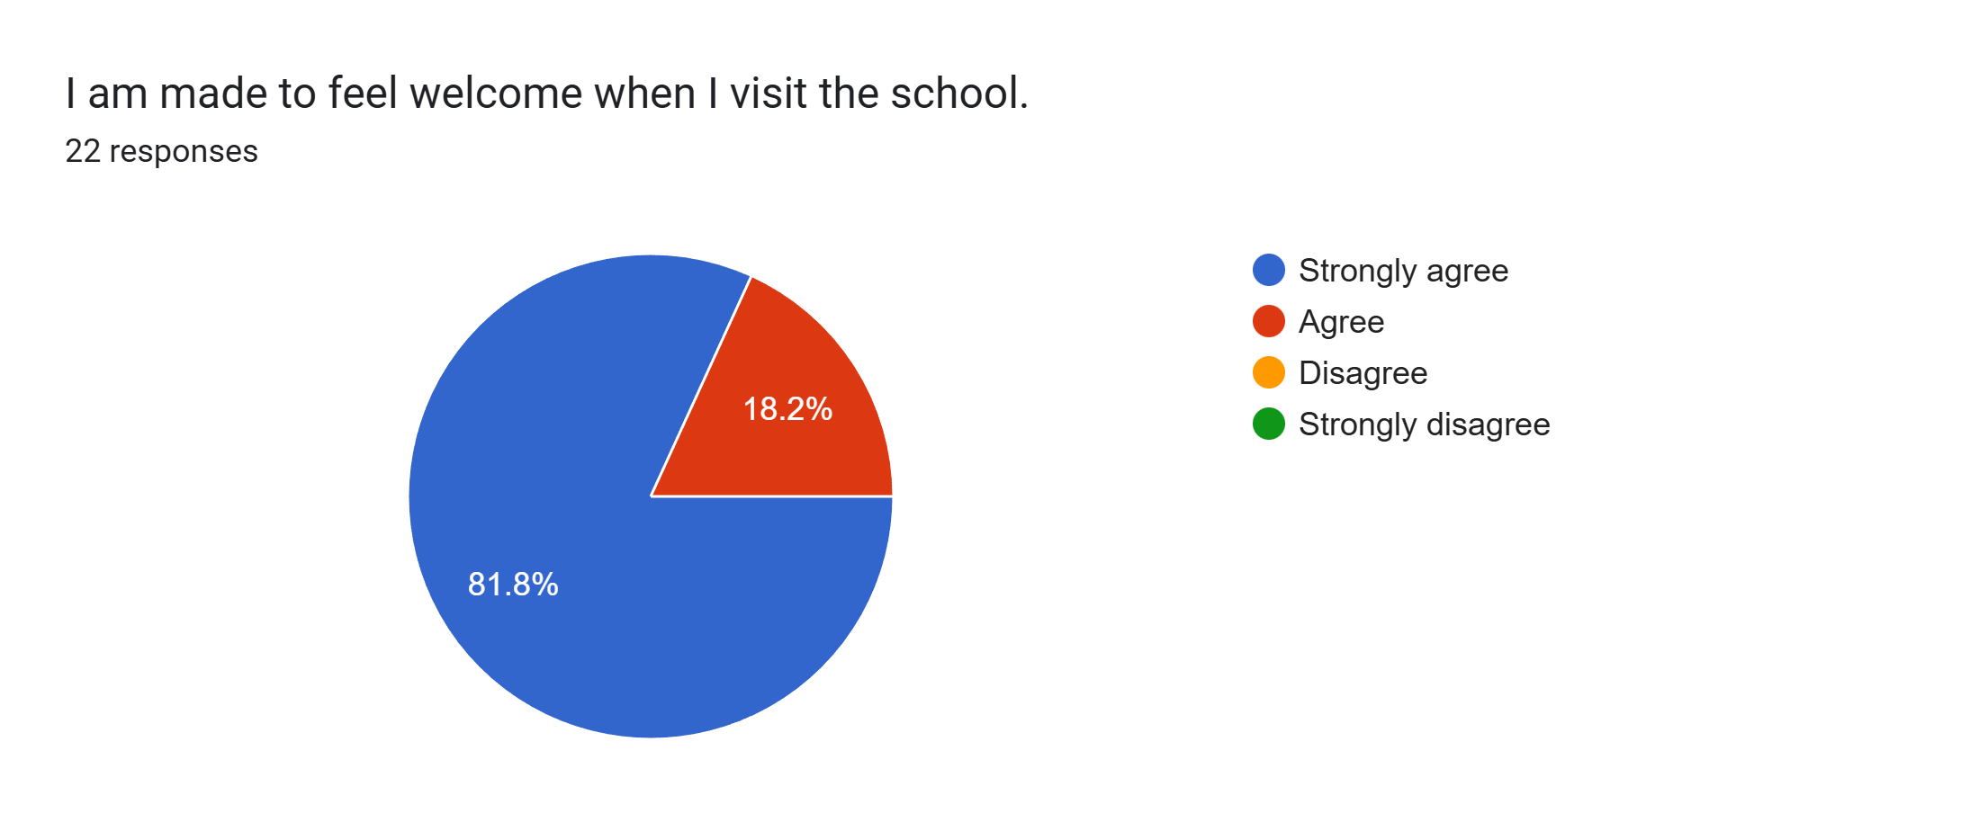
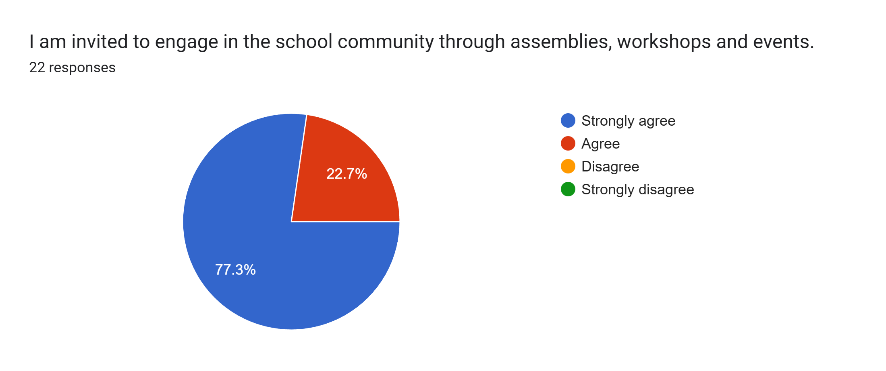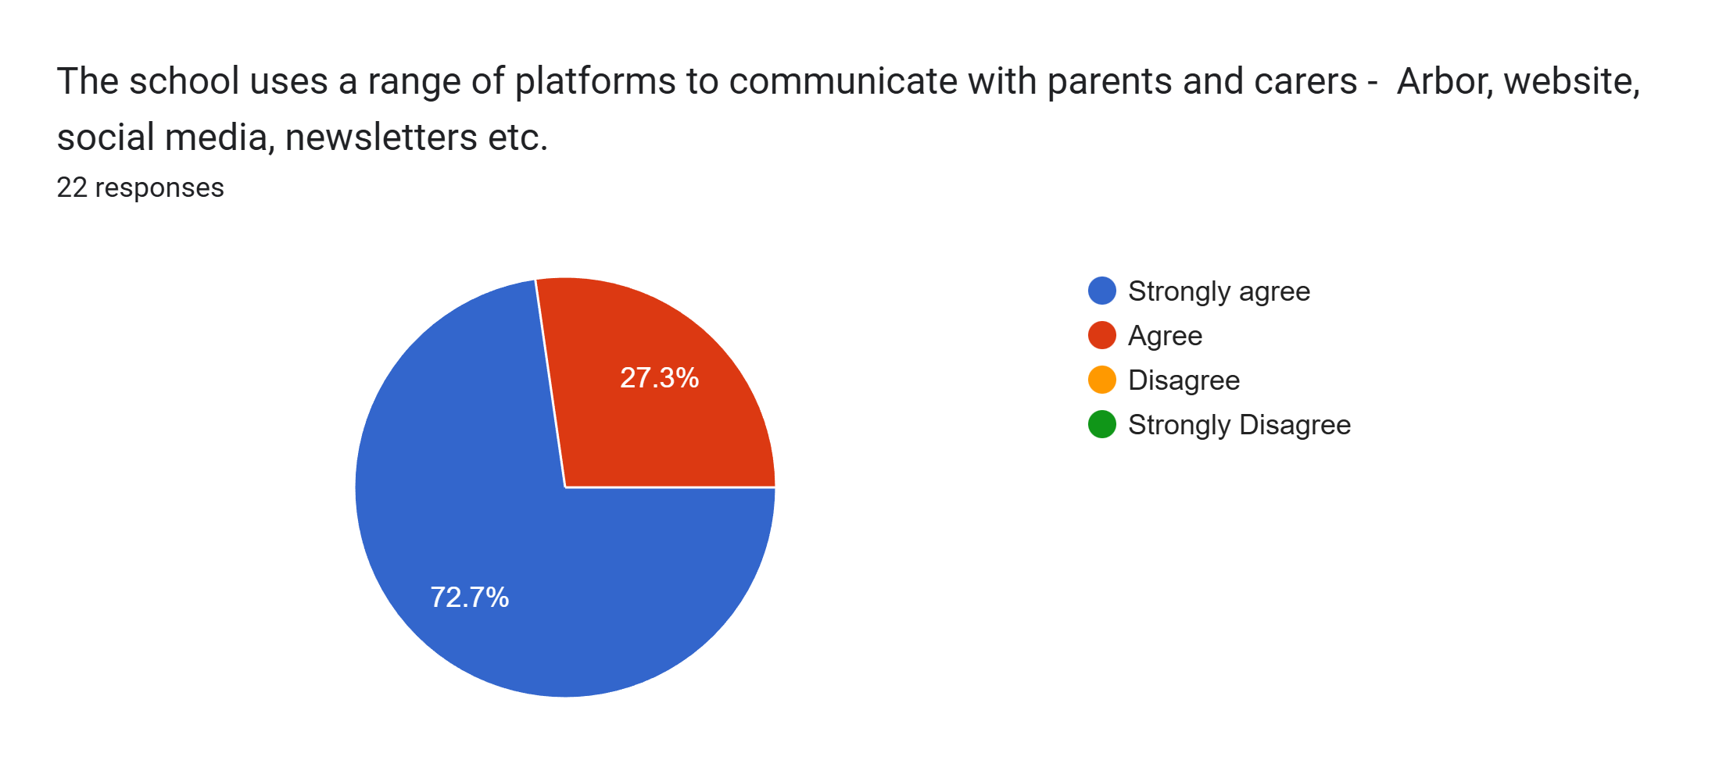
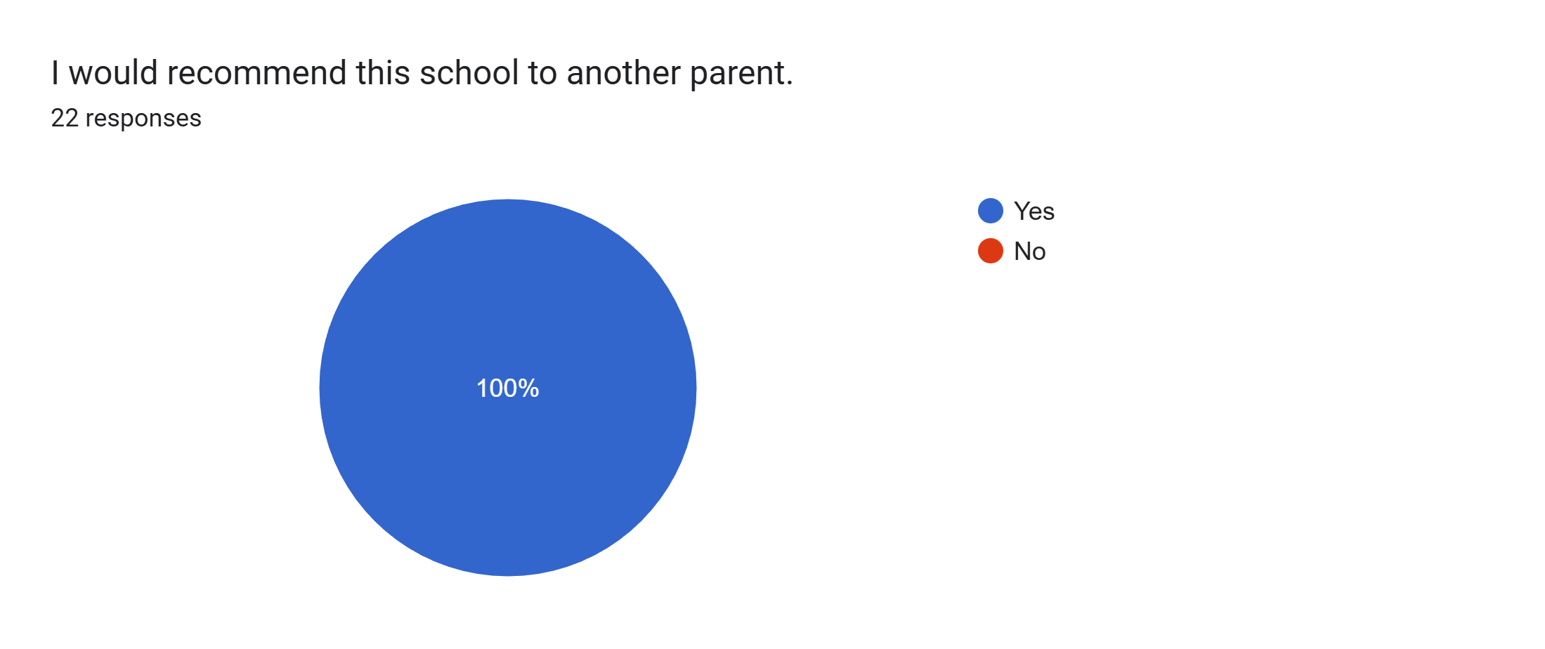
What other comments would you like to make to staff:
- Lovely staff.
- Thank you for all that you do.
- Lovely school. I would highly recommend it to anyone.
- They are wonderful - thank you to all staff.
- An excellent parents’ evening. We are so pleased at how well he is doing this year in school.
- Excellent staff friendly and welcoming.
- Very friendly and approachable.
- My daughter loves her new teacher and is thriving which is all I could ask for.
- Thank you to everyone.
- Lovely school.
- Such a great improvement with my son due to Miss Beggs being fantastic with him and really taking the time out to build a great relationship with him.
- Great school. My son is doing well and enjoys his time here.
- Brilliant school.
- Fabulous teacher.
- My child loves coming to this school and we will be sad to see them leave.
- Amazing school.

