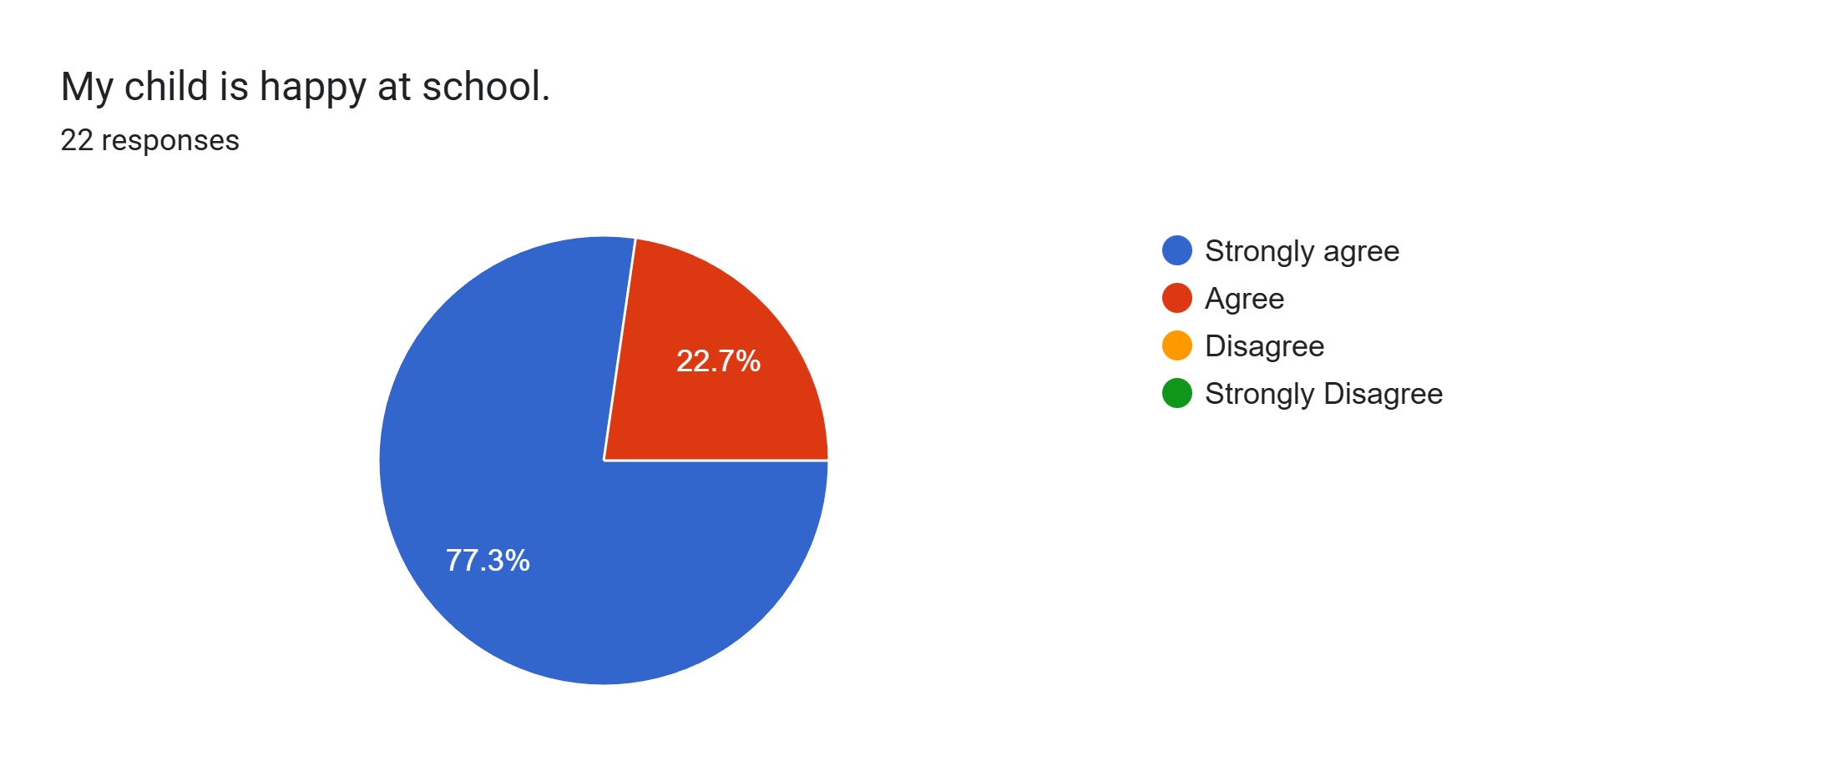
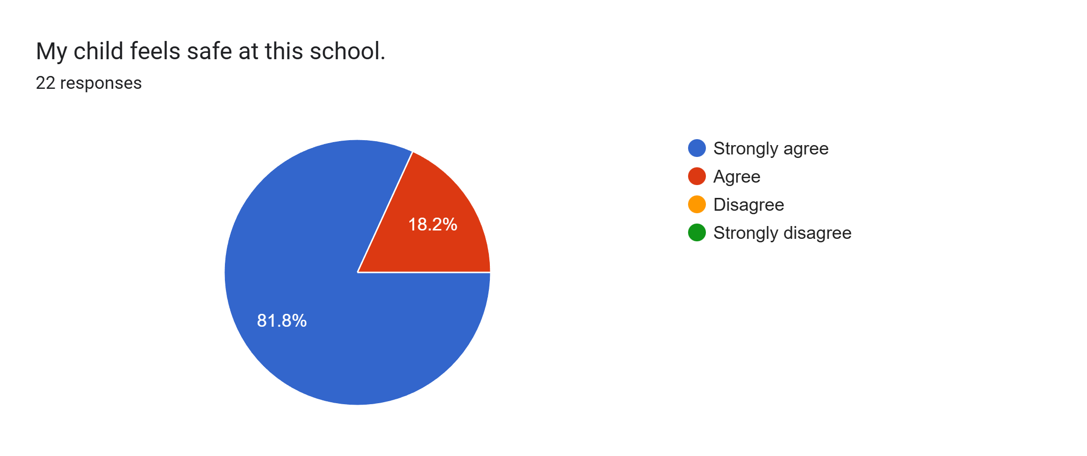
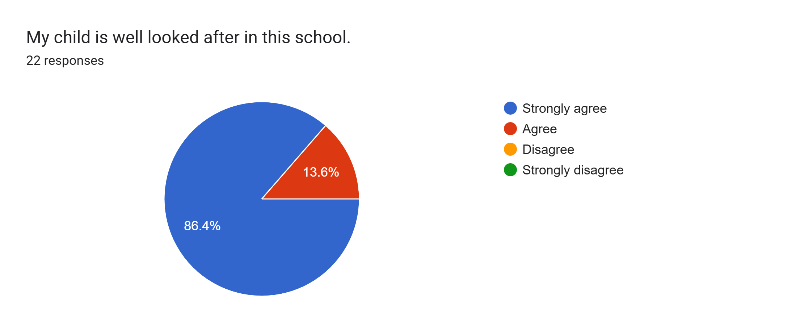
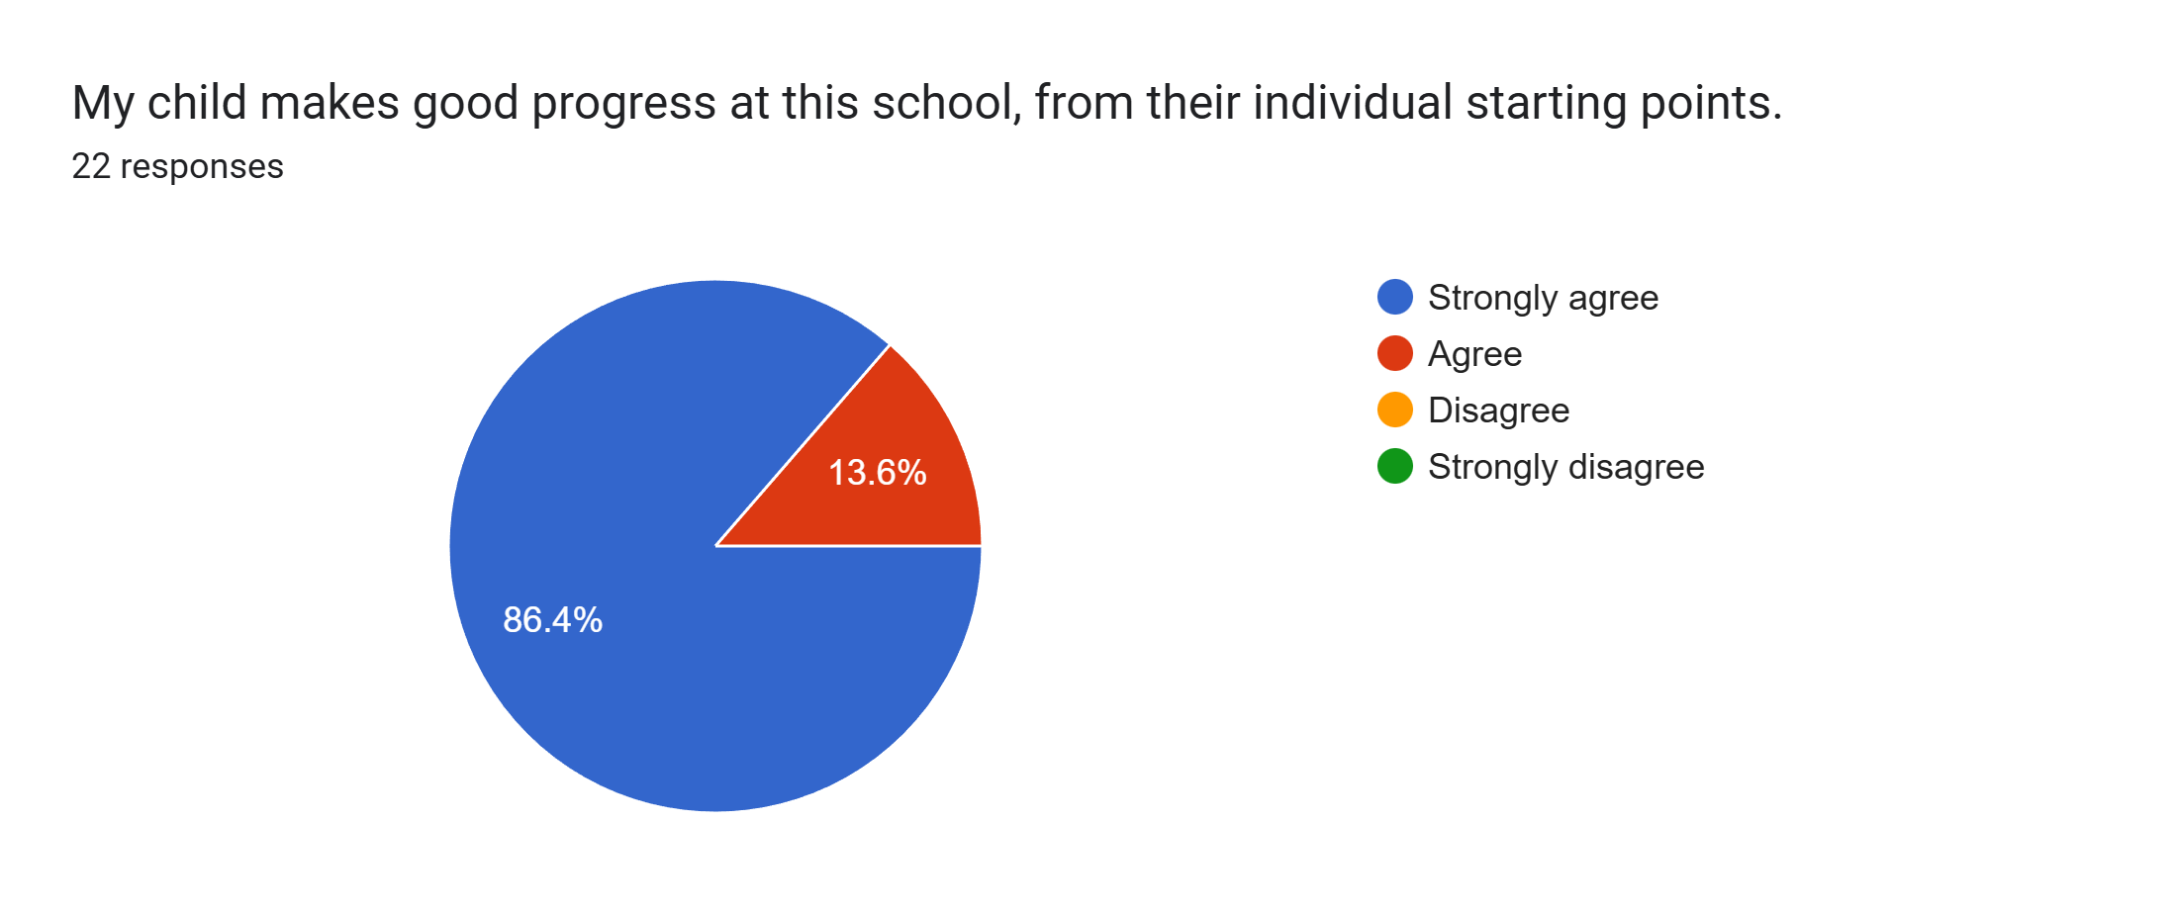
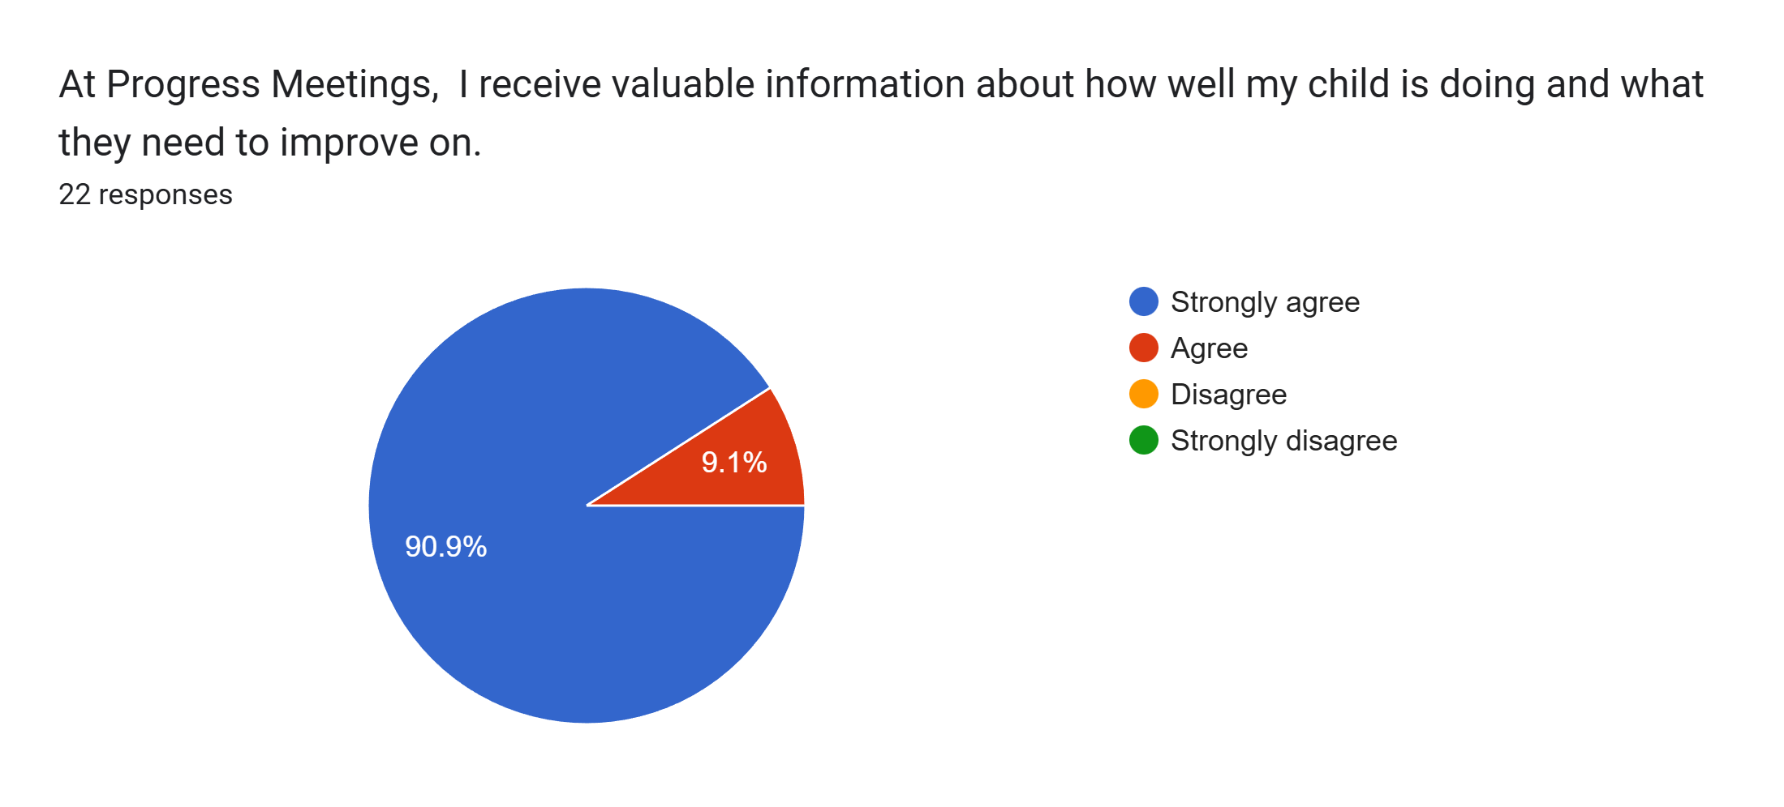
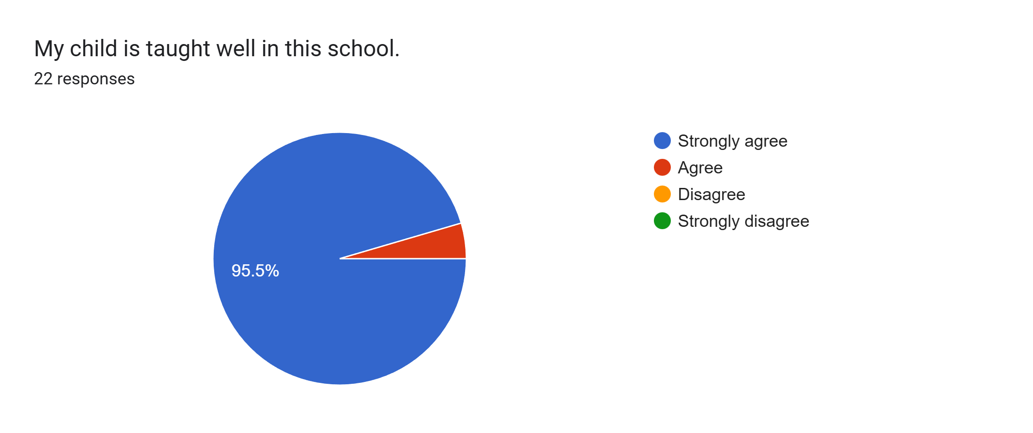
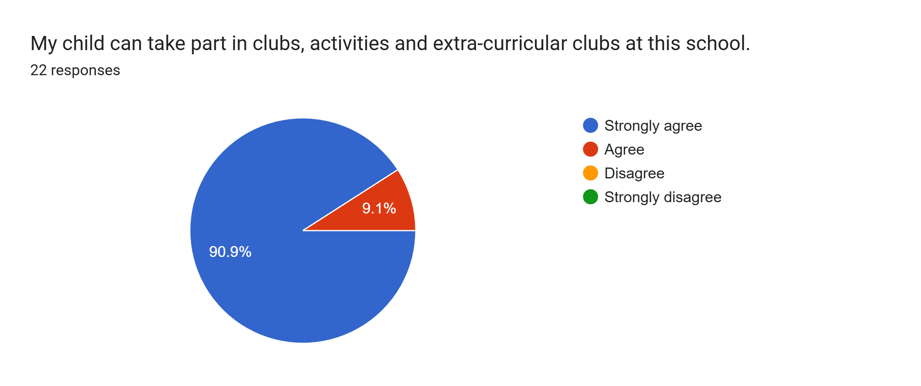
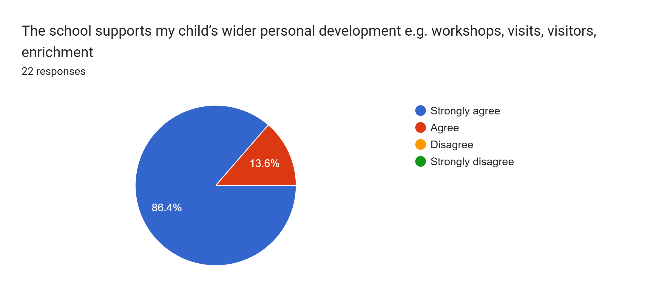
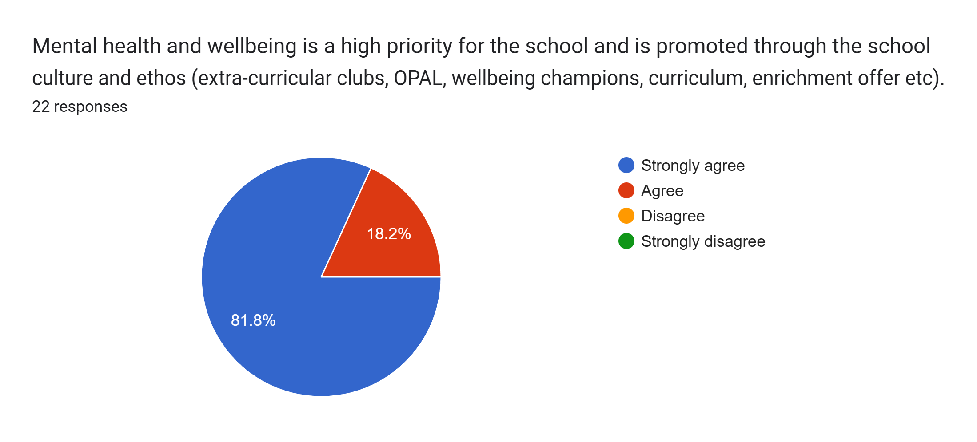
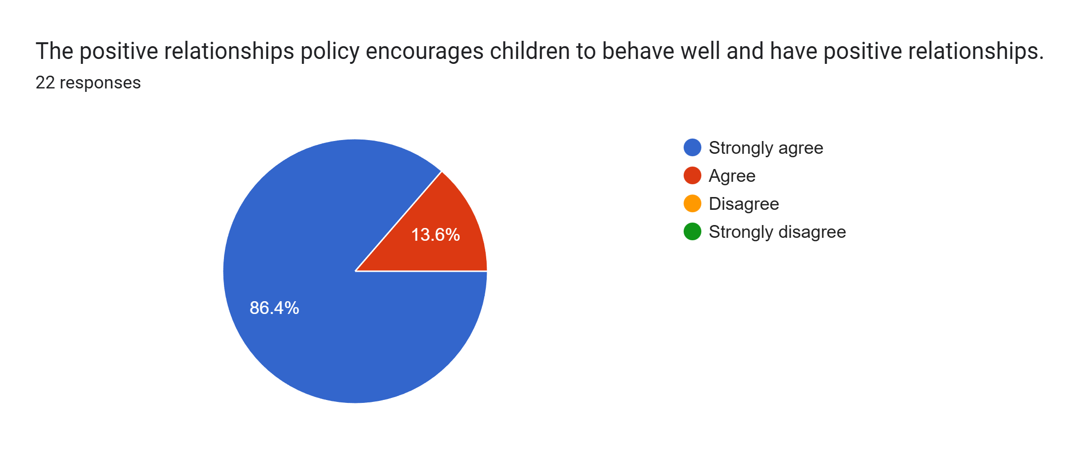
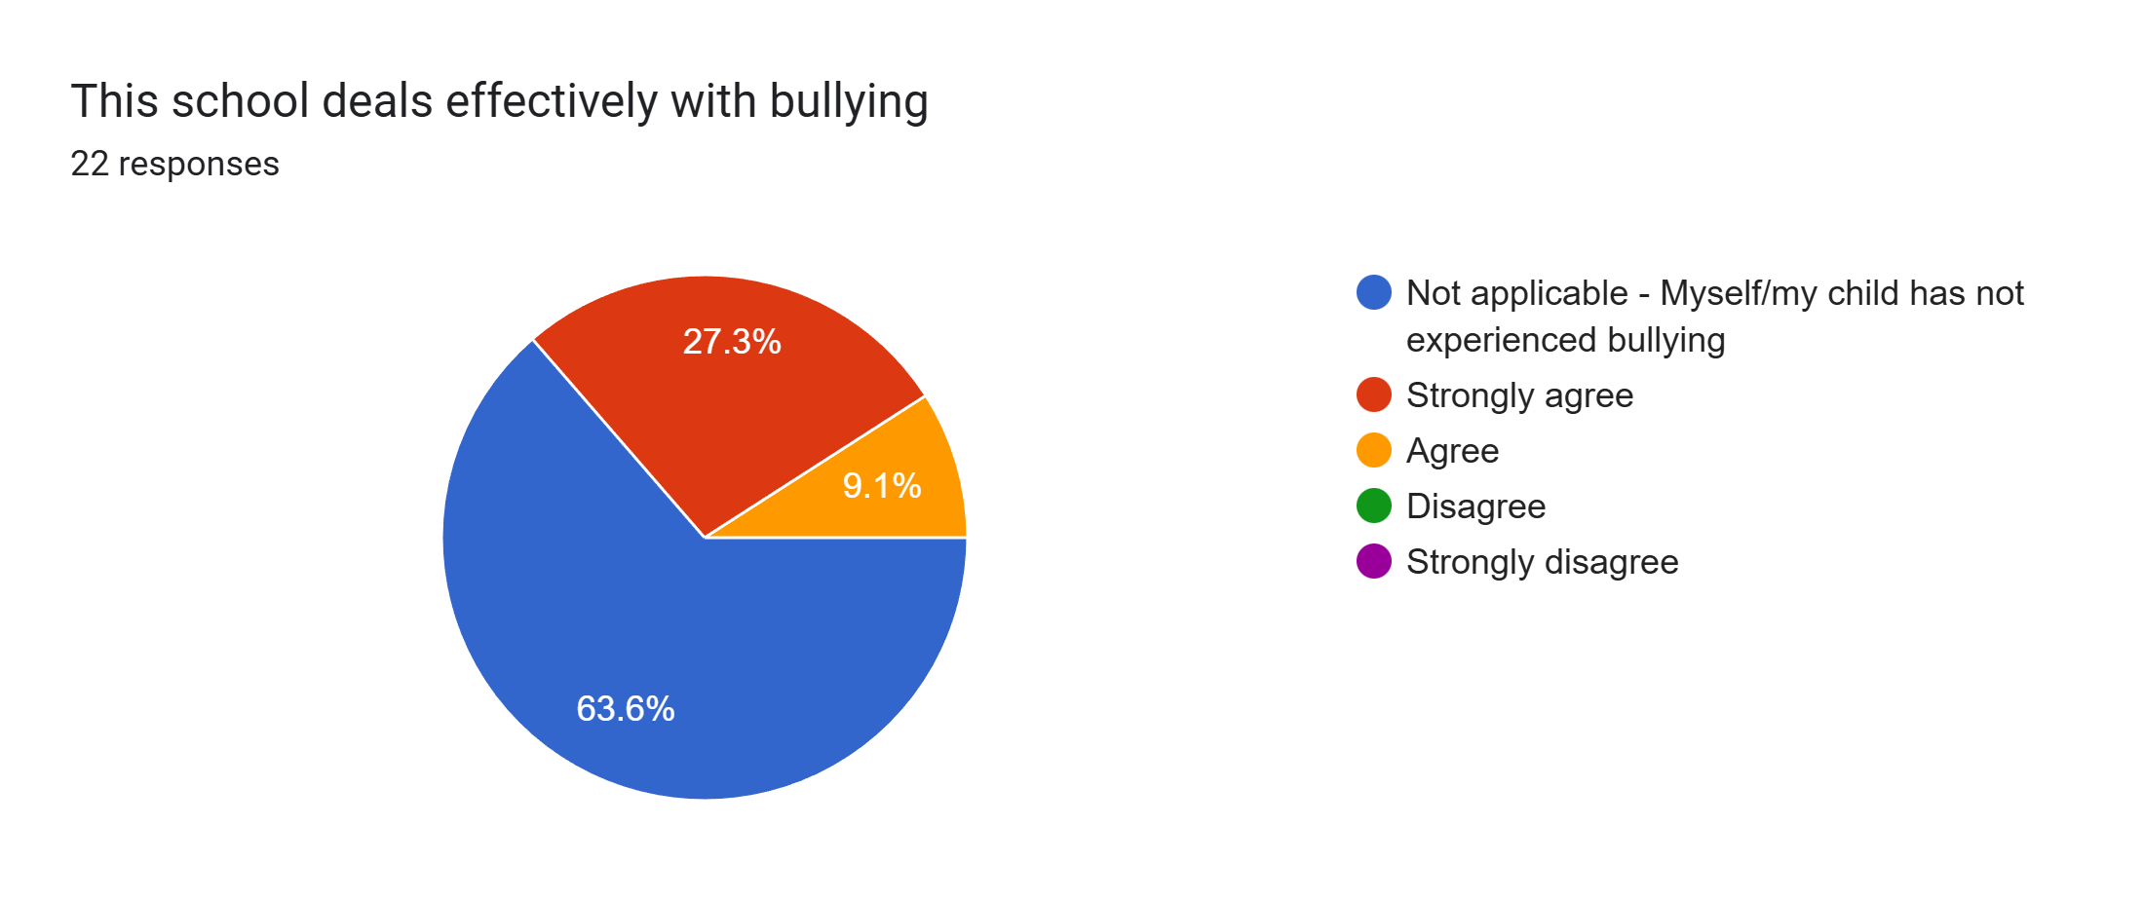
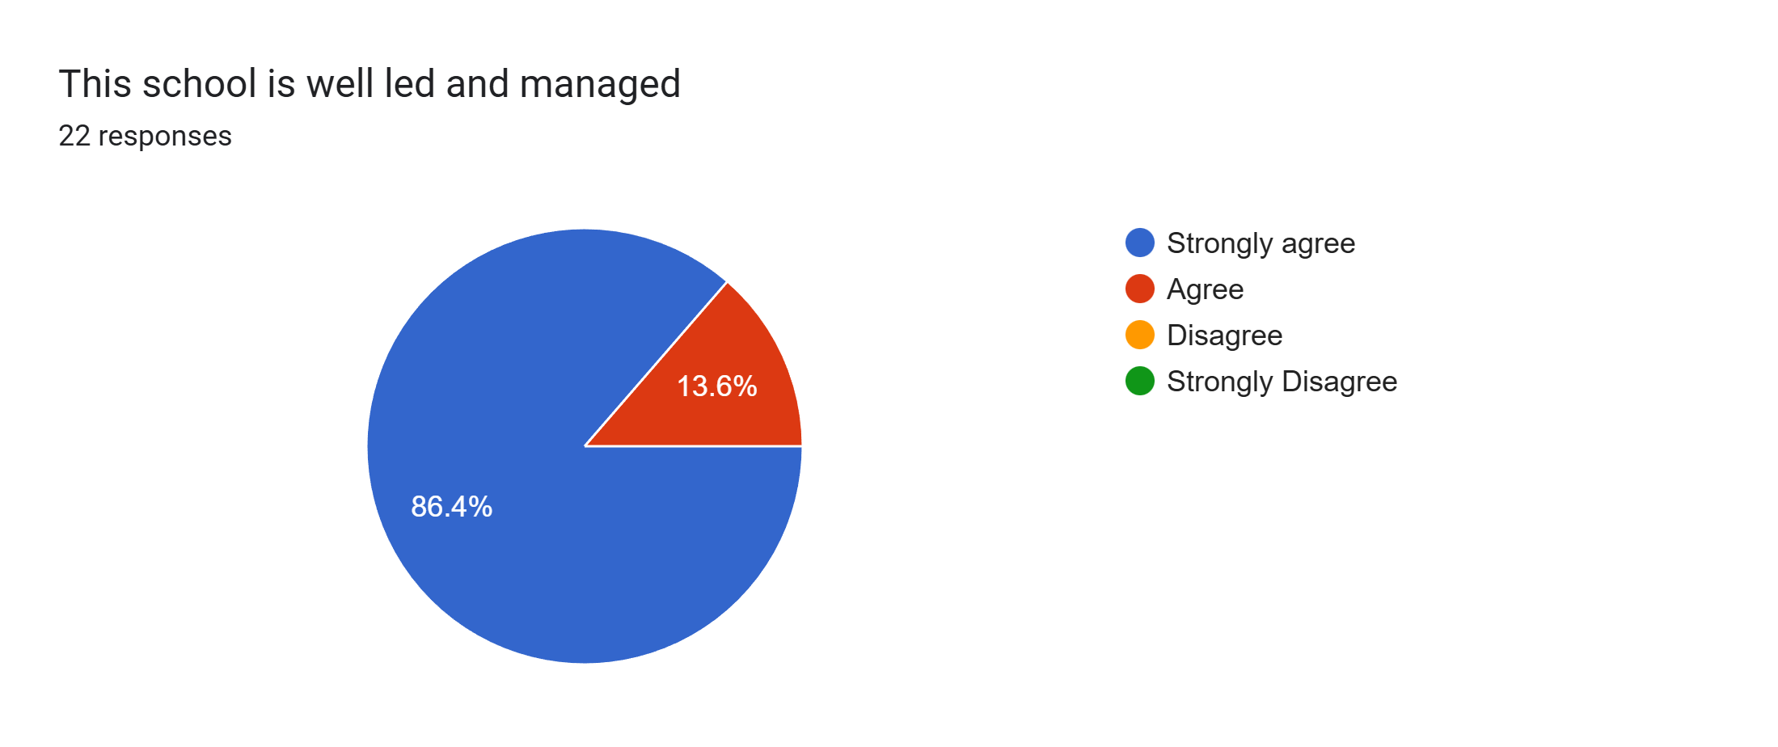
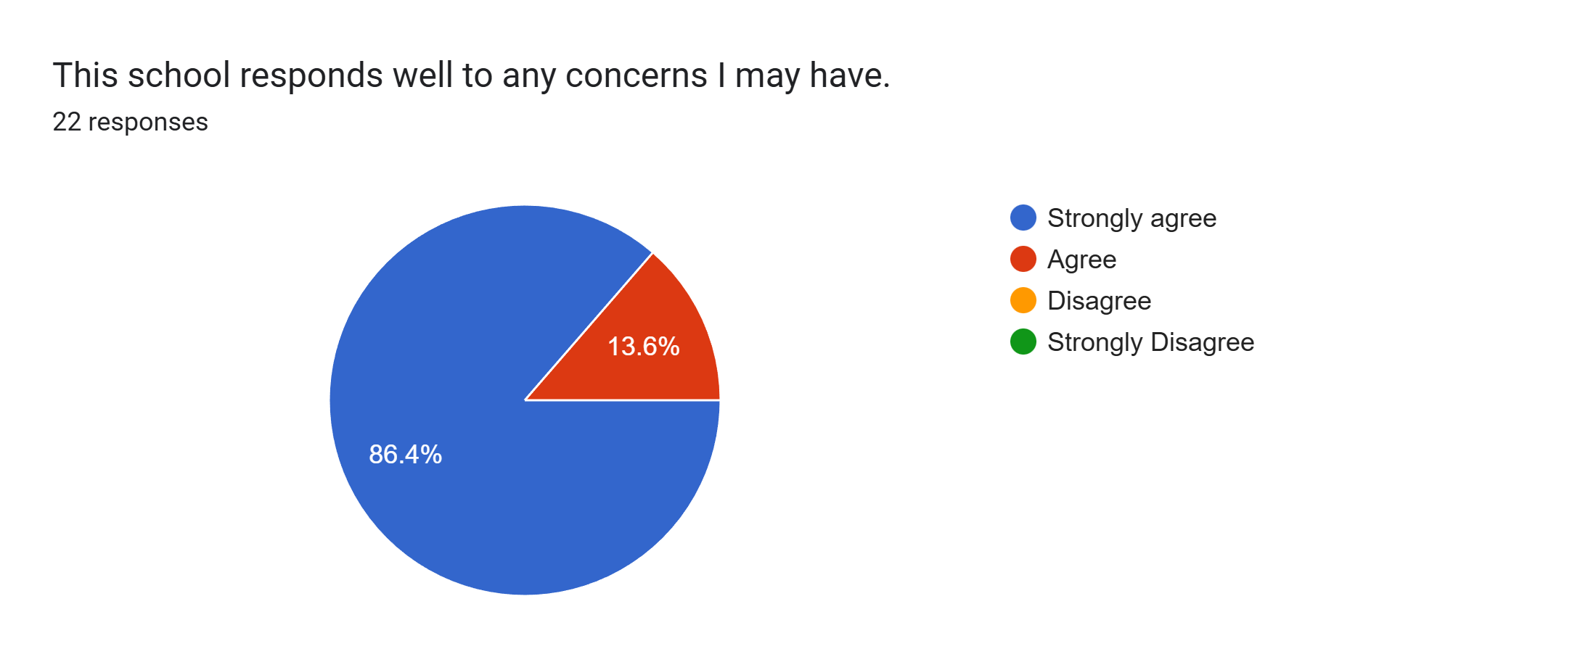
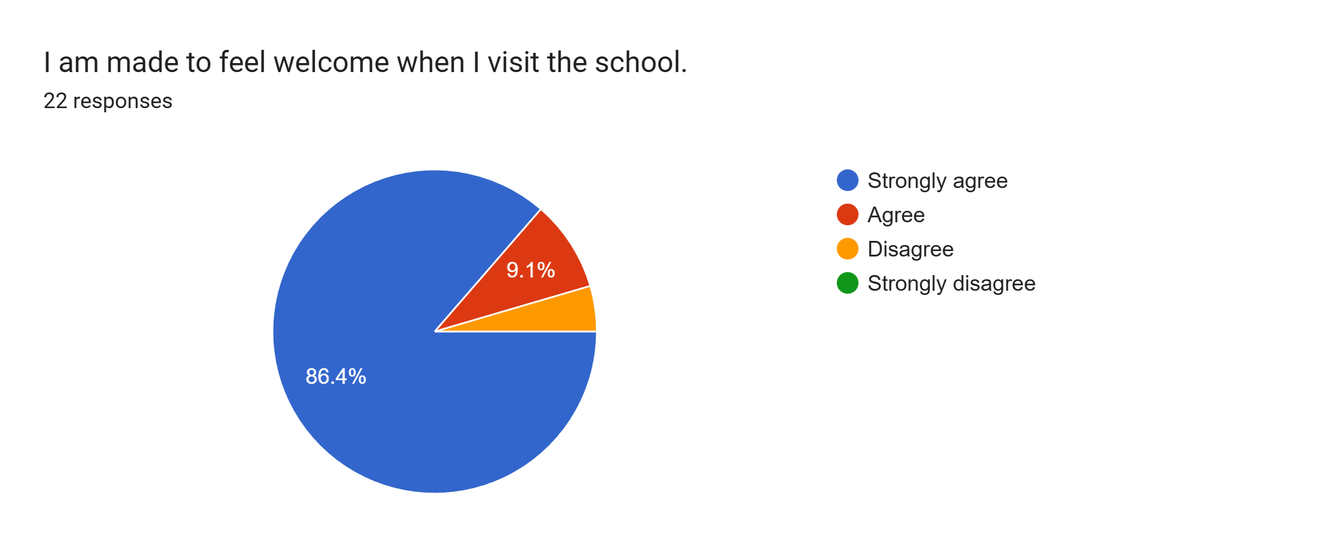
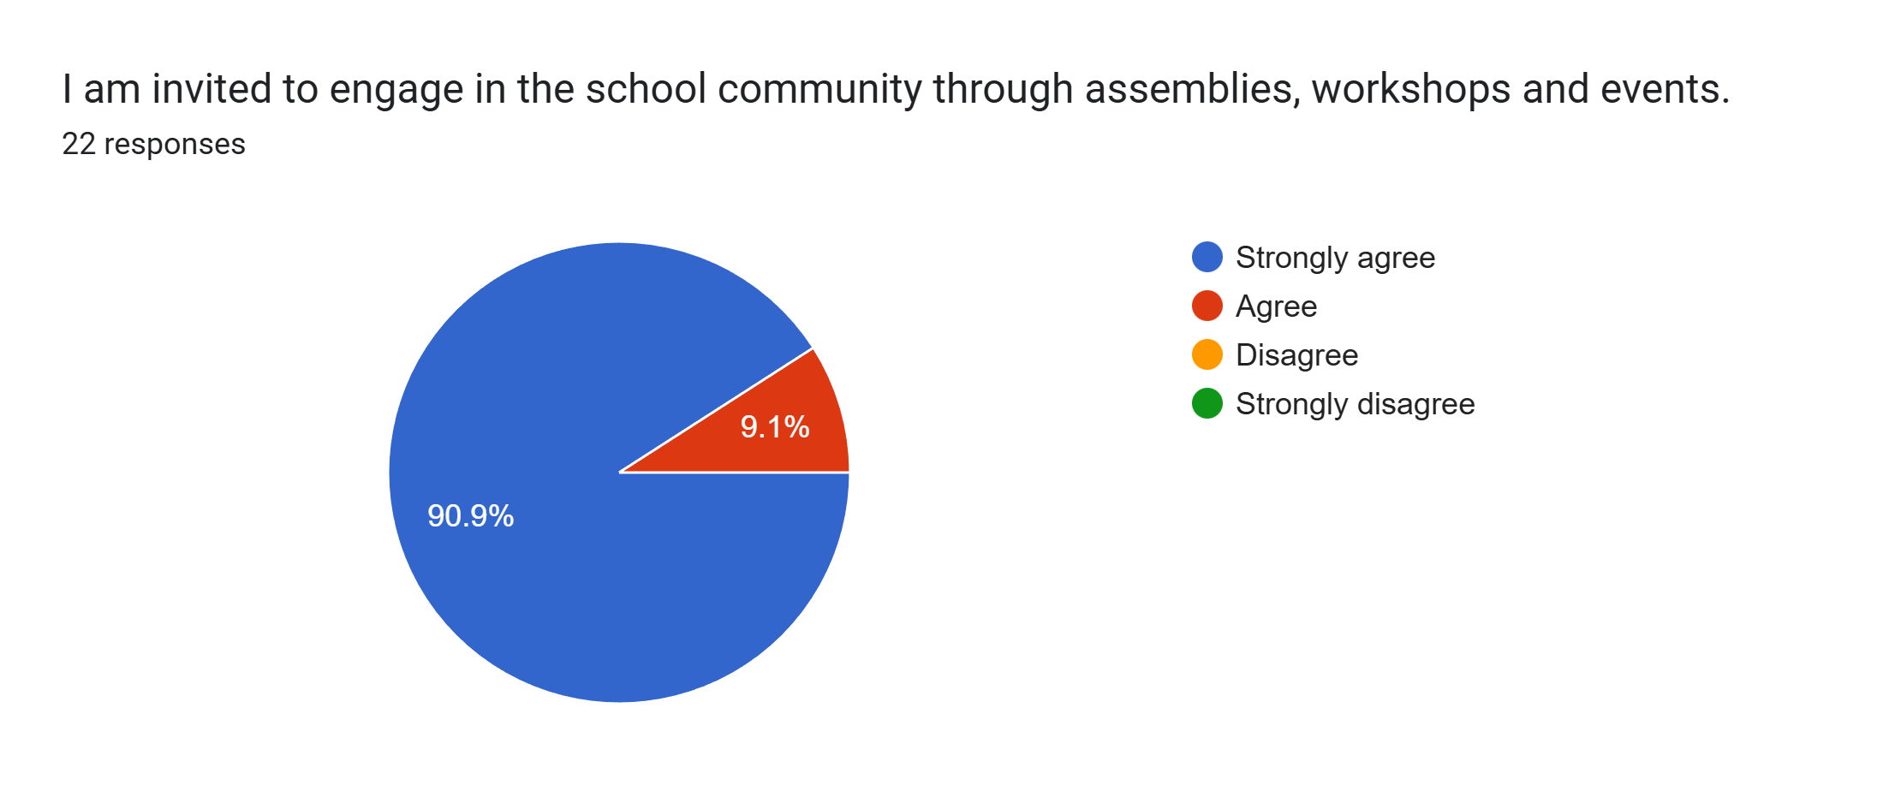
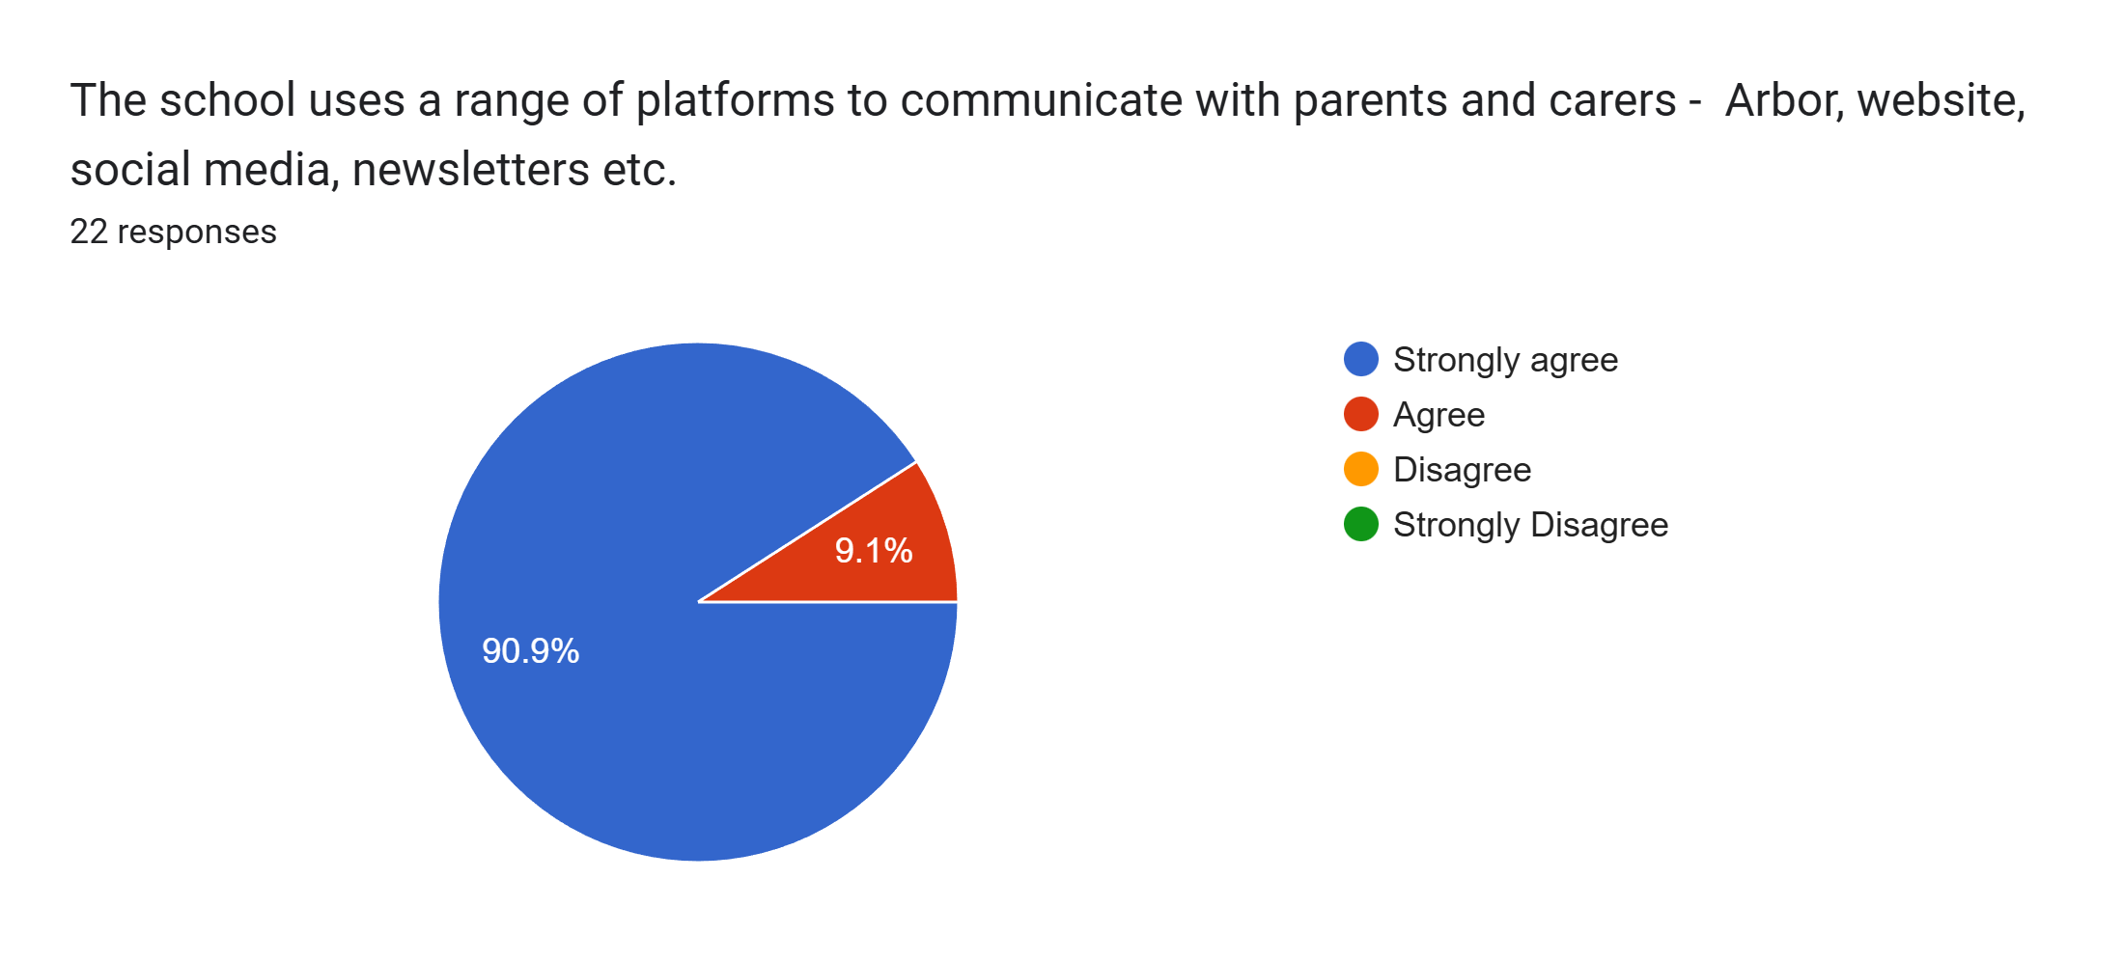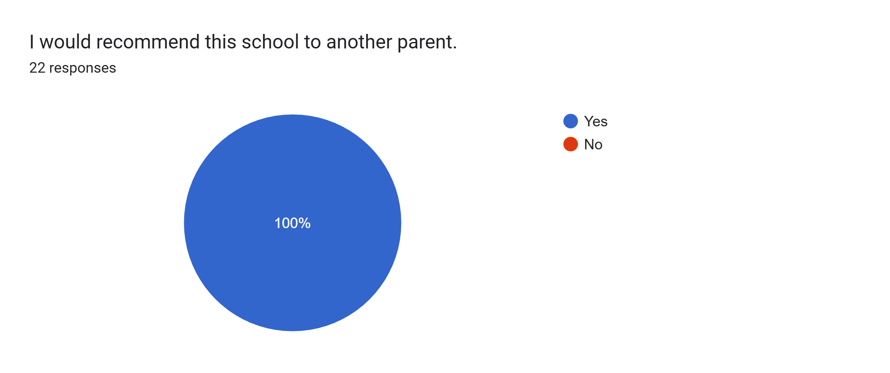
What other comments would you like to make to staff:
- Great.
- Lovely staff.
- Thank you for all your hard work. It's gratefully appreciated.
- Thank you.
- Thank you.
- Since my children have been here I feel like they are doing good. I am very proud of both of my children and I hope they keep up the good work.
- Great school - my son thrives here.
- My son has been well supported at school.
- Thank you so much for all support.
- Amazing school.
- Amazing.
- Thank you all.
- Lovley teacher.
- Thank you. I have noticed a significant change in my son this past 18 months and I put it down to this school and how much they invest in the kids. He’s so much more willing to learn and happier overall.
- Staff in year 5 are amazing. My daughter is really happy in school.
- Very kind and understanding.
- So proud of my daughter’s progress with Miss Sutton in year 5.
- Great school.
- My son has really enjoyed this year so far. He loves his teachers and is really thriving this year. His teachers are wonderful.

