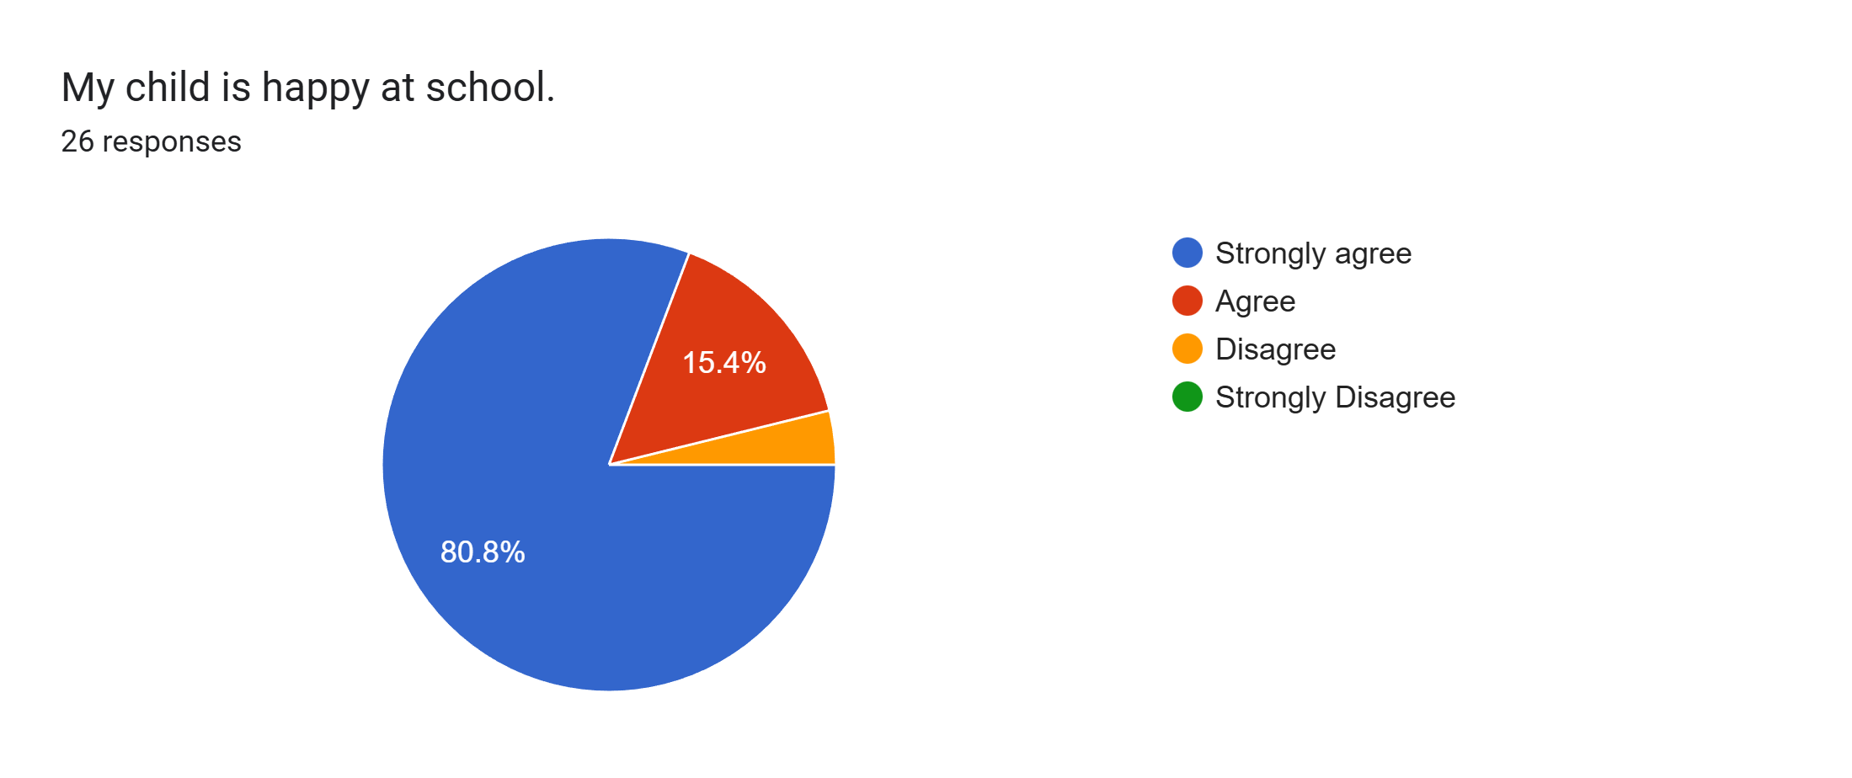
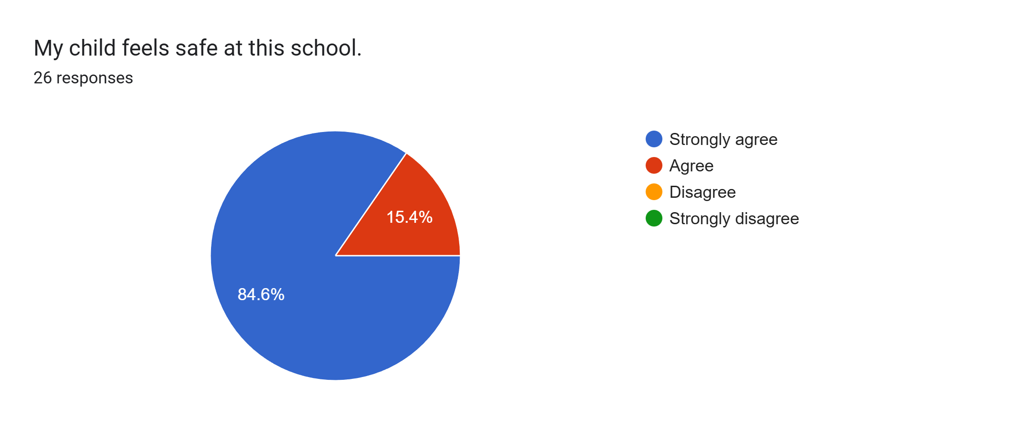
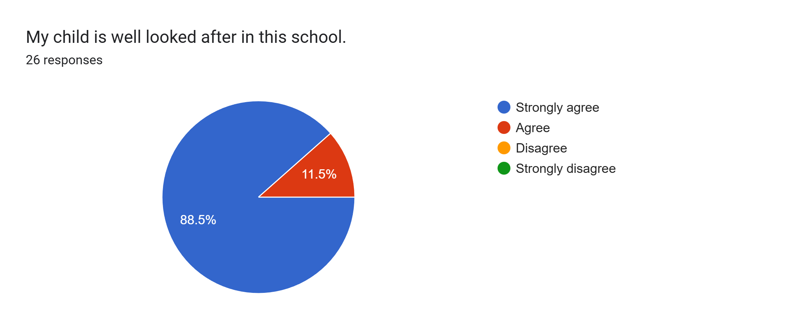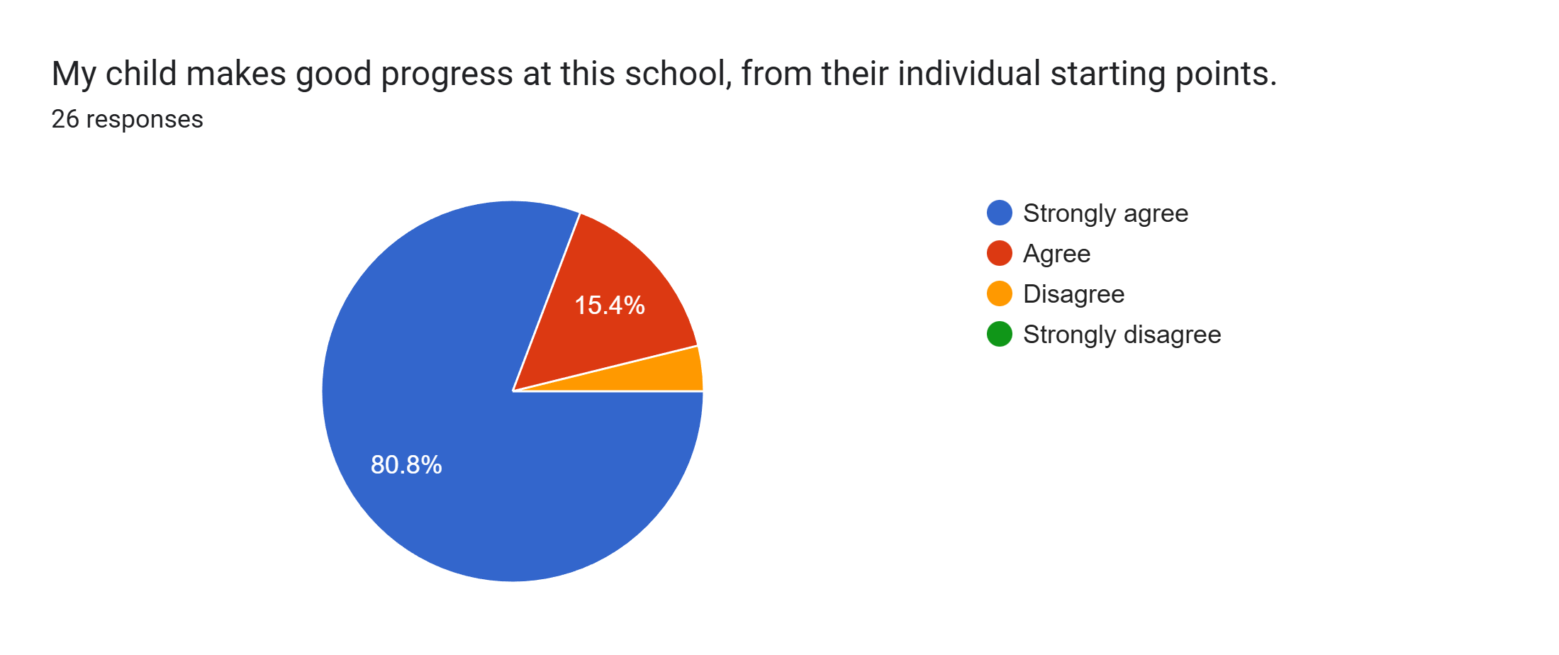
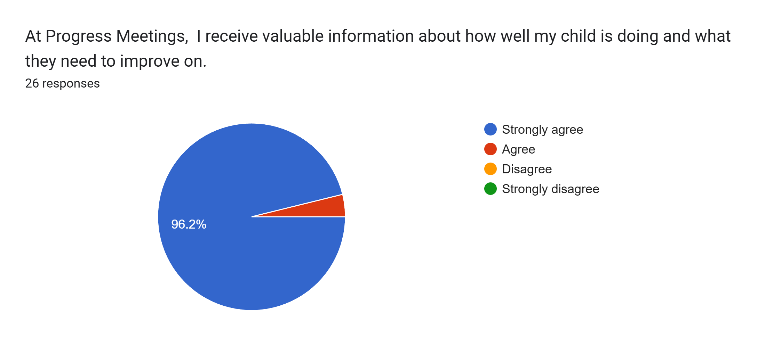
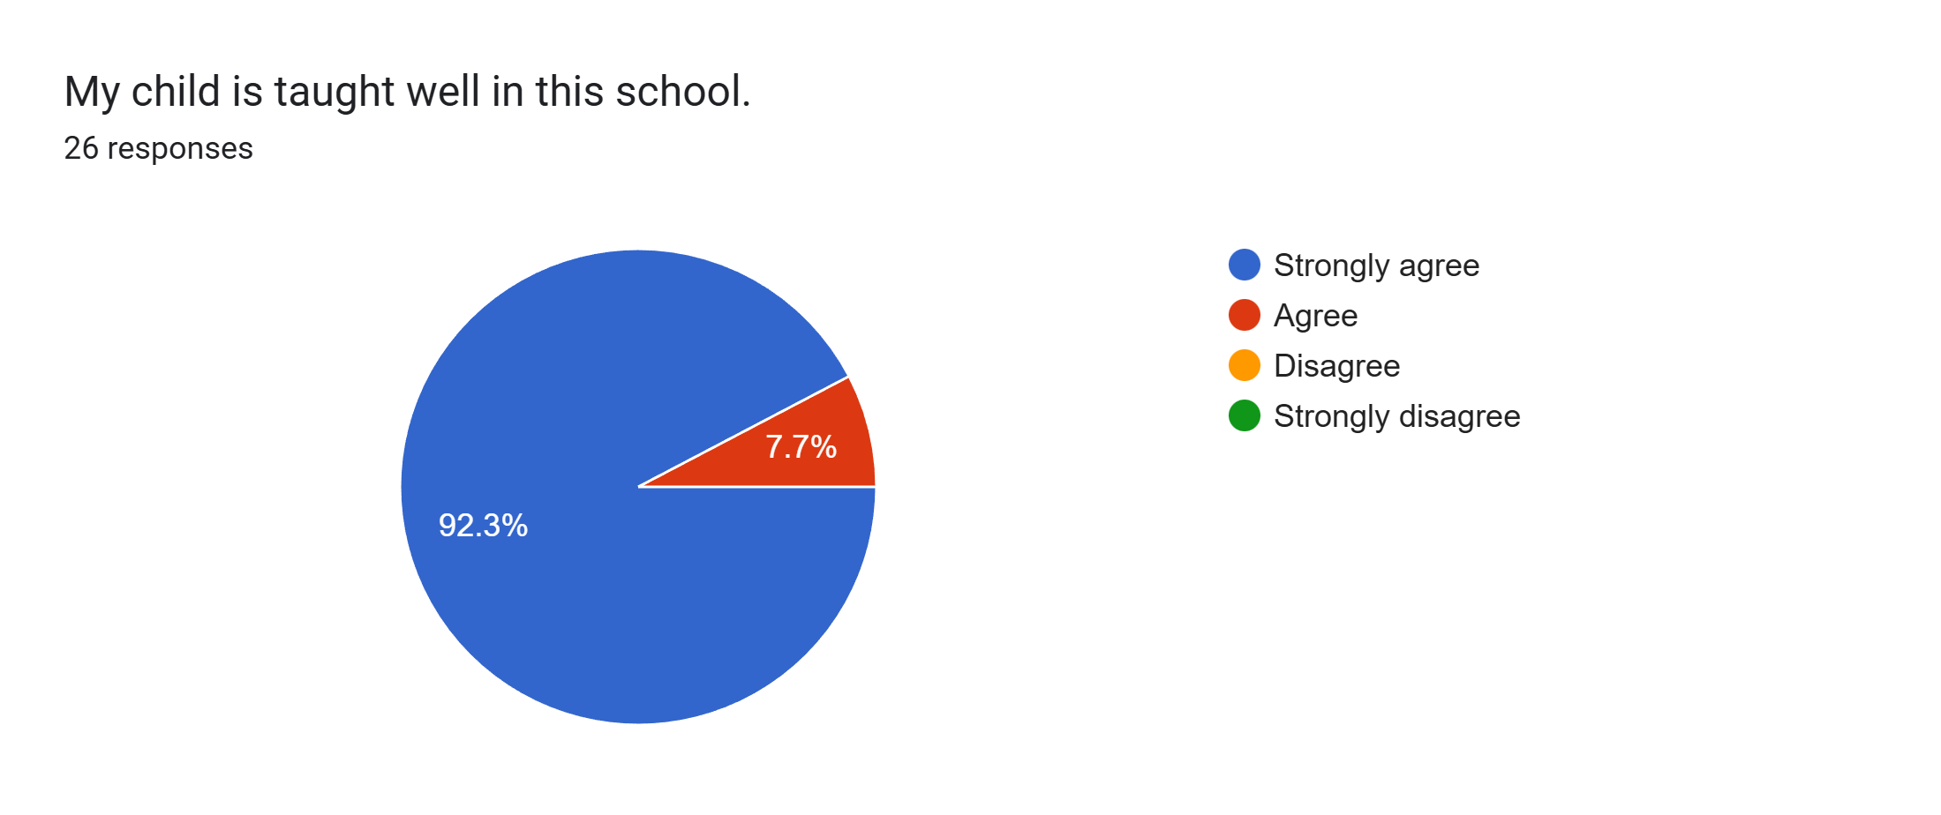
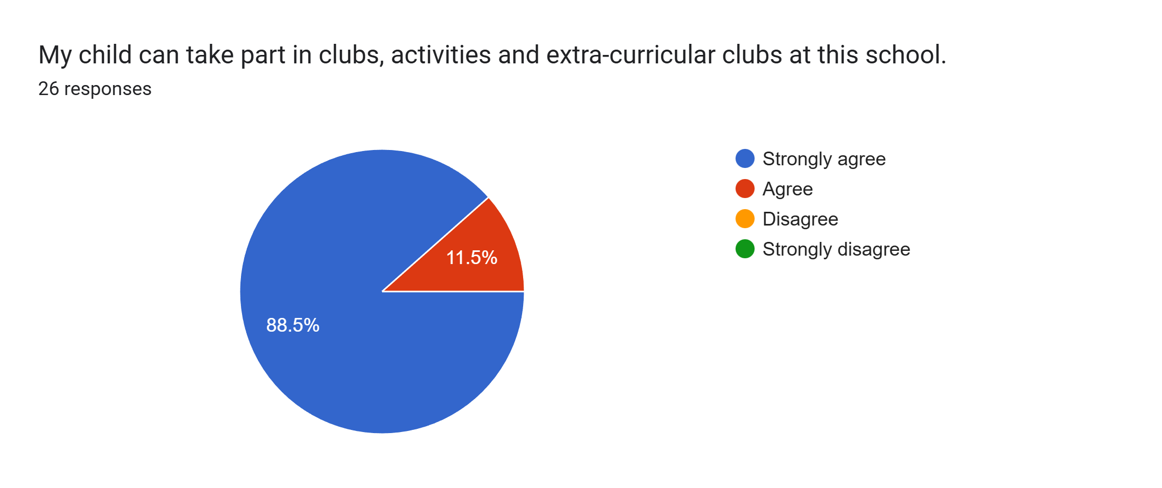
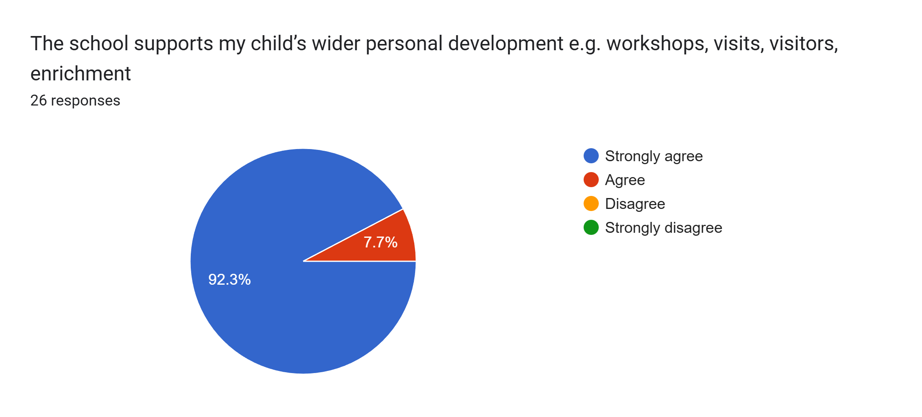
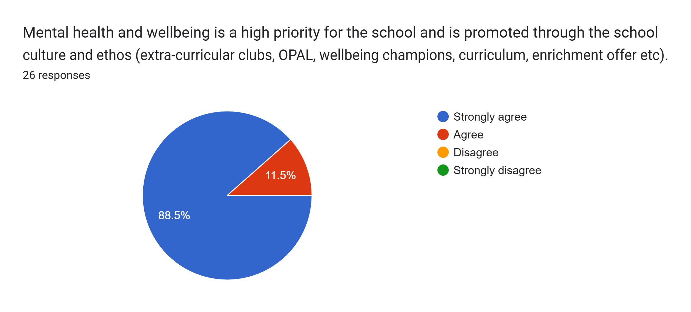
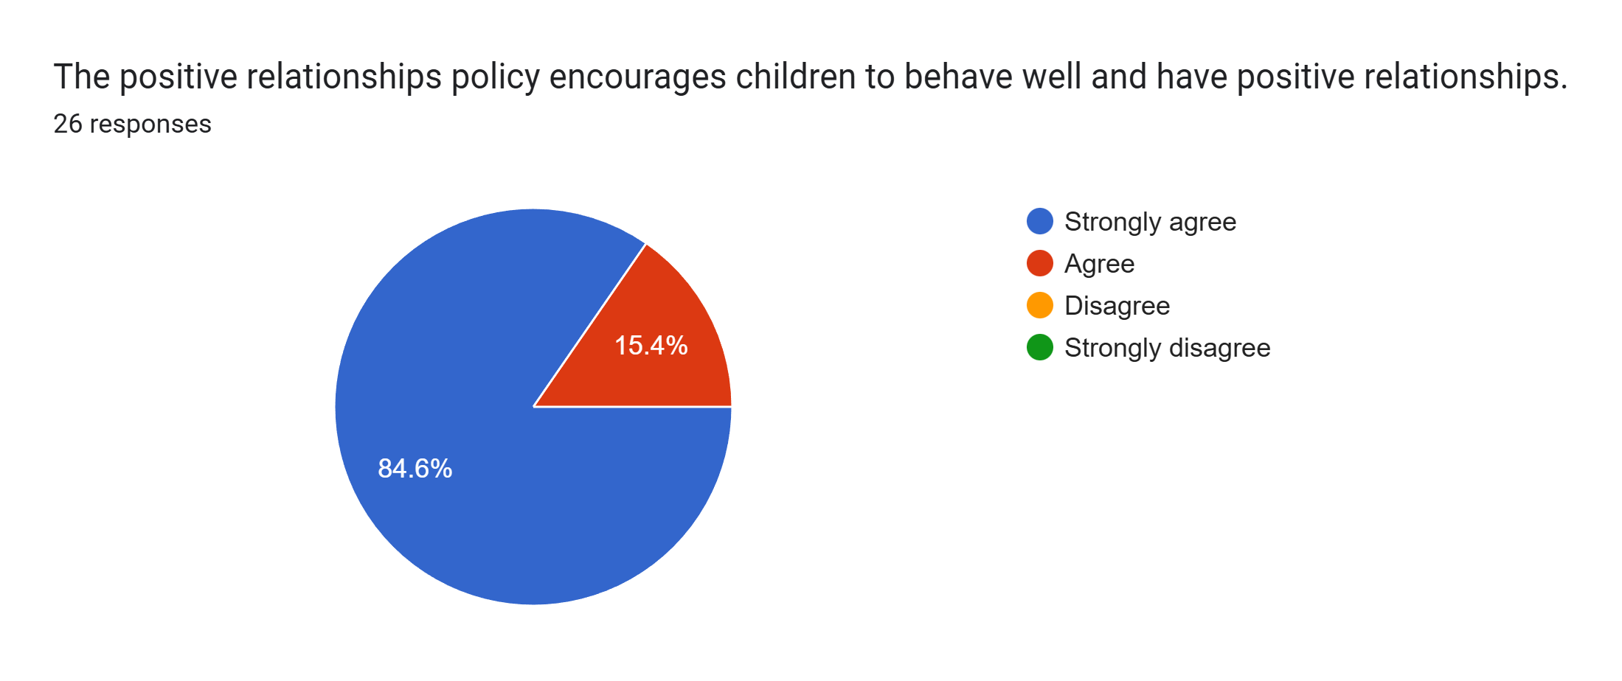
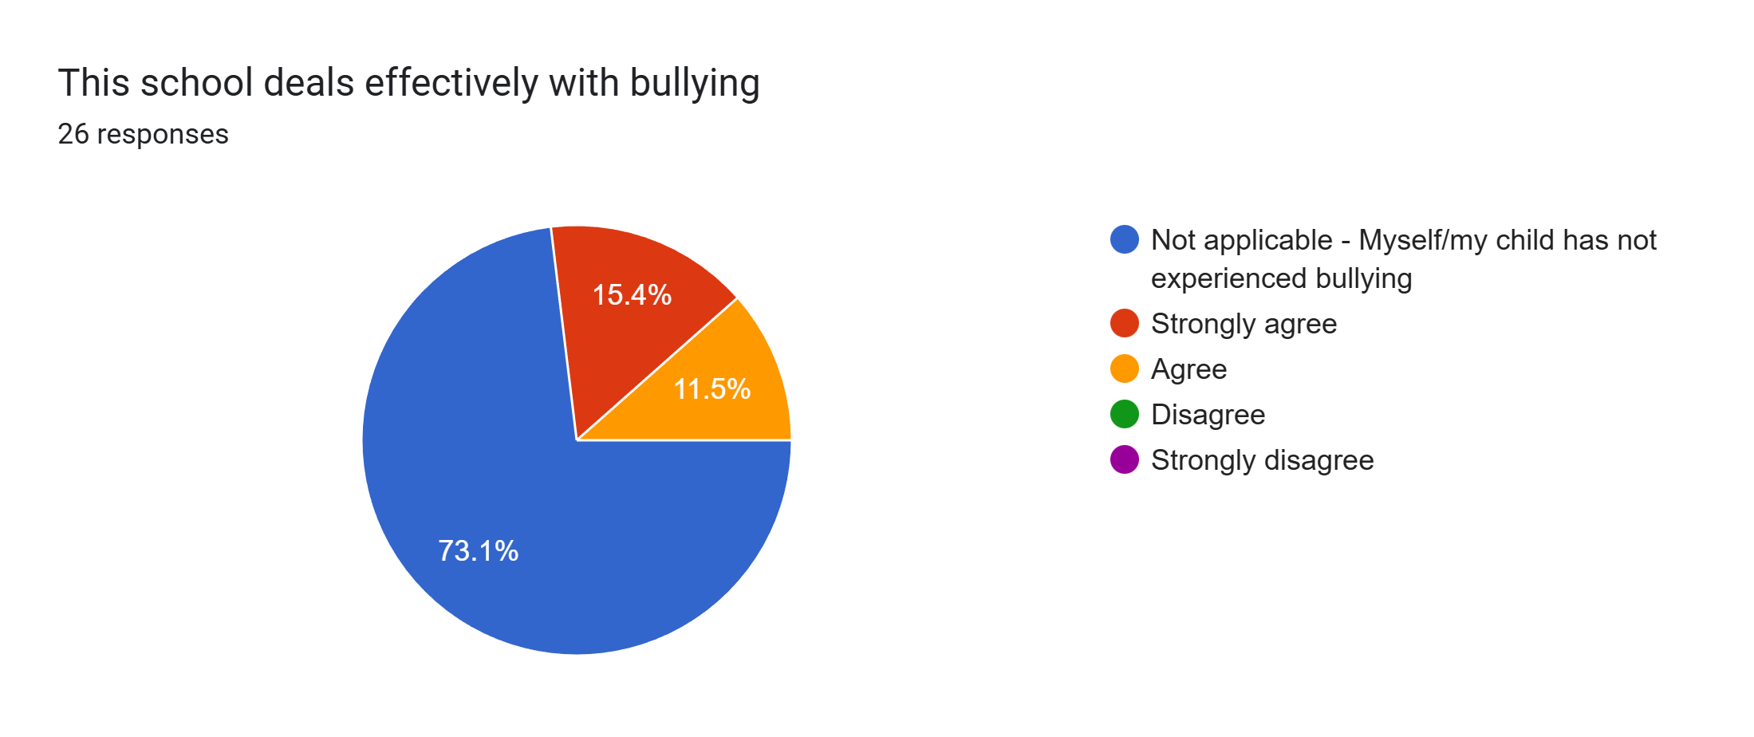
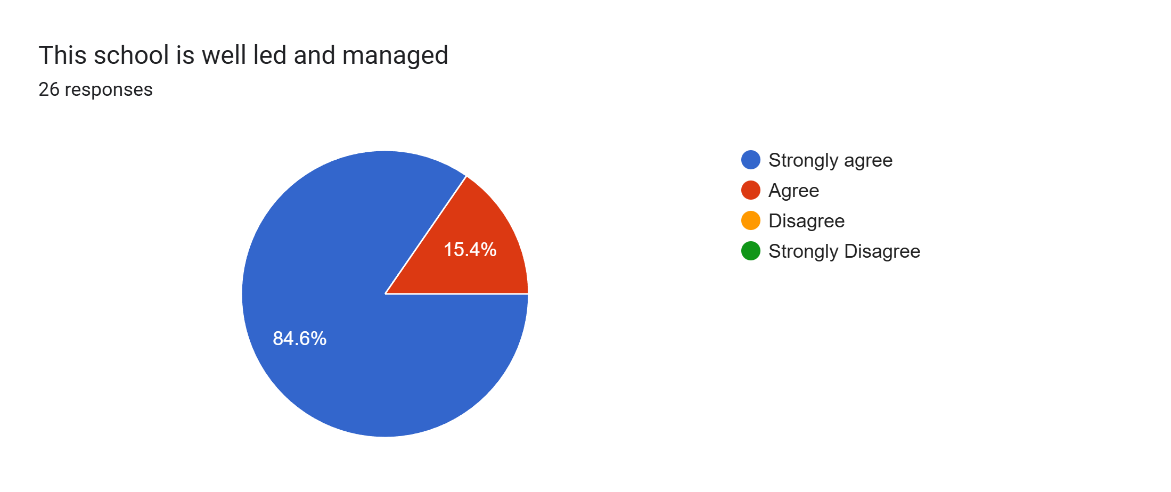
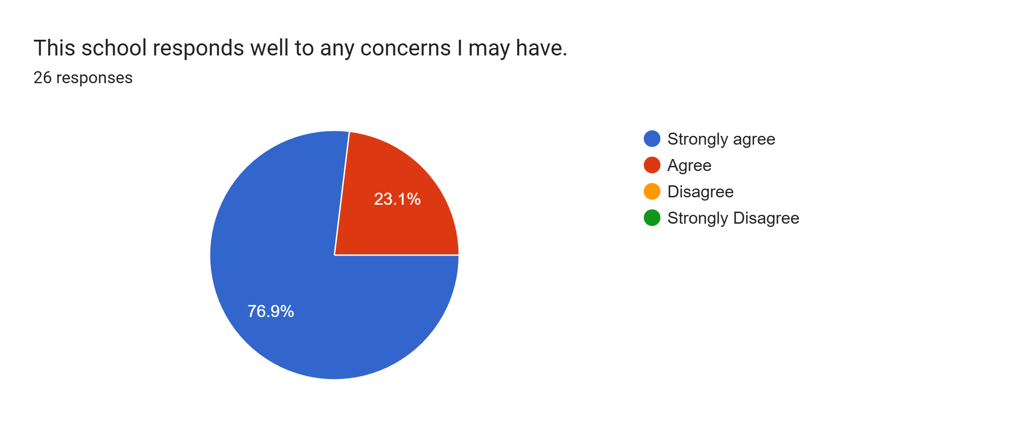
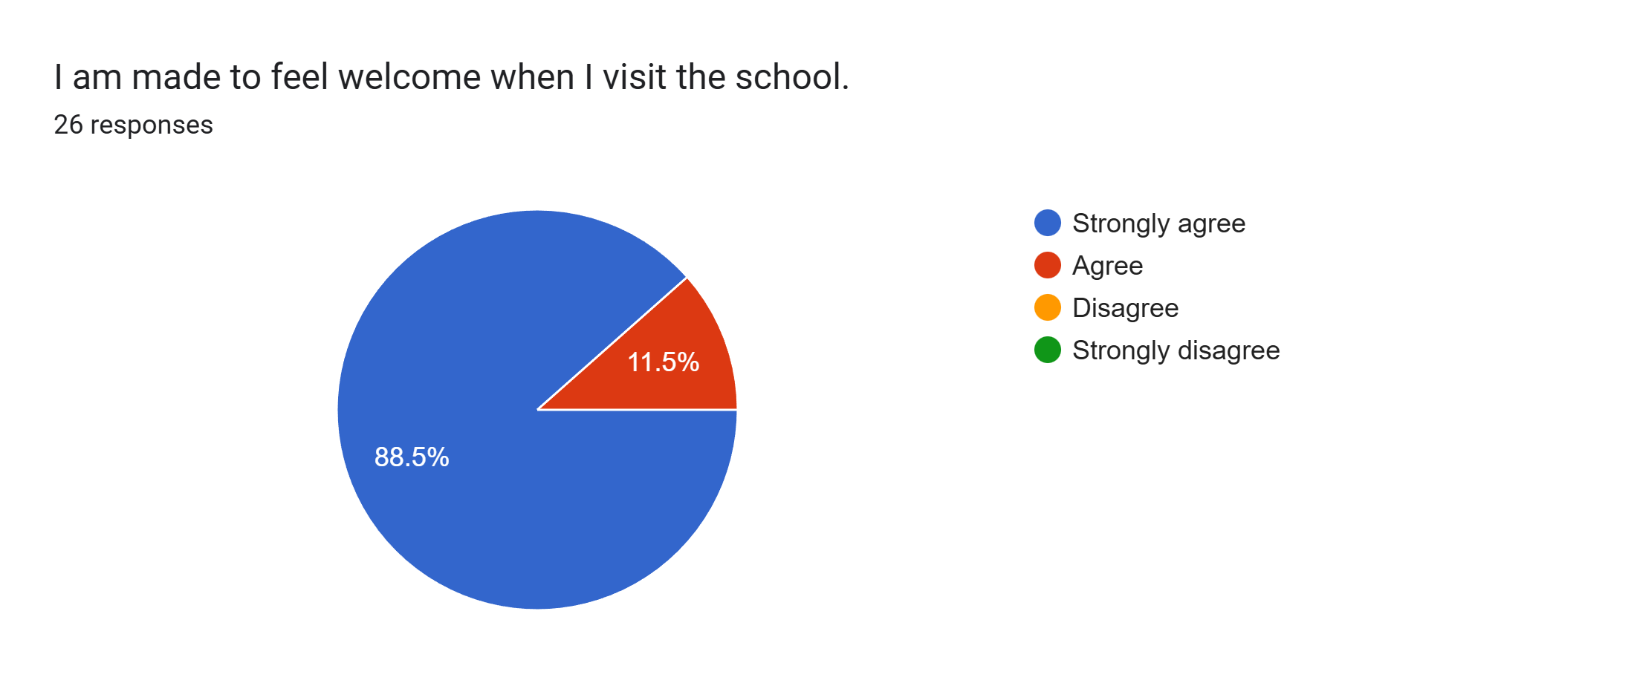
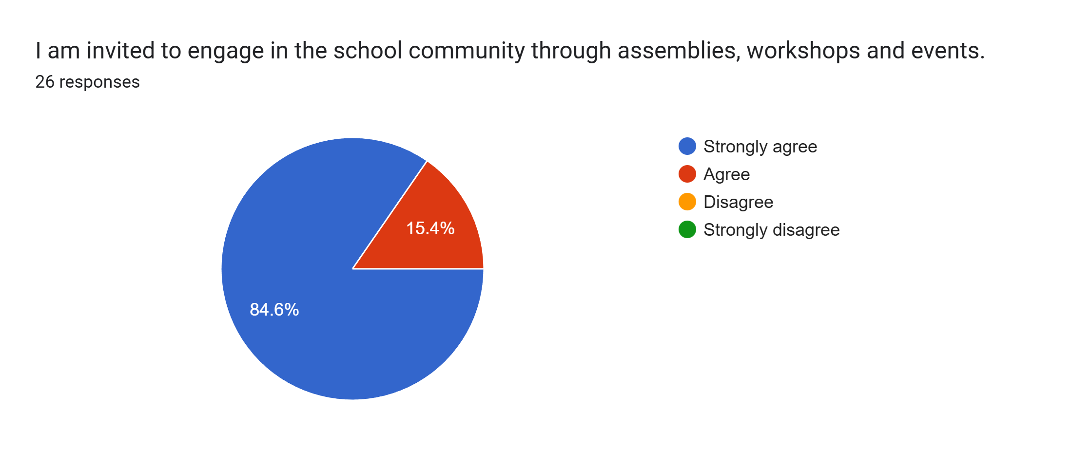
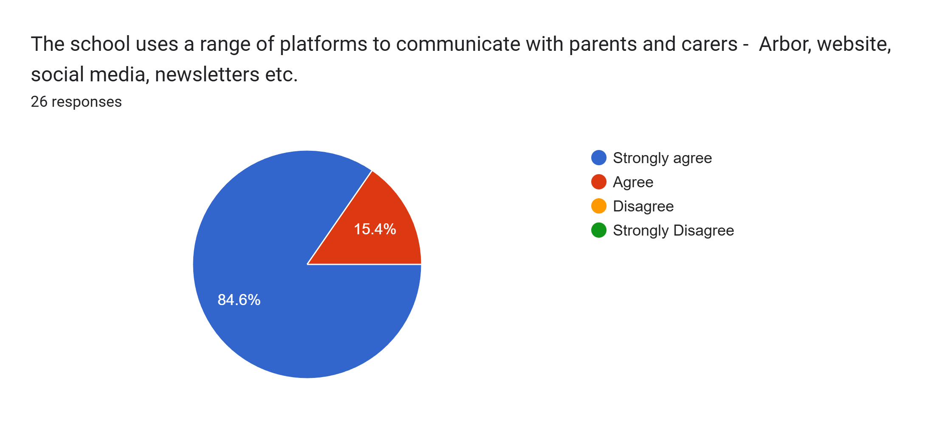
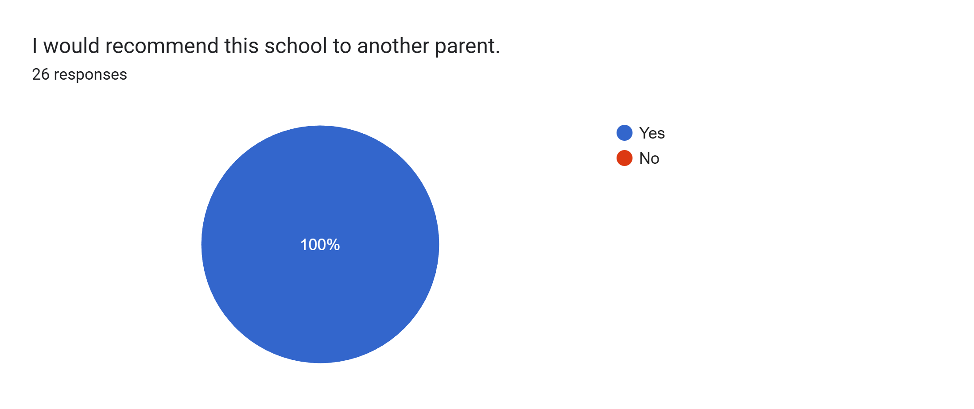

What other comments would you like to make to staff:
- Thanks for being amazing.
- My daughter is happy here which makes me happy.
- Thank you for always thinking about the whole experience of the kids.
- Amazing school and teachers. Thank you to Mr Wright and Miss Tucker - you are both amazing.
- Amazing school.
- The staff always take time to help with my son’s needs.
- Everything is good at the school.
- Thank you for everything you do and for making school such an enjoyable place for the kids to be.
- No issues.
- We are happy about everything. Thank you.
- Thank you for putting plans in place to aid my daughter’s wellbeing.
- Thank you so much for a lovely progress meeting. It was so nice to be able to sit and talk about how my child is developing. Looking forward to the rest of the year.
- Very happy with staff and school.
- Great staff.
- Amazing staff go above and beyond for our daughter.
- Lovely school and my son is happy here.
- Thank you to Mr Wright. You have made a brilliant start to the year. Thank you for listening to me.
- They are the best.
- Thank you for continually creating such a warm and loving learning environment for my child.
- Great school and staff.

