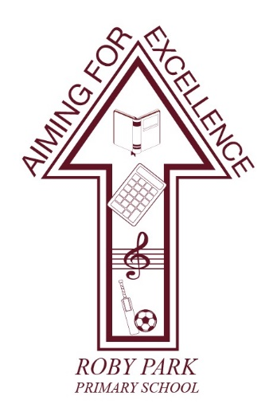

Roby Park Primary School

Easton Road

Huyton

Knowsley

L36 4NY

Tel: 0151 477 8340

Website: www.robyparkprimary.co.uk

E-mail: robypark@knowsley.gov.uk

Headteacher: Mrs K Allen

Date: Monday 19th January 2026

Parent Code of Conduct

Dear parent/carers,

At Roby Park Primary School, we greatly value the strong partnership between our staff, parents and carers in supporting pupils’ education. Working together is essential to help children develop the skills they need for adulthood, and we encourage all families to play an active role in school life.

Unfortunately, the actions of a small minority can sometimes undermine this positive relationship. As the Governing Body, we believe that every member of our school community - staff, parents, carers and pupils - deserves a safe and respectful environment. This letter serves as a reminder of the standards of conduct expected from all visitors to our school.

Abusive Behaviour
Nationally, one in three teachers has experienced abusive behaviour from parents or carers. We are committed to ensuring that no one in our school community faces aggression or abuse. This includes face-to-face interactions, written communication, telephone calls, and social media.

Unfortunately, here at Roby Park, our teaching and support staff have experienced it in all its forms and as a Governing body we are taking a zero-tolerance approach to this behaviour.

To maintain a safe environment, the following behaviours will not be tolerated:
- Swearing, name calling or displaying aggression
- Threatening physical harm to any member of the school community
- Damaging or destroying school property
- Intimidating any members of the school community
- Making malicious or unfounded allegations against staff or community members
- Insulting, intimidating or undermining any member of the school community
- Threatening to force entry on to the school site or refusing to leave when requested to leave

These are some examples of the behaviour that some members of our school community have experienced in person and online.

Anyone displaying disruptive or unreasonable behaviour will be dealt with under the school’s Code of Conduct. In more serious cases, restrictions may be imposed, including a permanent ban from school premises and events, and limiting communication to writing or via a third party. In extreme cases, incidents will be reported to Merseyside Police.

Social Media Use
While we respect the right to free speech and acknowledge the benefits of social media, we have sadly seen a rise in online abuse of members of our school community – including comments made in WhatsApp groups. Inappropriate use of social media can cause harm. Please note that posts are rarely truly private - comments can be shared widely. Threatening or discriminatory posts may be referred to the police and reported to the platform. We ask that you never refer to individual pupils or staff members on any form of social media.

If you have concerns or disagree with a decision, we welcome constructive feedback. Please raise issues directly with the relevant staff member. If matters cannot be resolved this way, they should be addressed through our Complaints Policy.

Governor Coffee & Chat Sessions
As the Governing body, we have a duty of care to make sure that our school community is safe. It is our responsibility to make sure that our children feel safe in school, along with their parents who entrust us with their care. We take this responsibility very seriously and have consulted with Merseyside Police to ensure our response to future incidents are robust and preventative.

To further support open communication, we will announce dates for Governor Coffee & Chat sessions in the coming months, where parents and carers will have the opportunity to chat with members of the Governing Team regarding how they can get involved and help develop initiatives and ideas to further improve the Roby Park school community and what we offer.

Thank you for your continued support in creating a safe and respectful school environment.

Warm regards,

Mrs Kami Lester
Chair of Governors

