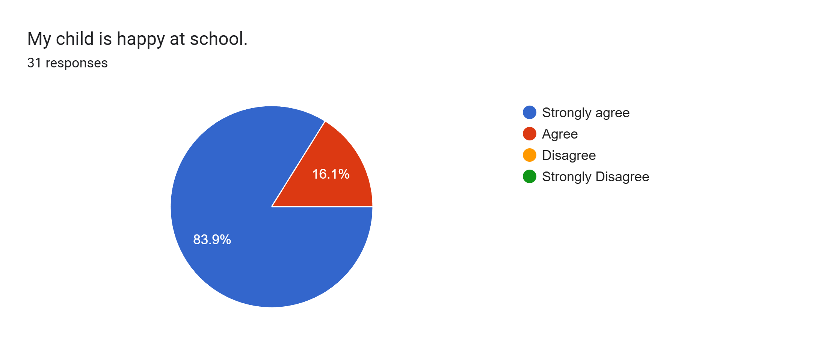

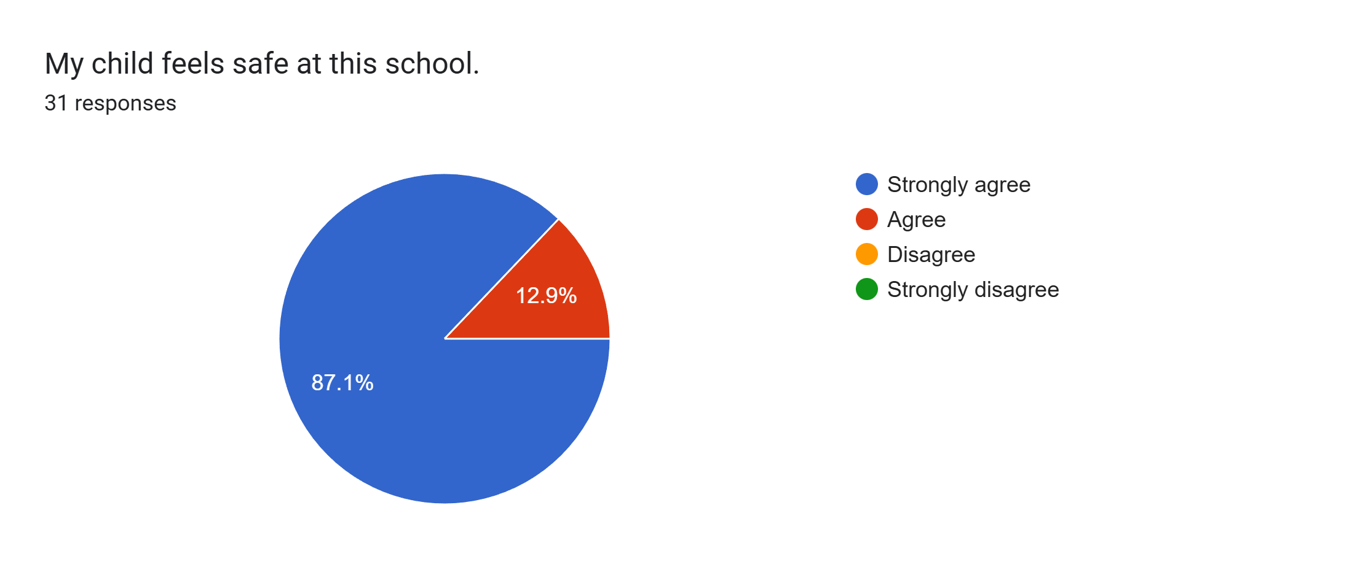
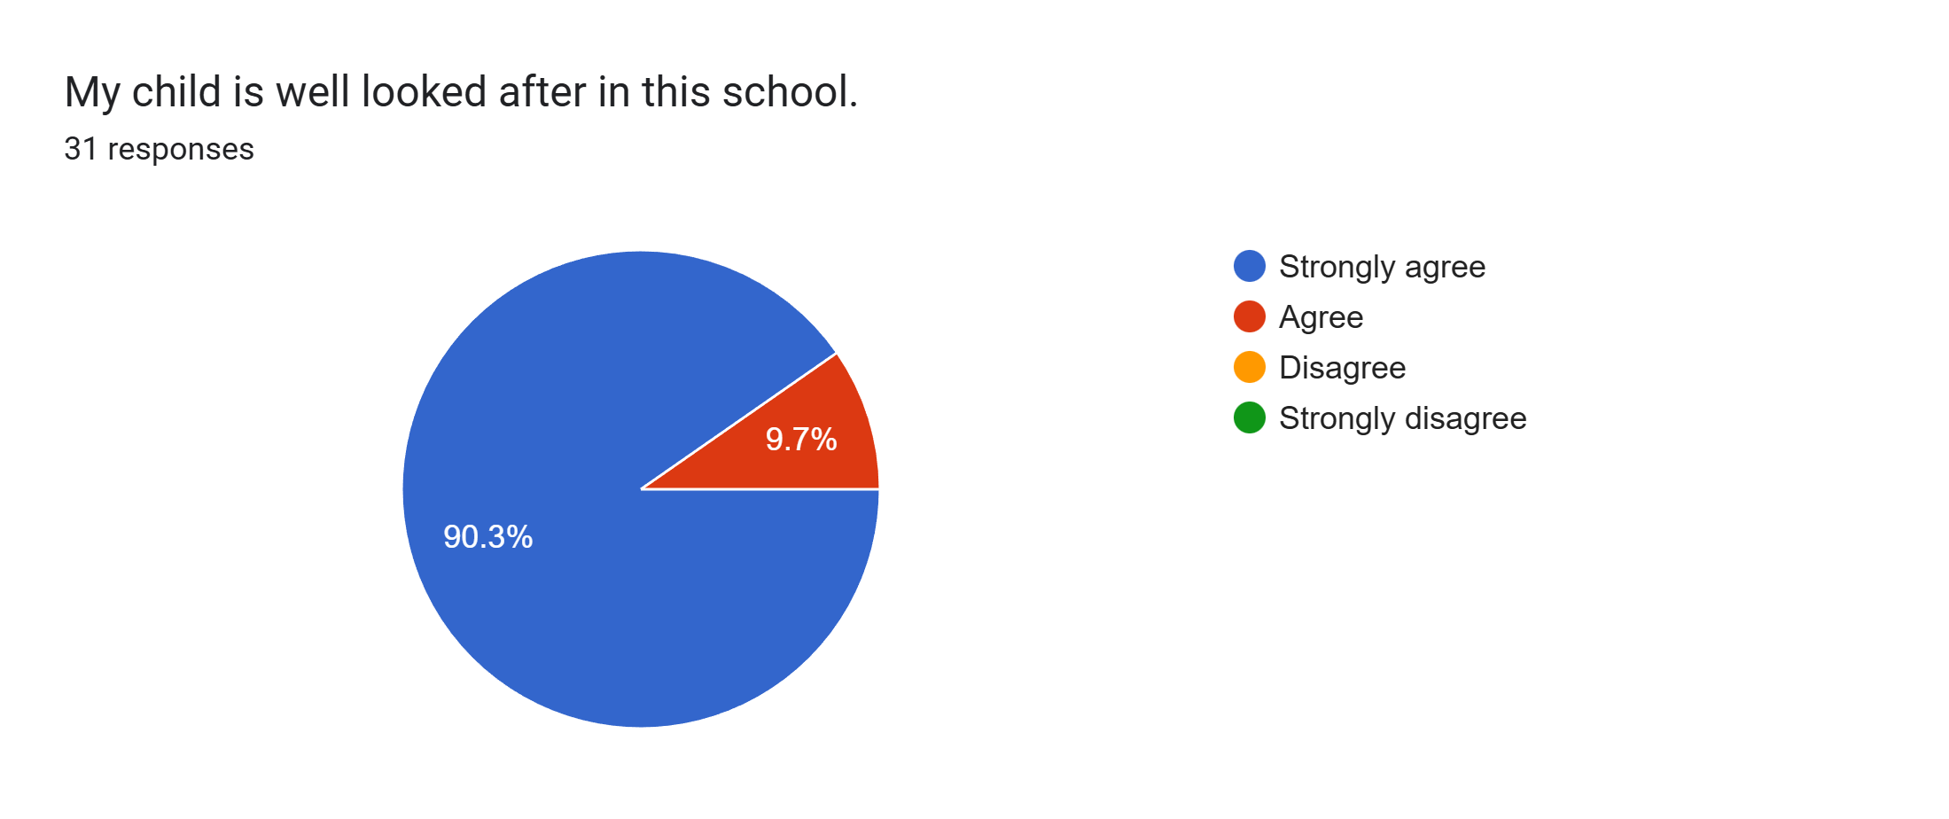
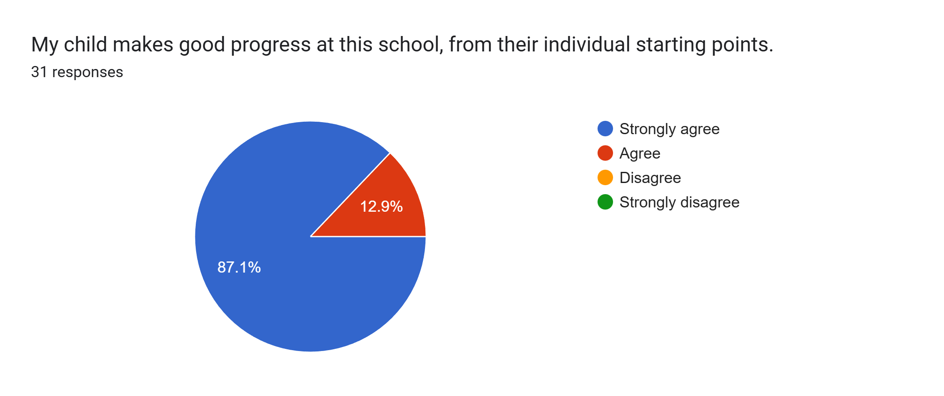
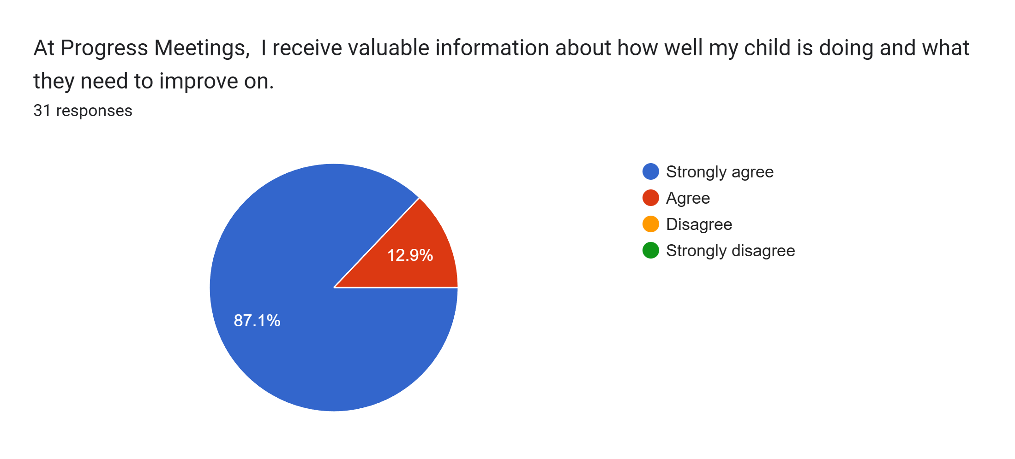
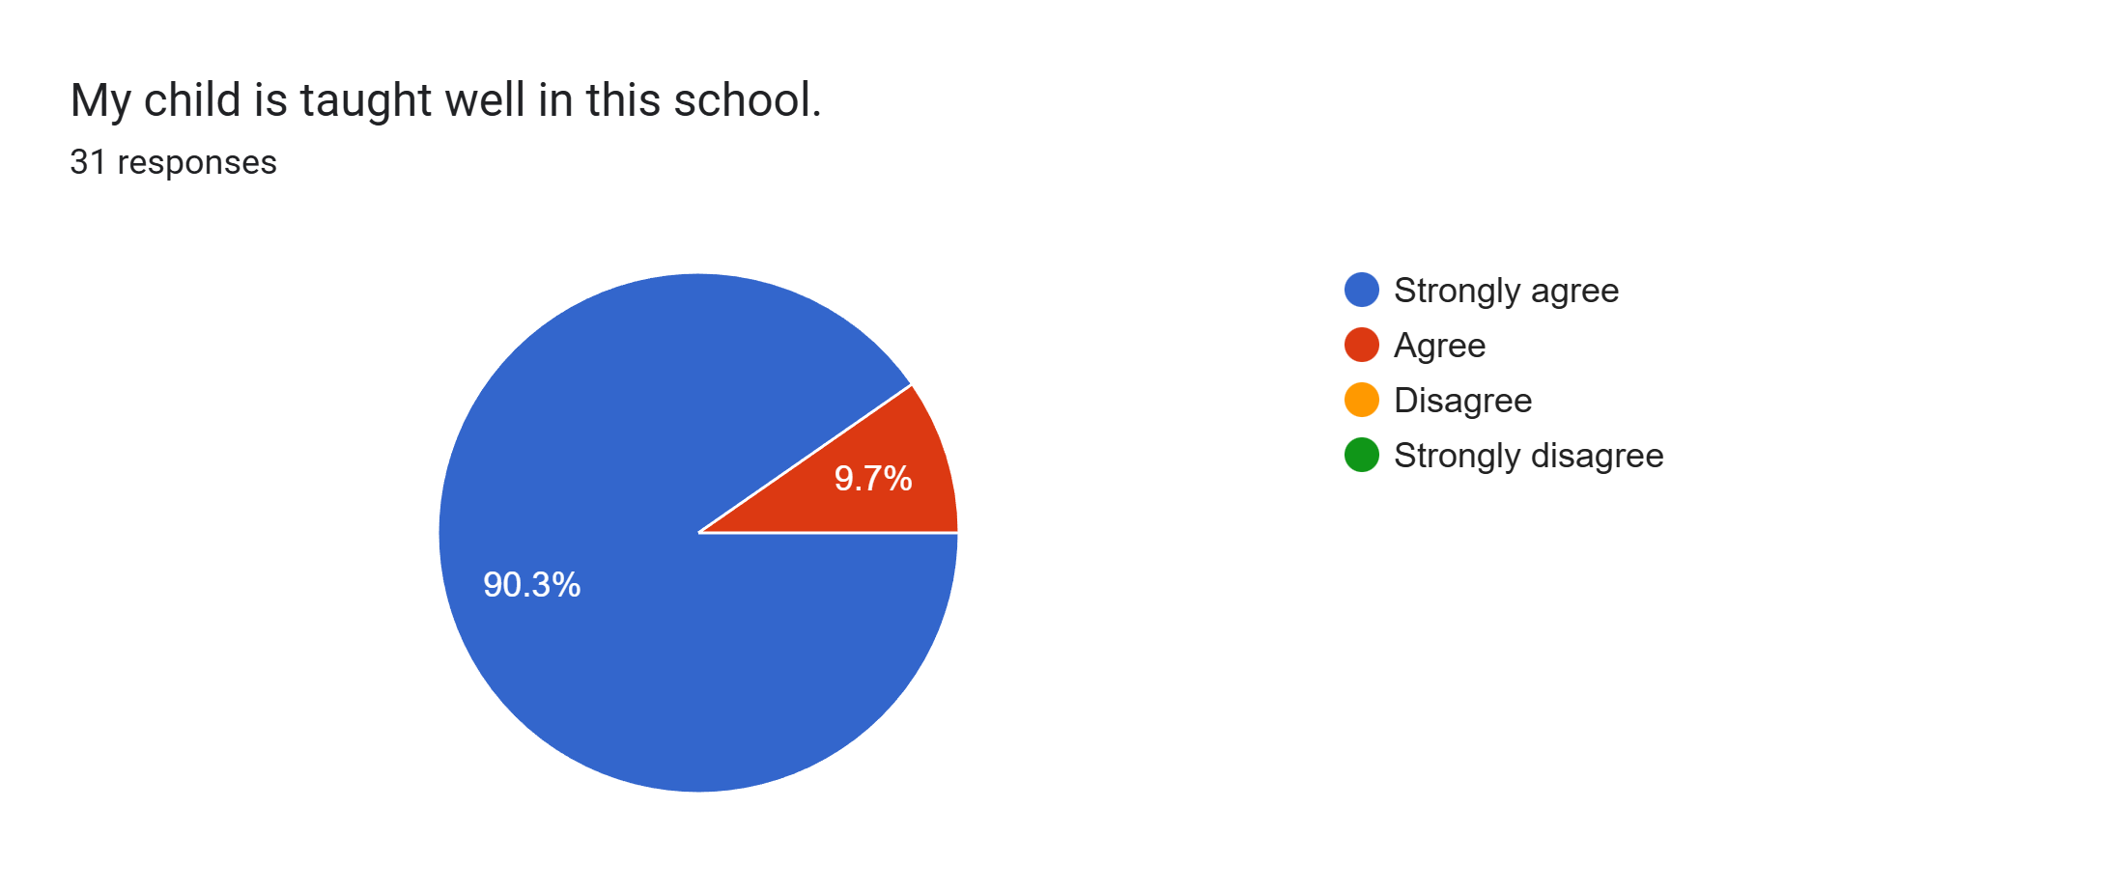
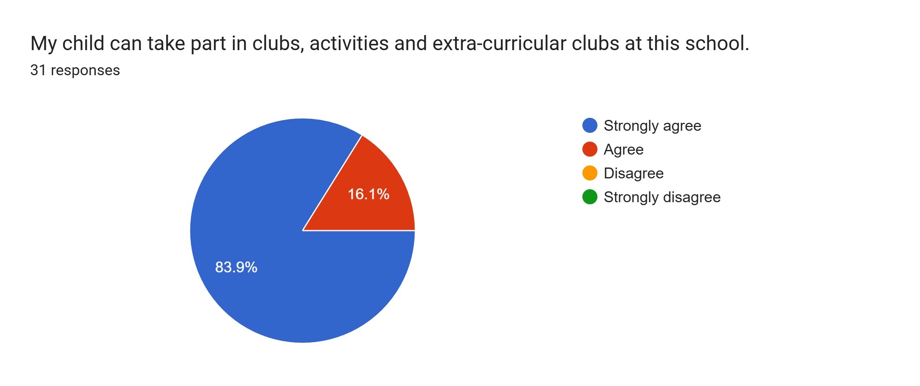
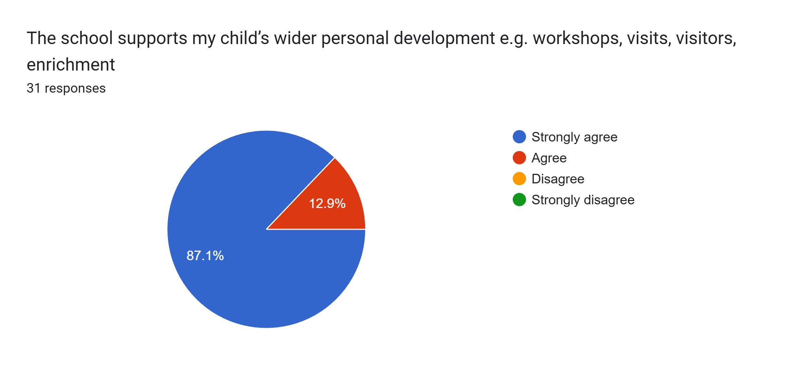
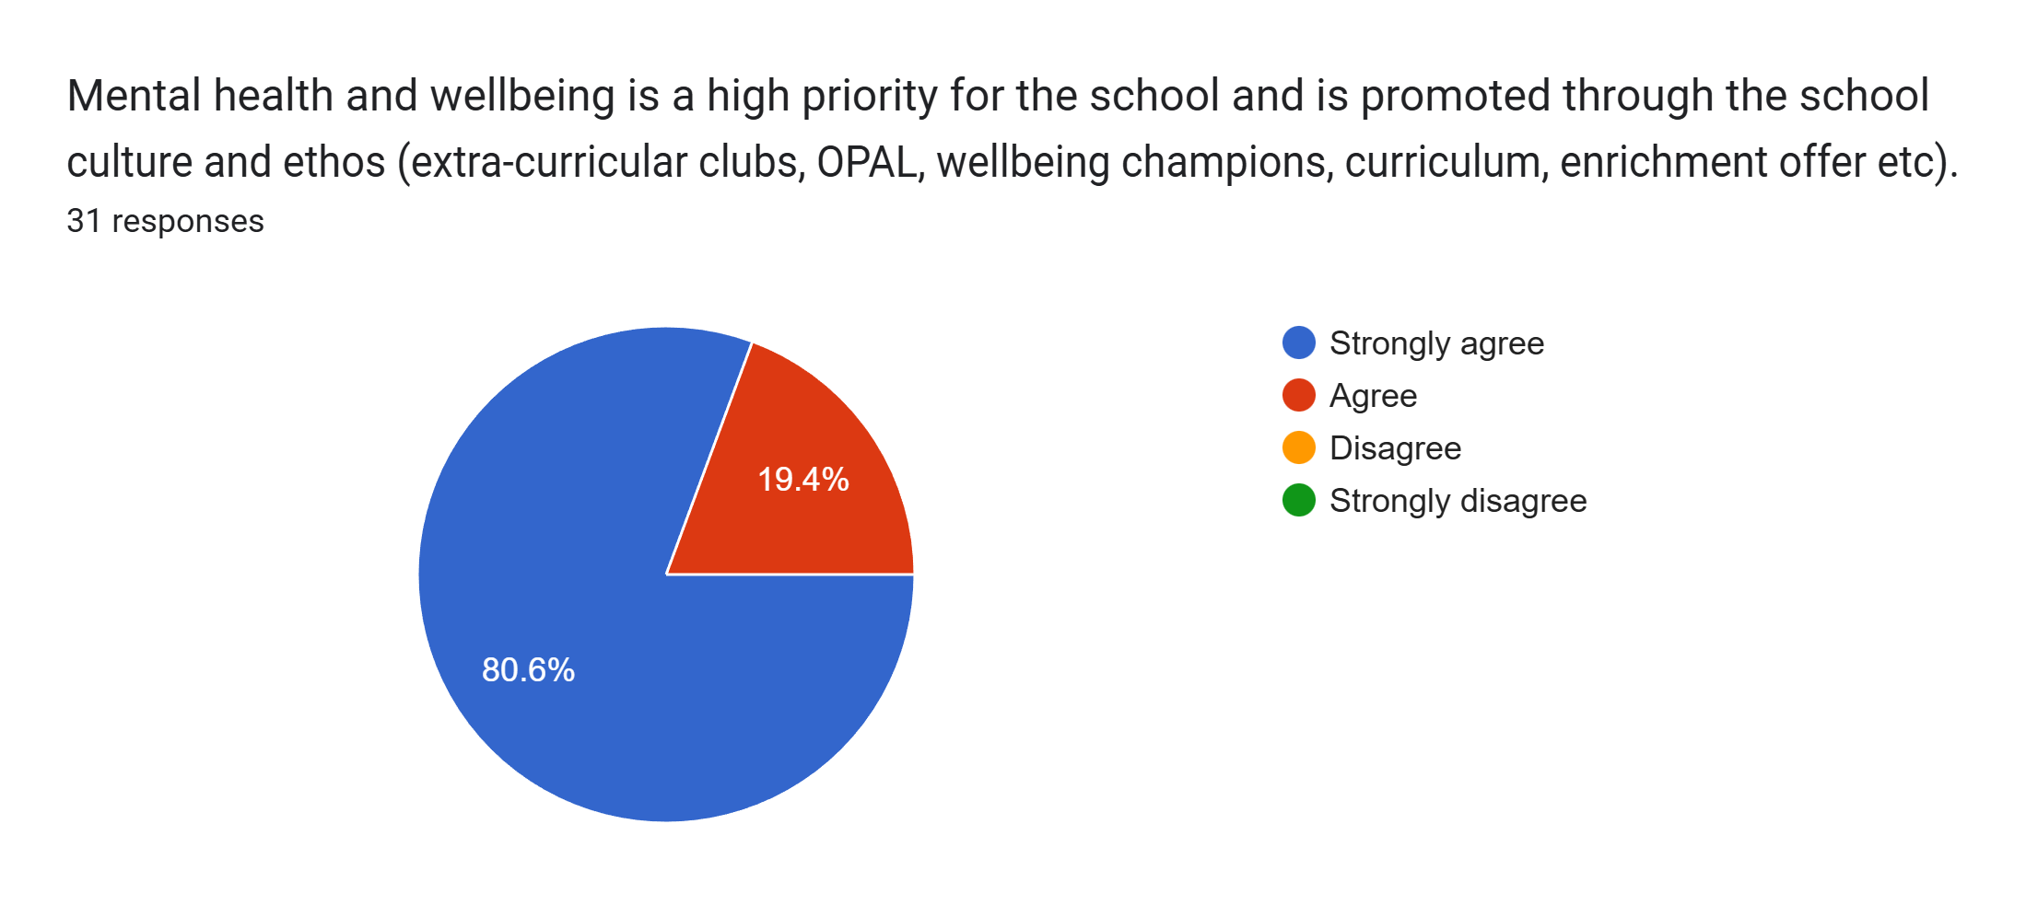
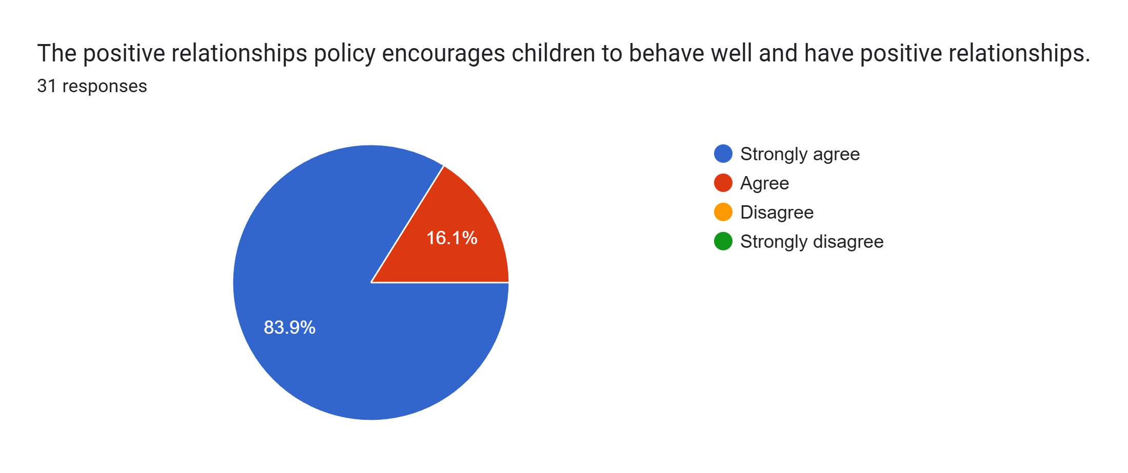
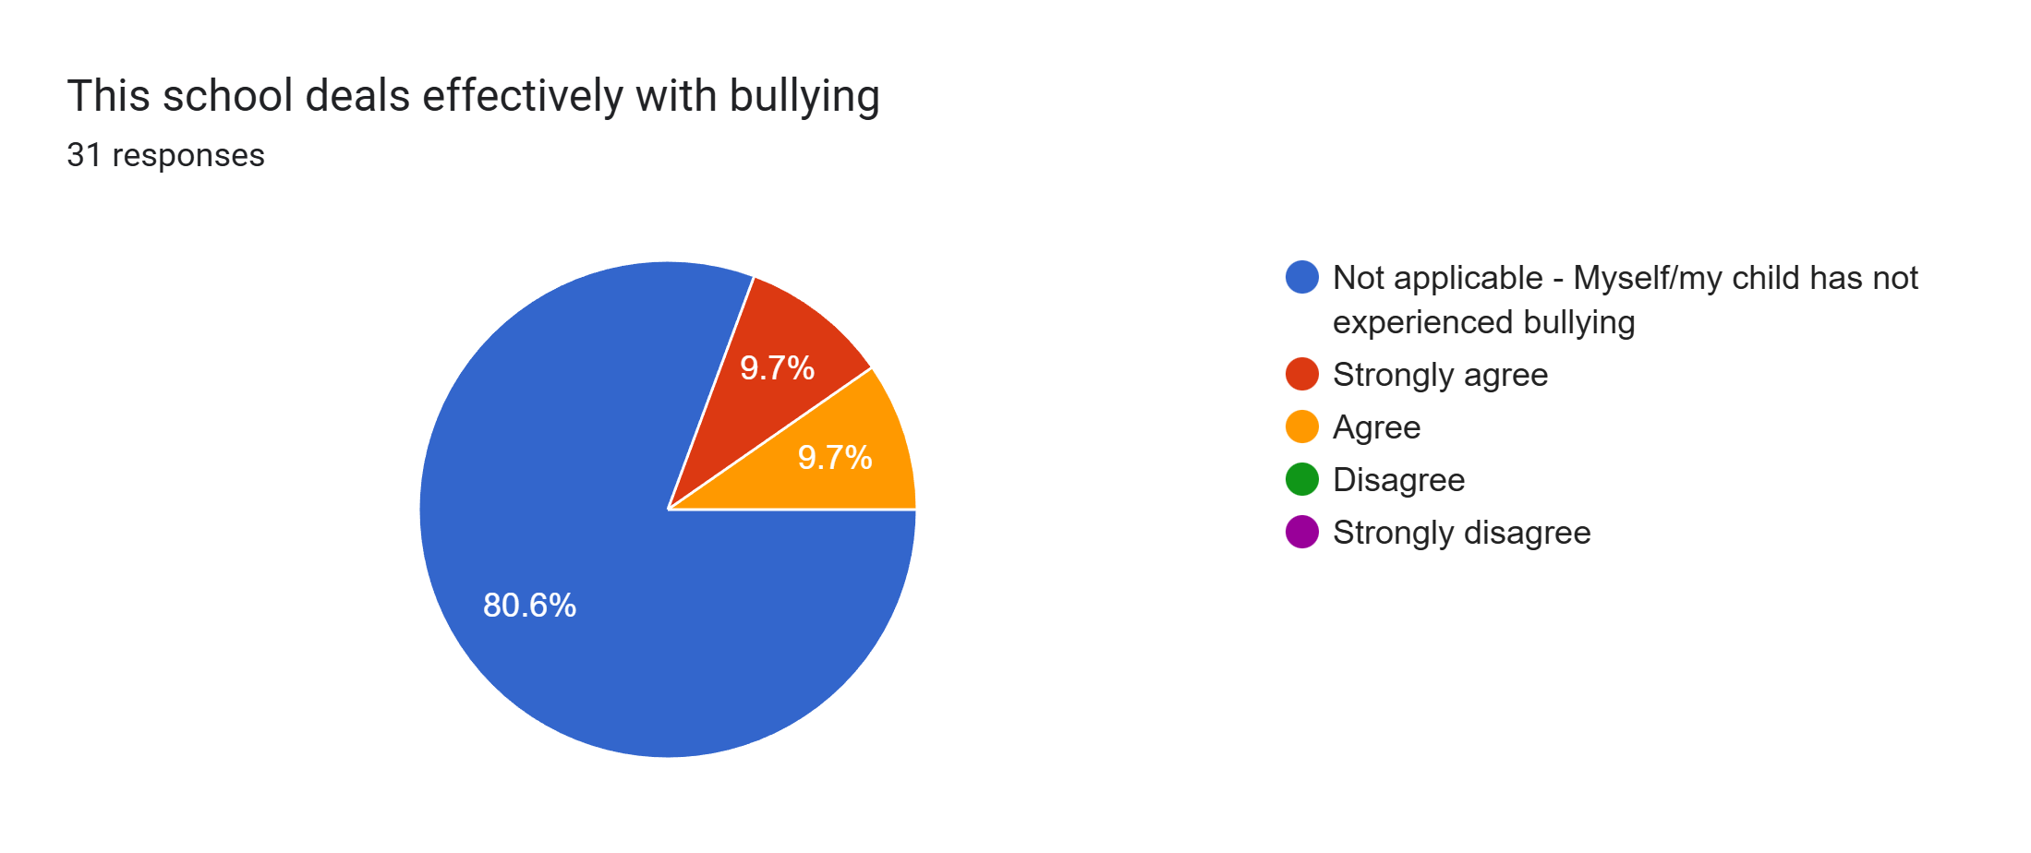
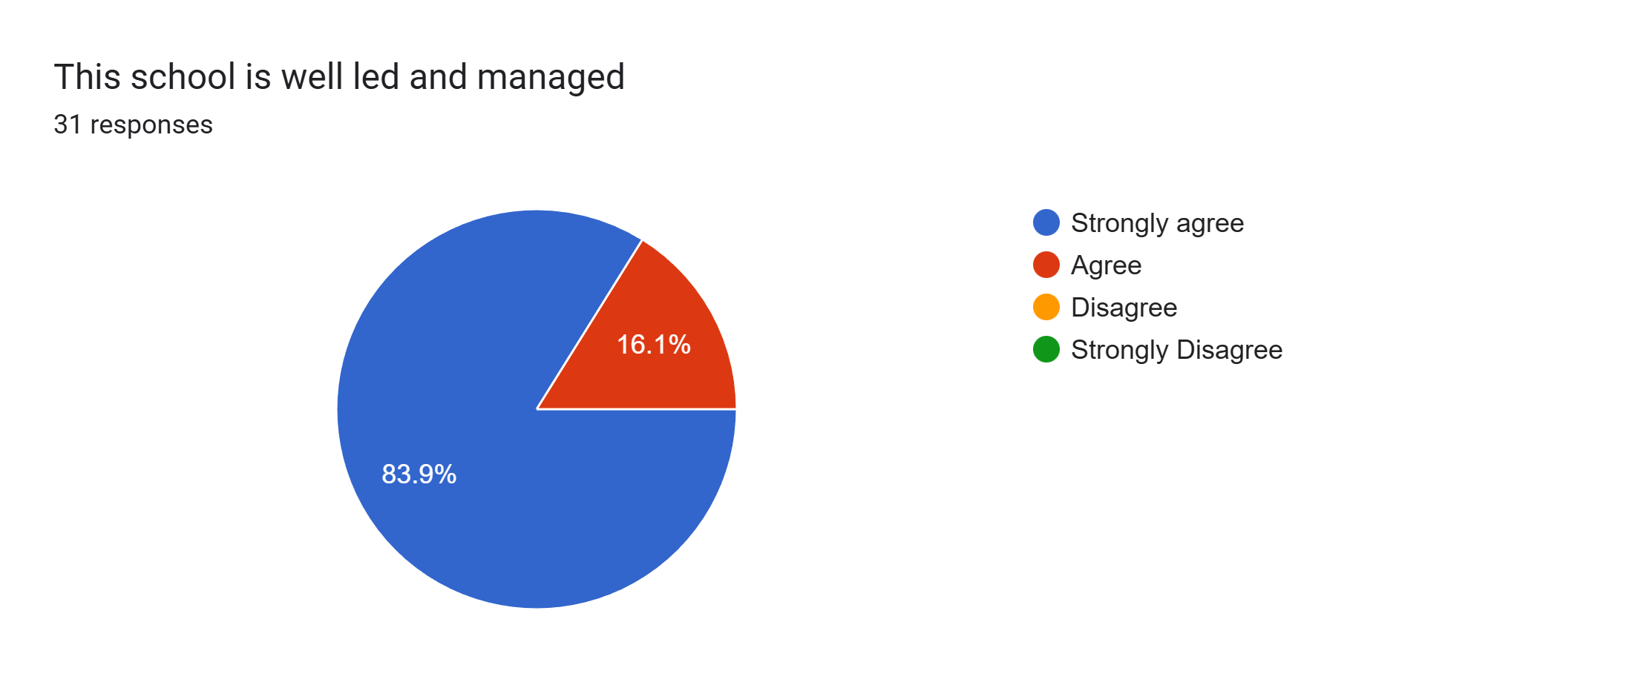
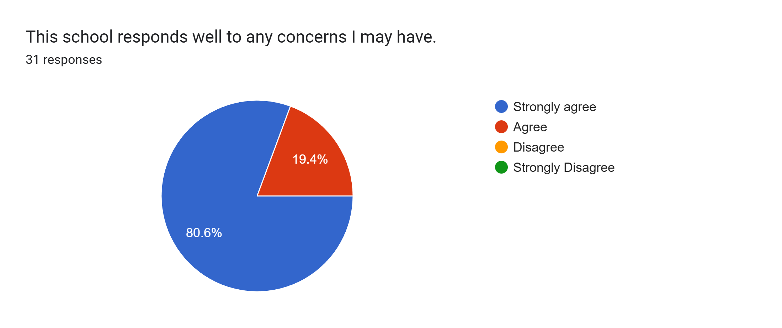
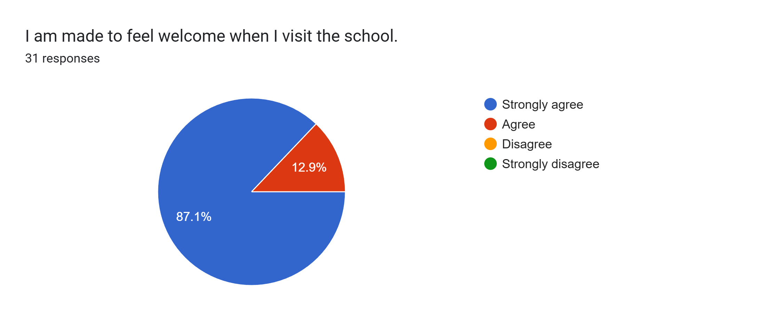
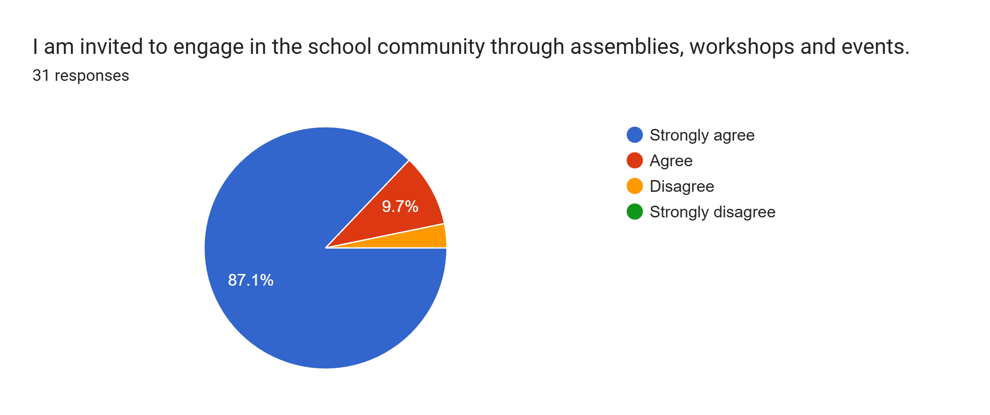
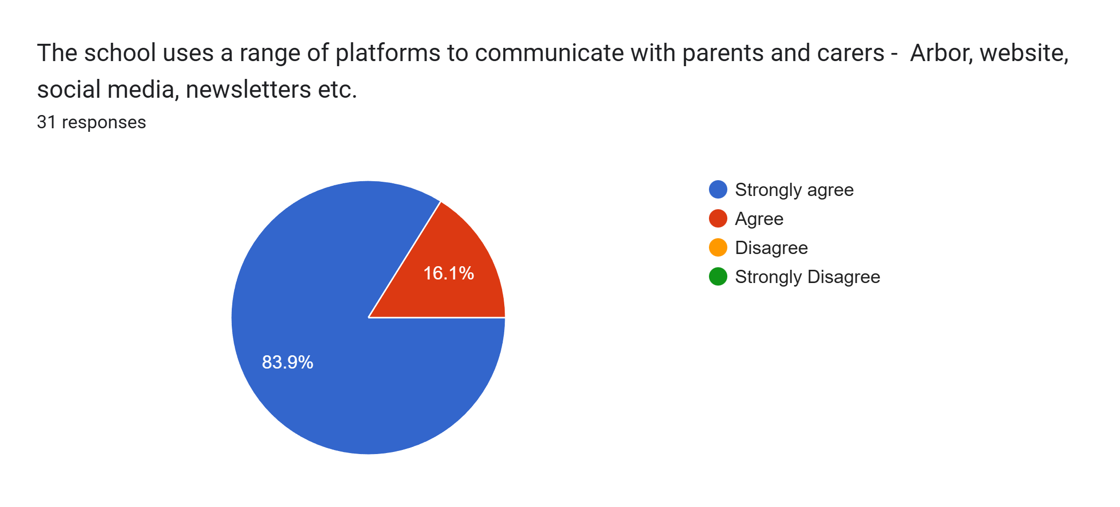
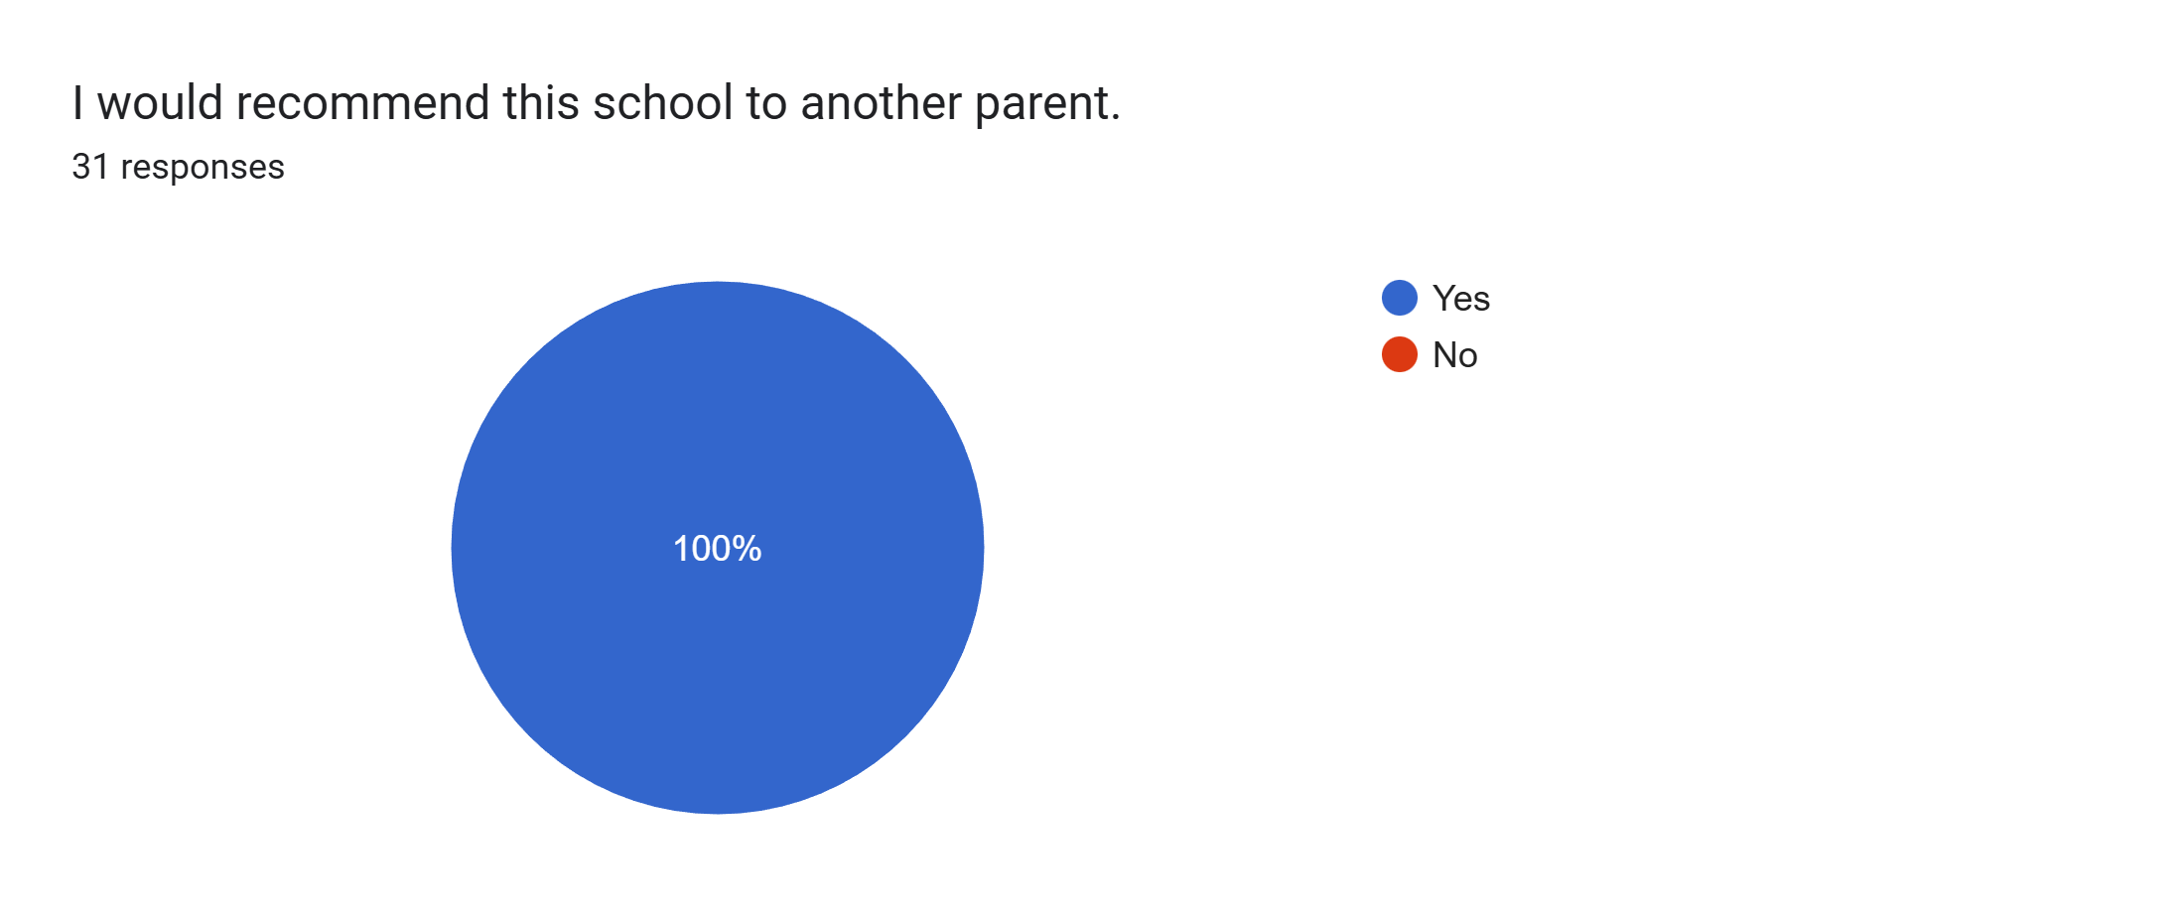

What other comments would you like to make to staff:
- Thank you.
- I'm happy thanks to the teacher Miss Murphy, other teachers and staff.
- We love how our daughter is thriving at Roby Park and that everyone knows her and her little quirks!
- Thank you for supporting my son’s education and helping him settle into his first year of school in a good education setting. Very grateful for all the support from school he has received and has made great progress in himself since joining. Very pleased with school and staff and the professionalism.
- My son absolutely loves school - we have no concerns.
- Thank you so much - you are all amazing. My son loves school.
- Thank you all.
- Really warm and welcoming teachers. Myself and my son’s dad are very impressed. Oliver loves school and speaks very highly.
- Lovely school and my child is well looked after.
- Thank you so much for everything!
- My son is very happy at school and making brilliant progress.
- Thank you.
- We're really happy with how our son has settled in, the support he has received and the progress he is making.
- Thank you all for everything you do. It is very much appreciated.
- Really pleased with how our daughter has settled into reception. Big thank you to Miss Murphy and all the teaching staff! Could not fault the school.
- Kids are very happy.
- Since joining Roby Park, our son has truly flourished. Miss Murphy has instilled a love of learning in him which has seen him overcome some challenges and now he loves every day in school. Leaders truly engage with parents and we can't thank you enough for your ongoing support.
- Thank you for everything you are doing for our child.
- Staff are very helpful.
- Staff are lovely.
- Lovely teacher, very helpful and caring to our son.
- Couldn't ask for any more, thank you all.
- Thank you for everything you all do. The kids absolutely love the school and it’s the staff who make that happen.
- Would like to thank Miss Murphy for all she does. Great teacher.
- Thank you for making our daughter’s transition to school so easy - she has nothing but good things to say when she comes home and you can see she’s genuinely so happy and thriving. Thank you, Miss Murphy, Mrs Taberner & all reception teachers.

