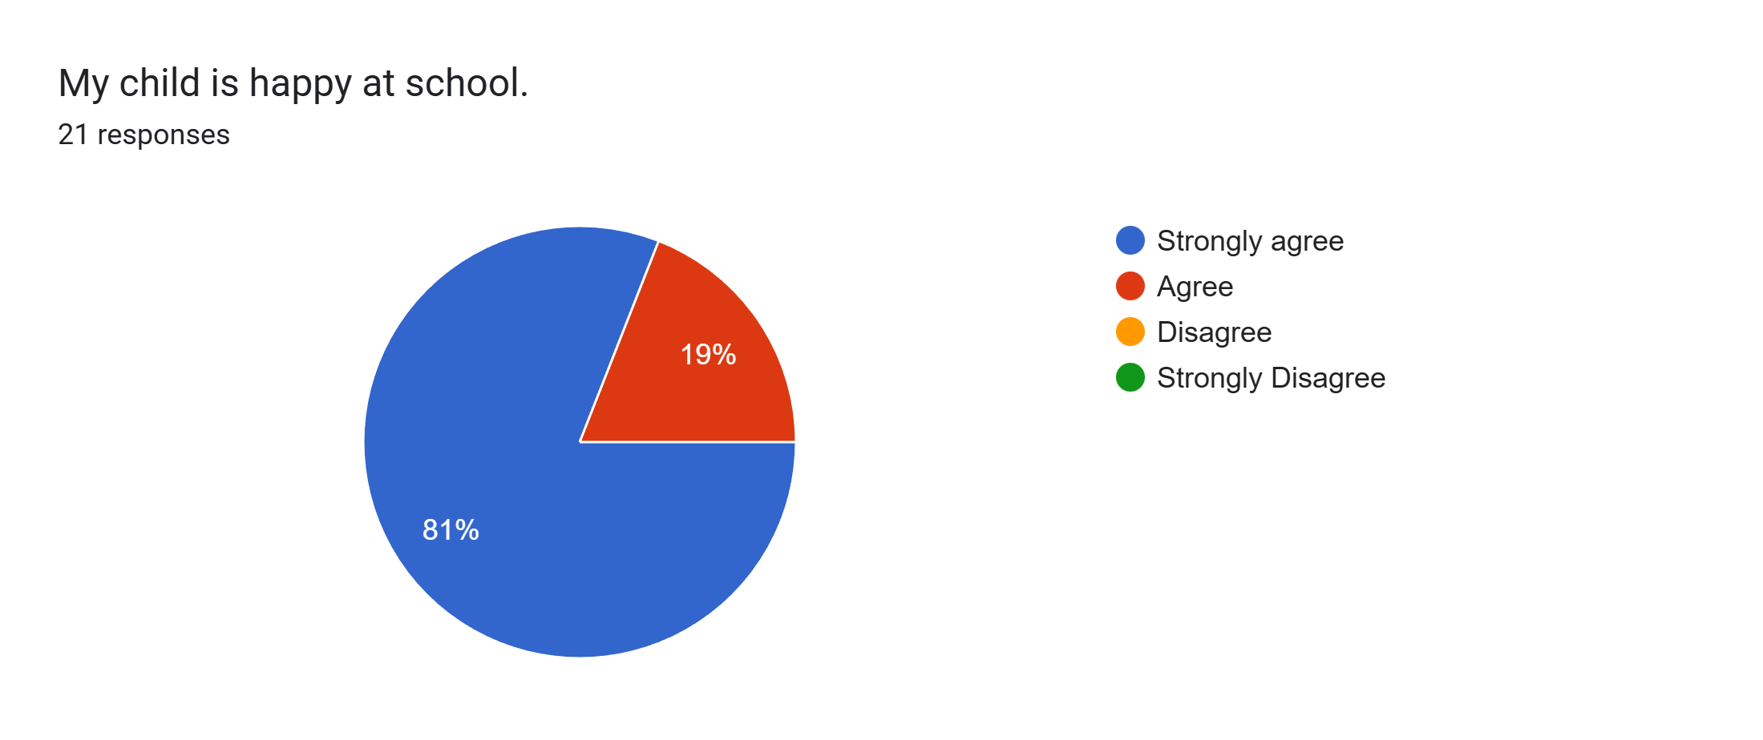
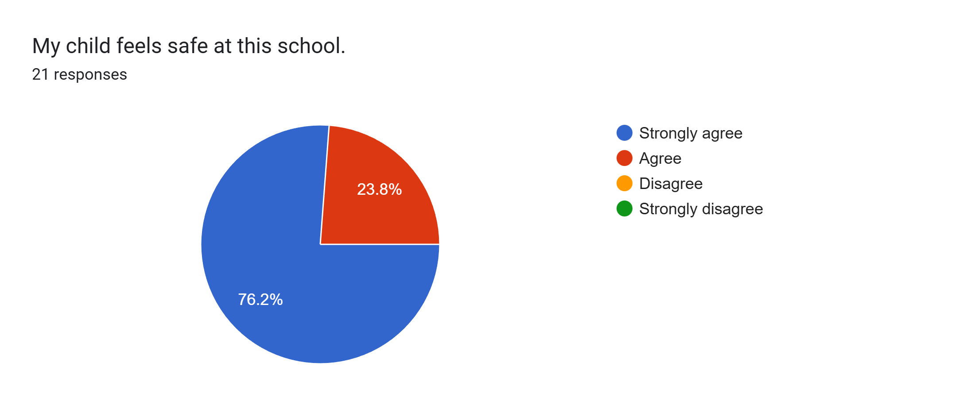
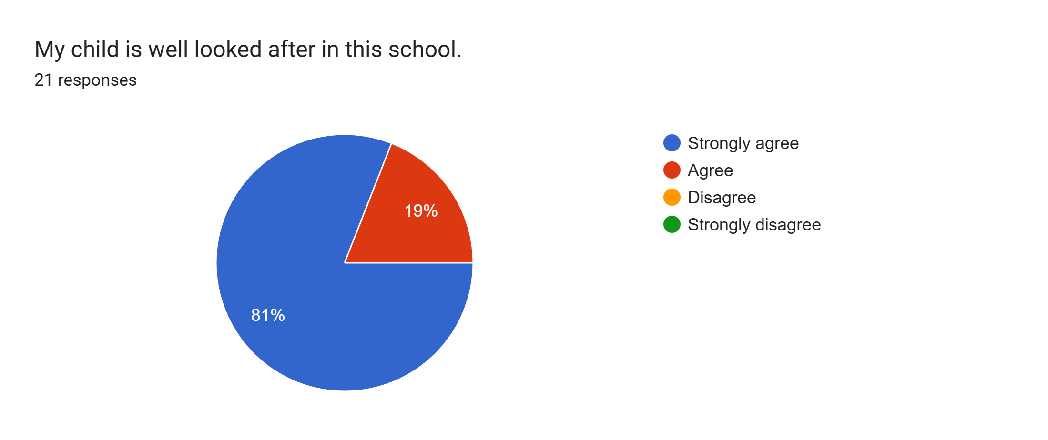
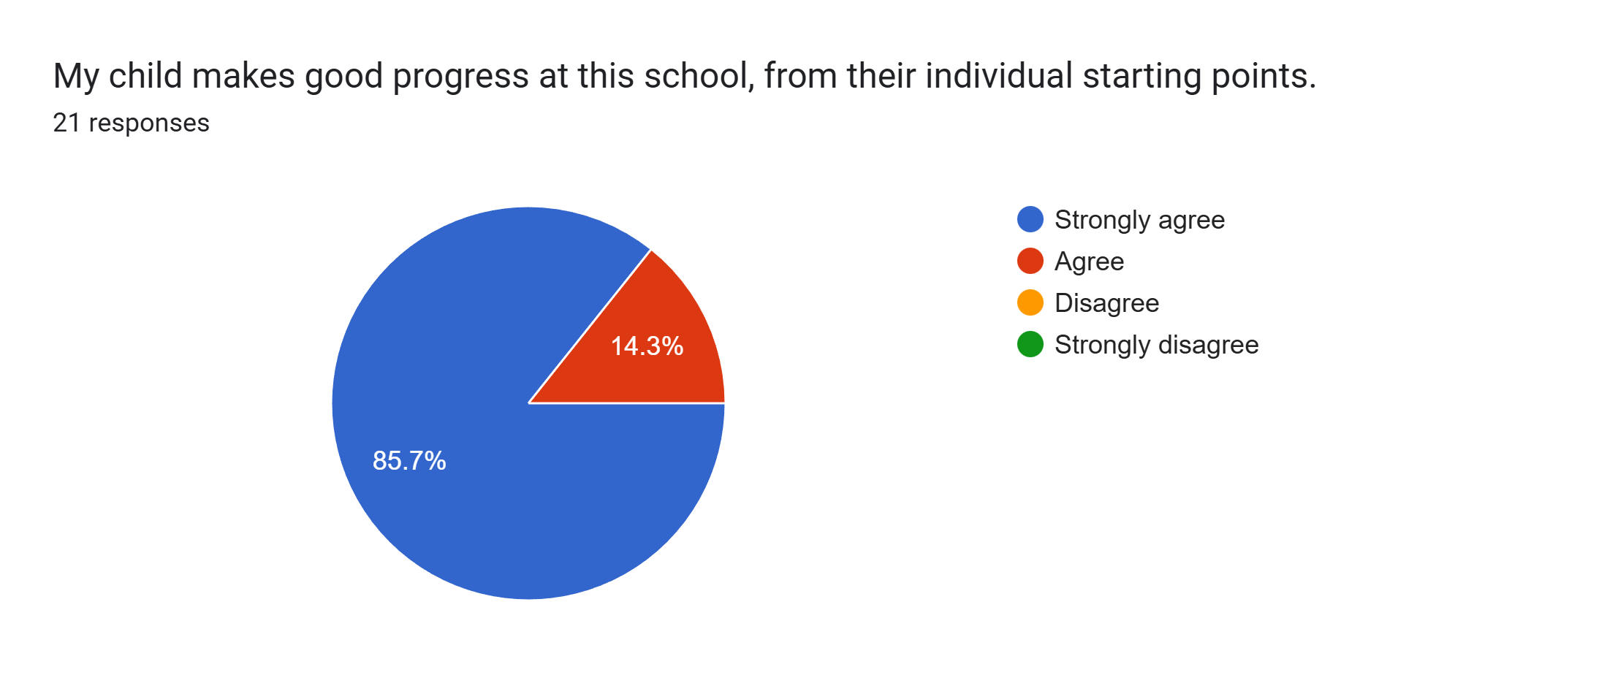
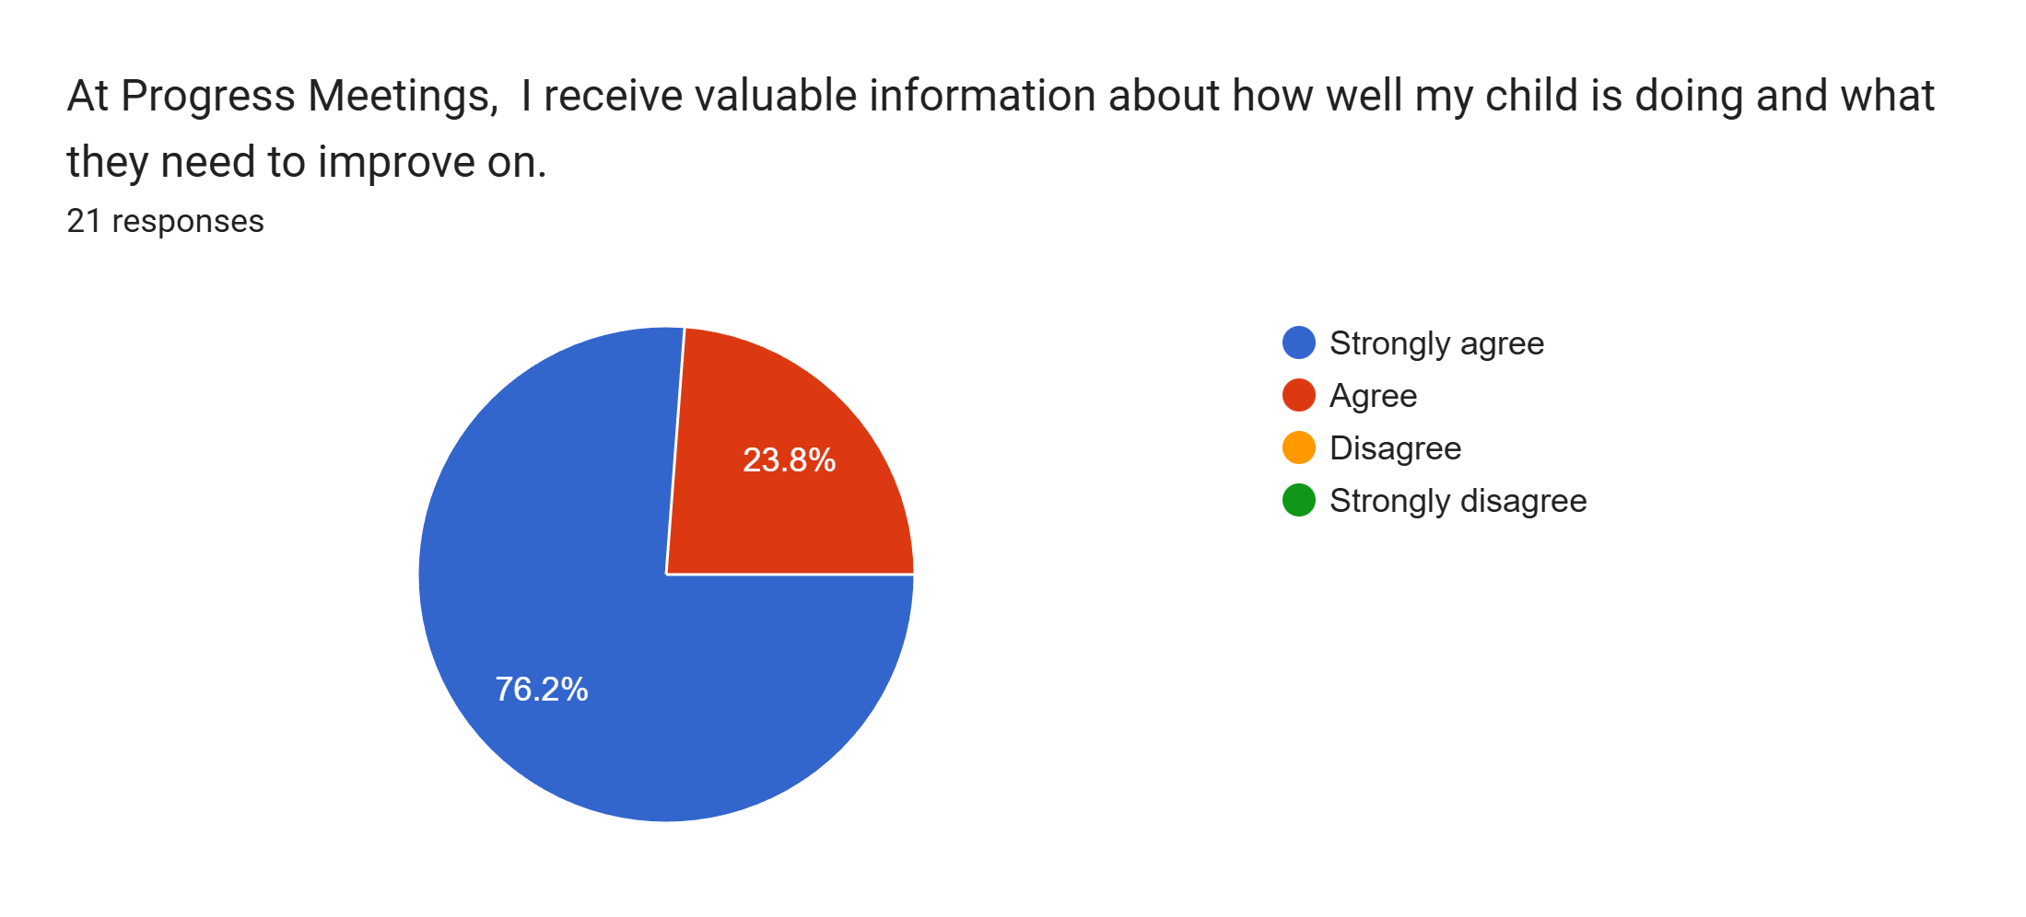
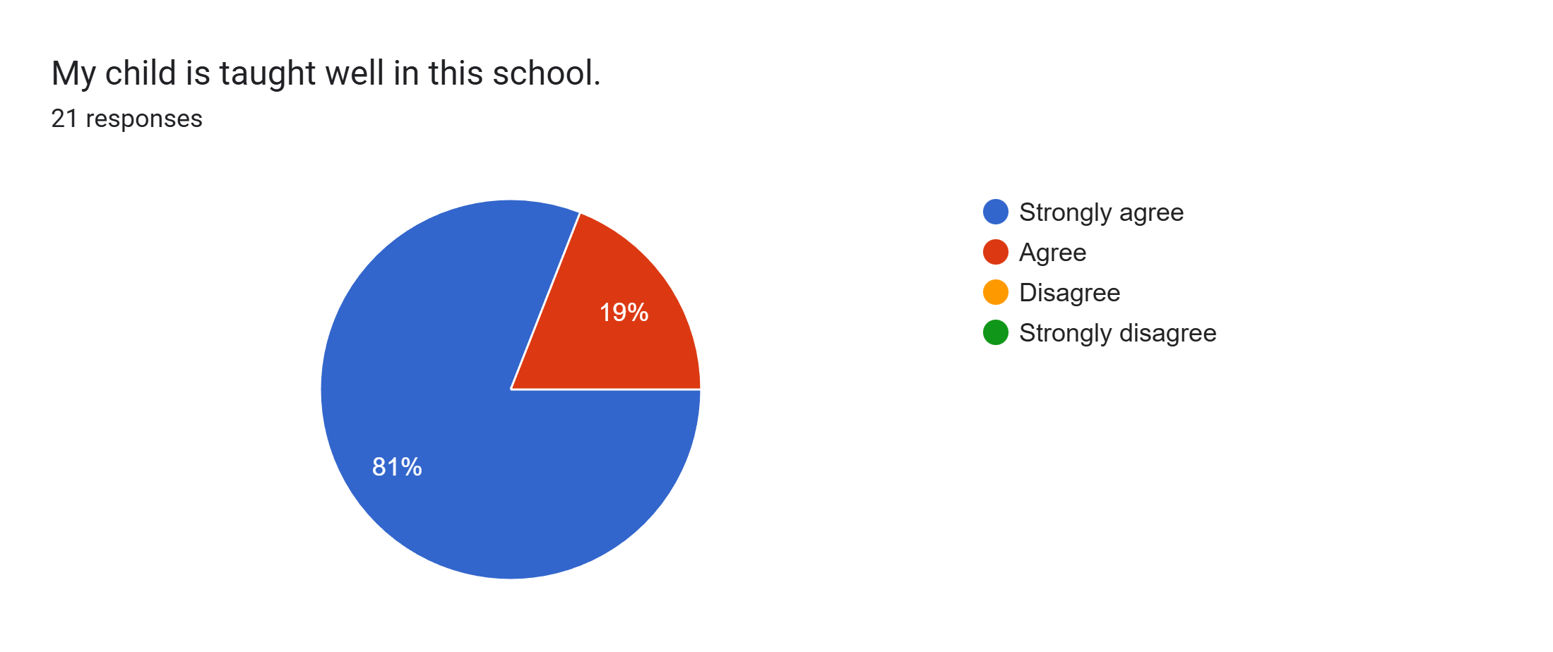
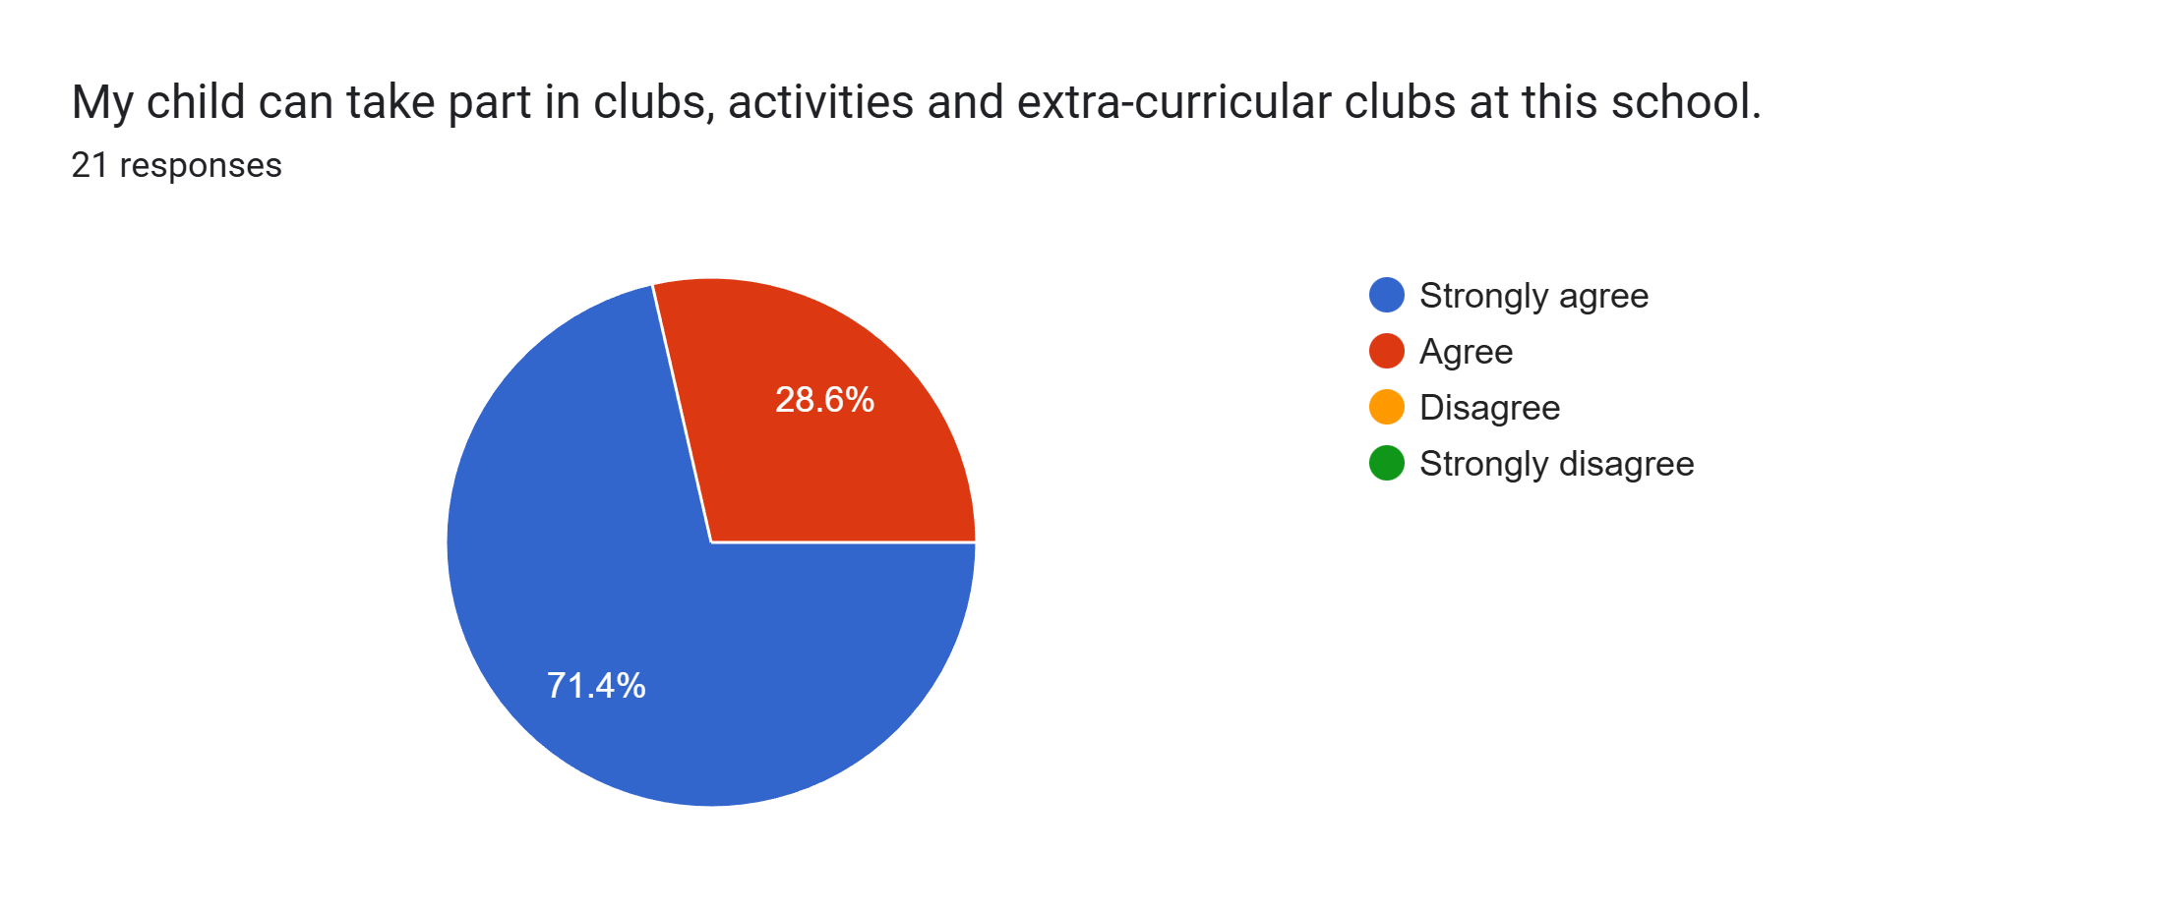
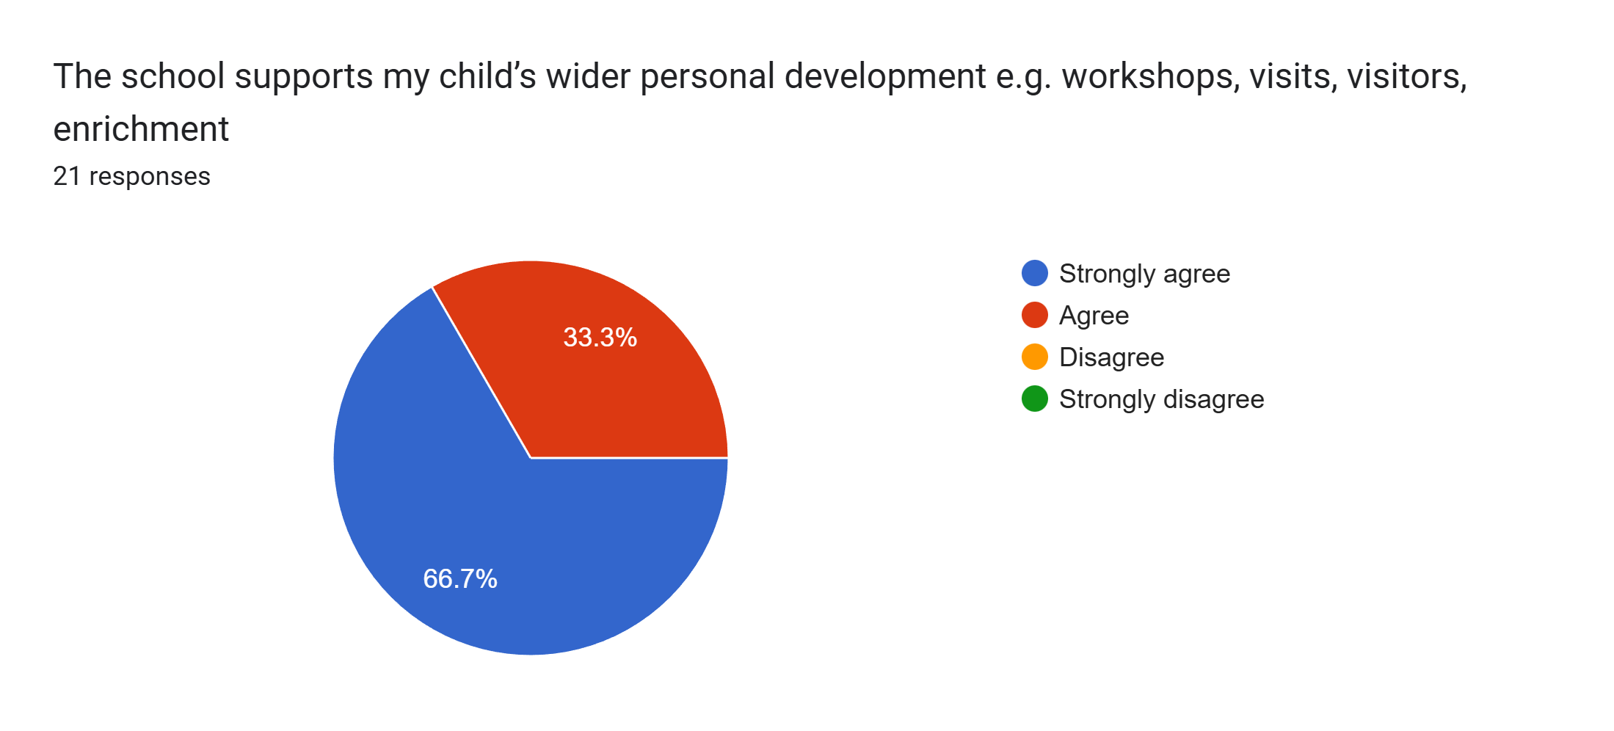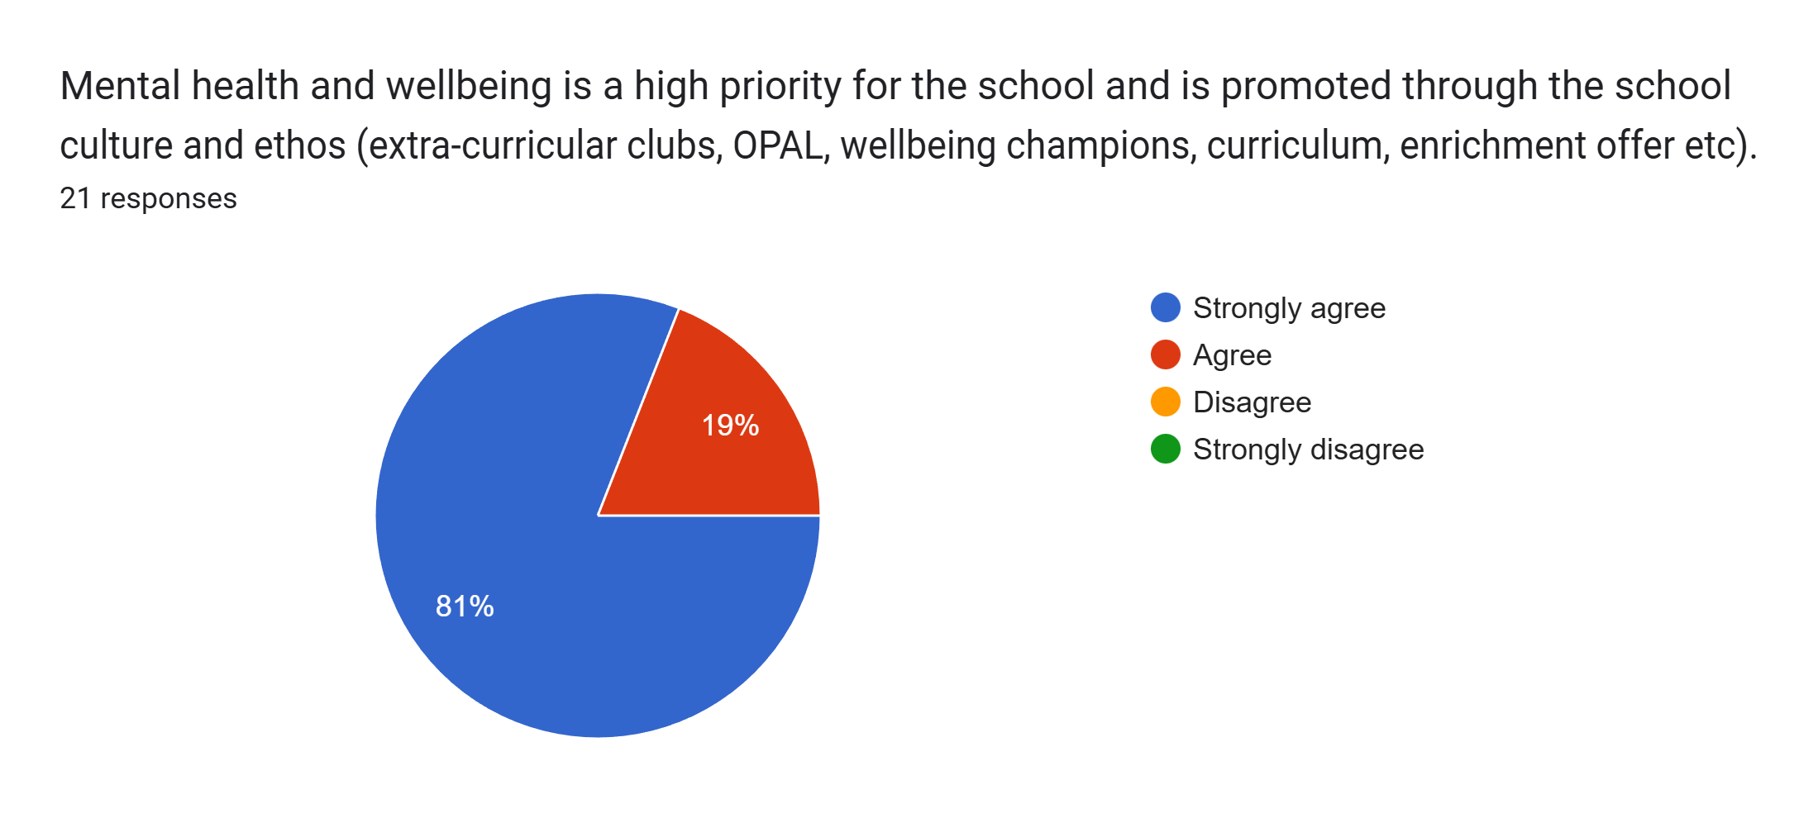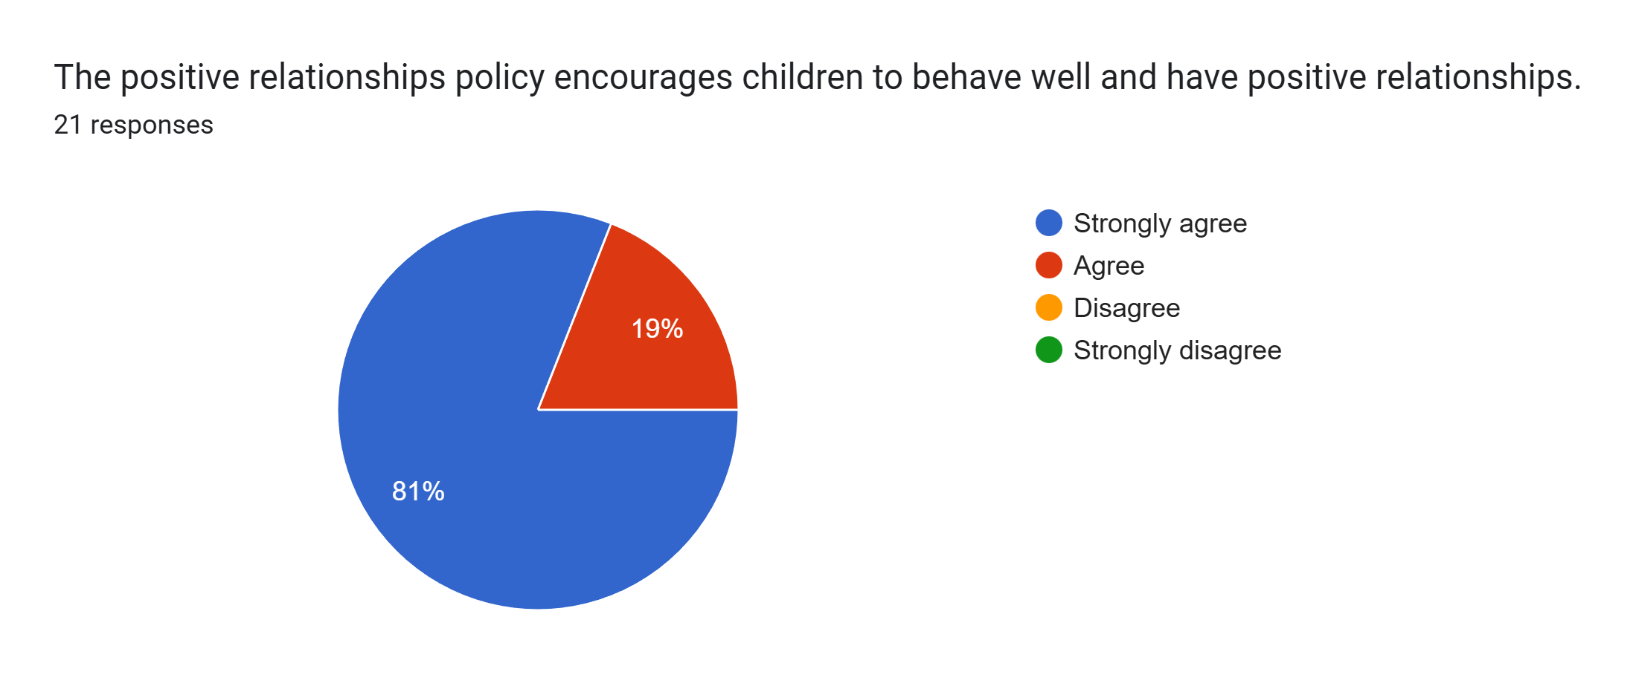
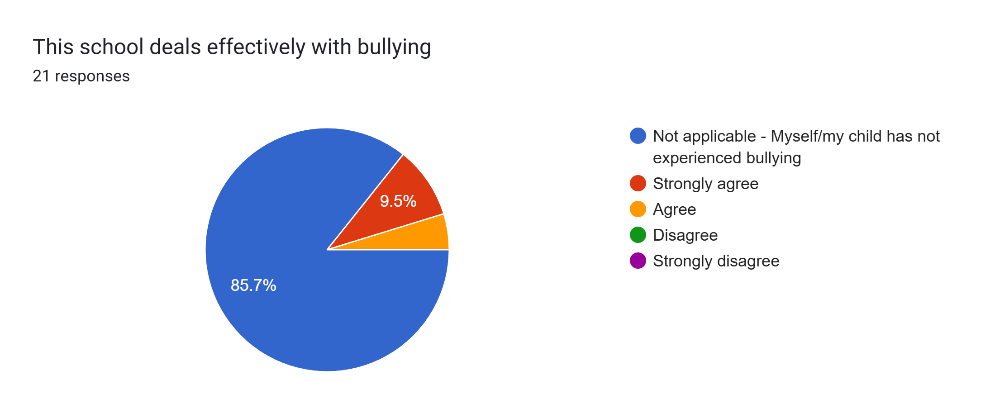
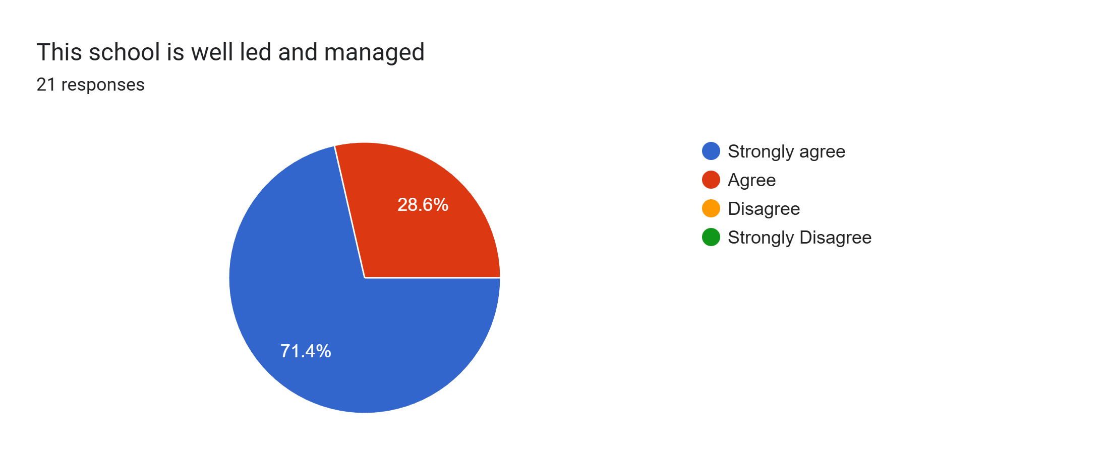
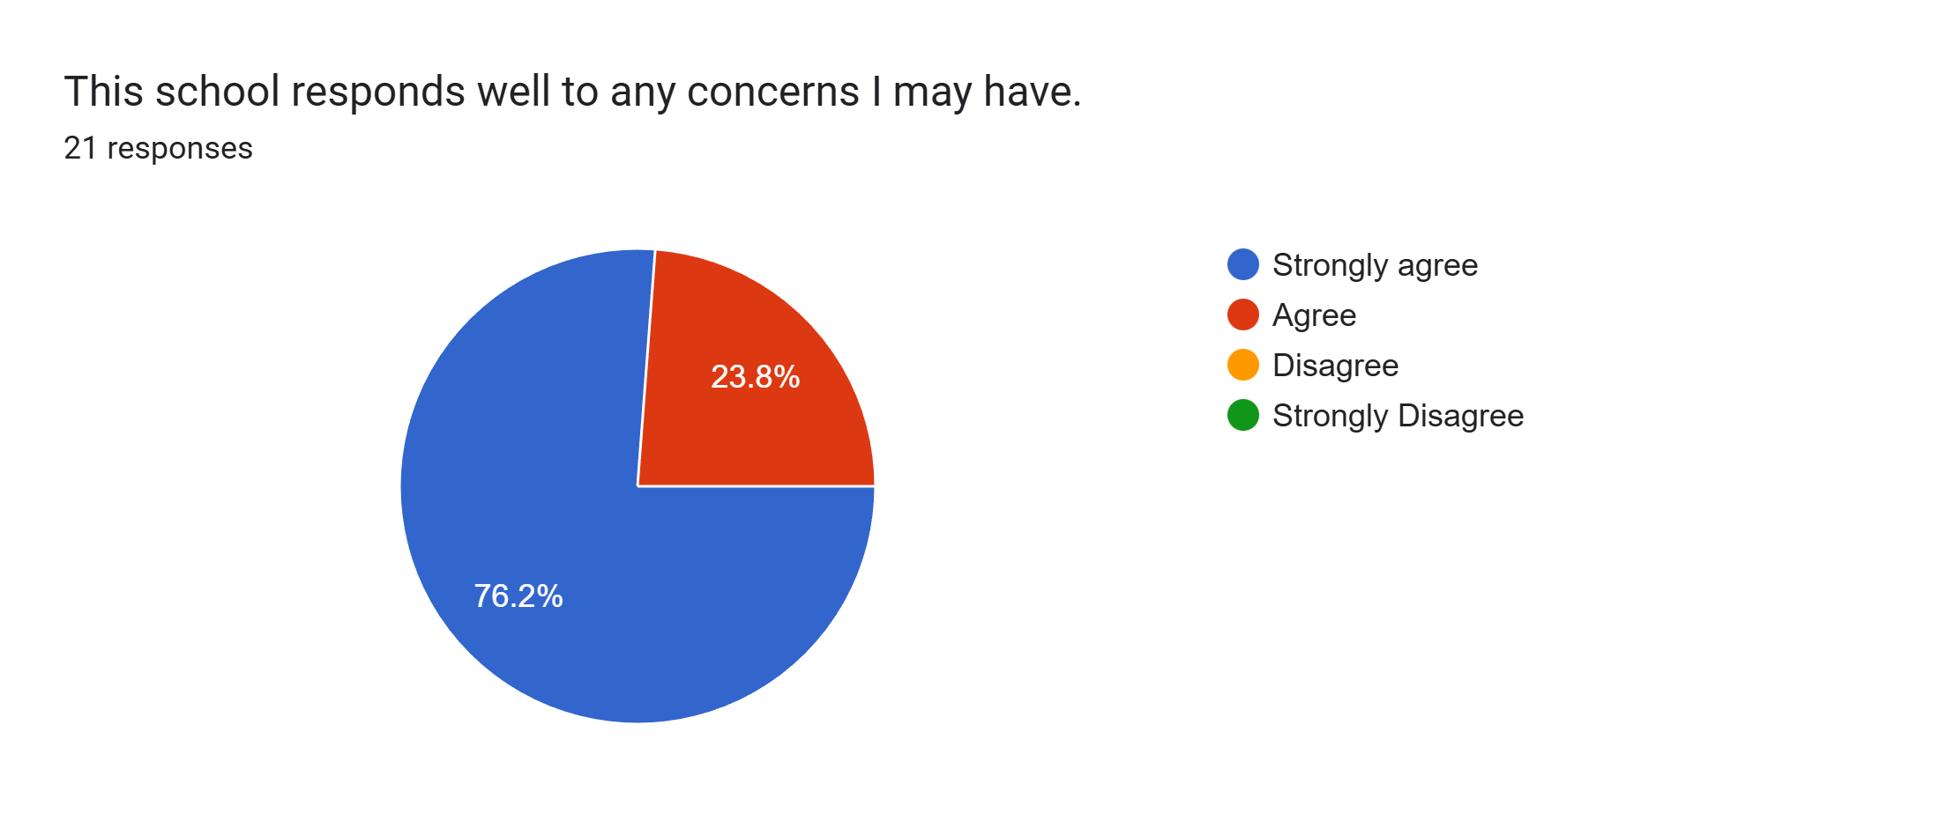
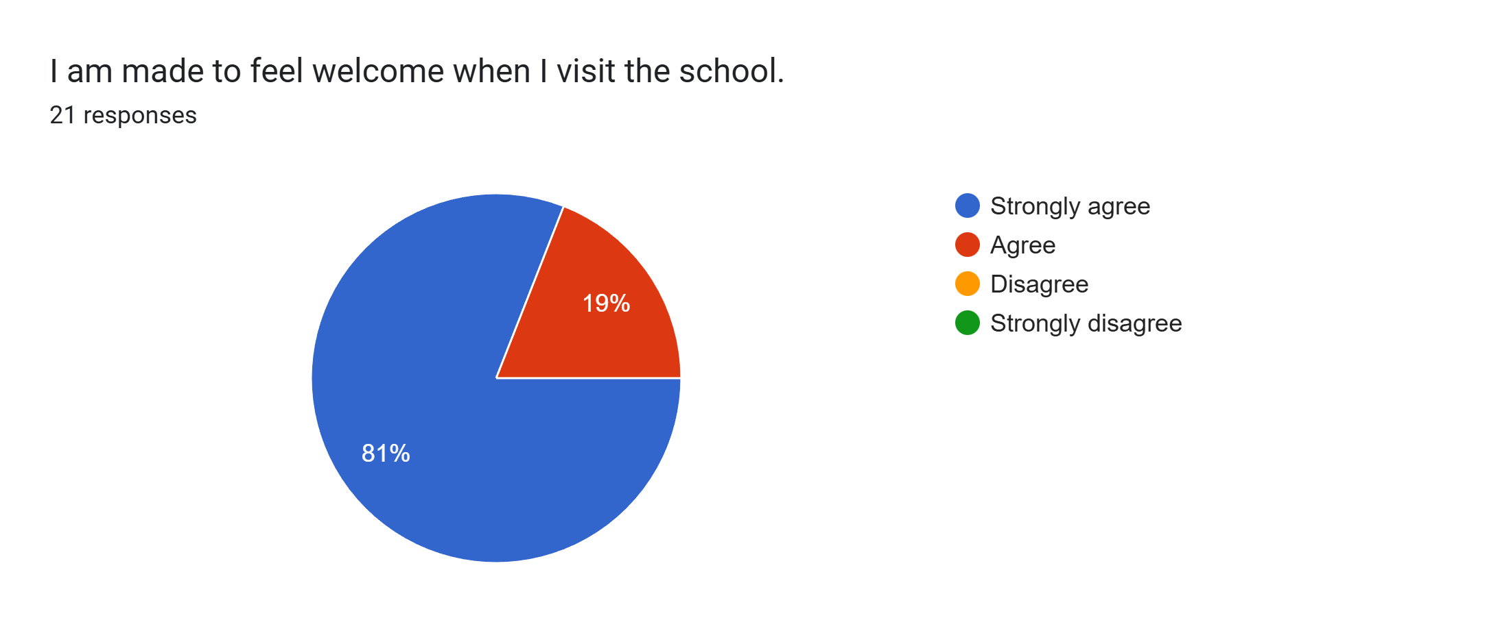
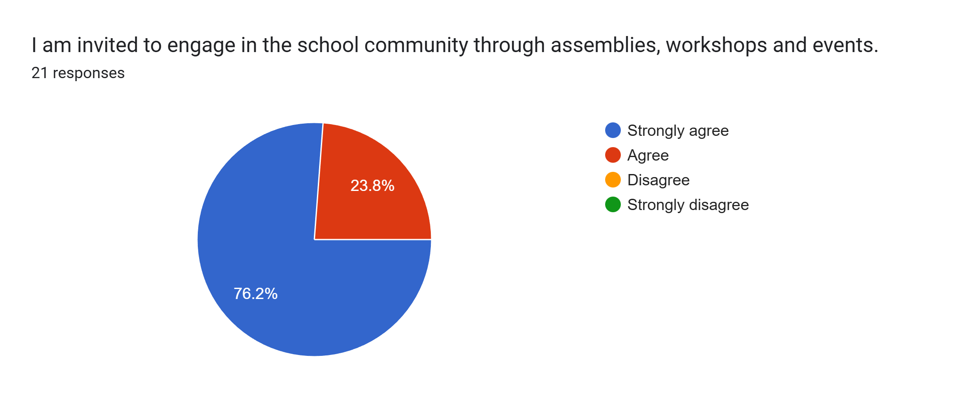
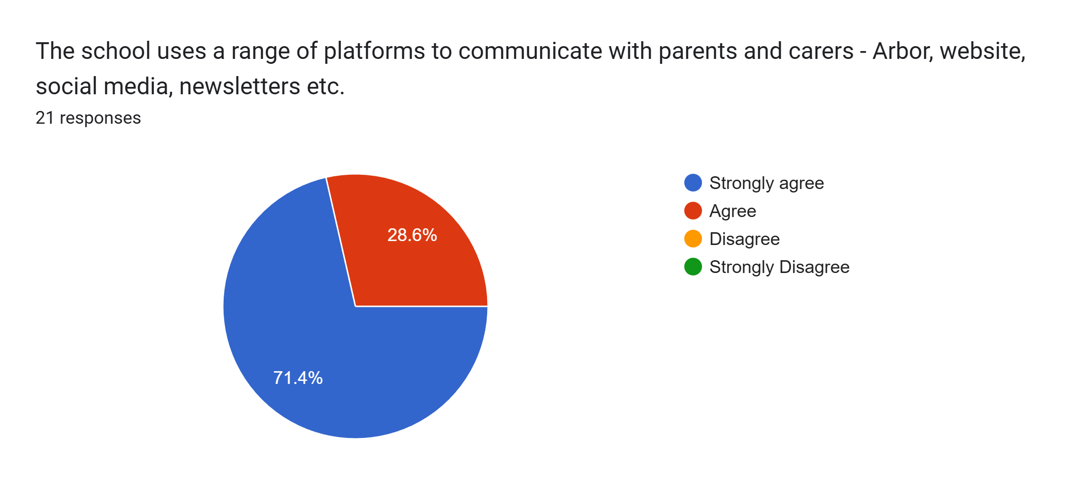
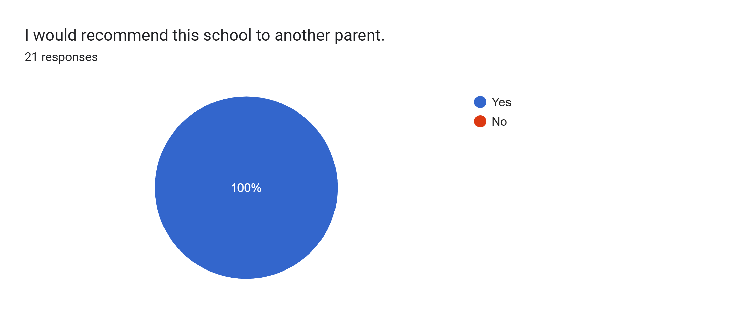

What other comments would you like to make to staff:
- Thank you for all your hard work.
- Amazing school.
- Thank you for everything you do to help my son develop.
- Great.
- My son is really happy and settled well in to Roby Park, compared to past nurseries. He is so excited of a morning to attend school and see his friends.
- I felt really happy at parents evening that he is hitting his mile stones and has such lovely teachers.
- Thank you for taking care of my child.
- The staff have been fabulous settling my son in. I can’t thank them enough. My son loves school and the teaching staff.
- We really like the teachers and how they are with our daughter and we feel listened to.
- Thank you for the support.
- Our daughter has settled in exceptionally well and we've seen improvements in her development in the short time she's been here. We're very happy with how everything is going and happy to hear she is doing well from the teachers' perspective too.
- My daughter loves coming to nursery. She has so much fun playing and learning. Thanks for being great teachers.
- Just a message of gratitude for all the hard work, effort and kindness shown every day.
- I am so happy with school and staff. My son loves his teachers and school…so happy my children go to Roby Park. Thank you x
- Great job guys! My daughter is very happy with school and enjoys talking to us about her day every day.
- Nursery staff and early years staff are absolutely fantastic. We can't thank them enough or fault them at all. Our daughter loves the school and is making great progress so very happy.
- Enjoyed meeting with the staff and it was insightful to hear how our daughter had settled.
- I’m very happy with my child in this school. The teachers are lovely.
- Thank you for a wonderful start to our daughter’s school life x
- Really happy with how much the teachers have helped my daughter come along.

