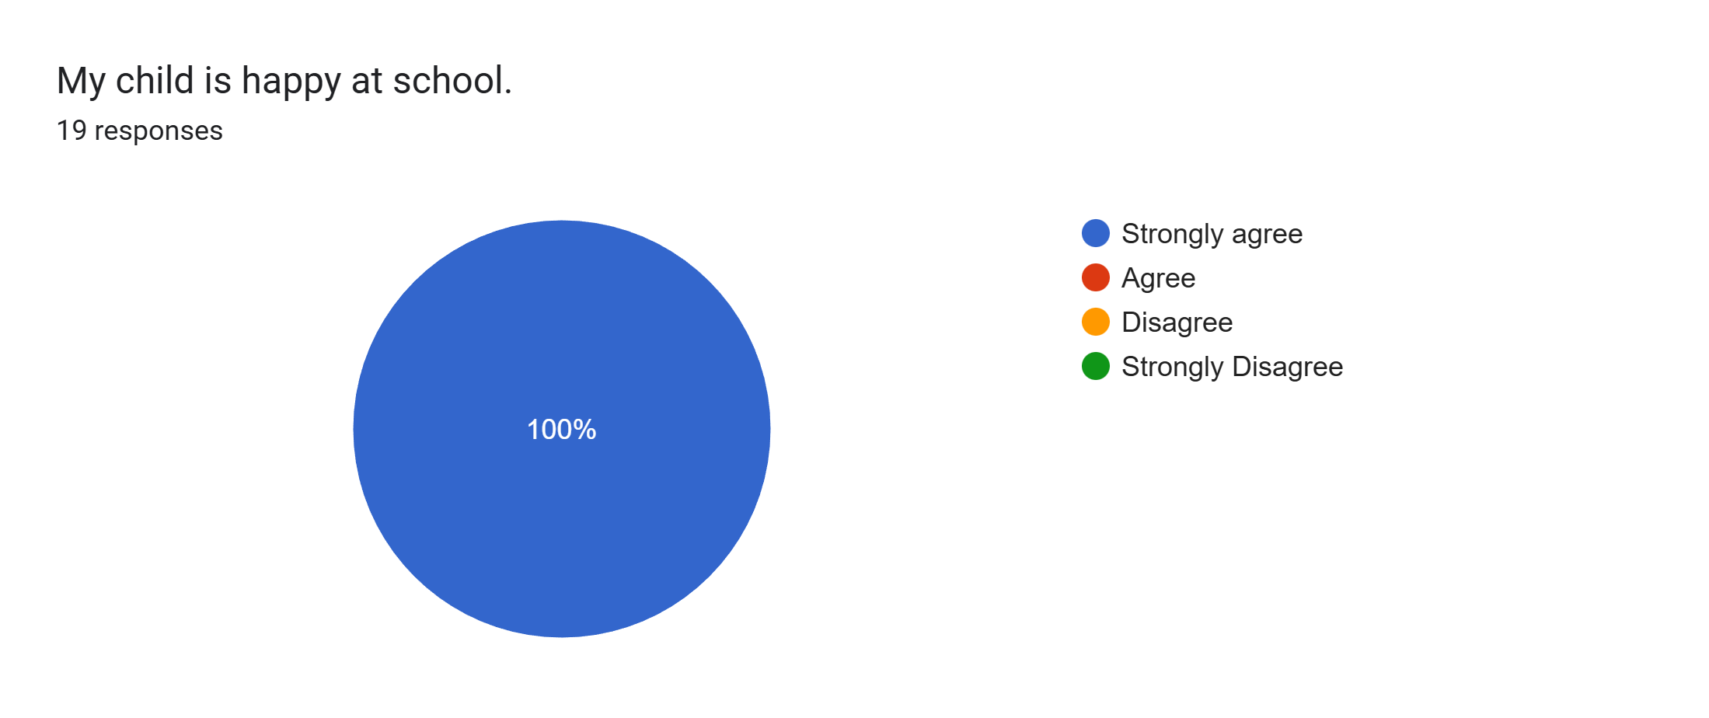
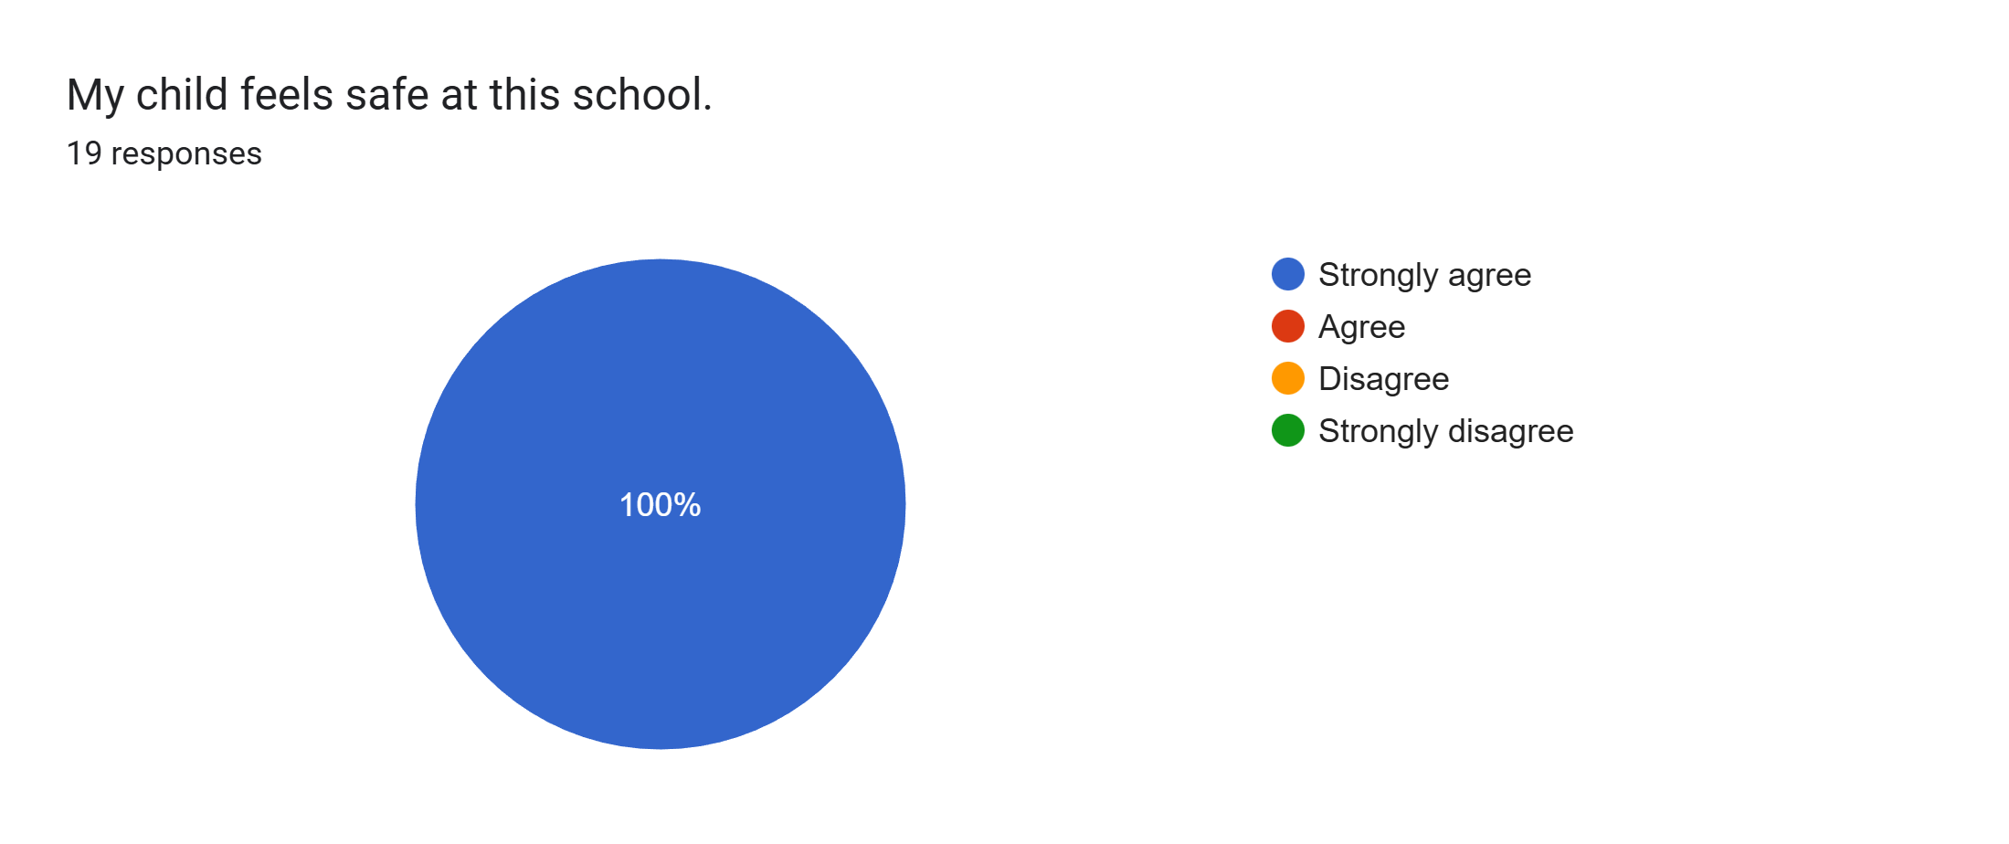
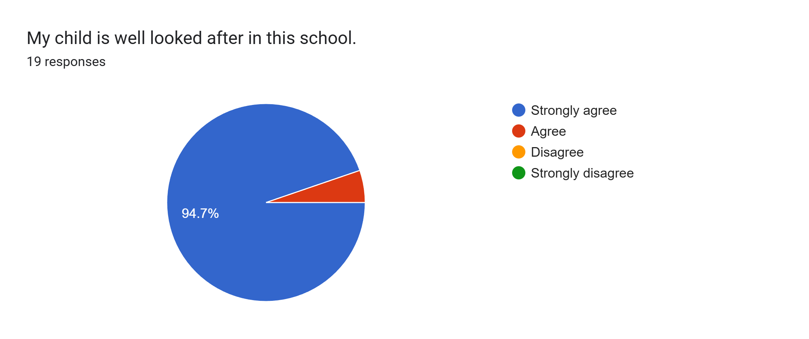
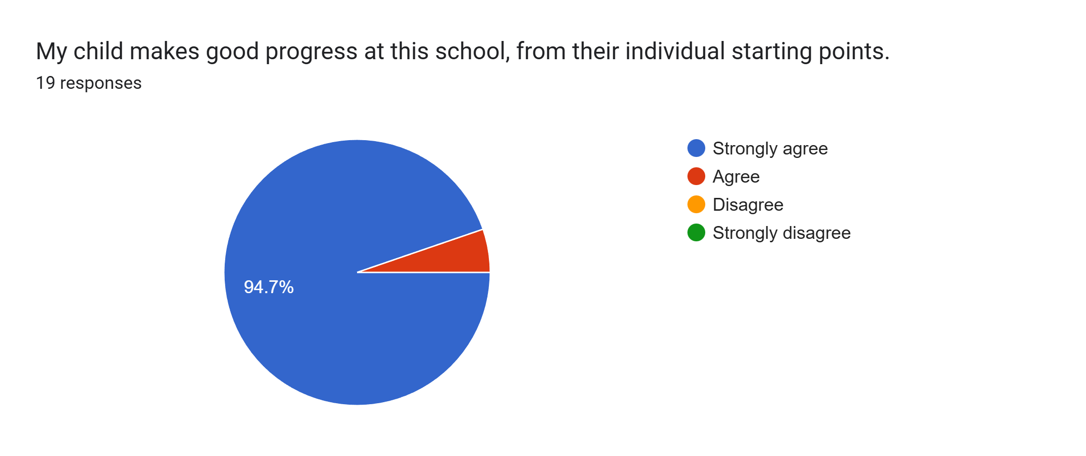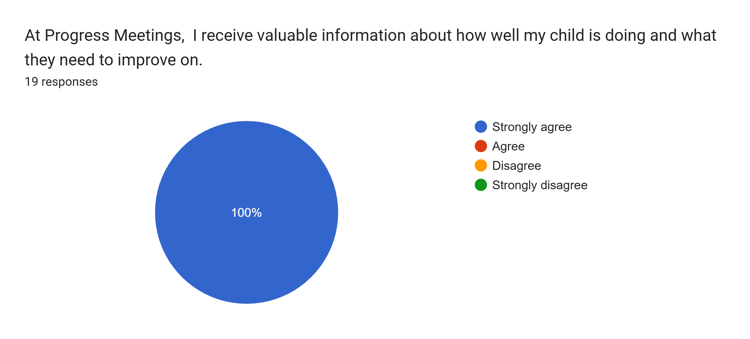
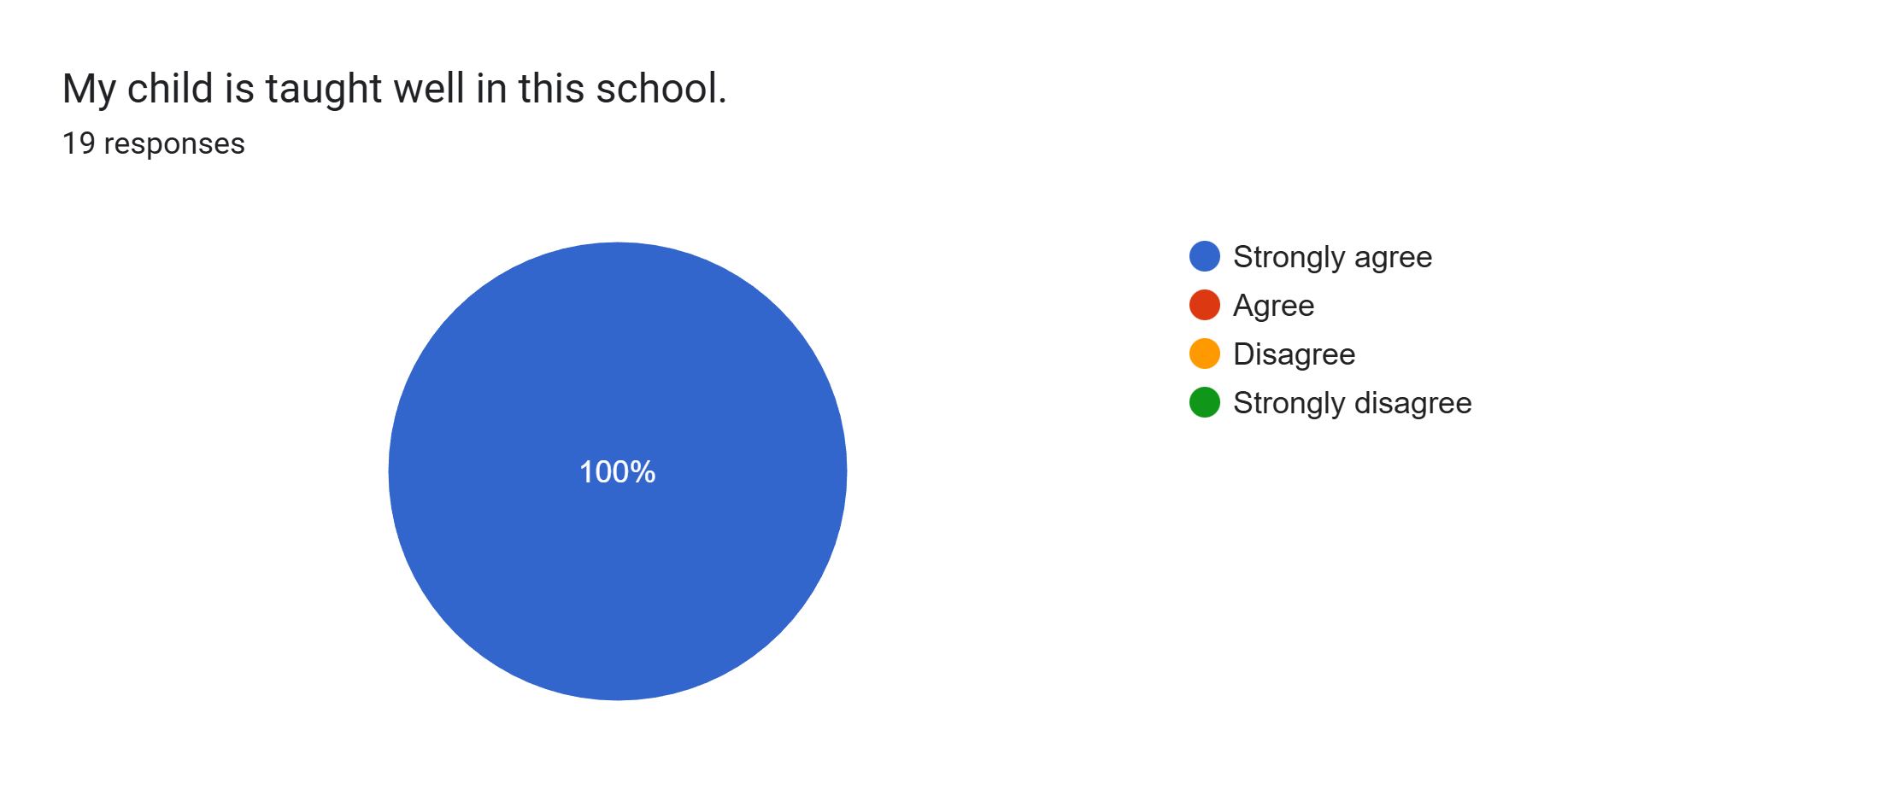
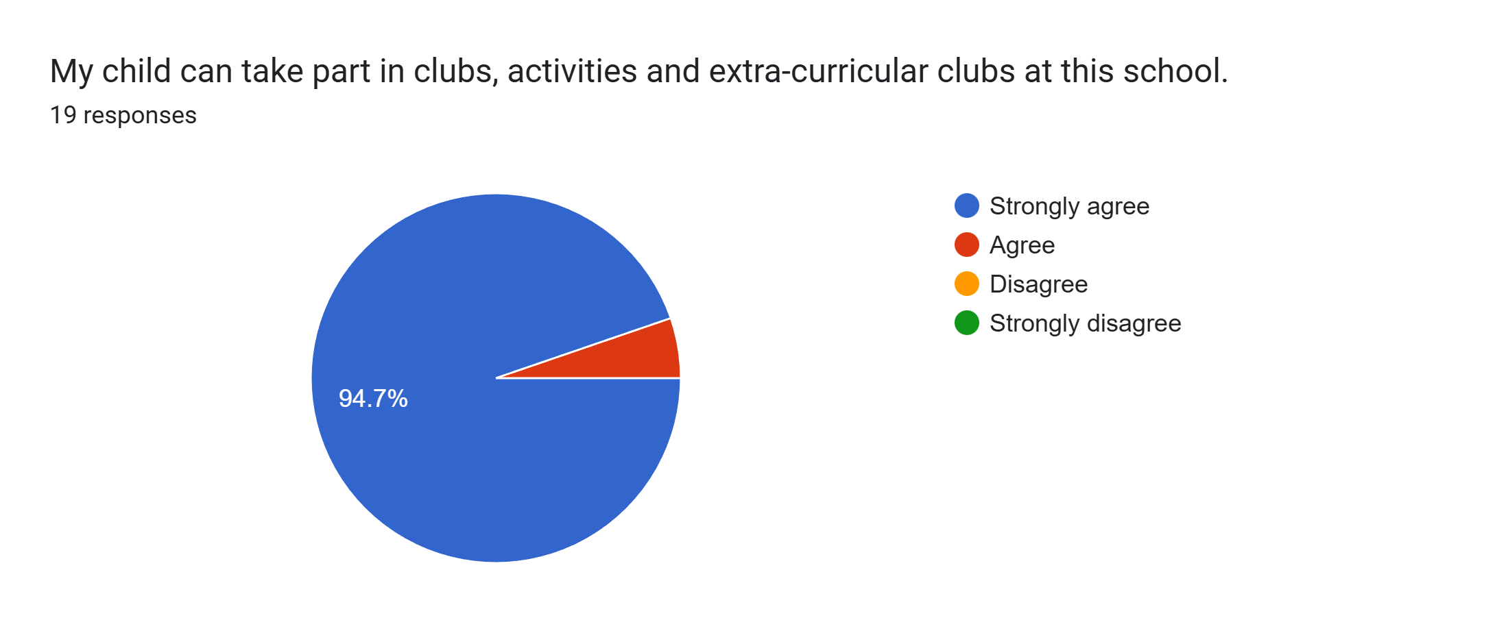
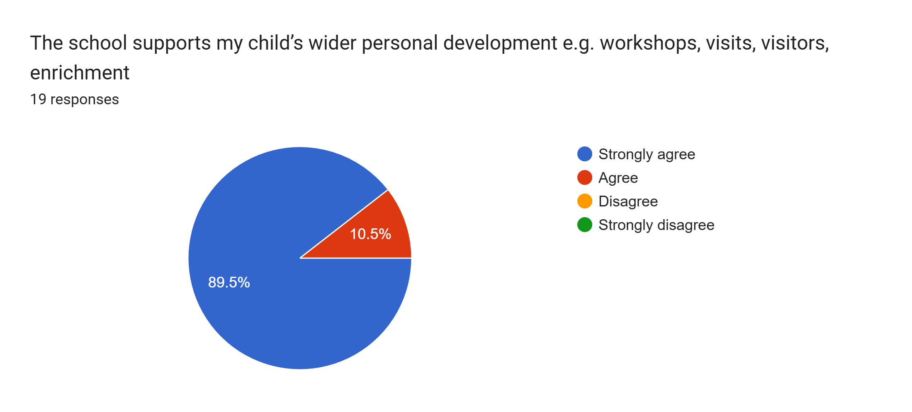
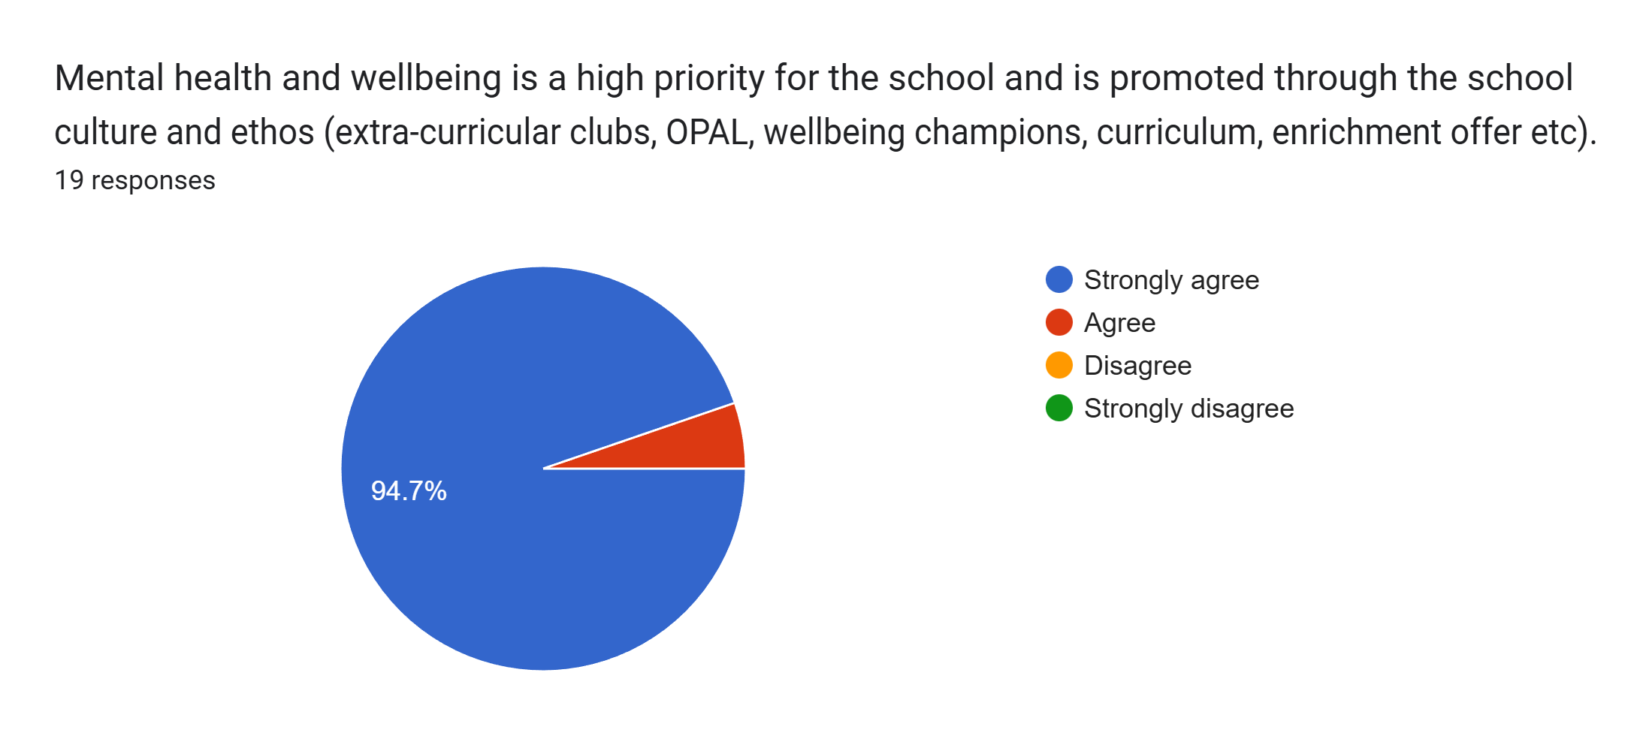
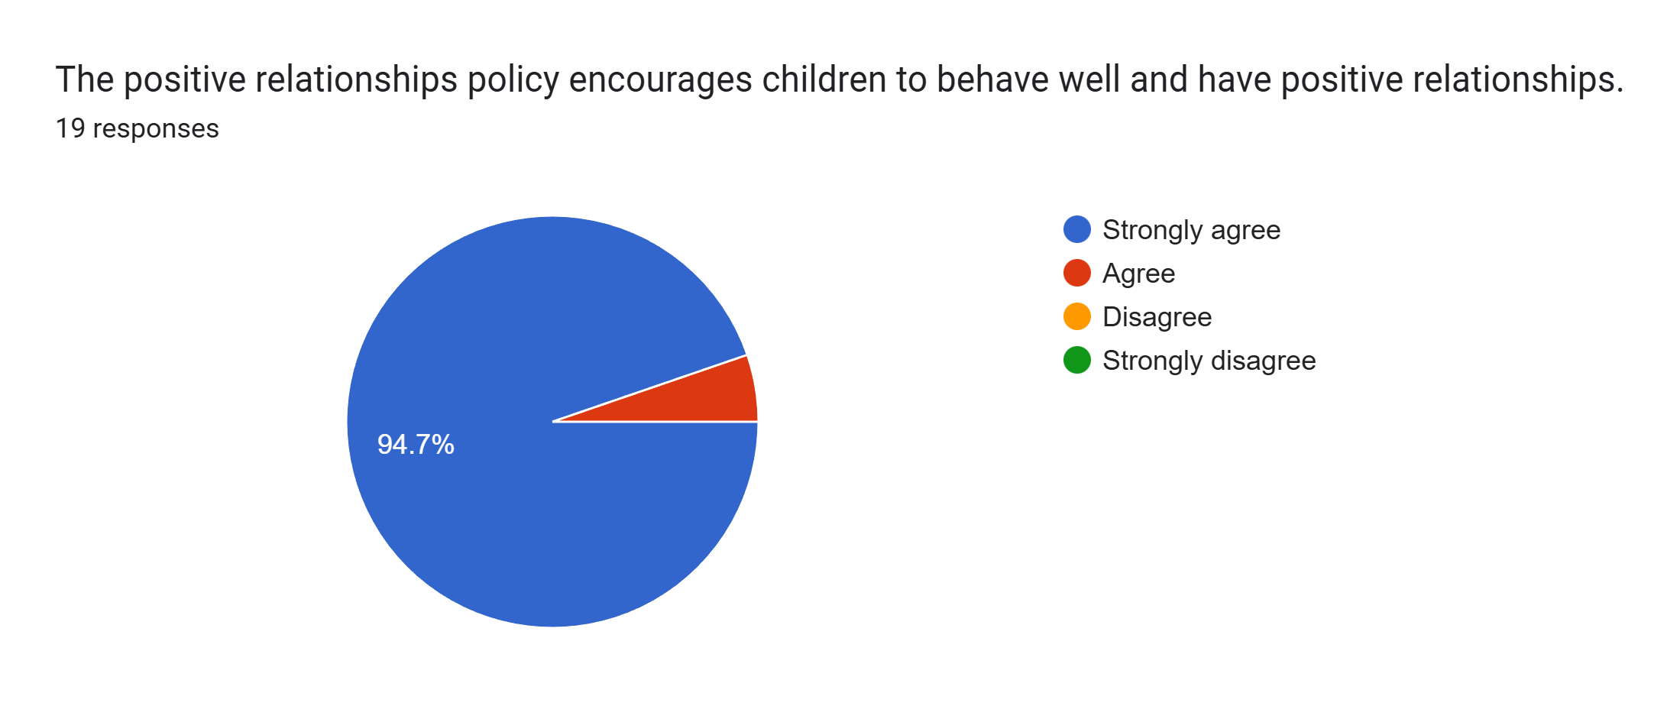
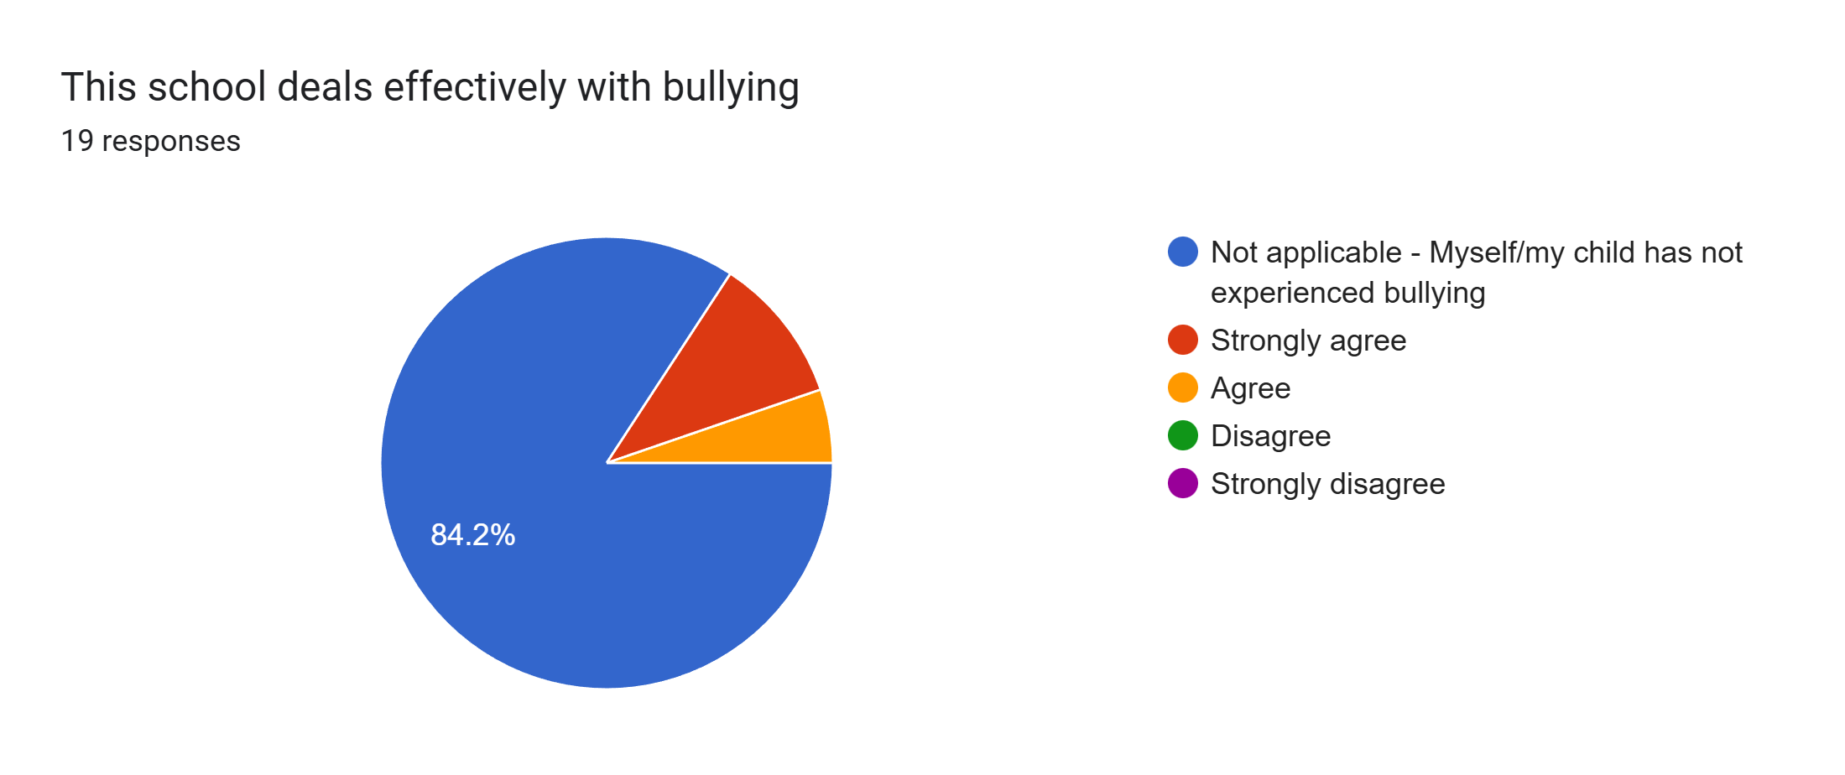
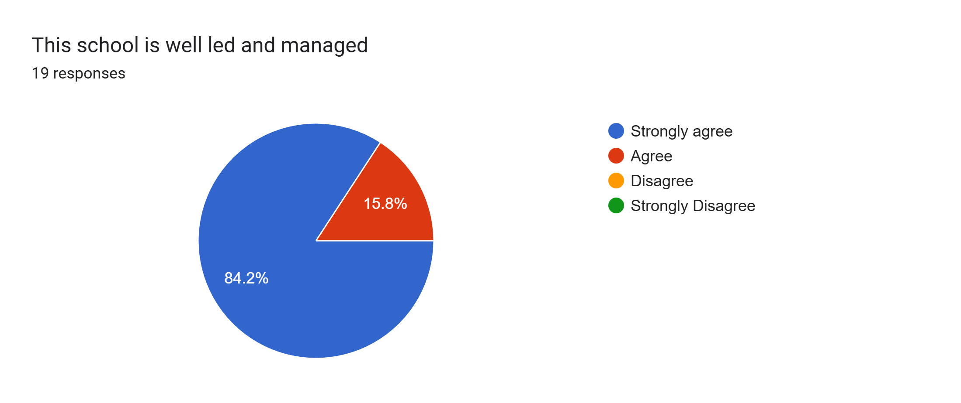
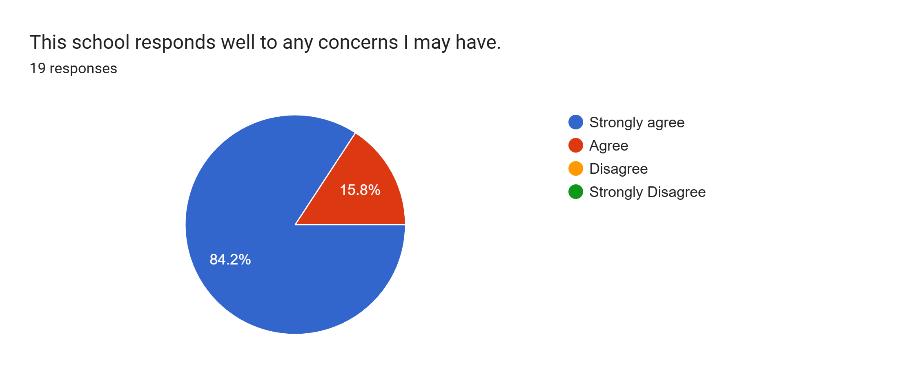
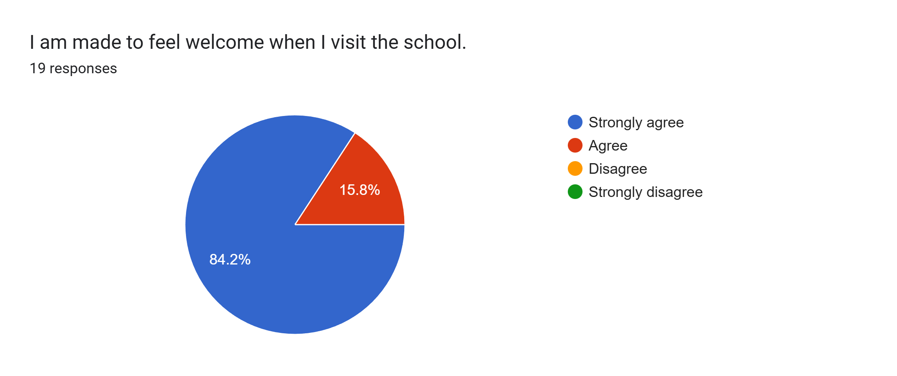
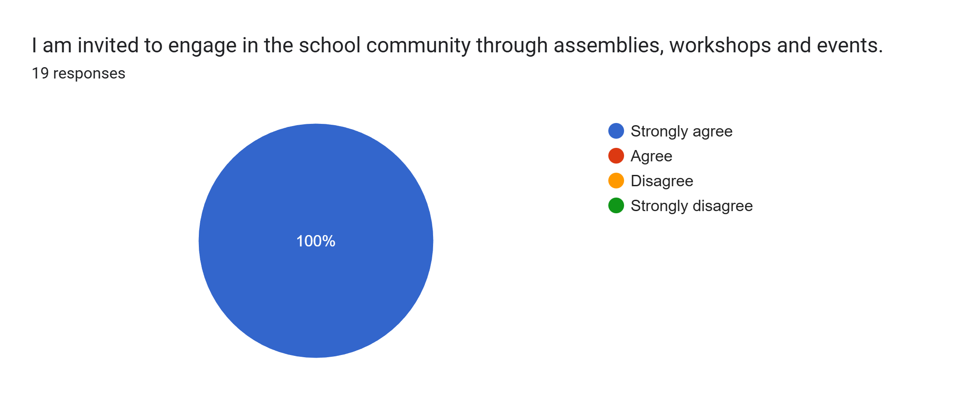
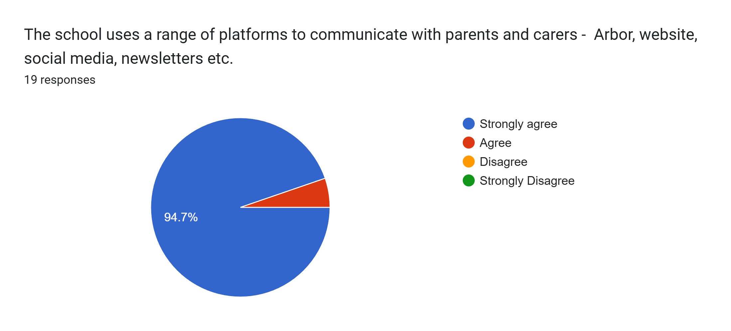
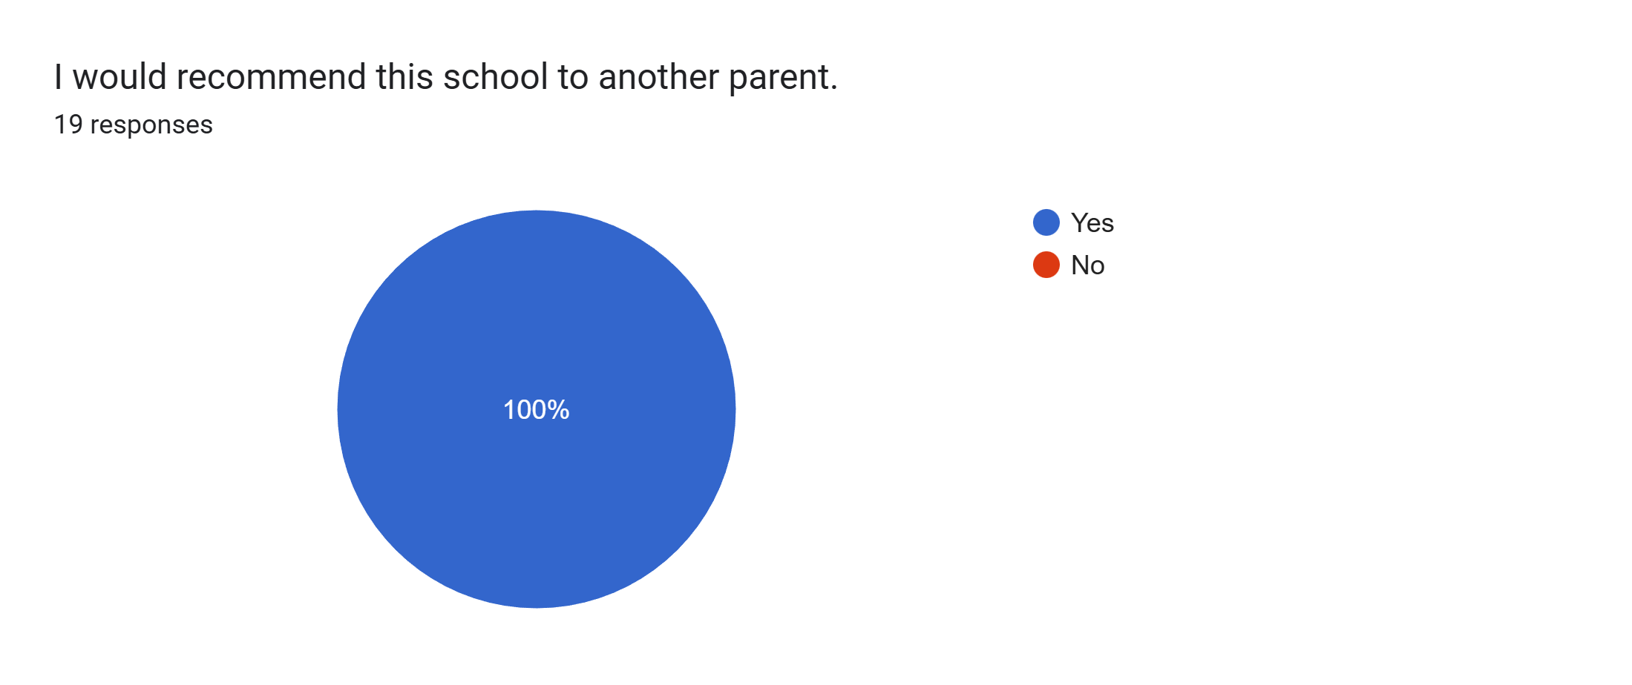

What other comments would you like to make to staff:
- Our daughter loves being in Mr Swatman’s class and is coming on great.
- Thank you for all your help and support making our son’s school experience a happy and enjoyable place to be.
- Thank you for helping my son in such a positive way.
- Mrs Williams goes above and beyond for my daughter.
- Very pleased with how well she is doing this year.
- Great staff and lovely environment.
- An excellent parents’ evening. We are so pleased at how well he is getting on in year 2.
- Teacher is so understanding and has so much time for the children.
- Amazing school and staff.
- All good x
- My son is really liking year 2 and we are very pleased with how he is doing!
- Lovely teacher. My daughter is really happy with her teacher and enjoys coming to school.
- Happy with my daughter’s progress and the opportunities provided.
- Brilliant school.
- Great school – I am happy I chose it for my son. The teachers are nice. Thank you.
- My son is coming on so well and I am so proud to see the progress he has made this year.
- Mr Swatman and all the teaching assistants are amazing and my son is happy in this class.

