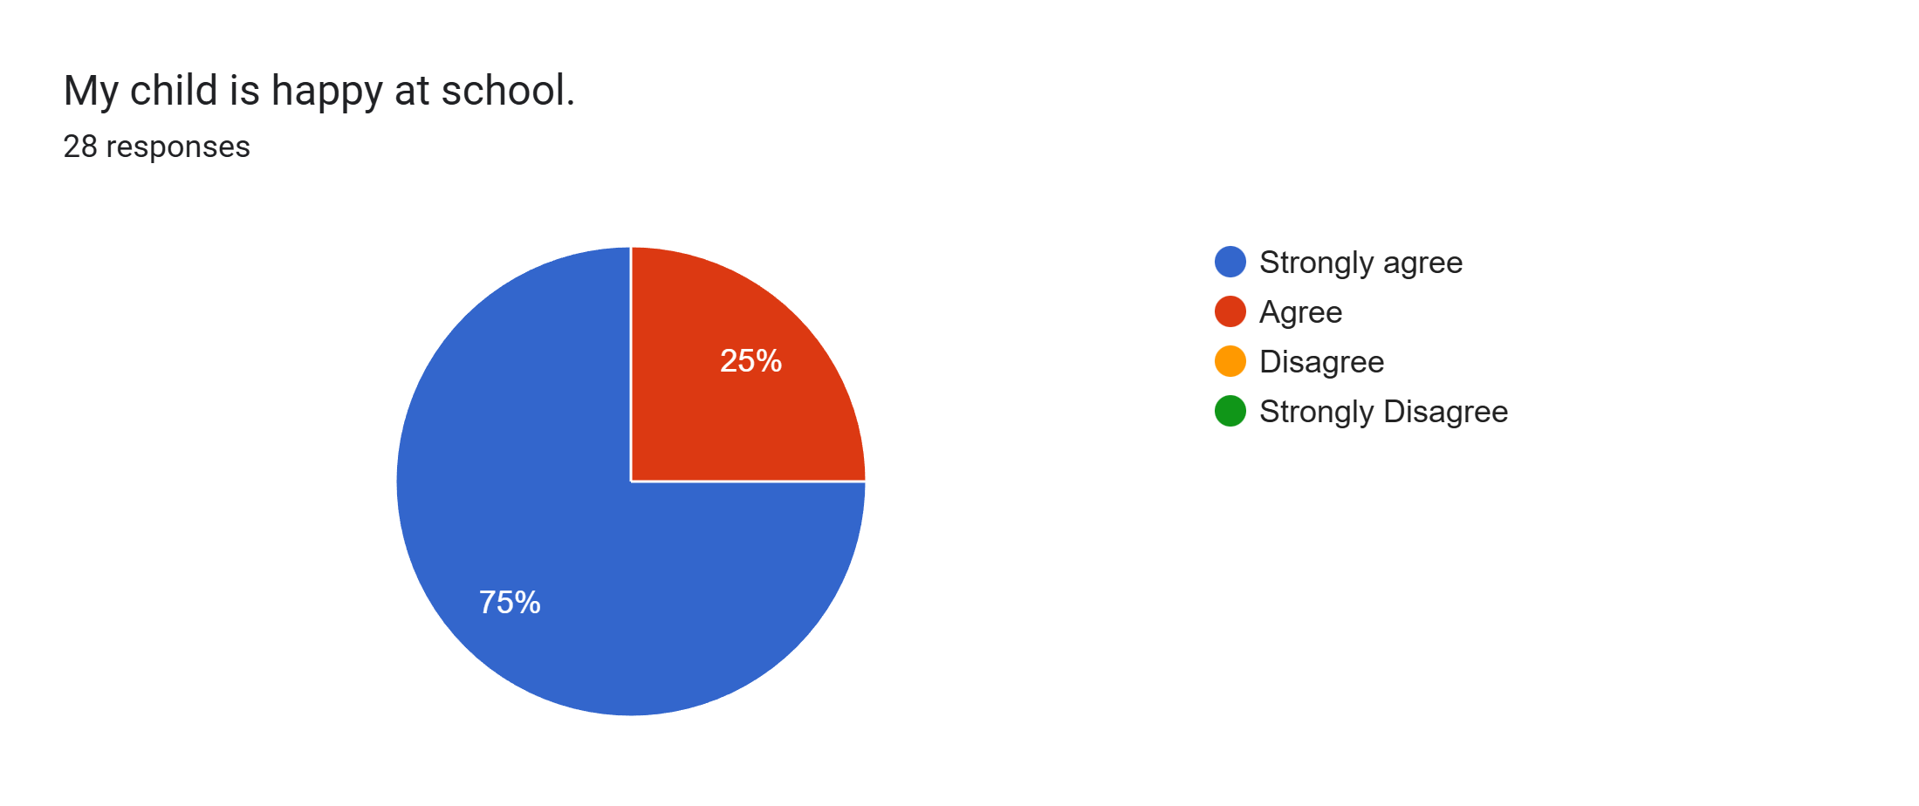
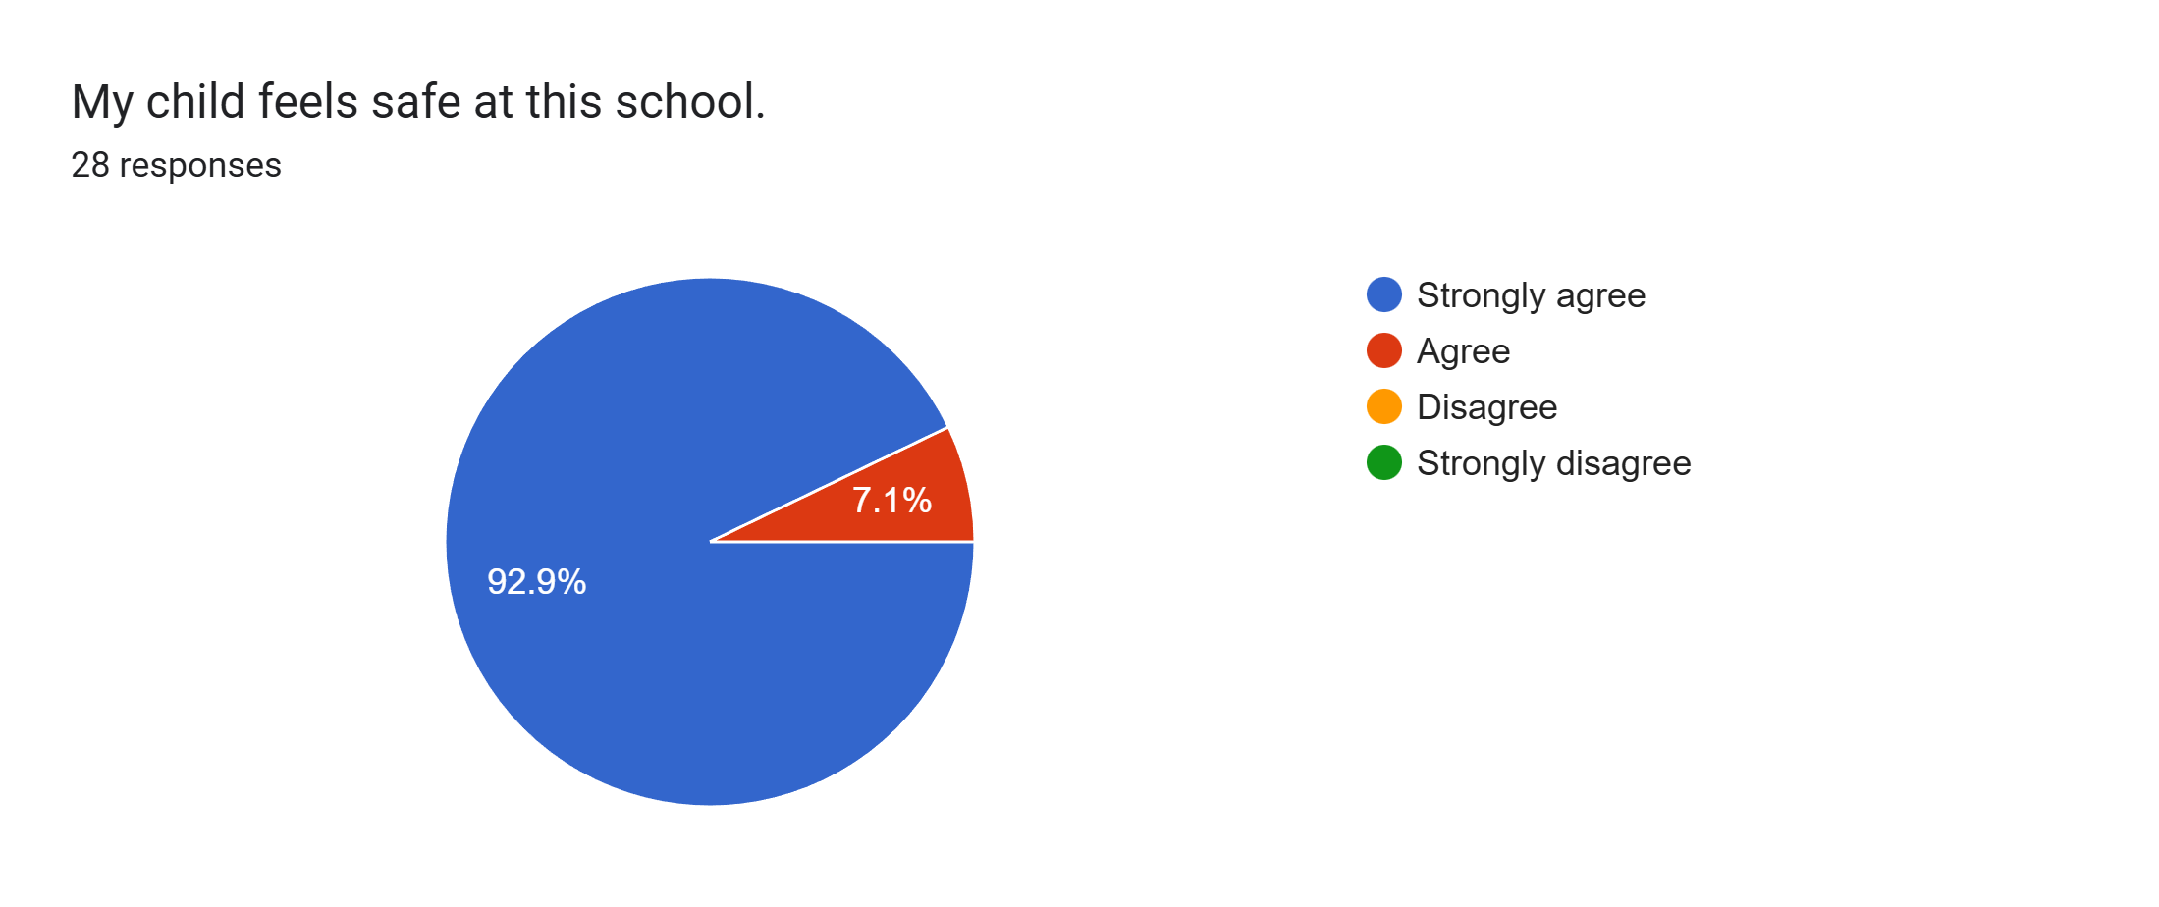
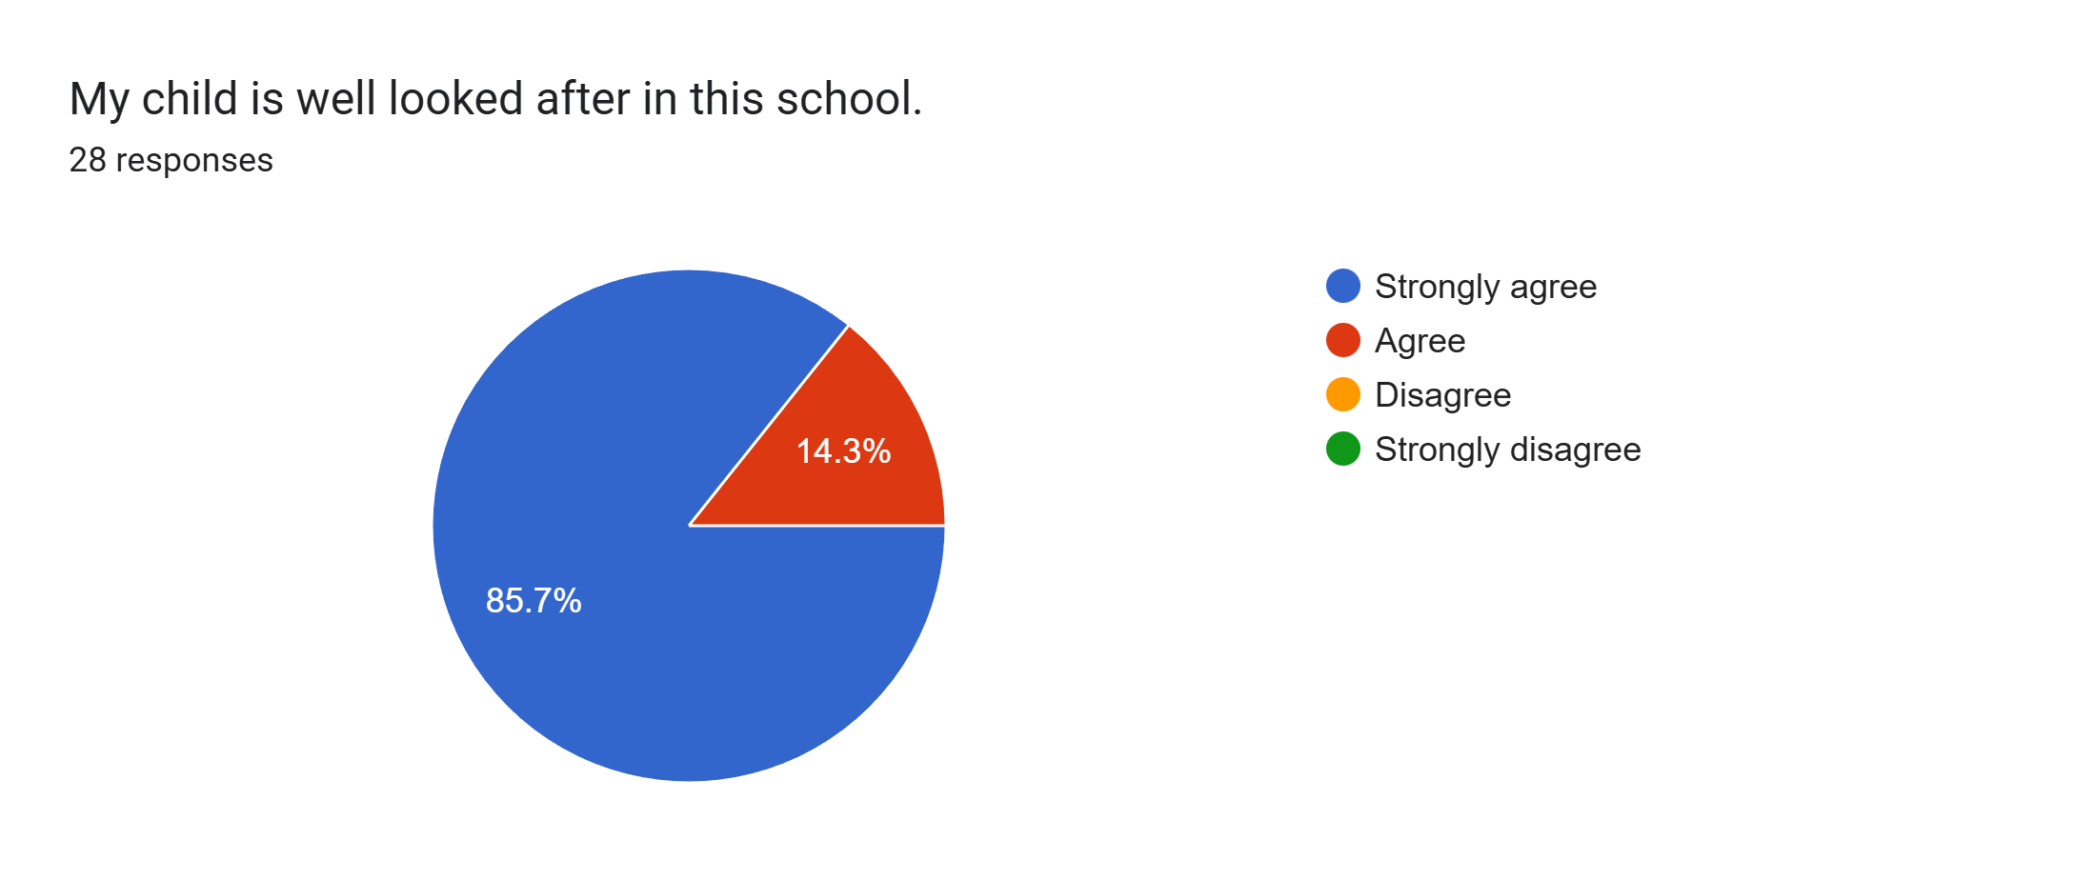
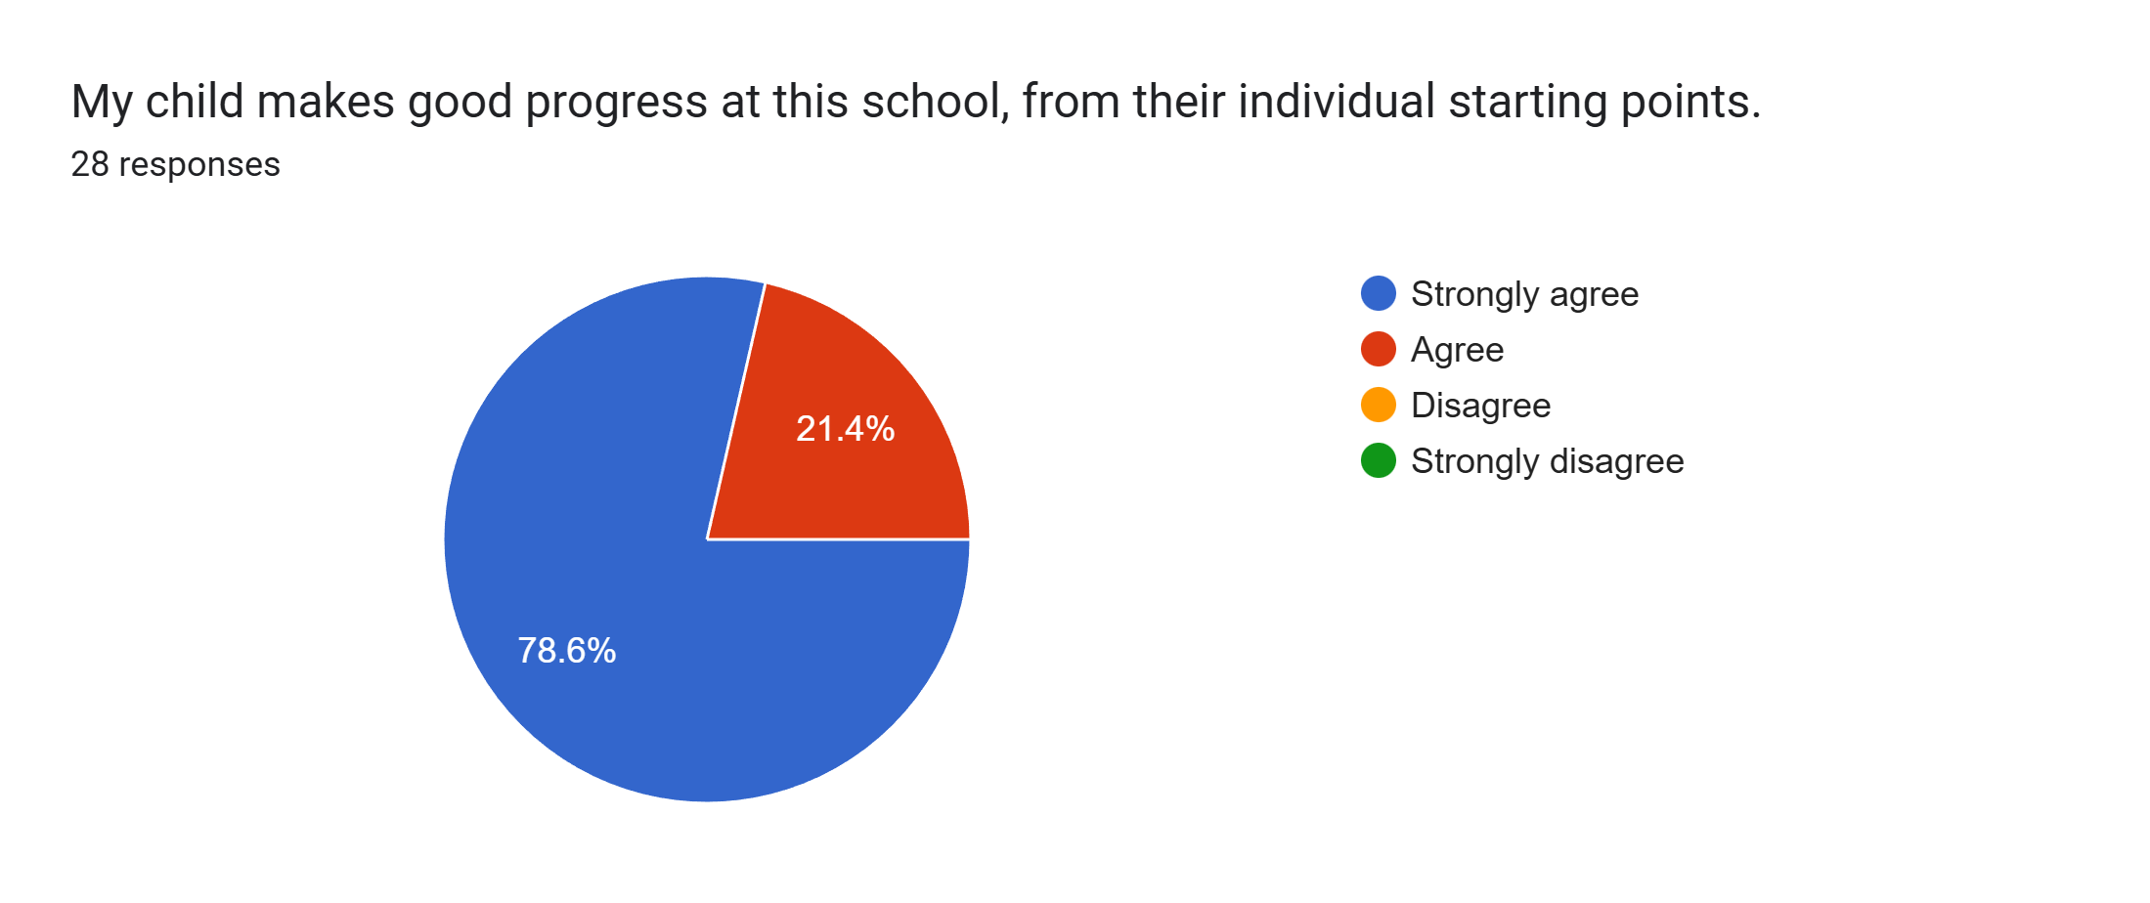
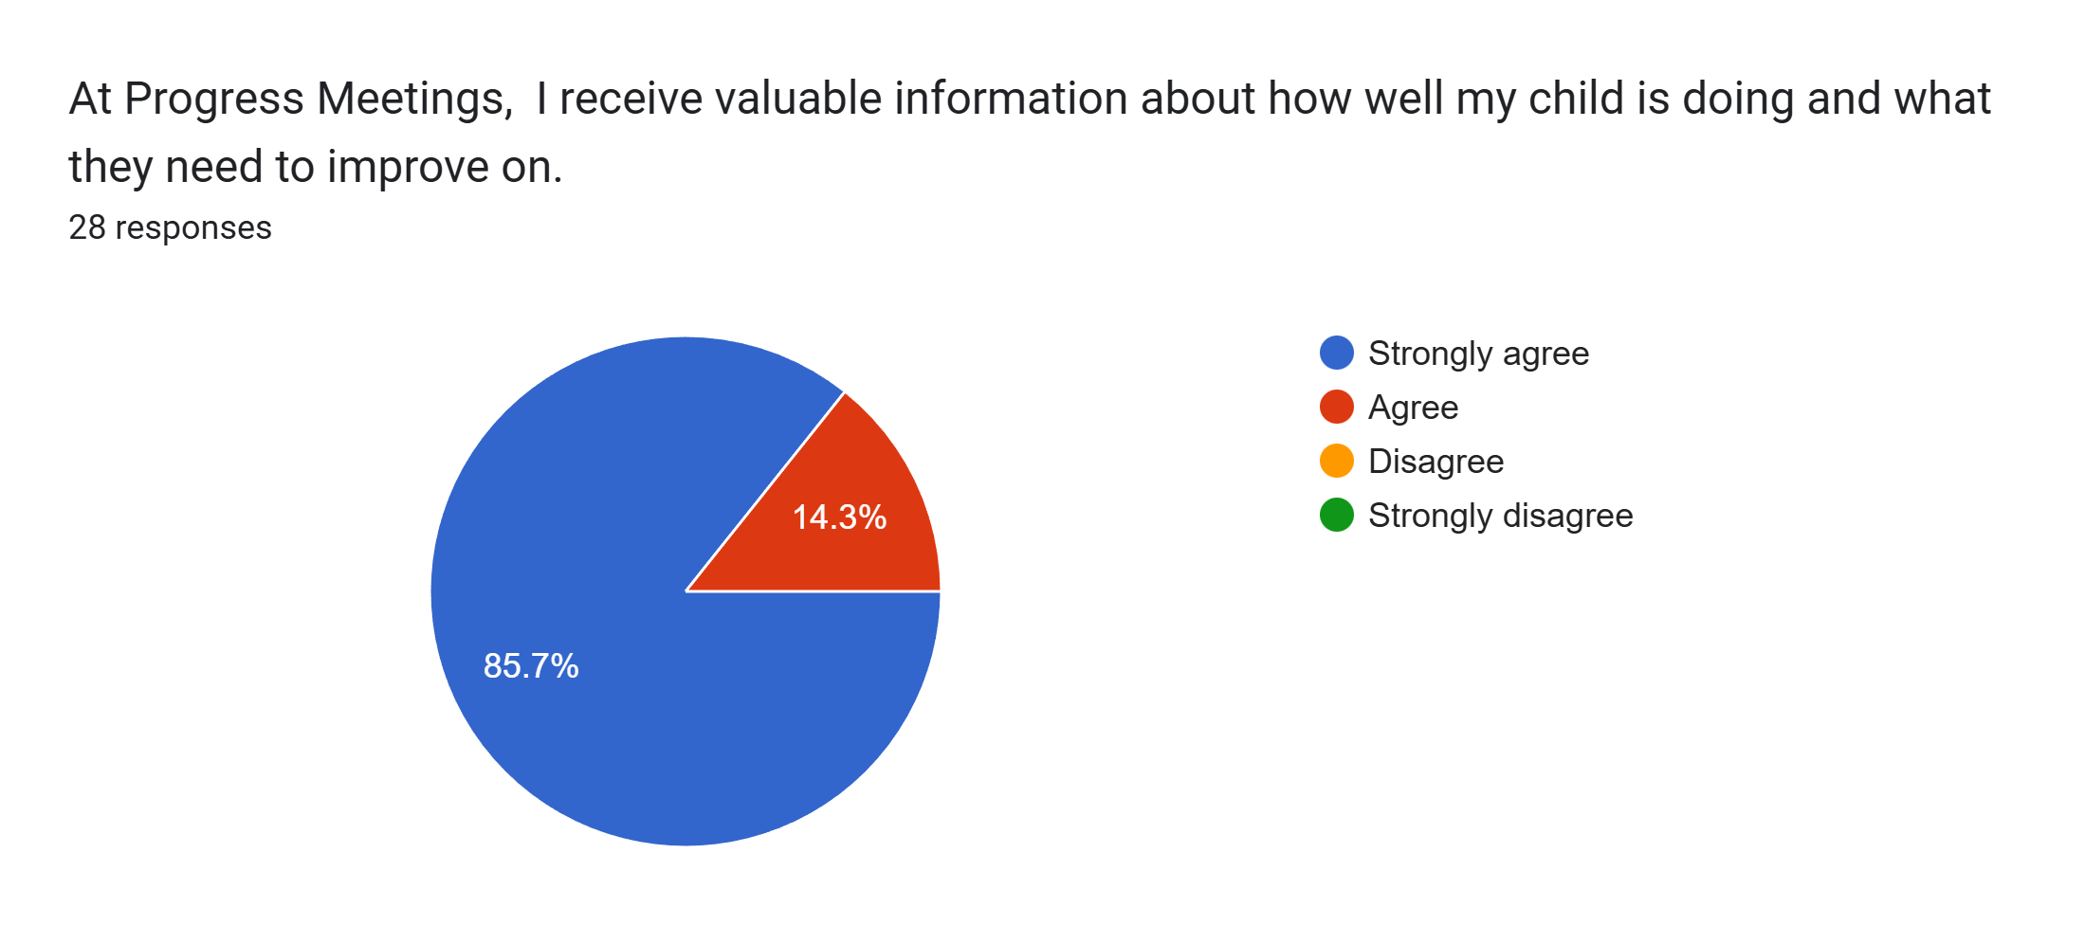
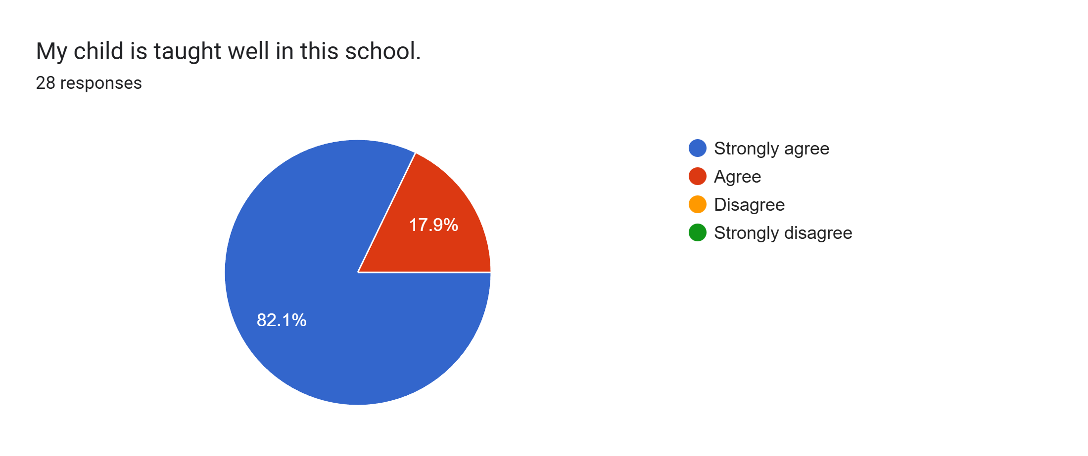
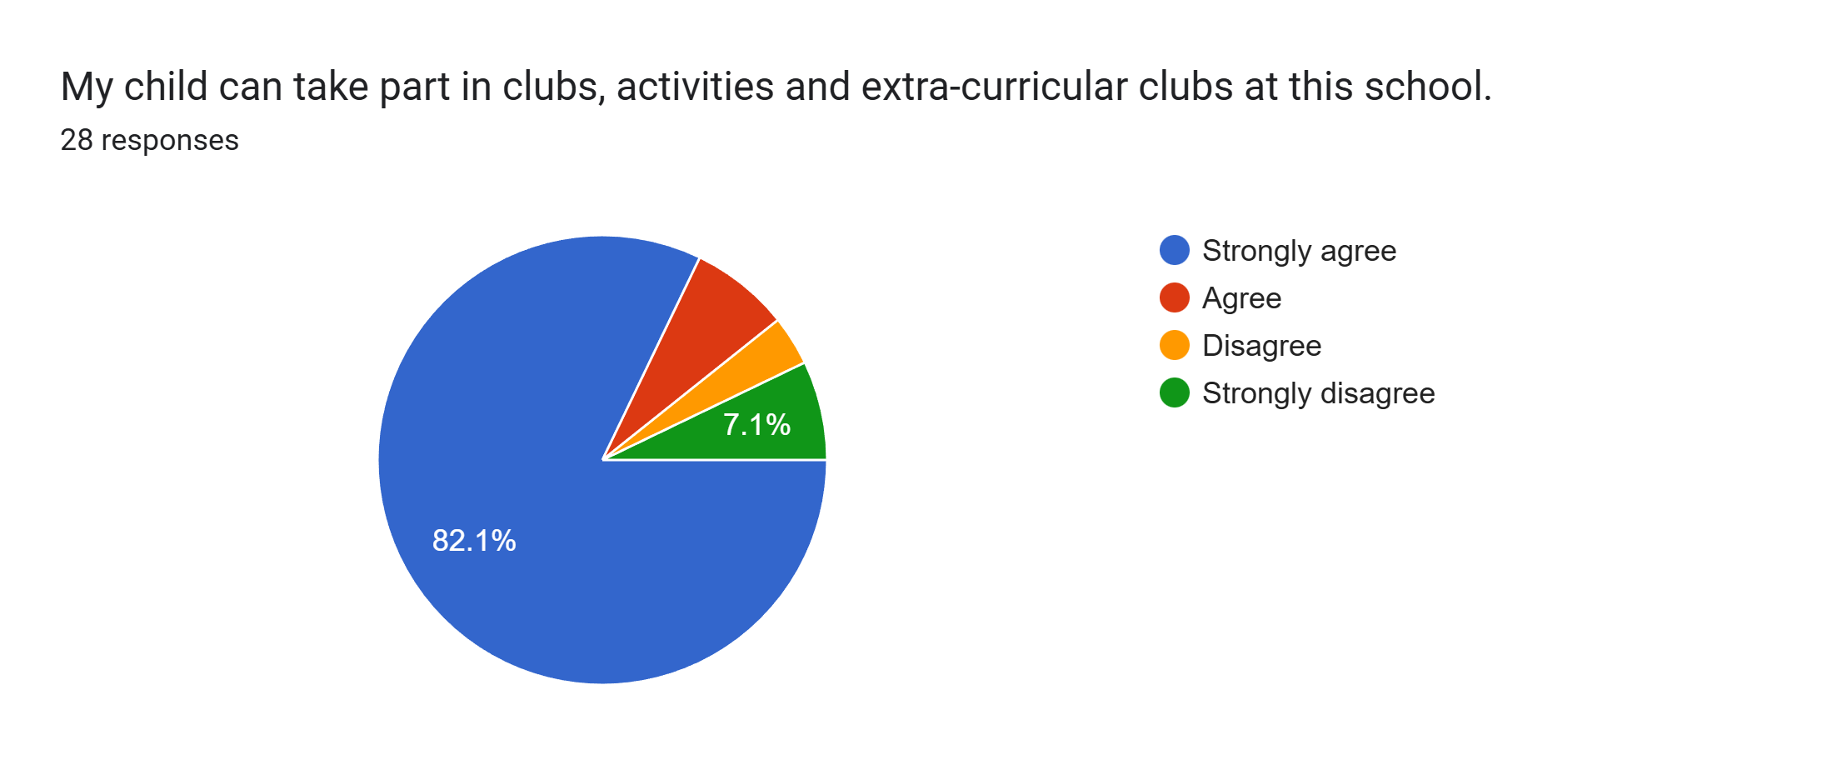
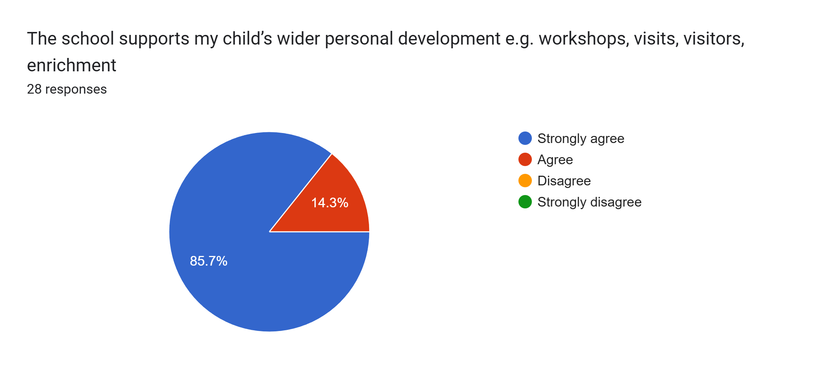
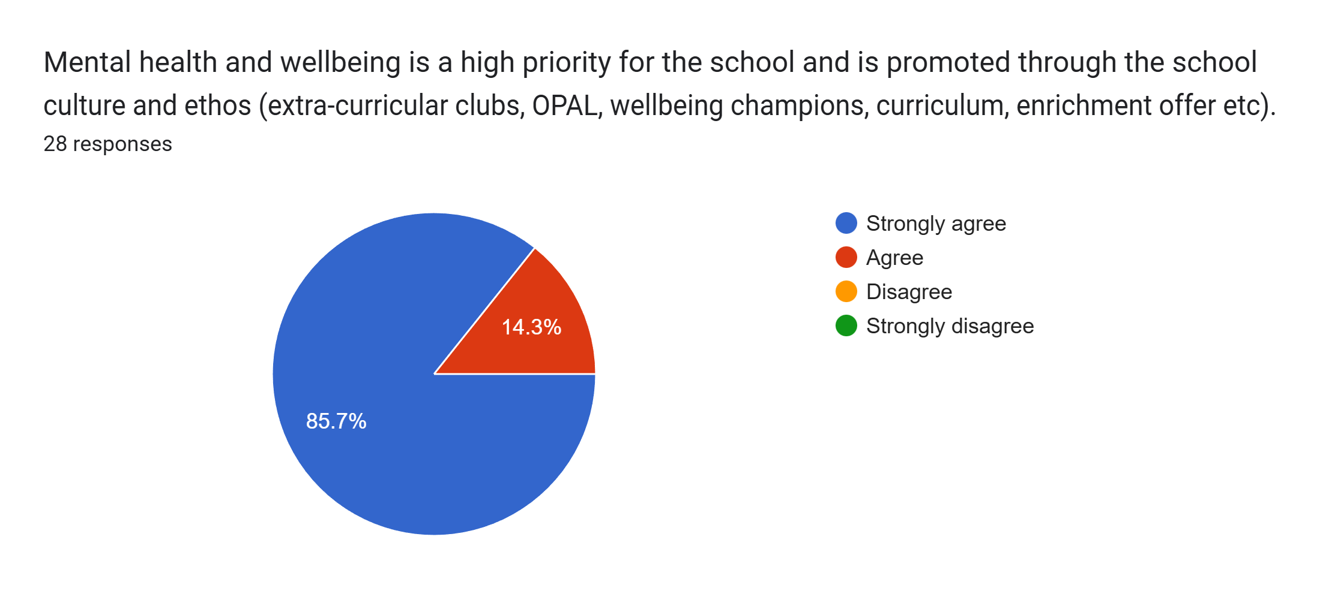
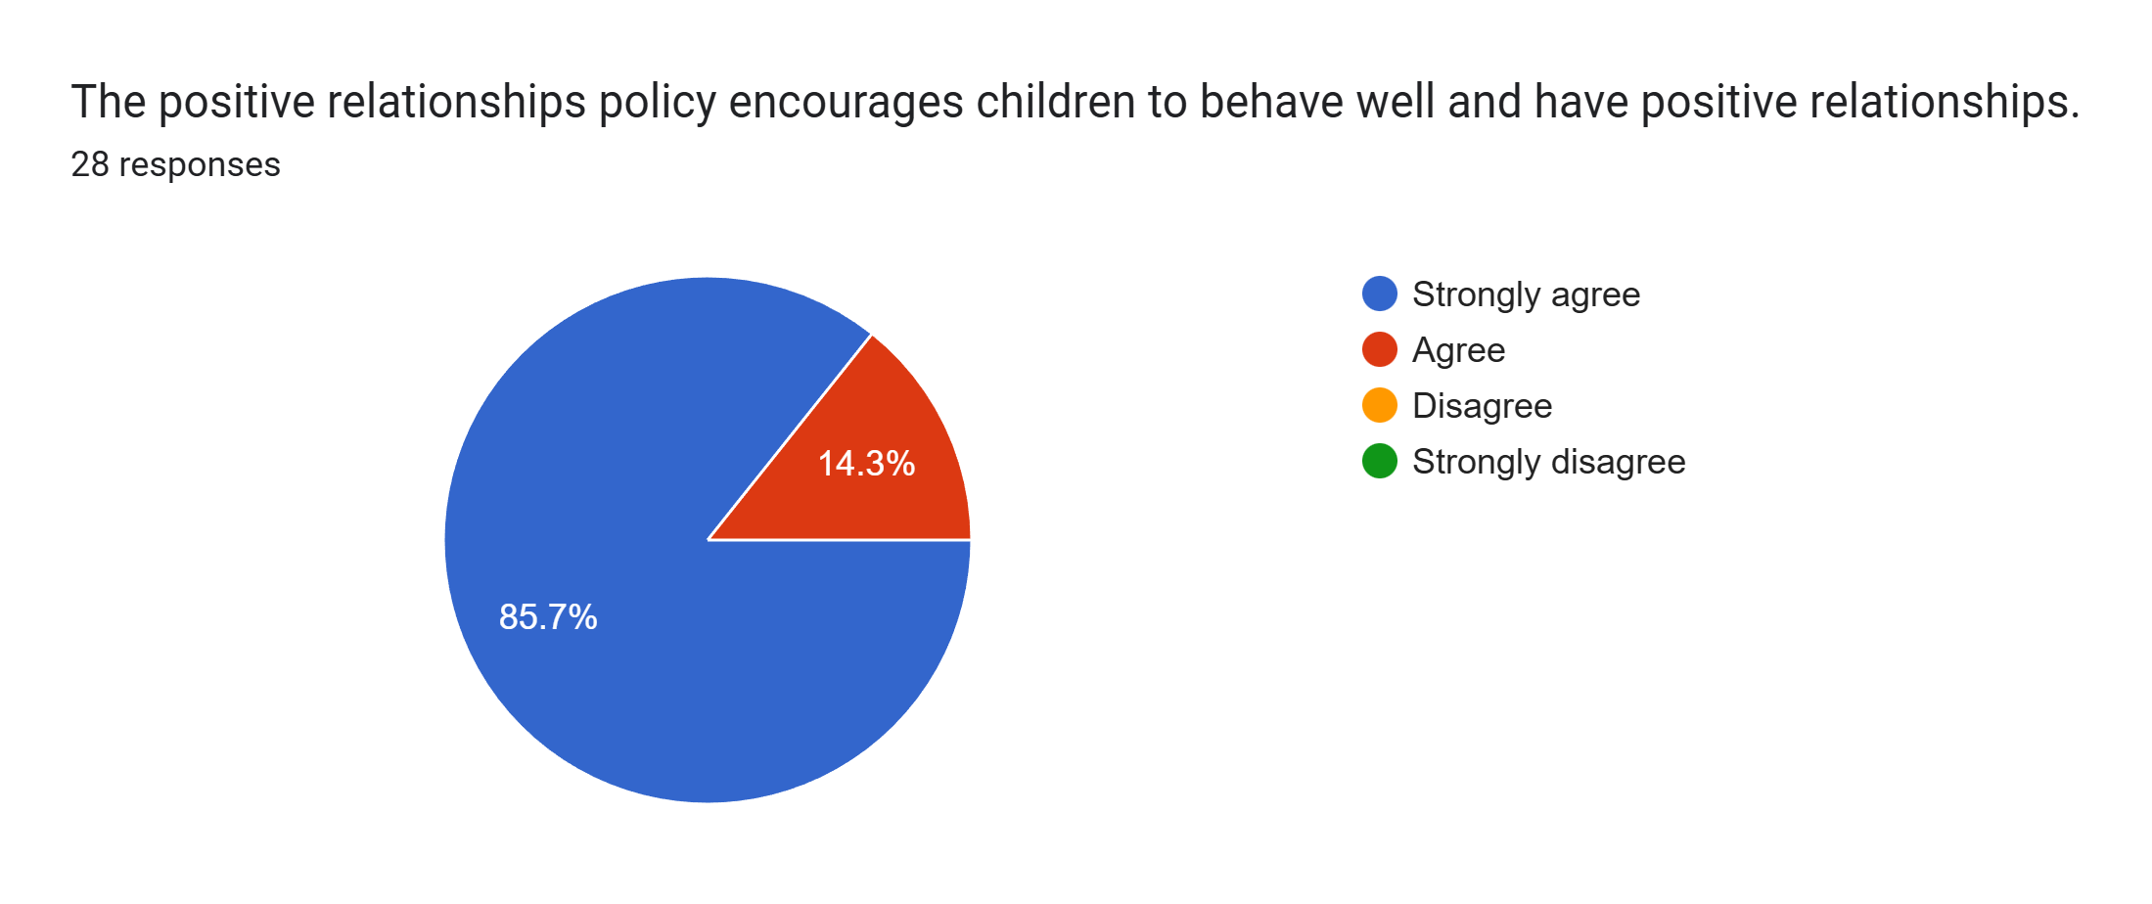
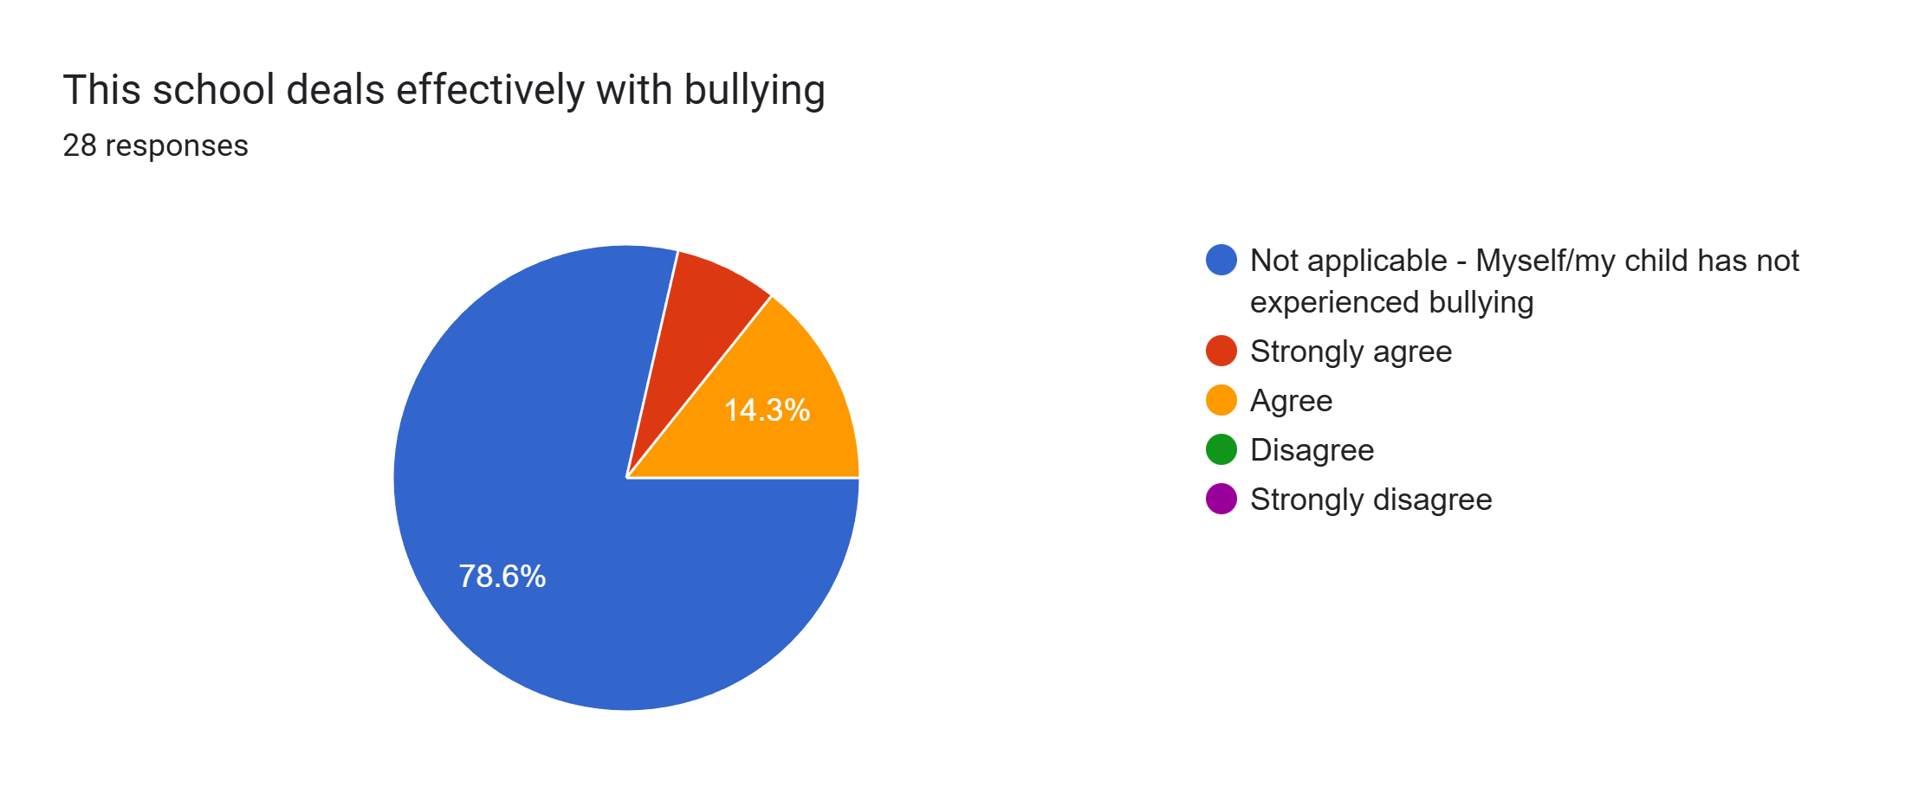
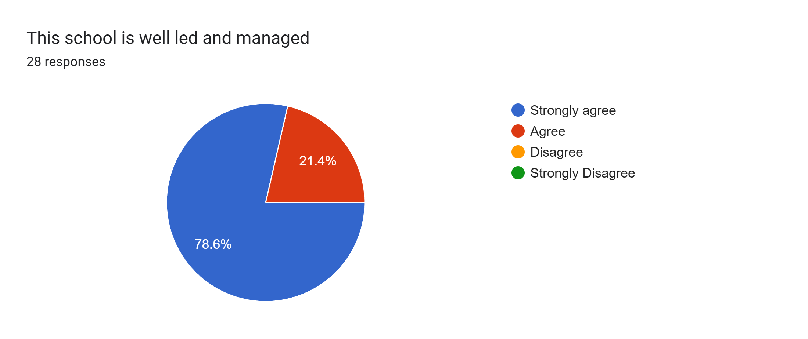
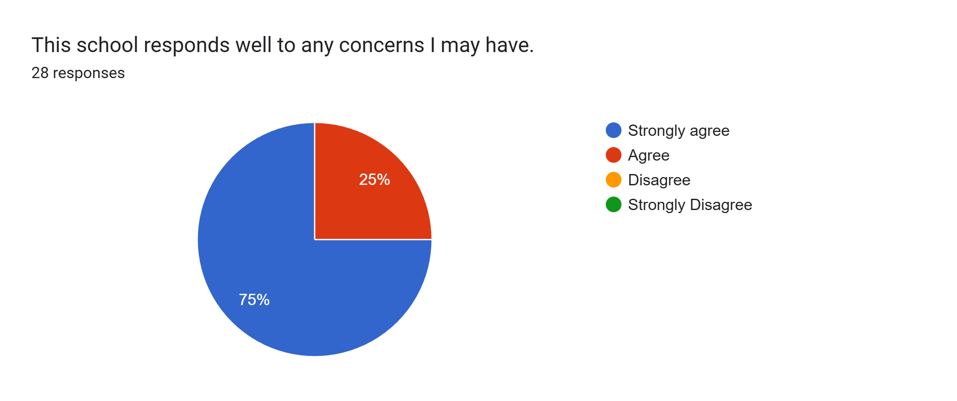
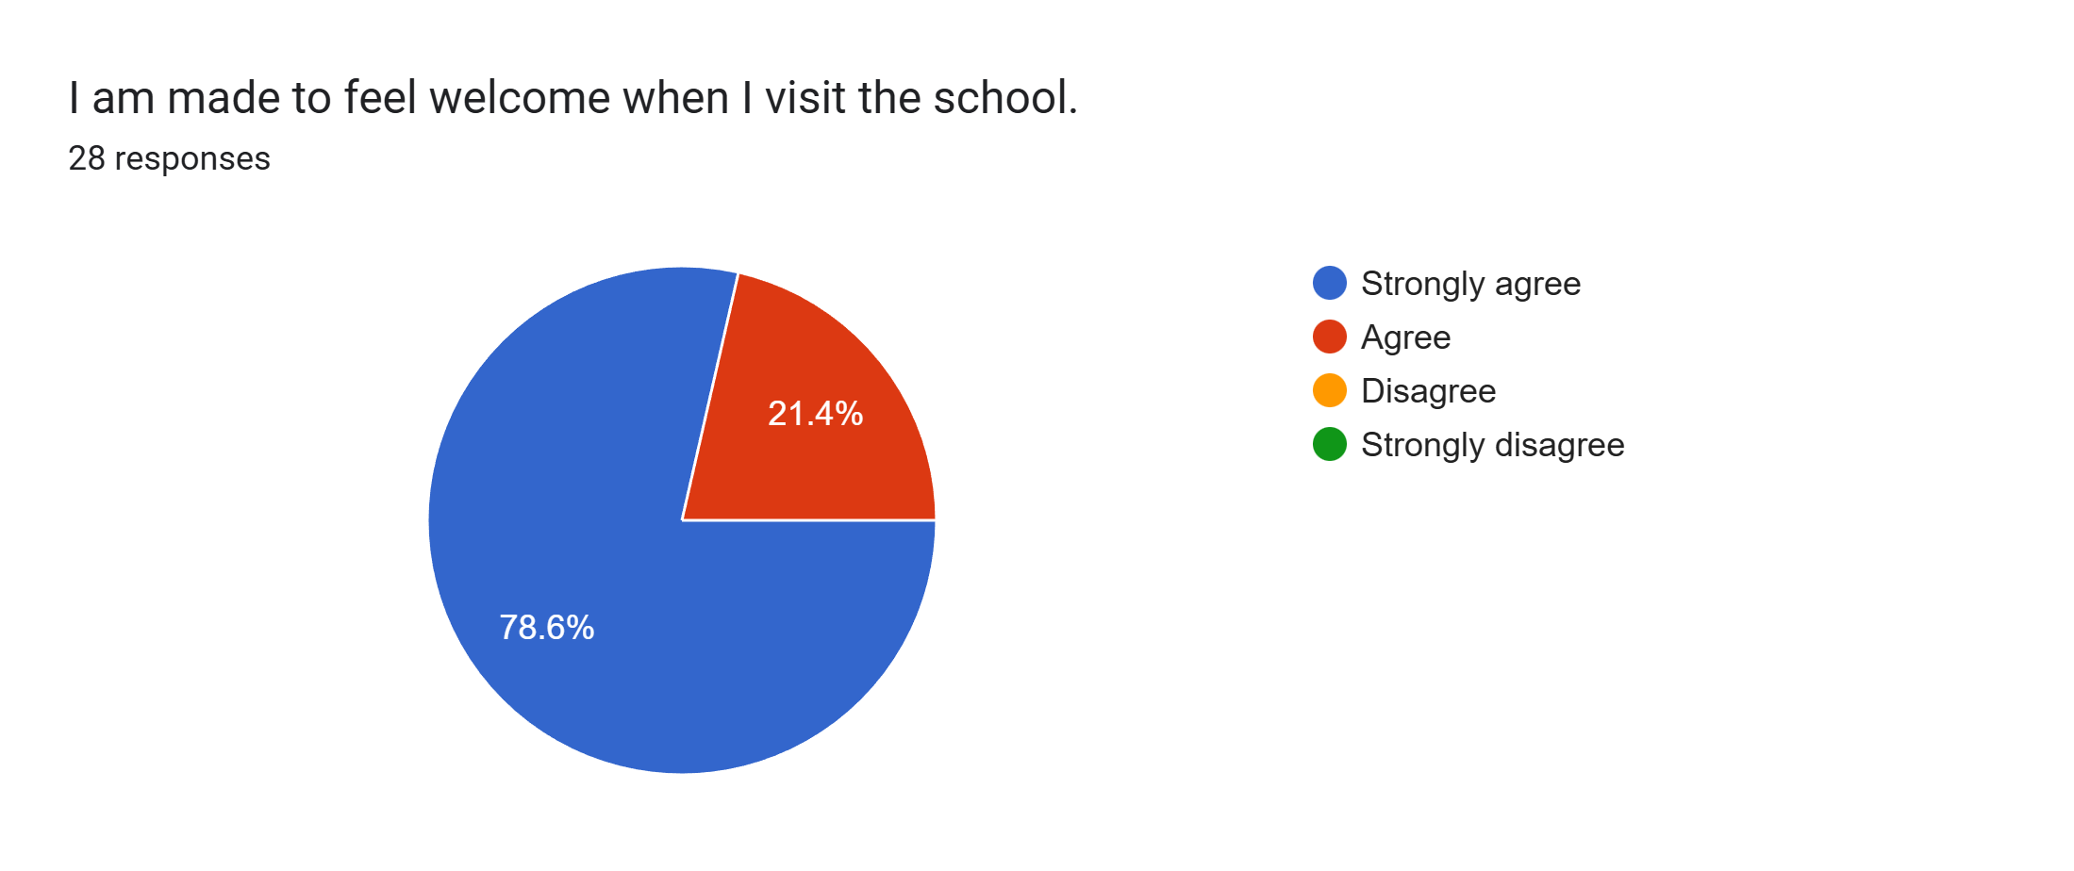
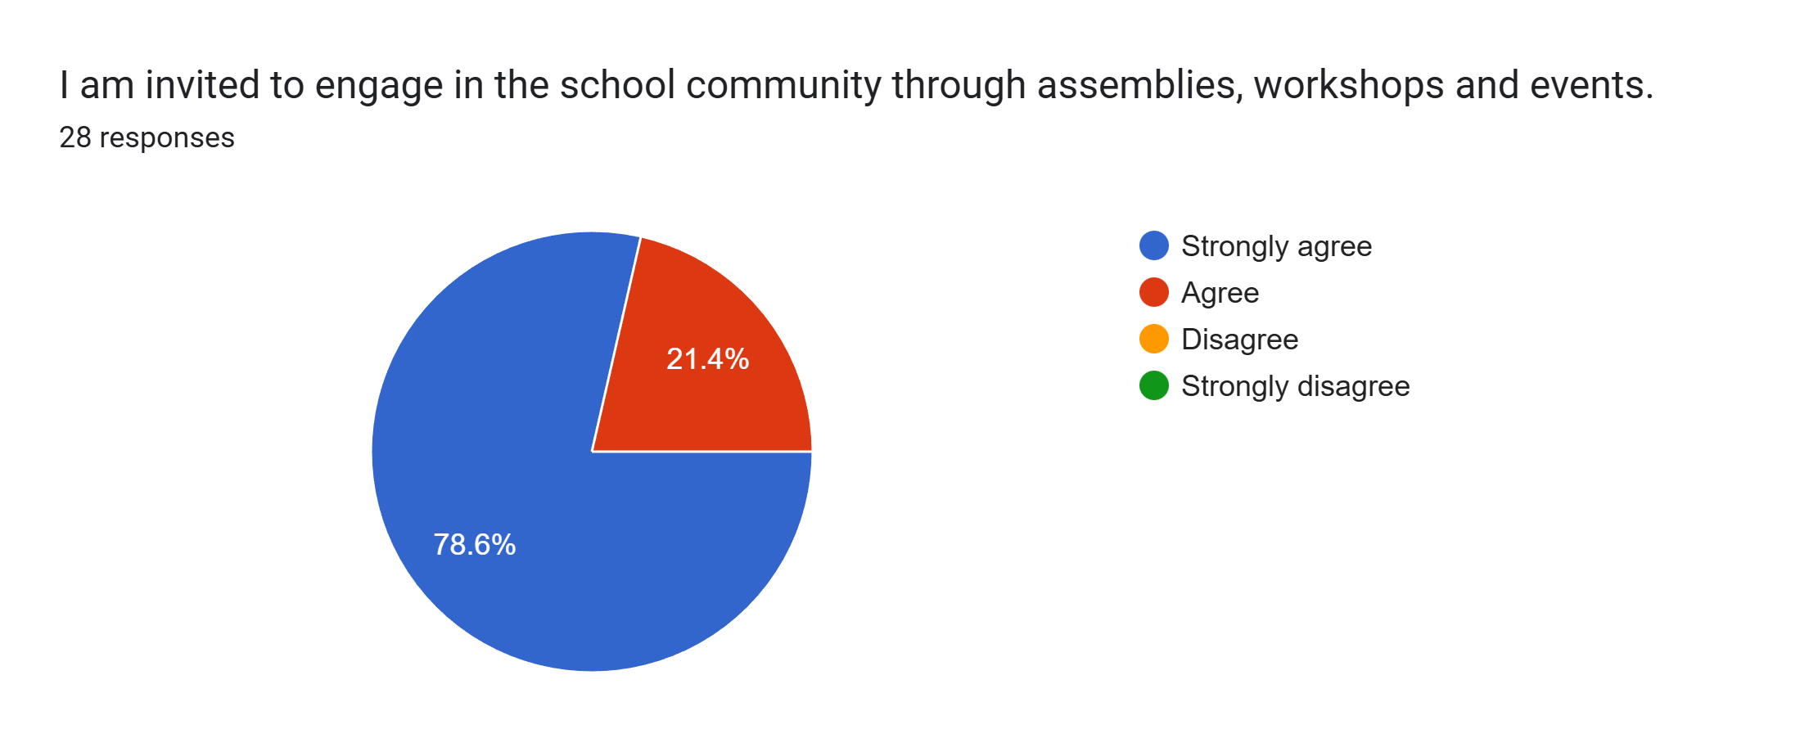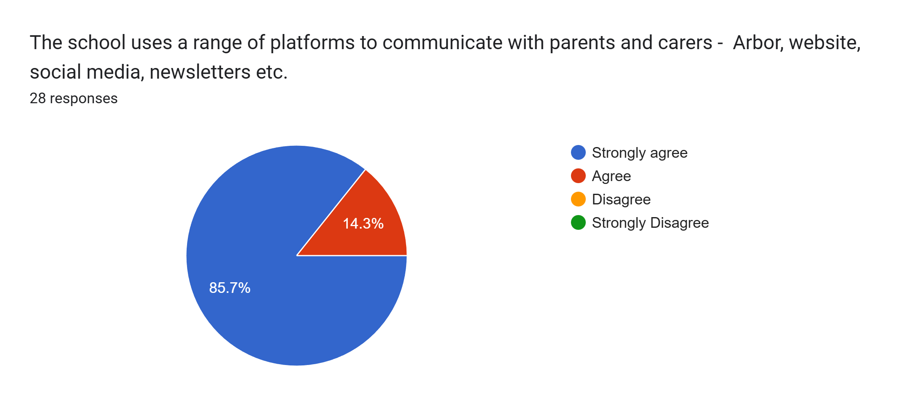
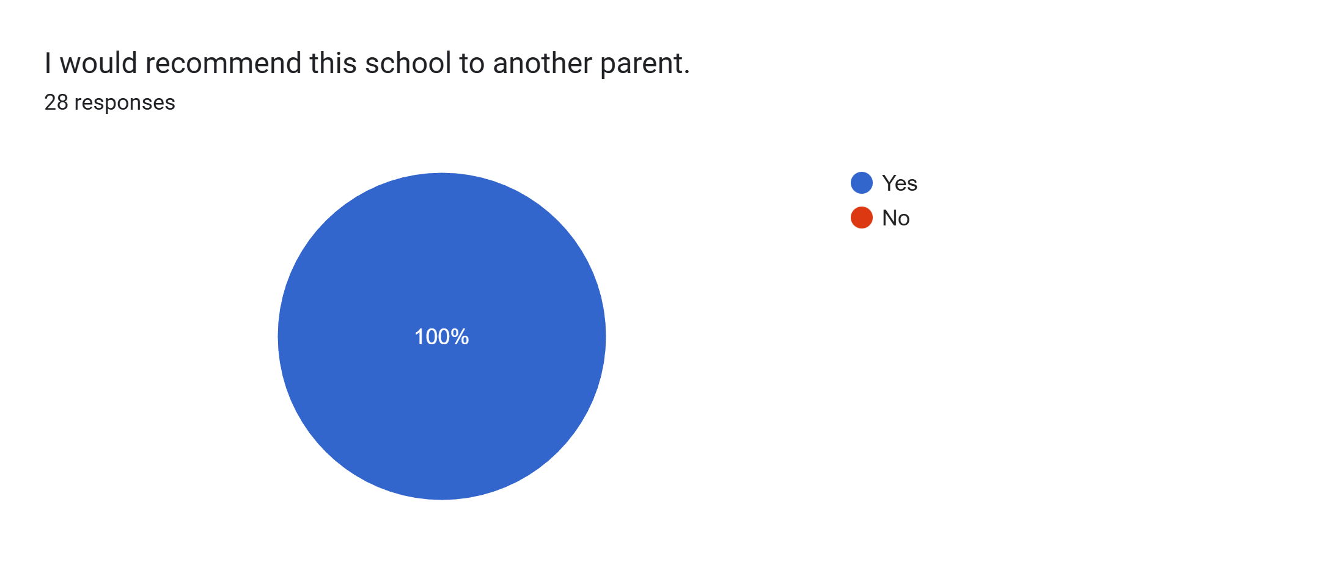

What other comments would you like to make to staff:
- Your efforts are much appreciated.
- Our daughter is really happy at school.
- I am extremely pleased with my daughter’s teachers.
- Wonderful as always x
- Amazing, thank you so much.
- Happy as always.
- Staff are very approachable and very understanding.
- Our daughter is making great progress in all aspects, academically and socially. Thank you.
- Amazing.
- Amazing school.
- My child is adjusting really well moving up into year 1 with Miss Clarkson.
- Great school.
- Thank you for all your hard work.
- Thank you.
- Thank you for everything you all do and making school fun and exciting for our children.
- Lovely school.
- My son is very happy at school and loves all the staff. I am very happy at how he has settled into year one. I also love how many after school activities are available and I love all the rainbows staff - they are amazing with him.
- My son loves school, thank you for all you do.
- My daughter is very happy at school and is supported by all staff very well.
- Happy with everyone!
- Amazing.
- Excellent school, love everything about it.

