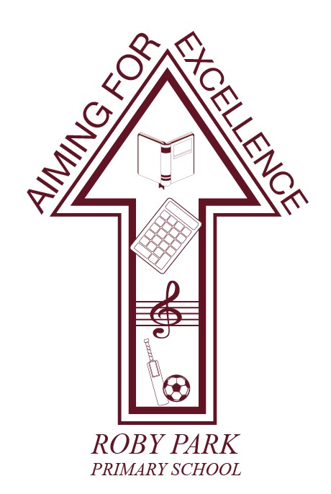

Separated Parents Policy

Written Sept 2025

Review Sept 2026

Signed – Mrs Kat Allen

(Headteacher)

Signed – Mr Mike Long

(Chair of Governors)
This policy takes into account the government’s explanation of Parental rights and responsibilities and the Department for Education’s (DfE) guidance Understanding and dealing with issues relating to parental responsibility
Government guidance outlines what is parental responsibility and who can obtain it.

1. Introduction
At Roby Park Primary School, we aim to maintain contact with both parents in the best interests of their child(ren). This policy aims to minimise any impact and to clarify to all parties what is expected from separated parents and what can be expected from the School.

The basis of the advice within this policy is with regards to a child or children who have already been admitted to the School.

The person(s) with parental responsibility who applied for the child’s admission should have involved all others with parental responsibility in making the decision to apply. They should have provided the School with details of all those with parental responsibility for a child. Where this has not happened, the School welcomes direct contact from those with parental responsibility providing their own details. However, the School cannot be held responsible for excluding a parent or person with parental responsibility if the information has not been provided to them.

If parents separate whilst their child already attends the School, the parents must notify the School immediately so that the School can ensure continuing contact with both parents and, in the event that the parents have separated on an acrimonious basis the School will endeavour to accommodate each parent separately in terms of communications and any attendances at the School.

2. Definition of “parent”
The definition of a “parent” for School purposes is much wider than for any other situation. Section 576 of The Education Act 1996 defines a parent as:
- all biological parents, whether they are married or not
- includes any person who, although not a biological parent, has parental responsibility for a child or young person - this could be an adoptive parent, a step-parent, guardian or other relative
- any person who, although not a biological parent and does not have parental responsibility, has care of a child or young person.

A person typically has care of a child or young person if they are the person with whom the child lives, either full or part time and who looks after the child, irrespective of what their biological or legal relationship is with the child. For example, this may be a foster carer or family and friends carer who do not have parental responsibility but have been delegated the responsibility for taking day-to-day decisions about the child.

Parents, as defined above, are entitled to share in the decisions about the child’s education and to be treated equally by Schools. In particular, these entitlements include, but are not limited to, the following:
- receiving copies of School reports
- having access to School records
- attending parent meetings
- receiving newsletters
- invitations to School events
- information about School trips
- School photographs relating to their child
- participation in any exclusion procedure and
- dealing with any medical issues that arise and/or vaccinations that may be offered.

The School recognises that whilst the parents of some pupils may be separated, divorced or estranged, they are still entitled to the above and this entitlement cannot be restricted without a Court order. If the parents are involved in proceedings before the Court directly relating to the child(ren), the parents should seek the Court’s permission to disclose the Court order(s) made to the School. In addition, and should the Courts so require, the School will be willing to provide a letter setting out any information that is specified in a Court order.

3. Parental responsibility
Parental responsibility is defined in the Children Act 1989 and means the rights, duties, powers, responsibilities and authority that a parent has for their child. In addition to a child’s natural parents, it can be acquired by Court order, being appointed a guardian, adopting a child or a formal agreement.

The information provided to the School when the child was enrolled detailing who has parental responsibility for the child will be presumed to be correct unless a Court order or original birth certificate proving otherwise is provided to the School. The School will be reliant on such information being provided as accurate and true. The information provided regarding the address(es) where the child lives will be presumed to be correct unless the School is provided with a copy of a Court order setting out arrangements for where the child should live.

Every parent with parental responsibility for a child has an equal right to be engaged with decisions regarding their education. Unless there is a Court order limiting an individual's exercise of parental responsibility the School must treat all parents equally and must provide them with the same information.

Where contact has been limited by a Court order, the parent still has the right to receive information about the child and be involved in decisions regarding their education and welfare, unless a Court order restricts what information they can receive or removes their parental responsibility. We will not remove a parent’s contact details without such a Court order being in place or a parent asks for their own contact details to be removed.

4. Court orders
At Roby Park Primary School, our sole wish is to promote the best interests of the child, working in partnership with all parents and/or those with parental responsibility. If there is a Court order in place, the School will always act in ways to ensure, as best it can, that no Court order is breached. The School can only be expected to comply with an order if it is properly notified and has received a sealed digital or paper copy for its files, and only to the extent that it relates to the School.

The School has no responsibility for enforcing any Court order but will endeavour to ensure that if there are restrictions in place with regards to the collection of a child, such restrictions are adhered to.

In the event that the School is not informed of the existence of such an order, the parents will be treated equally by the School. If there is an order in place and neither the parents and/or those with parental responsibility inform the School then if there is any breach of such order, the School cannot be held responsible and/or liable

5. Disputes and disagreements
Roby Park Primary School hopes that parents and all those with parental responsibility will support the School in working together for the benefit of their children.

It is very important to note that any dispute between parents sharing these rights will need to be resolved between them. In all cases where parents and/or those with parental responsibility cannot agree on various issues, parents should seek independent legal advice as to the options available to resolve those issues, either by agreement or by obtaining a Court order.

Parents should seek to resolve contact issues without involving the School. The School will not mediate, “take sides” or act as an intermediary between parents who do not communicate with each other.

6. Changes in family circumstances
We ask parents to inform the School whenever something outside School – such as a change in family circumstances – occurs so that we can sensitively support the child in School. We expect parents to update the School whenever emergency contact details change for one or both parents and/or there is a new arrangement for collecting children at the end of the School day, in particular if there is any Court order that has been made.

We recognise the sensitivity of some situations and all staff are aware of the need for discretion and confidentiality. School staff will be informed on a strict need-to-know basis so that suitable support can be offered.

7. The release of child(ren)
On being admitted to the School, and unless notified to the contrary, the School will release children to either or both parents and/or those with parental responsibility and/or those with care of the child. If one parent seeks to remove the child from School in contravention of the notified arrangements, and the parent to whom the child would normally be released has not consented, the following steps will be followed:
- The Headteacher or designated deputy will meet with the parent seeking to remove the child and then telephone the parent to whom the child would normally be released and explain the request.
- If the parent to whom the child would normally be released agrees (such agreement to immediately be confirmed by an email to ensure there is record on the School’s files), the child may be released and the records will reflect that the permission was granted.
- In the event that the parent to whom the child would normally be released to cannot be reached, the Headteacher or designated deputy dealing with the issue may make a decision based upon all relevant information available to him/her.
- The Headteacher or designated deputy may have to refuse permission if consent cannot be obtained.
- During any discussion or communication with parents and/or those with parental responsibility, the child may be supervised by an appropriate member of School staff in a separate room.
- In extreme circumstances if there is a belief that a possible abduction of the child may occur or if the parent is disruptive, the Police will be notified immediately.

8. Communication between School and separated parents
Bulletins, newsletters and general updates are sent via the Arbor app to all parents and/or those who have parental responsibility for whom we have up-to-date contact details. These updates contain all the main class/School events, including progress meetings, productions, sports days and class outings and events.

The School is able to deal with separate requests for invitations to School events and performances made by separated, divorced or estranged parents who have parental responsibility. However, the School would be grateful if parents could communicate directly on such matters if they can although in some instances the School recognises that this may not be possible should there be a Court order in place preventing the parties from contacting each other. The School will try to comply with requests; however, in certain circumstances, and as stated above, it will not always be possible, for example when a Court order preventing contact with the child or each other is in place.

In all circumstances, we aim to maintain our open-door policy with all parents. Class teachers and the Headteacher will be available by appointment to discuss any issues.

9. Progress meeting appointments
Whenever requested, we will offer separate progress meeting appointments for separated, divorced or estranged parents who have parental responsibility.

10. End of year reports
Any person who is known to the School to have parental responsibility for a child has the right to receive an end of year report for their child. This will be provided to separated, divorced or estranged parents who have parental responsibility and for whom the School has up-to-date contact details.

11. Change of name
A parent can only change their child’s name (forename and/or surname) either by both parents providing a letter confirming such consent and bearing wet signatures or by an order of the Court. Unless either of the above are provided, the child will be known and addressed by their birth name as recorded on their birth certificate.

The School is under no obligation to do so but they may, effect an informal change of name if that is requested by the parent(s) for example (a) verbally addressing a child (b) name on books etc. It is important to note that the School database, unless changed by an order of the Court, will reflect the child’s name at birth. In addition, and as stated, any informal change of name addressing the child is at the School’s complete discretion after the School has taken into account all of the circumstances.

12. Access to School information
Key information is available on the Roby Park Primary School website. Parents may also receive information via the Arbor app or email.

For parents who do not have access to the internet paper copies of communications may be requested from the School.

