

RSE Policy
Written Sept 2025

Review Sept 2026

Signed – Mrs Kat Allen

(Headteacher)

Signed – Mr Mike Long

(Chair of Governors

Contents
1. Aims 3
2. Statutory requirements 3
3. Policy development 3
4. Definition 3
5. Curriculum 4
6. Delivery of RSE 4
7. Roles and responsibilities 4
8. Parents’ right to withdraw 5
9. Training 5
10. Monitoring arrangements 5
Appendix 1: Curriculum map 6
Appendix 2: By the end of primary school pupils should know 7
Appendix 3: Parent form: withdrawal from sex education within RSE 16

Aims
The aims of relationships and sex education (RSE) at our school are to:
- Provide a framework in which sensitive discussions can take place
- Prepare pupils for puberty, and give them an understanding of sexual development and the importance of health and hygiene
- Help pupils develop feelings of self-respect, confidence and empathy
- Create a positive culture around issues of sexuality and relationships
- Teach pupils the correct vocabulary to describe themselves and their bodies

2. Statutory requirements
As a maintained primary school we must provide relationships education to all pupils as per section 34 of the Children and Social work act 2017.
However, we are not required to provide sex education but we do need to teach the elements of sex education contained in the science curriculum.
In teaching RSE, we must have regard to guidance issued by the secretary of state as outlined in section 403 of the Education Act 1996.

At Roby Park, we teach RSE as set out in this policy.

3. Policy development
This policy has been developed in consultation with staff, pupils and parents. The consultation and policy development process involved the following steps:
- Review – a member of staff or working group pulled together all relevant information including relevant national and local guidance

- Staff consultation – all school staff were given the opportunity to look at the policy and make recommendations

- Parent/stakeholder consultation – parents and any interested parties were invited to attend a meeting about the policy

- Pupil consultation – we investigated what exactly pupils want from their RSE

- Ratification – once amendments were made, the policy was shared with governors and ratified

4. Definition
RSE is about the emotional, social and cultural development of pupils, and involves learning about relationships, sexual health, sexuality, healthy lifestyles, diversity and personal identity.
RSE involves a combination of sharing information, and exploring issues and values.
RSE is not about the promotion of sexual activity.

5. Curriculum
Our curriculum is set out as per Appendix 1 but we may need to adapt it as and when necessary.

We have developed the curriculum in consultation with parents, pupils and staff, taking into account the age, needs and feelings of pupils. If pupils ask questions outside the scope of this policy, teachers will respond in an appropriate manner so they are fully informed and don’t seek answers online.

Primary sex education will focus on:
- Preparing boys and girls for the changes that adolescence brings
- How a baby is conceived and born
For more information about our curriculum, see our curriculum map in Appendix 1.

6. Delivery of RSE
RSE is taught within the personal, social, health and economic (PSHE) education curriculum. Biological aspects of RSE are taught within the science curriculum, and other aspects are included in religious education (RE).
Pupils also receive stand-alone sex education sessions delivered by class teachers, following the CWP scheme of work.
Relationships education focuses on teaching the fundamental building blocks and characteristics of positive relationships including:
- Families and people who care for me
- Caring friendships
- Respectful relationships
- Online relationships
- Being safe
For more information about our RSE curriculum, see Appendices 1 and 2.

These areas of learning are taught within the context of family life taking care to ensure that there is no stigmatisation of children based on their home circumstances (families can include single parent families, LGBT parents, families headed by grandparents, adoptive parents, foster parents/carers amongst other structures) along with reflecting sensitively that some children may have a different structure of support around them (for example: looked after children or young carers).

7. Roles and responsibilities
7.1 The governing board
The governing board will approve the RSE policy, and hold the headteacher to account for its implementation.
7.2 The headteacher
The headteacher is responsible for ensuring that RSE is taught consistently across the school, and for managing requests to withdraw pupils from non-statutory components of RSE (see section 8).
7.3 Staff
Staff are responsible for:
- Delivering RSE in a sensitive way
- Modelling positive attitudes to RSE
- Monitoring progress
- Responding to the needs of individual pupils
- Responding appropriately to pupils whose parents wish them to be withdrawn from the non-statutory components of RSE
Staff do not have the right to opt out of teaching RSE. Staff who have concerns about teaching RSE are encouraged to discuss this with the headteacher.
All class teachers are responsible for the delivery of the RSE scheme to their individual classes.
7.4 Pupils
Pupils are expected to engage fully in RSE and, when discussing issues related to RSE, treat others with respect and sensitivity.

8. Parents’ right to withdraw
Parents do not have the right to withdraw their children from relationships education.
Parents have the right to withdraw their children from the non-statutory components of sex education within RSE.
Requests for withdrawal should be put in writing using the form found in Appendix 3 of this policy and addressed to the headteacher.
Alternative work will be given to pupils who are withdrawn from sex education.

9. Training
Staff are trained on the delivery of RSE as part of their induction and it is included in our continuing professional development calendar.
The headteacher will also invite visitors from outside the school, such as school nurses or sexual health professionals, to provide support and training to staff teaching RSE when/if needed.

10. Monitoring arrangements
The delivery of RSE is monitored by Mrs Jackie McCormick through learning walks, work sampling and pupil voice.
Pupils’ development in RSE is monitored by class teachers as part of our internal assessment systems.
This policy will be reviewed by the PSHE subject leader annually. At every review, the policy will be approved by the Headteacher and Governing Body.

Appendix 1: Curriculum map
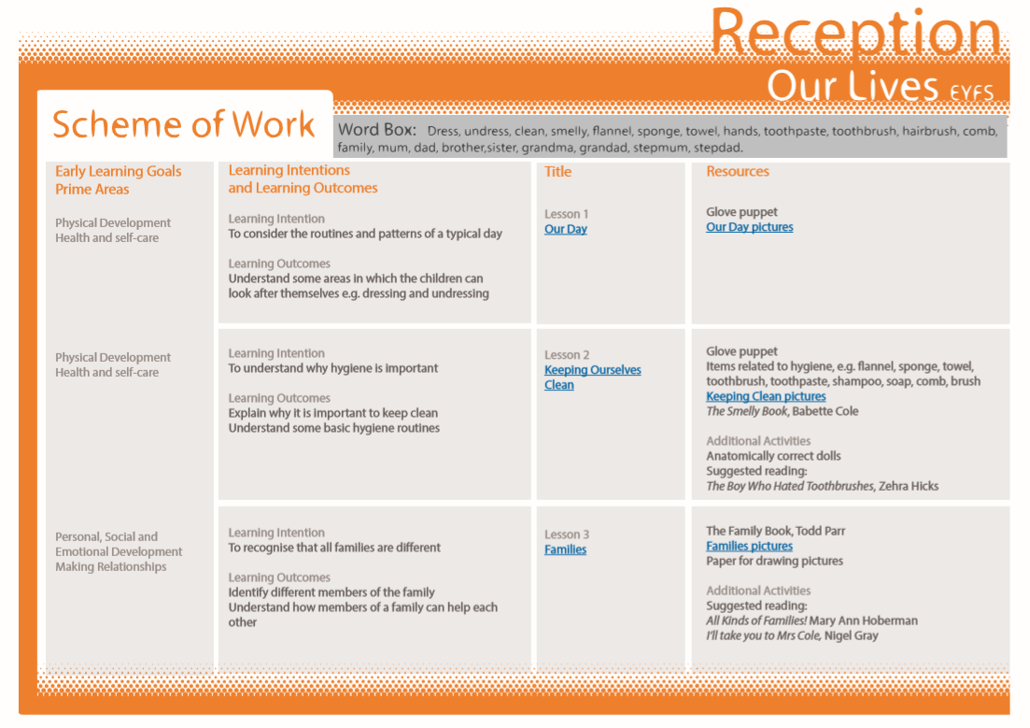
Relationships and sex education curriculum map

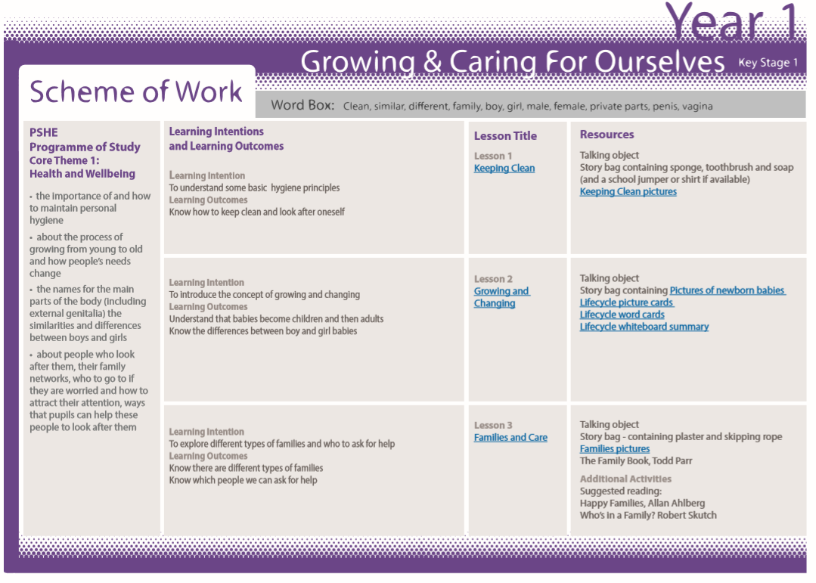

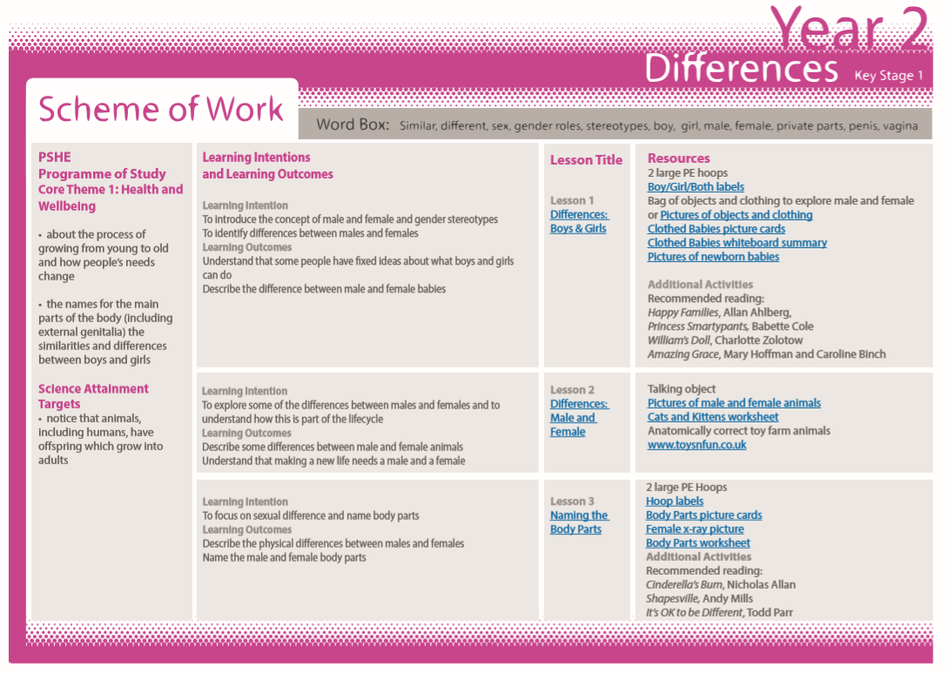

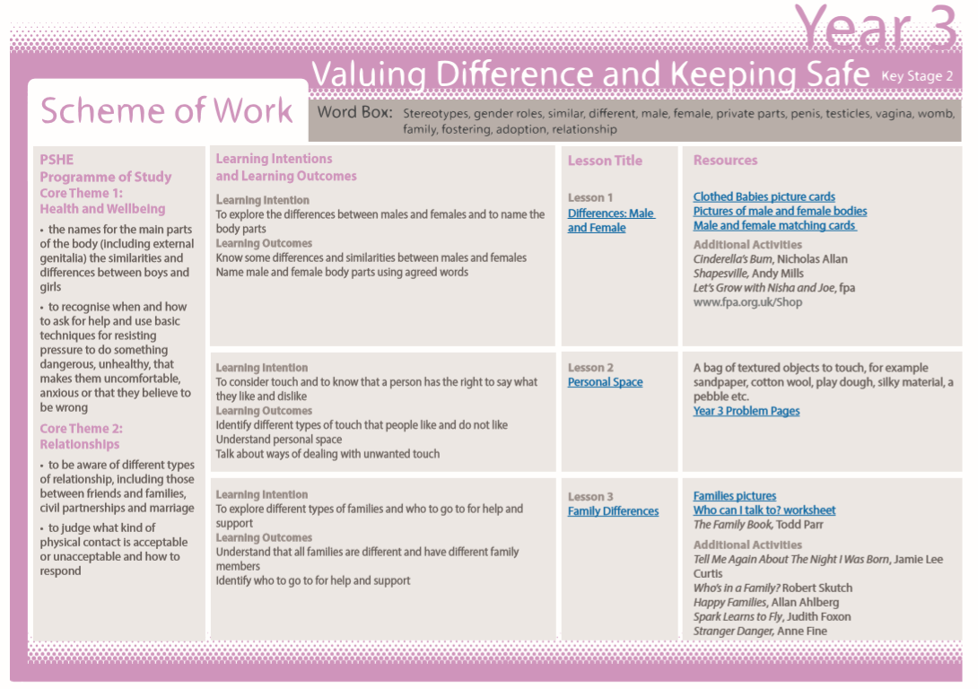

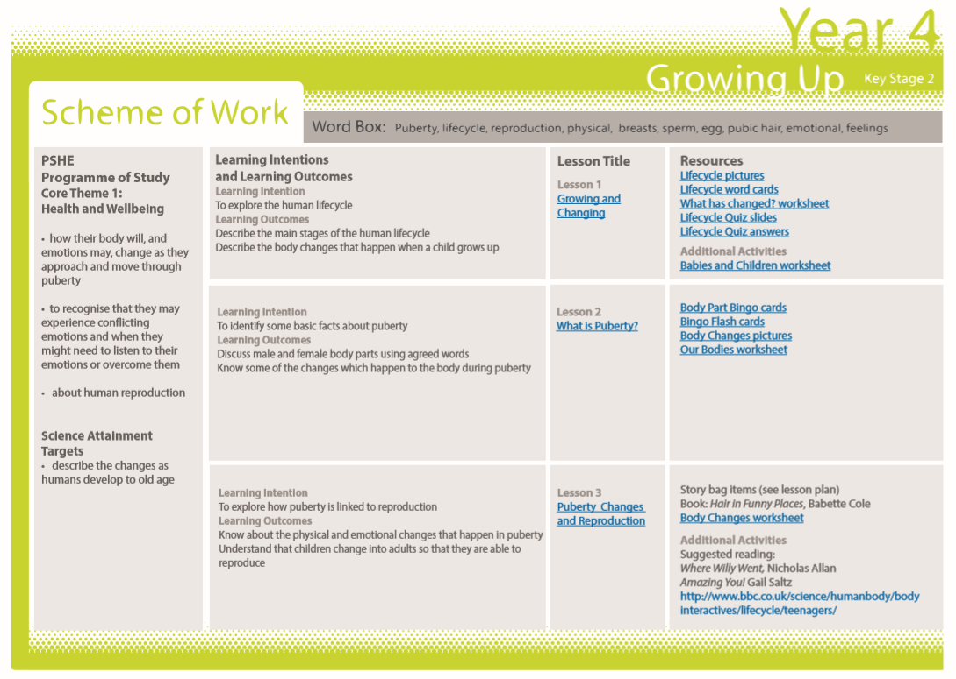

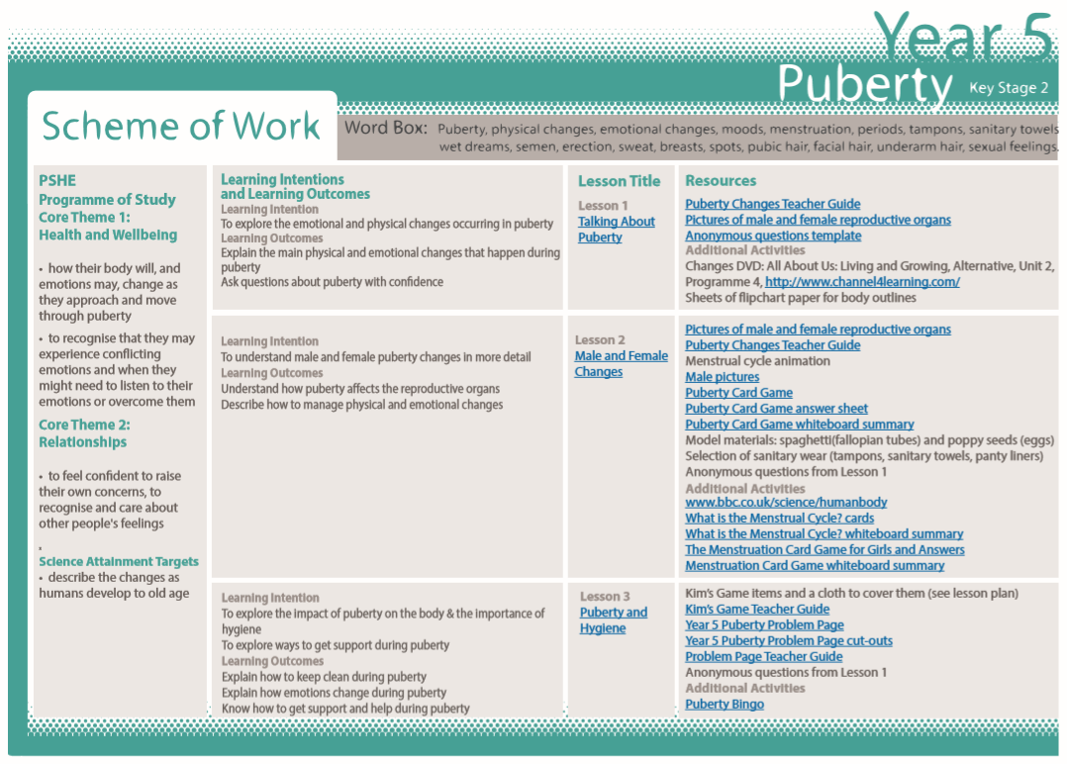

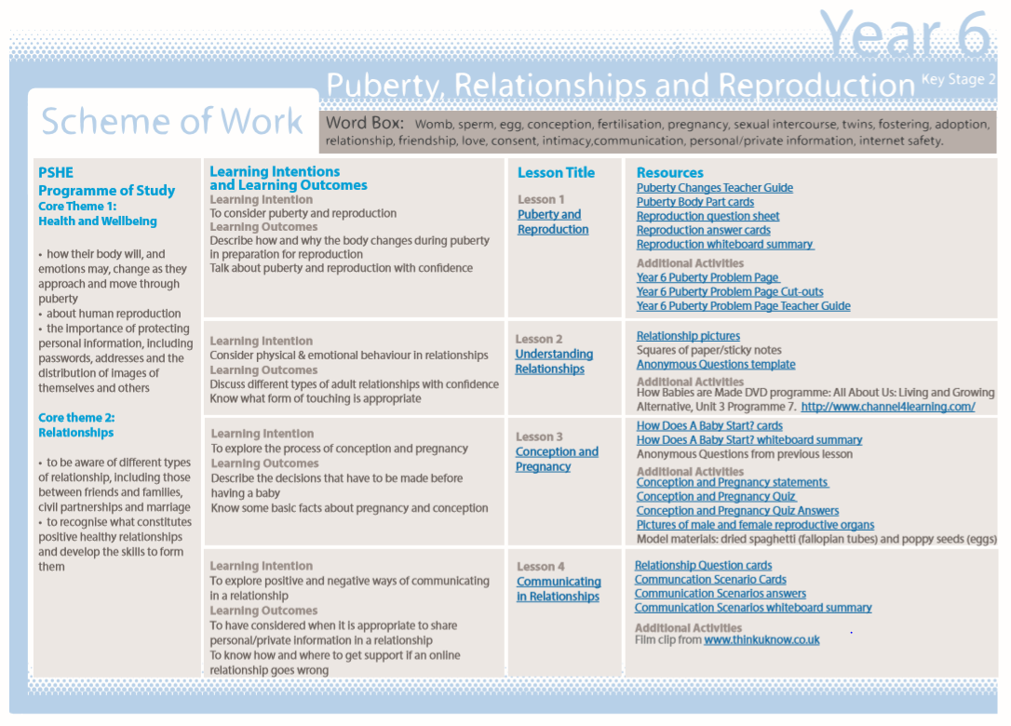

Appendix 2: By the end of primary school pupils should know
Topic | Pupils should know
Families and people who care about me | - That families are important for children growing up because they can give love, security and stability  - The characteristics of healthy family life, commitment to each other, including in times of difficulty, protection and care for children and other family members, the importance of spending time together and sharing each other’s lives  - That others’ families, either in school or in the wider world, sometimes look different from their family, but that they should respect those differences and know that other children’s families are also characterised by love and care  - That stable, caring relationships, which may be of different types, are at the heart of happy families, and are important for children’s security as they grow up  - That marriage represents a formal and legally recognised commitment of two people to each other which is intended to be lifelong  - How to recognise if family relationships are making them feel unhappy or unsafe, and how to seek help or advice from others if needed
Caring friendships | - How important friendships are in making us feel happy and secure, and how people choose and make friends  - The characteristics of friendships, including mutual respect, truthfulness, trustworthiness, loyalty, kindness, generosity, trust, sharing interests and experiences and support with problems and difficulties  - That healthy friendships are positive and welcoming towards others, and do not make others feel lonely or excluded  - That most friendships have ups and downs, and that these can often be worked through so that the friendship is repaired or even strengthened, and that resorting to violence is never right  - How to recognise who to trust and who not to trust, how to judge when a friendship is making them feel unhappy or uncomfortable, managing conflict, how to manage these situations and how to seek help or advice from others, if needed
Respectful relationships | - The importance of respecting others, even when they are very different from them (for example, physically, in character, personality or backgrounds), or make different choices or have different preferences or beliefs  - Practical steps they can take in a range of different contexts to improve or support respectful relationships  - The conventions of courtesy and manners  - The importance of self-respect and how this links to their own happiness  - That in school and in wider society they can expect to be treated with respect by others, and that in turn they should show due respect to others, including those in positions of authority  - About different types of bullying (including cyberbullying), the impact of bullying, responsibilities of bystanders (primarily reporting bullying to an adult) and how to get help  - What a stereotype is, and how stereotypes can be unfair, negative or destructive  - The importance of permission-seeking and giving in relationships with friends, peers and adults
Online relationships | - That people sometimes behave differently online, including by pretending to be someone they are not  - That the same principles apply to online relationships as to face-to face relationships, including the importance of respect for others online including when we are anonymous  - The rules and principles for keeping safe online, how to recognise risks, harmful content and contact, and how to report them  - How to critically consider their online friendships and sources of information including awareness of the risks associated with people they have never met  - How information and data is shared and used online
Being safe | - What sorts of boundaries are appropriate in friendships with peers and others (including in a digital context)  - About the concept of privacy and the implications of it for both children and adults; including that it is not always right to keep secrets if they relate to being safe  - That each person’s body belongs to them, and the differences between appropriate and inappropriate or unsafe physical, and other, contact  - How to respond safely and appropriately to adults they may encounter (in all contexts, including online) whom they do not know  - How to recognise and report feelings of being unsafe or feeling bad about any adult  - How to ask for advice or help for themselves or others, and to keep trying until they are heard  - How to report concerns or abuse, and the vocabulary and confidence needed to do so  - Where to get advice e.g. family, school and/or other sources

Appendix 3: Parent form: withdrawal from sex education within RSE

To be completed by parents
Name of child |  | Class
Name of parent |  | Date
Reason for withdrawing from sex education within relationships and sex education
Any other information you would like the school to consider
Parent signature

To be completed by the school
Agreed actions from discussion with parents

