

Positive Relationships & Behaviour Policy

Written Sept 2025

Review Sept 2026

Signed – Mrs Kat Allen

(Headteacher)

Signed – Mr Mike Long

(Chair of Governors)

- Rationale
- Aims and Objectives
- Managing behaviour relationally: The Thrive Approach
- Three Expectations and Consistency: ‘The Roby Park Way’
- Recognition for effort
- Behaviour Steps
- More Serious Behaviour Incidents
- External Support
- Appendix 1: Roby Park Primary school Thrive Charter
- Appendix 2: Vital Relational Functions (VRFs)
- Appendix 3: Dan Hughes’ PACE Approach
- Appendix 4: Recognition Boards
- Appendix 5: Relational Policy: One Page Summary
- Appendix 6: Give Me 5 Listening Code

- Rationale
At Roby Park Primary School, we recognise that wellbeing and behaviour are inextricably linked. Research into child development, neuroscience and attachment theory all provide us with the understanding of the direct correlation between positive mental health and optimum educational outcomes. When children experience safety in their relationships, they can challenge themselves and are open to new learning. We know that a strong focus on pupil wellbeing increases the likelihood of children achieving their full potential so it is vital that wellbeing is placed at the very heart of our school offer.

We recognise that behaviour is a form of communication, we therefore take responsibility for listening to the needs a child is expressing through their behaviour, whilst setting clear boundaries and expectations. We encourage all stakeholders to recognise both their rights and responsibilities.

We recognise the link between understanding the needs of our pupils and how this contributes to their ability to self-regulate. We use this knowledge to build resilience by managing their behaviour in a positive manner so they can be ready to engage with their learning. It is imperative we understand how as care givers, we can offer the pupils the security and positive relationships needed to meet their individual wellbeing and mental health needs, guiding them along their journey in becoming independent and resilient, life-long learners.

Guided by the Thrive Approach, we focus on relational connection and regulation first. We will do this by putting relationships at the heart of our approach by truly listening and responding to our children's voices, to create and foster a safe and happy environment where all feel safe, secure and respected.

This Positive Relationships & Behaviour Policy links to other school policies and documents including:
- Keeping Children Safe in Education
- Child Protection policy
- Anti-bullying policy
- Positive Handling Policy
- Home-School Agreement

The Positive Relationships & Behaviour Policy refers to DfE statutory guidance and documents that should be read alongside this policy.

These include:
- Suspension and Permanent Exclusion from maintained schools, academies and pupil referral units in England, including pupil movement Guidance for maintained schools, academies, and pupil referral units in England September 2022
- Behaviour in schools Advice for headteachers and school staff September 2023
- The Education and Inspections Act 2006
- DfE Dealing with allegations of abuse against teachers and other staff.

At Roby Park Primary school there may be children who have individual plans that support behaviour. These children may have identified needs that are not covered by this policy. In these cases, the children's individual plans could take precedent over this Positive Relationships Policy.

- Aims and Objectives
To build a community which promotes and embeds our ten school values of
- Collaboration
- Creativity
- Motivation
- Resilience
- Reflection
- Inquisitive
- Inclusivity
- Aspiration
- Responsibility
- Courage

- To provide guidance to staff, parents and carers, governors and other stakeholders on how to support pupils to co-regulate and self-regulate, manage their behaviour and feel safe so they are ready to learn.
- To provide a holistic, inclusive model for our understanding of self-regulation and behavioural needs.
- To underpin our beliefs with evidence-based practice and current research.

- To achieve these aims we will:
  - Create and maintain a positive and safe school climate where effective learning can take place and all pupils can grow socially, emotionally and academically, with mutual respect between all members of the school community.
  - Create a culture with high expectations for good behaviour supporting life-long learning through a positive and safe school climate.
  - Provide a safe, nurturing environment, using responsibility, PACE (Playfulness, Acceptance, Curiosity and Empathy) and restorative approaches to foster appropriate behaviour.
  - Promote self-awareness, self-control and acceptance of responsibility for our own actions.
  - Maintain a consistent, safe, caring and happy school community.

- Managing behaviour relationally: The Thrive Approach
At Roby Park Primary School, we strive to demonstrate a relational approach to supporting social and emotional development and behaviour based on the following principles
(Appendix 1):
- We understand that each developmental stage has a range of typical behaviours which provide opportunities for adults to role-model and explicitly teach appropriate behaviours.
- We understand behaviour communicates unmet needs and can separate the child/young person from their behaviour. We accurately assess and understand the pupils’ needs by referring to their class, group and individual assessments.
- We acknowledge the distinction between shame and guilt and recognise that shame prevents healthy emotional development. We provide empathy as an anti-dote to shame.
- We provide a safe environment, predictability and routine to build a sense of safety in the emotional and physical environment.
- We encourage the children at Roby Park to become accountable for their actions, own their behaviour and understand the impact they may have on themselves and others, promoting a solution-focused approach to changing future behaviours.
- We keep in mind that we are the adults and that children are still growing, learning and developing. Mistakes are part of the learning process; we recognise that all our pupils are at different stages of the developmental process. We don’t make a judgement about it; instead, we support and guide our pupils to make appropriate choices.
- We seek to restore relationships and change behaviours rather than punish the actions a child may have taken. This does not exclude the use of sanctions as consequences, we seek the most appropriate way of supporting children to develop robust self-regulation systems and therefore the skills of self-control, empathy and emotional management.
- By supporting the growth of emotional development and self-regulating skills pupils can learn to improve their behaviour. Learning new behaviour is a task, just like learning to read or write.
- Supporting pupils to effectively communicate is a very important way to promote them to self-regulate, build resilience and behave in a positive manner. All adults learn strategies to support pupils to improve their behaviour and have evolved ways of responding to pupils’ behaviour based on personal and professional experiences and training and experiential learning. All staff are given the opportunity to learn, understand and have insight into why our pupils become dysregulated, and reflect on how and why it impacts on their behaviour.
- In recognition of the rupture and repair cycle, all incidents will conclude with a restorative conversation with the member of staff with whom the rupture occurred. This is an important step, as it ensures that the relationships between staff and pupils are maintained and grow stronger.

We establish and maintain positive relationships with parents and carers, these are key to recognising and understanding a child’s ever-changing emotional state. Regular conversations take place to ensure we understand the whole picture of a child’s ‘lived experience’; provision meets this need and effective adult relationships will support a child who may have experienced trauma. All staff are trained in emotion coaching strategies and sensory integration, they understand the impact of early trauma and how this can affect attachment and development.

Embodying the Thrive Approach is transformational; it is the golden thread that runs through our school. We understand that every interaction has an impact, that our support to remove barriers ‘no matter what’ makes a positive difference.

Roby Park Primary School’s Positive Relationship & Behaviour Policy is based on the knowledge that behaviour is a communication of unmet need.
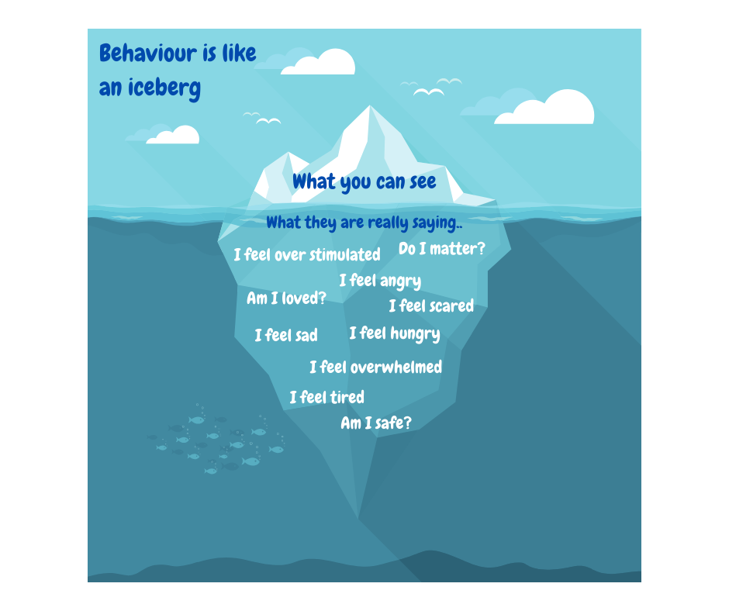

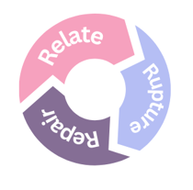

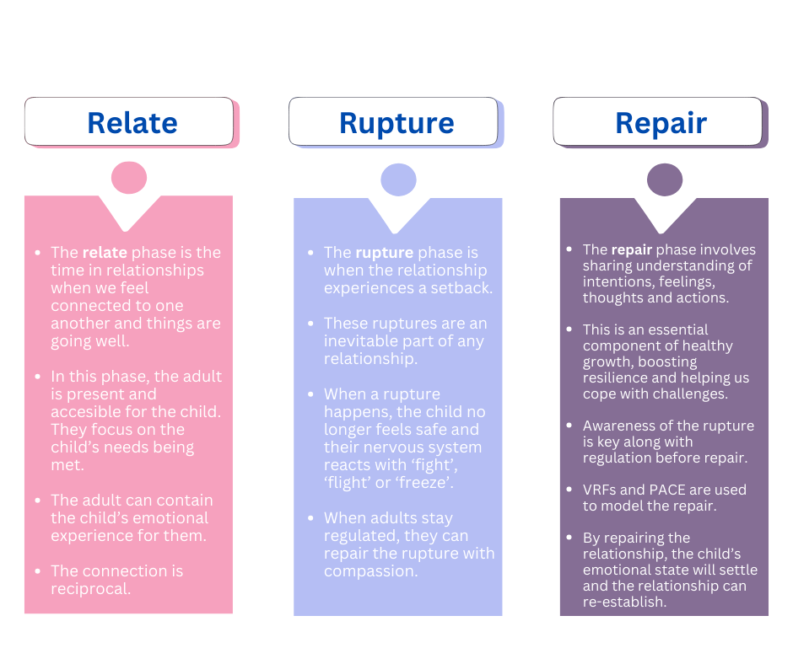

- Three Expectations and Consistency – ‘The Roby Park Way’

Consistency in practice:
Consistency lies in the behaviour of adults and not simply in the application of procedure. A truly sustainable consistent approach does not come in a toolkit of strategies but in the whole school community having an agreed understanding of behaviour in the context of neuroscience. The key is to develop a consistency that ripples through every interaction on behaviour. Where children feel heard and treated as valued individuals, they respect adults and accept their authority. Thrive is not an intervention, but a way of being.

How all members of staff behave:
- Positively
- Calmly
- Consistently

Senior leaders will:
- Be visible and positive
- Be visible at transition times
- Engage in learning time and wellbeing walks to see behaviour, provide support and coach and model expectations
- Drop into classrooms to catch children being positive
- Ensure restorative conversations take place
- Provide breathing space for children when required

All staff every day will:
- Promote a positive culture
- Provide early intervention to support children’s behaviour (see behaviour step)
- Use VRFs (see Appendix 2)
- Use PACE (see appendix 4)
- Use our listening code ‘Give me 5’

Staff every day will:
- Greet every child at the classroom door at the start of the day and at the start of the lesson following play and lunchtime.
- Be responsible for the consistent awarding of recognition in their classroom.
- Practice VRF’s, PACE and 3Rs.
- Take responsibility for their own learning.

We communicate behaviour through:
- Recognition boards
- Behaviour shout out cards sent home
- Behaviour shout out in app messages sent to parents/carers
- Weekly learning hero certificates
- Headteacher awards
- Deputy Headteacher awards
- Kindness awards
- Pupil of the Year certificates
- Celebration assemblies
- Whole school recognition board in the hall for those who go above and beyond
- Newsletters
- Social media posts

Our three expectations:
- Be respectful.
- Be kind.
- Be honest.

Support beyond the classroom (to be used for change of adult or to support the restorative conversation):
• Deputy Headteacher
• Headteacher

Senior leader alternatives to suspension and exclusion, where possible:
• Parent meetings
• Behaviour Support Plans
• Behaviour Outreach Service
• Family Support Worker
• Early Help
• Educational Psychologist

All staff every day will:
- Build relationships by using the VRFs, PACE, meet and greet and check ins.
- Refer to ‘Be Respectful. Be Kind. Be Honest’ as our school ethos.
- Model behaviours we want to see and always highlight the behaviour we want to see in positive terms.
- Plan lessons that engage, excite, challenge and meet the needs of all children.
- Promote intrinsic motivation by recognising the process of learning (behaviours for learning).
- Seek both resolution and learning when dealing with incidents. Follow up every time, retain ownership and engage in restorative dialogue with children to repair the rupture.
- Always remind children about the expectations.
- Use VRF’s - Attune, Validate, Contain, Regulate, Relate Reason (See Appendix 2)

‘Give Me 5’ Listening Code
When I am asked for my attention I:
- STOP what I am doing
- EMPTY my hands
- LOOK at the teacher
- LISTEN to the person speaking
- THINK and respond

Senior leaders will:
- Meet and greet children at the beginning of the day and end of the day on the front door.
- Be a visible presence around the school, especially during transition times.
- Celebrate staff, leaders and children whose effort goes above and beyond expectations.
- Model PACE and VRFs in their own interactions.
- Regularly share good practice.
- Support staff in managing children with more complex behaviours.
- Regularly review provision for children who fall beyond the range of written policies.
- Ensure there is a consistent approach to the management and organisation of learning and teaching.
- Ensure that recognitions are awarded consistently and fairly.
- Ensure that the Positive Relationships & Behaviour Policy is consistently followed.

When dealing with behaviour referrals, Senior leaders will not work in isolation. Instead, they will stand alongside colleagues to support, guide, model and show a unified consistency to the children. Senior leaders are first to offer support, they lead by example.

5. Recognition for effort
The best form of behaviour intervention acknowledges and enhances the positive.
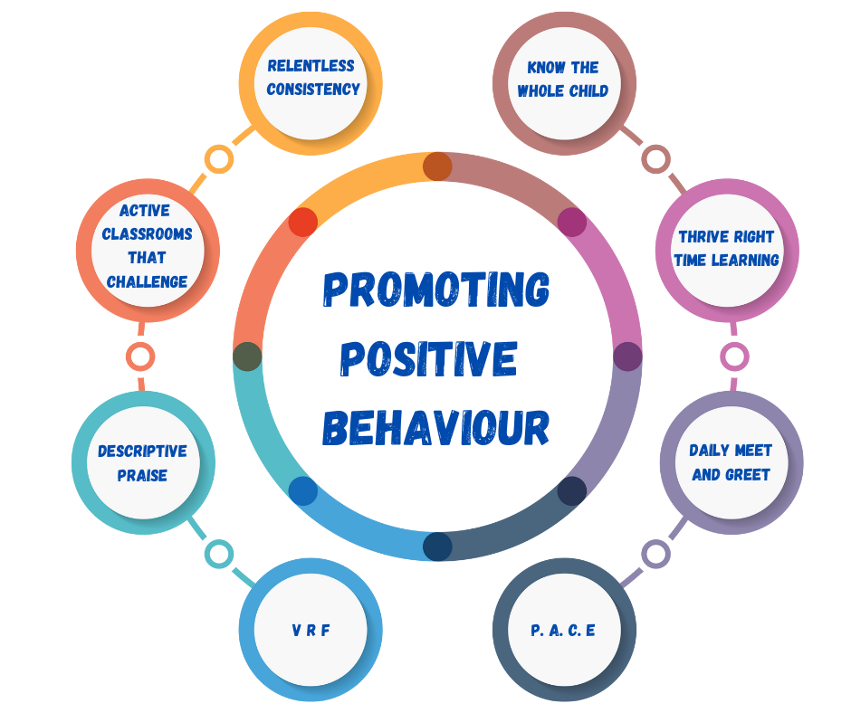

The use of praise in developing a positive atmosphere in the classroom cannot be underestimated. It is the key to developing positive relationships, including with those children who seem the hardest to reach.
We promote a growth mindset when using praise by recognising the process of learning. We identify and name the key skills and attributes shown, leading to intrinsic motivation, resilience and life-long learning.

We will recognise those children who demonstrate behaviours we want to see in and around school through:
- Behaviour shout cards
- Behaviour shout out in app messages to parents
- Recognition Boards
- Recognition board in the hall
- Newsletters
- Celebration assemblies
- Social media posts
- Attendance recognition

6. Behaviour Steps
Best practice is always to promote positive behaviour by stating the behaviour you want to see in positive terms.

It is vital that knowledge of the child’s social and emotional development is considered. Steps should always be used with care and consideration, considering individual needs. All children must be given time in between steps to make good choice.

- RELATE | Consistent high-quality teaching. Redirect using PACE, VRFs and praise.
- REMIND | Praise in public and remind in private.  Reminder of ethos: ‘Be Respectful. Be Kind. Be Honest’. Repeat reminder if necessary but usually no more than twice.
- FINAL REMINDER | A clear conversation and ‘final reminder’ delivered privately to the child using the 30 second script to make them aware of their behaviour and clearly outlining the consequences if they continue.  Children will be reminded of their unique positive qualities and previous examples of positive choices to separate the behaviour from the child.
- TIME IN | At this step the child will be asked/accompanied to go to the calm corner in the classroom book area for a ‘Time In’, they will have access to calm box resources until an adult can speak to the child privately as a co-regulator.  Step 4 always concludes in Repair with the adult where (or with whom) the rupture occurred.
- TIME IN (BREATHING SPACE) | At this step the child will be referred to the Thrive Room; this can be at the point of need or at a time where reflection, followed by a restorative conversation would lead to a positive outcome. Children can also choose to access the Thrive Room if they would benefit from out of class co or self-regulation. This provides opportunities to express emotions and reflect.  Step 5 always concludes in Repair with the adult where (or with whom) the rupture occurred.
- PERSONAL PROVISION PLAN / INDIVIDUAL THRIVE ACTION PLAN | Child supported with a PPP / individual Thrive action plan with agreed targets that will be monitored, shared at a meeting with the teacher, child, parent and SENCO.
- PASTORAL  SUPPORT PLAN | A pastoral support plan (PSP) aims to help a child to improve their social, emotional and behavioural skills. The PSP will identify precise and specific targets for the child to work towards and will include the teacher, child, parents and pastoral lead in the drafting process.

Step 1 - Relate
Consistent high-quality teaching. Use praise, recognise and name good behaviour, move around the space, refocus through direct questioning, use polite but firm reminders. Reposition and redirect using PACE, VRFs.

Step 2 – Remind
Praise the behaviours you want to see. Where behaviour does not meet your expectations, a reminder of the expectations for children of ‘Be Respectful. Be Kind. Be Honest’. Repeat reminder if necessary but usually no more than twice.

Step 3 – Final Reminder
The 30 second script, at the child’s level, involves a conversation with the pupil that goes to redress their behaviour in the first instance. The key to these conversations is framing the pupil in the positive light we know they can exhibit:
- I noticed you are having trouble with [state the behaviour you see to separate the behaviour from the child].
- I am wondering if you are feeling […]?
- You know we have a ‘Be Respectful. Be Kind. Be Honest’ ethos in the classroom. It was the expectation about [lining up / bringing toys into school / not allowing others to learn] that you broke.
- Do you remember when you [did that kind thing for…]? That is who I need to see today.
- When I come back in 2 minutes, I want to see your wonderful […]. Thank you for listening. Now walk away but remember to return at the given time!
- The 30-second script can go a long way to reduce the disruption in lessons, build a positive relationship and enable children to reset their behaviour. Praise in public and remind in private.

Step 4 - Time In
If a child reaches this stage, they are beginning to dysregulate. Children will have a ‘time in’ for regulation in a space within the classroom (book corner). Children will be allowed to use the calm box until an adult can speak to the child privately as a co-regulator.
- The child will be asked to go to the calm corner in the classroom where they will access a calm box containing items to support the child’s regulation. Items within the box will help the child to re-engage their prefrontal cortex, such as breathing and grounding techniques.
- The teacher will have a chance to speak to the child away from the class and will use WIN; ‘I am wondering, imagining, noticing…’.
- Boundaries are reset.
- Child is asked to reflect on their next step. Again, they are reminded of their previous behaviours for learning.
- Usually, after no more than 10 minutes the child is given the opportunity to re-engage with the learning and / or follow instructions.

For there to be a positive outcome, the focus should be on the level of connection and support. This step is about giving pupils the opportunities and the tools to be successful. This does not come from isolation of shame; it comes from practice and supported learning.

Step 4 always concludes in Repair with the adult where (or with whom) the rupture occurred.

This graphic shows the interaction between the VRFs and the Three Rs in supporting a dysregulated child through to ‘Reason’:
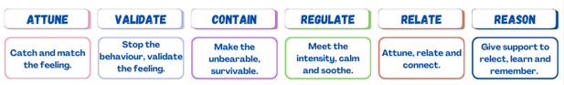

There may be occasions where there is significant dysregulation and ‘time in’ at the book corner is not appropriate. In this instance the child should be moved to the Thrive Room to support them to regulate and/or to defuse a situation. In general, three minutes should be enough time.

Step 5 – Time In (Thrive Room)
If step 4 is unsuccessful, or if a child refuses a Time In within the classroom, then the child will attend the Thrive Room at the point of need or at a time where reflection, followed by a restorative conversation would lead to a positive outcome. Immediate support will be provided where the level of dysregulation increases risk for the child, other pupils or the staff member.

Staff will always deliver proportionate sanctions calmly and with care, where appropriate. It is essential the adult is regulated and if they are not, feels secure to ask for another member of staff to step in.

Step 6 – Personal provision plan / individual Thrive action plan
If a child is dysregulating regularly, then they will have individualised targets in their PPP or their individual Thrive action plan. Decisions to place children on any formalised behaviour monitoring will be taken by the Headteacher, in collaboration with the class teacher and SENCo.

Step 7 – Pastoral support plan (PSP)

Could be prompted by | Following incidents of more serious behaviour.
Maximum time frame | Targets to be reviewed every half term at a PSP meeting.
Formative measure | Individual PSP meeting and specific targets agreed with Class Teacher, Behaviour
Maintained by | Support/SLT, parents and child (where appropriate). SENDCo,

If a child continues to be dysregulating regularly, then they will have an individualised plan. A Pastoral support Plan (PSP) is put in place when less formal measures have not been successful in helping to improve a child’s behaviour. Its purpose is to promote social inclusion and help to reduce the need for Suspension or Exclusion. The effectiveness of the PSP relies on identifying the underlying causes of the child’s behaviours; the SENCO and class teacher will seek to identify the barriers to behaviour through an individualised Thrive assessment and action plan. The action plan will be shared with parents as part of the PSP meeting and help to form the formal targets for the child’s PSP.

A child’s behaviour may deteriorate before it improves when a PSP is introduced. Recognition and reinforcements used to promote positive social behaviour must be immediate and at a high frequency in the early stages of a PSP for maximum success, especially with younger children.

The PSP will include clear expectations for behaviour and targets that provide limited (maximum of three) unambiguous and, above all, achievable targets for the child’s behaviour. Targets will be identified through the Thrive assessment.

Restorative Conversations
Restorative approaches teach behaviour. Where a child’s behaviour needs to be addressed, holding a restorative conversation can reframe their behaviour, allow the pupil to reflect on changes that can be made and ensure that everyone starts the next lesson with a clean slate and without judgement. Done correctly, they can be incredibly powerful and create a positive relationship between staff and children.

We understand that children who are dysregulated do not have access to their pre-frontal cortex. The key with a restorative conversation is to only engage in the conversation when the child and adult are emotionally regulated – only then can the learning take place.

Offer a postponement and some support if the child is not ready to speak: ‘I can see that you aren’t quite ready to talk. Do you need a minute or two, or would you like to meet later today?’

It is important that the repair takes place with the member of staff involved in the incident, to complete the rupture – repair cycle.

To meet their individual needs, strategies that help a child to regulate vary according to the child.

Once the child is regulated, the child needs an adult to lend them their thinking brain. The following questions will allow learning to take place:
- Can you show me what happened (using the arts will allow the child to express the incident - this may involve acting it out with puppets or using a sand tray which will be detailed in a child’s PPP.)
- I’m wondering if you felt a bit angry / frightened / scared etc.
- I can imagine it’s difficult to have those big feelings but it’s not ok to […], I think I could help you with that.
- How do you think […] is feeling?
- How can we repair it?

The adult lends the child their thinking brain to problem solve and find an appropriate solution.

Think about your positioning in the room, focus on the issue at hand (do not bring up previous incidents, secondary behaviours or events that are not relevant) and plan the conclusion. Use WIN (I’m wondering, imagining, noticing…)

All staff will take responsibility for leading restorative conversations; Senior Leaders can provide support to ensure a positive outcome.

7. More Serious Behaviour Incidents

8. INTERNAL INCLUSION | An Internal inclusion may be appropriate to support learning and ensure children’s safety. A child internally excluded would not have contact with their class but instead have specific wellbeing support focussing on social, emotional and behavioural skills, where appropriate, and their education would continue.
9. SUSPENSION | A Suspension would follow Government guidance and upon return to school, a child would have support through a reintegration meeting plan. A PSP will be put into place if the school feels the child is at risk of further suspensions, which have increased.
10. PERMANENT EXCLUSION | Serious incidents need to be treated on an individual basis and the circumstances investigated. Any Exclusion would follow Government guidance, it could be considered for a first or ‘one off’ offence.

If any member of staff requires assistance in the classroom for example, because of pupil disruption or because a child has put themselves in danger, that member of staff will call for HT or DHT. The member of SLT will understand that help is needed urgently.

Steps 8, 9 and 10 – Exclusion
Where more serious behaviour incidents occur, we will look to support the child consistently and subjectively in line with the incident and the individuals involved, utilising knowledge of the child and their behaviours. Staff have received Positive Handling training, part of our response and a strategy for de-escalation. If a physical intervention is required, staff are trained to use positive handling techniques.

An internal exclusion will be given where possible over a Suspension. The class teacher/Headteacher/Deputy Headteacher and the child reflect on successes and challenges and agree next steps.

Where a child is given a Suspension, or following a referral to outside agencies, the reports received will form the targets for their PSP.

Where a child is excluded, consideration should be given to the appropriate level of support required when the child returns to lessons.
For children with a special educational need, reasonable adjustments will be made according to Code of Practice (2015) and Equality Act (2010). In these situations, working alongside parents to agree targets and building in steps to success are key.

External Support
In rare occurrences where a child’s behaviour has not improved following targeted support, we will engage external agencies to assist us.
Agencies involved could include:
- CAMHS (Child and Adolescent Mental Health Services) - an NHS service dedicated to the Mental Health needs of an individual child, where appropriate.
- Referrals – e.g. Paediatrician, Educational Psychologist, therapists, Behaviour Outreach, Family Support Workers, Early Help, ASC advisory teachers
- Alternative provision commissioned places

This list is not exhaustive, the needs of the child will dictate which support is required. Parents will be informed, and their views and consent sought should the school refer to one of the above agencies.

Appendix 1: Roby Park Primary School Thrive Charter

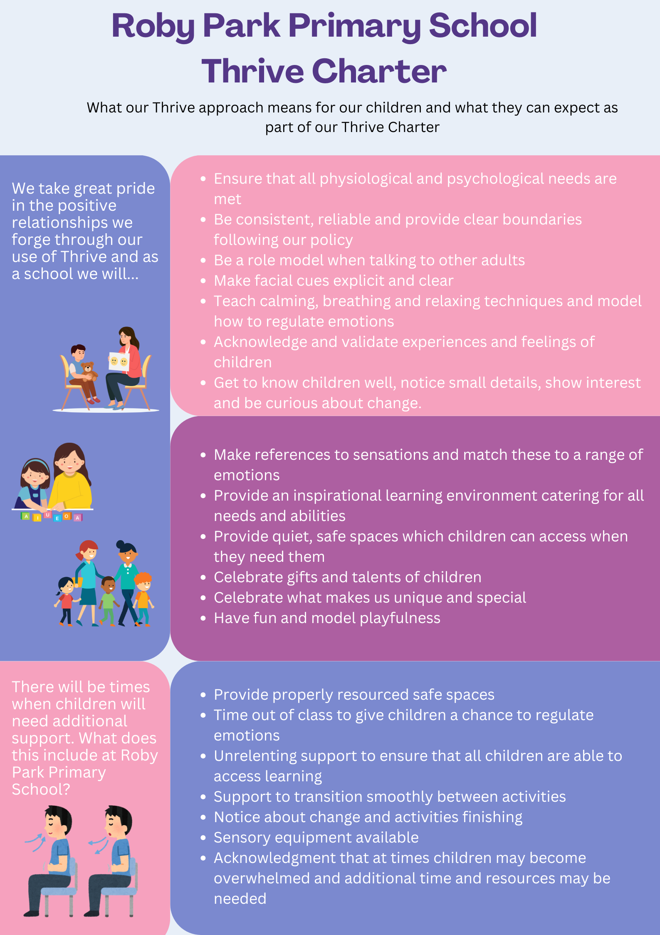

Appendix 2: Vital Relational Functions (VRFs)

The VRF’s are drawn from the teachings and findings of leading commentators on emotional, psychological and child development (Sunderland, Kohut, Stern). These skills provide a relational basis for a child’s emotional, social and neurological development.

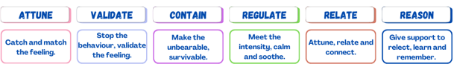

Attune | Demonstrating an understanding of how they are feeling by “catching and matching” their emotional state.
Validate | Demonstrating that their feelings are real and justified.
Contain | Offering their feelings back to them, named and in small pieces.
Regulate | Communicating the capacity to regulate emotional states by modelling how to do it.

The provision of emotional containment by the adult who is working closely and regularly with the child is a significant contributing factor to the child’s developing capacity to contain and regulate his/her own emotions. The relationship between a child and a significant adult can be an under-recognised and under-used resource that has a significant impact on a child’s ability to regulate and build positive relationships.

Appendix 3: Dan Hughes’ PACE Approach

PACE refers to Playfulness, Acceptance, Curiosity and Empathy:
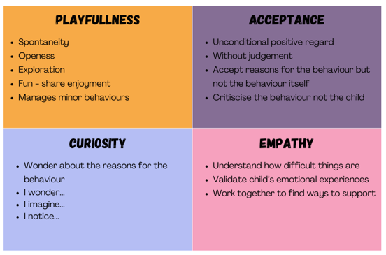

For more information about the PACE approach please refer to literature by Dan Hughes.

Real examples of PACE in action: Pupil in heightened state of anxiety, attempting to climb fence and not following instructions to come down.
Application of PACE:
- Playfulness – Use playful language to de-escalate the situation. ‘Goodness me I really would rather you came down. Problem is that if you fall, I’ll have to fill out a lot of forms and I'm a bit like you – ‘I’d rather be doing lots of fun things’
- Acceptance - the pupil is experiencing extreme anxiety because of a fall out with a friend and that this is a real experience. Communicate that you accept how they feel.
I can see that this has made you feel really upset.’ Avoiding saying things like, ‘Oh it doesn't matter, don't be upset about a silly fall out.’
- Curiosity- Enquire and check what the young person's emotional experience is.
‘I wonder if you're feeling angry because of what X just said?’
- Empathy - Show that you understand that how difficult they are finding things.
‘I understand that this must be really difficult for you. I know that when I’m feeling upset, I just want to away from everything.’

Appendix 4: Recognition Boards

Extract from When the Adults Change Everything Changes
(Written by Paul Dix)

A recognition board is the simplest way to shift the culture in your classroom. It doesn't prevent you from dealing robustly with poor behaviour, it just means that you will be dealing with less of it. The behaviour of one child is not everyone else's business. It is between you and the individual. The advertising poor behaviour doesn't help but routinely advertising the behaviour that you do want does.

Simply write at the top of the board the behaviour on which you want to focus. Try ‘One voice’ for classes who constantly talk over each other, ‘Speak politely’ to emphasise manners or ‘Hands and feet to yourself’ for those who give them to others too freely. Perhaps your focus is less about social behaviours and more about learning behaviours. In this case the focus might be ‘Accurate peer feedback’, Persuasive language’ or ‘Show working’.

When you see children demonstrating the behaviour well, write their name on the board. The recognition board is not intended to show praise on the individual. It is a collaborative strategy: we are one team, focused on one learning behaviour and moving in one direction.

Pursue the behaviour you want by chasing it hard and reinforcing it enthusiastically.

The recognition board fosters a positive interdependence in the classroom, but there is no prize, no material reward. At the end of the lesson / session / day (depending on context) the aim is for everyone to have their name on the board.

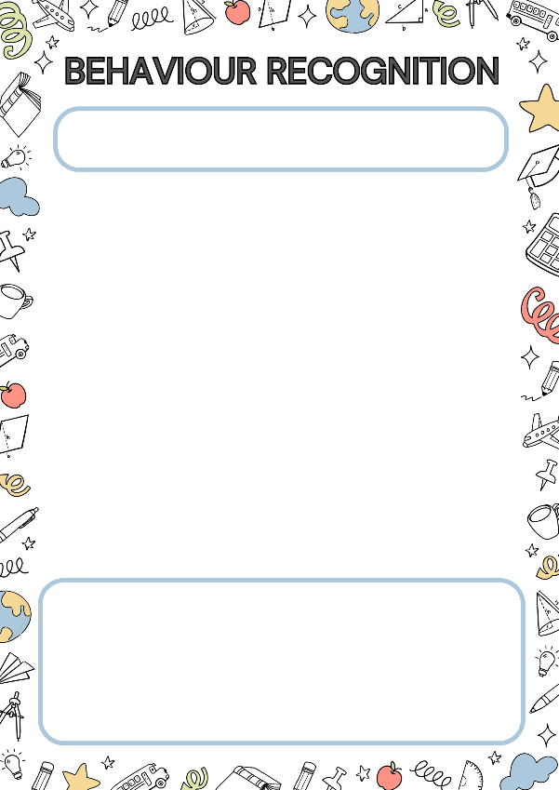
Behaviour Recognition Boards designed to go in each of the 8 classrooms.

Learning behaviours will be focused on for a minimum of half a day to a maximum of two weeks.

Appendix 5: Positive Relationships & Behaviour Policy: One Page Summary

Appendix 6: Give Me 5 Listening Code

