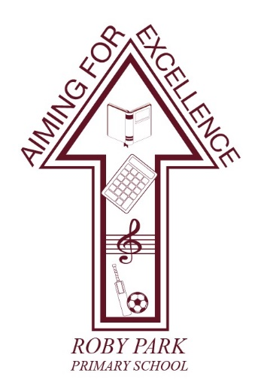

Roby Park Primary School

Easton Road

Huyton

Knowsley

L36 4NY

Tel: 0151 477 8340


Website: www.robyparkprimary.co.uk

E-mail: robypark@knowsley.gov.uk

Headteacher: Mrs K Allen

Date: Friday 27th June 2025
Young Voices

Dear Parents/Carers,

Following on from last year’s hugely successful Young Voices performance, I am delighted to announce that we have booked Young Voices for 2026! The largest children’s choir concert in the world will be hosted at the Co-op Live – Manchester on Friday 6th February 2026.

There are only limited places for this choir and, due to popularity, places will be given on a first-come first-serve basis. Places are open for students in Years 3-6 (2025/26). If your child would like to attend, rehearsals will take place on Fridays during the school day. In Autumn term 2, an after-school club will take place. As part of your commitment to the choir, children are expected to attend every single rehearsal.

Travel arrangements and costs will be shared nearer the time.

If you would like to join us, in the audience, at the Co-op Arena for this incredible event, we are able to purchase adult audience tickets on your behalf at £24.00 per adult. The closing date for the school to order tickets is Friday 19th September 2025 so we will require you to complete a Google Form committing to how many tickets you want to purchase so we order the correct amount of tickets on your behalf. Parents will be able to pay for these tickets from the school, via Arbor. These tickets, once ordered, are non-refundable.

Tshirts cost £15 each also and can be purchased on Arbor in the new academic year.

To secure your place on the Young Voices Choir 2026, please complete the Google Form: https://forms.gle/sbpTYL4JAhXSv9dD6

For further information about this exciting event, please visit https://www.youngvoices.co.uk/

If you have any questions, please contact the school’s office or Mrs Allen for further information.

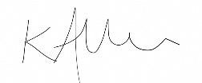
Warmest regards,

Kat Allen
Headteacher

