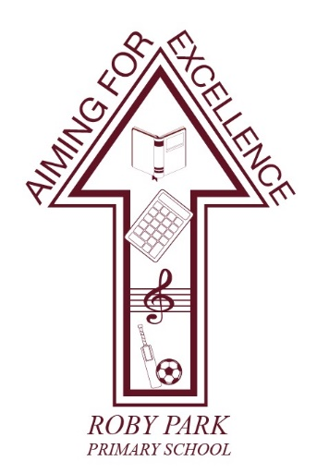

Roby Park Primary School

Easton Road

Huyton

Knowsley

L36 4NY

Tel: 0151 477 8340

Website: www.robyparkprimary.co.uk

E-mail: robypark@knowsley.gov.uk

Headteacher: Mrs K Allen

Date: Monday 16th June

Y6 London Residential
Mon 30th June – Weds 2nd July

Dear parents/carers,

We have been busy finalising our plans for London.

Itinerary

Monday 30th June | Tuesday 1st July | Wednesday 2nd July
London River Cruise  Pizza Express  Back to the Future @ Adelphi Theatre | Shrek Adventure  London Eye  Downing Street  Buckingham Palace  Hard Rock Cafe | Legoland Windsor

Departure Time
All children need to be at school no later than 7.15am so they can go to the bathroom ahead of a prompt 7.30am departure. The coach will not wait so please be early.

Arrival Home Time
We anticipate arriving home, on Wednesday 2nd July, between 9 – 10pm. Updates will be sent via Arbo in app messaging so please keep an eye on your messages for any updates.

Kit List

Towel  Suncream  Toothbrush  Toothpaste  Shampoo  Conditioner  Body wash  Roll on deodorant  Hairbrush/comb  Hair bobbles | Underwear x4  Socks x4  3x daytime outfits  Pyjamas x2  3x cardigans/jumpers  1x light weight waterproof jacket with hood | Trainers  Indoors shoes/slippers | Binbag for dirty washing  Reusable water bottle

Footwear
Children will be on foot throughout the residential, walking around London taking in the sights. Therefore, they need to be in comfortable trainers which have been worn and not brand new footwear as these will cause blisters.

Backpacks
On Friday 27th June, your child will be sent home with a Roby Park backpack which will be used for our day trips. Please make sure inside their backpack they have:
- Reusable water bottle
- Snack
- Packed lunch
- Wallet/purse
- Suncream

Lunch
Your child needs to have a packed lunch in their backpack which they will eat on our journey down.

Mobile Phones
Unfortunately, children will not be allowed to take their mobile phones or any electronic devices due to safeguarding. Please make sure your child’s mobile remains at home.

Money
Children are able to bring pocket money with them should they want to buy anything. The amount of pocket money provided is down to parental discretion. Children are solely responsible for looking after their own money.

As discussed in the welcome meeting, we recommend children bringing a pre-paid card with them as a payment method as many places in London only take car payment and not cash.

Medicines
Medical forms will be sent home on Tuesday 17th June. Please make sure they are returned no later than Friday 27th June, with any relevant labelled medication or inhalers.

Suncream
Please provide your child with factor 50 suncream as the weather currently is predicted to be warm and sunny so we want to avoid the risk of sunburn. Children will be responsible for putting on their own sun cream and will be reminded by adults to apply it throughout the day.

Travel Sickness Tablets
Please make sure if your child suffers from travel sickness, they either wear the travel sickness bands or take travel sickness medication prior to leaving home. Please provide us with further medication/bands for their return journey.

If you have any questions, please do not hesitate to contact myself or Miss Beggs.

Warmest regards,

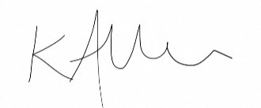

Mrs Kat Allen
Headteacher

