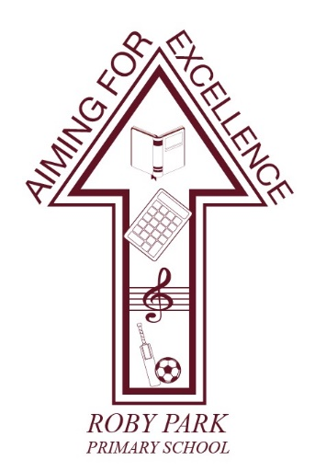

Roby Park Primary School

Easton Road

Huyton

Knowsley

L36 4NY

Tel: 0151 477 8340

Website: www.robyparkprimary.co.uk

E-mail: robypark@knowsley.gov.uk

Headteacher: Mrs K Allen

Date: Friday 11th April 2025

Y6 Enrichment Experiences Update
Dear parents/carers,

Y6 Leavers Hoodies
If your child would like a Y6 leavers hoody, we will be putting in soon so the children can have them for their sleepover should they want them. The hoodies are now available to purchase on Arbor, for £22.

Y6 SATs Celebration Sleepover
To celebrate the children’s hard work and to celebrate the end of the Year 6 SATs week, we have arranged a Year 6 Celebration Sleepover here at Roby Park.

Children can choose a themed teepee to sleep in. They can choose from:
- Jungle safari  - Pretty pink  - Hogwarts | - Undercover army  - Tiktok  - Unicorns and rainbows | - Football  - Totally tropical  - Pink unicorns and rainbows | - Circus  - Frozen
On Friday 16th May, following the completion of their final SATs test, children can come to school in their own clothes and they will enjoy a day of Forest School activities and inflatables on the school field.

In the evening, they will enjoy a movie night with pizza. The children can all bring with them a midnight snack to enjoy throughout the evening.

All children should be collected from the playground, via the Easton Road gate only, at 8.45am on Saturday 17th May.

As a school, we have subsidised the Celebration Sleepover and therefore are asking parents to pay £20 which can be paid on Arbor (under clubs & trips) which will contribute towards the cost of the event. In order to secure your child’s place, please make your £20 payment online by no later than 9th May 2024.

If you know your child is not attending the sleepover, please let us know by sending an email to robypark@knowsley.gov.uk as soon as possible please.

Y6 Prom
On Tuesday 15th July, our Y6 children will enjoy their Y6 leavers prom. The evening will run from 4.30 – 7.30pm and it will take place in the school hall.

Please note the event will start straight away at 4.30pm so please make sure children are able to join us on time. So
that children can get ready for their prom, we are allowing them to leave school at 2pm to get ready.

Closer to the time, a letter will be sent home requesting permission for children to walk home by themselves or to let us
know that you will be collecting them at 2pm. We will also be requesting permission for your child to have pictures with their friends in our ‘Photo Booth’.

During the evening, the children will be able to have a dance and enjoy games with the help of our amazing party entertainer, celebrate the years they have spent at Roby Park, take pictures of themselves with their friends in their very own photo booth and enjoy some tasty treats!

We are excited to have invited Angels and Scallies Parties to host this incredible event and the school will be subsidising it. The cost per child is £45 however we are asking families to pay just £20. The prom will include:

3 hours of DJ & entertainment | Mocktails wall | Candy floss machine | Candy wheel
Red carpet | Hotdog machine | Slush machine | Doughnut wall
 | Selfie Mirror | Medals & speeches

The hall will be decorated with sequin class of 2025 backdrop, balloons, tablecloths, chair covers, sashes and prom light up letters.

If your child is able to attend this event, please make payment on Arbor by 27th June 2024. If you know your child is not attending the prom, please let us know by sending an email to robypark@knowsley.gov.uk as soon as possible please.

As we secured funding for the children attending the London residential, some parents will be due a refund. If you would like us to use some of your refund to cover the costs of the hoody, sleepover and prom, we can do that for you. Miss Smith will be in touch with those who this is a possibility for and will find out your preference.

Warmest regards
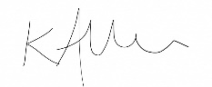
Kat Allen
Headteacher

