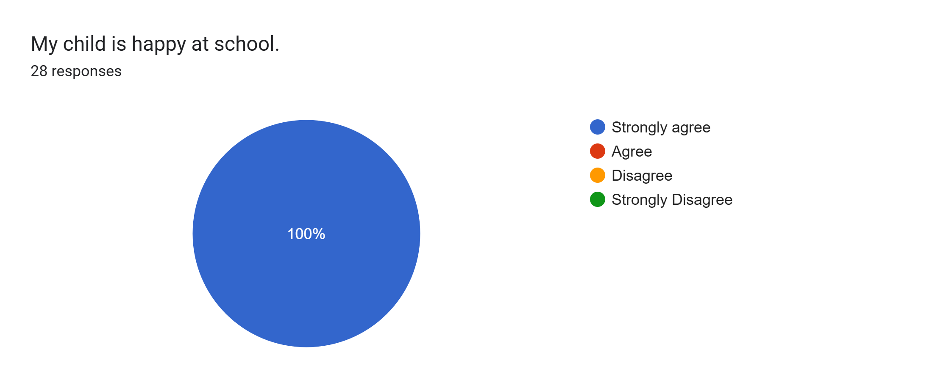
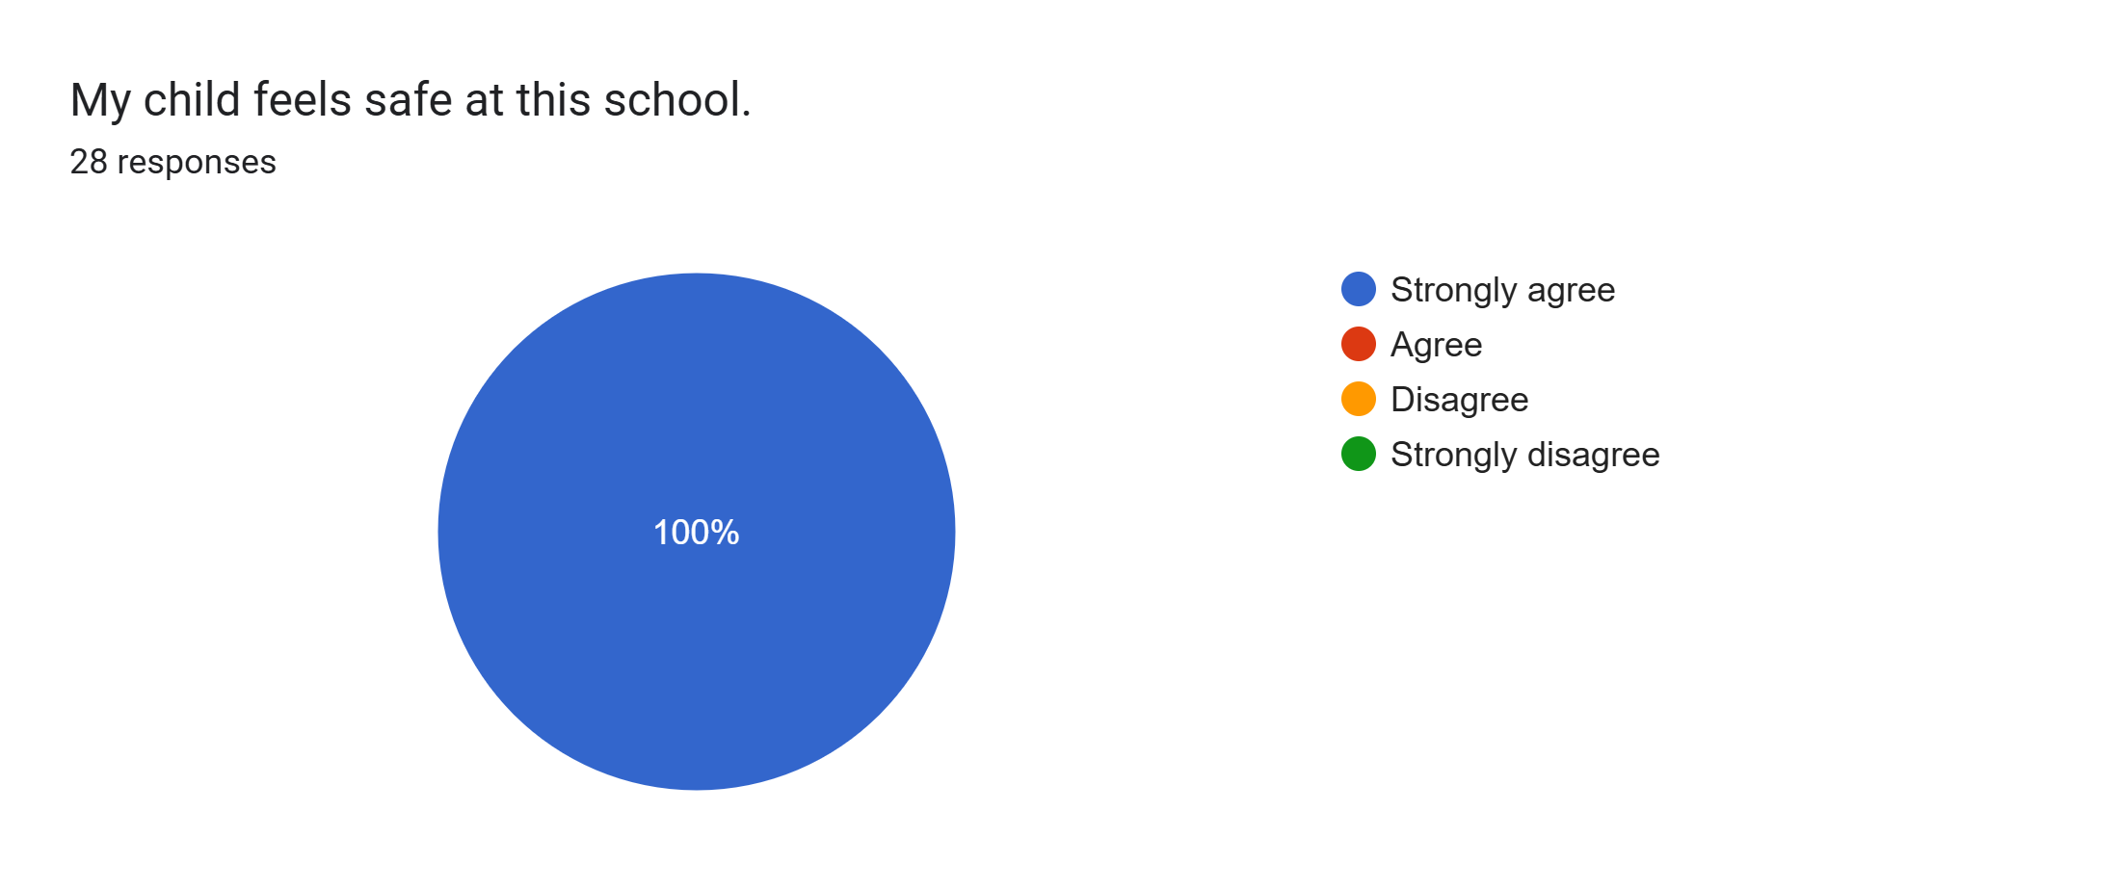
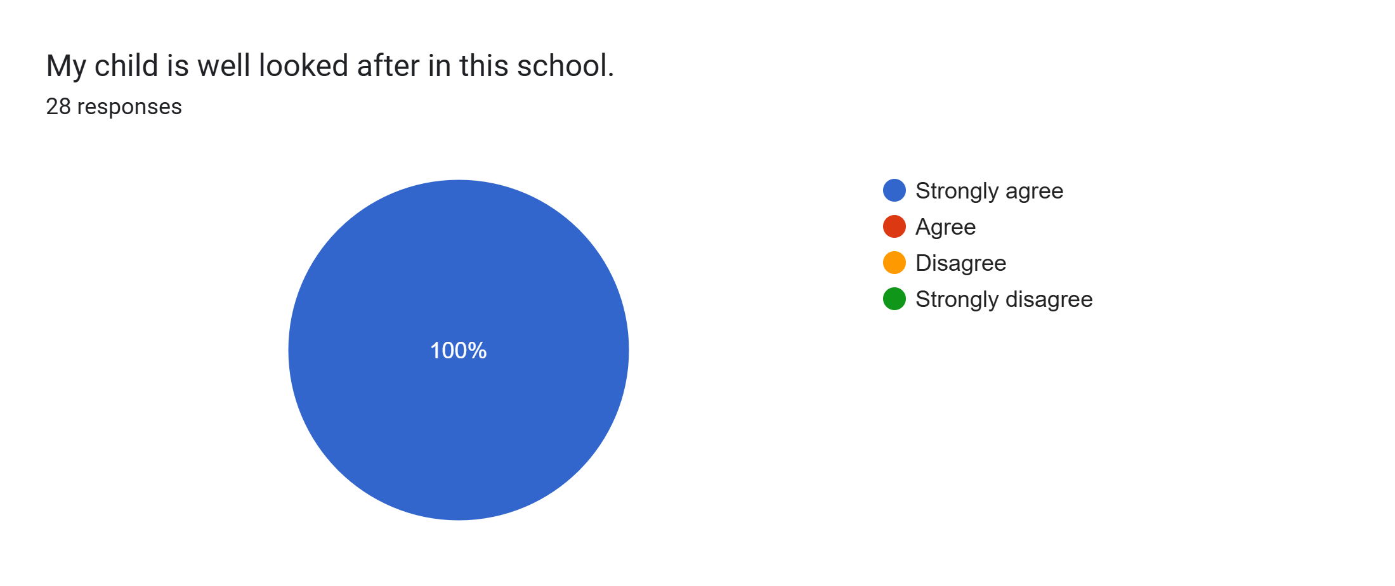
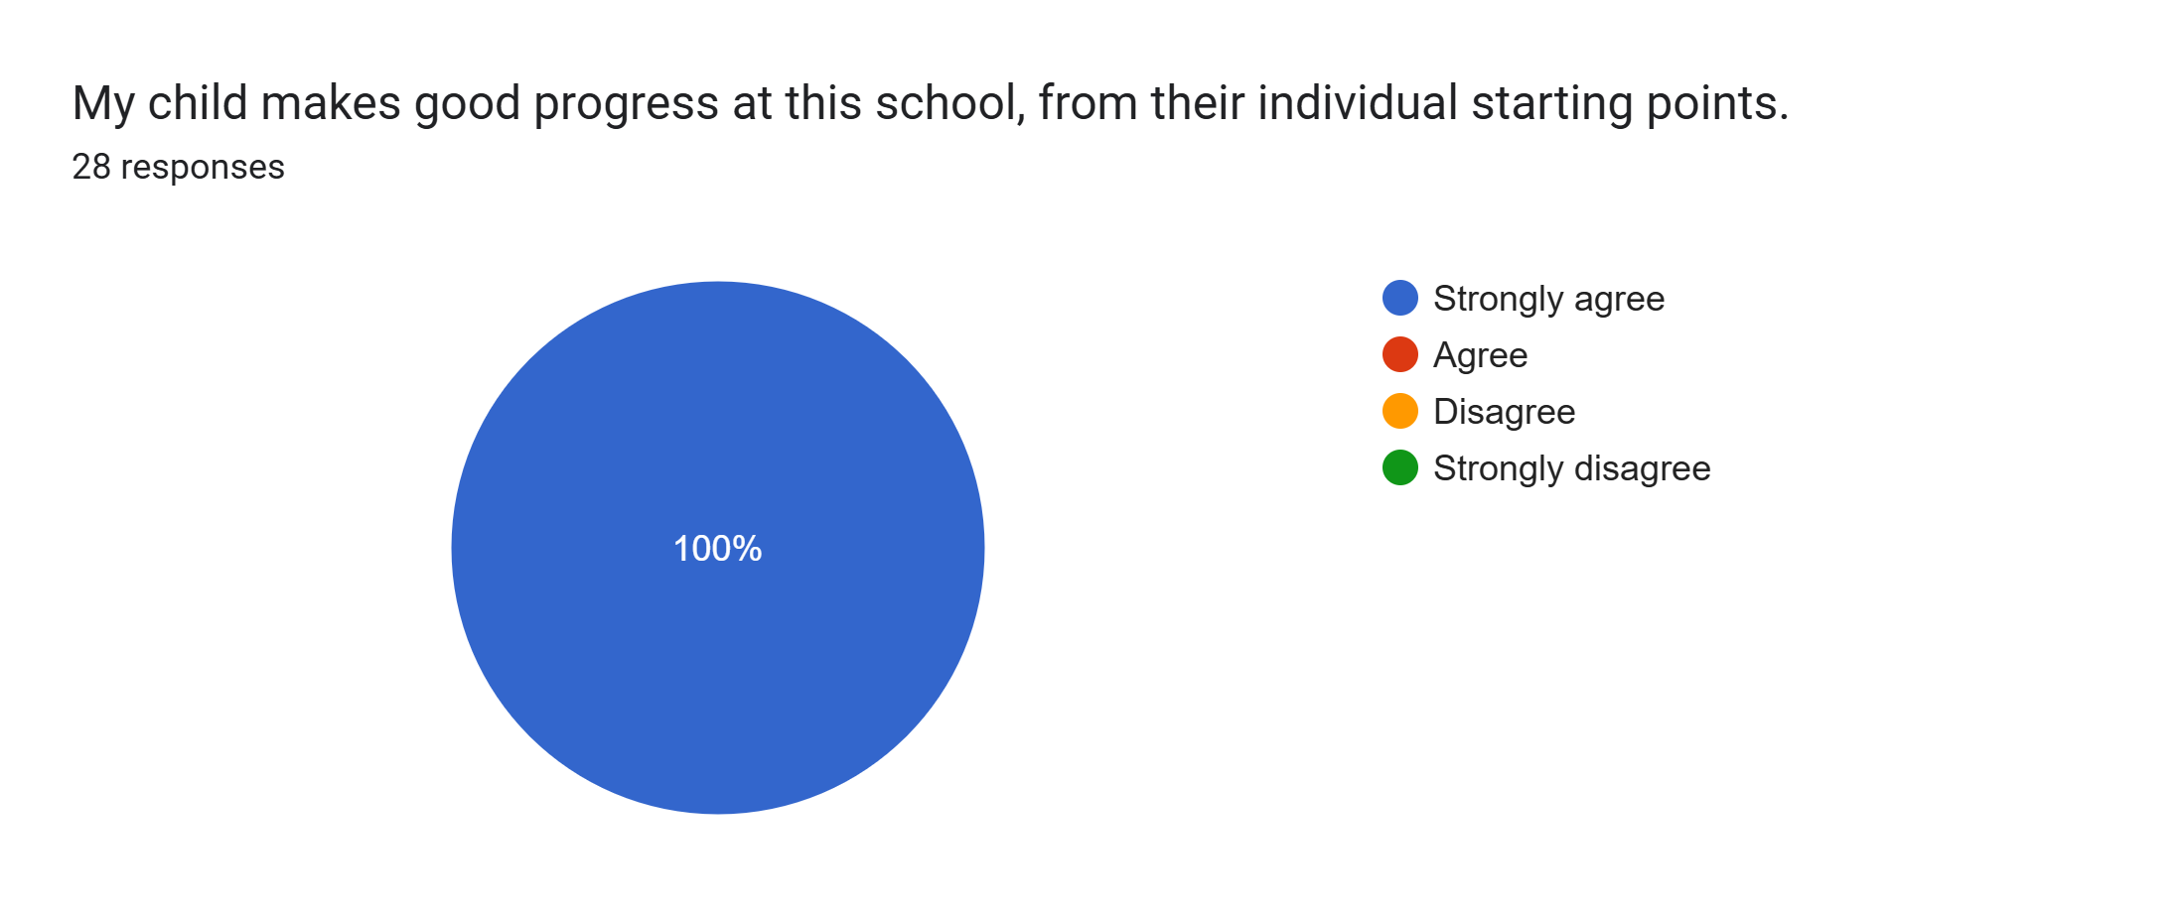
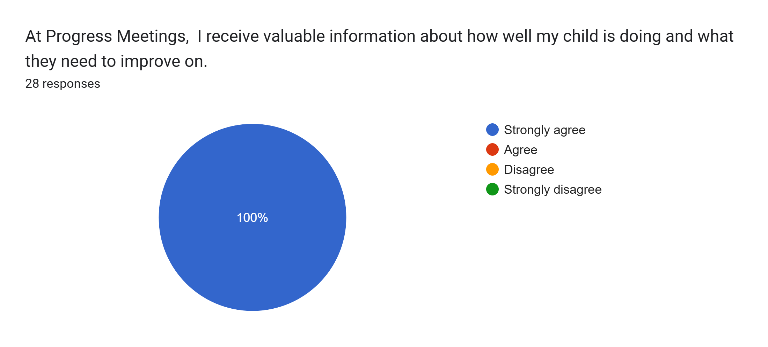
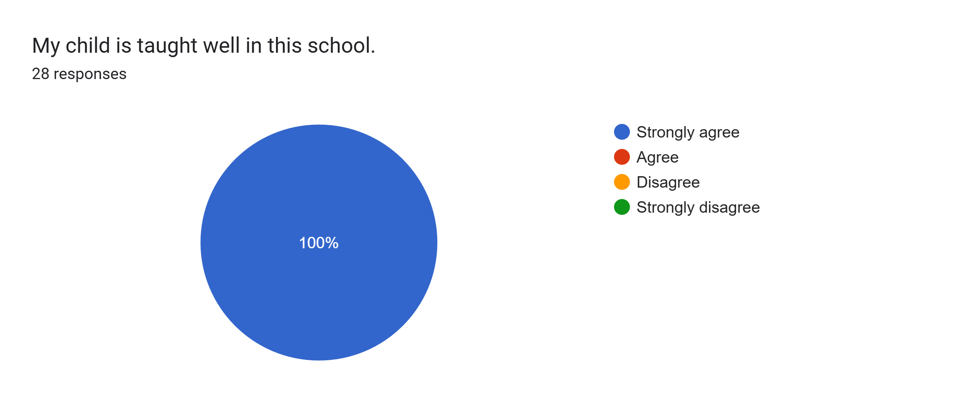
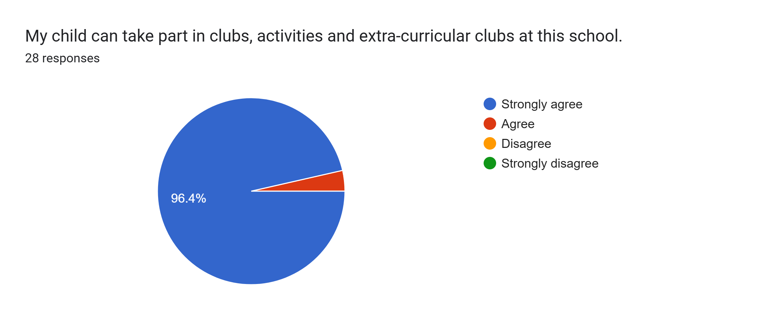
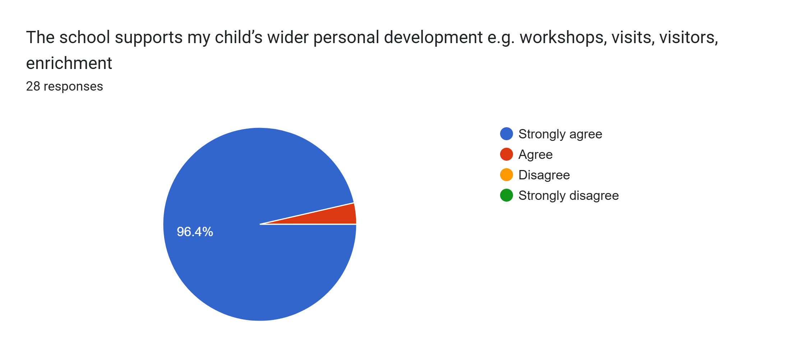
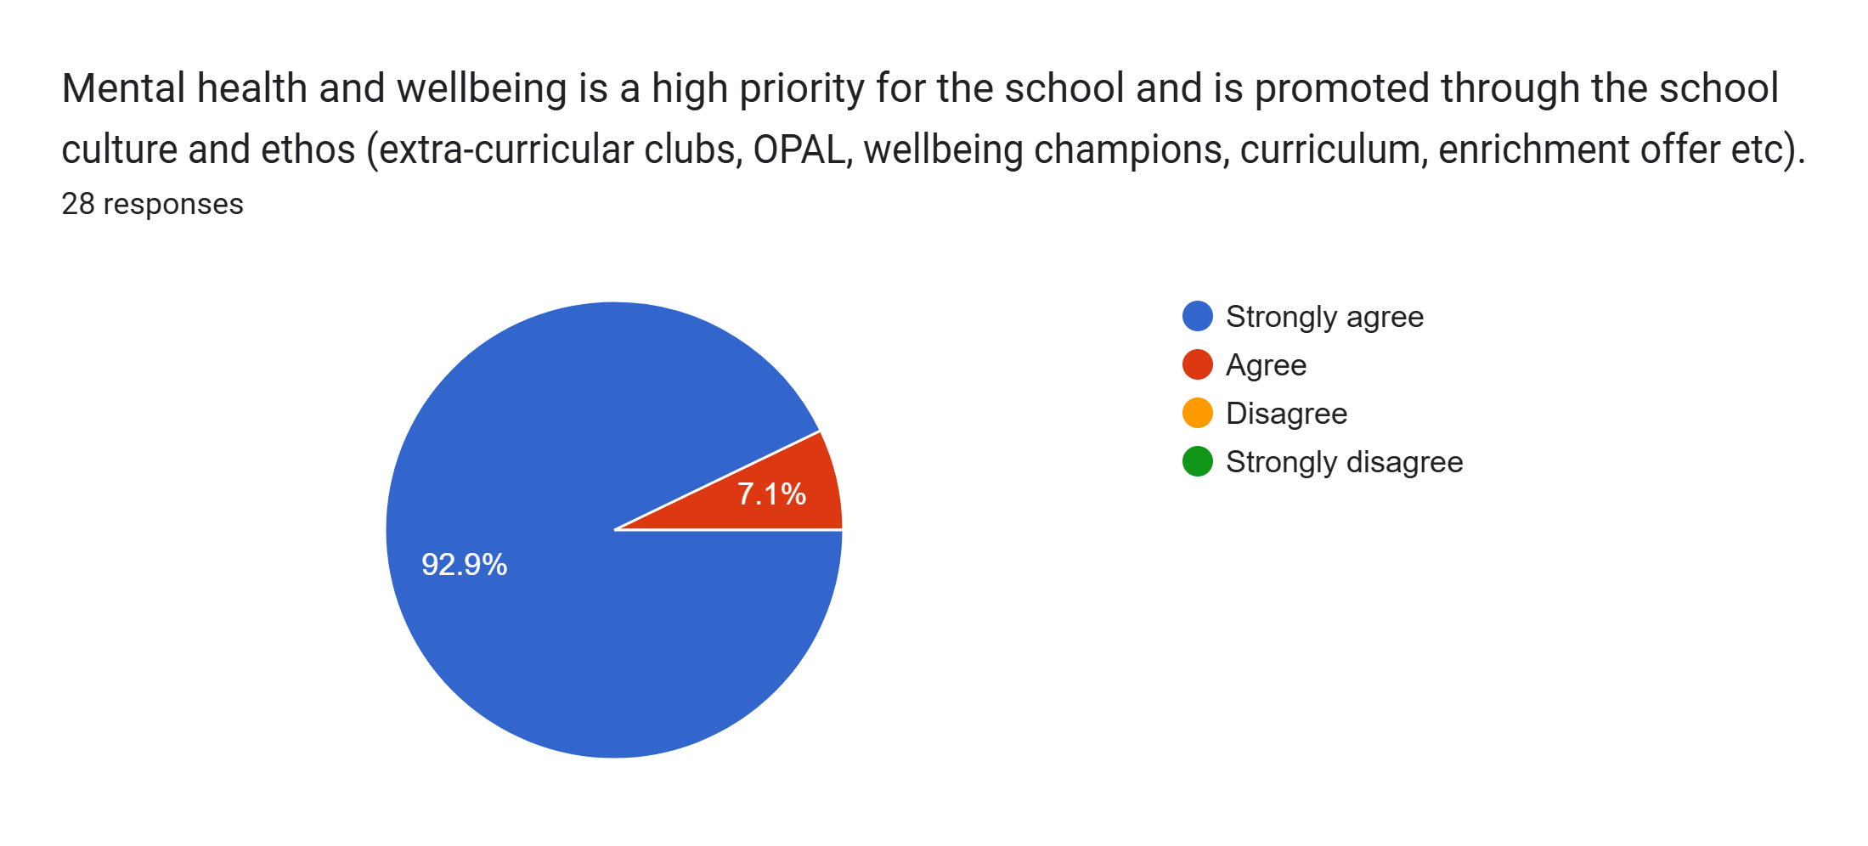
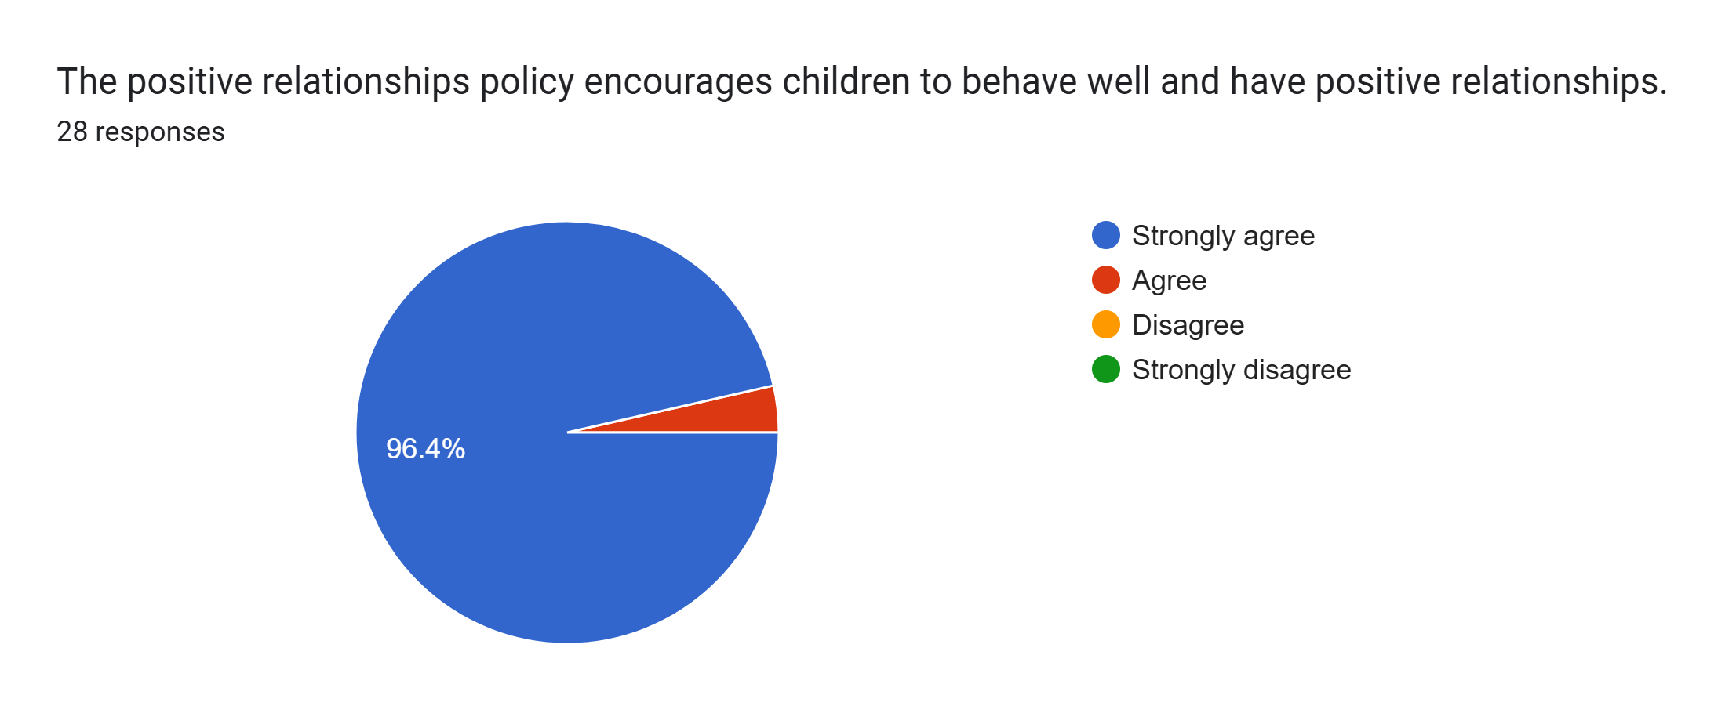
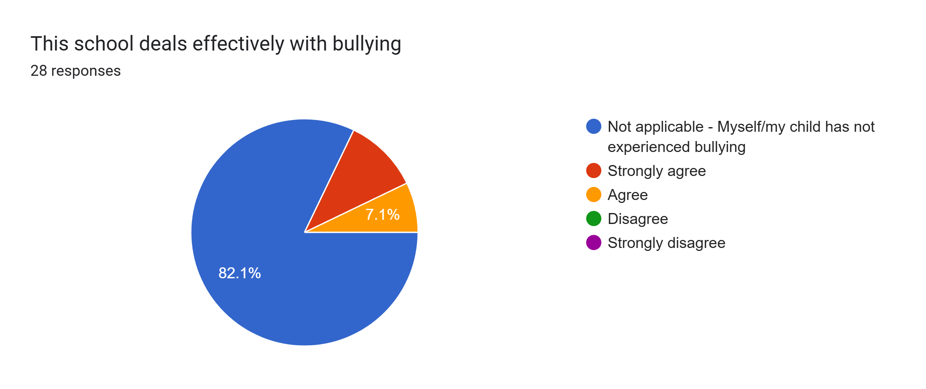
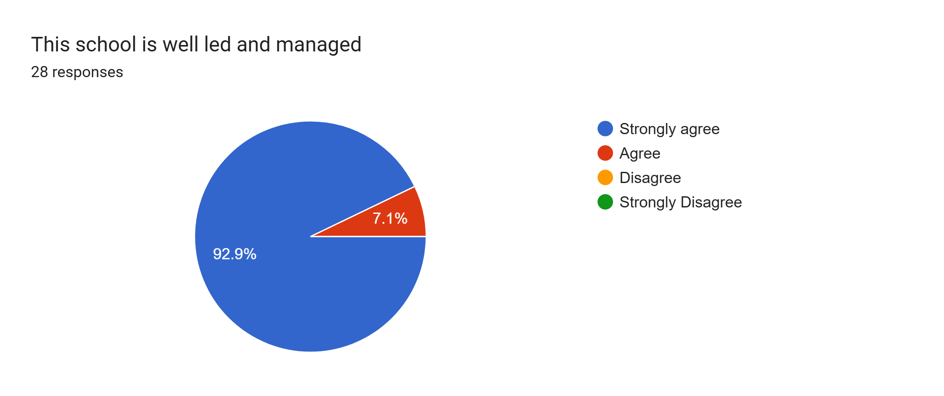
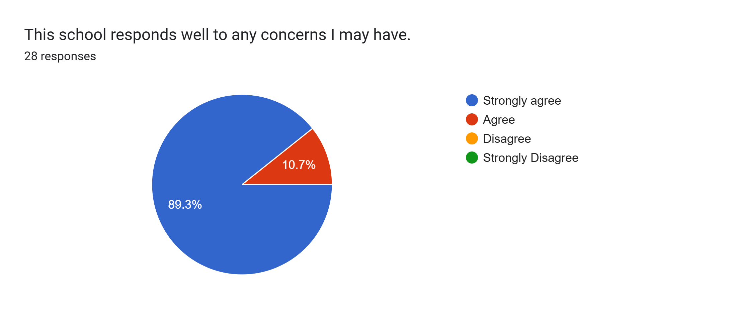
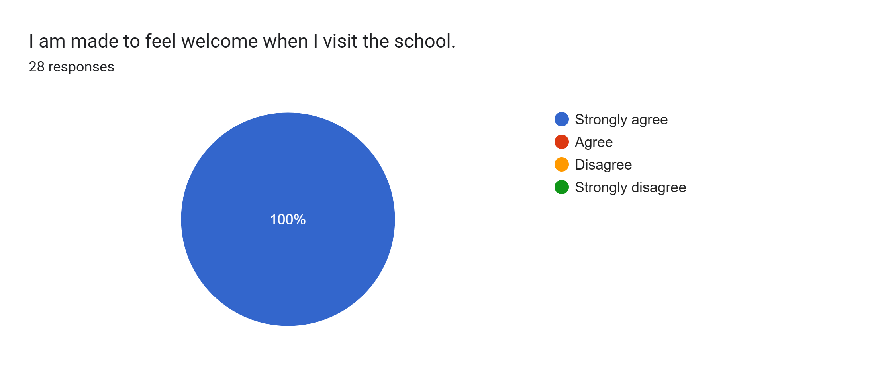
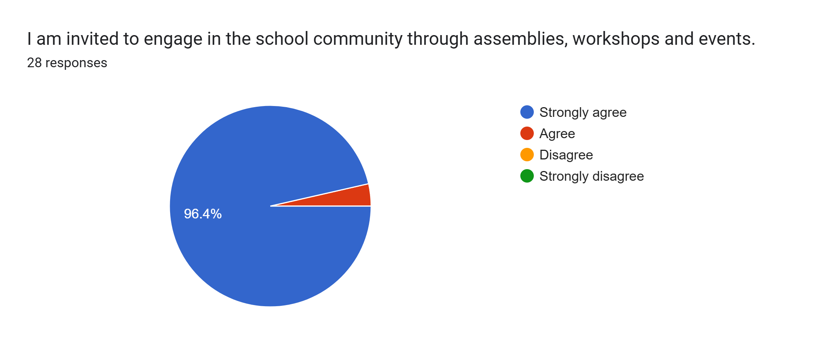
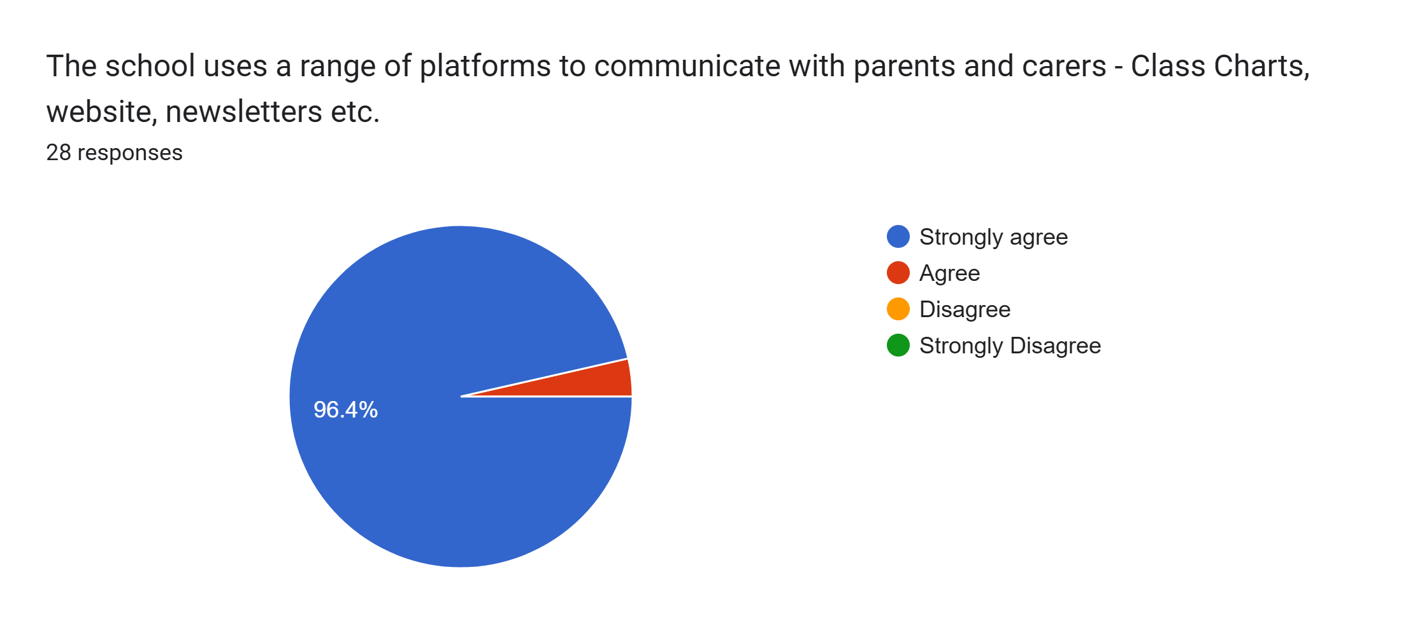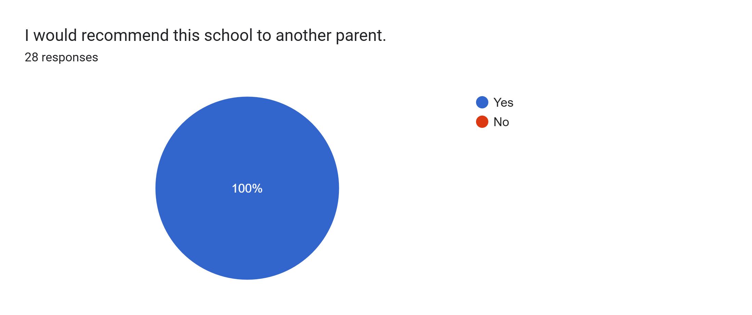
What other comments would you like to make to staff:
- Thank you.
- Dolly is doing really well and the teachers are brilliant. Thank you.
- Great school.
- Amazing, couldn't ask for more.
- Approaching the teachers are really easy.
- Always amazing.
- Amazing school.
- Thank you for making school so enjoyable
- Fionn is very happy to attend school. He loves coming every day. I am so happy with the progress he has made.
- We're very happy with her progress. Thank you.
- Amazing.
- The children feel so safe here, thank you.
- The most wonderful school and teaching staff!
- Thanks for everything you are doing for my children.
- Really happy with the progress Lottie has made with the support of her teachers. She is always so happy coming into school.
- School is a really nice school and Delilah is so happy in it.
- Amazing, friendly, welcoming staff.
- Nothing but positive.
- Love the school.
- Really great staff, thankyou.
- Love the ethos here, thank you all.
- Arthur loves school and is very happy here.
- Zach loves coming to school not only to play with friends but to learn too

