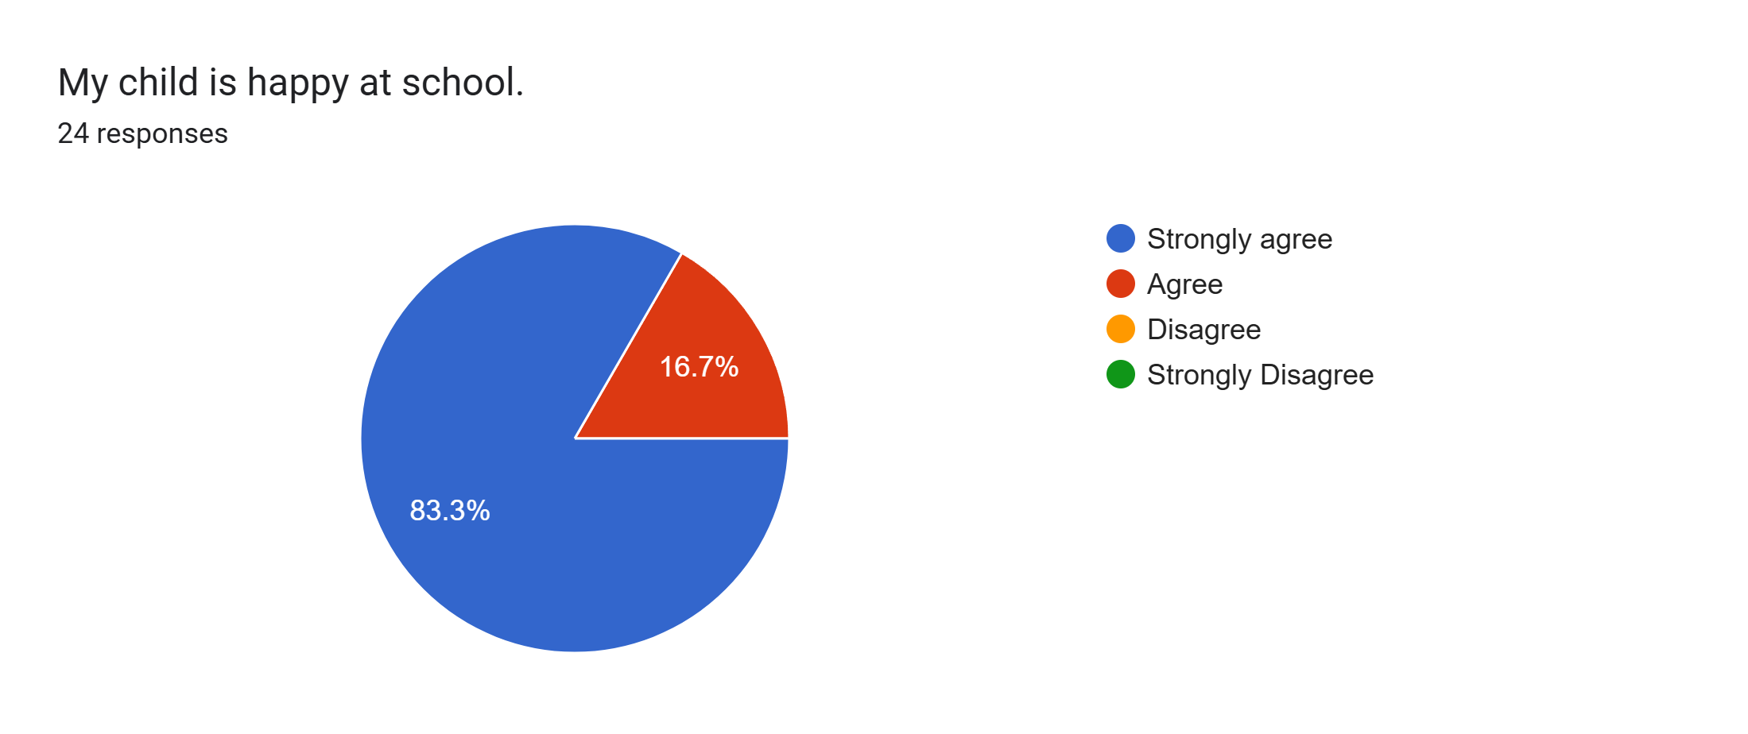
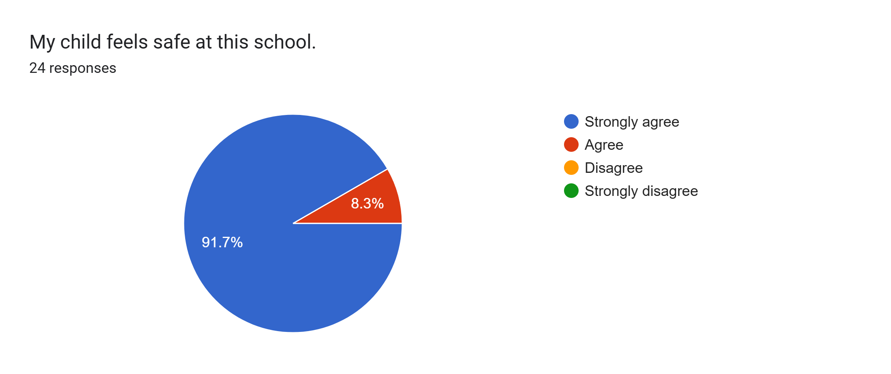
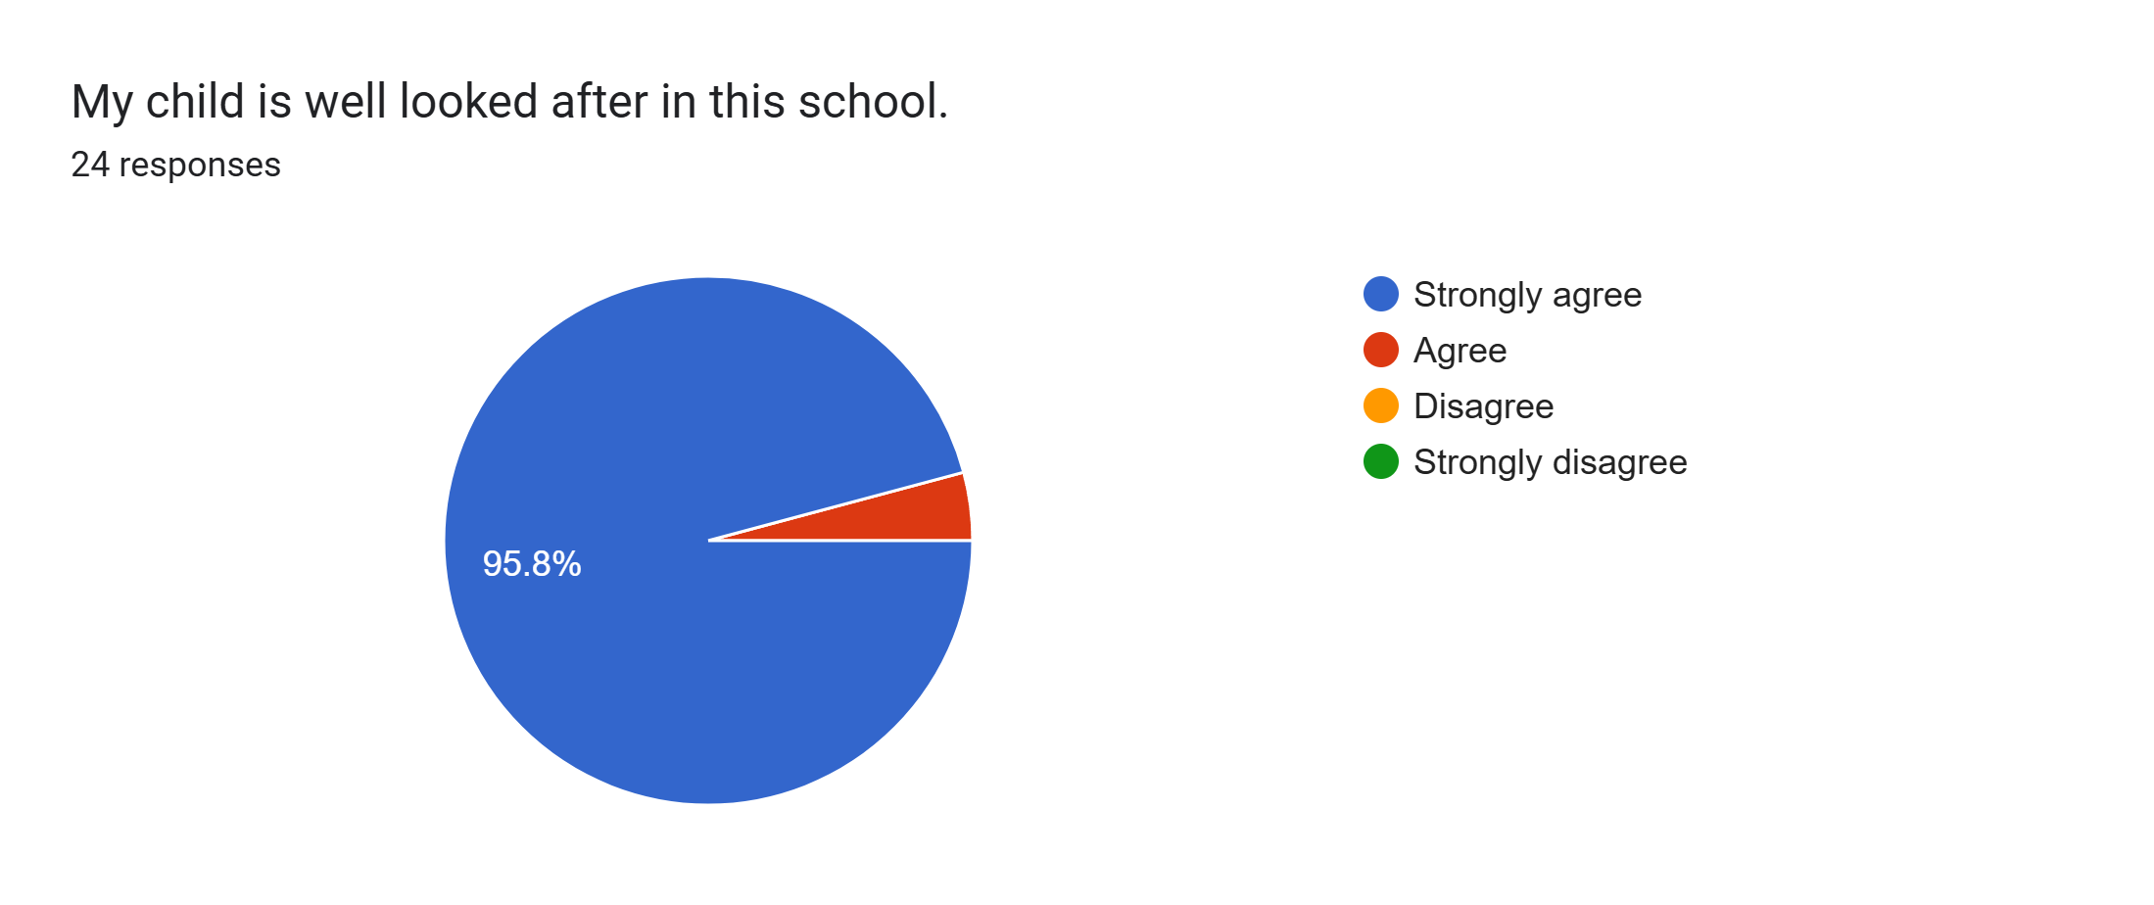
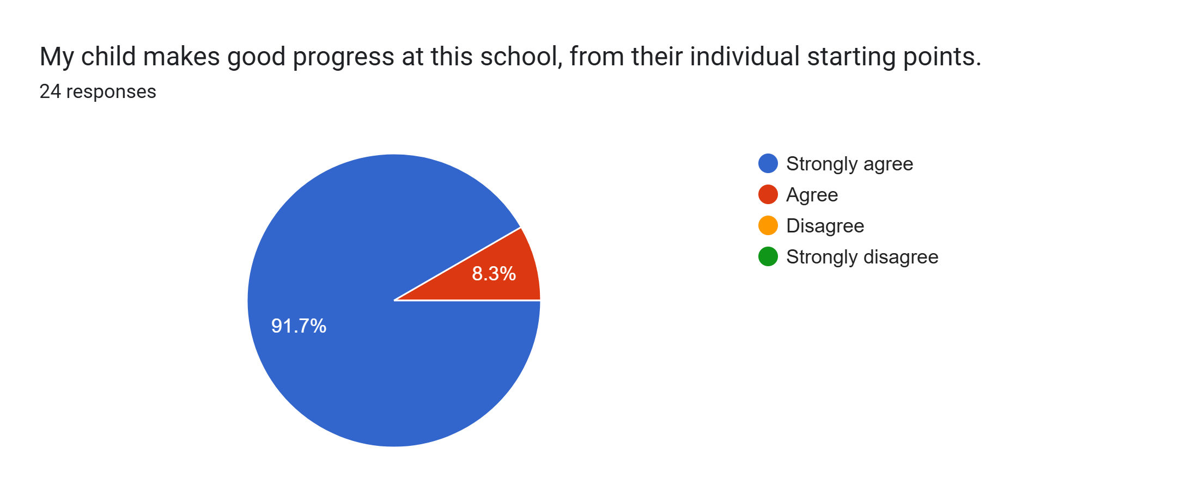
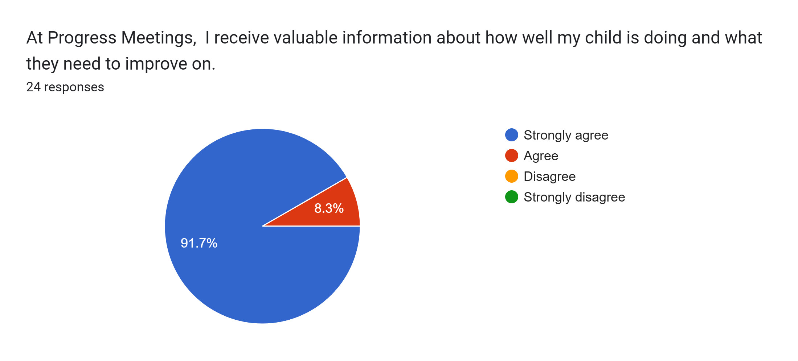
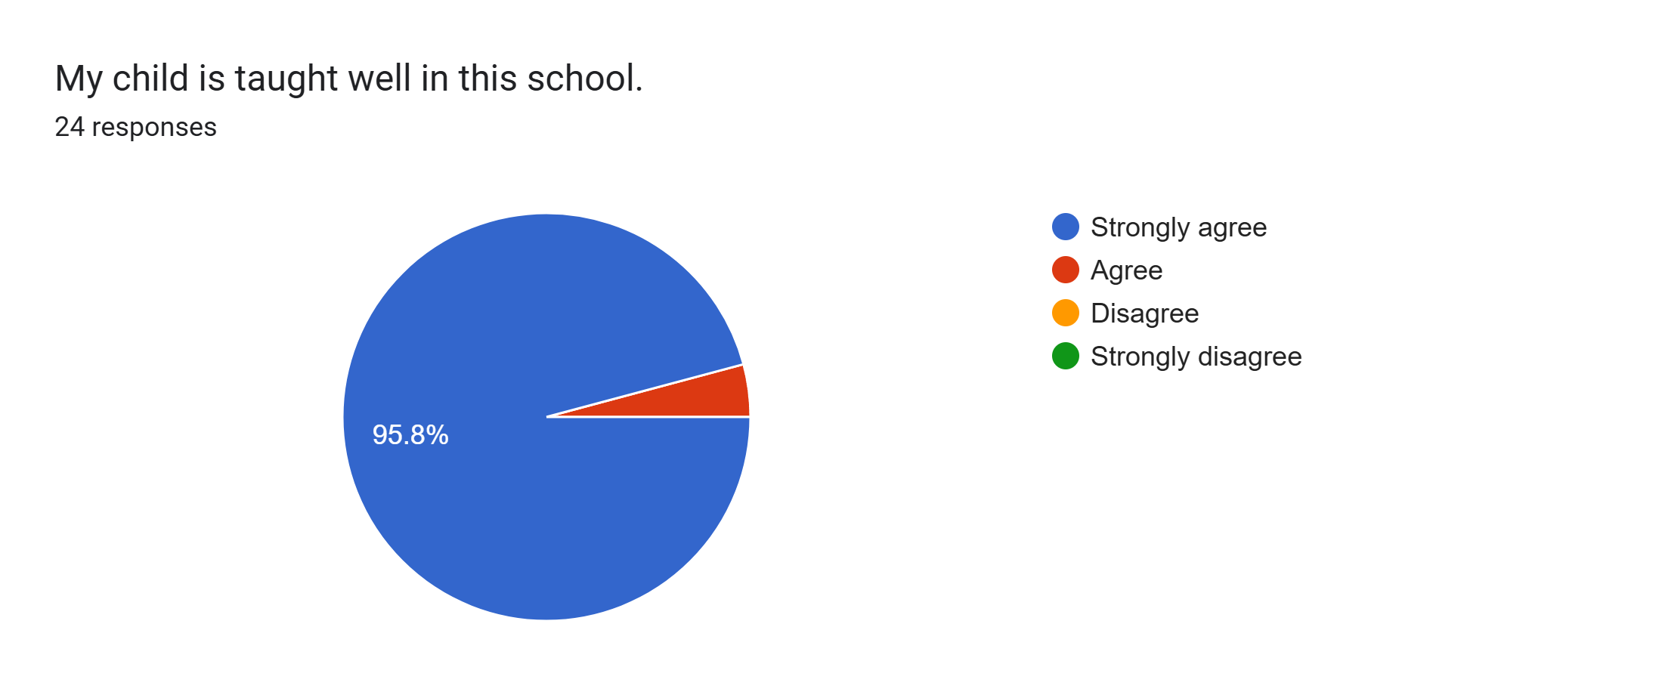
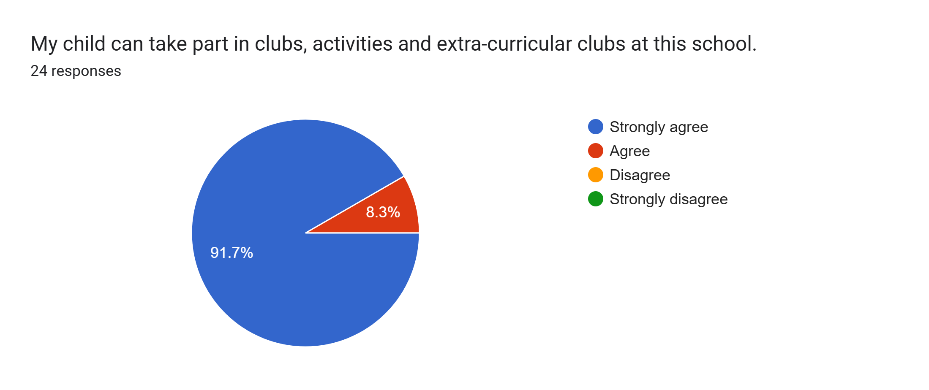
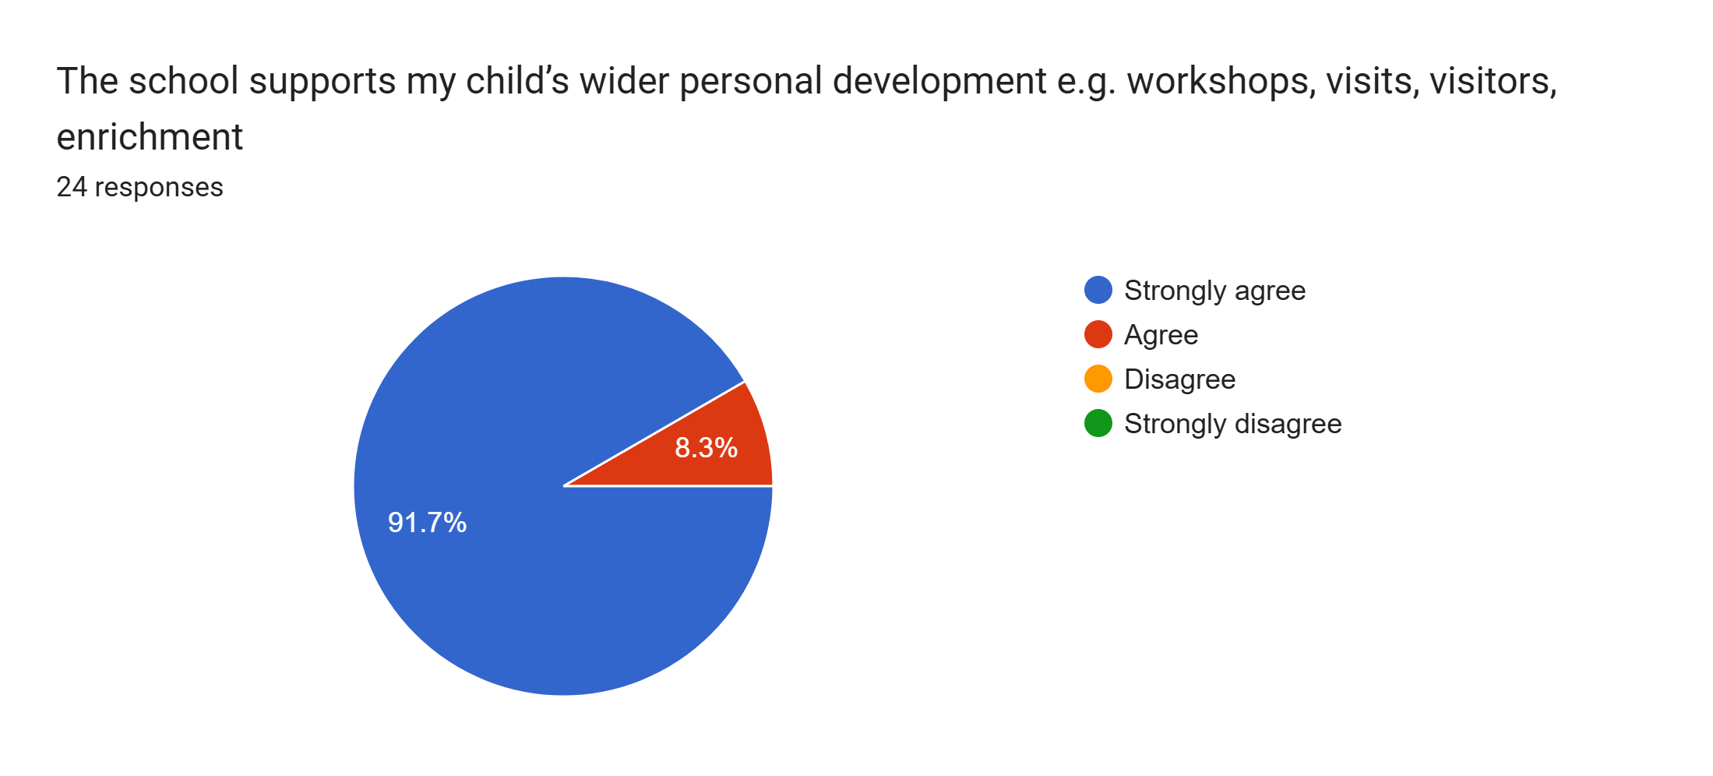
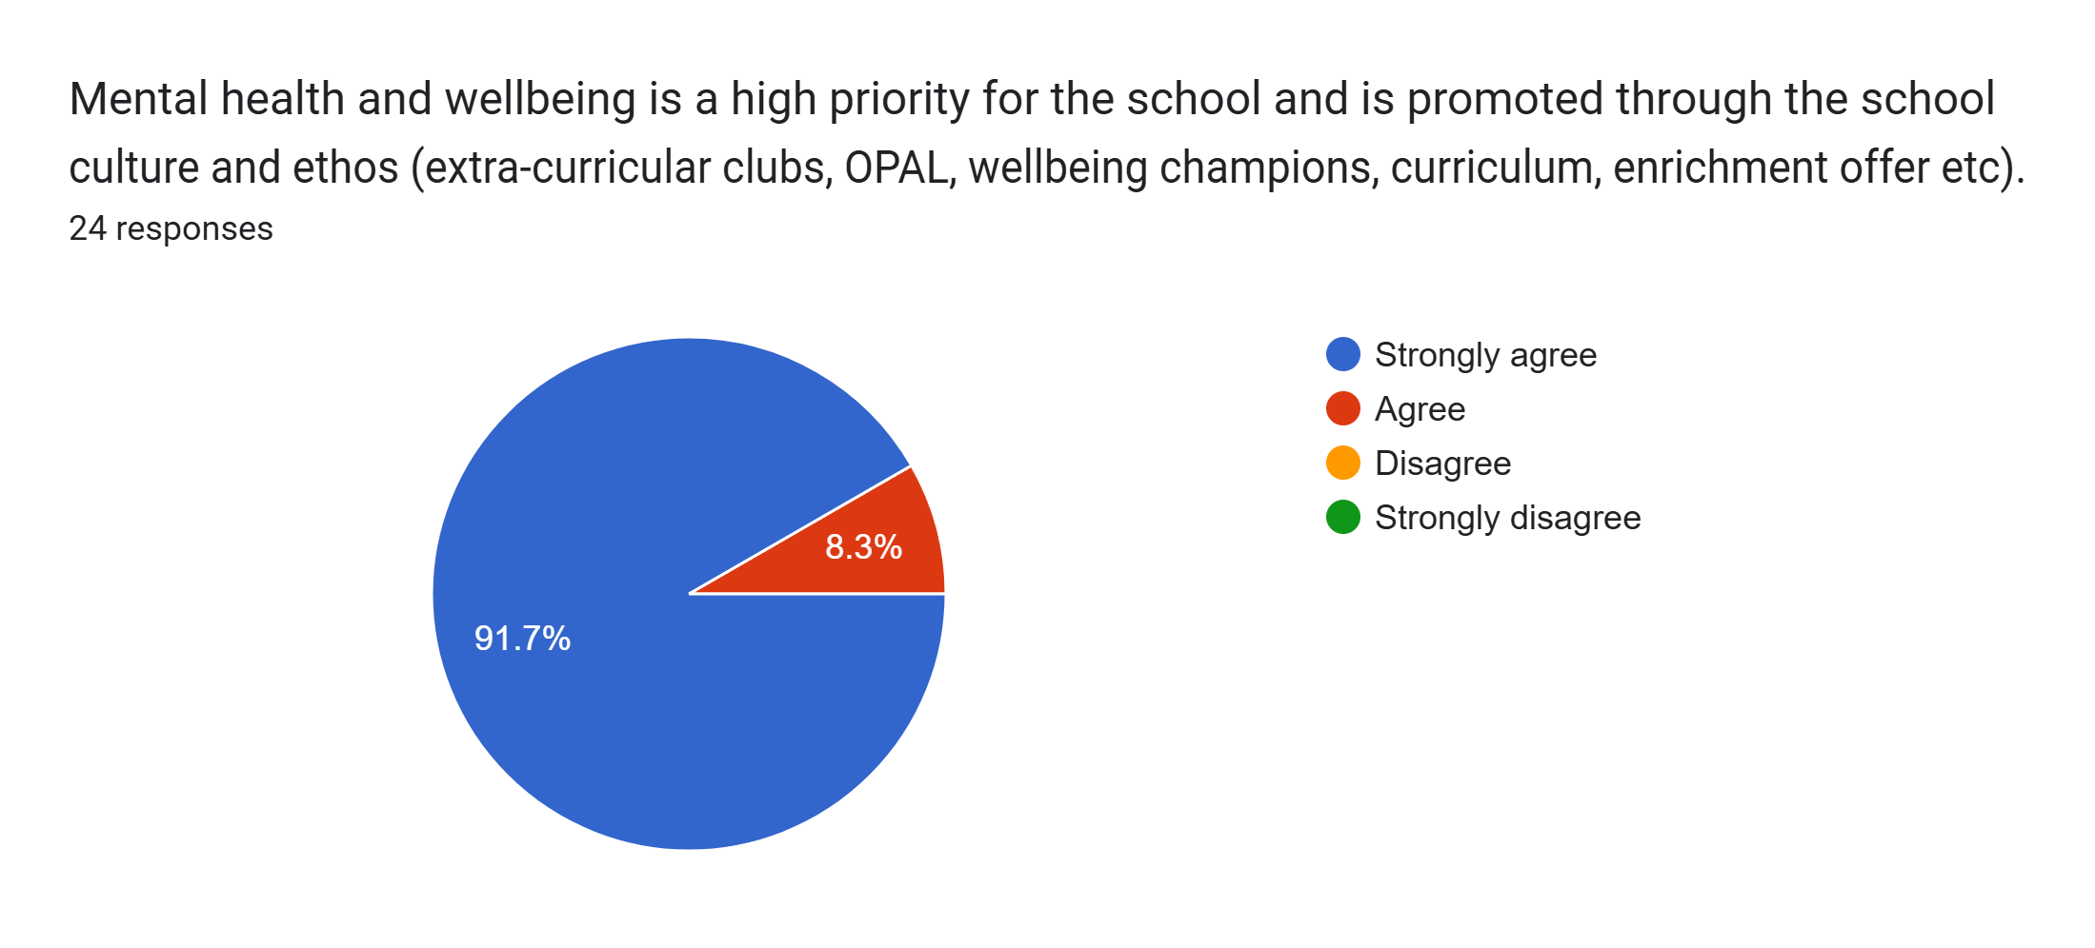
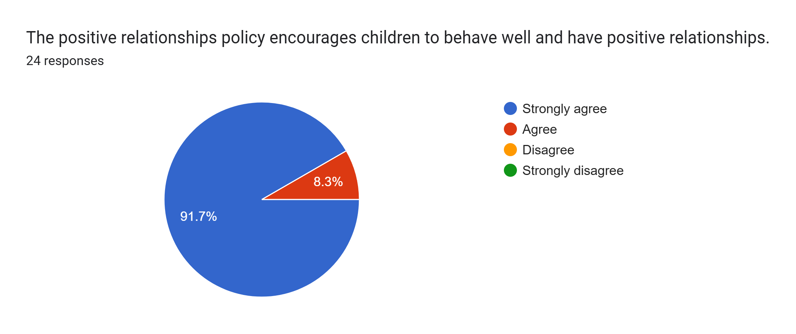
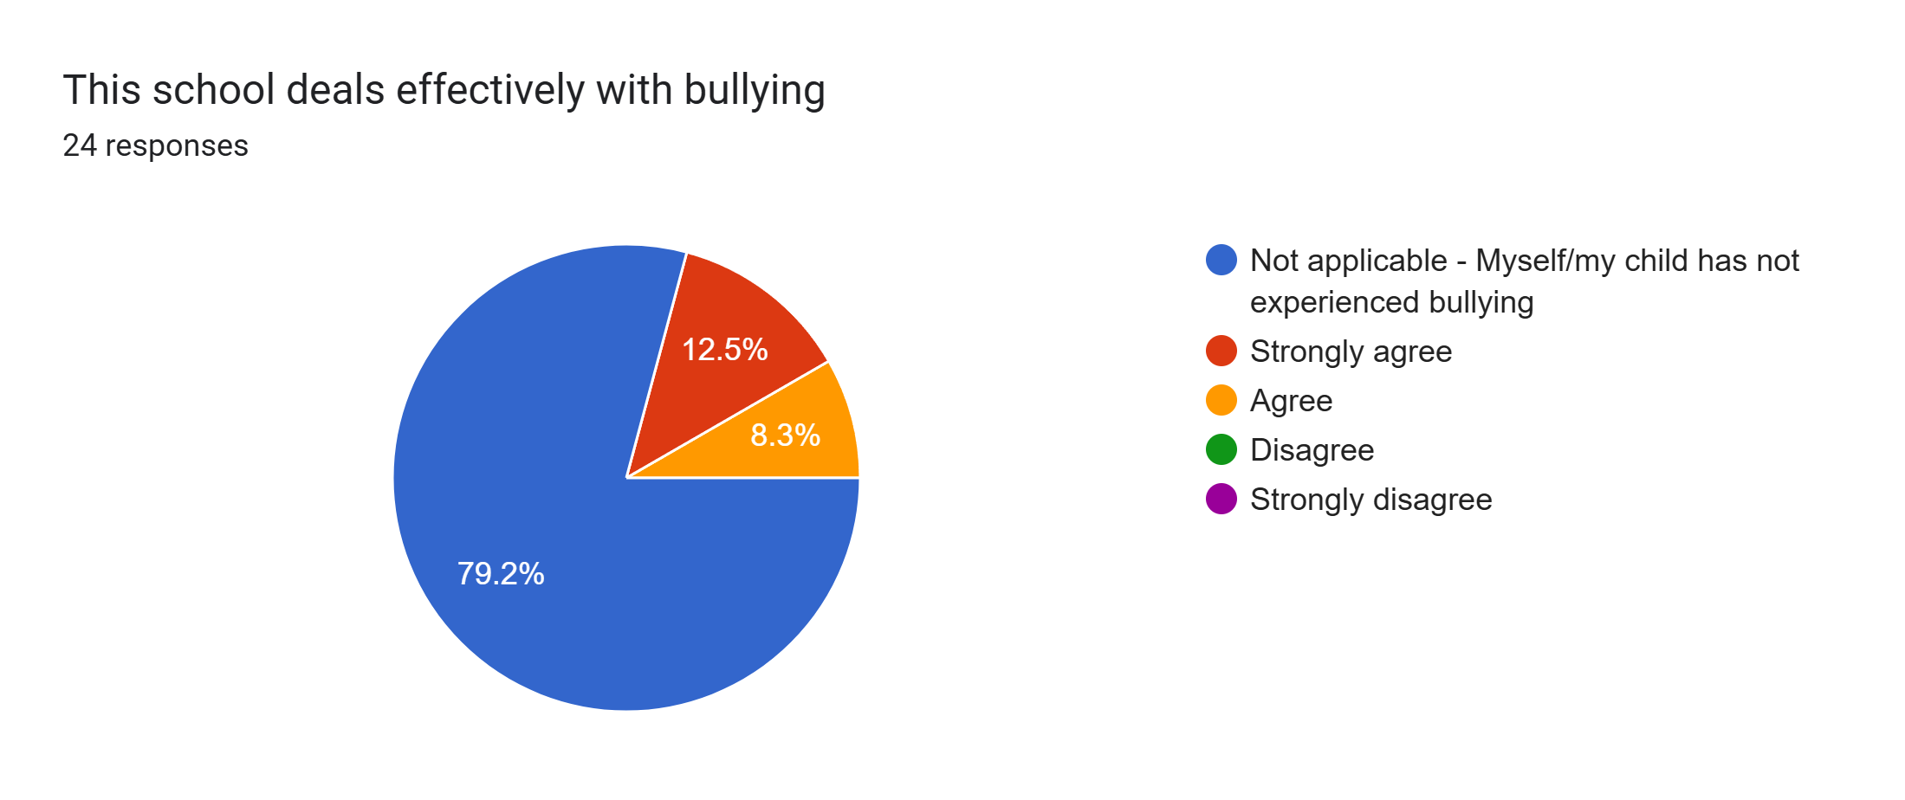
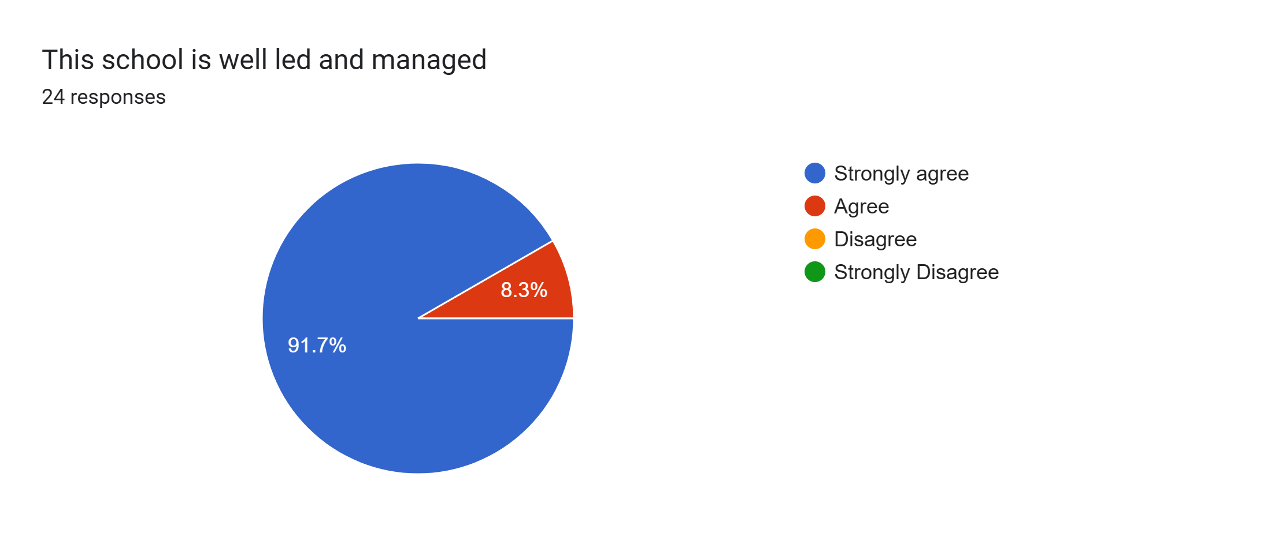
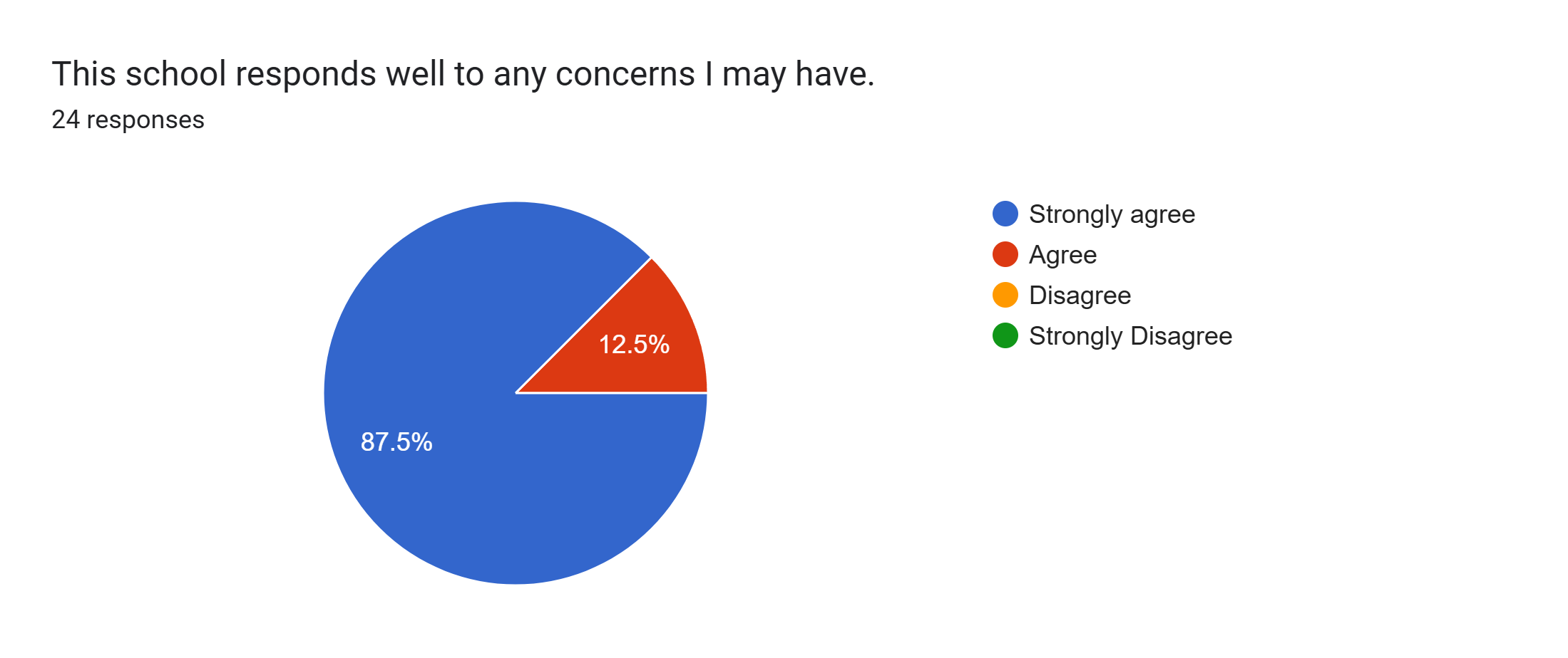
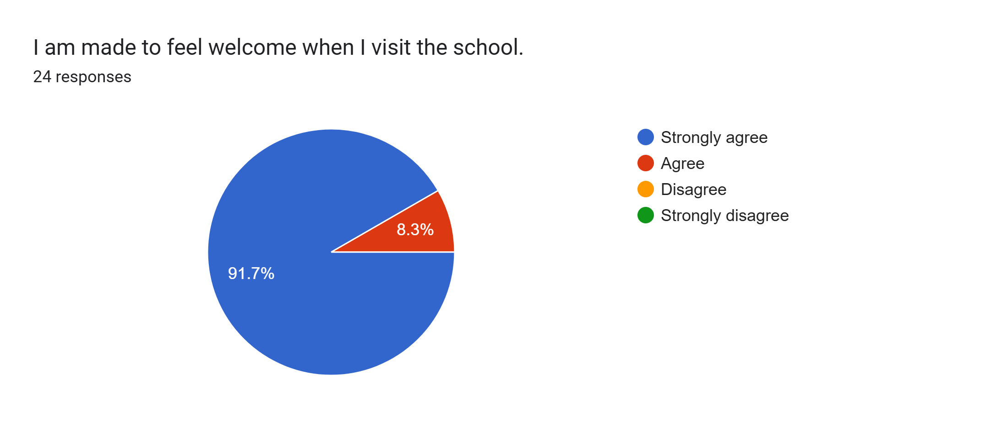
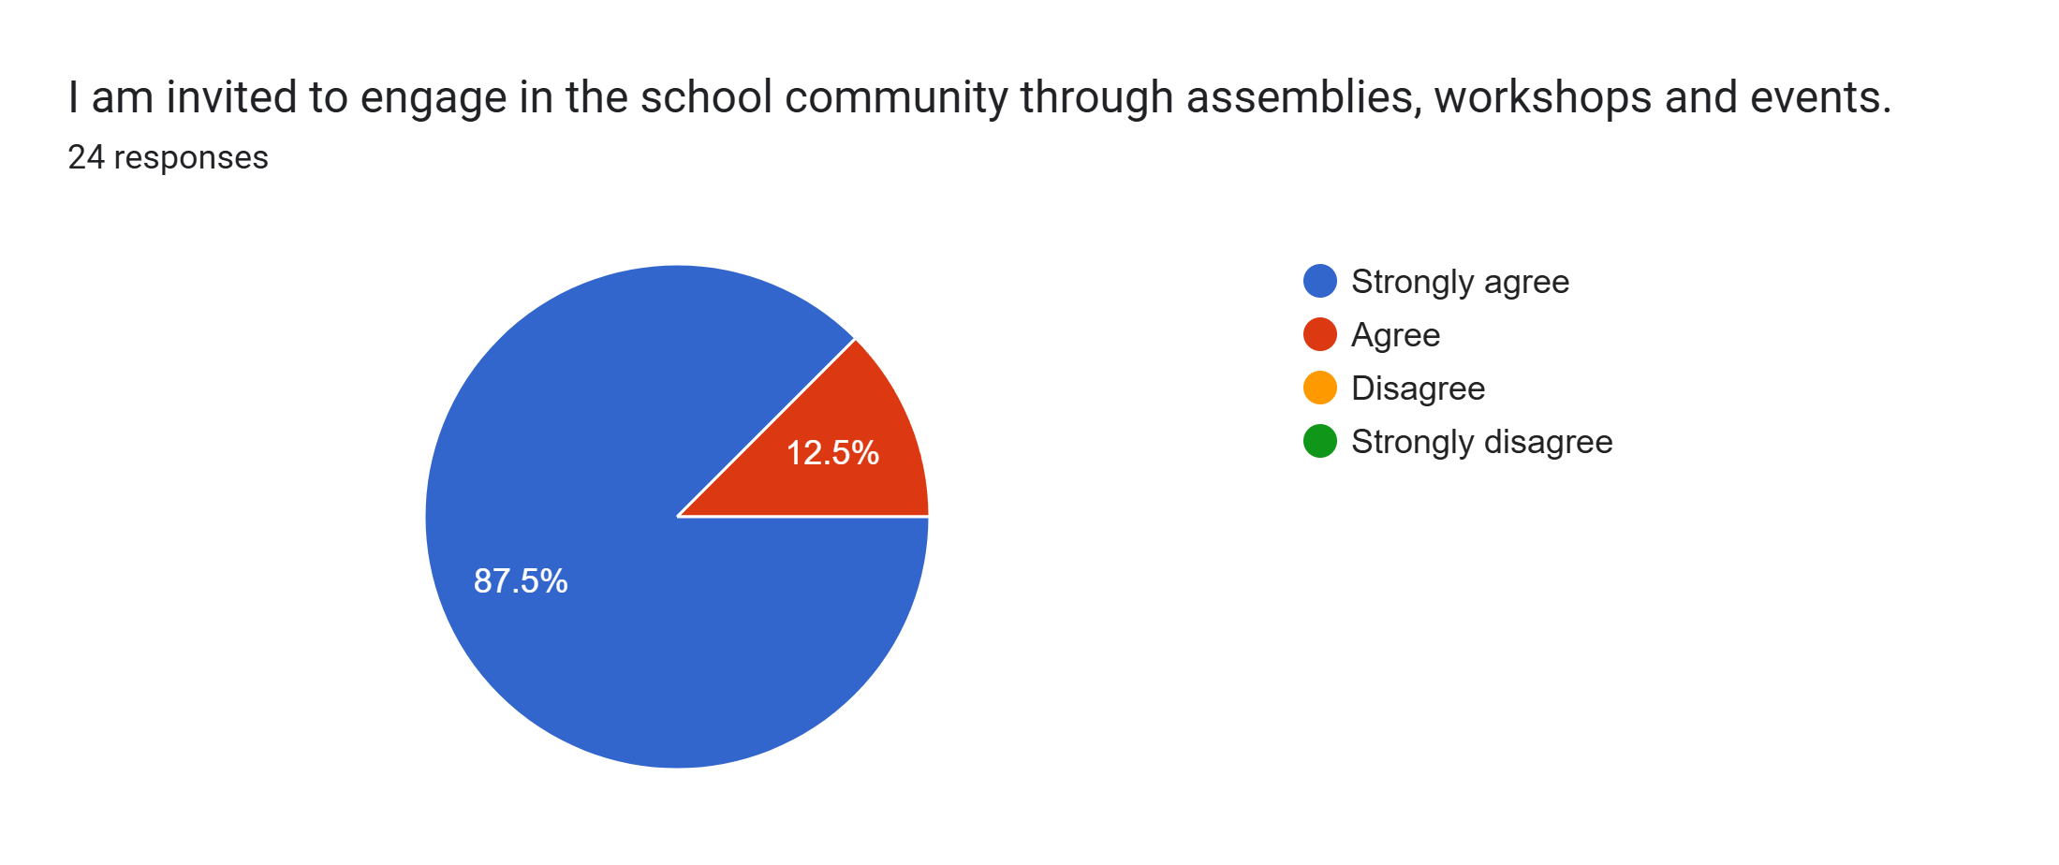
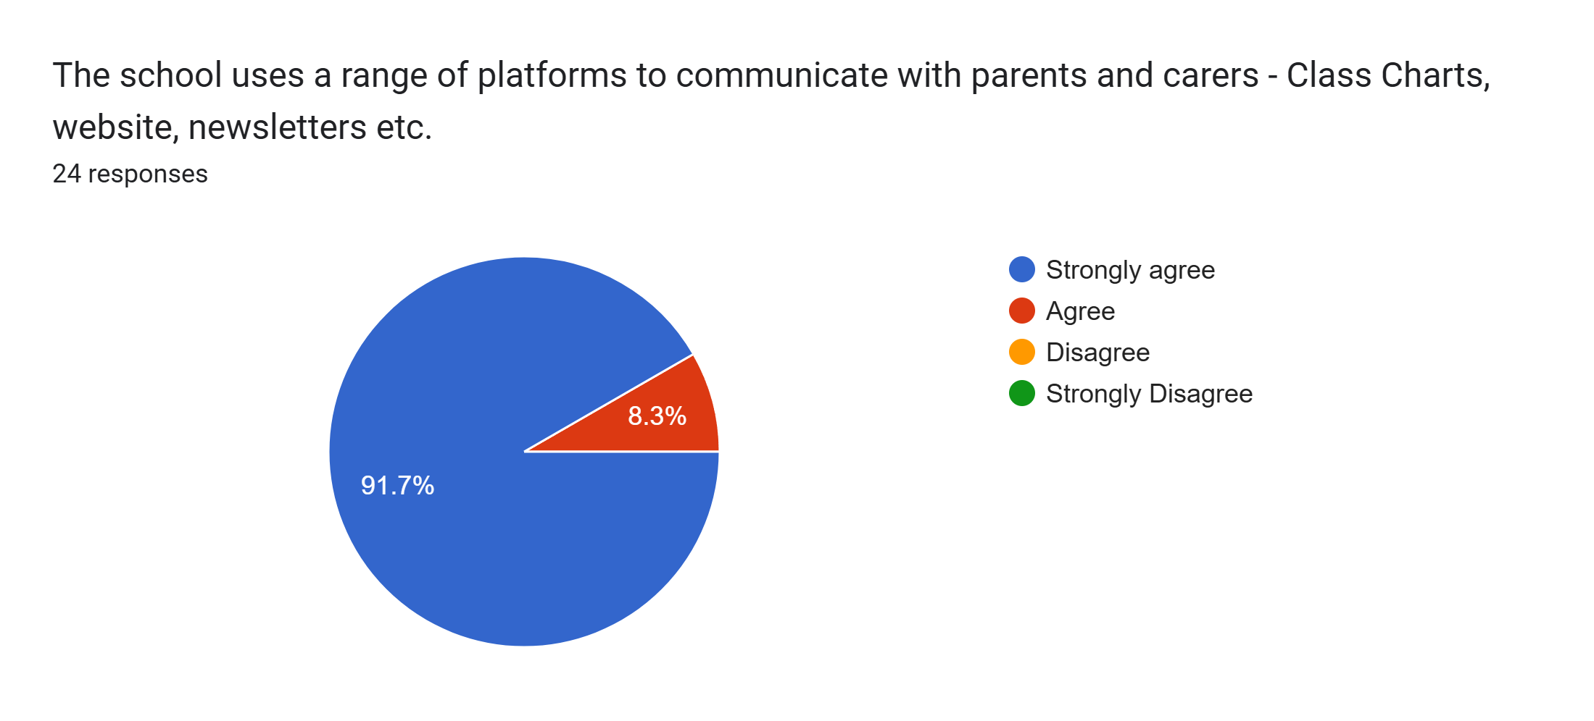
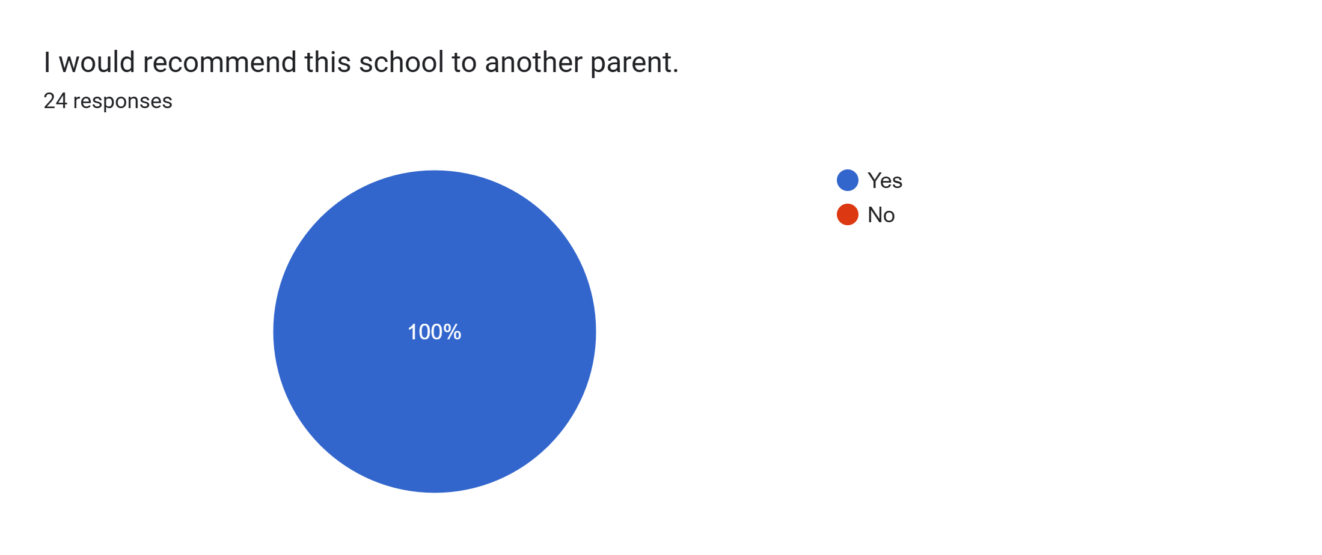
What other comments would you like to make to staff:
- Thank you.
- Thank you for all you do to help Freddie.
- Really pleased and happy with everything that is done for Daisy.
- Lovely and approachable teacher.
- We love this school and hope Alice will still be able to attend for reception - fingers crossed!
- Lovely to hear how my child is progressing.
- Really happy with progress Blossom has made since starting Roby Park nursery.
- Thank you.
- Excellent school, the child centred approach is fantastic.
- Lovely school.
- Sid loves coming to school. Thank you for being so amazing with him.
- Thanks for caring for Myles and guiding him into this big wide world. We appreciate you all, dad and mum.
- Thank you for all your hard work.
- Thank you for your time helping Elsie learn and grow.
- Thank you to Miss Waters for unlocking Dylan's potential and striving to give him the best start to his education.
- Thank you for everything!
- My child is coming on so much in nursery and I’m so pleased with how happy he is and how lovely all the teachers are.
- Very patient and attentive staff.
- Thank you for all you do for our Son. He is thriving in this school and it is lovely to see xx
- Thank you for everything.
- The effort that the staff put in is excellent and we are grateful for how Emily is looked after and treated. We cannot thank them enough.
- Thank you.

