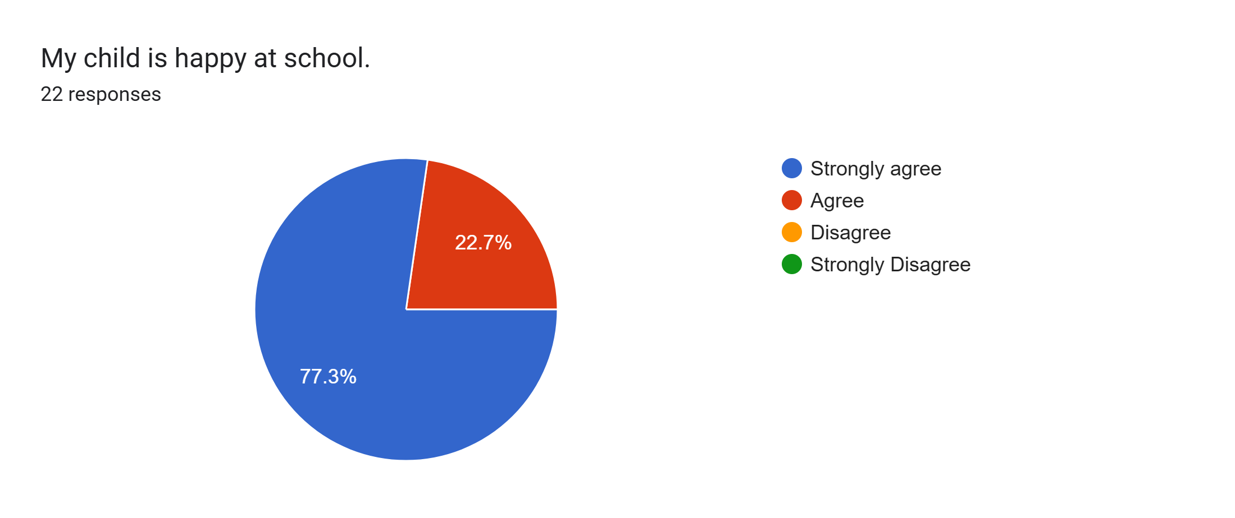
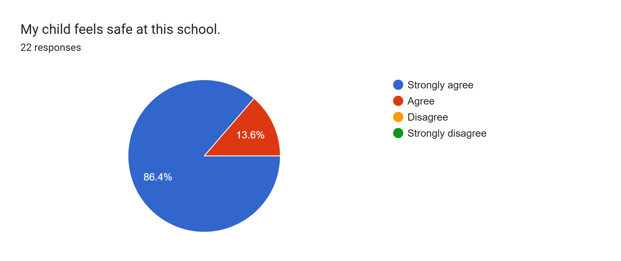
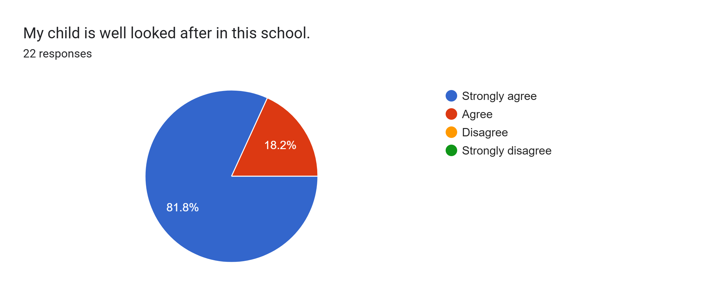
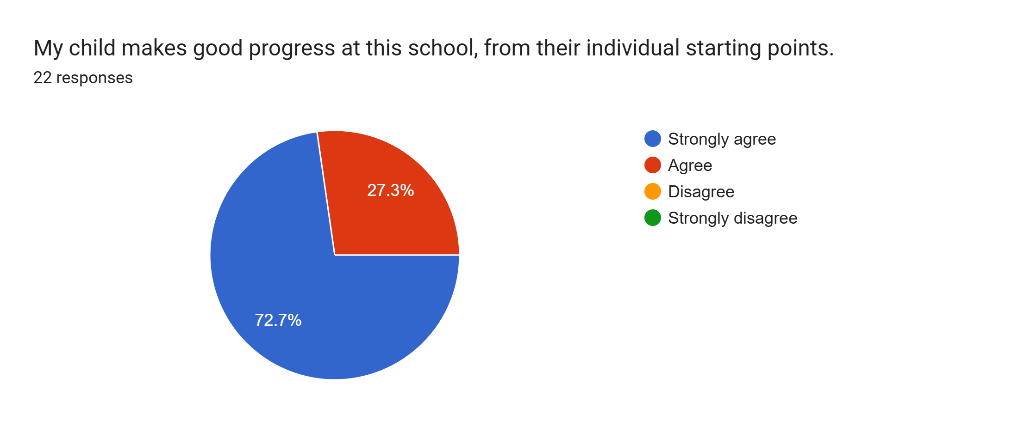
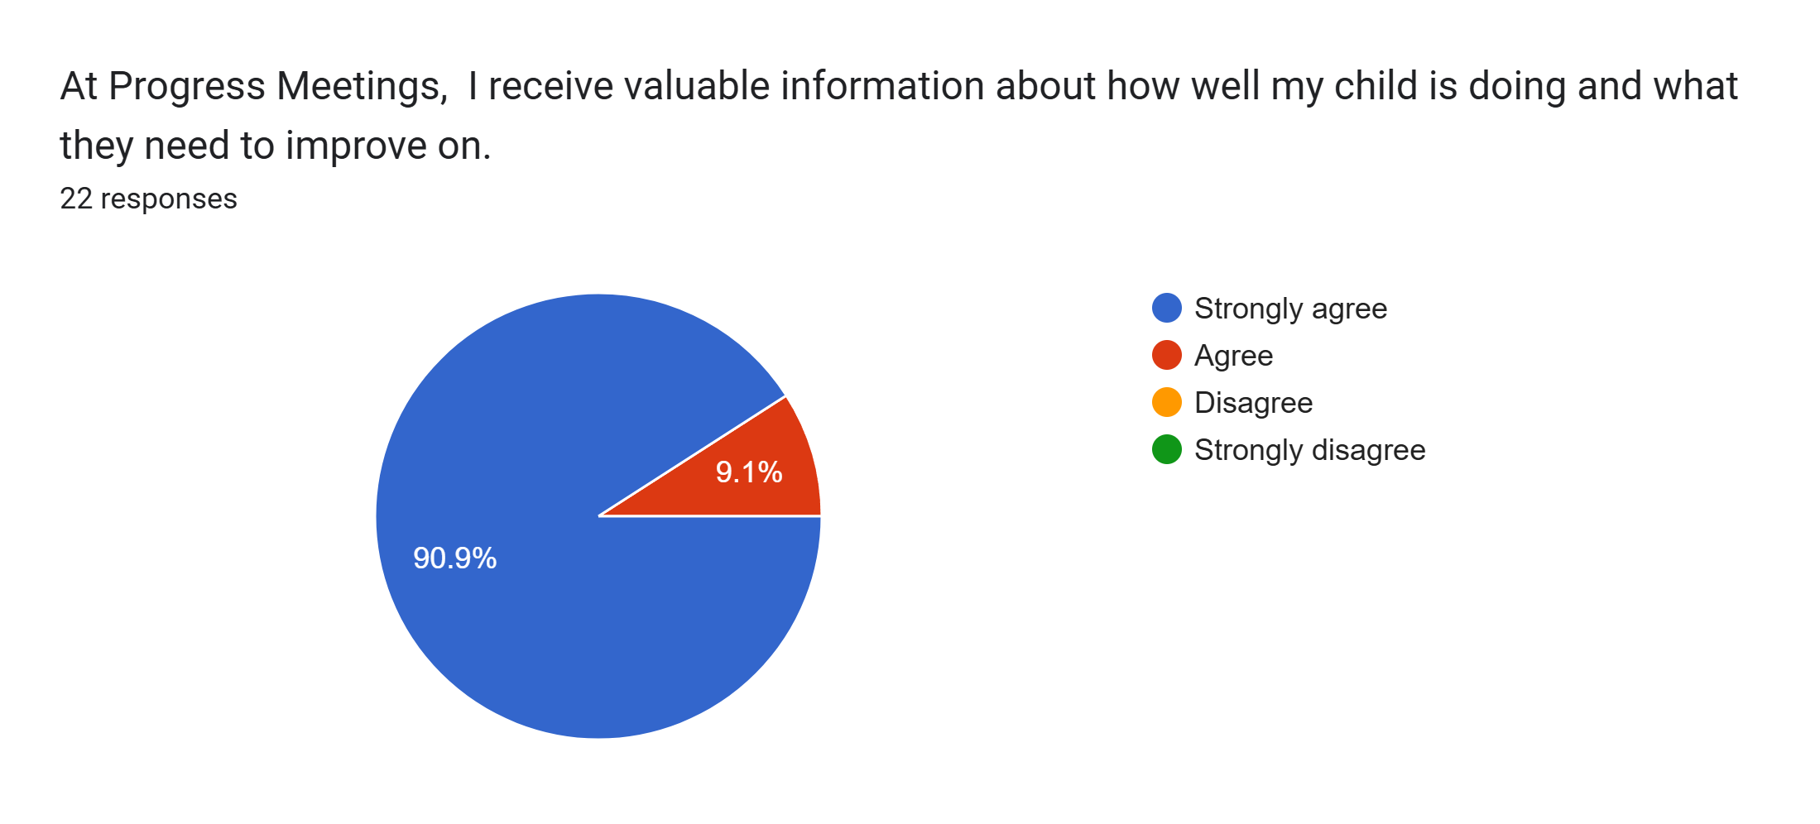
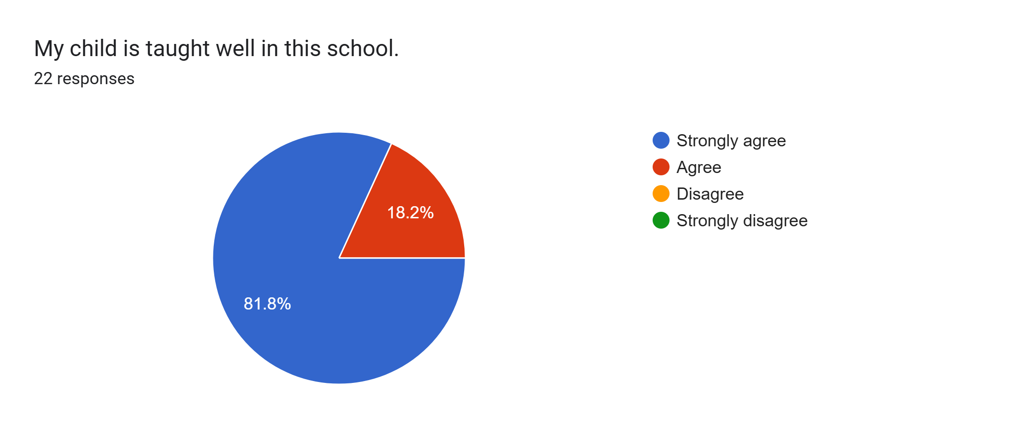
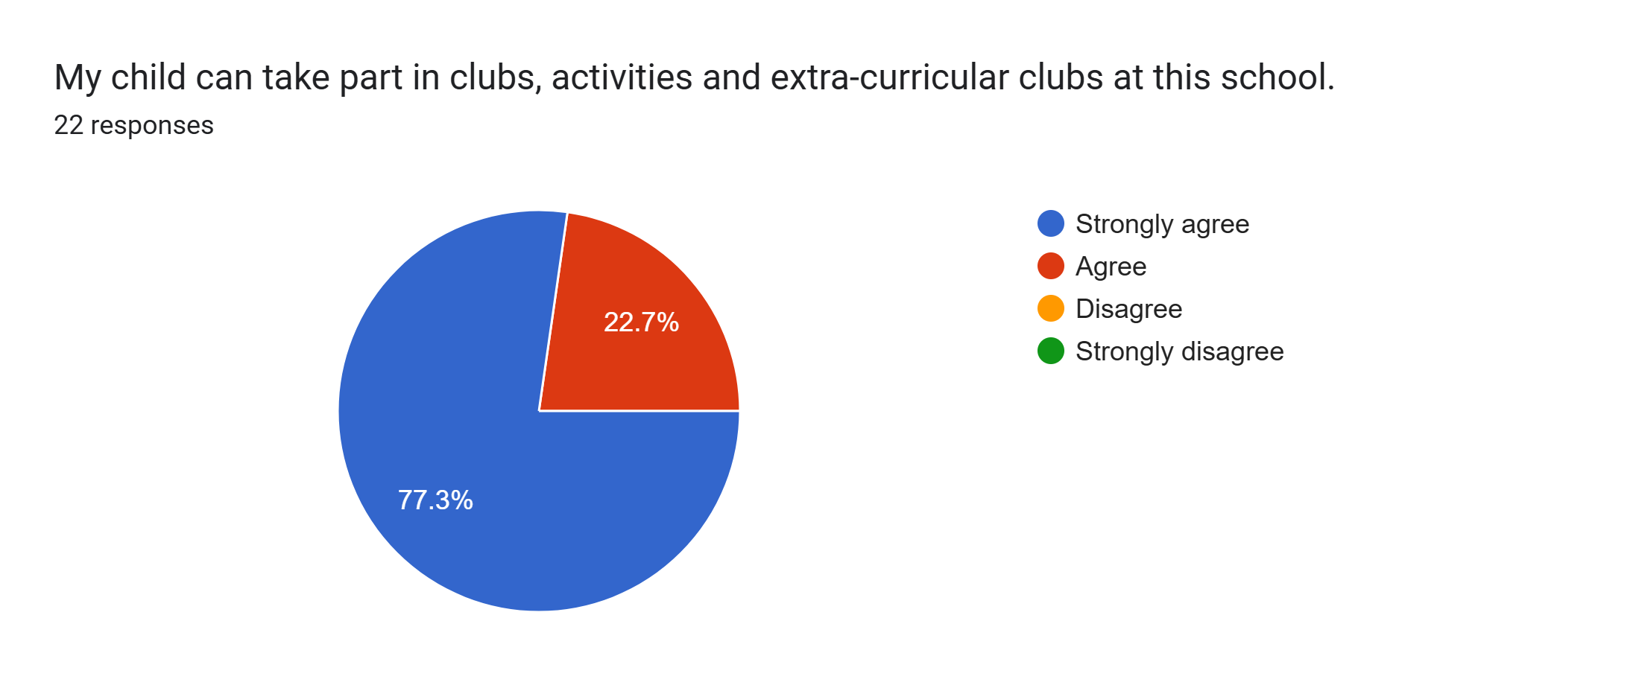
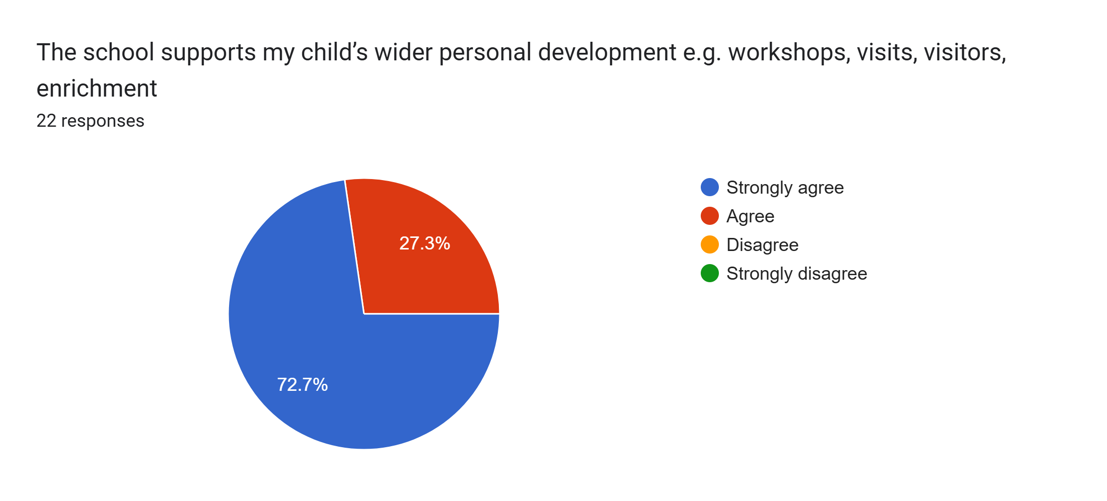
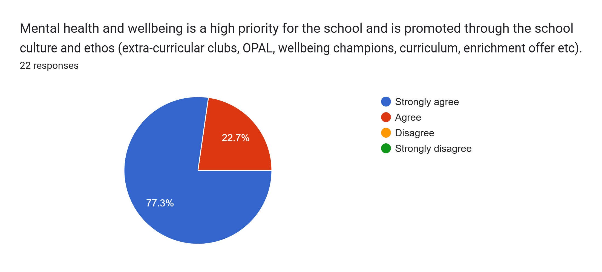
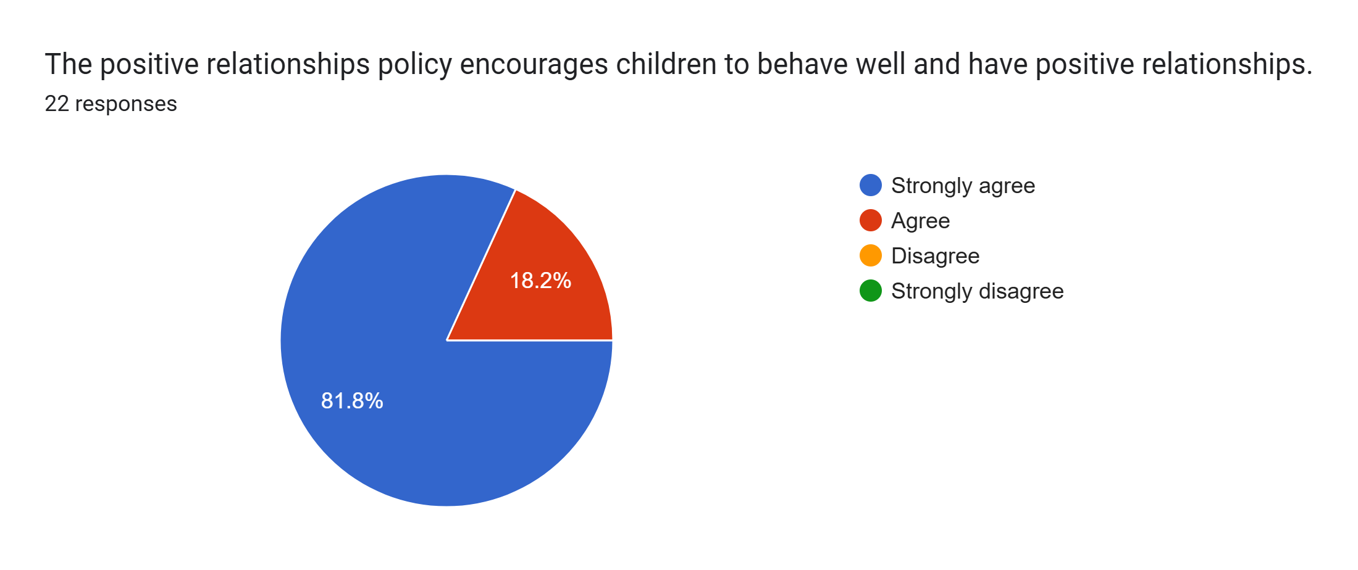
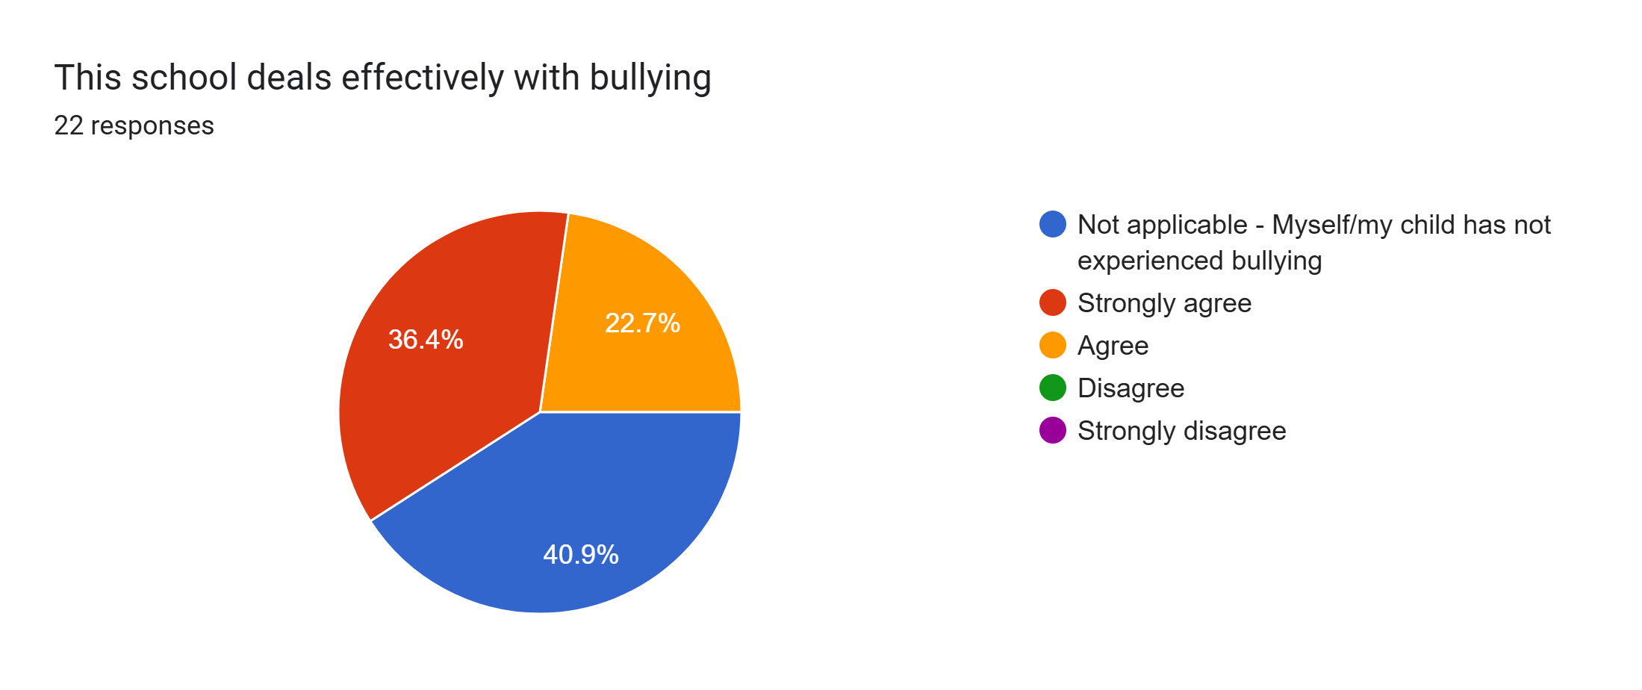
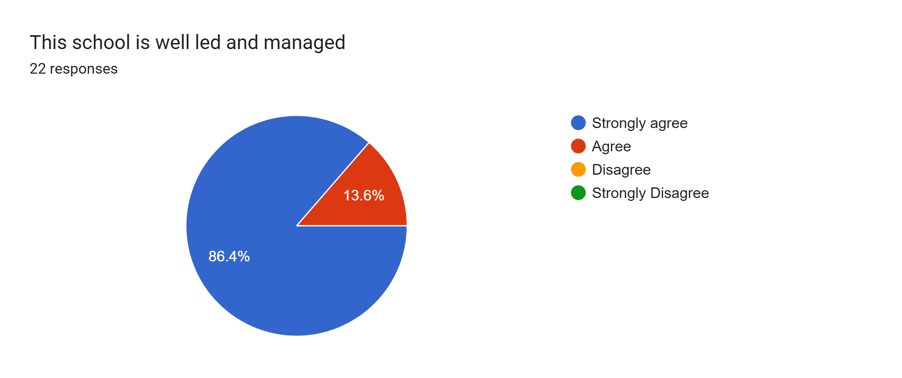
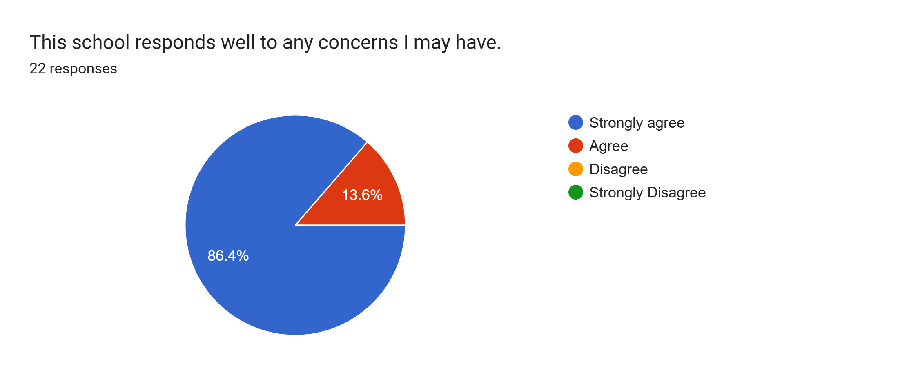
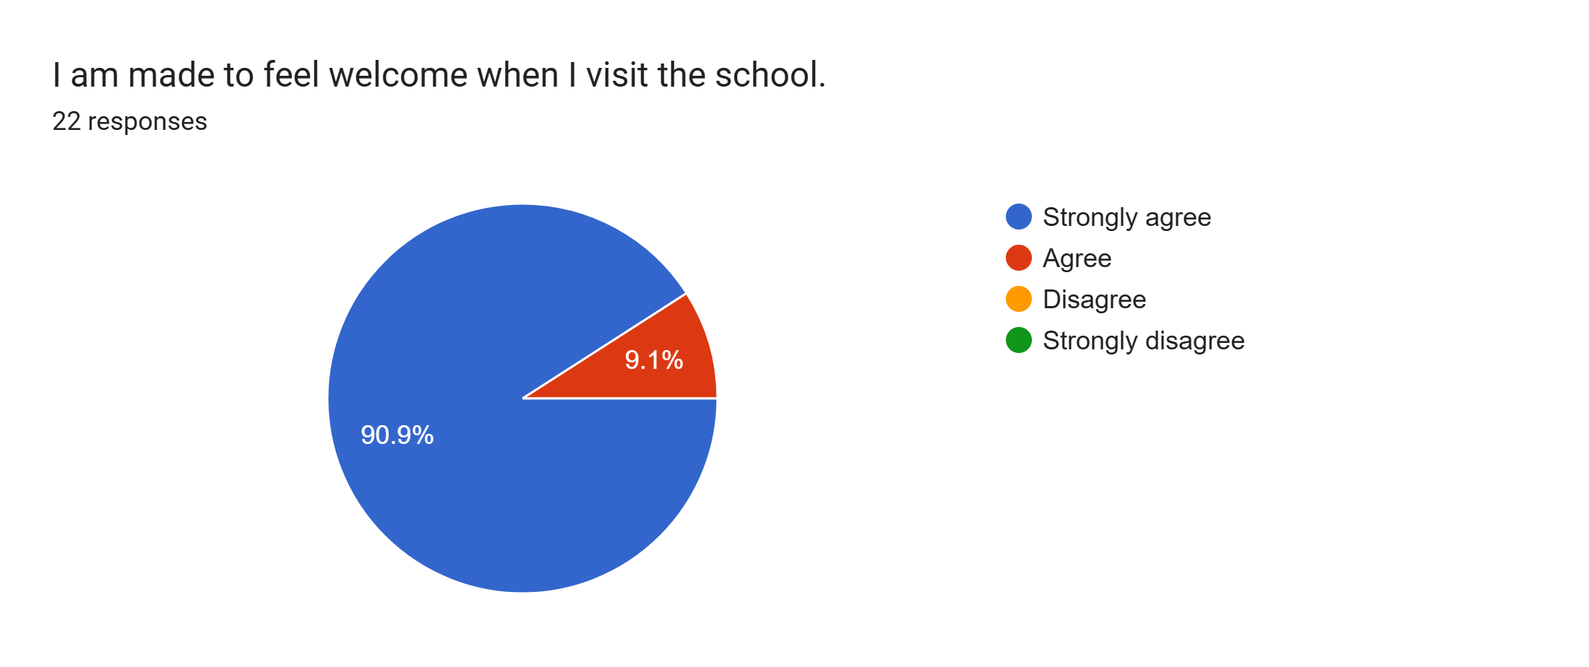
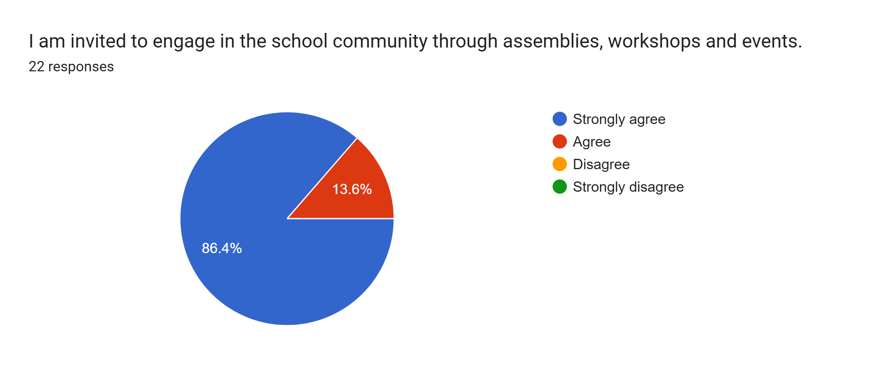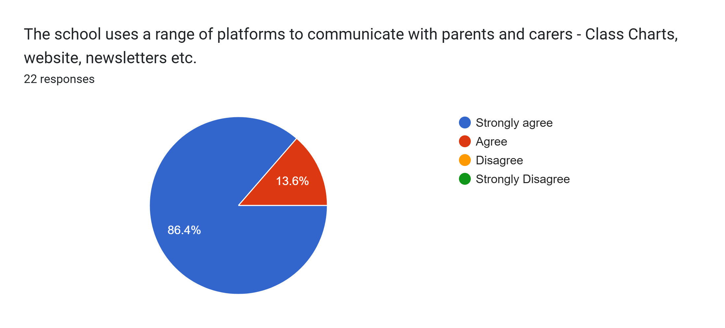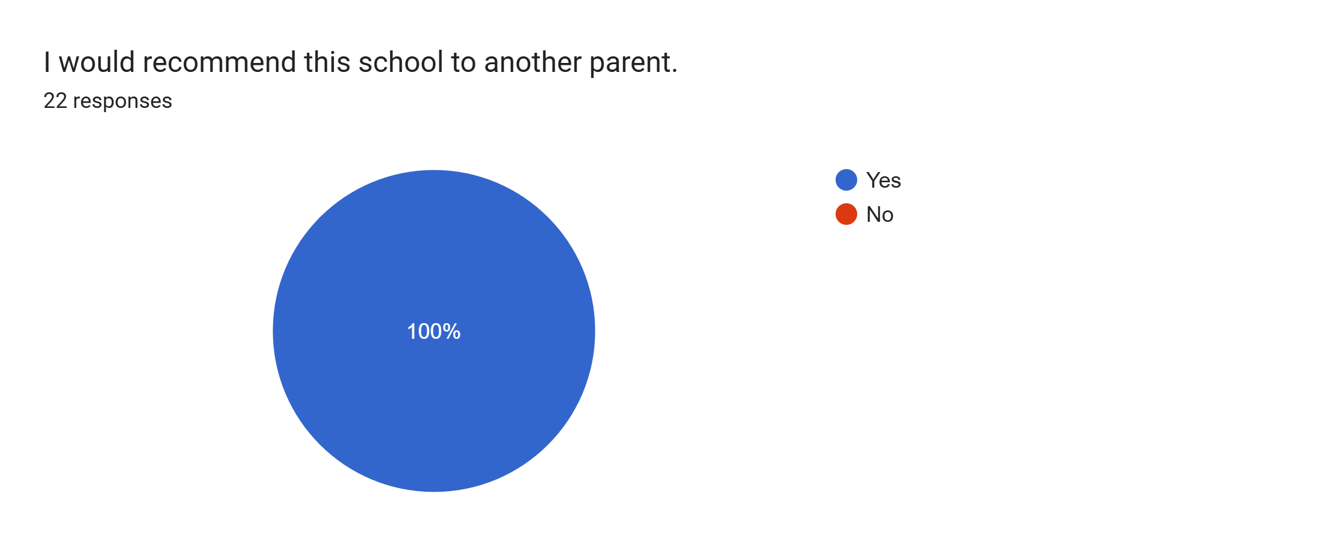
What other comments would you like to make to staff:
- Amazing.
- Great staff well ran school.
- Brilliant parents evening and useful information shared. Thank you.
- Thank you all.
- Great.
- Lovely teachers.
- Lovely and friendly.
- Thank you to you all for everything you do.
- Keep it up.
- Great to hear how my child’s progressing.
- Perfect.
- Brilliant school.
- Thank you for all your help my child’s is so happy.
- Great send staff.
- Thank you for supporting Jaxon in school.
- Excellent support and teaching provided to Alexis, she’s been much happier since starting Roby Park.
- Thank you for all your efforts.
- Ruby is very happy and progressing in school.

