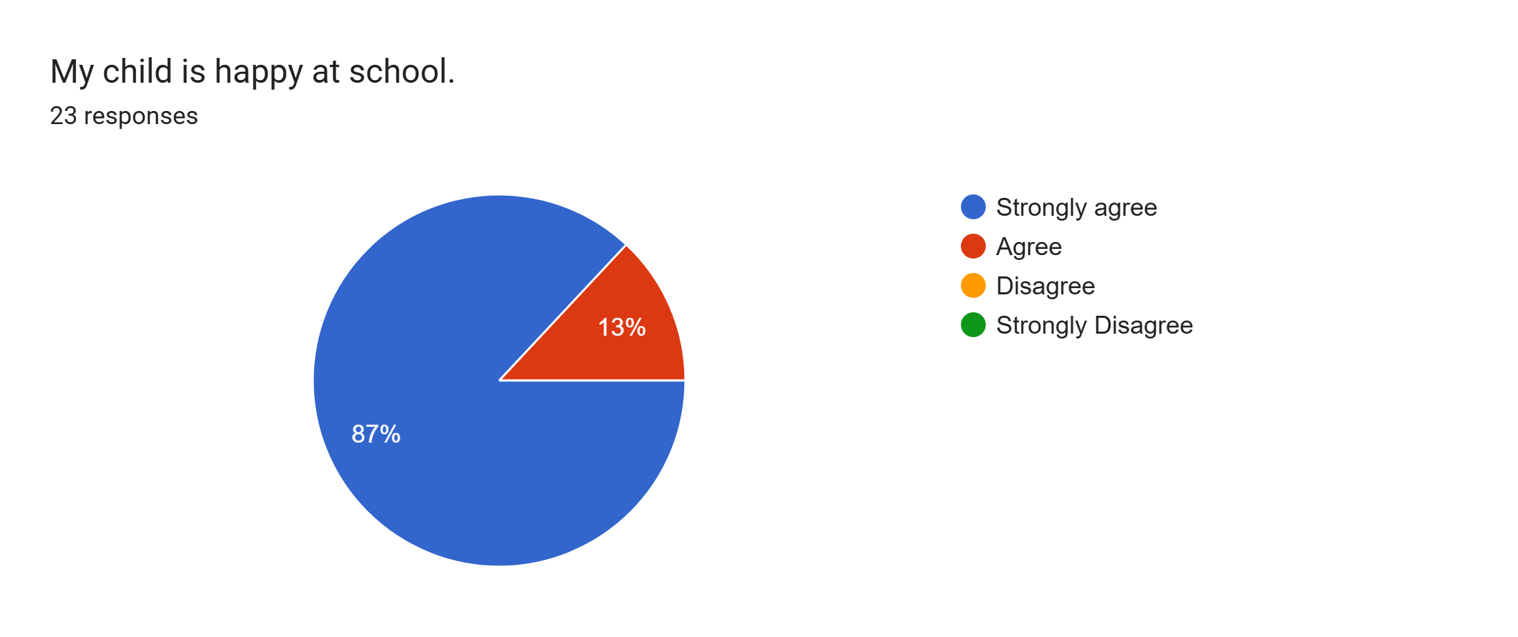
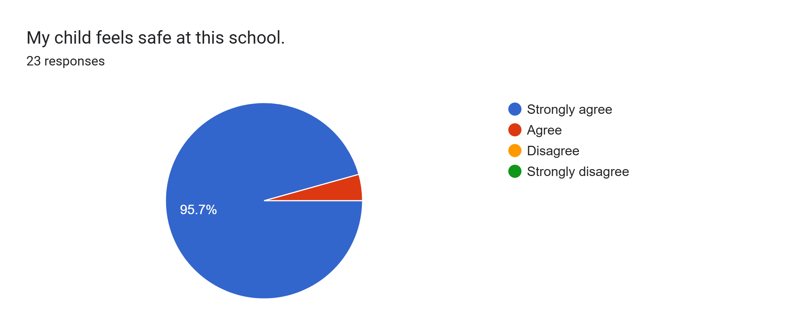
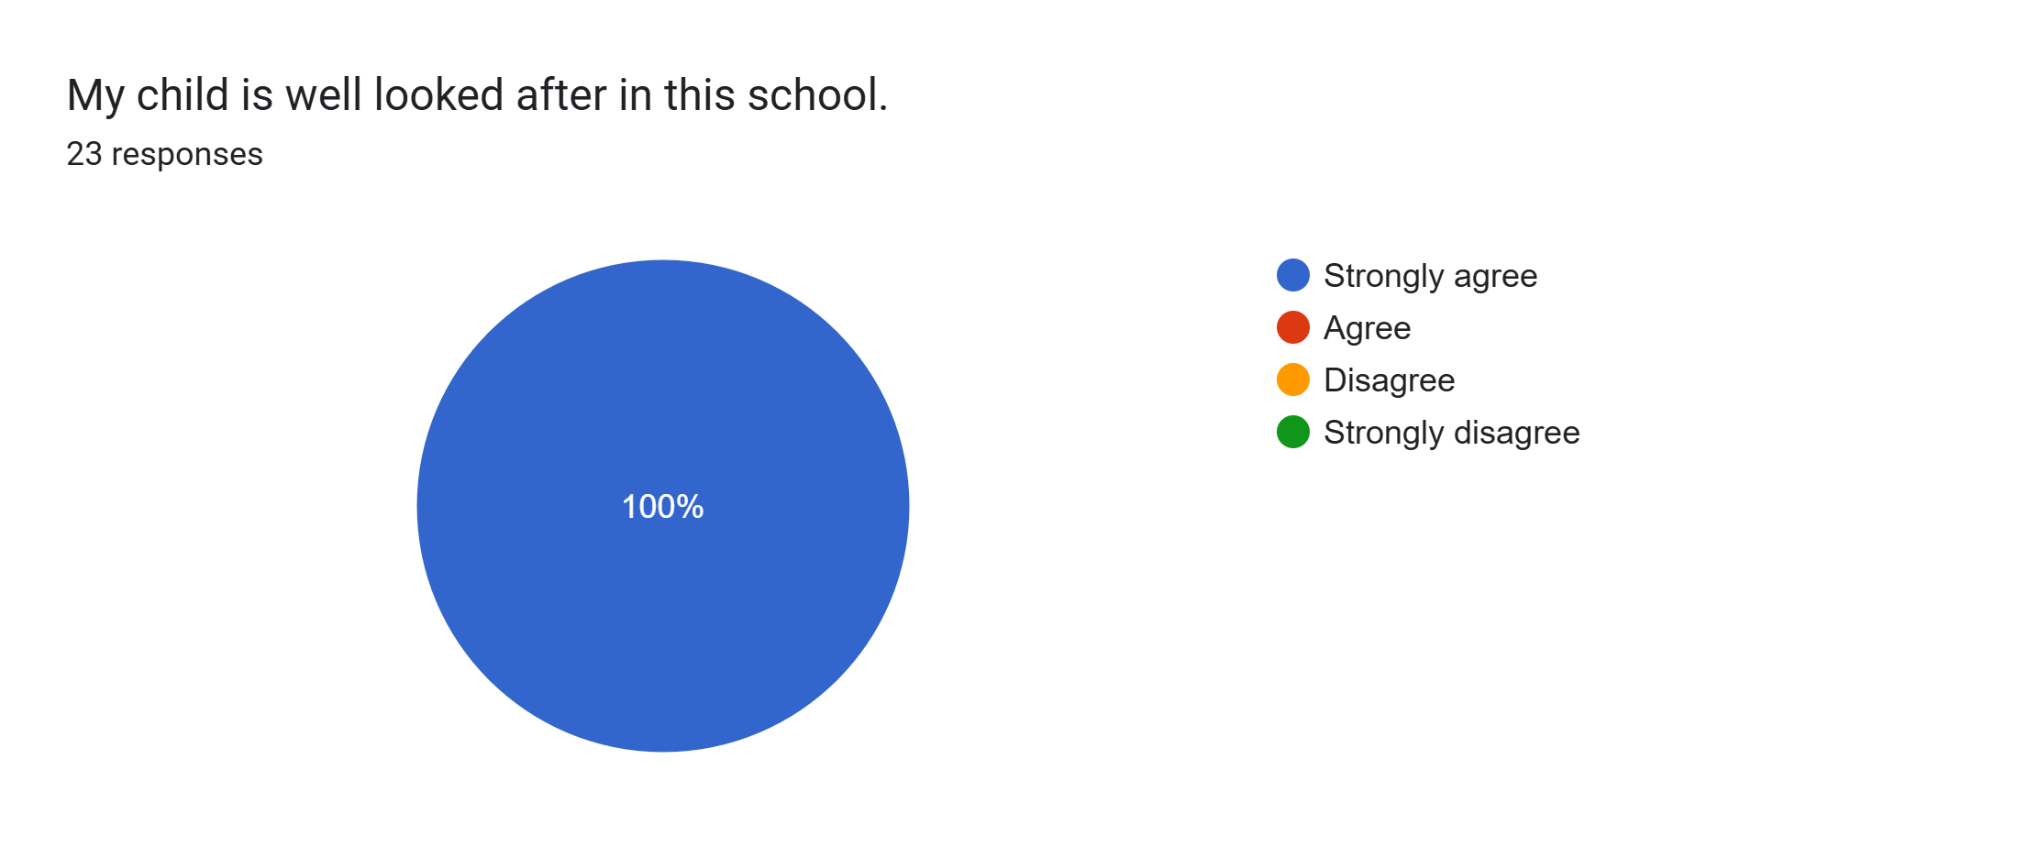
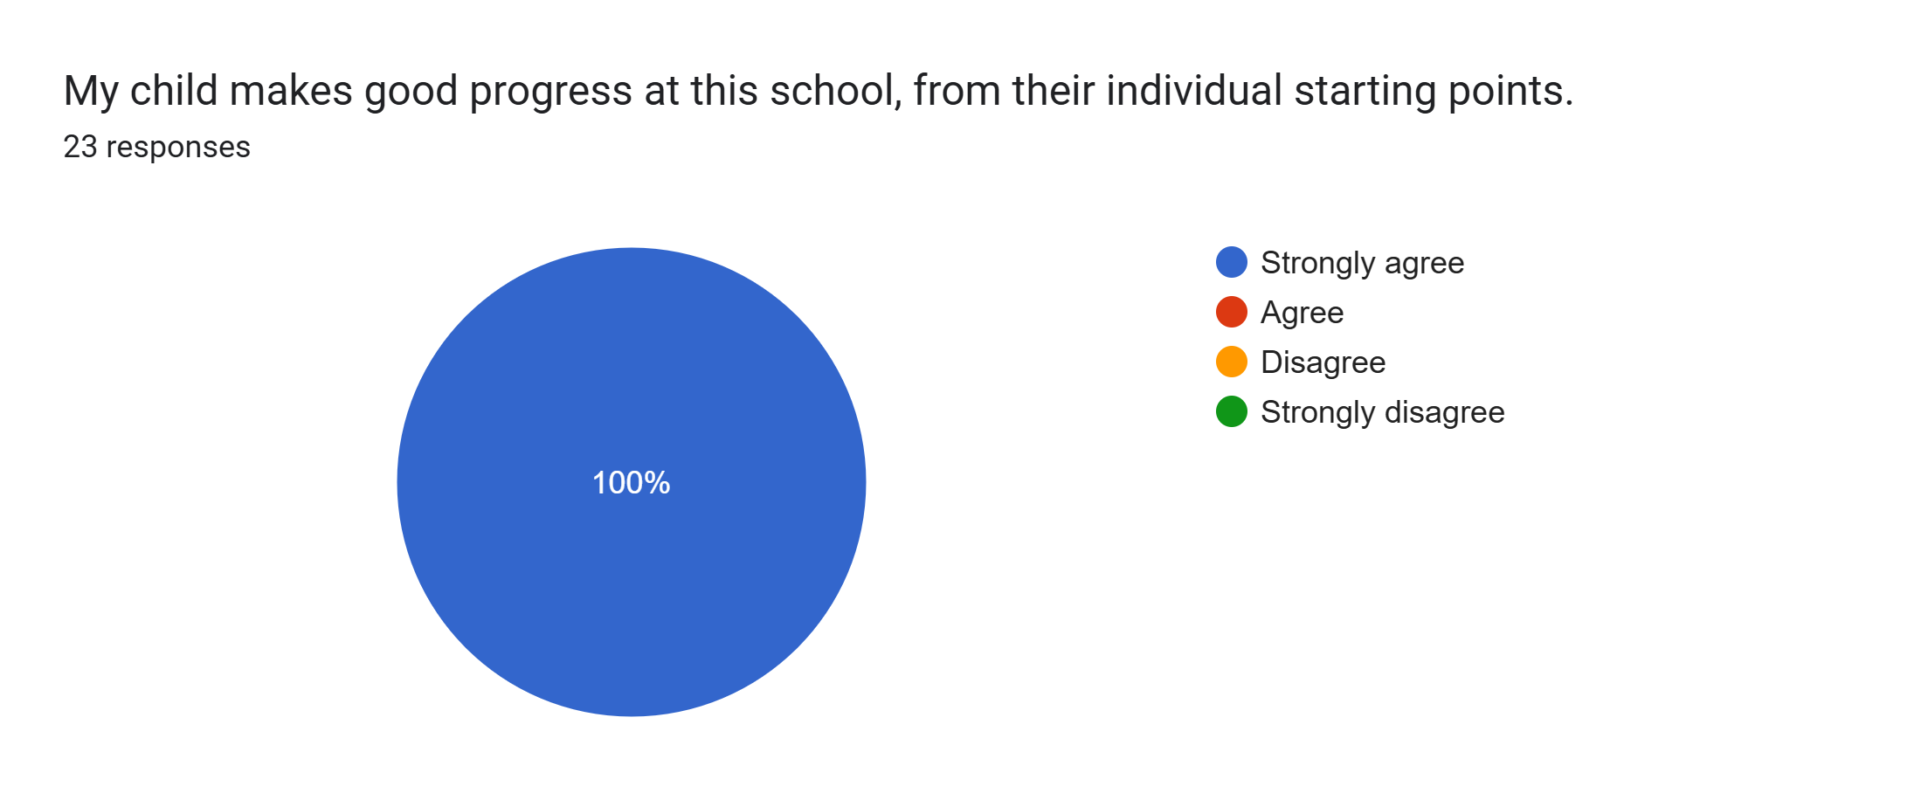
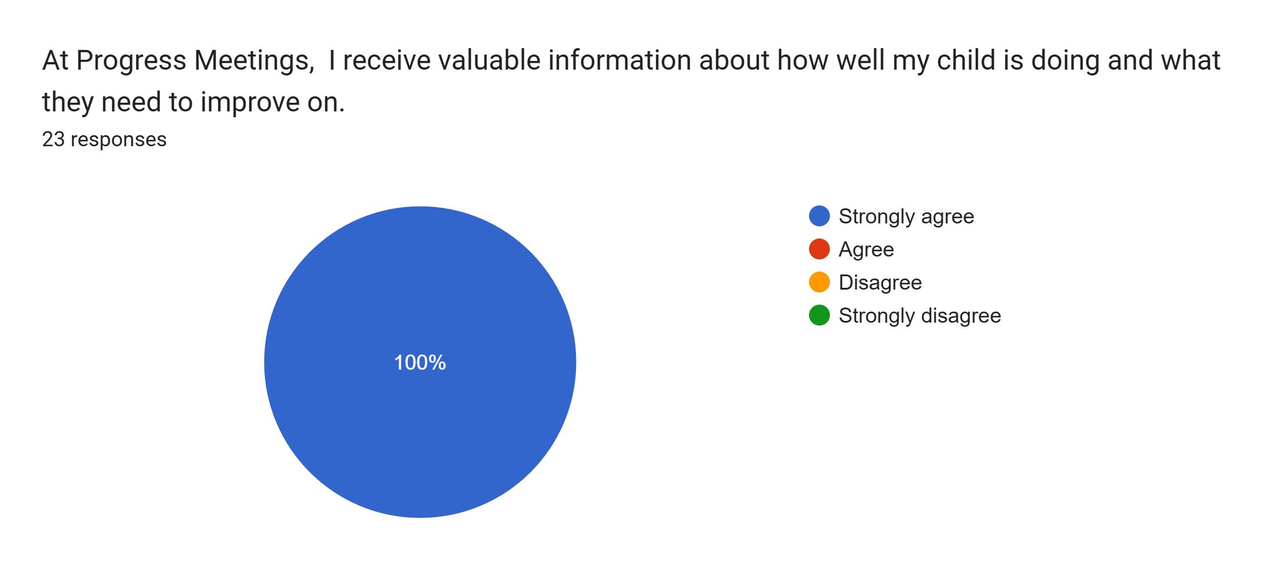
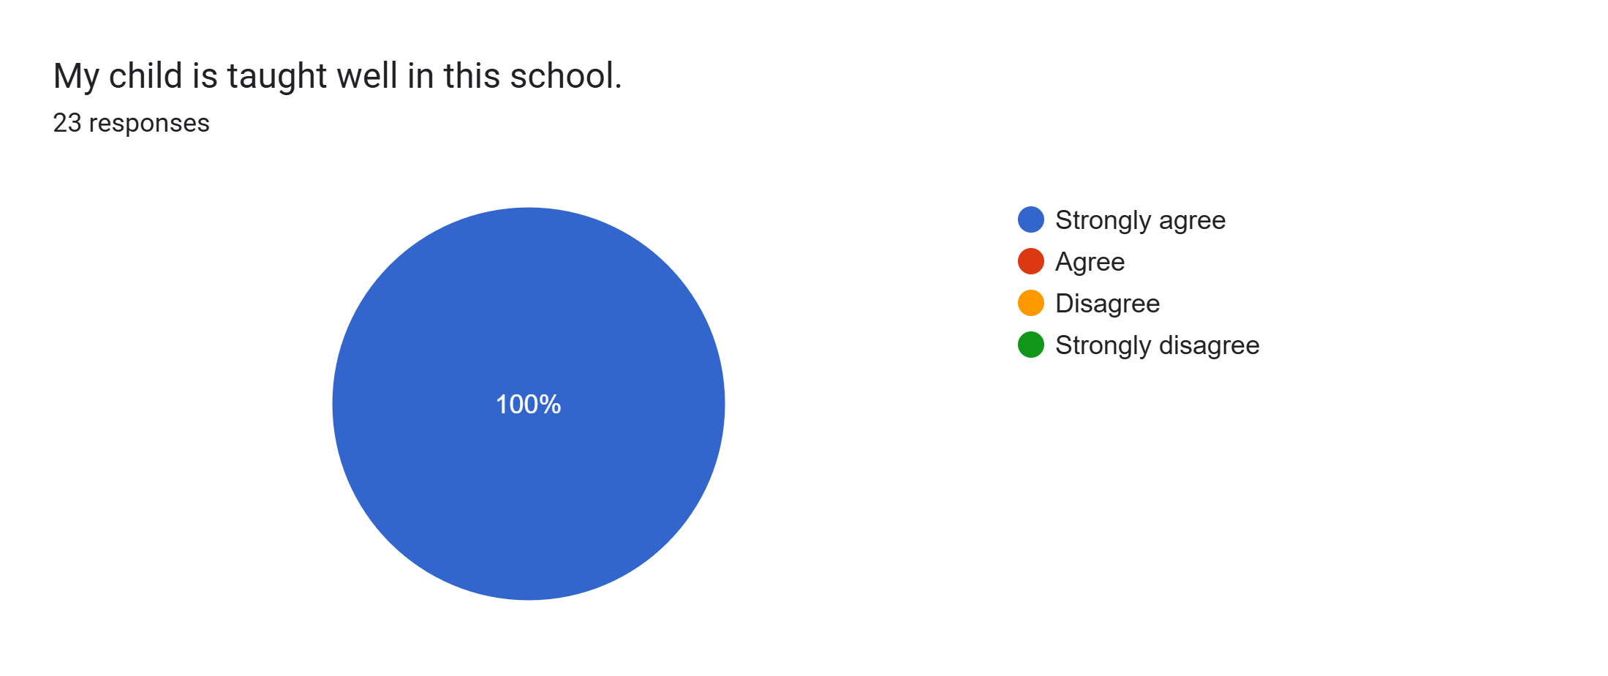
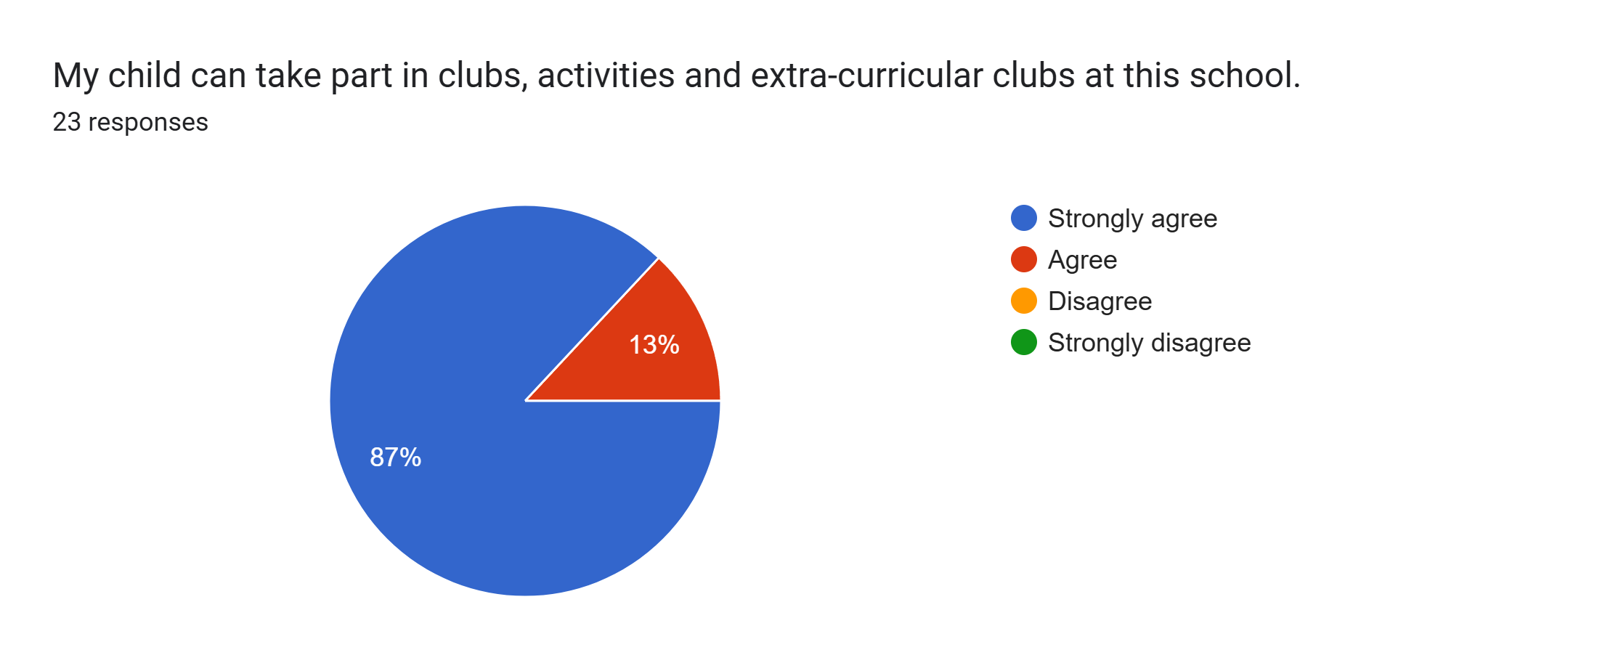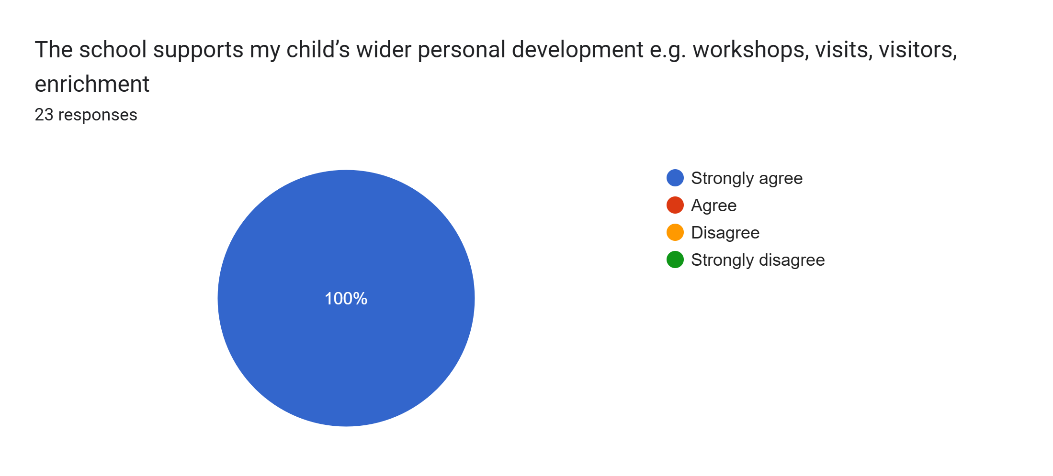
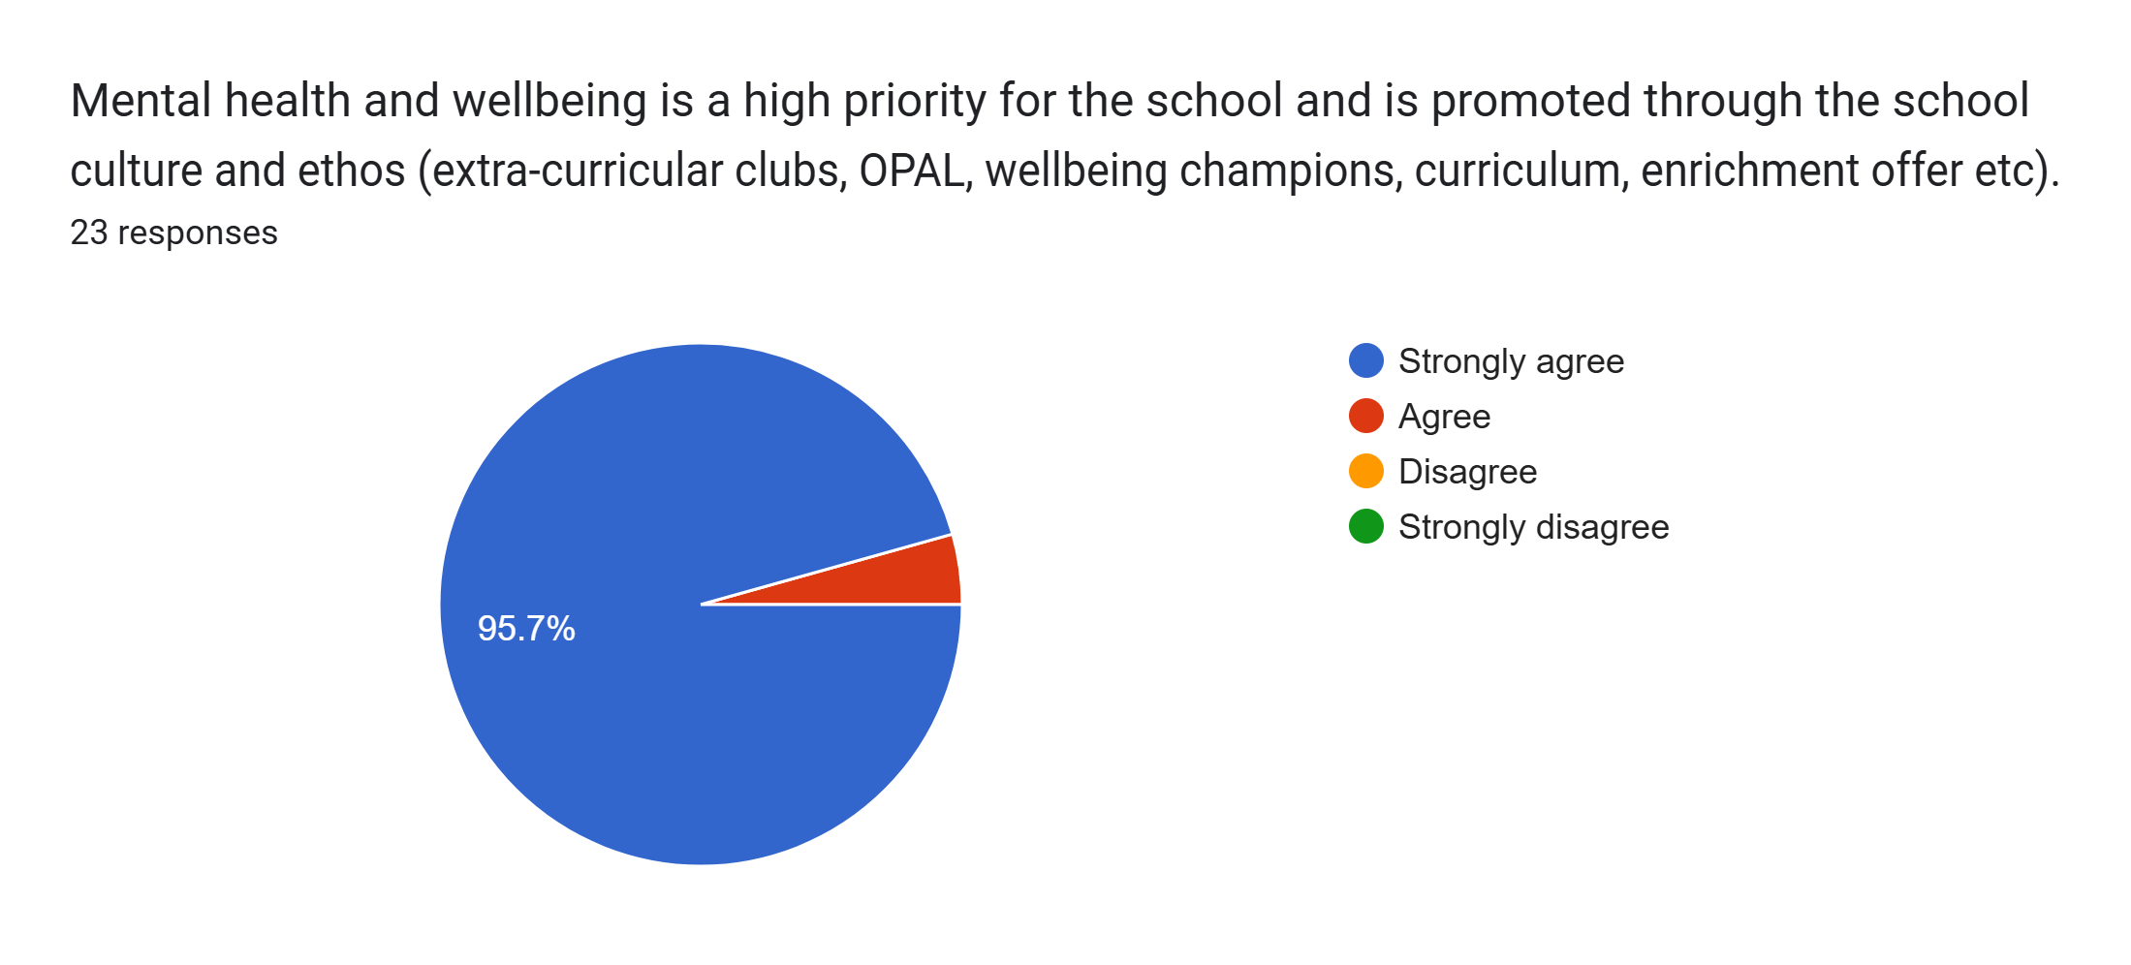
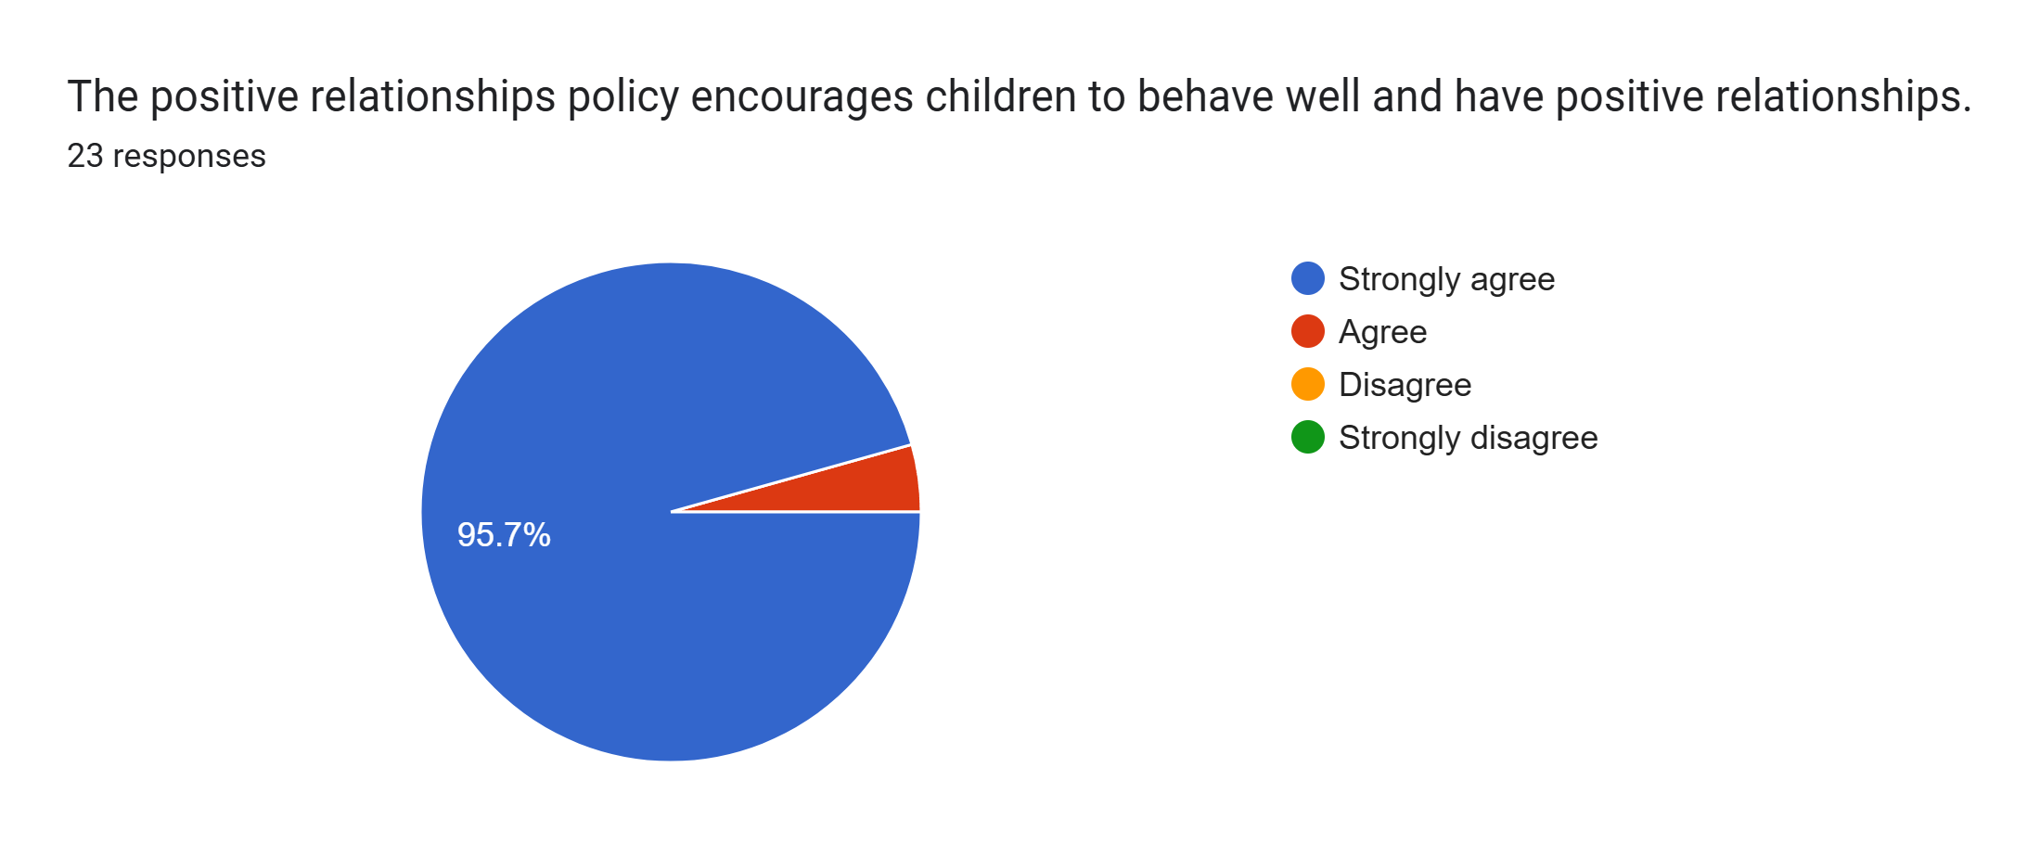
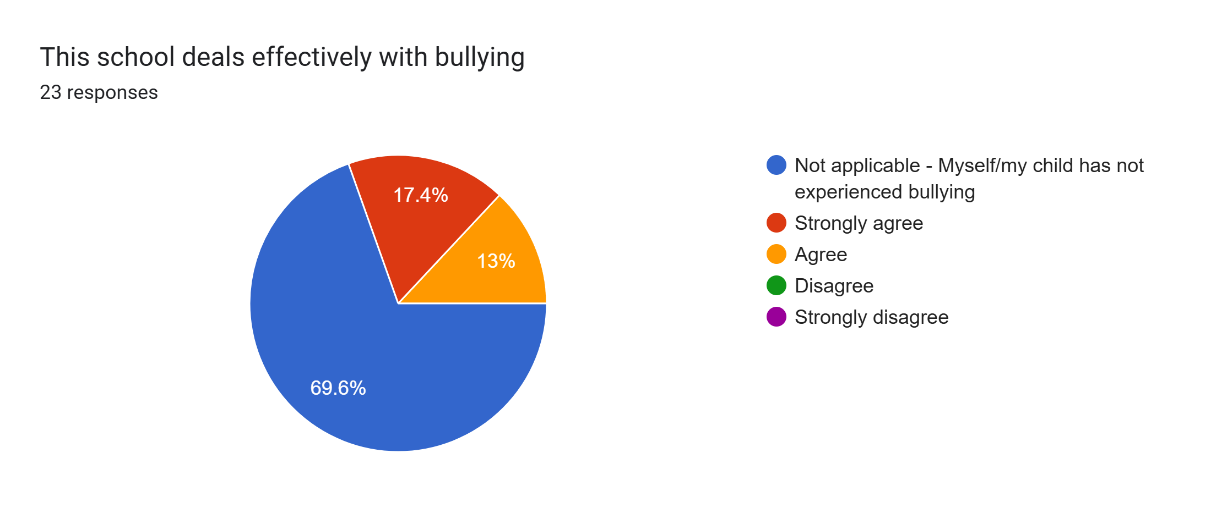
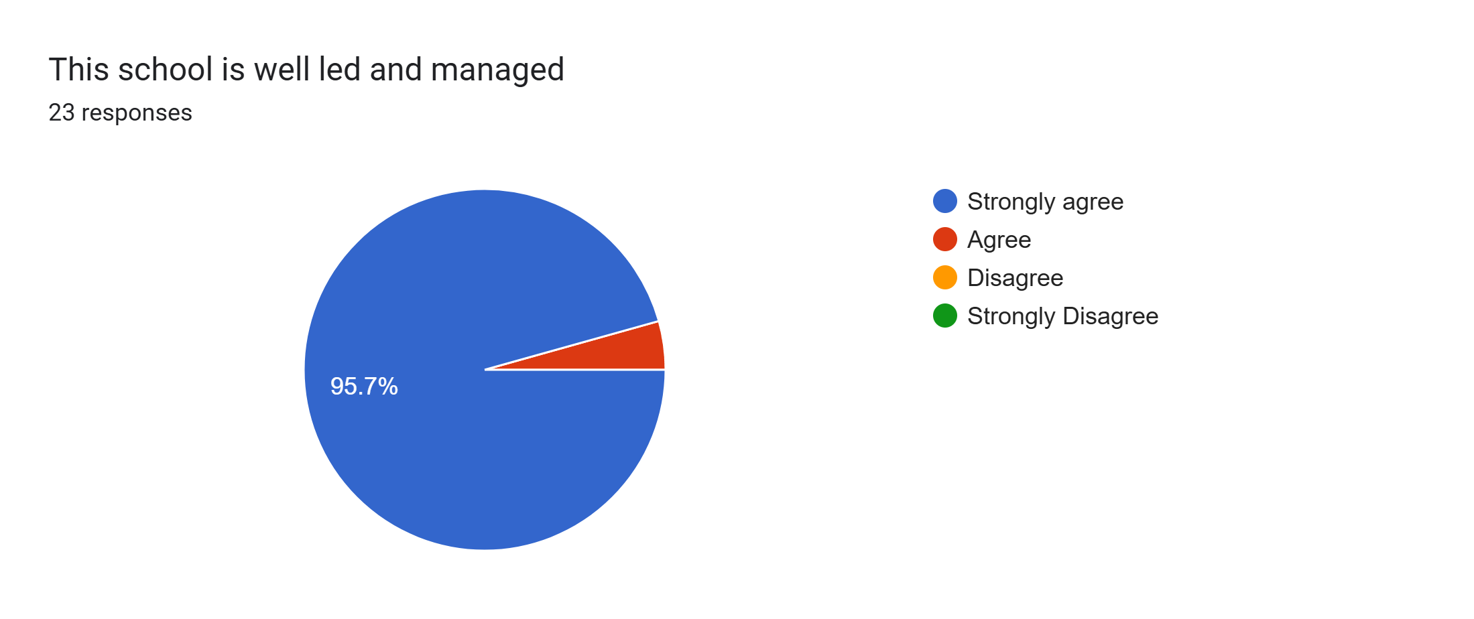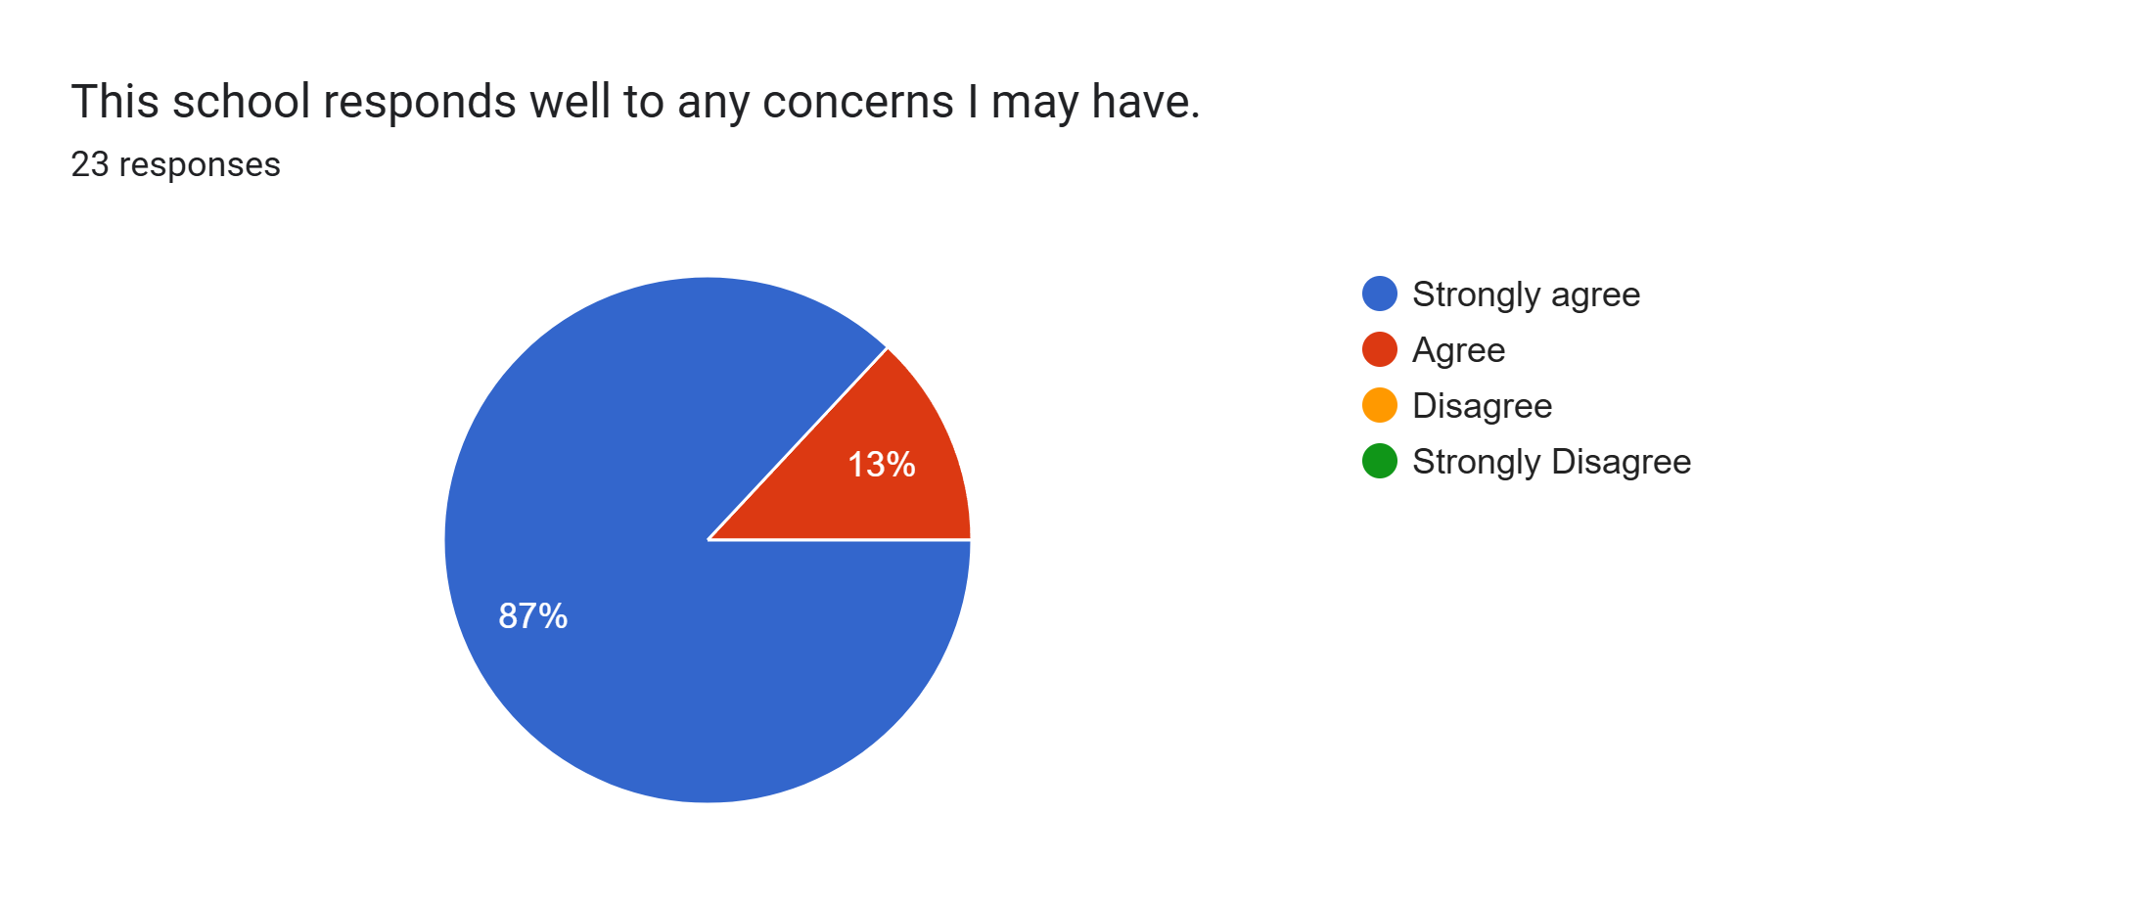
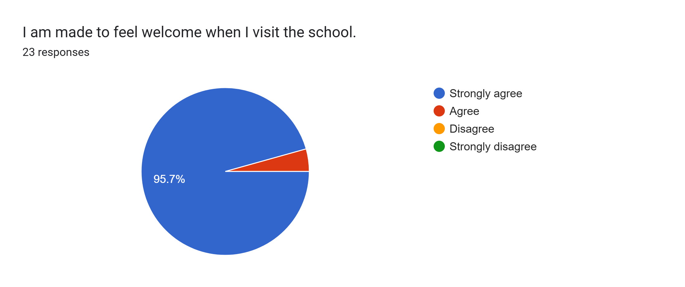
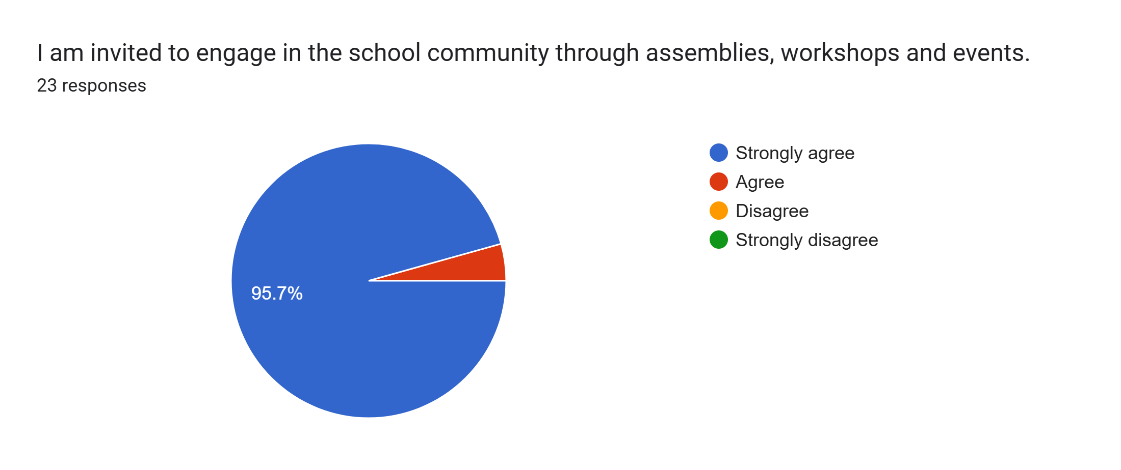
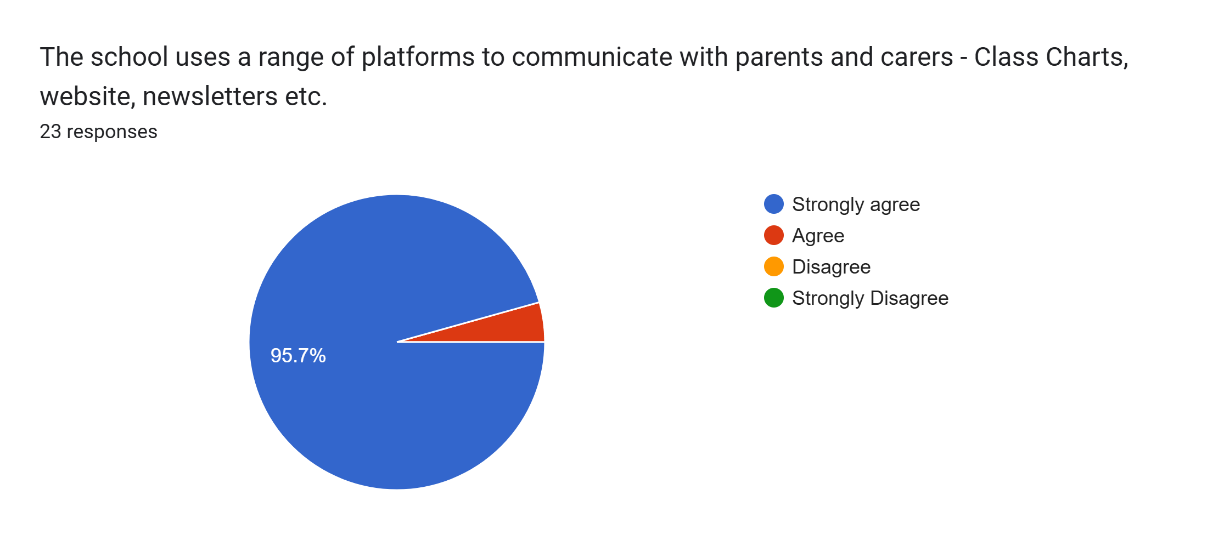
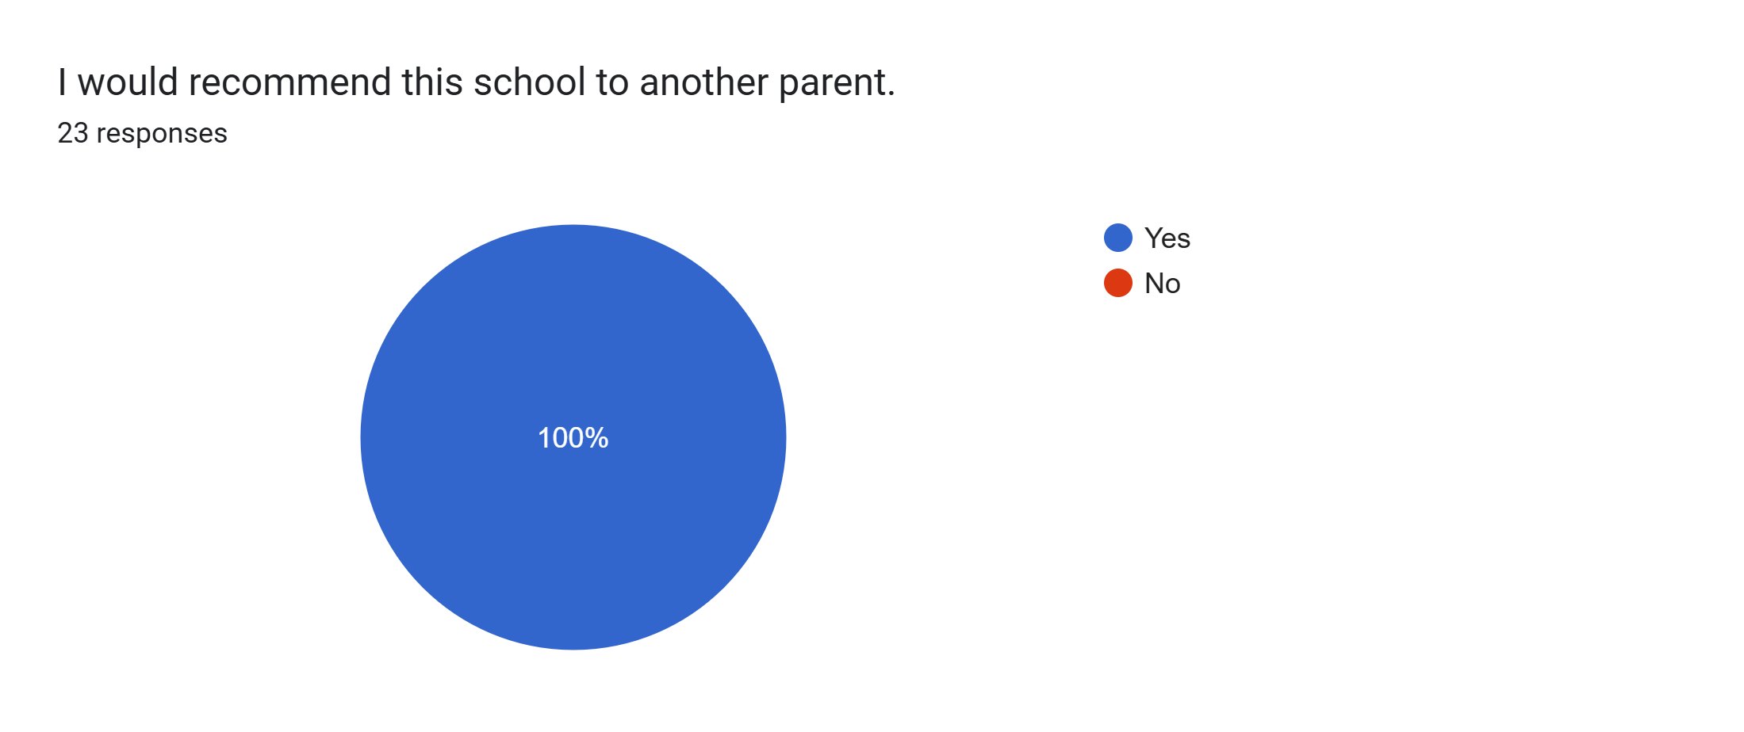

What other comments would you like to make to staff:
- The staff and teachers are amazing.
- Great teaching.
- Really happy with the school.
- Thank you for being amazing teachers.
- Nothing - I am more than happy.
- Natia has come on so much, thank you.
- The staff and teachers are amazing.
- Amazing staff.
- Really pleased with Christopher’s progress.
- We're so happy with Roby Park as Aubrey’s school, we couldn't ask for a more perfect environment for her to learn and develop.Thank you.
- Amazing, couldn't ask for more.
- Thank you Miss Sutton for all your help and support.
- Lewie really enjoys school which is a big thing so if he is happy so am I.
- This is a brilliant school and staff are lovely.
- Matilda is making such good progress at school. I am so proud.
- We love this school and all that you do for our kids.
- All positive.

