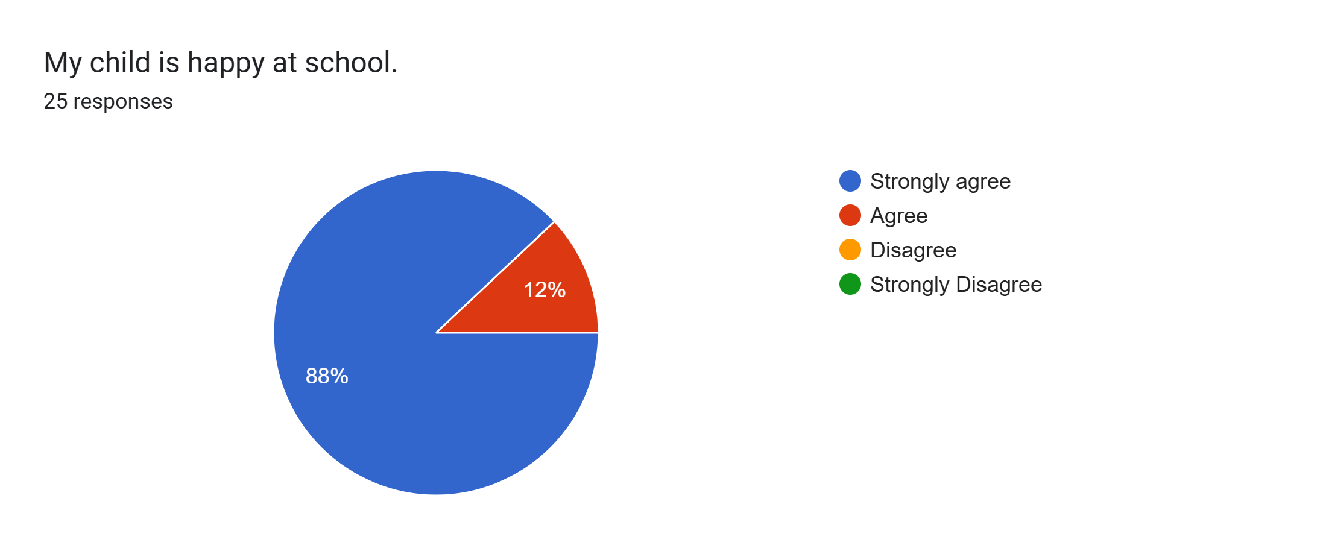
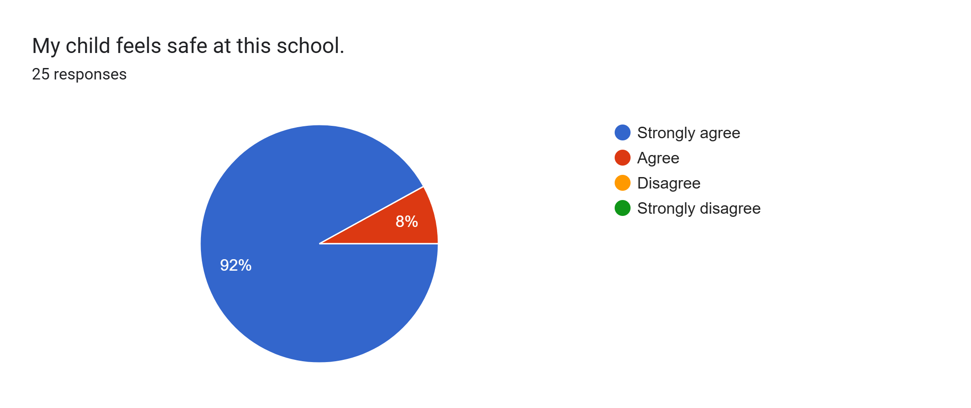
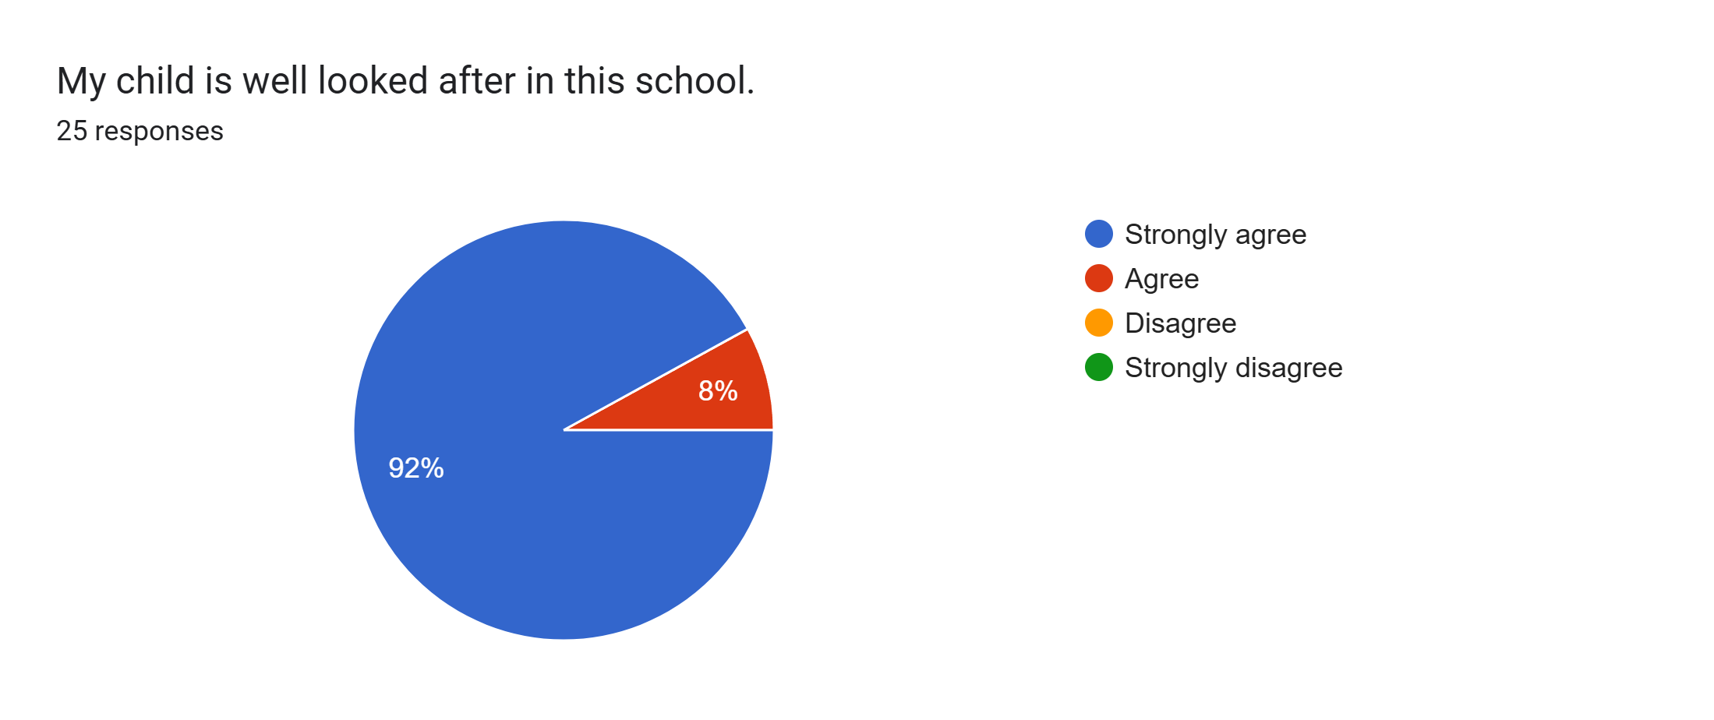
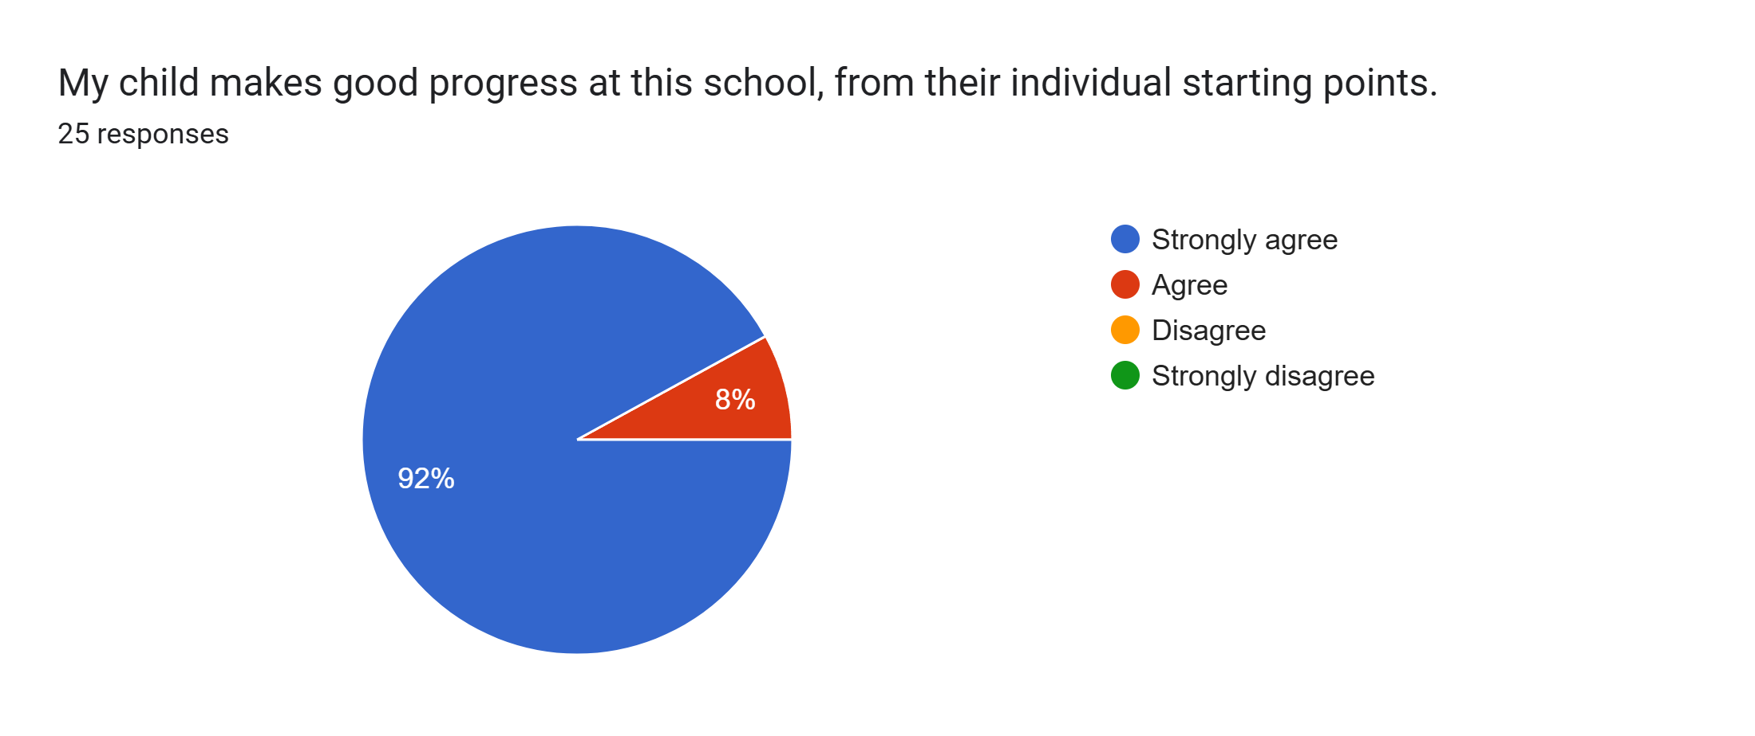
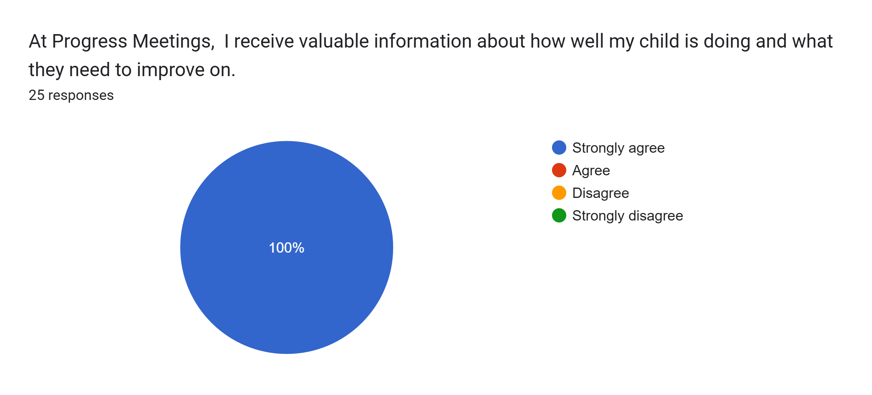
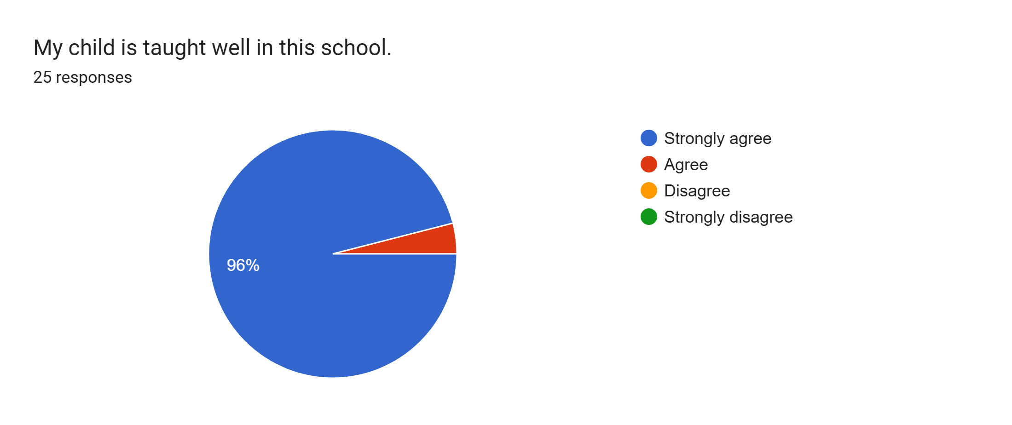
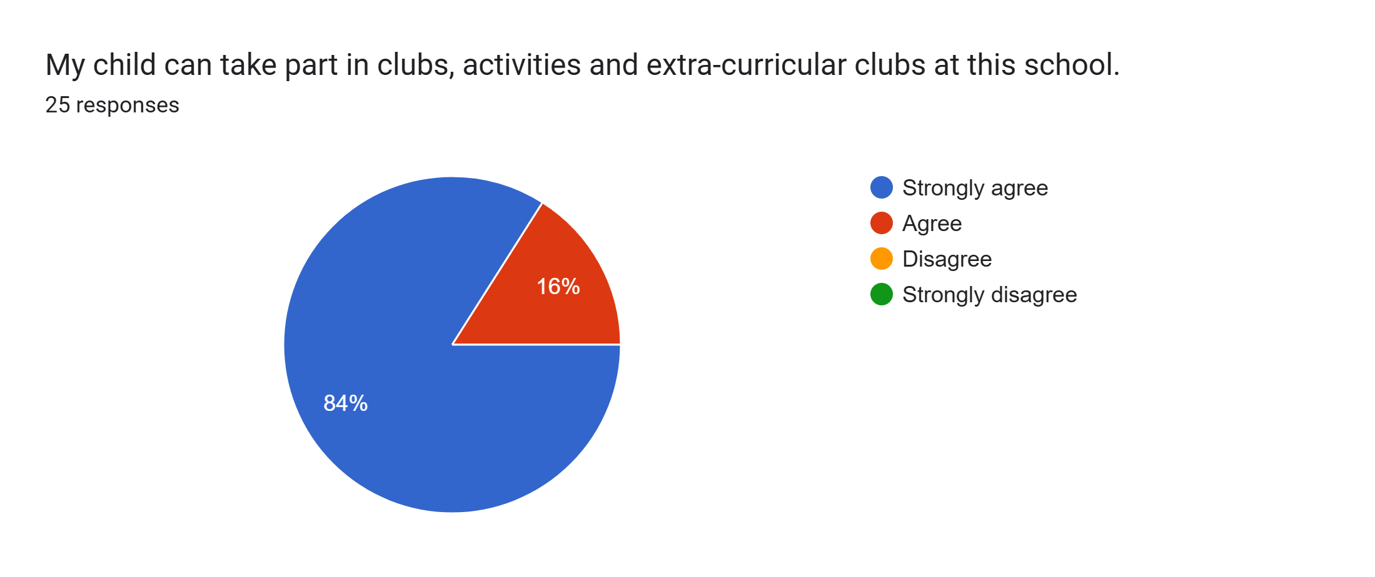
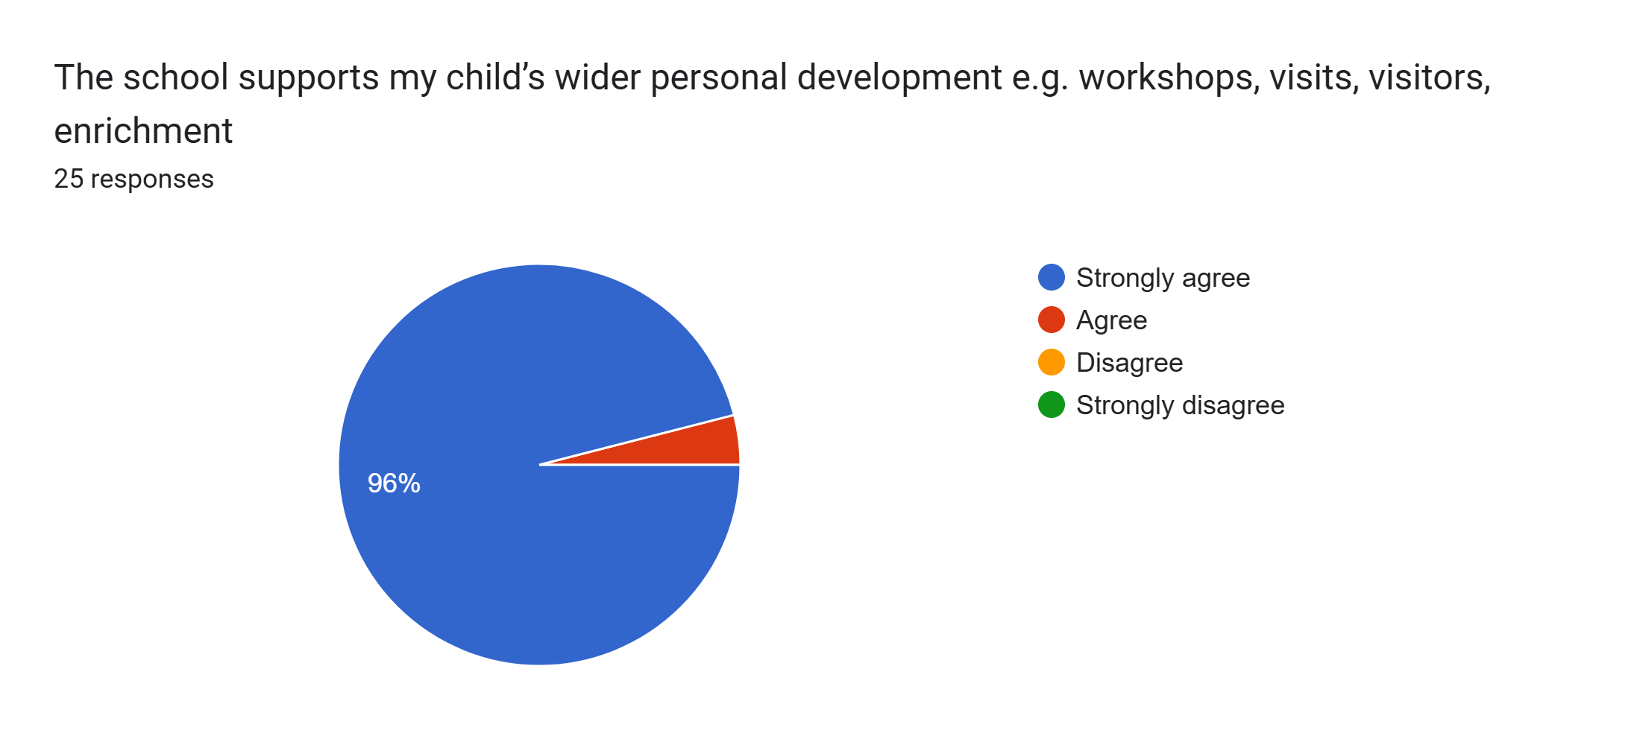
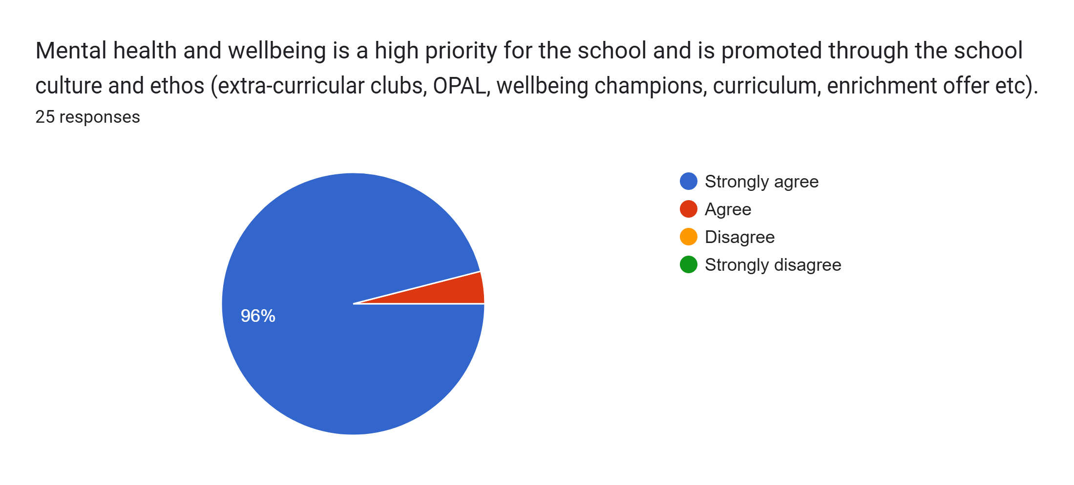
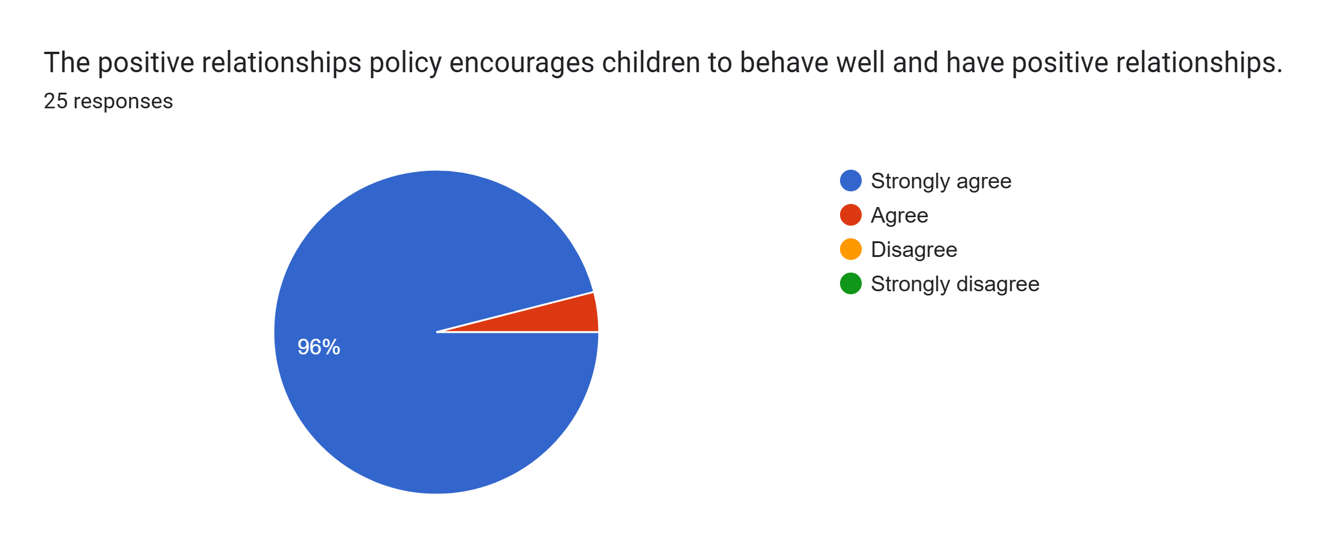
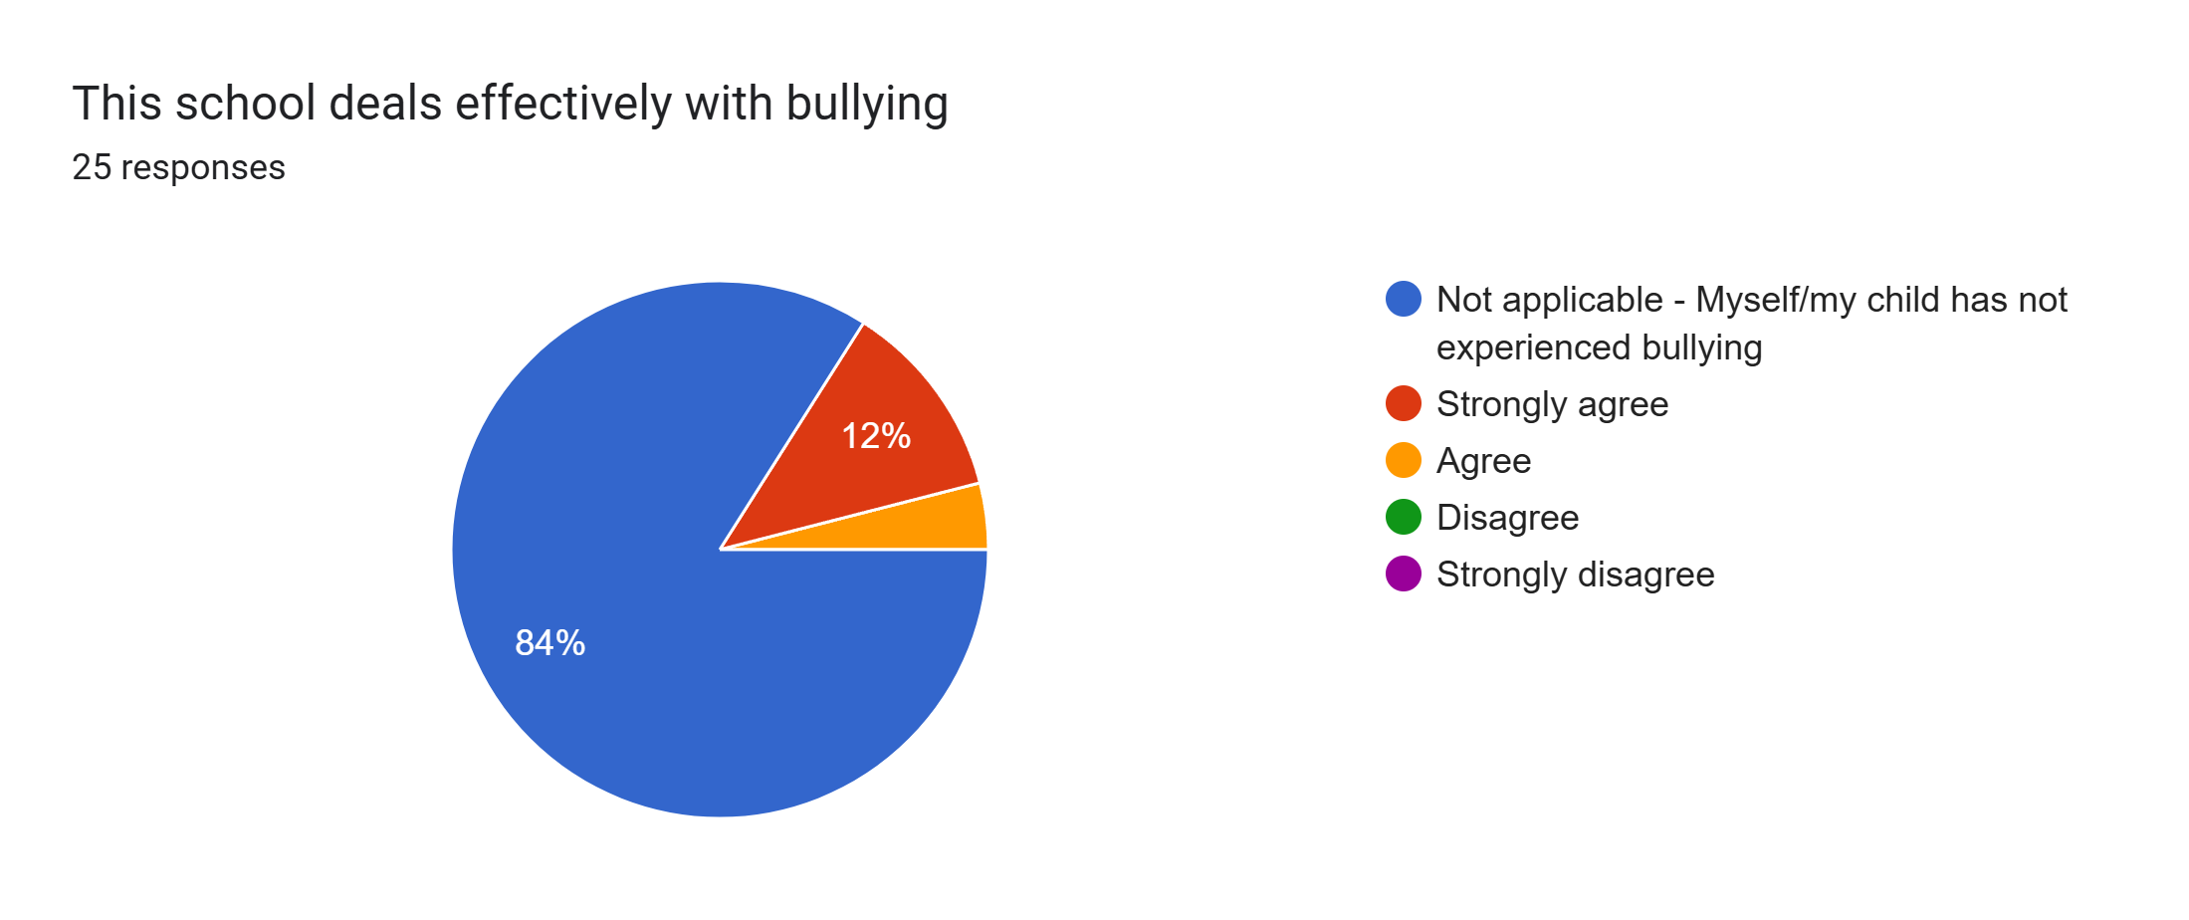
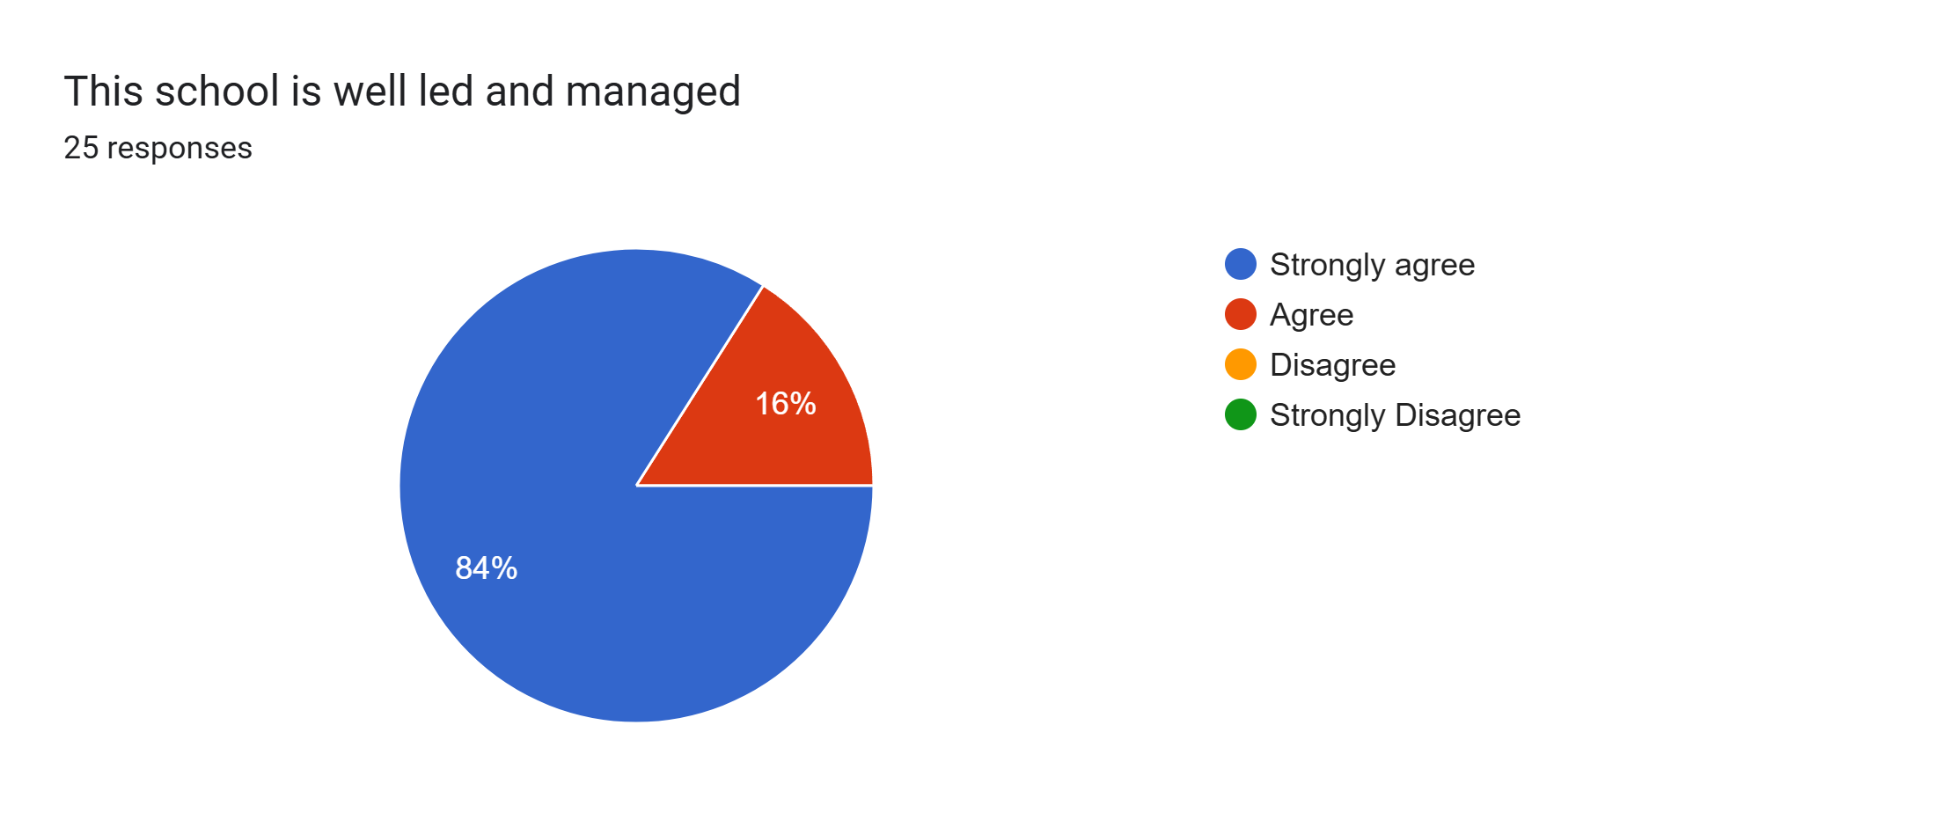
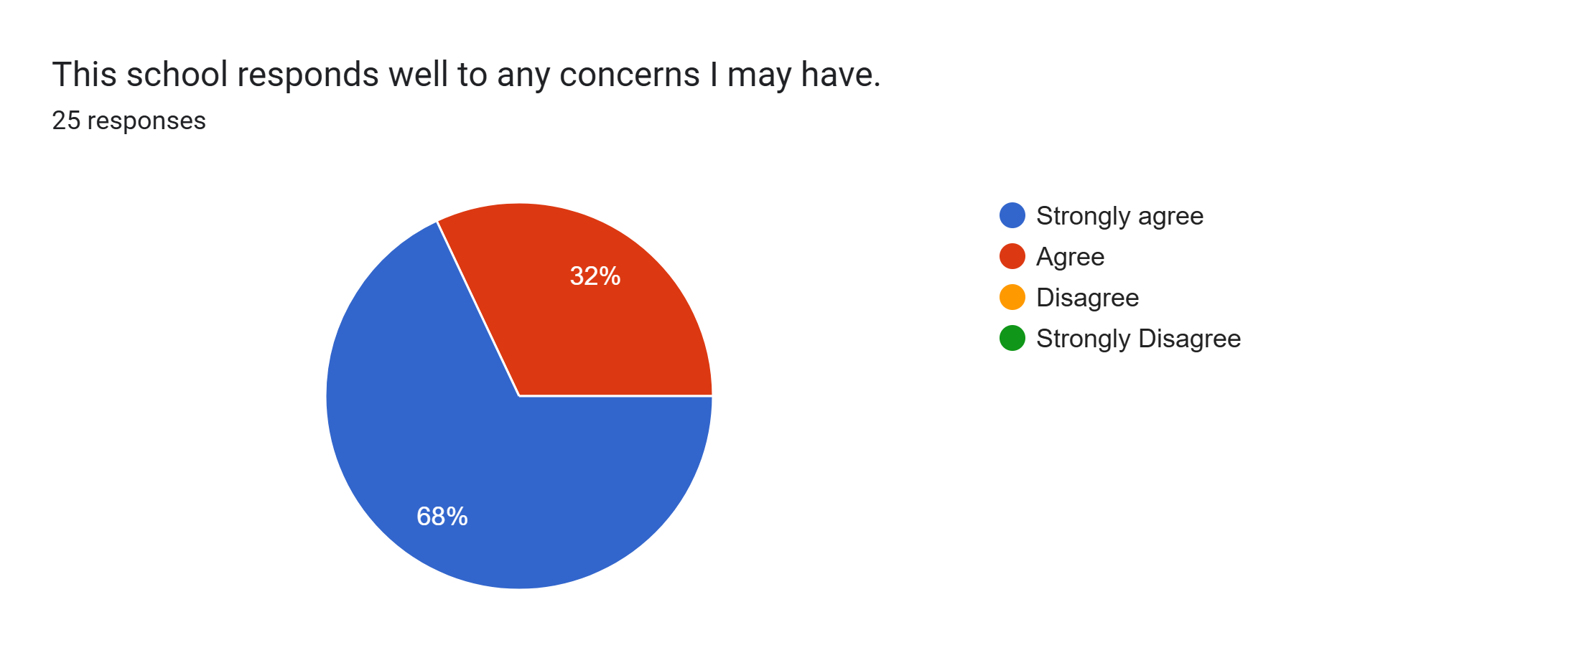
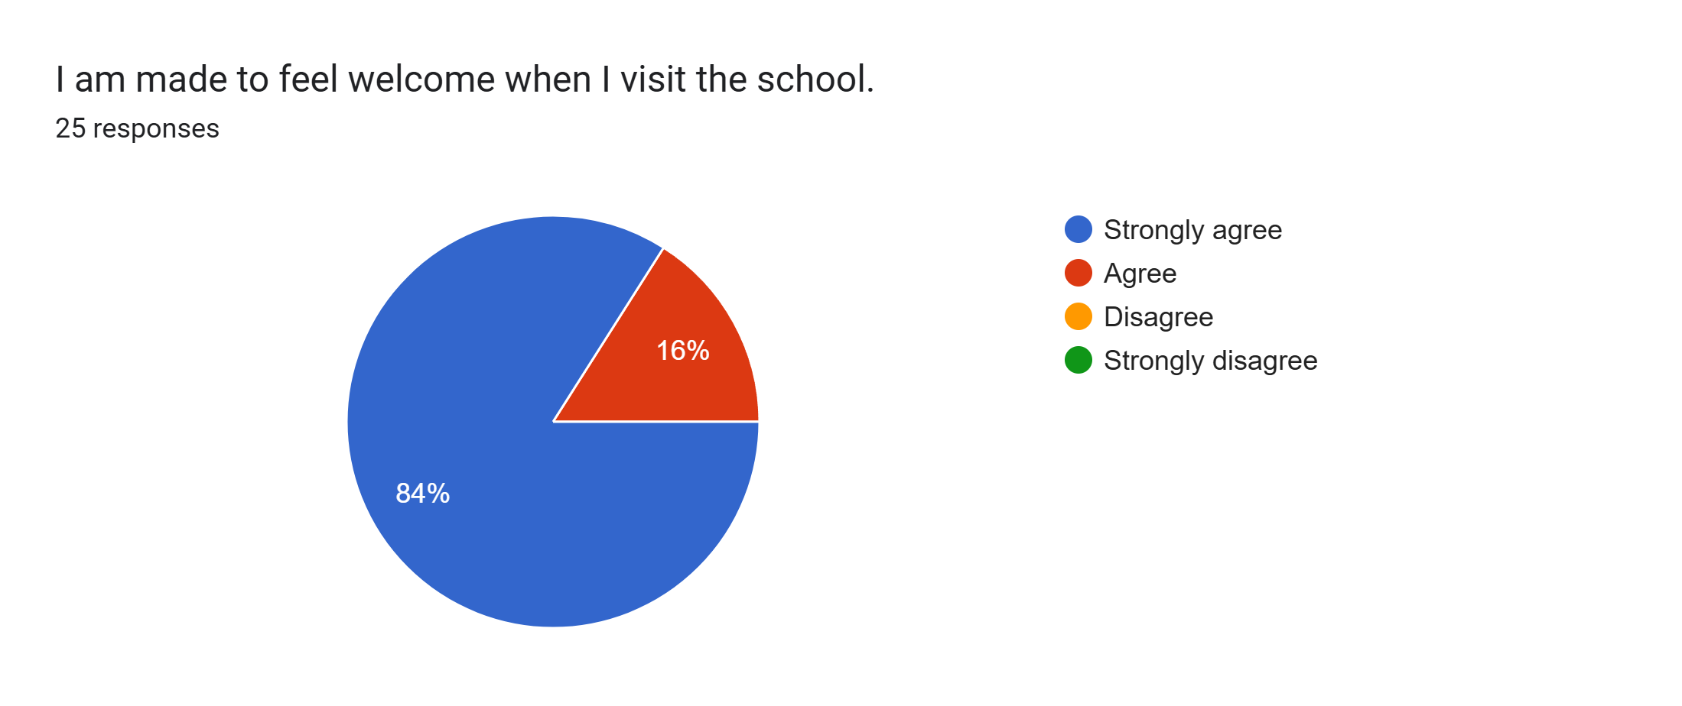
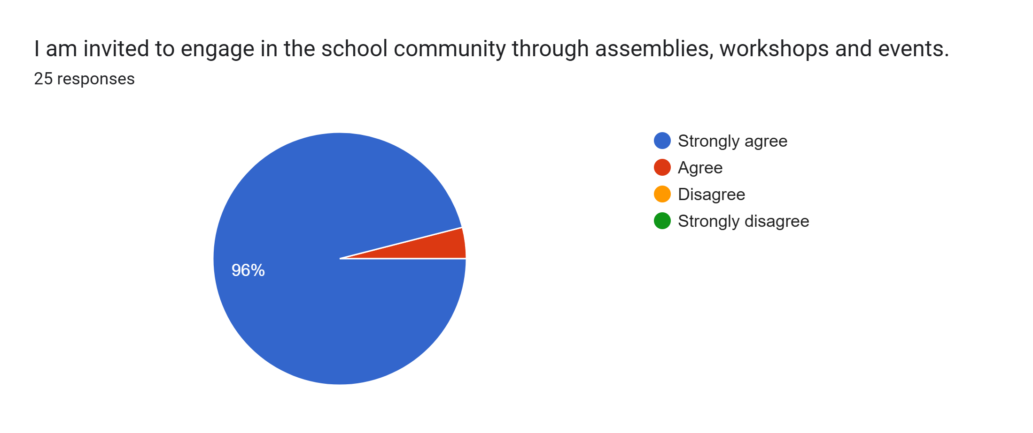
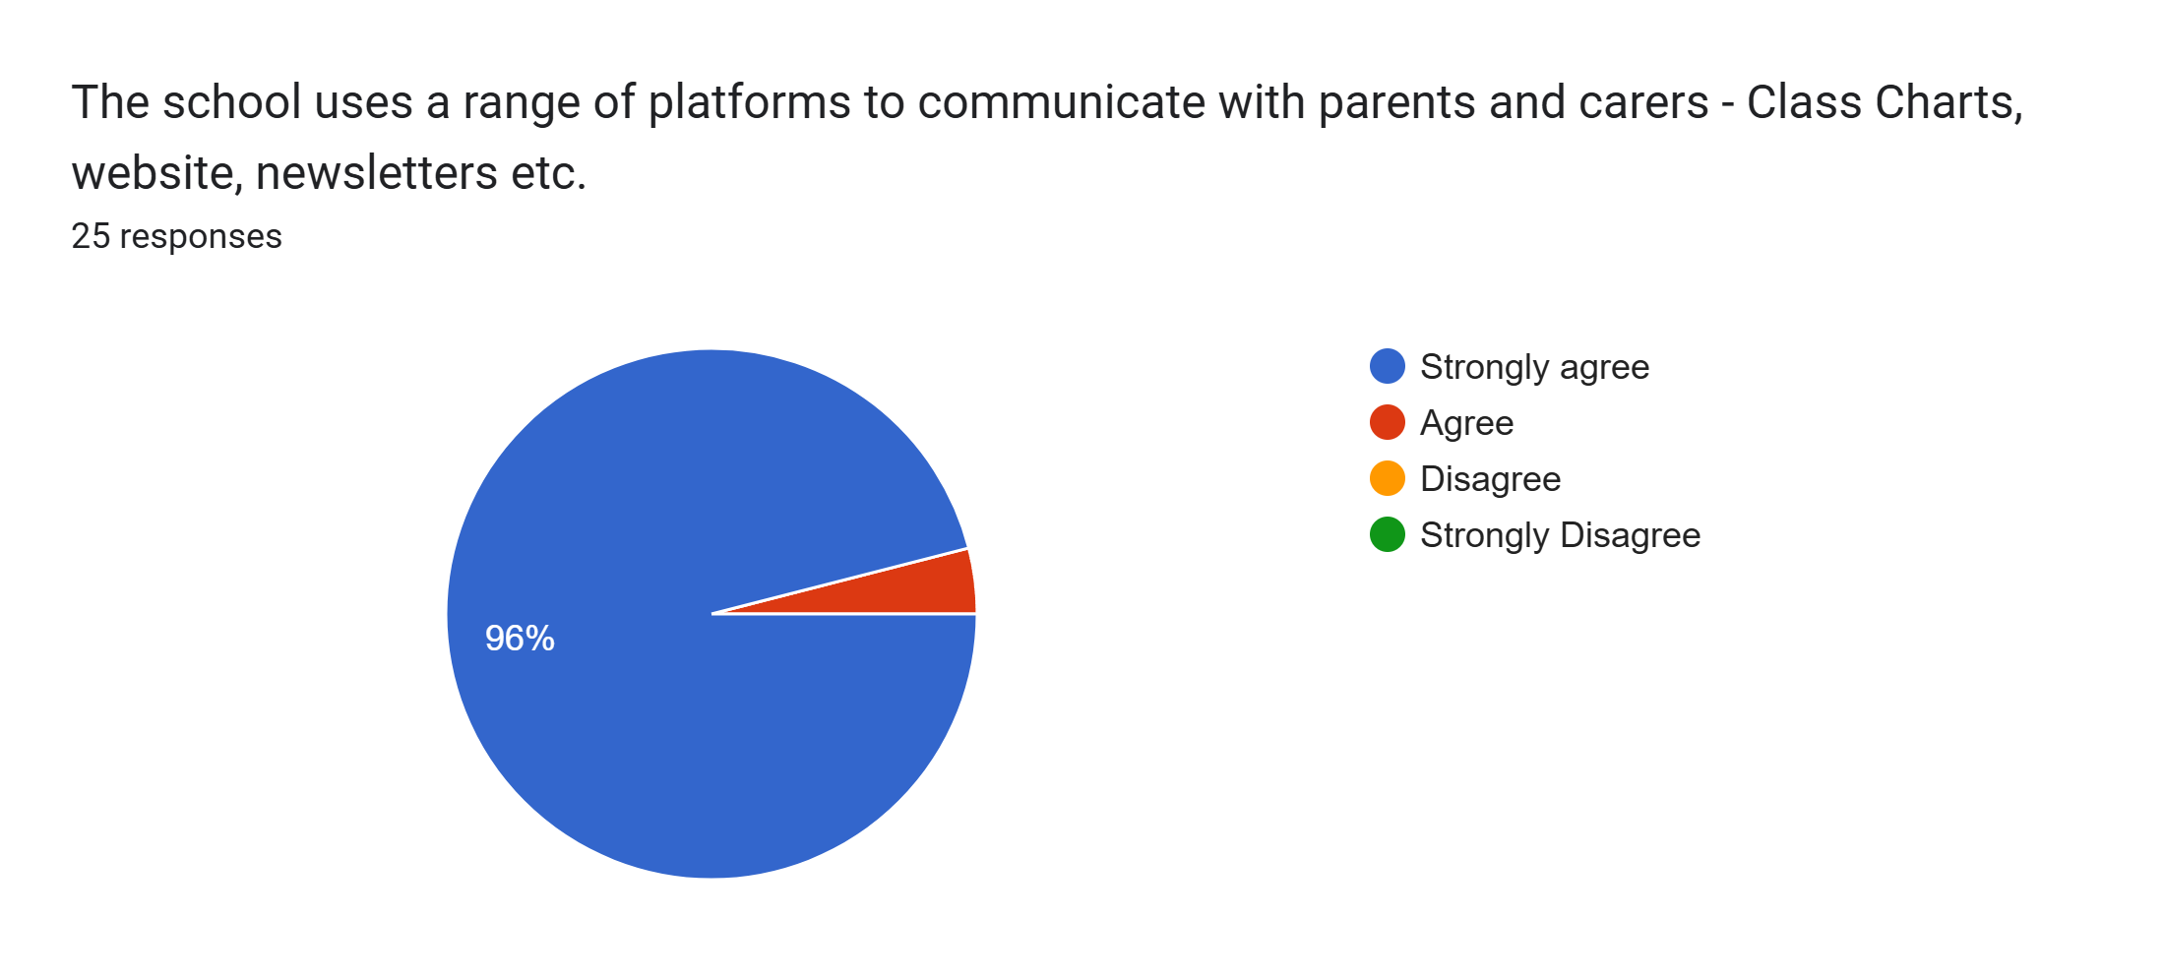
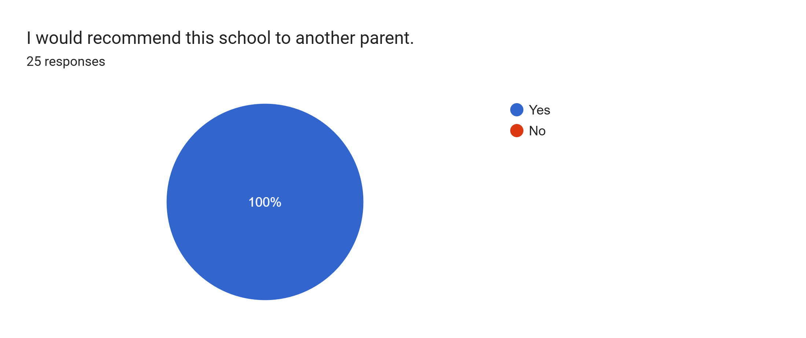
What other comments would you like to make to staff:
- Lovely progress meeting for my son and proud to hear such nice things about him. It’s reassuring to know he is well supported in class and in school, especially with his personal development. Thank you.
- Thank you for being fab and caring so much.
- Well done for continuing to make the school so fantastic for our children. Your hard work is appreciated.
- Mr Swatman is brilliant with kids.
- Thank you very much.
- Lovely school.
- Brilliant. Couldn't support Lara more in her learning as she is coming on loads. Amazing school.
- Thank you for supporting Nathan in his learning.
- My child is so happy at this school.
- Mr Swatman is a fantastic teacher.
- My son has found learning easier being accommodated for his needs.
- Great progress meeting as always. It was lovely to hear how my daughter’s confidence has grown a lot and how settled she is in class now. It is so reassuring knowing school, Mr Swatman and Mrs Woolley understand and support her needs, allowing her to shine. Thank you.
- I think all the staff are brilliant and doing a great job.
- Thank you to Mr Swatman and Mrs Woolley for all of your support and effort with Aubree. Thank you for encouraging her and building her confidence. She loves school and learning and it is because of you and all that you do.
- Thank you listening and supporting our son.
- Very happy with Callum’s learning and overall school experience.
- Thank you to Mr Swatman, Mrs Woolley and Miss Collins for building Elliot's confidence.

