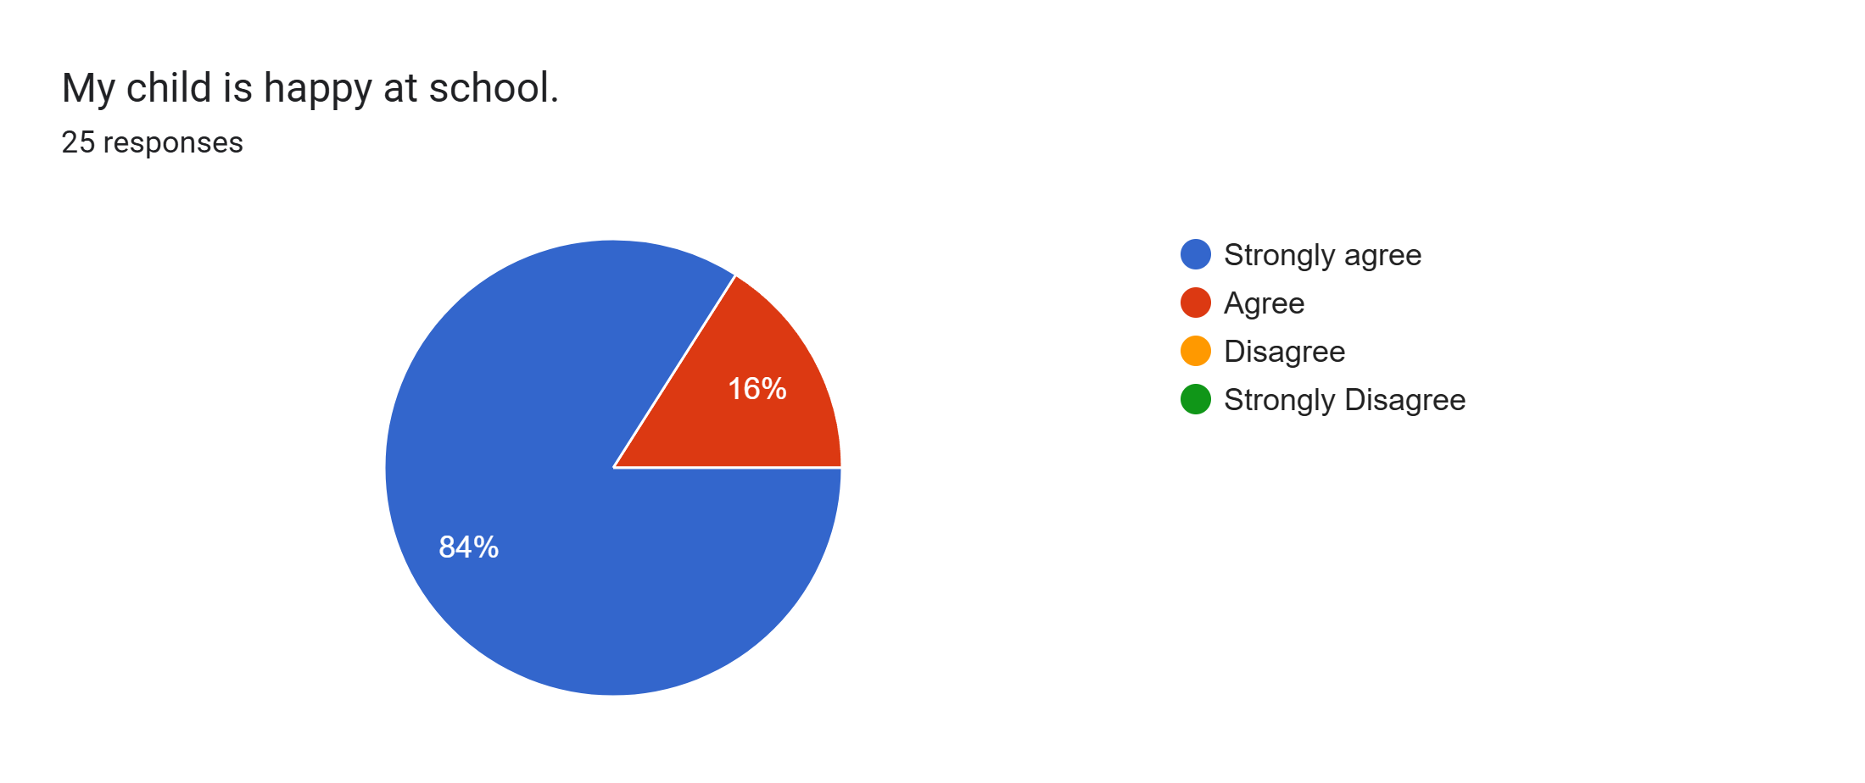
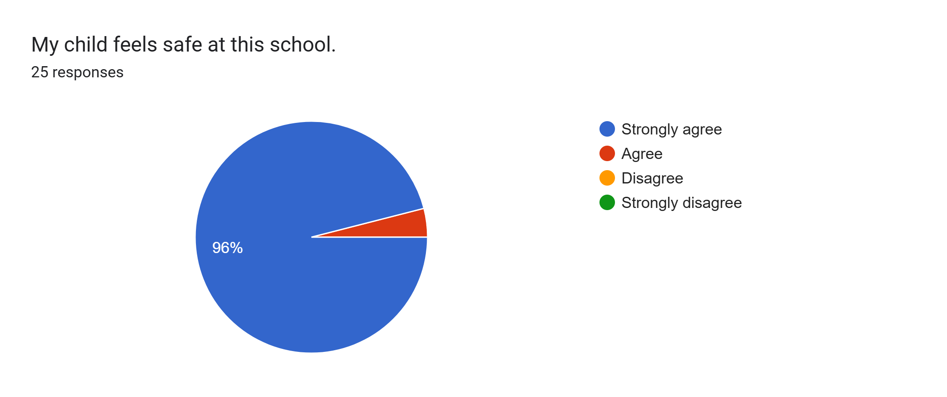
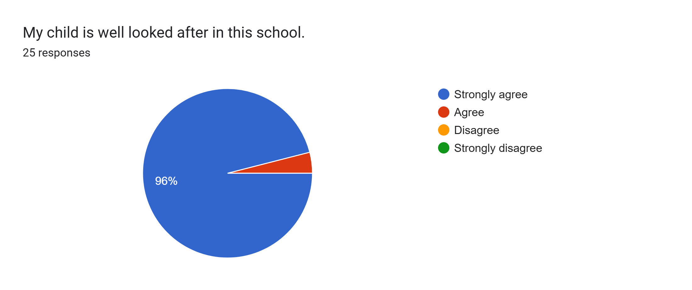
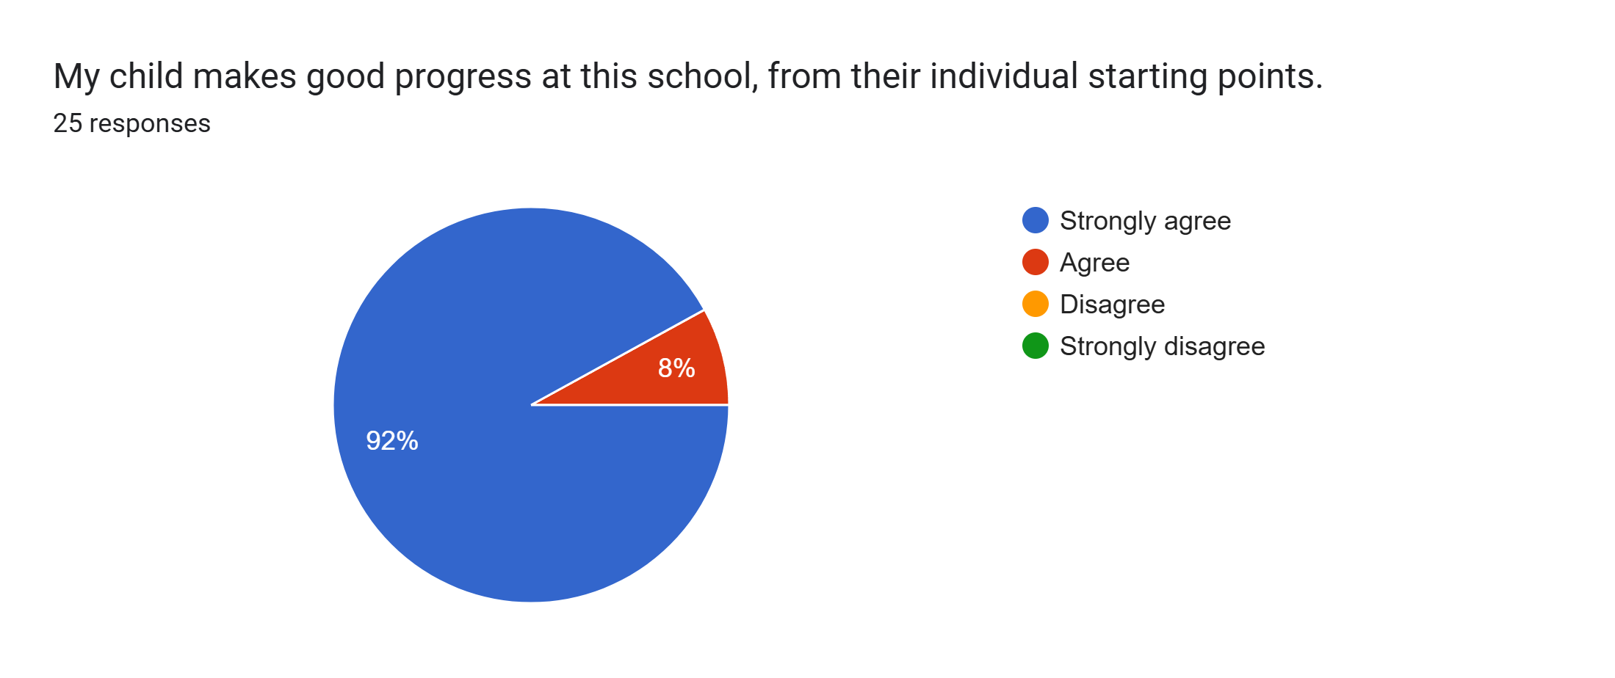
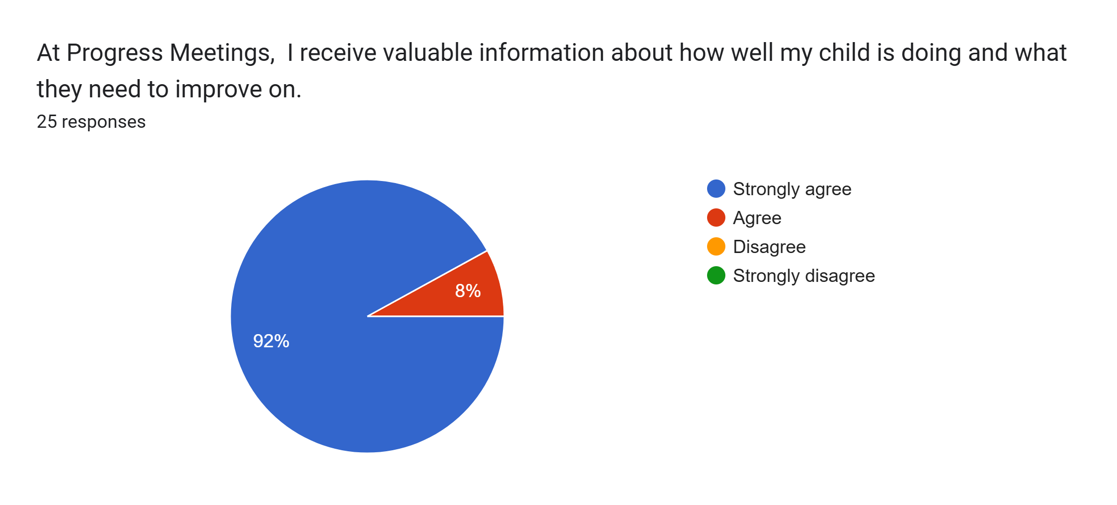
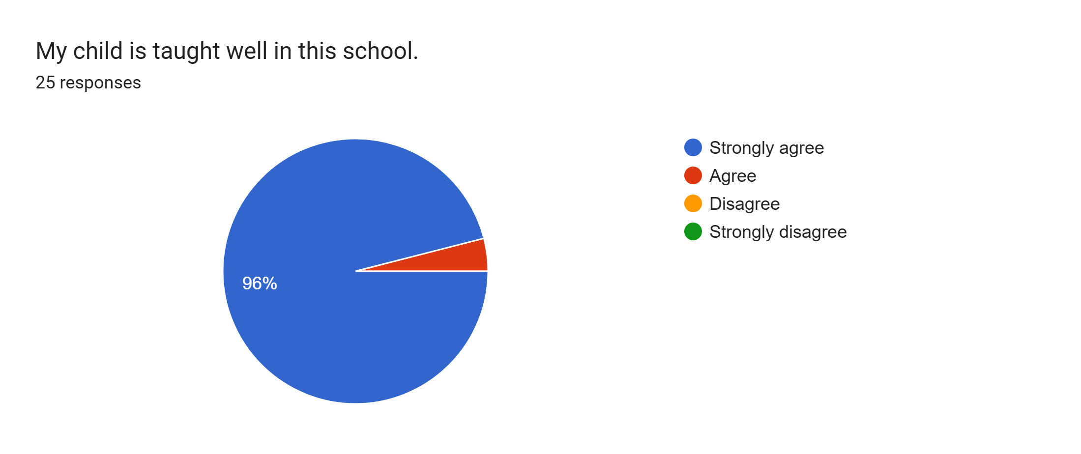
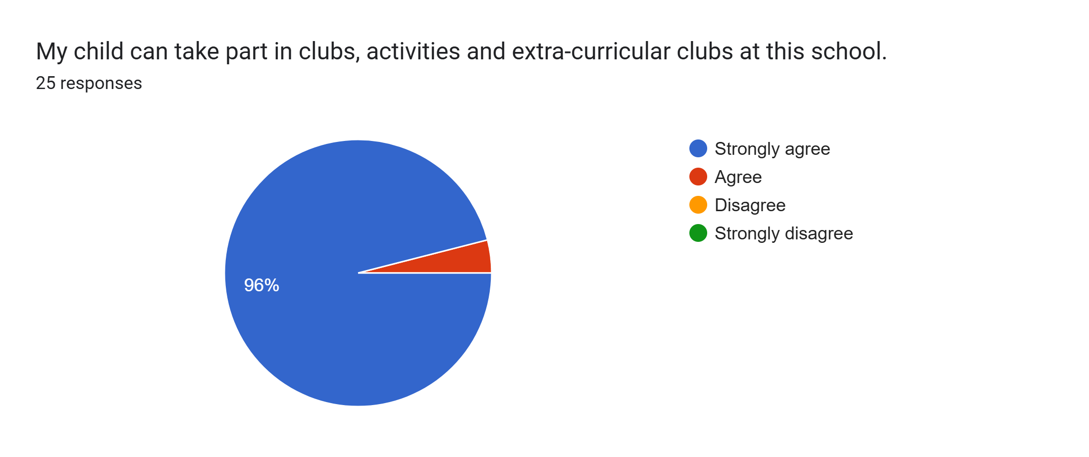
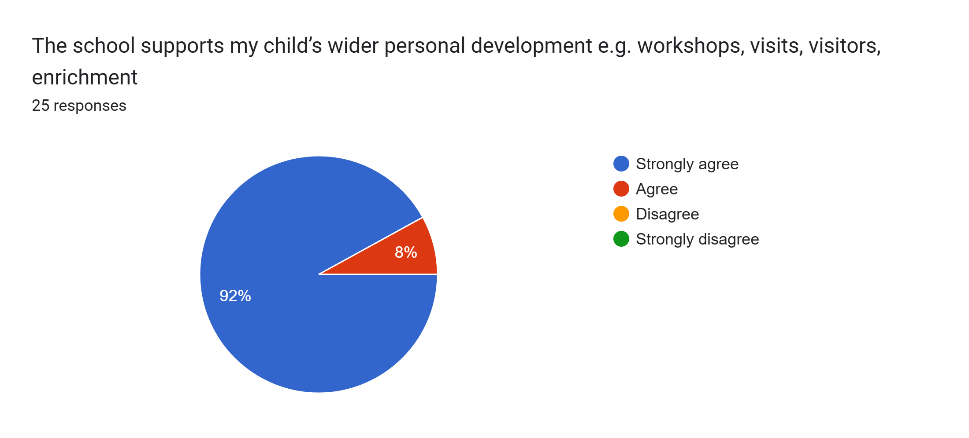
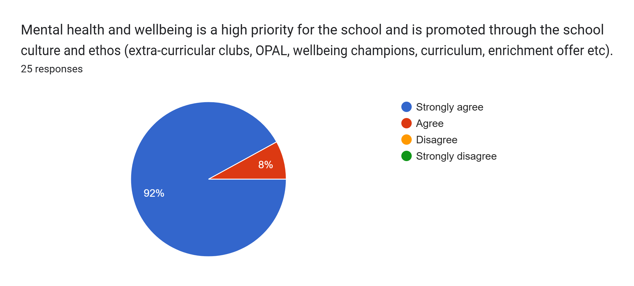
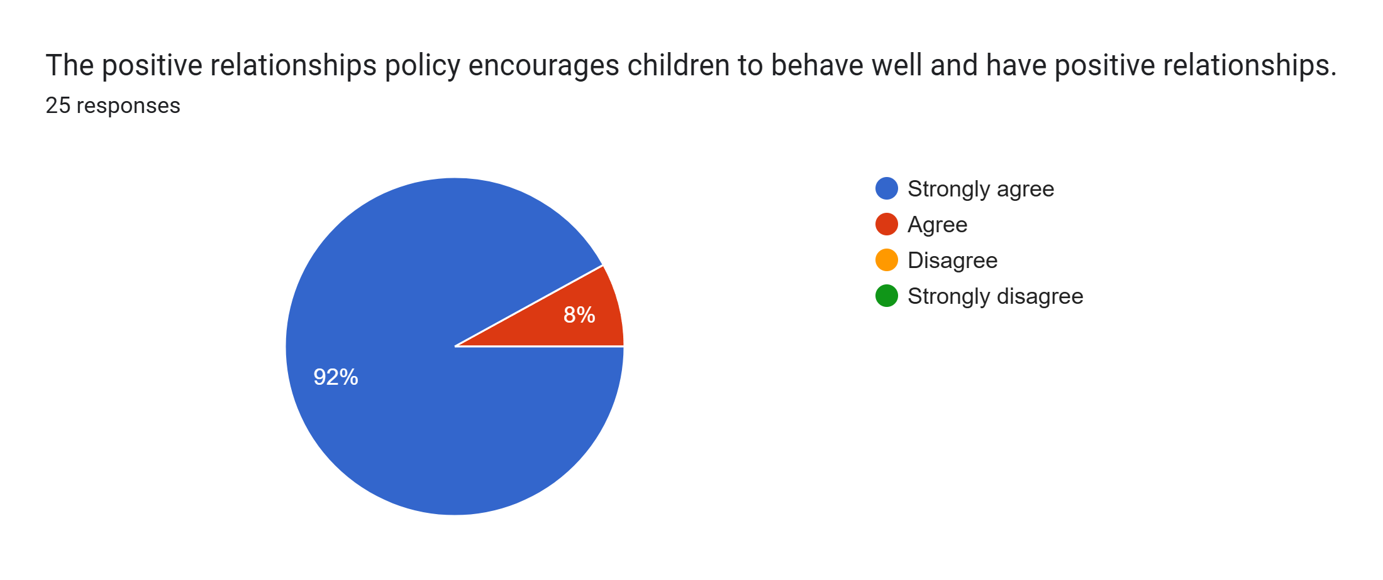
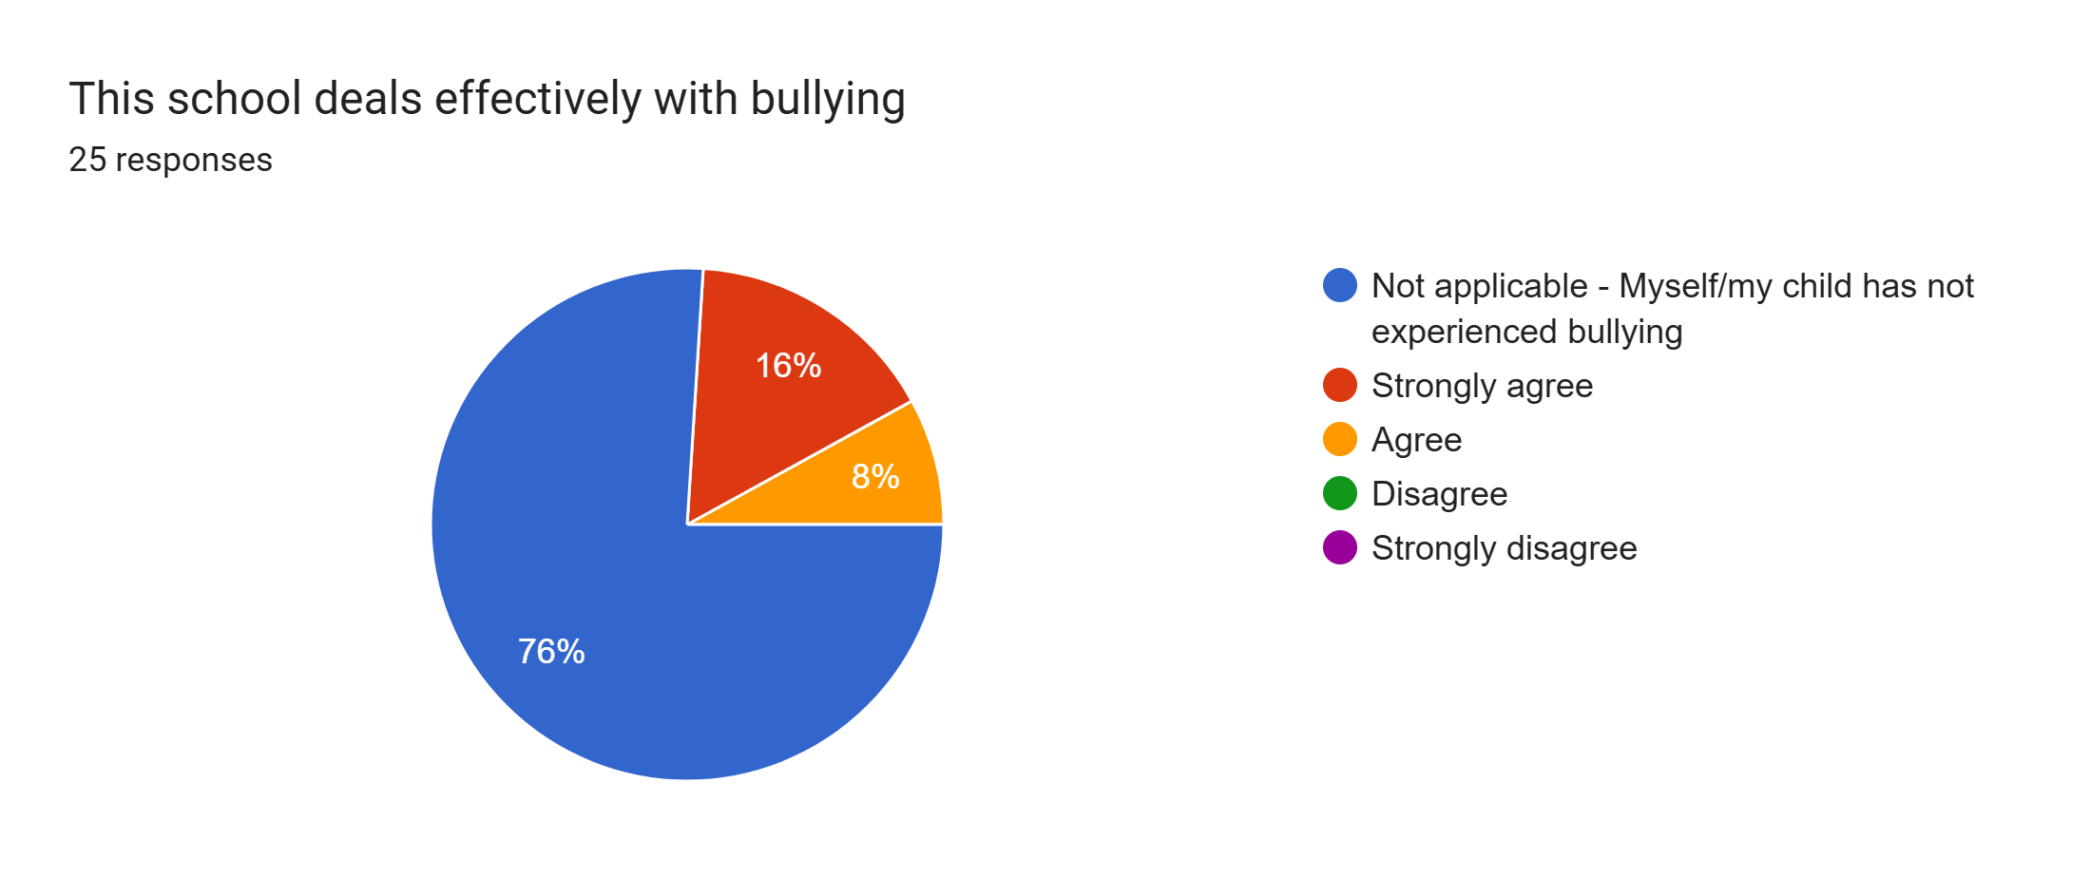
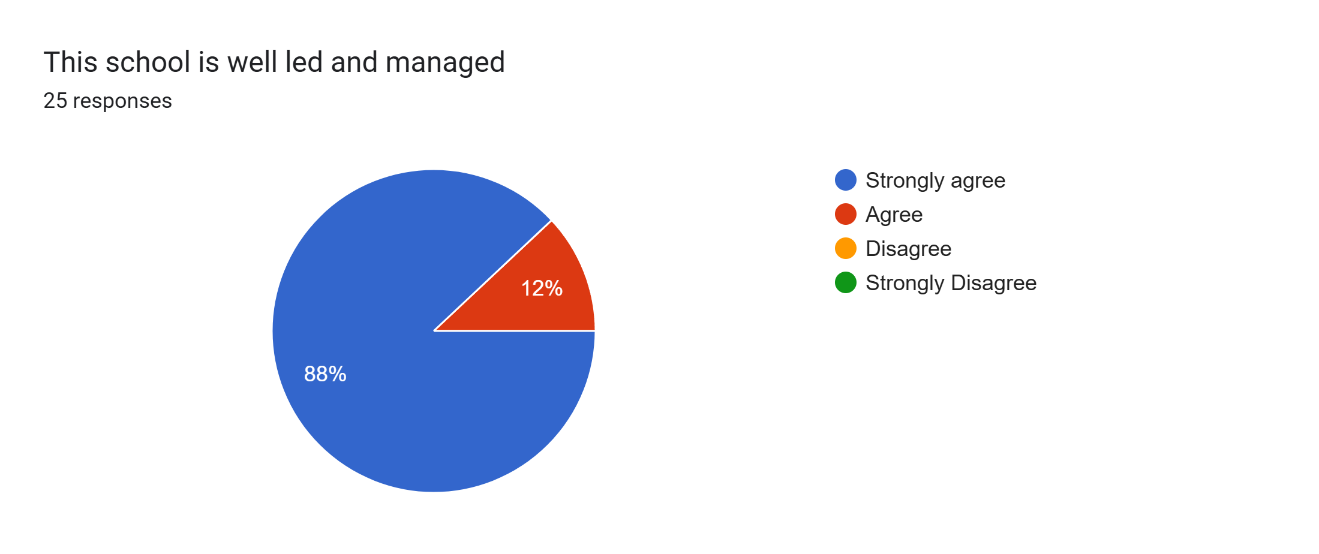
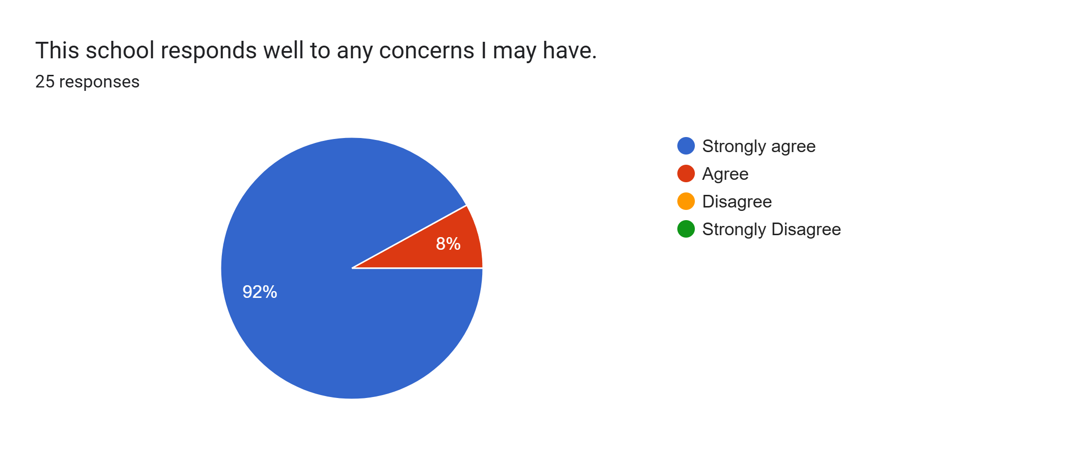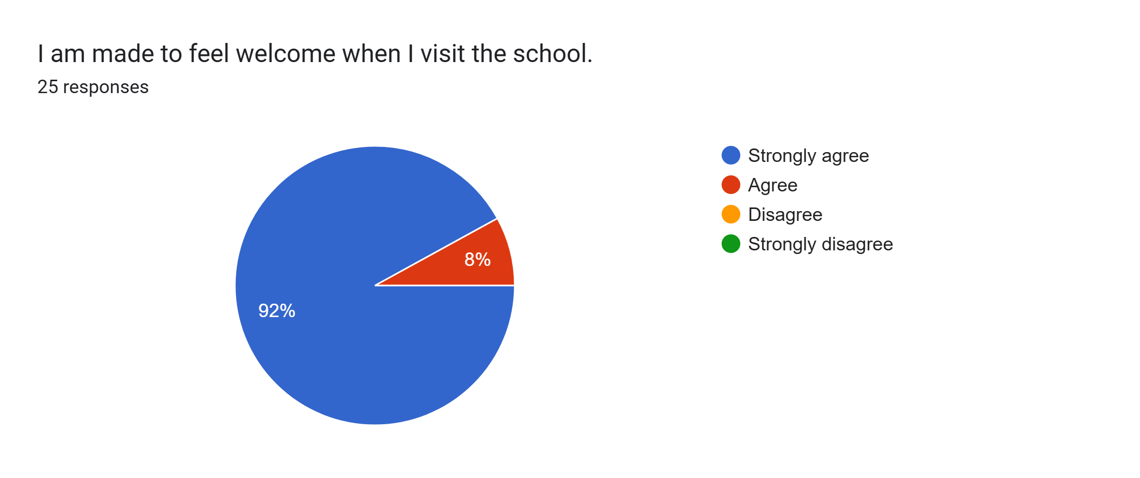
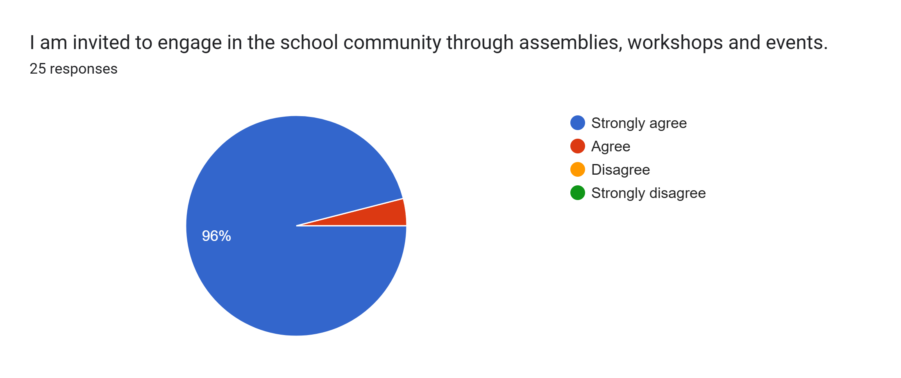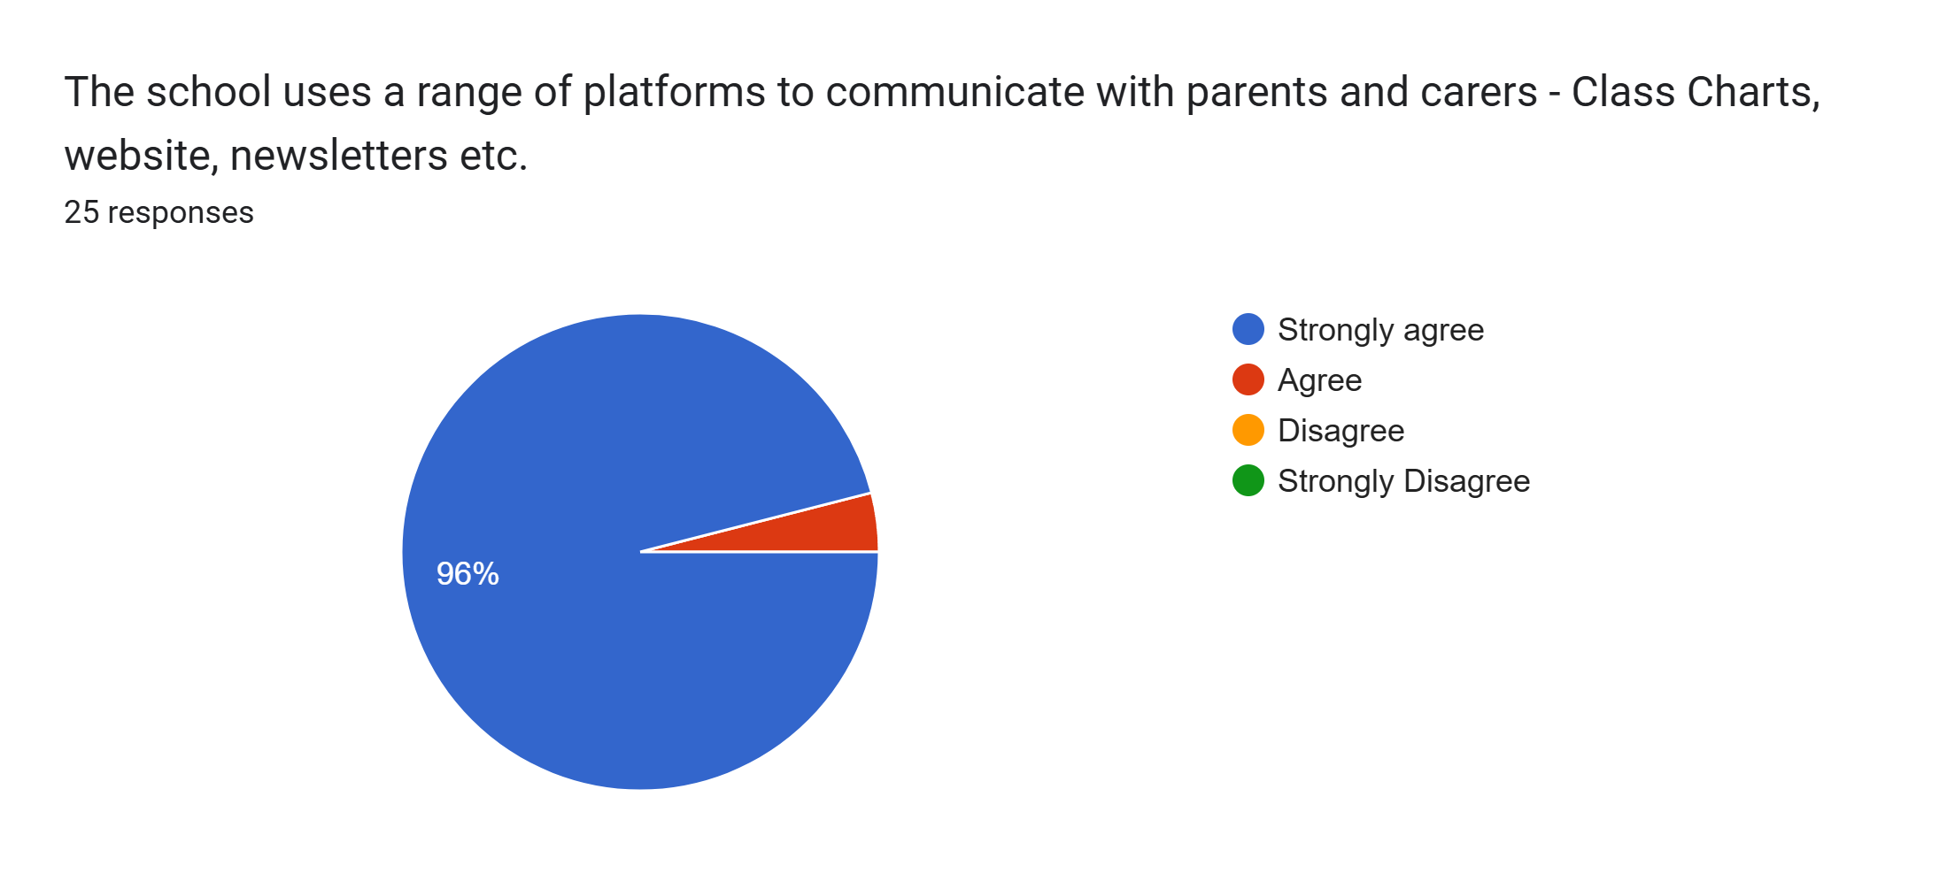
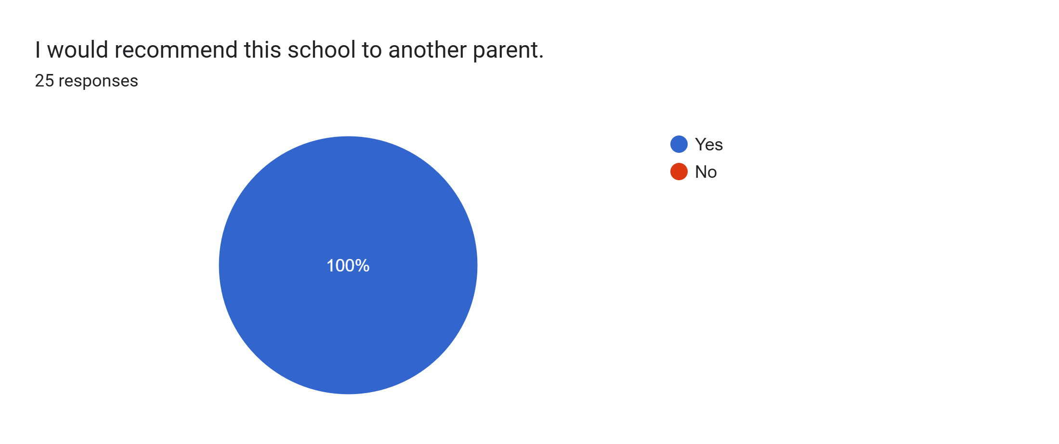
What other comments would you like to make to staff:
- Perfect.
- Lovely school staff, very helpful and supportive.
- Great.
- Lucca enjoys coming to school everyday and is eager to learn.
- Lovely staff.
- Lovely and friendly.
- I’m really happy with Roby Park School.
- Brilliant parent evenings. Thank you.
- Staff are helpful and friendly.
- Happy with Fliss's progress and activities at school.
- Anya has come on so much, thank you.
- Thanks for everything.
- Rivah likes school.
- Couldn't fault Miss Clarkson for all her support.
- Brilliant school and staff. Isla is coming on a lot.
- Absolutely amazing.
- Excellent friendly school, love it.
- Thank you for everything.
- Thanks for all your help and support.

