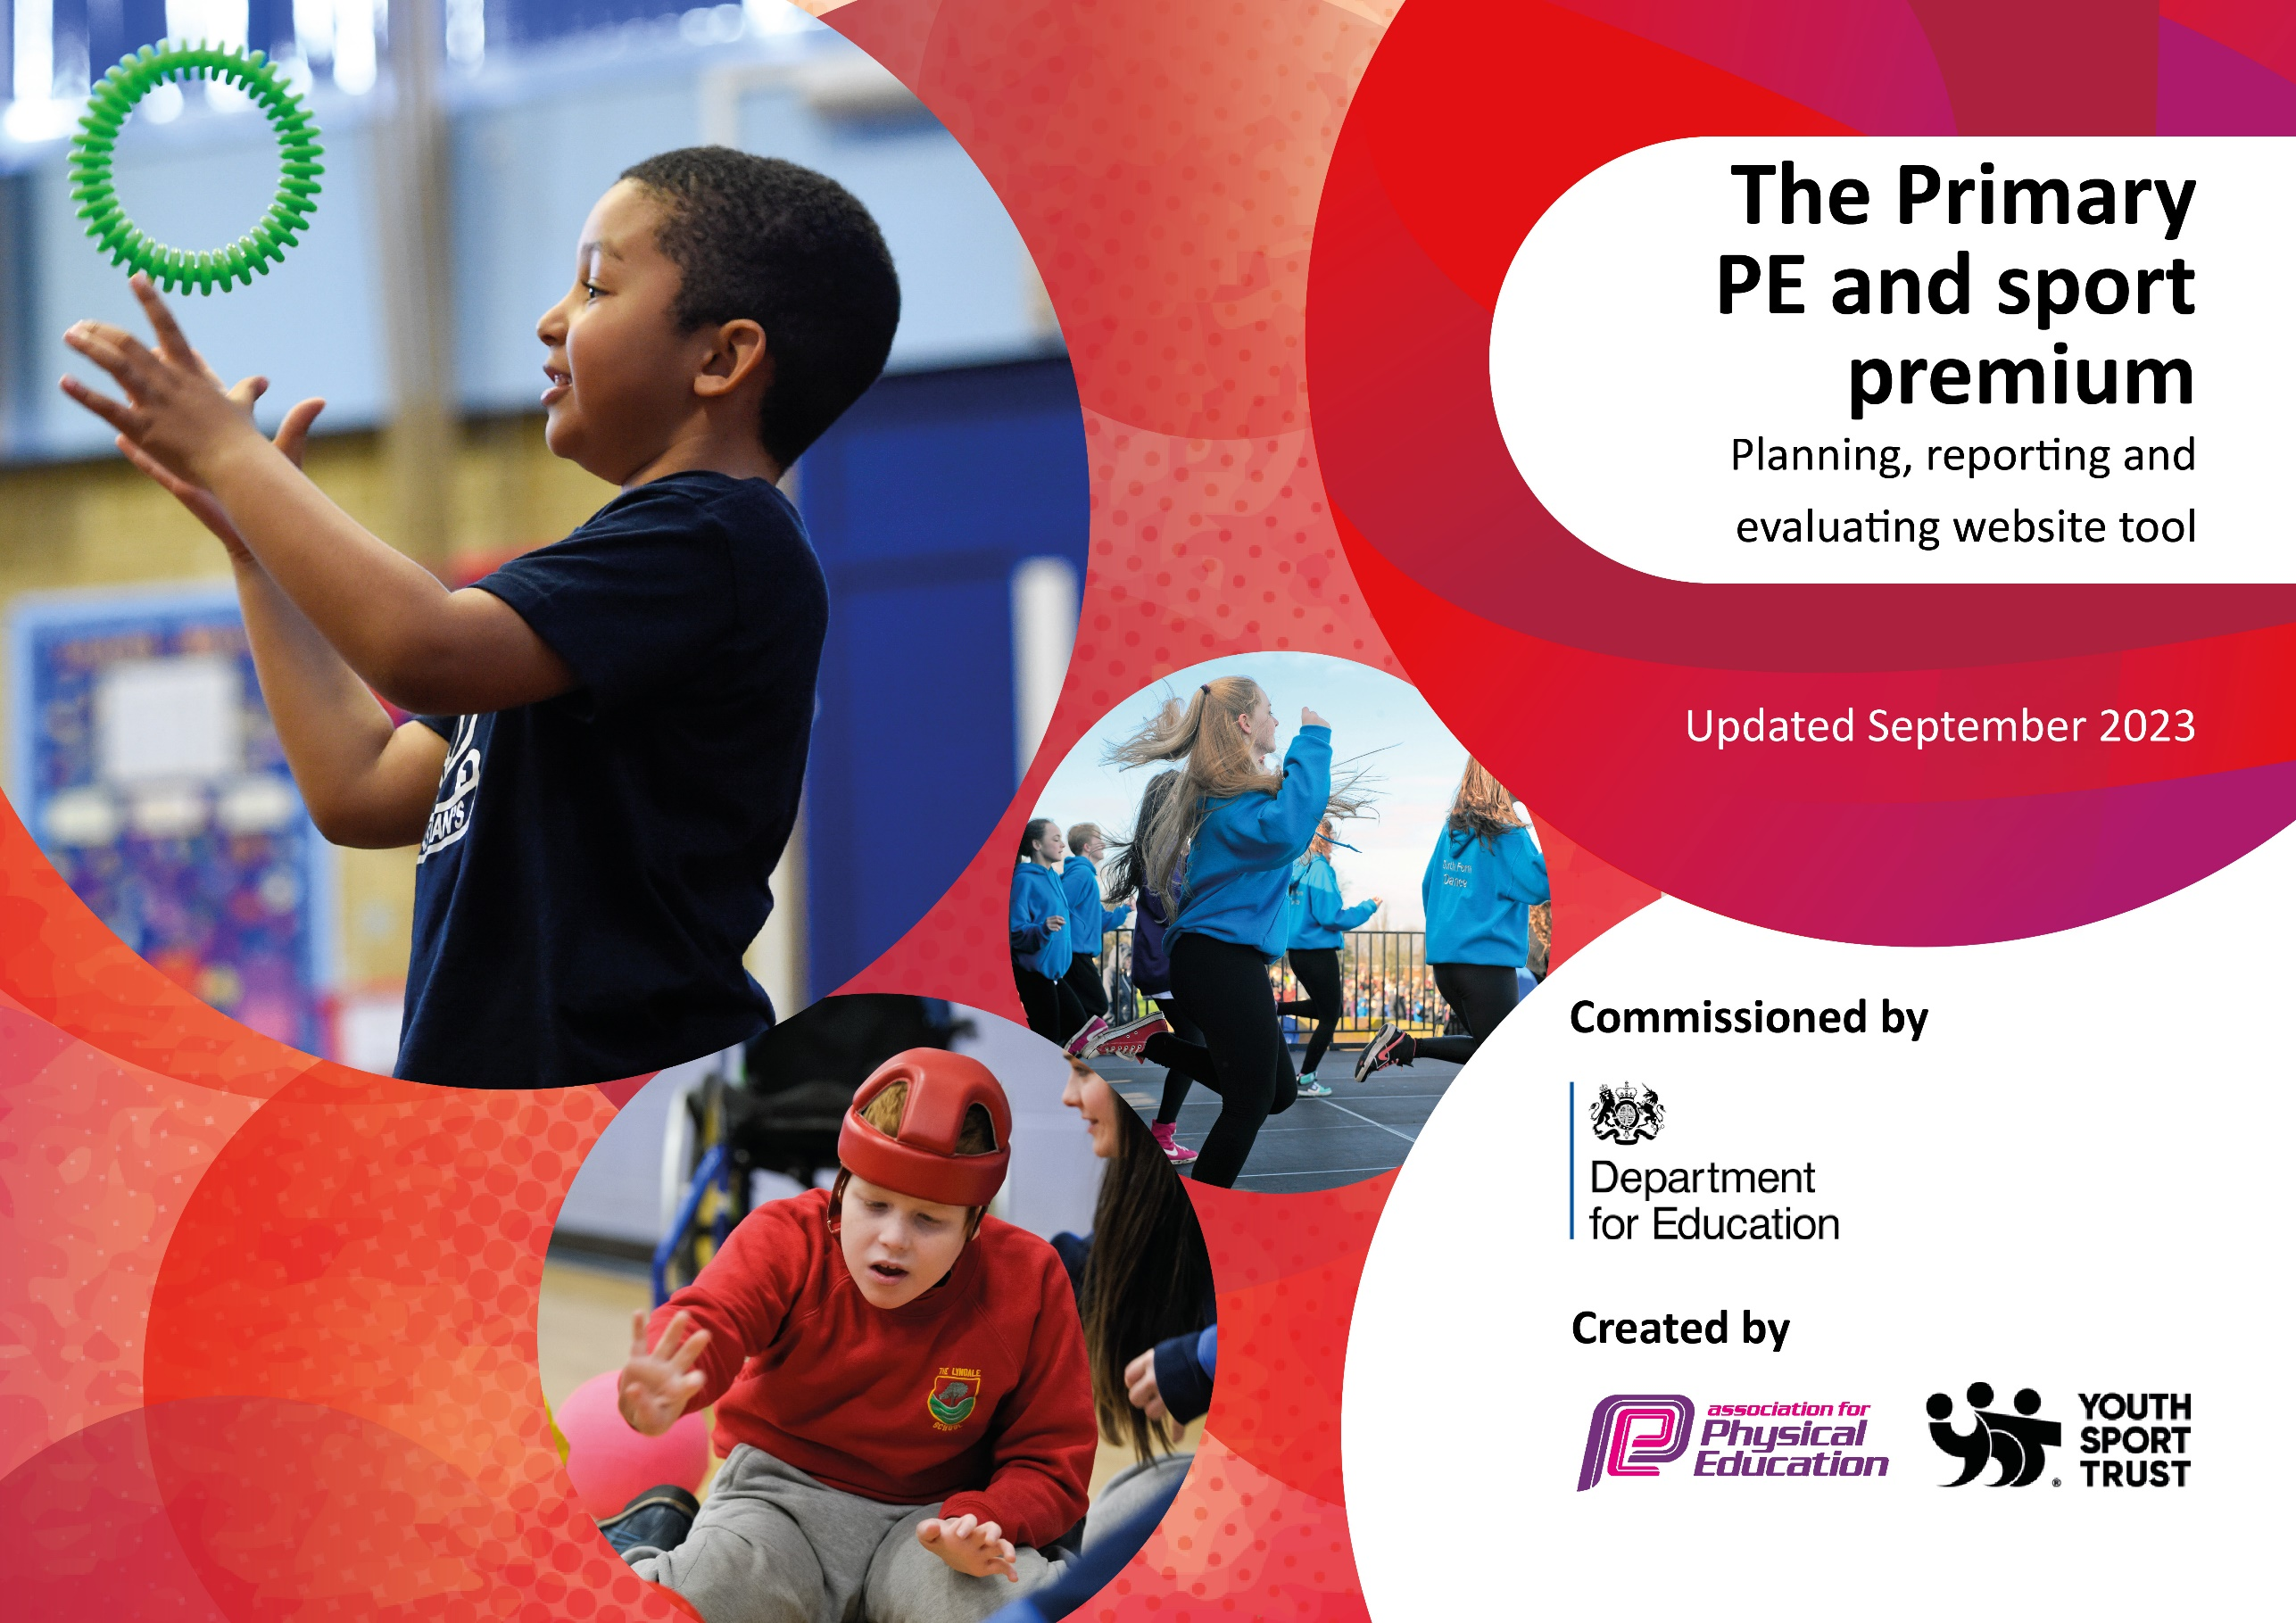

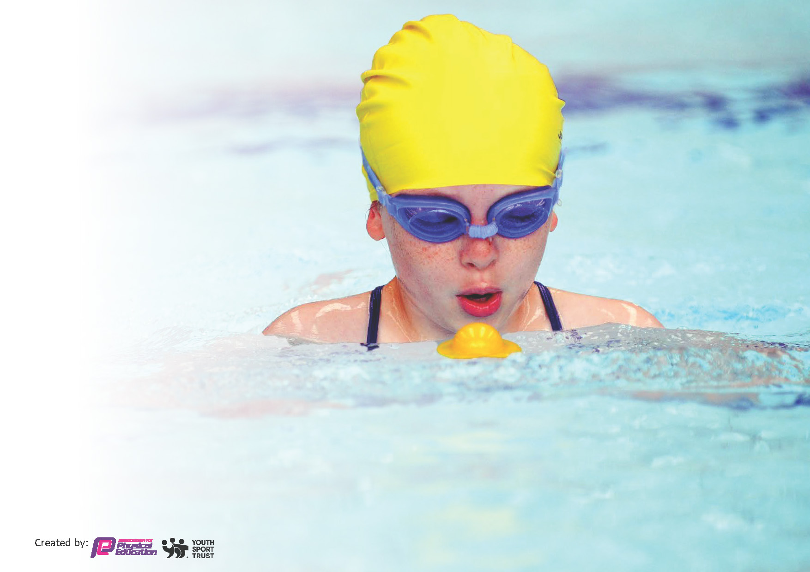
This template can be used for multiple purposes:
by:
- It enables schools to effectively plan their use of the Primary PE and sport premium
- It helps schools to meet the requirements (as set out in guidance) to publish information on their Primary PE and sport premium
- It will be an effective document to support Ofsted inspections enabling schools to evidence progress in Physical Education (PE) and evidence swimming attainment, which forms part of the PE National Curriculum. We would recommend schools consider
the Intent, Implementation and Impact of any spend, as examined within the Education Inspection Framework.

It is important that your grant is used effectively and based on school need.

Schools must use the funding to make additional and sustainable
improvements to the quality of the PE, School Sport and Physical Activity (PESSPA)
they offer. This means that you should use the Primary PE and sport premium to:

- Build capacity and capability within the school to ensure that improvements made now will benefit pupils joining the school in future years
- Develop or add to the PESSPA activities that your school already offers.

The Primary PE and sport premium should not be used to fund capital spend projects; the school’s core budget should fund these. Further detail on capital expenditure can be found in the updated Primary PE and sport premium guidance.

The Primary PE and sport premium guidance, outlines 5 key priorities that funding should be used towards. It is not

necessary that spending has to meet all the key priorities, you should select the priorities that you aim to use any funding towards.

Although completing this template is not a requirement for schools, schools are required to publish details of how they spend this funding. Schools must also outline what the impact this funding has had on pupils’ PE and sport participation and attainment and how any spending will be sustainable in the future. All funding must be spent by 31st July 2024.

The Department for Education has worked closely with the Association for Physical Education (afPE) and the Youth Sport Trust (YST) to develop this template and encourages schools to use it. This template is an effective way of meeting the reporting requirements of the Primary PE and sport premium.
Review of last year’s spend and key achievements (2022/2023)

We recommend you start by reflecting on the impact of current provision and reviewing your previous spend.

Activity/Action | Impact | Comments
Scooter equipment | The scooter equipment is available at break times for all children and has increased the engagement of all pupils in regular physical activity. One child said, “I love going on the scooters at break time because it is fun.”  Another child said, “I don’t go on the scooters all break time but I just jump on them so I can burn some energy.” | The scooters have helped broaden the number of physical activities that are provided at break and lunchtime. By increasing the number of activities we have seen an increase in the number of children who are active at break times. This has been apparent during observations made by the PE lead during termly playtime reviews.
Activall boards | 100% of children have participated in 4 inter school competitions (as of spring 2) where the children have competed to beat their own personal best scores. 100% of children have participated in a national intra school competition through the Activall website. | Child sports leaders to be trained to support other children with the use of activall boards.
Get Set 4 PE subscription | - Increased staff knowledge and  understanding  - All teachers able to confidently plan, teach and assess PE  - More sustainable workforce  including young leaders.  - Enhanced quality of provision  - Increased pupil participation in  competitive activities and festivals  - Increased range of opportunities  - A more inclusive curriculum which inspires and engages all pupils  -Discussions inform us that pupils  enjoy the variety of activities on offer during curriculum PE | Assessment to continue to be carried out using Get Set 4 PE for specific objectives. JH to also use insight to record the children’s attainment step e.g. well below expected, just below expected, at expected or above expected as the data analysis reports are more comprehensive and is then in line with all other foundation subjects.
Ensure a wider offer is in place for all children, giving them access to a range of extra-curricular opportunities that promote physical and mental wellbeing. | 2022 – 2023 extra-curricular club data  Autumn term data tables 2022  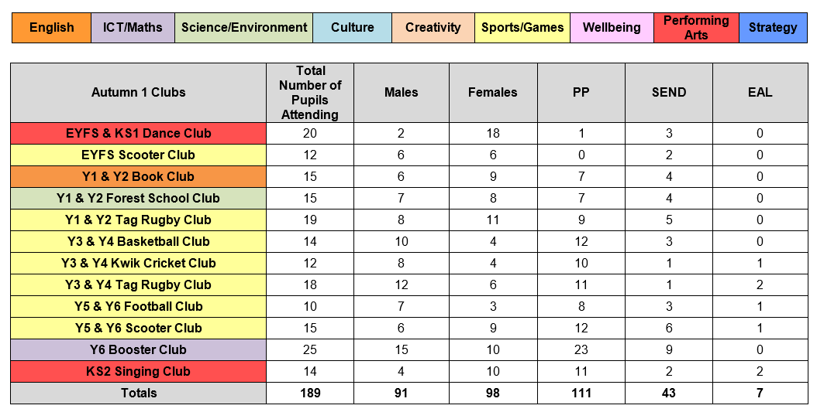  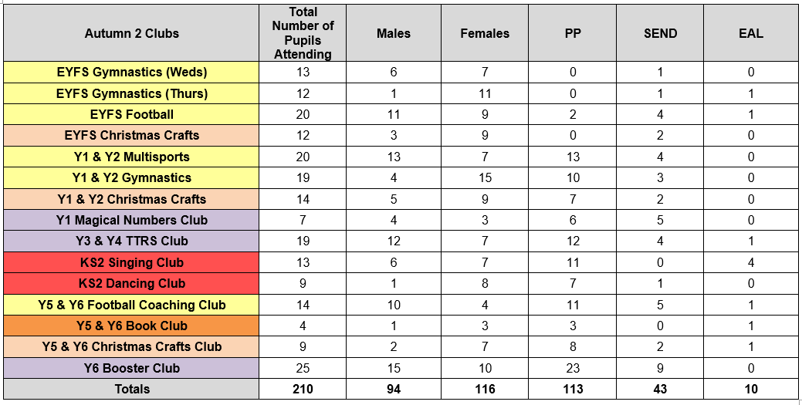  Spring term data tables 2023  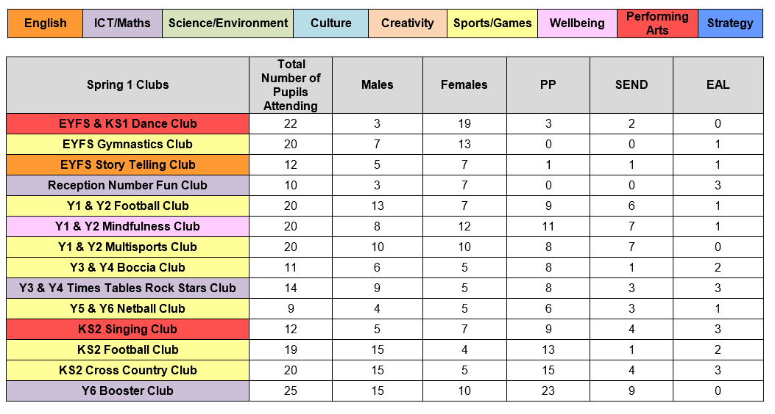  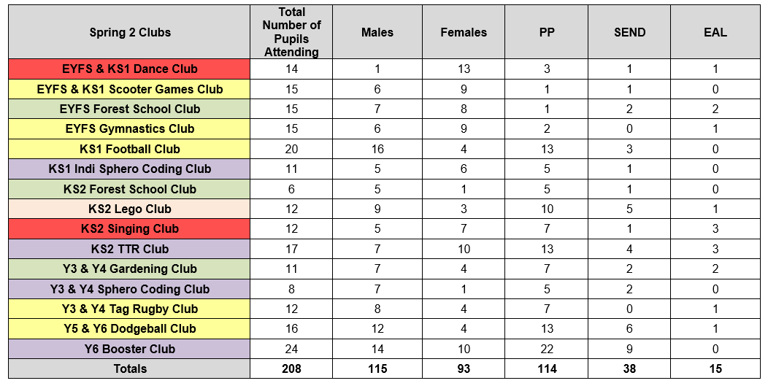  Summer term data table 2023  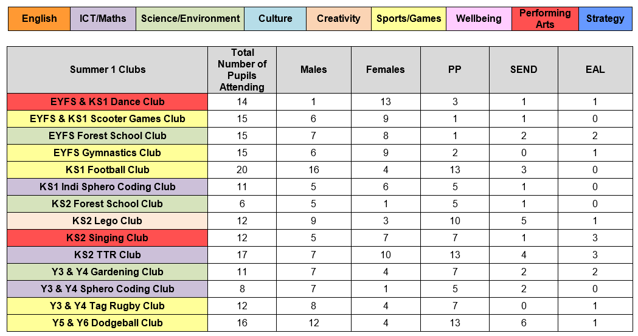  135 children attended a extra-curricular sports club Autumn 1  107 children attended an extra-curricular sports club in Autumn 2  161 children attended an extra-curricular sports club in spring 1  113 children attended an extra-curricular sports club in spring 2  113 children attended an extra-curricular in the summer term | Extra-curricular provision is broad and extensive. The sports/physical activity clubs are well attended. For the next academic year consider ways to supplement and develop the extra-curricular provision through teacher/TA delivered clubs to increase sustainability.

Key priorities and Planning
This planning template will allow schools to accurately plan their spending.

Action – what are you planning to do | Who does this action impact? | Key indicator to meet | Impacts and how sustainability will be achieved? | Cost linked to the action
Provide all children with the opportunity to participate in sports competitions In line with new guidance from the Youth Sport Trust, these include Aspire competitions in the form of competitive pathway events, Inspire events to engage with those children not normally involved with sports teams and Celebrate events to target the less active in fun and exciting games and festivals. | Pupils | Key indicator 5 - Increased participation in competitive sport  Key indicator 4 - Broader experience of a range of sports and activities offered to all pupils  Key indicator 2 - Engagement of all pupils in regular physical activity | Greater life satisfaction with an enhanced sense of purpose and pride, as individuals' self-esteem and confidence increase, while developing and promoting positive physical and mental wellbeing | Knowsley School Sport Partnership annual membership - £1700
Develop the confidence and competence of all teaching staff when delivering Outdoor Adventurous Activities | Teaching staff and pupils | Key indicator 1 - Increased confidence, knowledge and skills of all staff in teaching PE and sport | Enhanced self-awareness and interpersonal skills, resilience, risk management, and independence. OAA experiences create vivid long-term memories through autonomy and exploration. These activities can develop healthy lifelong habits which positively influence academic attainment.  Staff quotes  “I have gained a better understanding of the types of activities I can use in forest school and OAA sessions.”  “My knowledge of how the progression of activities can support the children’s learning has improved.” | CPD for all teaching staff - £7095
To provide free extra-curricular sports clubs for children to experience a wide range | Pupils | Key indicator 4 - Broader experience of a range of sports and activities offered to all pupils | Extra- curricular activities give young people the confidence to interact socially with others, extend their social networks beyond existing friendship groups, and provide them with new skills and abilities.  Autumn 1 – 102 children attended an extra-curricular sports club  Autumn 2 – 91 children attended an extra-curricular sports club  Spring 1 – 114 children attended an extra-curricular sports club  Spring 2 – 75 children attended an extra-curricular club  Summer 1 - 96 children attended an extra-curricular club  Summer 2 – 152 children attended an extra-curricular club  630 extra-curricular sports club places provided across the academic year  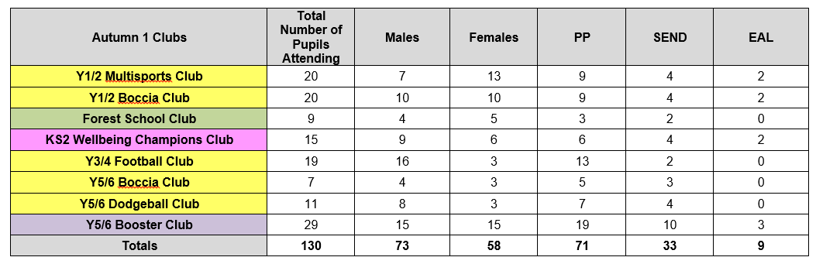  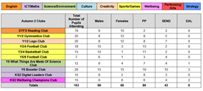  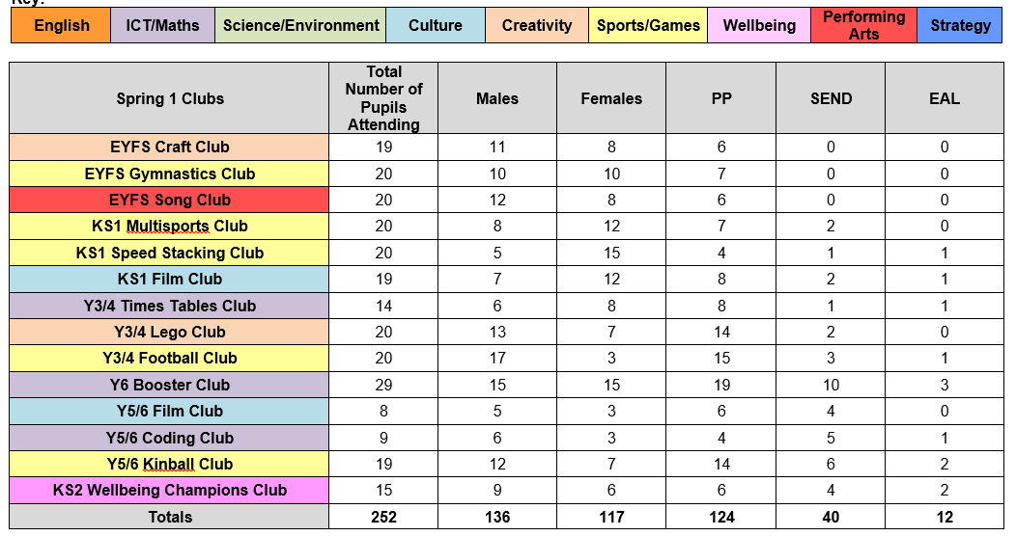  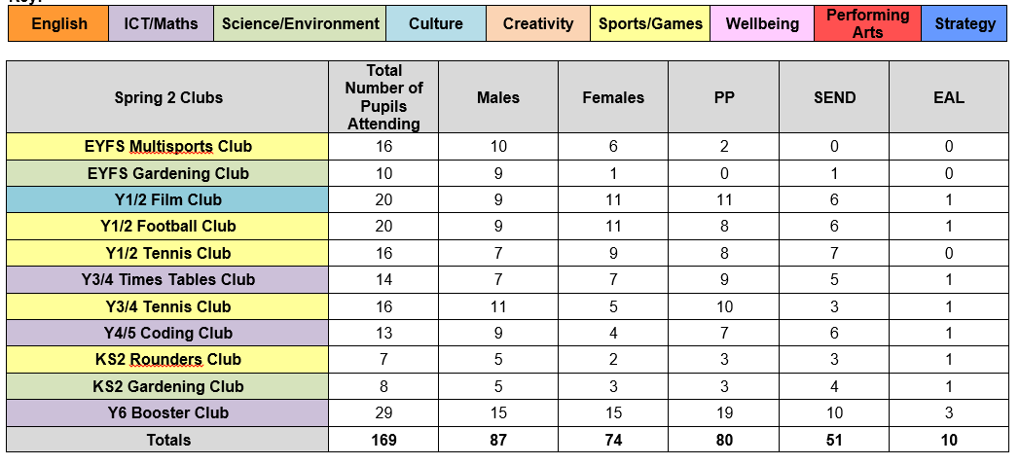 | School Sports coach – 165 sessions across the year - £2475
Provide consistently high quality, sustainable play opportunities for all children. | Pupils | Key indicator 3 - The profile of PE and sport is raised across the school as a tool for whole-school improvement  Key indicator 2 - The engagement of all pupils in regular physical activity | Physical activity and play is an essential part of a happy and healthy childhood and research shows that children spend up to 20% or 1.4 years of their time in primary school at play.  100% children are accessing  See pictures in key achievements | OPAL Project - £5500
To improve and develop the gross motor skills of targeted children to help support academic attainment  To target and support the least active children ensuring they receive additional support in order for them to meet and surpass the Chief Medical Officers guidelines. | Pupils | Key indicator 3 - The profile of PE and sport is raised across the school as a tool for whole-school improvement | Please see insight provision reviews for impact data. | Sports coach - 6.25 hours of targeted physical interventions per week for 39 weeks - £3656.25  £860 covered by sport premium funding and the remaining £2796.25 covered by curriculum budget.
Provide all children at Roby Park Primary with high quality swimming tuition | Pupils | Key indicator 4 - Broader experience of a range of sports and activities offered to all pupils | The percentage of Y6 children meeting the national curriculum requirements has increased from last year. We have increased the number of hours of swimming tuition each child will receive at Roby Park which will increase their.  https://www.knowsleynews.co.uk/pop-up-pool-helping-pupils-learn-to-swim/  Pupil quotes  “I’m so proud that I’ve conquered my fear of swimming. It’s really fun and I can’t wait to go swimming again next week.”  “I am a lot more confident in the swimming pool now.”  “I couldn’t swim the first week we started but by the end I was able to swim without a float.” | £7600 for 5 weeks pool hire with swimming teacher and life guard  Costs covered by Curriculum budget
To provide all children with the opportunity to experience new and innovative sports such as kin ball | Pupils and staff | Key indicator 1 - Increased confidence, knowledge and skills of all staff in teaching PE and sport  Key indicator 4 - Broader experience of a range of sports and activities offered to all pupils | Extra-curricular summer term data  Pupil quotes  “Kinball is really fun and everyone can play.”  “I think it is great that boys and girls play on the same team.”  “Kinball is really good at improving our communication skills.” | £763 Kinball equipment Curriculum budget
Improve and develop our physical activity provision available at break times | Pupils | Key indicator 4 - Broader experience of a range of sports and activities offered to all pupils | Children have an instinctive attraction to the natural world and an ability to use natural resources in their play. By installing a large sandpit on the school field we have broadened the number of physical activities the children can participate in. By increasing the number of activities we have seen an increase in the number of children who are active at break times. This has been apparent during observations made by the PE lead during termly playtime reviews.  Pupil quotes  “The sandpit is so much fun.”  “It can be tiring digging holes in the sandpit but me and my friends find it really fun.” | Installation of 8x4 sandpit £8500 school budget

Key achievements 2023-2024
This template will be completed at the end of the academic year and will showcase the key achievements schools have made with their Primary PE and sport premium spending.

Activity/Action | Impact | Comments
Swimming | 100% of children from nursery to Y6 took part in swimming lessons during 2023-2024 academic year.  Percentage of Y6 children meeting the national curriculum has increased by 12%  Local newspaper shared the positive impact of our swimming lessons with the local community.  https://www.knowsleynews.co.uk/pop-up-pool-helping-pupils-learn-to-swim/  School attendance while the swimming pool was on site was 98%.  Quotes from children  “I’m so proud that I’ve conquered my fear of swimming. It’s really fun and I can’t wait to go swimming again next week.”  Cllr Harvey, Knowsley Cabinet Member for Children’s Services  “Roby Park’s pop-up pool in the playground is a brilliant way to build confidence in the water and get pupils swimming – and the children are clearly having a wonderful time in the pool.  “Swimming is not only a fantastic form of exercise, but also a vital life skill and this is such a great way for the school to teach pupils these important lessons.” | This year we made significant changes to the way we teach swimming. These changes were made to ensure all of our children leave Roby Park having met the curriculum expectations. This is a long term approach and we believe each year we follow this model for school swimming we will see an increase in the number of children meeting the national curriculum expectations. This is because we are increasing the number of swimming lessons the children have during their time at Roby Park and we are introducing them to swimming at an earlier age.
To provide free extra-curricular sports clubs for children to experience a wide range | Autumn 1 Extra-curricular clubs participation data  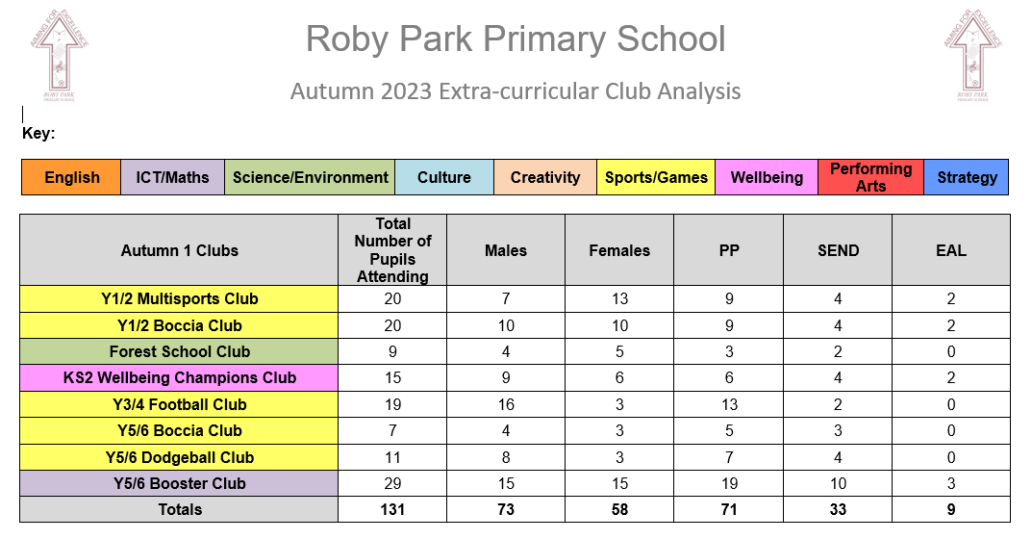  Autumn 2 Extra-curricular clubs participation data  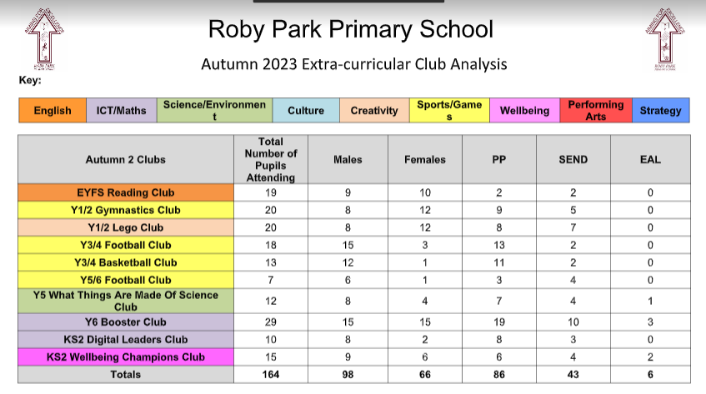  Spring 1 Extra-curricular clubs participation data  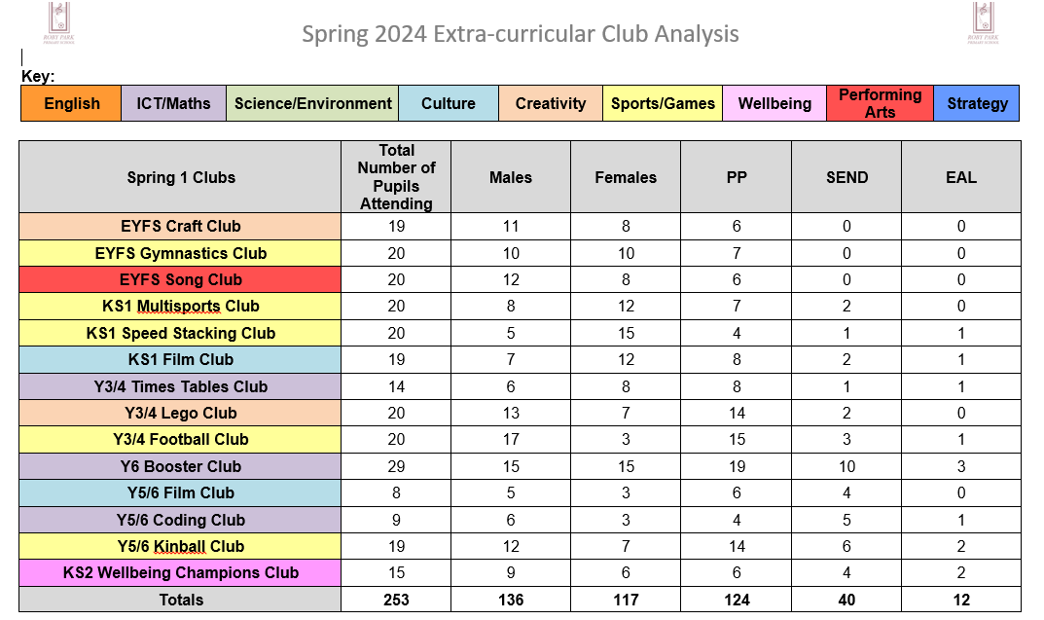  Spring 2 Extra-curricular clubs participation data  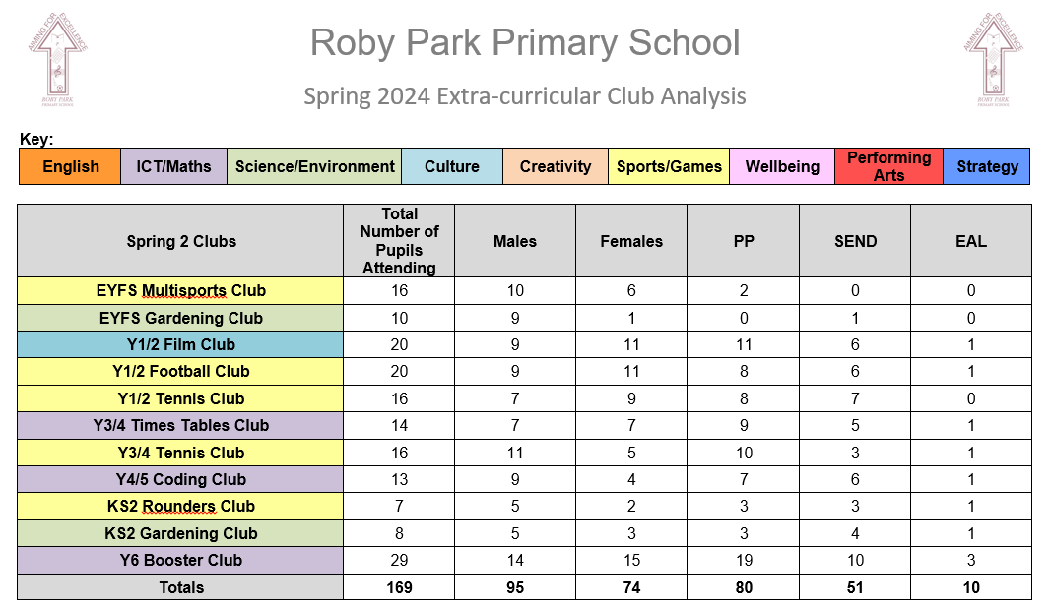  Summer 1 Extra-curricular clubs participation data  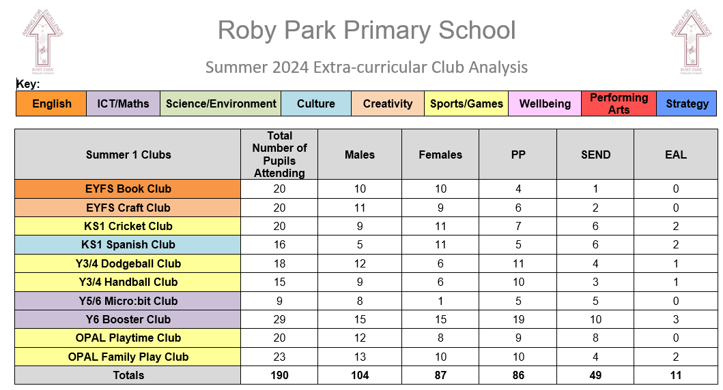  Summer 2 Extra-curricular clubs participation data  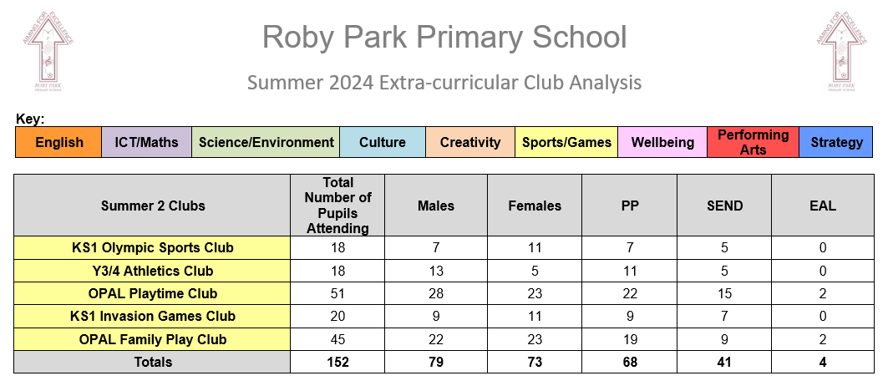  Autumn 1 – 102 children attended an extra-curricular sports club  Autumn 2 – 91 children attended an extra-curricular sports club  Spring 1 – 114 children attended an extra-curricular sports club  Spring 2 – 75 children attended an extra-curricular club  Summer 1 - 96 children attended an extra-curricular club  Summer 2 – 152 children attended an extra-curricular club  630 extra-curricular sports club places provided across the academic year.
OPAL programme | Impact of the OPAL programme at Roby Park  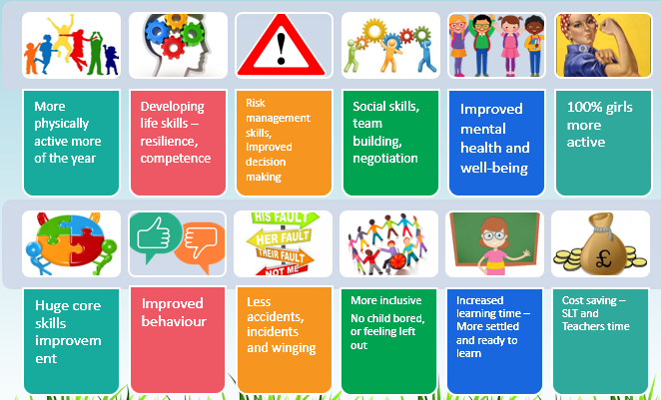  Parent Quotes  “It is great to see how much effort the staff have put into improving the children's playtimes.”  “With everything that you offer at playtime the children will never get bored.”  “The children all look so happy and it is lovely that we get the chance to see them playing like this in school.”  “The way you are using the field and the trees is amazing. It really gives the children a sense of freedom.”  “The field looks brilliant. I love how it has been cut and the wildflowers are starting to come through. It looks great.”  “I love how happy the children are. This approach is having a positive impact on the children’s wellbeing.”  “The facilities are brilliant and they are used really well.”  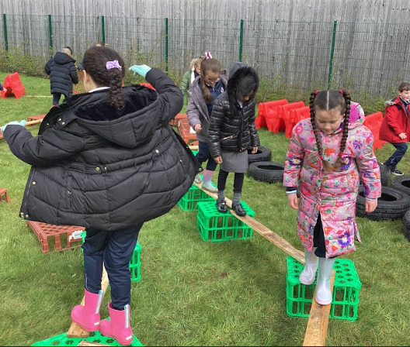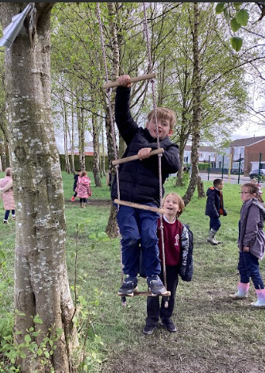  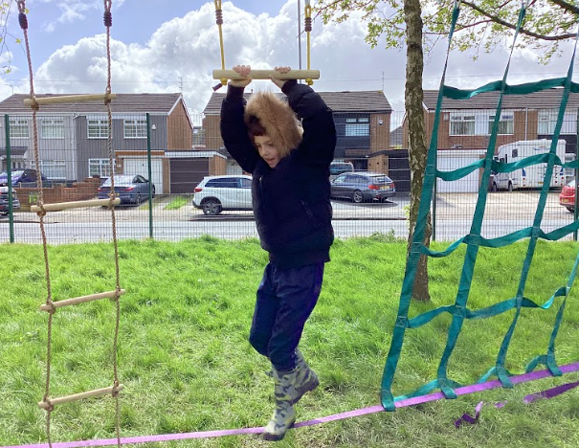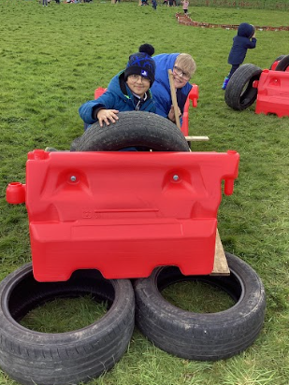  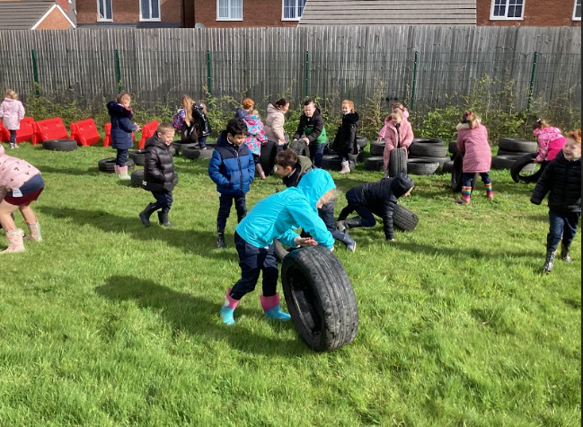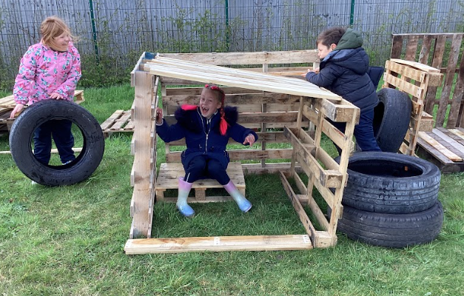  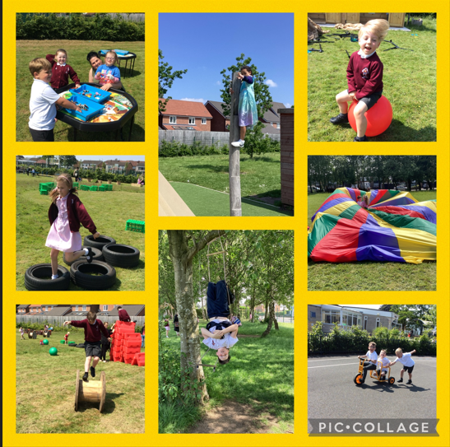  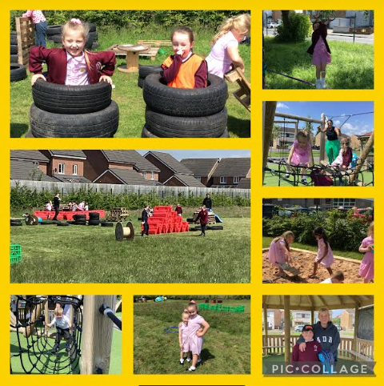 | OPAL Project has enabled us to improve the quality of our play provision and this has increased the children’s participation in daily physical activity. We now have a strategic approach to providing the very best play and physical activity opportunities for all children.
Confidence and competence of all teaching staff when delivering Outdoor Adventurous Activities | Staff quotes  “I have gained a better understanding of the types of activities I can use in forest school and OAA sessions.”  “My knowledge of how the progression of activities can support the children’s learning has improved.” | Forest school and OAA sessions will continue to be provided by specialist teachers who will continue to work with Roby Park staff in order to develop and improve their practice in the 2024-2025 academic year.

Swimming Data
Meeting National Curriculum requirements for swimming and water safety.
Priority should always be given to ensuring that pupils can perform safe self-rescue even if they do not fully meet the first two requirements of the National Curriculum programme of study

Question | Stats: | Further context  Relative to local challenges
What percentage of your current Year 6 cohort can swim competently, confidently and proficiently over a distance of at least 25 metres? | 69% | This academic year we have changed the way we deliver the national curriculum requirements for swimming and water safety. We used Elite swimming to hire a swimming pool that was assembled on our school site for 5 weeks. The pool hire included a qualified swimming teacher and a qualified life guard.  By having a pool on site we’re able to provide all children from Nursery to Year Six with high quality, structured swimming lessons, plus we were able to maximise the children’s learning time by reducing transport times and transport costs.  Research from Swim England shows that the earlier children receive swimming tuition, the more comfortable and competent they are in the water. We have seen an increase in the number of Year Six children meeting the national curriculum requirements this year and expect that this continue following the increase in the number of hours of swimming lesson we now provide our children during their time at primary school.
What percentage of your current Year 6 cohort can use a range of strokes effectively [for example, front crawl, backstroke, and breaststroke]? | 69% | Please see above

What percentage of your current Year 6 cohort are able to perform safe self-rescue in different water-based situations? | 100% | Please see above
If your schools swimming data is below national expectation, you can choose to use the Primary PE and sport premium to provide additional top-up sessions for those pupils that did not meet National Curriculum  requirements after the completion of core lessons. Have you done this? | No
Have you provided CPD to improve the knowledge and confidence of staff to be able to teach swimming and water safety? | No

Signed off by:

Head Teacher: | Kat Allen
Subject Leader or the individual responsible for the Primary PE and sport premium: | Chris Swatman  PE Lead
Governor: | Kami Lecester  Quality of Education Governor
Date: | 29.7.2024

