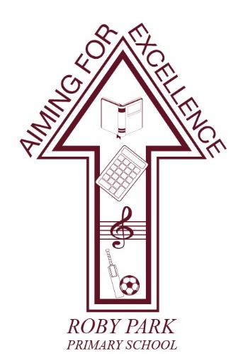

**Roby Park Primary School**

Easton Road

Huyton

Knowsley

L36 4NY

Tel: 0151 477 8340

Website: [www.robyparkprimary.co.uk](http://www.robyparkprimary.co.uk)

E-mail: [robypark@knowsley.gov.uk](mailto:robypark@knowsley.gov.uk)

**Headteacher: Mrs K Allen**

Date: Friday 6th September

**Young Voices**

Dear Parents/Carers,

I am delighted to announce that we have booked Young Voices for 2025! The largest children’s choir concert in the world will be hosted at the Co-op Live – Manchester on **Monday 24th February 2025**.

There are only limited places for this choir and, due to popularity, places will be given on a first-come first-serve basis. Places are open for students in current years 3-6. If your child would like to attend, rehearsals will begin on Tuesday 10th September from 3:00 – 4:00pm with Mr Couling in the hall. As part of your commitment to the choir, children are expected to attend every single rehearsal.

Travel arrangements and costs will be shared nearer the time which can be paid for on Parent Pay. School will pay for a Young Voices tshirt package for each choir member.

If you would like to join us, in the audience, at the Co-op Arena for this incredible event, we are able to purchase adult audience tickets on your behalf at £24.00 per adult. The closing date for the school to order tickets is **Friday 20th September 2024** so we will require you to complete a Google Form committing to how many tickets you want to purchase so we order the correct amount of tickets on your behalf. Parents will be able to then pay for these tickets from the school, via Parent Pay, at a later date. These tickets, once ordered, are non-refundable.

This choir is extremely popular and attendance to rehearsals will be taken regularly, please note that multiple absences may mean that your place on the choir is reviewed and/or withdrawn.

To secure your place on the Young Voices Choir 2025, please book via Parent Booking and complete the Google Form: <https://forms.gle/ft3AErMNjXAJQVTf8>

For further information about this exciting event, please visit <https://www.youngvoices.co.uk/>

If you have any questions, please contact the school’s office or Mr Couling for further information.

Warmest regards,

Kat Allen

Headteacher