Attendance Policy

Written Sept 2024

Review Sept 2025

Signed – Mrs Kat Allen

(Headteacher)

Signed – Mr Frank Walsh

(Chair of Governors)

Name of the Senior Attendance Champion: Kathy Lyon

Introduction
Roby Park Primary School is proudly recognised as an Inclusive Attendance school. Our unwavering commitment to attendance centres around child-centric actions, evidence-informed practices, and a shared understanding of everyone's roles and collective responsibilities to promote exceptional attendance.

Inclusive Attendance Professional Development Model
The Inclusive Attendance professional development model fundamentally guides our attendance approach. Comprising six tailored Learning Modules, this model empowers us to deepen our understanding by facilitating continuous professional learning for all staff. Within this model, the four domains of practice ensure the provision of professional learning, professional development, evidence-based practices, and exemplary leadership and management to seamlessly integrate theory into practice.
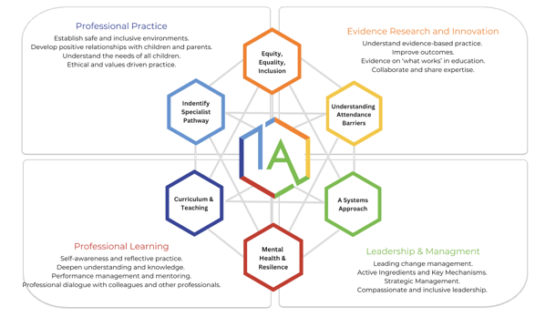

Annual Inclusive Attendance 7-Month Development Programme
Each year, Roby Park Primary School review and further enhances attendance practices through dedicated participation in the Inclusive Attendance 7-month development programme. This investment allows us to remain at the forefront of educational change and extends unparalleled support to our children and their families, equipping them with access to the finest possible assistance.

A Multi-Tiered System of Support
To guarantee a comprehensive approach to attendance, Roby Park Primary School implement a Multi-Tiered System of Support. A Multi-Tiered System of Support (MTSS) for school attendance involves three tiers of intervention, with roles for teachers, the school, children, parents, and external agencies – including the Local Authority. Data-driven decision-making and training requirements are pivotal to the implementation of this system. The system aligns with the Department for Education's (DFE) "Working Together to Improve School Attendance" statutory paper 2024.

Tier 1 - Universal Approach: Establishing a baseline universal attendance approach that benefits all children.
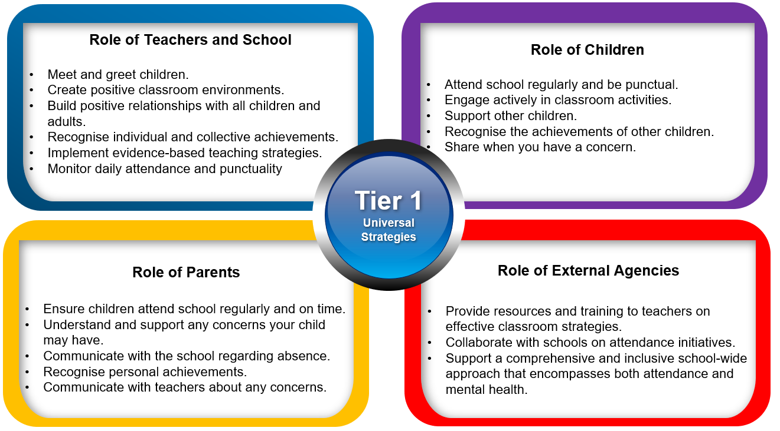

Tier 2 – Internal individualised Strategies and Early Help Support: Tailoring strategies to individual needs and providing early help support for persistent attendance challenges.
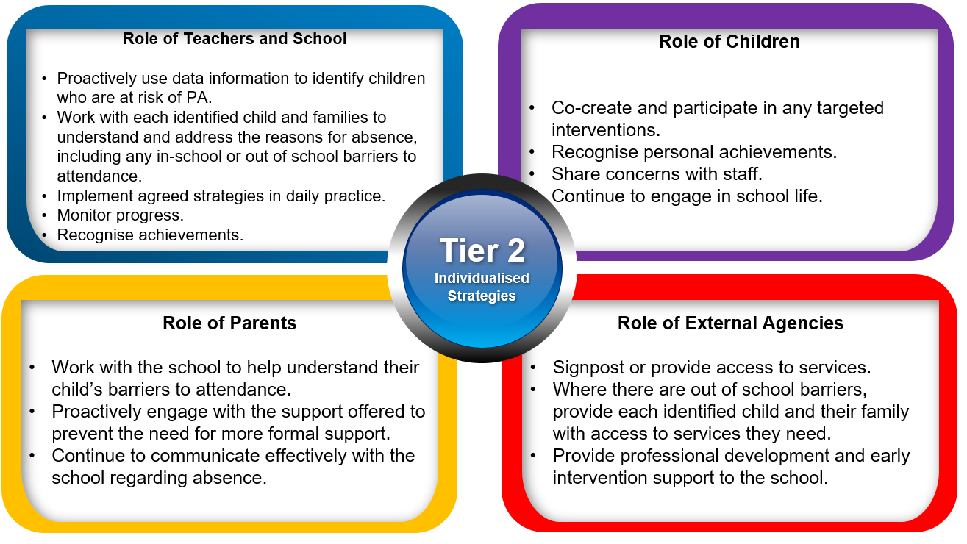

Tier 3 - Higher Needs Strategies Support: Furnishing specialised support for children, young people, and families with complex attendance requirements, including access to external agency support when necessary.
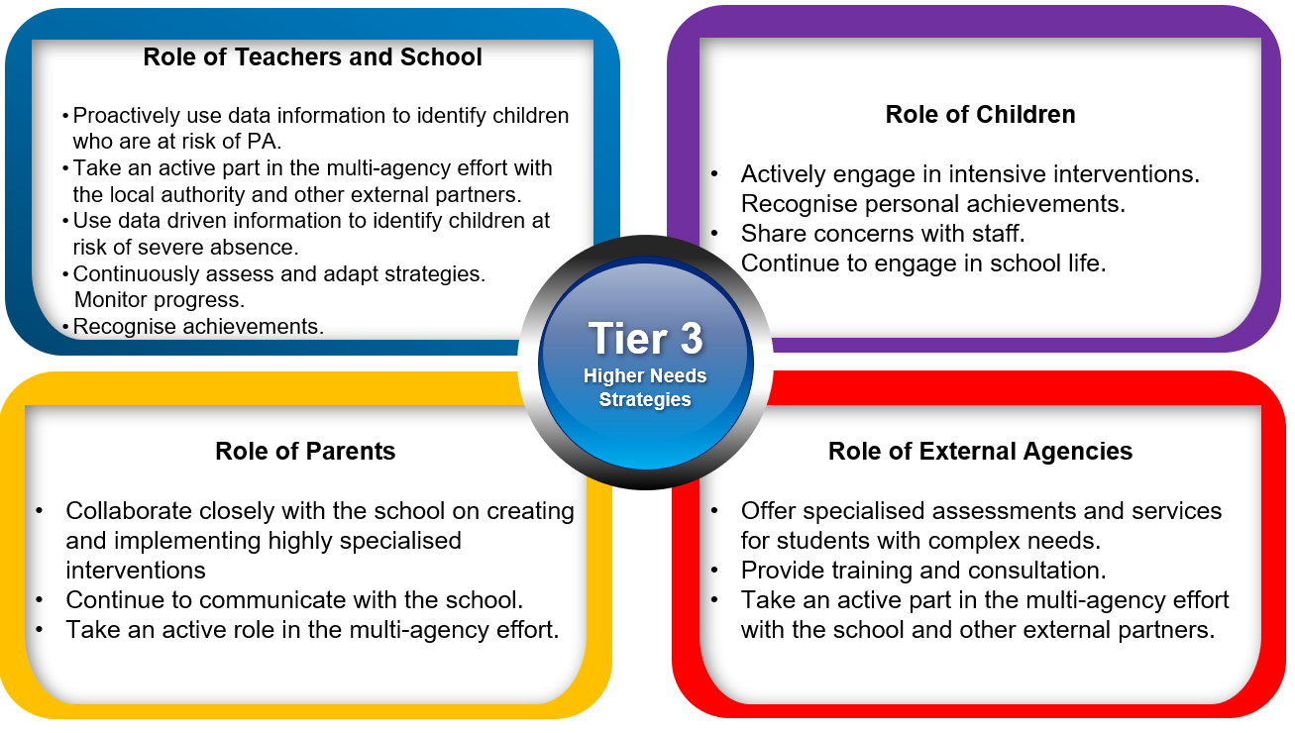

Recognition-Based Approach
Our attendance philosophy is rooted in a recognition-based approach that recognises both personal and collective achievements. This approach serves to cultivate positive environments, nurture relationships, foster inclusivity, and ultimately cultivate intrinsic motivation among our children, families, and staff.

Recognition based certificates and rewards are earned as a class based on a range of attendance and punctuality achievements.

Teachers send weekly attendance recognition postcards to parents recognising their commitment to attendance and punctuality.

The Importance of School Attendance at Roby Park Primary School
School attendance is not merely a requirement but a fundamental pillar of education. It plays a pivotal role in shaping academic success, personal growth, and future prospects, making it an indispensable aspect of any educational system. Regular attendance to school can have a significant impact on:

- Relationships: School provides a vital social environment for children to interact with peers, develop friendships, and learn essential social skills. Consistent attendance ensures children remain connected to their peer group.
- Teacher Interaction: Regular attendance allows for meaningful teacher-child interactions. Teachers can provide personalised support, address questions, and assess individual progress more effectively when children attend regularly.
- Wellbeing: High levels of school attendance contribute to the overall wellbeing.
- School Engagement: Children who attend school regularly are more likely to engage in extracurricular activities, sports, and other enriching experiences that contribute to their overall development.
- Academic Achievement: Regular attendance directly correlates with academic success. Children who attend school consistently are more likely to keep up with the curriculum, perform better in exams, and improve their life outcomes.
- Sticky Knowledge: School is where children acquire knowledge and skills that are crucial for their personal and professional growth. Missing days means missing out on valuable learning opportunities.
- Preventing Knowledge Gaps: Frequent absences can lead to significant knowledge gaps, making it challenging for children to catch up with missed lessons, potentially resulting in long-term academic struggles.
- Building Routine: School attendance establishes a structured routine in children’s lives, teaching them time management and responsibility, which are valuable life skills.
- Legal and Parental Responsibility: Parents or guardians are legally responsible for ensuring their child's regular school attendance. Failing to do so can lead to legal consequences.

Factors Influencing Attendance
There are many factors which can impact on a child attending school, if you have any concerns you should contact the school as soon as possible:

Health Issues: Children may experience physical or mental health issues that lead to absences. Chronic illnesses, infections, and mental health conditions can impact a student's ability to attend school regularly.

Family Circumstances: Family-related factors such as bereavement, family illness, or caring responsibilities can result in absences from school. In some cases, students may need to take time off to support their families.

Bullying and Safety Concerns: Experiences of bullying, harassment, or safety concerns at school can deter students from attending. They may fear for their safety or well-being, leading to increased absenteeism.

Socioeconomic Factors: Families facing financial difficulties may struggle to provide necessary resources for their children to attend school regularly. Issues such as lack of appropriate clothing, food, or a stable home environment can contribute to absenteeism.

Special Educational Needs (SEN): Students with special educational needs may require additional support and accommodations to attend school regularly.

Engagement and Motivation: Lack of engagement with school activities and a perceived lack of relevance in the curriculum can lead to disinterest in attending. Children who are not motivated may avoid attending school.

Academic Challenges: Students facing academic difficulties or feeling overwhelmed by class work may avoid school. They may fear falling behind or failing in their studies.

Cultural and Language Barriers: Children from diverse backgrounds may face challenges related to language barriers or cultural differences. These challenges can affect their attendance and engagement with school.

Peer Pressure and Social Factors: Influence from peers can impact attendance. Children may avoid attending school to align with the behaviour of their peers or to engage in social activities outside of school.

Parental Involvement: Parental support and involvement in a child's education can positively influence attendance. Lack of parental engagement may lead to increased absenteeism.

Supporting Attendance at Roby Park Primary School
To address any identified attendance issues effectively, Roby Park Primary School will implement a range of strategies such as early intervention, support for vulnerable families, intervention programmes, and creating a positive and inclusive school environment. Understanding the specific factors affecting attendance for individual children and families is crucial for developing any targeted interventions and support systems to improve attendance outcomes.

Contact Details of School Staff at Roby Park Primary School

Name of Staff Member | Roles and Responsibilities | Contact Details
Kathy Lyon | Attendance Champion | attendance@robyparkprimary.co.uk
Lauren Smith | Attendance Support Officer
Kat Allen  Kathy Lyon | Safeguarding Leader (DSL) | wellbeing@robyparkprimary.co.uk
Kat Allen | Head Teacher – if different to the Attendance Champion | robypark@knowsley.gov.uk
Mike Long | Governor for School Attendance

Strategies for Using Data to Target Attendance Improvement Efforts at Roby Park Primary School
- The whole school cohort and individual year groups.
- Individual pupils.
- Demographic groups, e.g., pupils from different ethnic groups or economic backgrounds.
- Other groups of pupils, e.g., pupils with SEND, LAC, and pupils eligible for FSM.
- Pupils who have an allocated social worker or are known to social care.
- A pupil who is absent for prolonged periods, or repeated occasions, which may indicate a safeguarding concern, such as CSE or CRE, particularly county lines.
- Pupils at risk of PA.
- Pupils at risk of SA.
- Intervention planning.

School Times of the Day at Roby Park Primary School:
The school day begins at 8.45am and ends at 3.00pm.

Registration opens at 8.45am and closes at 8.50am.

Children are expected to arrive on time and attend all scheduled lessons and activities.

Reporting a Child's Absence
Parents or carers must contact the school on the first day of their child's absence to provide the reason for the absence.

In the first instance, a phone call should be made to the school office on 0151 477 8340 before 8.30am. Alternatively, parents/carers can email the attendance@robyparkprimary.co.uk informing the school of the reason for their child’s absence. It may be necessary for parents/carers to supply medical evidence in the form of appointment cards or prescribed medication.

Day to Day Processes for Managing Attendance at Roby Park Primary School
- Teachers complete morning registration, recording on MIS system those present no later than 9.00am.
- Attendance lead reviews registers, ensuring all children have a code.
- Any absence notifications from parents/carers are uploaded onto MIS system.
- Phone calls are made to those absent with no explanation and this is the child’s first day of absence.
- Welfare calls are made to children who continue to be absent.
- Children, who are PA and absent, are referred to the Local Authority School Attendance Service Officer if we can not make contact with parents/carers and have no reason for absence.
- School Attendance Officer will conduct a home visit, leaving a calling card if there is no contact made.
- Parents/carers receive a welfare call every day that their child is absent from school.

Coding of Attendance
- Attendance will be recorded using the DFE's statutory attendance codes, please refer to the appendix for coding.

Safeguarding at Roby Park Primary School
Attendance is analysed to identify patterns of absence that may cause concern. Children who miss ten days of school with no valid reason and children have not been seen by school staff or the Attendance Service Officer, will be reported to the Local Authority School Attendance Service as a child missing in education (CME).

On some occasions, it will be necessary to request a police welfare check.
If the school has concerns around child exploitation, school will make a referral into the Knowsley Multi-Agency Vulnerable Children’s Meeting (VCM) or SHIELD.

Requesting Absence Leave
Parents or carers must request leave of absence for their child in writing at least 10 school days in advance, by completing a leave of absence request form which can be obtained from the school office. Absence requests will be responded to within 5 working days.

Holiday Request
Holidays during term time will not be authorised.

Holiday requests must be made in writing, and a decision will be communicated to the parents or carers within 5 school days.

Leave of absence during term time will only be authorised in exceptional circumstances.

Strategy for Reducing Persistent and Severe Absence at Roby Park Primary School
See multi-tiered system of support.

Details of the National Framework for Penalty Notices at Roby Park Primary School
Educational Penalty Notice Code of Conduct: https://robyparkprimary.co.uk/wp-content/uploads/2024/06/Education-Penalty-Notice-code-of-conduct-Sept-2023-final-002.pdf

Knowsley Attendance Service EPN Leaflet: https://robyparkprimary.co.uk/wp-content/uploads/2024/06/KNOWSLEY-SCHOOL-ATTENDANCE-SERVICE-EPN-Leaflet-sept-23-Copy.docx

Knowsley Local Authority Attendance Strategy: https://robyparkprimary.co.uk/wp-content/uploads/2024/06/Final_KNOWSLEY-ATTENDANCE-STRATEGY-2021-2024.pdf

Removal from Roll
This refers to the process of a child’s name being officially taken off the school's register, typically due to extended non-attendance or other circumstances. Elective Home Education (EHE) is an option that some parents choose after removal from roll, where they take responsibility for providing education to their child at home.

Elective Home Education
Inform school in writing that you wish to remove your child from roll and electively home educate. School will then inform the Local Authority EHE team.

Definitions
In the context of school attendance and education in the UK, the terms "Persistent Absence," "Risk of Persistent Absence," and "Severe Absence" are used to describe different levels of irregular attendance by students. These terms are important for tracking and addressing attendance issues.

Persistent Absence (PA)
Definition: Persistent Absence is a term used to describe a level of student absence from school that is considered to be a significant cause for concern.

Threshold: In England, a student is considered to be persistently absent when they have an attendance rate of 90% or below. This means they have missed 10% or more of their school sessions.

Risk of Persistent Absence
Definition: The term "Risk of Persistent Absence" refers to a situation in which a student's attendance is at a level that suggests they are at risk of becoming persistently absent.

Threshold: While there is no specific threshold for "Risk of Persistent Absence," it is typically used to describe students whose attendance is consistently low and becoming a concern, as the school communicates to parents in days, we identify 10 days or more as Risk of PA and we will follow internal school procedures.

Severe Absence (or Severe Persistent Absence)
Definition: The term "Severe Absence" or "Severe Persistent Absence" is used to describe the most serious cases of non-attendance.

Threshold: Particular focus and support will be provided to pupils who are absent from school more than they are present (those missing 50% or more of school). These severely absent pupils may find it more difficult to be in school or face bigger barriers to their regular attendance and as such are likely to need more intensive support across a range of external agency partners.

Absence Definitions
- Arrival at school after the register has closed.
- Not attending school for any reason.

Authorised Absence
- An absence for sickness for which the school has granted leave.
- Medical or dental appointments which unavoidably fall during school time, for which the school has granted leave.
- Religious or cultural observances for which the school has granted leave
- An absence due to a family emergency

Unauthorised Absence
- Parents keeping children off school unnecessarily or without reason.
- Truancy before or during the school day.
- Absences which have never been properly explained.
- Arrival at school after the register has closed.
- Absence due to shopping, looking after other children or birthdays.
- Absence due to day trips and holidays in term-time which have not been agreed.
- Leaving school for no reason during the day.

Policies and Practice
This attendance policy operates within the framework of statutory attendance regulations outlined in the Education (Pupil Registration) (England) Regulations 2006 and subsequent amendments. Roby Park Primary School adhere to the following key attendance acts in the UK:

Education Act 1996: The Education Act 1996 is the primary piece of legislation that sets out the legal framework for school attendance in England and Wales. It outlines the responsibilities of parents, carers, and schools in ensuring regular school attendance. Sections 444-447 of the Act deal with offenses related to non-attendance and penalties for parents and carers.

Education (Pupil Registration) Regulations 2006: These regulations specify the procedures for registering pupils and maintaining attendance records in schools in England. They also define the circumstances in which a pupil can be marked as absent or present.

Education (Pupil Registration) (England) (Amendment) Regulations 2013: These regulations amended the 2006 regulations and introduced stricter rules on authorizing term-time holidays. Under these regulations, headteachers are only allowed to grant leave of absence in exceptional circumstances.

School Attendance Code of Practice: The School Attendance Code of Practice provides guidance to schools, local authorities, and parents on the law and procedures relating to school attendance and absence. It sets out the principles for promoting good attendance and dealing with poor attendance.

Local Authority School Attendance Guidance: Each local authority in the UK may provide its own guidance and policies on school attendance. Schools should be aware of and follow the specific guidance issued by their local authority.

Department for Education (DFE) Guidance: The DFE periodically issues guidance documents and updates related to school attendance. Schools should stay informed about the latest DFE guidance 2024 and follow any recommendations or requirements outlined in these documents.

Child Employment Legislation: Legislation such as the Children and Young Persons Act 1933 and the Children (Performances) Regulations 1968 govern the employment and attendance of children involved in performances, modelling, and other activities outside of regular school hours.

Children Missing Education (CME) Statutory Guidance: This guidance outlines the responsibilities of local authorities in identifying and tracking children who may be missing education, including those who are not on a school roll or are not receiving suitable education.

Section 19 of the Education Act 1996 (England and Wales) outlines the duty of local authorities in ensuring that suitable education is provided for children of compulsory school age.

Additional Policies aligned to the Attendance Policy at Roby Park Primary School
- Positive Relationships Policy
- Teaching and Learning Policy
- Child Protection Policy
- Mental Health & Wellbeing Policy
- Wellbeing Strategy
- SEND Information Report
- SEND Policy

Roles and Responsibilities
Teachers: Teachers play a vital role in monitoring and promoting school attendance. Ensuring regular and punctual attendance is essential for the academic success and well-being of children.

Monitoring Attendance: Teachers are responsible for monitoring the daily attendance of their children. They should maintain accurate attendance records, noting both present and absent students.

Promoting Punctuality: Teachers should encourage students to arrive at school on time each day. Punctuality is essential for a smooth start to the school day and minimises disruptions in the classroom.

Early Intervention: Teachers should identify patterns of poor attendance or lateness and intervene early to address any underlying issues. This may include communicating with the student, their parents or guardians, and relevant support services.

Maintaining Communication: Teachers should maintain open lines of communication with parents or guardians regarding attendance. They should inform parents of any concerns about a child's attendance or punctuality.

Providing Support: Teachers can provide academic and emotional support to children who may be experiencing attendance challenges. Identifying the root causes and addressing them proactively can help improve attendance.

Setting Expectations: Teachers can set clear expectations for attendance and punctuality in their classrooms. This includes communicating the importance of regular attendance for learning and academic progress.

Creating a Welcoming Classroom Environment: Teachers should strive to create a positive and welcoming classroom environment where students feel motivated and engaged. A supportive atmosphere can encourage attendance.

Problem-Solving: Encourage children to develop problem-solving skills to address any challenges they may encounter at school. This includes seeking help with academic difficulties or addressing issues with classmates.

Identifying Barriers: Teachers should be alert to potential barriers to attendance, such as bullying, health issues, or family problems. Identifying these barriers and reporting them to school staff can lead to effective interventions.

Implementing School Policies: Teachers should adhere to and implement the school's attendance policies and procedures.

Attendance Records: Accurate attendance records are crucial. Teachers should submit attendance data promptly to the school's administrative team. This information is used for reporting to local authorities and the Department for Education (DFE).

Collaboration: Collaborating with other school staff, such as attendance support officer, counsellors, and administrators, is essential for addressing attendance concerns effectively. Teamwork ensures a coordinated approach to supporting students.

Supporting Positive Behaviour: Teachers can implement strategies to reinforce positive behaviour related to attendance, such as recognising attendance and punctuality.

Safeguarding: Teachers should be aware of safeguarding protocols and report any concerns related to a child's safety or well-being promptly to the appropriate school staff.

Professional Development: Continuous professional development will enhance teachers' skills in addressing attendance issues and implementing strategies to promote regular attendance.

Role Modelling: Teachers can serve as role models by demonstrating punctuality and a commitment to their own professional responsibilities.

Support Staff: Support staff in schools also play important roles in supporting and promoting attendance. Their contributions can have a significant impact on attendance and overall well-being.

Monitoring Attendance: Support staff often work closely with children and have a good understanding of individual attendance patterns. They should be vigilant in monitoring attendance and promptly report any concerns to teachers or school administrators.

Positive Relationships: Support staff can build positive and trusting relationships with children. By creating a supportive and welcoming environment, they can encourage children to attend school regularly.

Attendance Support: Support staff can provide individualised support to children who may be struggling with attendance. This support may include identifying barriers to attendance and working with children to address them.

Reinforcing Expectations: Support staff can reinforce the importance of regular attendance and punctuality to children. They can remind children of the school's attendance policies and expectations.

Communication: Support staff can maintain open lines of communication with children’s parents or guardians. They can inform parents of any attendance concerns and collaborate with them to find solutions.

Attendance Interventions: Support staff can collaborate with teachers, counsellors, and school administrators to implement attendance interventions when needed. This may involve developing action plans for children with attendance issues.

Supporting Students with Special Needs: Support staff often work with children with special educational needs. They should ensure that these children receive the necessary support to overcome attendance barriers and participate in school activities.

Identifying Patterns: Support staff can help identify attendance patterns, such as recurring absences or lateness, and report them to the appropriate school staff. Identifying patterns early can lead to targeted interventions.

Promoting Engagement: Support staff can engage children in meaningful learning activities and provide extra support when students are struggling academically. A positive classroom experience can motivate students to attend school regularly.

Safeguarding: Support staff should be aware of safeguarding protocols and report any safeguarding concerns or signs of distress related to a child's attendance promptly to designated school staff.

Role Modelling: Support staff can serve as positive role models by demonstrating punctuality, professionalism, and a commitment to their work. Children may be inspired by their dedication.

Professional Development: Continuous professional development can enhance support staff skills in addressing attendance issues and supporting children effectively.

Collaboration: Collaborating with teachers and other school staff is essential. Support staff can work together with the school's attendance officer, counsellors, and administrators to implement effective attendance strategies.

Recognition of Attendance: Support staff can participate in recognising children’s attendance.

Roby Park Primary School Attendance Champion
Attendance Champion: The role of an Attendance Champion in improving children's attendance in schools is critical in ensuring that students attend school regularly and achieve their educational potential. Attendance Champions have a multifaceted role that encompasses various responsibilities and strategies aimed at enhancing attendance rates.

Developing and Implementing Attendance Policies: Attendance Champions work closely with school leadership and staff to develop and implement effective attendance policies and procedures.

Data Analysis: Attendance Champions collect and analyse attendance data to identify trends and patterns. They use this information to pinpoint areas of concern, such as high levels of persistent absence, frequent lateness, or particular year groups or demographic groups with attendance challenges.

Early Intervention: Recognising that early intervention is crucial, Attendance Champions identify children at risk of poor attendance. They collaborate with teachers, parents, and support staff to address attendance issues as soon as they arise.

Supporting Families: Attendance Champions work closely with parents and guardians to build positive relationships and engage them in improving their child's attendance. They may conduct home visits, organise meetings, and provide guidance on strategies to promote regular attendance.

Providing Resources: Attendance Champions may connect families with resources and services that can help alleviate attendance-related challenges, such as housing support, counselling, or healthcare services.

Monitoring and Reporting: Attendance Champions continuously monitor attendance records and report attendance data to school leadership, governing bodies, and local authorities as required. They ensure that accurate records are maintained.

Interventions and Incentives: Attendance Champions design and implement interventions and incentives to motivate children to attend school. This may include recognition for attendance, recognition programmes, or targeted interventions for specific groups of students.

Staff Training: Attendance Champions provide training to school staff on effective attendance monitoring, reporting, and intervention strategies. They ensure that all staff members understand their roles in promoting attendance.

Legal Compliance: Attendance Champions are knowledgeable about legal requirements related to attendance, including regulations governing authorised and unauthorised absences. They ensure the school complies with these regulations.

Safeguarding: Attendance Champions are vigilant for safeguarding concerns related to attendance. They recognise signs of neglect or abuse and report them to designated safeguarding officers or authorities as necessary.

Community Engagement: Attendance Champions may collaborate with community organisations, social services, and local authorities to address attendance issues within the broader community context.

Continuous Improvement: Attendance Champions regularly evaluate the effectiveness of attendance strategies and interventions. They adapt their approaches based on data and feedback to achieve sustained improvements in attendance rates.

Promoting a Positive School Culture: Attendance Champions contribute to creating a school culture where attendance is valued, and students feel motivated and supported to attend regularly.

Governors: School governors play a crucial role in supporting children's attendance in schools in the UK. Their responsibilities encompass strategic oversight, policy development, and ensuring that the school meets its statutory obligations regarding attendance.

Policy Development: Governors collaborate with school leadership to develop and review attendance policies. These policies should align with statutory requirements and provide clear guidance on attendance monitoring, reporting, and interventions.

Statutory Compliance: Governors ensure that the school complies with all relevant statutory requirements related to attendance. They are responsible for monitoring the school's adherence to attendance regulations.

Strategic Oversight: Governors take a strategic approach to attendance. They consider attendance as a key performance indicator and monitor trends and patterns in attendance data.

Monitoring Attendance Data: Governors review attendance data regularly to identify trends and areas of concern. They may request reports on attendance rates, persistent absence, and unauthorised absences.

Accountability: Governors hold school leadership accountable for attendance outcomes. They may question school leaders about their strategies for improving attendance and the effectiveness of interventions.

Policy Implementation: Governors ensure that attendance policies are effectively implemented throughout the school. They may inquire about the practical application of attendance policies and procedures.

Setting Targets: Governors collaborate with school leaders to set attendance targets and goals. They help establish benchmarks for improving attendance rates.

Reviewing Interventions: Governors assess the effectiveness of attendance interventions and strategies. They may request reports on the impact of interventions and whether they have led to improved attendance.

Parental Engagement: Governors support efforts to engage parents and guardians in promoting attendance. They may encourage the school to develop strategies for involving parents in attendance improvement initiatives.

Training and Development: Governors ensure that school staff, including teachers and support staff, receive training and development related to effective attendance monitoring and intervention strategies.

Safeguarding: Governors are vigilant for safeguarding concerns related to attendance. They work closely with the designated safeguarding lead to address any safeguarding issues that arise.

Community Links: Governors may establish links with community organisations, local authorities, and social services to access additional resources and support for students with attendance difficulties.

Challenge and Support: While supporting school leadership in attendance improvement efforts, governors also challenge when necessary. They ask probing questions and seek assurances that the school is taking appropriate action to address attendance issues.

Continuous Improvement: Governors regularly evaluate the school's approach to attendance and seek ways to continuously improve attendance outcomes.

Senior Leaders: Senior leaders play a critical role in supporting attendance for children. They provide leadership, set the tone for the school's attendance culture, and oversee the implementation of policies and strategies to promote regular attendance.

Leadership: Senior staff, including the headteacher and deputy headteacher, lead by example. They emphasise the importance of regular attendance and set high expectations for all staff and students.

Policy Development: Senior leaders are responsible for developing, reviewing, and implementing attendance policies in line with statutory requirements. They ensure that policies are clear, effective, and communicated to all stakeholders.

Monitoring and Reporting: They monitor attendance data regularly, analysing trends and patterns. Senior leaders use this data to identify students at risk of poor attendance and to measure the impact of attendance improvement strategies.

Setting Expectations: Senior leaders establish clear expectations for staff regarding attendance monitoring, recording, and intervention. They ensure that staff understand their roles in promoting regular attendance.

Professional Development: They provide training and professional development opportunities for staff, including teachers, teaching assistants, and support staff, to enhance their knowledge and skills in attendance-related matters.

Early Intervention: Senior leaders support early intervention efforts by identifying children with attendance issues and working with staff to implement targeted interventions. They ensure that appropriate support is provided to address attendance barriers.

Parental Engagement: They promote parental engagement in attendance improvement initiatives. Senior leaders encourage open communication with parents and guardians and may organise meetings or workshops to involve parents in addressing attendance challenges.

Data Analysis: Senior leaders use attendance data to inform decision-making. They set attendance targets and benchmarks for improvement and regularly review progress toward these goals.

Supporting Vulnerable Students: They are attentive to the needs of vulnerable students, including those with medical conditions, special educational needs, or safeguarding concerns. Senior leaders ensure that these students receive appropriate support to attend school regularly.

Recognising Attendance: They may implement incentives and recognition programmes to recognise children and reinforcing a positive attendance culture.

Enforcing Policies: Senior leaders enforce attendance policies consistently and fairly, addressing unauthorised absences promptly. They communicate the consequences of poor attendance to students and parents.

Safeguarding: Senior leaders are alert to safeguarding concerns related to attendance. They collaborate with designated safeguarding leads to address any child protection issues arising from attendance concerns.

Continuous Improvement: They continuously assess the effectiveness of attendance strategies and interventions, adjusting as needed to achieve sustained improvements.

Promoting a Positive Culture: Senior leaders actively promote a positive school culture where regular attendance is recognised, and children feel motivated to attend school regularly.

Parents: Parents play a crucial role in supporting attendance in school. Their involvement and commitment to their child's education can have a significant impact on attendance rates.

Establish a Routine: Parents should establish a daily routine that includes regular school attendance. Consistency in waking up, getting ready for school, and arriving on time helps children develop good attendance habits.

Communicate with the School: Establish open lines of communication with the school. Inform the school promptly if your child is going to be absent due to illness or other reasons. This helps the school keep accurate attendance records.

Ensure a Healthy Lifestyle: Promote good health practices, including proper nutrition, regular exercise, and adequate sleep. A healthy child is less likely to miss school due to illness.

Positive Attitude Towards Education: Encourage a positive attitude towards education. Discuss the value of school and the opportunities it provides for the child's future.

Set Expectations: Clearly communicate your expectations about attendance to your child. Emphasize the importance of attending school regularly and on time.

Be Involved in Homework: Support your child's learning by showing interest in their homework and school assignments. Provide a quiet, conducive space for homework.

Responsibility: They should also ensure they have the necessary materials and supplies for school.

Attend Progress Meetings: Participate in Progress Meetings and other informal meetings. These provide an opportunity to discuss your child's progress and address any attendance or academic concerns.

Monitor Progress: Keep track of your child's progress and attendance. Be aware of any sudden changes in attendance patterns that may signal underlying issues.

Address Bullying or Safety Concerns: If your child is experiencing bullying or safety concerns at school, take the issue seriously. Communicate with the school to ensure a safe and supportive environment.

Problem-Solving: Encourage children to develop problem-solving skills to address any challenges they may encounter at school. This includes seeking help with academic difficulties or addressing issues with classmates.

Promote a Love for Learning: Encourage curiosity and a love for learning. Explore educational activities and resources outside of school to spark your child's interest in different subjects.

Lead by Example: Demonstrate the importance of commitment and responsibility by being punctual and dependable in your own daily activities.

Stay Informed: Stay informed about school policies and attendance guidelines. Understand the consequences of excessive absenteeism.

Seek Support if Needed: If your child is facing challenges that affect attendance, such as health issues or academic struggles, seek support from the school, healthcare professionals, or relevant agencies.

Encourage Peer Relationships: Encourage your child to form positive relationships with peers. Friendships can make school a more enjoyable and supportive environment.

Celebrate Achievements: Celebrate your child's achievements and milestones at school. Recognize their efforts and successes to boost their self-esteem and motivation.

Collaborate with the School: Work collaboratively with the school to address any attendance issues. Explore support services or interventions if necessary.

Children: Children also play a significant role in attending school regularly and ensuring their educational success.

Commitment to Learning: Children should recognise the value of education and commit to attending school regularly. They can understand that attending school is essential for gaining knowledge, skills, and opportunities for the future.

Punctuality: Children should strive to arrive at school on time each day. Being punctual helps them settle into the daily routine and ensures they do not miss important instructions or activities.

Positive Attitude: Maintaining a positive attitude towards school and learning can make attending school a more enjoyable experience. Children should be open to new experiences and willing to engage in classroom activities.

Responsibility: Children can take responsibility for their own education by completing homework on time.

Peer Relationships: Building positive relationships with peers can make school a more welcoming place. Children should be friendly, respectful, and inclusive in their interactions with classmates.

Participation: Actively participating in classroom activities, discussions, and group projects can enhance a child's learning experience and motivation to attend school.

Safety Awareness: Children should follow safety guidelines and rules at school to ensure their well-being. They should report any safety concerns to teachers or school staff.

Respect for Teachers and Staff: Respecting teachers and school staff fosters a positive school environment. Children should follow instructions, be courteous, and seek help or clarification when needed.

Goal Setting: Children can set academic and personal goals for themselves. Having goals can provide motivation and a sense of purpose for attending school regularly.

Healthy Lifestyle: Maintaining a healthy lifestyle through proper nutrition, regular exercise, and adequate sleep contributes to overall well-being and can reduce the risk of illness-related absences.

Attendance Awareness: Children can develop awareness of the importance of attendance and its impact on their education. They should aim to achieve good attendance records and strive for excellent attendance.

Ownership of Learning: Encourage children to take ownership of their learning by asking questions, seeking clarification when needed, and demonstrating curiosity about various subjects.

Seeking Support: If a child is facing challenges that affect attendance, such as bullying or academic difficulties, they should seek support from teachers, school counsellors, or trusted adults.

Safeguarding Children and Attendance at Roby Park Primary School
The school has a duty to safeguard the welfare of all students. Any concerns about a child's attendance will be investigated promptly to ensure their well-being.

Unexplained or extended absences will trigger safeguarding procedures, including home visits and communication with relevant agencies.

We follow Keeping Children Safe In Education guidance to ensure safe practices.

Review
This Attendance Policy will be reviewed annually by the school's governing body to ensure its effectiveness and compliance with statutory requirements. Any amendments will be communicated to staff, parents, and carers as necessary.
Appendix 1: Coding Attendance in line with DFE guidance 2024:
Code /\ (Present at the school):
  - Pupils must be present during registration to be counted.
  - If a pupil leaves after registration, they are still counted as attending for statistical purposes.
Code L (Late arrival before the register is closed):
  - The pupil arrives after the register starts but before it closes.
  - Schools should discourage late arrival and set a consistent time limit for open registration, not exceeding 30 minutes.
  - If a pupil arrives late after the register closes, mark them as absent using code U or another appropriate absence code.
Code K (Attending education provision arranged by the local authority):
  - Pupil attends educational provision arranged by the local authority, not by the school.
  - Examples include attending courses at college or receiving home tutoring.
  - Schools must record the nature of the provision and ensure notification of absences.
Code V (Attending an educational visit or trip):
  - Pupil attends a school-arranged educational visit or trip supervised by school staff.
  - Must take place during the recorded session.
  - If pupil doesn't attend, record absence using relevant absence code.
Code P (Participating in a sporting activity):
  - Pupil attends an approved educational sporting activity.
  - Criteria for recording attendance include approval by the school, educational nature of the activity, and appropriate supervision.
  - Schools must ensure safeguarding measures and record absences with relevant codes.
Code W (Attending work experience):
  - Pupil attends work experience as part of their education arranged by the local authority or school.
  - Criteria for recording attendance are similar to other approved educational activities.
  - Schools must ensure safeguarding measures and record absences with relevant codes.
Code B (Attending any other approved educational activity):
  - Pupil attends an approved educational activity other than sports or work experience.
  - Criteria for recording attendance are similar to other approved educational activities.
  - Schools must record the nature of the activity and ensure safeguarding measures.
Code D (Dual registered at another school):
  - Used when a pupil is registered at more than one school, indicating absence with leave to attend the other school.
  - Main examples include attendance at a pupil referral unit, hospital school, or special school temporarily.
  - Schools must promptly follow up on unexpected or unexplained absences to avoid double counting.
Code C1 (Leave of absence for regulated performance or employment abroad):
  - Schools grant leave for pupils to participate in regulated performances or employment abroad under specific circumstances.
  - Criteria for granting leave include licenses issued by local authorities or exemptions.
  - Schools must record the absence using this code and consider its impact on the pupil's education.
Code M (Leave of absence for medical or dental appointment):
  - Schools encourage appointments outside of school hours; otherwise, prior agreement is necessary.
  - Leave of absence is granted under specific conditions, including exceptional circumstances.
  - Absences for medical or dental appointments are recorded using this code.
Code J (Leave of absence for interview for employment or admission):
  - Schools can grant leave for pupils to attend interviews for employment or admission to another educational institution.
  - Applications for leave must be made in advance, and leave is granted based on specific criteria.
  - The interview must occur during the recorded session, and the absence is classified as authorized.
Code S (Leave of absence for studying for a public examination):
  - Schools can grant leave for pupils to study for public examinations under specific conditions, agreed in advance with parents.
  - Study leave should be granted sparingly, and provisions must be made for pupils who choose to continue attending school for revision.
  - Absences for studying for public examinations are recorded using this code.
Code X (Non-compulsory school age pupil not required to attend school):
  - Schools can grant leave for non-compulsory school-age pupils to attend school part-time under certain circumstances.
  - Absences for non-compulsory school-age pupils are recorded using this code, with exceptions noted.
  - For pupils subject to a part-time timetable, this code should not be used, and appropriate absence codes should be applied.
Code C2 (Leave of absence for compulsory school age pupil subject to part-time timetable):
  - Schools can grant leave for compulsory school-age pupils to temporarily reduce their timetable to part-time in exceptional circumstances, agreed upon with parents.
  - Absences for pupils with part-time timetables are recorded using this code, ensuring agreement between the school and parents.
Code C (Leave of absence for exceptional circumstances):
  - Schools may grant leave of absence at their discretion, but only for exceptional circumstances.
  - Each application is assessed individually, considering specific facts and circumstances.
  - Absences for exceptional circumstances are recorded using this code, ensuring compliance with regulations and discretion exercised by the school.
Pregnant pupils:
  - Maternity leave for pregnant pupils is treated similarly to other leave of absence for exceptional circumstances.
  - Schools should act reasonably and grant an appropriate period of leave considering individual circumstances, at their discretion.
Code T (Parent traveling for occupational purposes):
  - Used when a pupil's parent(s) is traveling for trade or business, and the pupil is traveling with them.
  - Schools should only request proof of occupational travel when genuine doubt exists about the reason for absence.
  - Pupils should ideally attend schools where their parents are traveling, being dual registered at both their main school and the one they're temporarily attending.
  - Classified as authorized absence for statistical purposes.
Code R (Religious observance):
  - Used when a pupil is absent on a day exclusively set apart for religious observance by their religious body.
  - Schools may seek guidance from the parent's religious body to ascertain such days.
  - Strategies such as setting term dates around religious observance days are encouraged.
  - Classified as authorized absence for statistical purposes.
Code I (Illness - not medical or dental appointment):
  - Indicates a pupil's inability to attend school due to illness, both physical and mental health related.
  - Schools should not routinely request medical evidence but may do so when necessary.
  - Classified as authorized absence for statistical purposes.
Code E (Suspended or permanently excluded and no alternative provision made):
  - Used when a pupil is suspended or permanently excluded, and no alternative provision has been arranged.
  - Alternative provision should be arranged within six consecutive school days of suspension or permanent exclusion.
  - Classified as authorized absence for statistical purposes.
Code Q (Unable to attend school because of a lack of access arrangements):
  - Indicates a pupil's inability to attend school due to a failure by the local authority to provide access arrangements.
  - Classified as not a possible attendance for statistical purposes.
Code Y1 (Unable to attend due to transport normally provided not being available):
  - Used when a pupil can't attend because the school is beyond walking distance and the usual transport provided by the school or local authority is unavailable.
  - Walking distances for different age groups are specified.
  - Classified as not a possible attendance for statistical purposes.
Code Y2 (Unable to attend due to widespread disruption to travel):
  - Indicates a pupil's inability to attend school due to widespread travel disruptions caused by emergencies at the local, national, or international level.
  - Classified as not a possible attendance for statistical purposes.
Code Y3 (Unable to attend due to part of the school premises being closed):
  - Used when part of the school premises is unusable, and the pupil cannot practically be accommodated in the remaining usable parts.
  - Classified as not a possible attendance for statistical purposes.
Code Y4 (Unable to attend due to the whole school site being unexpectedly closed):
  - Applied when the entire school site is unexpectedly closed, such as due to adverse weather.
  - Attendance registers are not taken, and pupils are marked with this code to signify the closure.
  - Not applicable for planned closures like weekends or holidays.
  - Classified as not a possible attendance for statistical purposes.
Code Y5 (Unable to attend as pupil is in criminal justice detention):
  - Used when a pupil is unable to attend due to being in police detention, remanded, or serving a sentence of detention.
  - Communication with the Youth Offending Team is encouraged to support educational needs during detention.
  - Classified as not a possible attendance for statistical purposes.
Code Y6 (Unable to attend in accordance with public health guidance or law):
  - Applied when a pupil's travel or attendance at school would violate public health guidance or legislation related to disease transmission.
  - Classified as not a possible attendance for statistical purposes.
Code Y7 (Unable to attend because of any other unavoidable cause):
  - Used for an unavoidable cause preventing a pupil from attending school, not covered by other specific codes.
  - The nature of the unavoidable cause must be recorded.
  - Classified as not a possible attendance for statistical purposes.
Code G (Holiday not granted by the school):
  - Used when a pupil is absent for a holiday that the school did not approve in advance.
  - Schools cannot retrospectively grant leave of absence, and absence for holidays without prior approval is considered unauthorized.
  - Classified as unauthorized absence for statistical purposes.
Code N (Reason for absence not yet established):
  - Employed when the reason for a pupil's absence has not been determined before the register closes.
  - Schools must make efforts to ascertain the reason for absence promptly.
  - If the reason cannot be established within five school days, the absence must be amended to Code O.
  - Classified as unauthorized absence for statistical purposes.
Code O (Absent in other or unknown circumstances):
  - Used when no reason for absence is established, or the school is not satisfied with the reason given, which doesn't align with authorized codes.
  - Classified as unauthorized absence for statistical purposes.
Code U (Arrived in school after registration closed):
  - Applied when a pupil arrives late after the register has closed but before the end of the session.
  - Schools should discourage late arrival and set a specific time limit for registering attendance.
  - Late arrival beyond the specified time results in the pupil being marked as absent.
  - Classified as unauthorized absence for statistical purposes.
Administrative Code Z (Prospective pupil not on admission register):
  - Utilized to set up registers in advance for prospective pupils who have not yet officially joined the school.
  - Aims to streamline administrative processes.

