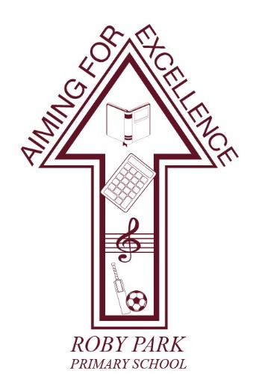

Roby Park Primary School

Easton Road

Huyton

Knowsley

L36 4NY

Tel: 0151 477 8340

Website: www.robyparkprimary.co.uk

E-mail: robypark@knowsley.gov.uk

Headteacher: Mrs K Allen

5th June 2024

Complimentary Roby Park PE Kit

Over the past few years, raising the profile of physical and mental wellbeing for all pupils has been a community wide priority at Roby Park. We work hard to ensure we offer an enriching and inclusive curriculum offer to all pupils and this spans to all areas of the curriculum.

P.E. is an essential part of all children’s education. Not only does it highlight the importance of physical health but it also teaches teamwork, leadership skills, develops resilience and impacts positively on children’s mental health. By allowing our children to come to school dressed in their PE kits on their designated PE day, it maximises learning time and therefore it is positively impacting upon learning.

At Roby Park, wearing a PE kit to school raises the profile of PE and keeps it at the forefront of learning. It demonstrates the value we put on PE and highlights how important it is for all of our children to live a healthy, active lifestyle. By offering a standardised PE uniform it ensures all of our pupils wear a kit that is safe, inclusive and fit for purpose.

We are pleased to announce we have once again secured funding, thanks to Next Energy, to provide every child at Roby Park with a complimentary PE kit worth over £30.

PE kit vouchers can be picked up from the office from Monday 10th June until Thursday 18th July. Lisa’s Schoolwear have said PE kits are available now in store.

Your voucher will entitle you to a free:
- Navy blue logo jacket
- Navy blue jogging bottoms
- White cotton logo tshirt

All we ask of parents/carers is for you to purchase the burgundy school shorts.

PE kits are provided free of charge to all children, on the proviso:
- Parents/carers must collect their kit from Lisa’s Schoolwear by Friday 13th September at the very latest. Vouchers will then be void so please order in plenty of time.
- Parents/carers are responsible for purchasing burgundy PE shorts for the warmer weather
- Any additional PE kit required is parent/carers responsibility to purchase
- PE kits must be looked after well - lost PE kit must be replaced
- Kits should be worn for inter-school competitions
- PE kits do not replace nor should they be worn in place of the correct daily school uniform

All PE kits (as well as school jumpers/cardigans/coats/bags) can be purchased at Schoolwear by Lisa. All enquiries should be directed to the shop.

Details of the shop are as follows:
Schoolwear by Lisa
275 E Prescot Rd., Liverpool L14 2DB
0151 259 8277

We hope you are excited as we are to see our commitment to the physical health and mental wellbeing of our children continue to become a greater and more inclusive priority, enabling all children to be equipped and thrive in P.E.

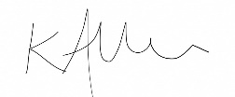
Warmest regards,

Kat Allen
Headteacher

