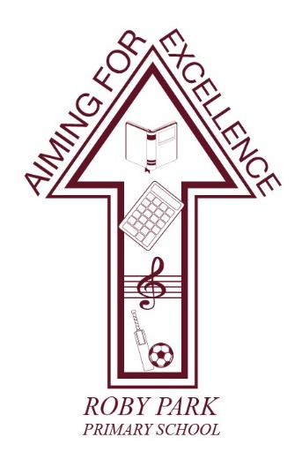

Roby Park Primary School

Easton Road

Huyton

Knowsley

L36 4NY

Tel: 0151 477 8340

Website: www.robyparkprimary.co.uk

E-mail: robypark@knowsley.gov.uk

Headteacher: Mrs K Allen

Date: Thursday 9th May 2024

Sports Day – Monday 20th May 2024

Dear parents/carers,

We shall be holding our annual Sports Day on Monday 20th May.

We are excited to be able to invite parents and carers in to spectate and enjoy the event….and even possibly participate in the parents’ races! Parents must be in place 15 minutes before each sports day begins. Please feel free to bring picnic blankets to sit on.

There is a designated area for parents and carers to spectate and we kindly ask adults not to approach children in order for us to safeguard our children, otherwise they will be asked to leave. Unfortunately, there will be no late entry possible due to all staff working and supporting children in the event so please be early.

EYFS & KS1 Sports Day starts at 9.30am so parents/carers can head straight to the spectator area once children have been dropped off. KS2 Sports Day starts at 1.30pm.

Children will move around 9 stations (7 events and 2 cheering stations) with their group. In their group there will be children from the 4 different houses. They will be competing for points for their house and the house with the most points at the end will win.

Children will have the chance to compete in:
Javelin | Shuttle run | Speed bounce | Running
Long jump | Egg & spoon race | Target throw

All children need to come into school wearing their full PE kit (burgundy shorts and logo white t-shirt) and trainers. The weather is due to be sunny and so we recommend you provide a hat for your child to wear and please put sunscreen on them before they come to school. Please provide your child with plenty of water to drink.

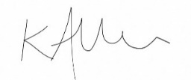
Warmest regards,

Mrs Kat Allen
Headteacher

