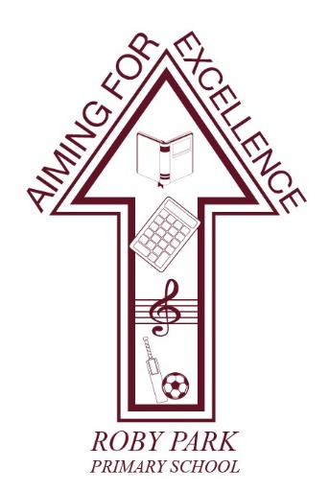

Roby Park Primary School

Easton Road

Huyton

Knowsley

L36 4NY

Tel: 0151 477 8340

Website: www.robyparkprimary.co.uk

E-mail: robypark@knowsley.gov.uk

Headteacher: Mrs K Allen

Date: Tuesday 7th May 2024

Dear parents/carers,

Year 6 SATs

Next week, children will sit their end of Key Stage 2 SATs tests for Reading, Maths and Spelling, Punctuation & Grammar. We are exceptionally proud of how hard the children have worked.

The timetable for the week is as follows:

Monday 13th May | Tuesday 14th May | Wednesday 15th May | Thursday 16th May
English Grammar, Punctuation and Spelling papers 1 and 2 | English Reading | Mathematics Arithmetic paper 1  Mathematics Reasoning paper 2 | Mathematics Reasoning paper 3

Y6 Complimentary Breakfast Club
To help ensure the children have the right start to each day, as well as being in a supportive environment with staff and peers, we will be offering a complimentary free breakfast each morning. Breakfast will start at 8.15am for all children. Children should come to school as normal via the Easton Road gate and enter school via the main entrance. Following breakfast, children will engage in mindfulness, yoga and positive affirmation activities which have been having a positive impact on children’s mindset and wellbeing.

Y6 SATS Celebration Sleepover
As you are aware, on Friday 17th May following the completion of their SATs tests, children can come to school in their own clothes and they will enjoy a day of Forest School activities and inflatables on the school field.

In the evening, they will enjoy a movie night with pizza followed by a sleepover in their chosen teepee. The children will have an absolutely wonderful time, celebrating with their friends and we look forward to sharing all of the videos and photographs with you via our social media channels.

Homework this Weekend
As we are a few days away from the SATs, it is vital children use their time wisely. For their homework this weekend, complete as many of these activities as you can:

*Go on a bike/scooter ride  *Spend time with people you love  *Spend time doing things you love | *Read a book/magazine  *Laugh until your tummy hurts  *See friends | *Watch your favourite tv show  *Go outside and enjoy the weather  *Play in your garden | *Eat sweets or ice—cream  *Go for a swim or a walk  *Rest  *Cook or make something

And children please remember….
You have all worked so hard to prepare for these tests and all that anybody asks of you is to try your best and your best is good enough. We wish you the best of luck and we are bursting with pride for the incredible young people you are growing up to be.

We want you to do your best but these tests will only tell your next school how they can further support you in English and Maths. The results do not reflect how unique, talented and special you all are. Whilst these tests measure your knowledge and skills in English and Maths, they do not measure your courage, compassion, happiness, confidence or kindness which are far more important.

And most importantly, please remember the results you achieve will not change how incredible you are, what you are capable of in the future and how much everyone loves and cares for you.

Warmest regards,

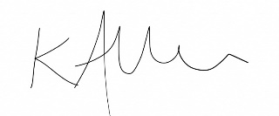

Kat Allen
Headteacher

