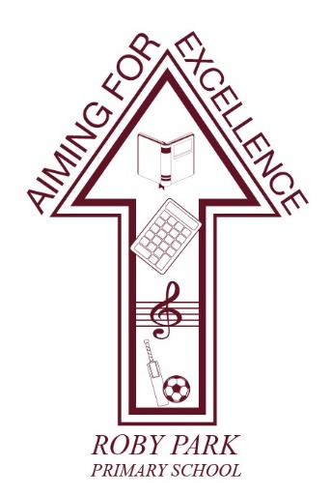

Roby Park Primary School

Easton Road

Huyton

Knowsley

L36 4NY

Tel: 0151 477 8340

Website: www.robyparkprimary.co.uk

E-mail: robypark@knowsley.gov.uk

Headteacher: Mrs K Allen
Friday 26th April 2024
End of Term Class Trips

Dear Parents/Carers

We are excited to inform you we have arranged exciting end of year class trips taking place in June and July. Trips organised are as follows:
Class | Date of Trip | Trip | Cost | Payment Deadline
YN | Thursday 13th June | Farmer Ted’s | £14.50 | Thursday 30th May
YR
Y1 | Monday 17th June | Smithills Animal Farm | £21.00 | Monday 3rd June
Y2 | Thursday 20th June | Bubbles Soft Play & New Brighton Beach | £15.50 | Thursday 6th June
Y3 | Monday 1st July | BeWilderwood | £17.50 | Wednesday 17th June
Y4
Y5 | Tuesday 11th June | West Kirkby Beach & Watersports | £29.00 | Tuesday 28th May
Y6 | Tuesday 18th June | Chester Zoo | £23.00 | Tuesday 4th June

Lunches
Please provide a healthy packed lunch and bottle of water for your child. Children who are eligible for Free School Meals will receive a packed lunch provided for them.

Payments
The cost for the class trips varies depending on location and are detailed in the above table. The school is also subsidising the trip by contributing towards the cost of the coaches for all class visits.

Parents/carers can either pay the balance in full; make instalments of your choice or pay instalments but all balances must be settled by the payment deadline.

Pocket Money
If parents/carers want to provide children with pocket money for the shops (YN, YR, Y1, Y3, Y4, Y6) or for ice creams (Y2, Y5), this is optional and no more than £10 please.

Parent Helpers
If you would like to volunteer to help on your child’s class end of year trip, please sign up here: https://forms.gle/titt7dUm92DFEo3B9

Warm regards
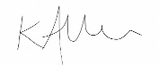

Mrs Kat Allen
Headteacher

