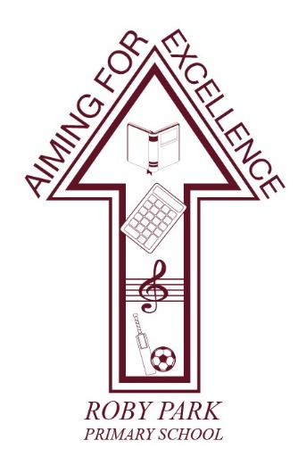

Roby Park Primary School

Easton Road

Huyton

Knowsley

L36 4NY

Tel: 0151 477 8340

Website: www.robyparkprimary.co.uk

E-mail: robypark@knowsley.gov.uk

Headteacher: Mrs K Allen

Date: 17th November 2023

Dear parents/carers,

Come and Join us for Christmas Family Dining!

Our popular family dining days are back! Georgios, our school cook, and his team are planning to cook Christmas dinner for everybody. The children and I would like to invite you to come and join us. The idea is simple; we think that our school dinners are fantastic and we want to encourage some festive family time at Roby Park!

You are invited to come into school and enjoy Christmas dinner with your child/ren all together on a day of your choosing. Even if your child normally has packed lunch, why not have a change for one day? Our hall will be decked out in festive decorations as you enjoy your Christmas feast.

You can book your chosen day for your Christmas family dining on Parent Booking. You can choose from either Monday 4th, Tuesday 5th, Wednesday 6th or Thursday 7th December. Service begins at 11.15am so we ask parents and carers to be on time. When booking your place, please include the total numbers in your party – all adults (maximum of 2) and number of children you have in school who will be joining you. We have a limited number at each sitting.

Should you not want to attend Christmas family dining, but your child would still like to enjoy a Christmas dinner, they can choose a Christmas dinner on their allocated days as follows:

Nursery & Reception | Monday 4th December
Y1 & Y2 | Tuesday 5th December
Y3 & Y4 | Wednesday 6th December
Y5 & Y6 | Thursday 7th December

During this week, for those children who have school dinners, there will be sandwiches and jacket potatoes available every day when it is not your child’s Christmas family dining day or their class’ Christmas dinner day.

Christmas meals cost £2.20 per child (this only applies to Nursery and Key Stage 2 children who are not entitled to free school meals) an adult meal costs £4.50 which should be paid via Parent Pay. When paying on Parent Pay, please carefully select whether you are paying for a turkey or vegetarian Christmas dinner.

Your place will only be secured by booking your places on Parent Booking and making payment on Parent Pay for yourself and children (if applicable), no later than 9am on Friday 24th November. Unfortunately, we will not be able to accommodate any late requests.

Tickets will be issued during the week of 27th November, these will be required for you to present on the day of your dining.

We look forward to seeing you.

Warm regards,

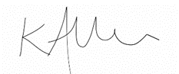

Mrs Kat Allen
Head Teacher

