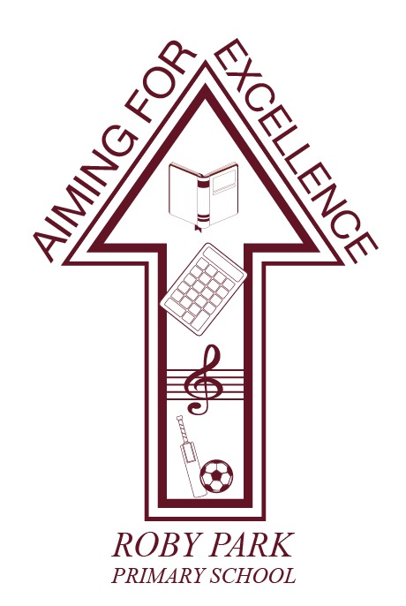

Physical Activity Policy

Written Sept 2023

Review Sept 2024

Signed – Mrs Kat Allen

(Headteacher)

Signed – Mr Frank Walsh

(Chair of Governors)

Physical Activity Policy

Introduction
As a school we recognise the vital contribution of physical activity in a child’s physical, cognitive, social and emotional development as well as the role it can play in a child’s spiritual, moral and cultural development.

We aim to provide a broad and balanced P.E. curriculum and a series of extracurricular activities to aid children’s increasing self-confidence and physical wellbeing. Through a balance of individual, paired and group activities, we aim to cater for the different strengths, needs and preferences of each child, using differentiated activities where appropriate. We believe that through the variety of opportunities that PE and Sport offer, children can develop a sense of personal achievement, fair play, teamwork and an understanding of the ways in which sport can remove social and cultural boundaries.

We plan a range of activities that aim to provide children with a broad base of movement knowledge, skills and understanding, which they can refine and expand throughout their primary school years. All children are encouraged to join after school clubs and extend their interest and involvement in sport.

We encourage children to develop their creative and expressive abilities, through improvisation and problem-solving. Children are taught to appreciate the importance of a healthy and fit body and begin to understand those factors which affect health and fitness.

Through the Government Funding for primary PE and Sport, the school will provide further opportunities for all children to develop their physical literacy. This will be through work with external agencies, specialists and staff development.

Aims
Physical development:
- To develop physical competence and confidence by acquiring and developing a range of fine and gross motor skills.
- To be aware of the different shapes and movements that can be made with the body.
- To develop knowledge, skills and understanding, and the ability to remember, repeat and refine actions with increasing control and accuracy.
- To promote fitness and a healthy lifestyle by understanding the effects of exercise on the body and the importance of developing strength, endurance and flexibility

Social and emotional development:
- To develop a love of physical exercise.
- To develop the ability to work independently and communicate and respond appropriately towards others using verbal and non-verbal communication.
- To develop confidence in their own skills and abilities.
- To promote an understanding of safe practice and develop a sense of responsibility towards the safety of themselves and others.
- To create and plan games and teach them to one another.
- To develop a sense of fair play.

Cognitive development:
- To develop decision making and problem solving skills.
- To develop reasoning skills and the ability to make judgements.
- To develop an increasing ability to select, link and apply skills, tactics and compositional ideas.
- To develop the ability to communicate non-verbally.
- To improve observational skills, the ability to describe and make simple judgements on their own and others’ work, and to use this knowledge and understanding to improve their own performance.
- To understand that using the correct technique will improve accuracy and individual performance.
- To be able to evaluate performance and act upon constructive criticism.

Spiritual, moral and cultural development:
- To develop a positive attitude to themselves and others.
- To experience a range of differing activities and realise that physical activity doesn’t have to be about winning a competition - doing your best is as important.
- To be able to encourage others and give praise for their achievements so that when children perform they do not fear failure.
- To treat your team, the opposition and the referee with respect.

The PE Curriculum:
We aim to provide a well-balanced curriculum which covers the statutory requirements for the Early Years Foundation Stage (EYFS) and the PE National Curriculum.

Foundation Stage
In F2 (EYFS), opportunities are provided for children to be active and to develop their co-ordination, control and movement through moving and handling activities which involve the use of a range of equipment and involve different spatial experiences. F2 children have 1 session per week delivered by teaching staff.

Key Stage 1
Pupils in KS1 engage in one lesson of high-quality PE during a normal week. In KS1 the curriculum focuses on fundamental skills to develop agility, balance and co-ordination and developing throwing, catching, jumping, running, kicking and striking. The curriculum is taught through the following areas;
Games, Gymnastics and Dance.

Key Stage 2
Pupils in KS2 have at least 1 lesson of PE per week across the academic year.

At KS2, pupils continue to apply and develop a range of skills, movements and tactical ideas. The curriculum is taught through invasion, net/wall, and fielding and striking games, gymnastics, dance, athletics and swimming. We also enrich children’s experiences through opportunities for outdoor and adventurous activities.

Resources
The curriculum will be taught by qualified sports coaches and class teachers. When possible, PE will always take place on the school playground, if not PE will take place in the school hall. A detailed breakdown of resources and provisions purchased using the Primary PE and Sport Premium is also available via our school website.

Safety
As with all physical activity, it is important that certain procedures are followed to minimise the risk of injury.
- Children should dress in shorts, tracksuit bottoms and t-shirts.
- Children will work in bare feet for all indoor and apparatus work.
- Pumps or trainers are worn for outdoor games, together with tracksuits if it is cold.
- Jewellery is not to be worn.
- Long hair should be tied back and rigid headbands should be removed.

All staff are aware of where to find AFPE’s Safe Practice book and the PE Subject Leader has been trained on Health and Safety in PE.

Staff are suitably qualified and competent to deliver the activity they are leading. If necessary, the

Subject Leader will arrange support and or training in identified areas.

All external staff will have suitable qualifications and experience for the activity they are delivering. A period of observation will take place when a new provider starts working in the school.

Swimming
All children in Year 6 will take part in school swimming lessons. The National Curriculum states that all children should be able to swim 25m by the end of KS2. All children must follow the local authority’s guidelines regarding swimwear. Girls should wear a one piece costume and boys swimming trunks.

Assessment and Consultation
Regular assessments will take place throughout the year. The teachers and sports coaches teaching PE will be responsible for recording assessment. The subject leader will use these assessments to produce an end of year overview, detailing the progress and achievement made in Physical Education.

At the end of each term the PE Lead will review the progress made within each year group. Regular communication will take place to ensure high quality provision is in place.

Out-of-School-hours Learning (OSHL)
Our extra-curricular programme compliments and supplements the range of activities covered in curriculum time. The planned programme for 2020-21 reflects a breadth and balance across the NC areas of activity, including dance, games and athletics. We follow a range of level 2 competitions, tournaments and festivals within the local area. At the beginning of each term, we publish a documented timetable of clubs. The extra-curricular content aims to be varied – including competitive and non-competitive and team and individual based clubs appropriate for all pupils.

Break time and lunch time provision
All children in Key Stage 1 & 2 have the opportunity to take part in structured physical activity during break and lunch times. A timetable of activities include: Football, Cricket, basketball and tennis. Our team of Play Leaders support children in KS1 and KS2 by playing structured and unstructured games, including some friendly competitions. Our qualified sports coach actively supports children to be as active as possible during lunch time. This includes setting up and supervising games, demonstrating how to use new equipment and ensuring all children have the opportunity to take part. Staff are expected to set a good example with regards to being active and should be dressed appropriately.

Working with external partners
The school works closely with a number of external partners and agencies to improve the physical activity on offer.

