Mental Health and Wellbeing Policy

Written September 2023

Review September 2024

Signed – Mrs Kat Allen

(Headteacher)

Signed – Mr Frank Walsh

(Chair of Governors)

Policy statement
“Mental health is a state of well-being in which every individual realises his or her own potential, can cope with the normal stresses of life, can work productively and fruitfully, and is able to make a contribution to her or his community.”
(World Health Organisation)
At our school, we aim to promote positive mental health for every pupil and every member of staff. We pursue this aim using universal whole school approaches and selected and targeted approaches for the more vulnerable.
In addition to promoting positive mental health, we aim to recognise and respond to mental ill health. In an average classroom, three children will be suffering from a diagnosable mental health issue. By developing and implementing practical, relevant and effective mental health policies and procedures we can promote a safe and stable environment for pupils affected both directly and indirectly by mental ill health.
Scope
This policy describes the school’s approach to promoting positive mental health and wellbeing. This Policy is intended as guidance for all staff including non-teaching staff and governors. It should be read in conjunction with our policies for Staff Wellbeing; Supporting Pupils with Medical Needs in cases where a child’s or staff member’s mental health overlaps with or is linked to a medical issue; the SEND Policy where a pupil has an identified special educational need; our Safeguarding Policy; and Anti-bullying Policy.

Aims
At our school, we aim to promote positive mental health and wellbeing of every member of our school community and recognise how important mental health and wellbeing is to our lives, as is physical health. We recognise that children’s mental health and overall wellbeing can affect their learning and achievement.
We aim to:
- Promote positive mental health in all staff and pupils
- Increase understanding and awareness of common mental health issues
- Alert staff to early warnings of mental health
- Provide support to staff working with pupils with mental health issues
- Provide information for pupils and families about how to promote positive mental health
- Reduce the stigma surrounding mental health issues
- Provide support to pupils and their families when a pupil, member of the family or friend is suffering mental ill health

Lead members of staff
Kat Allen Designated Safeguarding Lead
Kathy Lyon Deputy Safeguarding lead, Senior Mental Health Lead, Mental Health First Aider, SENDCo
Kirstie Carroll Deputy Safeguarding lead, Lead First Aider
Kelly Daniels Governor

Taking a Whole School Approach

We take a whole school approach to effective practice and provision is in place that promotes the emotional wellbeing and mental health of both staff and pupils. This is achieved by:
- Creating an ethos, policies and behaviours that support mental health and resilience and which everyone understands.
- Helping children to develop social relationships support each other and seek help when they need it.
- Helping children be resilient learners.
- Teaching children social and emotional skills and an awareness of mental health.
- Early identification of children who have mental health needs and planning to support their needs, including working with specialist services.
- Effectively working with parents and others.
- Supporting and training staff to develop their skills and own resilience.
- Developing an open culture that encourages discussion and understanding of mental health awareness.

Mental health and well-being is not just the absence of mental health problems. We want all children to:
- Make and sustain friendships
- Deal with and resolve conflict effectively and fairly
- Solve problems with others for themselves
- Manage strong feelings such as frustration, anger and anxiety
- Be able to promote calm, optimistic states that support the achievement of goals
- Recover from setbacks and persist in the face of the difficulties
- Work and play co-operatively
- Compete fairly and win and lose with dignity and respect for other competitors
- Recognise and stand up for their rights and the rights of others
- Understand and value the differences and commonalities between people, respecting the rights of others to have beliefs and values different from their own

We promote a mentally healthy environment through:
- Promoting pupil voice and opportunities to participate in decision-making.
- Celebrating academic and non-academic achievements.
- Providing opportunities to develop a sense of self-worth through taking responsibility for themselves and others
- Providing opportunities to reflect.
- Access to appropriate support that meets their needs.
- Creating a whole school community that upholds kindness, values difference and challenges exclusion.

Curriculum
Positive wellbeing is promoted through the curriculum and all school activities. Through a carefully planned approach to PSHE, our pupils are helped to acquire the knowledge and develop the skills and understanding they need to lead confident, healthy, independent lives, and to become resilient, informed and responsible citizens.
In addition, whole school approaches, such as assemblies, are used to further develop the pupils’ knowledge of strategies. Whole school events are held including; Yellow Day for Young Minds, Mental Health Awareness Week, World Mental Health Day, Growing Up Week and Friendship Week. During these events, the focus is on mindfulness and resilience and the purpose is to teach the pupils’ strategies for dealing with anxiety and copying with changes. Children will have the opportunity to raise difficult issues and as a result these will be acted on and a debrief provided.

All pupils have access to an online portal www.zumos.co.uk that promotes mental health and wellbeing self-support.
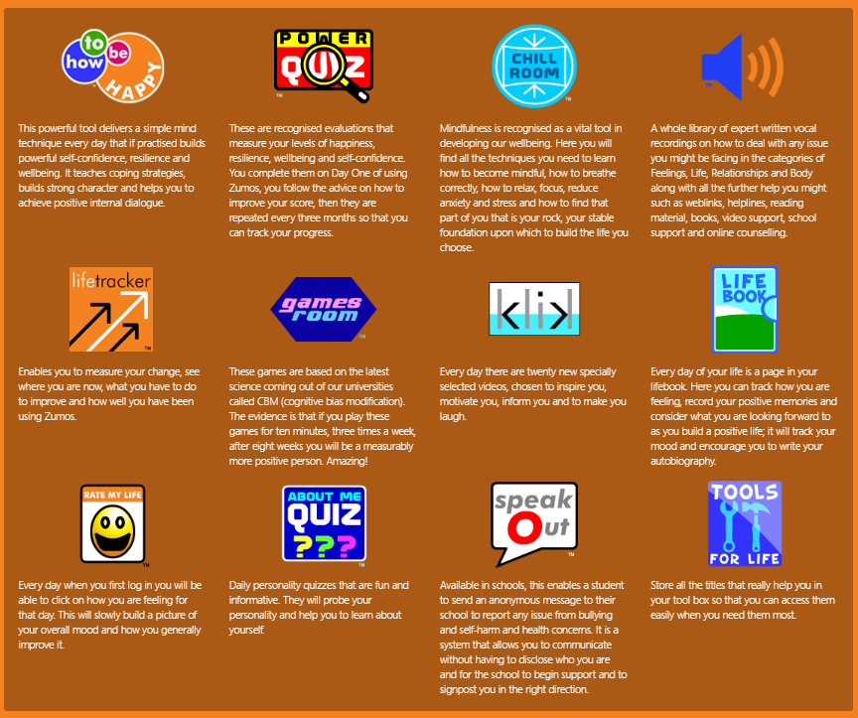

Risk and protective factors that are believed to be associated with mental health outcomes
 | RISK FACTORS | PROTECTIVE FACTORS
In the child | - Genetic influences  - Low IQ and learning disabilities Specific development delay or neuro-diversity  - Communication difficulties  - Difficult temperament  - Physical illness  - Academic failure  - Low self-esteem | - Secure attachment experience  - Outgoing temperament as an infant  - Good communication skills, sociability  - Being a planner and having a belief in control  - Humour  - A positive attitude  - Experiences of success and achievement  - Faith or spirituality  - Capacity to reflect
In the family | - Overt parental conflict including domestic violence  - Family breakdown (including where children are taken into care or adopted)  - Inconsistent or unclear discipline  - Hostile and rejecting relationships  - Failure to adapt to a child’s changing needs  - Physical, sexual, emotional abuse, or neglect  - Parental psychiatric illness Parental criminality, alcoholism or personality disorder  - Death and loss – including loss of friendship | - At least one good parent-child relationship (or one supportive adult)  - Affection  - Clear, consistent discipline  - Support for education  - Supportive long term relationship or the absence of severe discord
In the school | - Bullying including online (cyber)  - Discrimination  - Breakdown in or lack of positive friendships  - Deviant peer influences  - Peer pressure  - Peer on peer abuse  - Poor pupil to teacher/school staff relationships | - Clear policies on behaviour and bullying  - Staff behaviour policy (also known as code of conduct)  - ‘Open door’ policy for children to raise problems  - A whole-school approach to promoting good mental health  - Good pupil to teacher/school staff relationships  - Positive classroom management  - A sense of belonging  - Positive peer influences  - Positive friendships  - Effective safeguarding and Child Protection policies.  - An effective early help process  - Understand their role in and be part of effective multi-agency working  - Appropriate procedures to ensure staff are confident to can raise concerns about policies and processes, and know they will be dealt with fairly and effectively
In the community | - Socio-economic disadvantage  - Homelessness | - Wider supportive network  - Good housing  - High standard of living

Early intervention to identify issues and provide effective support is crucial. The school’s role in supporting and promoting positive mental health and wellbeing can be summarised as:
- Prevention: Creating a safe and calm environment where mental health problems are less likely, improving the mental health and wellbeing of the whole school population, and equipping children to be resilient so that they can manage the normal stress of life effectively. This will include teaching pupils about mental wellbeing through the curriculum and reinforcing this through our ethos and other school activities.
- Identification: Recognising emerging issues as early and accurately as possible.
- Early support: Helping children to access evidence based early support and interventions.
- Access to specialist support: Working effectively with external agencies to provide swift access or referrals to specialist support and treatment.

Graduated response
School will respond to support in mental health using a graduated response:

Stage 1: Universal Support
This is what school offers all children to promote positive mental health. Support is embedded in all classrooms and is part of the whole school approach. For example, Learning Heroes, Worry boxes/monsters, mindfulness in class, Wellbeing element of Class Charts, Bully Busters.
Stage 2: Selected support
This is where we put specific interventions into place. These are delivered in school by school staff, sometimes in consultation with other agencies. For example, Self-esteem groups, LEGO therapy, DESTY, anxiety and anger support, Mindfulness with Mojo and Character Mentoring.

Stage 3: Targeted support
This is where specific interventions are delivered in school or externally by external agencies. School remain involved. For example, Butterflies, Bully Busters, YPAS.

Children may move around within the different stages depending on their need/improvement.

Working in Partnership with Parents
At Roby Park Primary School, we understand and value the need to work closely with parents to ensure that the school’s health initiatives meet the needs of our pupils. We value the important contribution made by parents and appreciate the need to proactively engage parents and families in the health of the children. We seek to establish and maintain strong partnerships with families, outside agencies and the wider community to promote consistent support for children’s health and wellbeing.
To support parents, we:
- Highlight sources of information and support about mental health and wellbeing on our school website
- Ensure that all parents are aware of who to talk to, and how to go about this, if they have concerns about their child.
- Make our Mental Health and Wellbeing Policy easily accessible to parents.
- Share ideas about how parents can support positive mental health in their children.
- Keep parents informed about the mental health topics their children are learning about in PSHE and share ideas for extending and exploring this learning at home.
- Have an ‘open door’ policy with the Inclusion Manager
- Provide drop in sessions and coffee mornings
- Provide a wellbeing aspect to Class Charts so parents can communicate any issues to staff as they happen
- Provide a dedicated confidential email address that parents can contact if they have concerns about their child’s or anyone else’s mental health.

Working with Other Agencies and Partners
As part of our targeted provision the school will work with other agencies to support children’s emotional health and wellbeing including:
- School Health
- Educational Psychology services
- Behaviour Outreach support services
- Paediatricians
- CAMHS (Child and Adolescent Mental Health Service)

Training
We are committed to high quality, ongoing professional development on emotional wellbeing and mental health. All staff will receive regular training linked to recognising and responding to mental health issues. Specific issues will be covered through specialist training where it becomes appropriate due to developing situations with a child/ren.

